

KAUNAS UNIVERSITY OF TECHNOLOGY

FACULTY OF INFORMATICS

T120B169 App Development for Smart Mobile Systems

Wikipedia based Question-answer game (Quiz)

|  |
| --- |
| *Group, Name and Surname:*  *IFK-8 Gintas Kirdeikis*  *IFK-8 Gabrielius Kojelis*  *IFK-8 Edvinas Matulevičius*  *Ifk-8 Edvinas Kulboka* |
| Date: 2021*.12.16* |
|  |

Kaunas, 2021

Description of Your app 4

Functionality of your app 5

List of functions 5

Solution 7

Task #1. When a user enters his name in the text box (“textview”) and clicks “btn_button”, a temporary name is registered which will be shown on rankings after finishing a quiz. 7

Task #2. Navigation bar – once you register your name, a navigation bar appears on the left side of the game. You have options to “start a game”, “rules” and “scoreboard”. 8

Task #3. Added “portrait” phone orientation as main orientation. 10

Task #4. Added three dots on the top right side of the screen which will have settings of the game such as dark/light background switch 12

Task #5. Added Scoreboard page which will show top scores. 12

Task #6. Added main quiz game page which appears once you register a name. 14

Task #7. Added Rules page which will show main rules and how to play the quiz 16

Task #8. Added the option to scroll through the “rules” tab in the “navigation bar” when the size exceeds the contents on the screen using “ScrollView” 17

Task #9. Defence 1 task Added simple quiz functionality 18

Task #10. Added simple settings tab 23

Task #11. Defence 2 retake task – added edittext for answers. 25

Task #12. Created Wikipedia JSON API, added ssl support and attached let’s encrypt ssl sertificates. 27

Task #13. Implemented wikipedia api to quiz using retrofit 30

Task #14. Implemented progressbar defend 32

Task #15. Wikipedia Api improvements 34

Task #16. UI design changes, improvements 34

Task #17. fixed scoreboard 37

Task #18. added topic selection 38

Task #19. fixed bugs with questions and answers and added answer randomization 39

Task #20. fixed a bug that allowed user to change his answer before going to next question. 40

Task #21. Changed answer list from 2 to 3 41

Task #22. fixed progress bar loading 42

Task #23. Questions and answers are now visible only after fully loading 43

Reference list 46

Tables of Contents

# **Description of Your app**

1. What type is your application/game?

*Android based quiz game (questions-answers from wikipedia)*

1. Description.

The question-answer game will pull many different themed questions from “wikipedia” with many different difficulities. You can see one hint during a game that will suggest an answer depending on how many available options there are. A high score is shown after failing to answer 1-3 questions in a row that will be thought about during further development and might change. Also, rankings will be shown on app and you can also share your high score rank on social media. There also might be an option to log in and play on facebook or we might just make it so once you finish playing you can share your high score on social media.

# **Functionality of your app**

## **List of functions**

1. When a user enters his name in the text box (“textview”) and clicks “btn_button”, a temporary name is registered which will be shown on rankings after finishing a quiz.

(fixed)

1. Navigation bar – once you register your name, a navigation bar appears on the left side of the game. You have options to “start a game”, “rules” and “scoreboard”.

(not fully implemented, might add more options such as quit game button)

1. Added “portrait” phone orientation as main orientation.
2. Added three dots on the top right side of the screen which have settings of the game such as dark/light background switch

(not yet implemented, might change functionality and options later on)

1. Added Scoreboard page which will show top scores.

(not fully implemented)

1. Added main quiz game page which appears once you register a name.

(not fully implemented)

1. Added Rules page which will show main rules and how to play the quiz
2. Added the option to scroll through the “rules” tab in the “navigation bar” when the size exceeds the contents on the screen using “ScrollView”
3. Defence 1 task Added simple quiz functionality
4. Added simple settings tab
5. Defence 2 retake task – added edittext for answers.
6. Created Wikipedia JSON API, added ssl support and attached let’s encrypt ssl sertificates.
7. Created Wikipedia JSON API, added ssl support and attached let’s encrypt ssl sertificates.
8. Implemented progress bar defence task.

# **Solution**

## **Task #1.** When a user enters his name in the text box (“textview”) and clicks “btn_button”, a temporary name is registered which will be shown on rankings after finishing a quiz.

Description of the implementation (3-5 sentences).

User will be able to type in a desired name which he will want to be shown later on in leaderboards(rankings), if an empty name is left in text form, a text appears “please enter your name”.

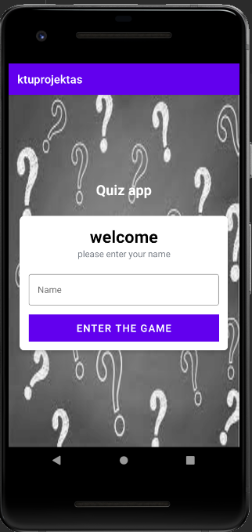

Figure 1. Screenshot #1

Each main function should be illustrated with the source code FRAGMENTS;

MainActivity.kt

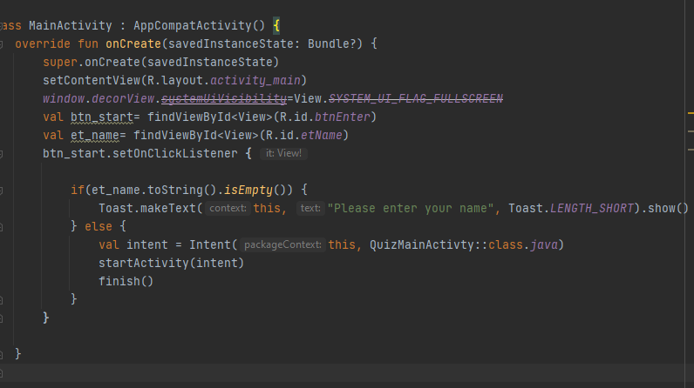

## **Task #2.** Navigation bar – once you register your name, a navigation bar appears on the left side of the game. You have options to “start a game”, “rules” and “scoreboard”.

Description of the implementation (3-5 sentences).

After you enter your desired name and click start, there will be a side left navigation bar on the top left of the screen which a USER is able to open and check out the rules or highest scores on the scoreboard before starting to play the wikipedia quiz.

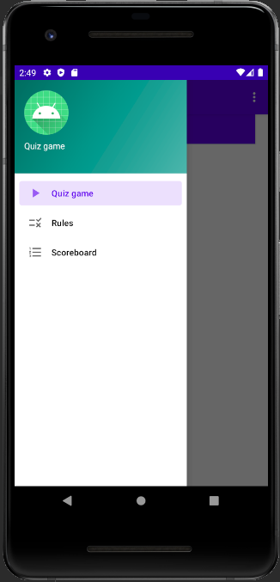

Figure 2. Screenshot #2

Each main function should be illustrated with the source code FRAGMENTS;

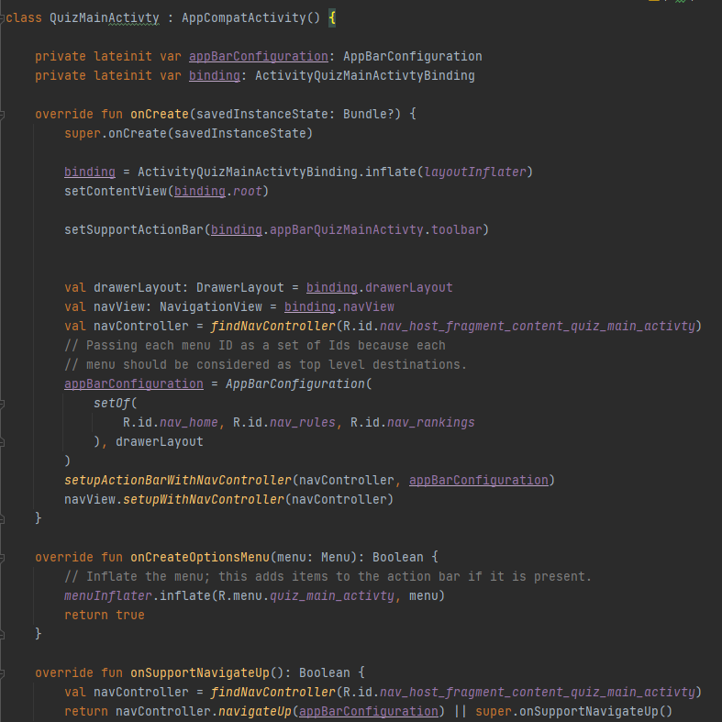

## **Task #3. A**dded “portrait” phone orientation as main orientation.

Description of the implementation (3-5 sentences).

Made it so portrait is the default navigation on the app for ease of use.

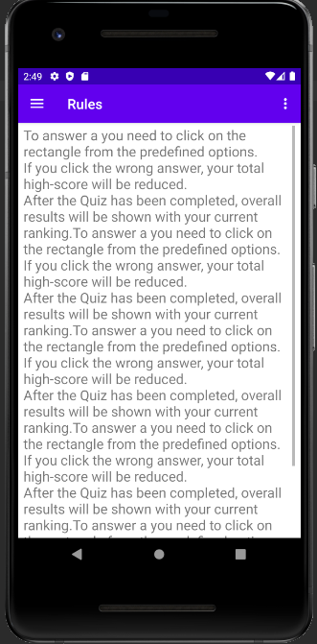

Figure 1. Screenshot #3

Each main function should be illustrated with the source code FRAGMENTS;

AndroidManifest.xml

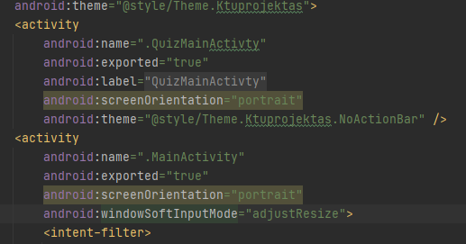

## **Task #4.** Added three dots on the top right side of the screen which will have settings of the game such as dark/light background switch

Description of the implementation (3-5 sentences).

Added three dots on the top right of the screen before you start playing the quiz, so users can change between dark/light backgrounds (still not decided if we will have that option in settings).

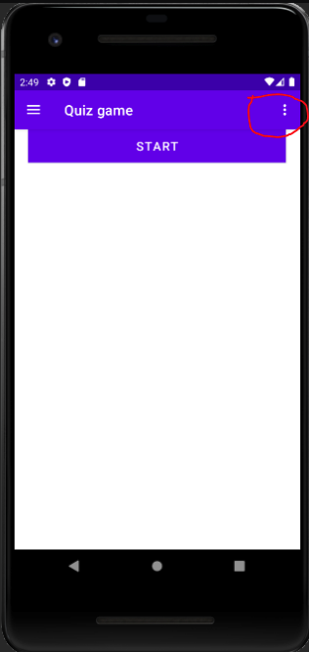

## **Task #5.** Added Scoreboard page which will show top scores.

Description of the implementation (3-5 sentences).

After you enter your desired name and click start, there will be a side left navigation bar on the top left of the screen which a USER is able to open and check out the Scoreboard of all top players.

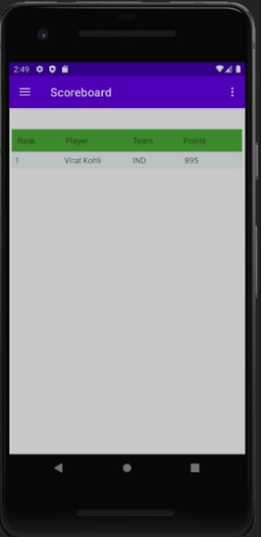

Figure 1. Screenshot #5

Each main function should be illustrated with the source code FRAGMENTS;

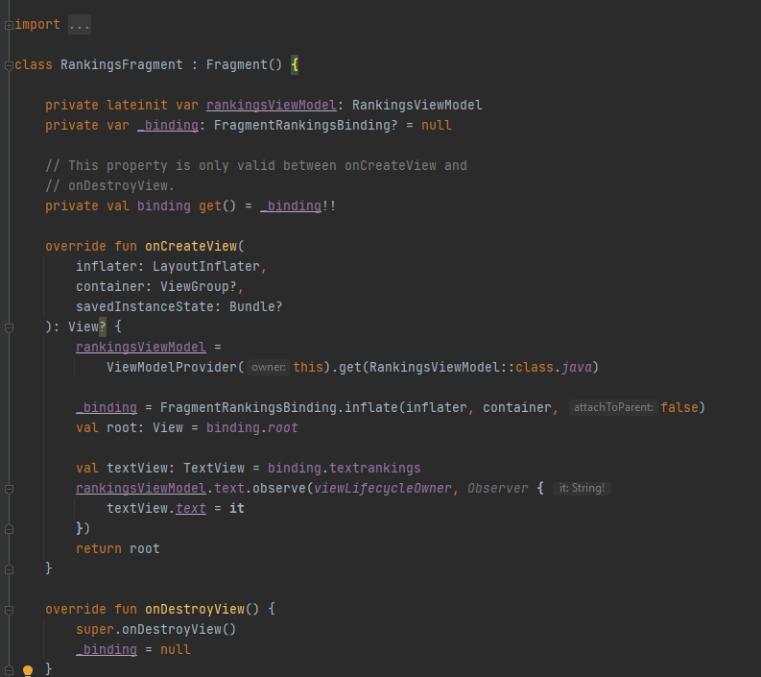

## **Task #6.** Added main quiz game page which appears once you register a name.

Description of the implementation (3-5 sentences).

After you enter your desired name, you can start playing the quiz. (more options will be added later)

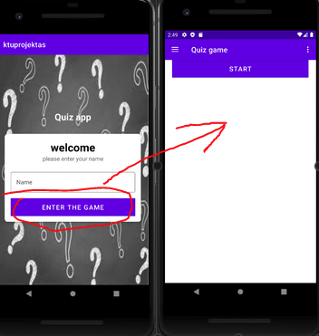

Figure 1. Screenshot #6

Each main function should be illustrated with the source code FRAGMENTS;

QuizMainActivty.kz

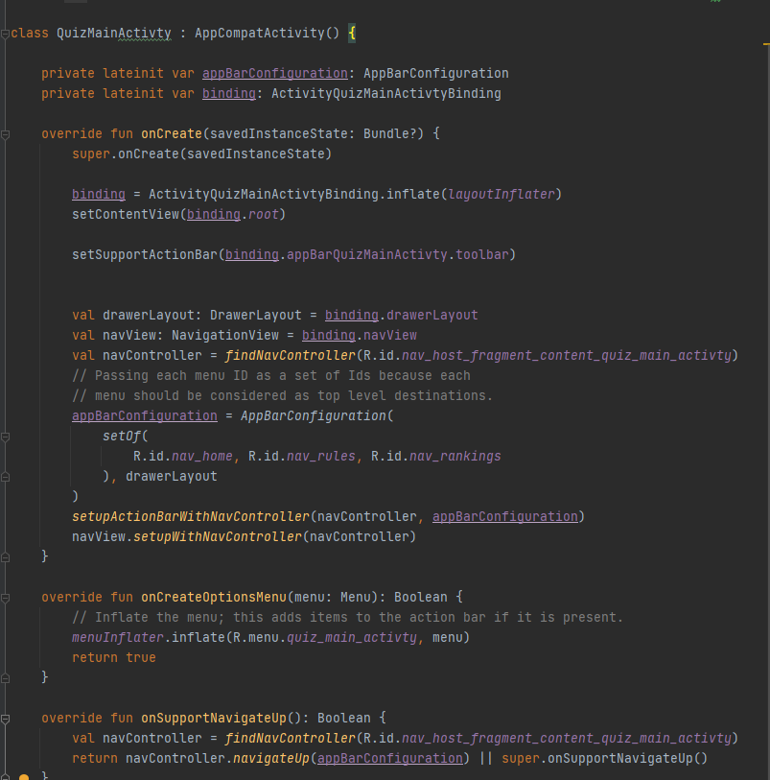

## **Task #7.** Added Rules page which will show main rules and how to play the quiz

Description of the implementation (3-5 sentences).

A simple page which shows main rules and how to play the quiz.



Figure 1. Screenshot #7

Each main function should be illustrated with the source code FRAGMENTS;

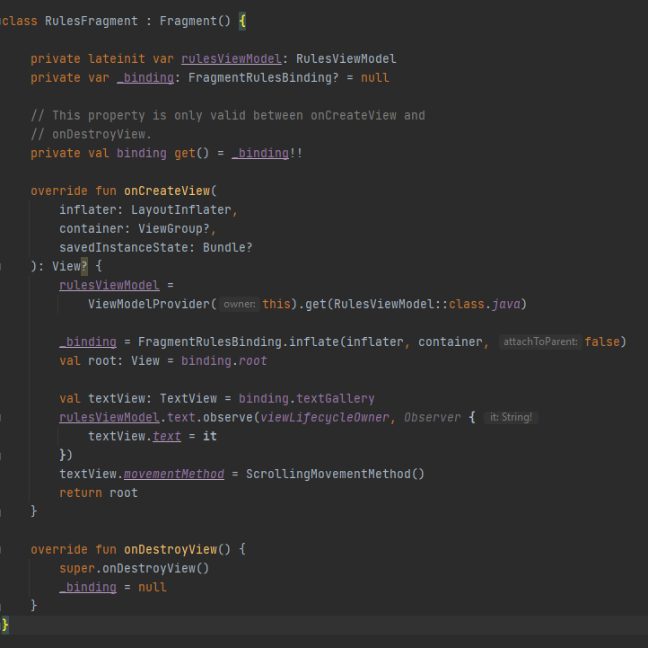

## **Task #8.** Added the option to scroll through the “rules” tab in the “navigation bar” when the size exceeds the contents on the screen using “ScrollView”

Description of the implementation (3-5 sentences).

Added a simple textview.movementmethod = scrollingmovementmethod() to have a scrollable rules page if the text doesn’t fit in one page.

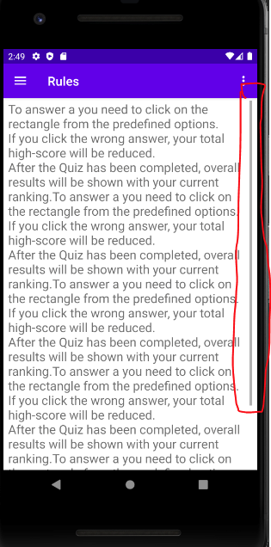

Figure 1. Screenshot #8

Each main function should be illustrated with the source code FRAGMENTS;



## **Task #9.** Defence 1 task Added simple quiz functionality

Description of the implementation (3-5 sentences).

Added a simple implementation of quiz game (without fetching questions from wiki). User has two options to choose: yes or no. The correct answer is marked green, incorrect red. In the end of the game app shows score to the player. In the next future player would be able to choose answer from more than 2 options and there will be only one correct. Questions and answers options are going to be pulled down from the wiki by using our specially written for this task API which probably would be based on PHP.

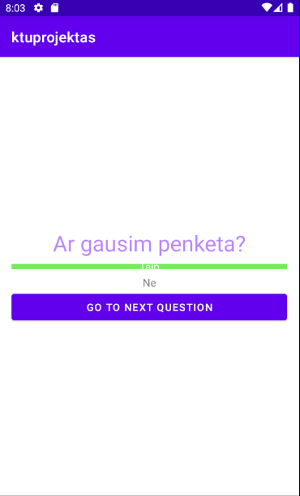

Figure 1. Screenshot #9

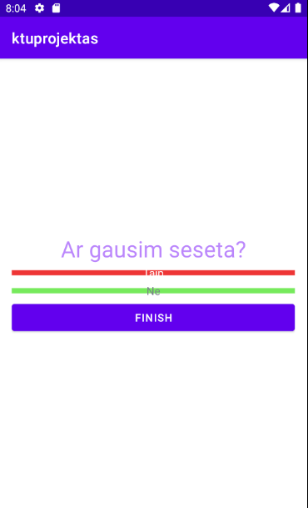

Figure 1. Screenshot #9

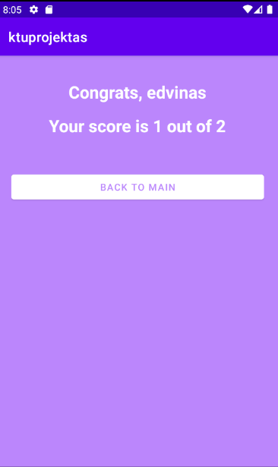

Figure 1. Screenshot #10

Each main function should be illustrated with the source code FRAGMENTS;

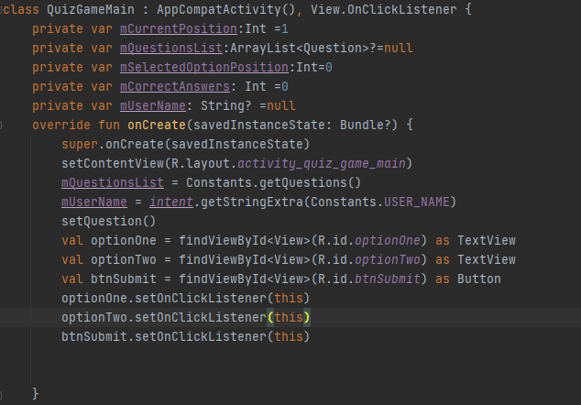

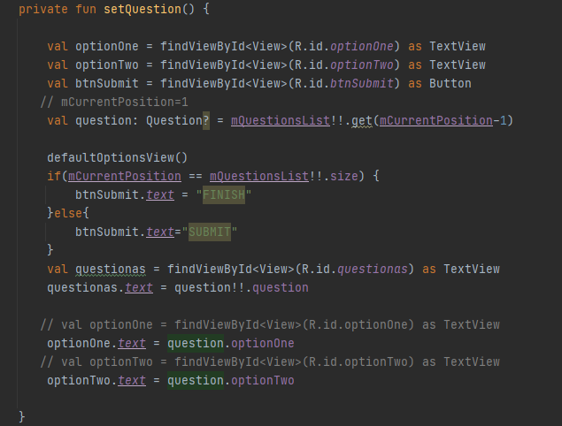

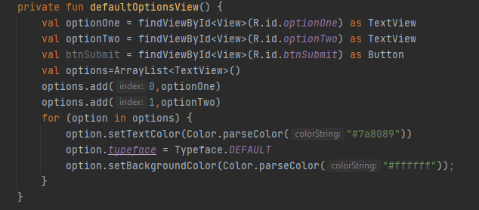

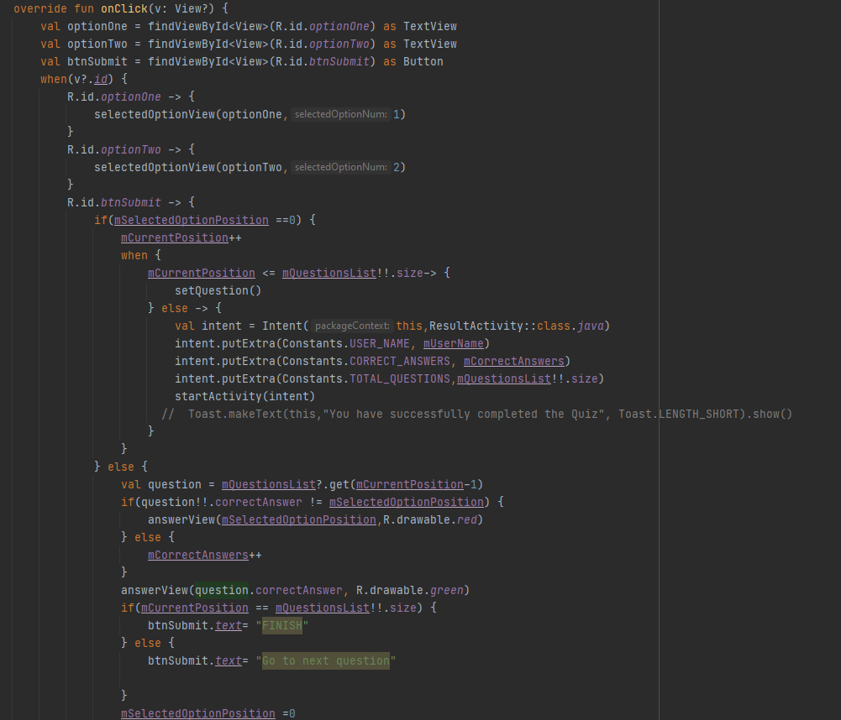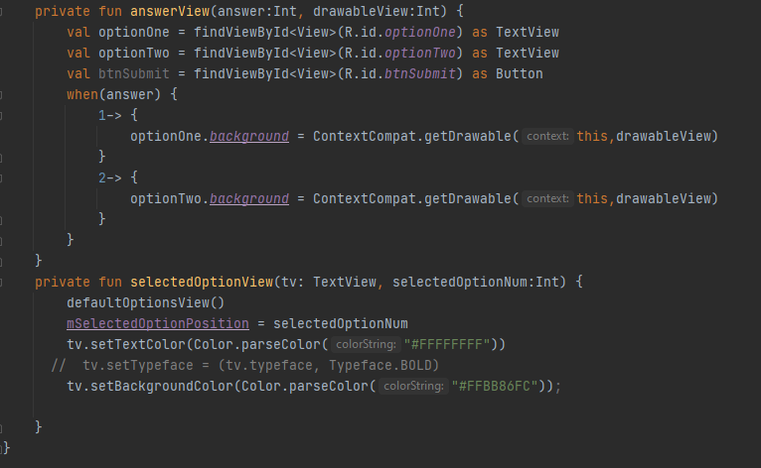

## **Task #10.** Added simple settings tab

Description of the implementation (3-5 sentences).

Added a simple implementation of settings that will have more options in further development

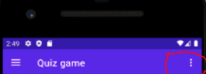

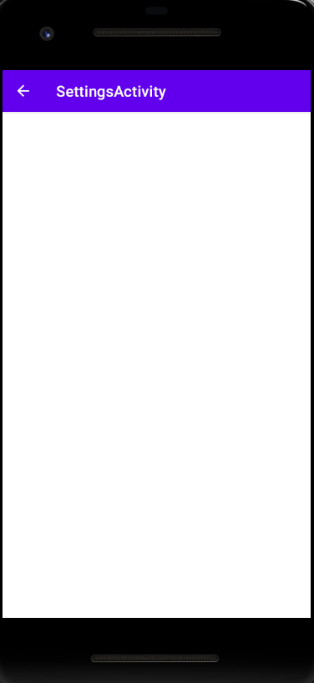

Figure 1. Screenshot #9

Each main function should be illustrated with the source code FRAGMENTS;

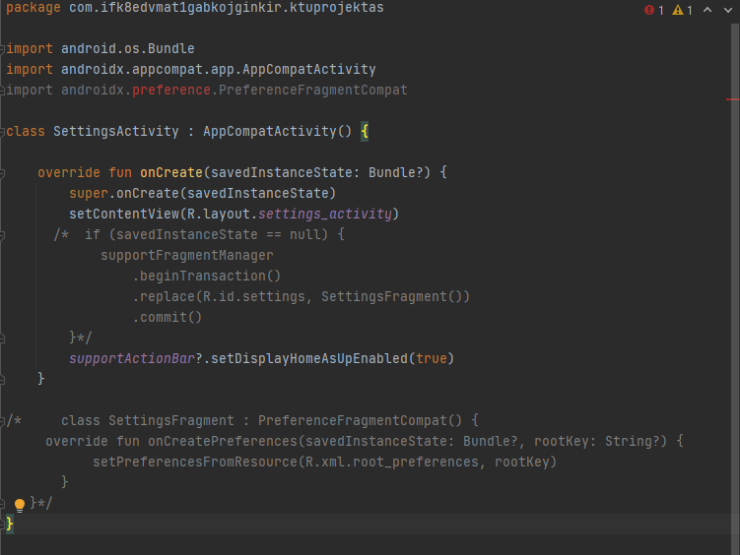

## **Task #11.** Defence 2 retake task – added edittext for answers.

Description of the implementation (3-5 sentences).

Added a simple implementation of edittext answer for defence task

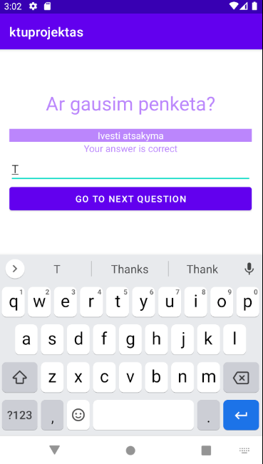

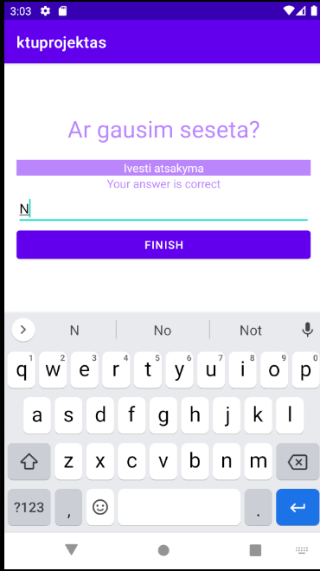

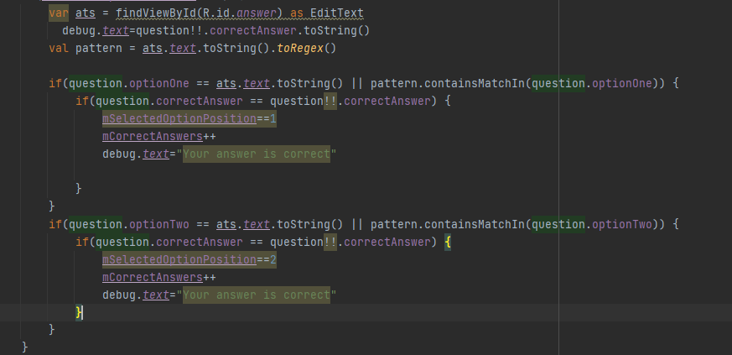

Figure 1. Screenshot #9

Each main function should be illustrated with the source code FRAGMENTS;



## **Task #12.** Created Wikipedia JSON API, added ssl support and attached let’s encrypt ssl sertificates.

Description of the implementation (3-5 sentences).

API based on python, parses data by using python library wikipedia, then generates questions and answers and returns data in json format

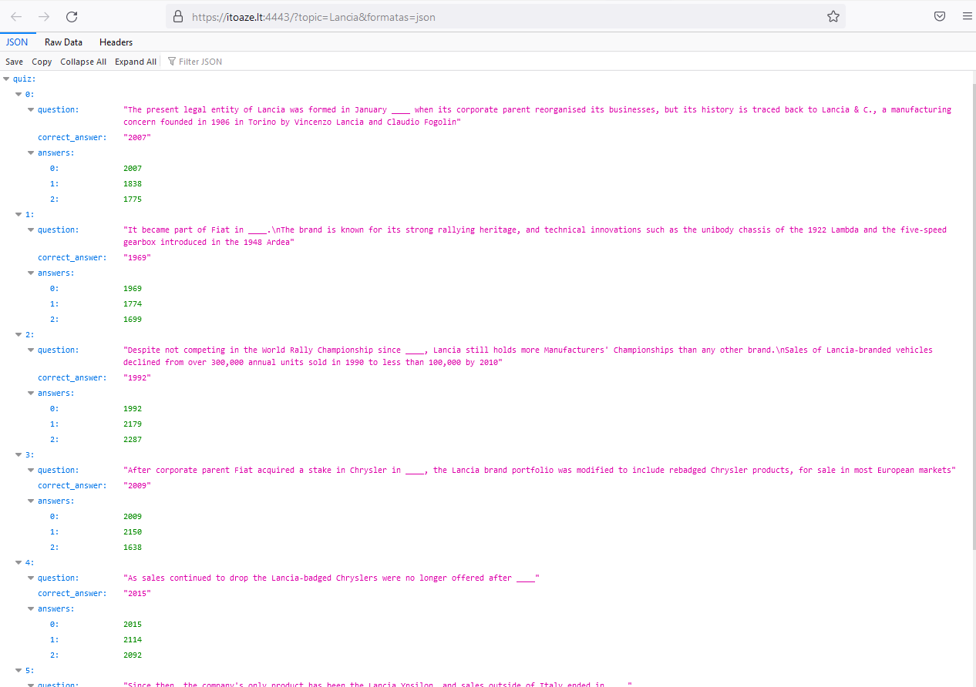

Figure 1. Screenshot #10

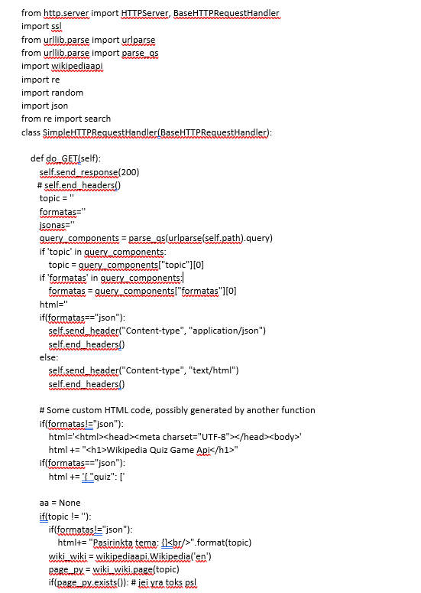

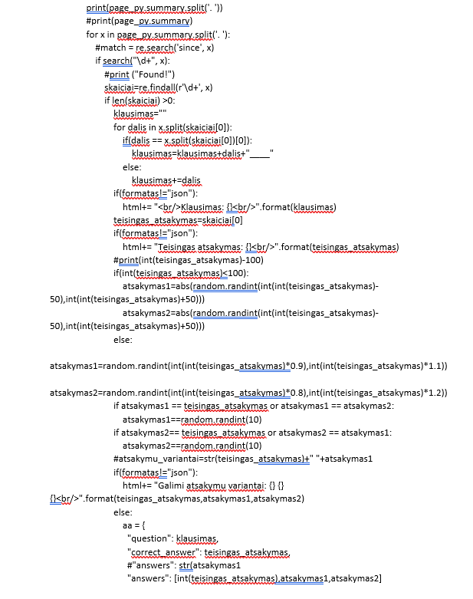

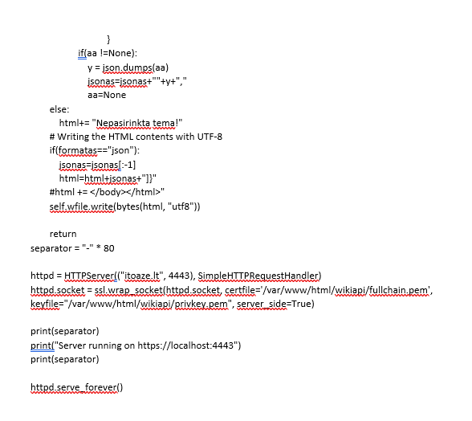

## **Task #13.** Implemented wikipedia api to quiz using retrofit

Description of the implementation (3-5 sentences).

Retrofit takes the url and makes a connection to decrypt json.

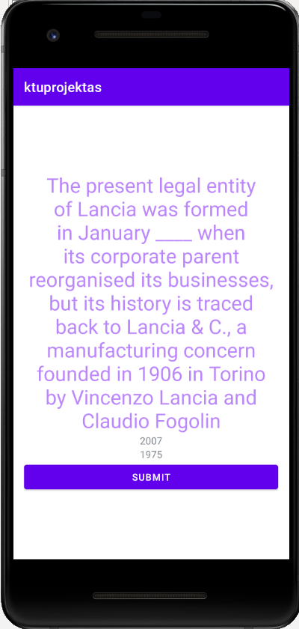

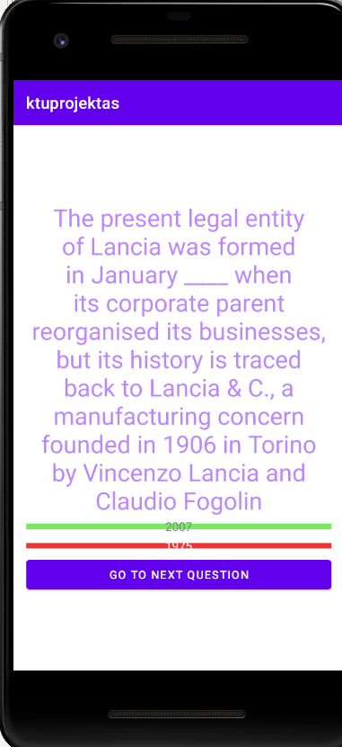

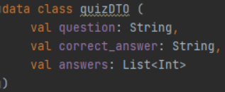

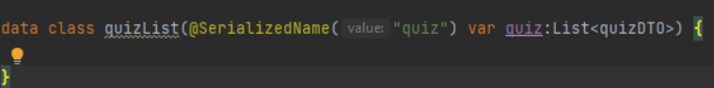

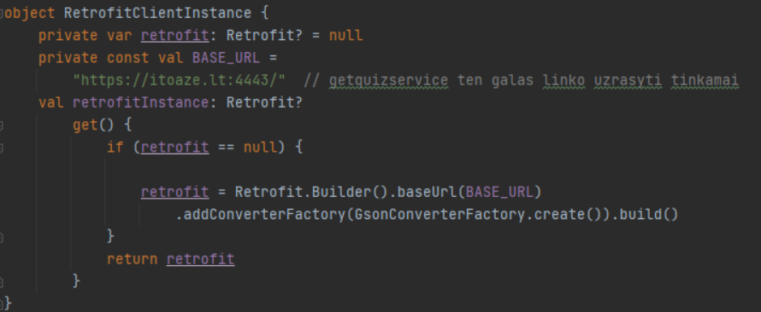



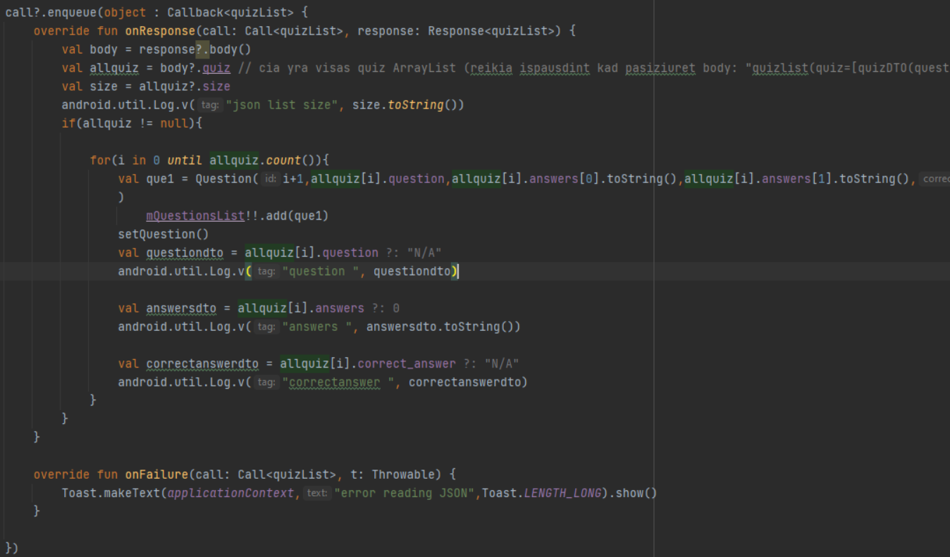

## **Task #14.** Implemented progressbar defend

Description of the implementation (3-5 sentences).

Progressbar fills red bar with green color depending on how many total questions there are in the list.

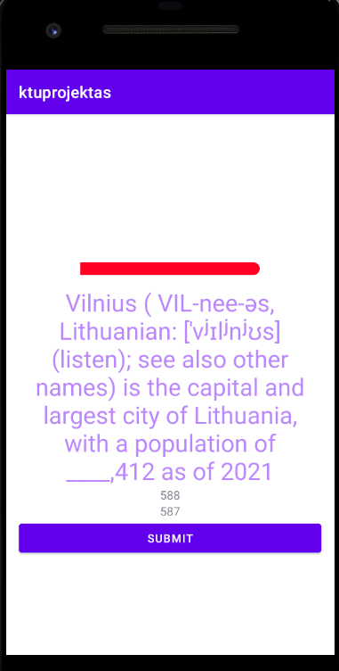

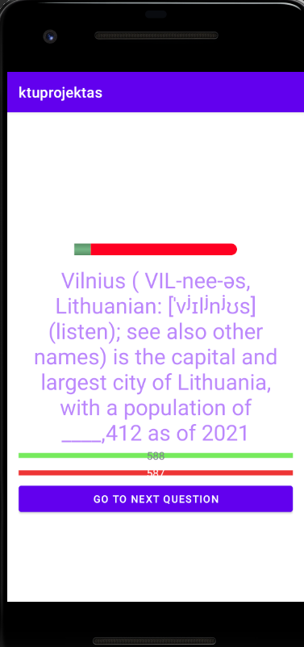

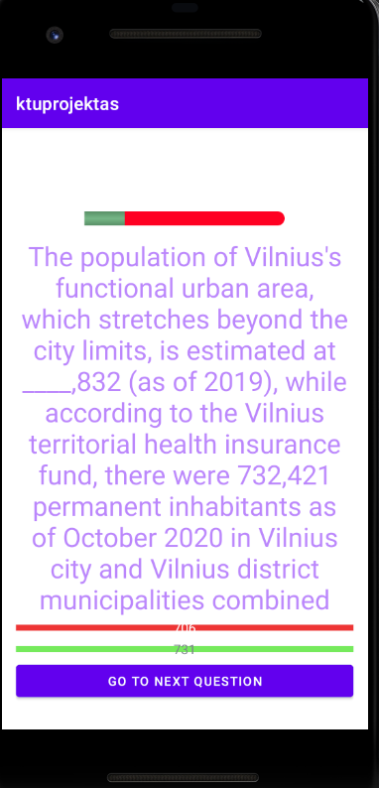



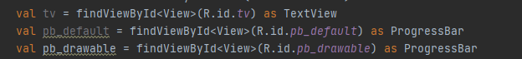

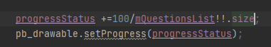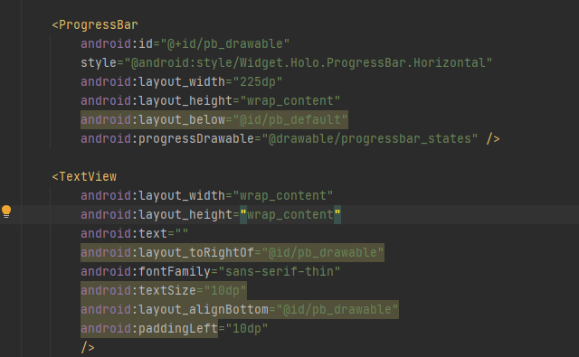

START OF L3 CHANGES.

## **Task #15.** Wikipedia Api improvements

Description of the implementation (3-5 sentences).

Wikipedia api has been changed to get questions from a selected topic faster(faster loading screen inbetween selecting a topic and starting the quiz).

## **Task #16.** UI design changes, improvements

Description of the implementation (3-5 sentences).

Improved and modernized the look of main-page, question-answer page, navigation bar, changed and overhauled the look of all buttons, title, background.

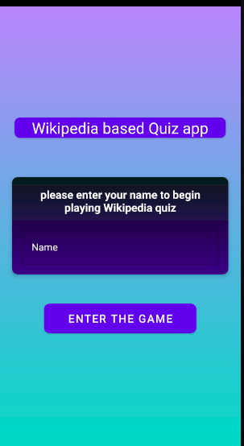

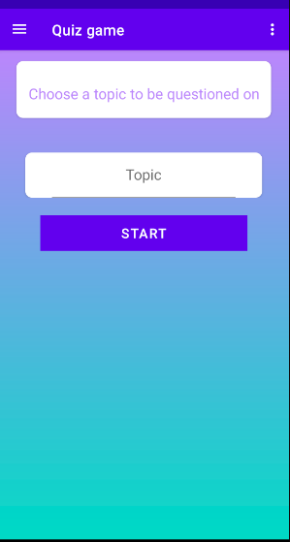

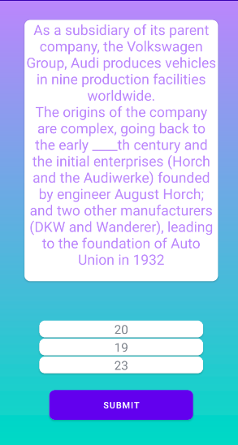

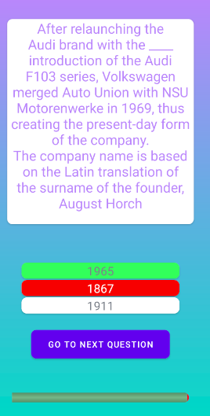

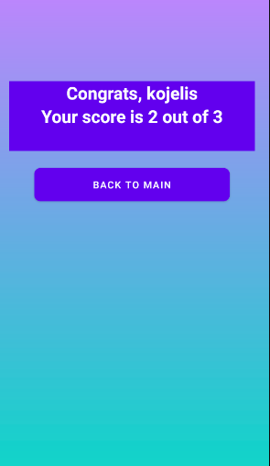

## **Task #17.** fixed scoreboard

Description of the implementation (3-5 sentences).

Changed scoreboard to be sorted by highest score first.

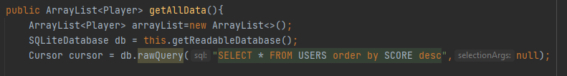

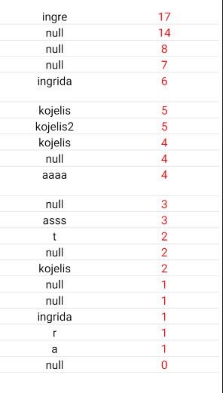

## **Task #18.** added topic selection

Description of the implementation (3-5 sentences).

Users can now type in a desired topic for example “google”, “amazon”... and start the Quiz.

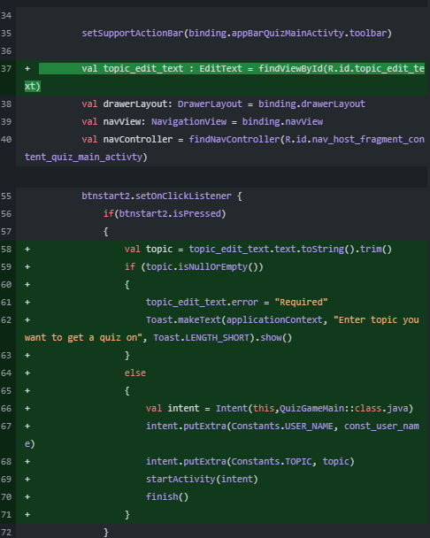

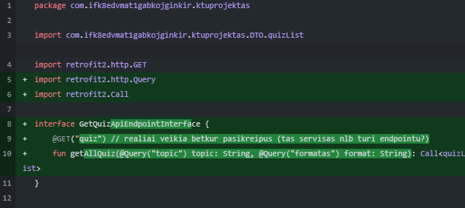

## **Task #19.** fixed bugs with questions and answers and added answer randomization

Description of the implementation (3-5 sentences).

Fixed a bug by Adding answer randomization so that the correct answer is more hard to find and not the 1st answer of the list of available answers.

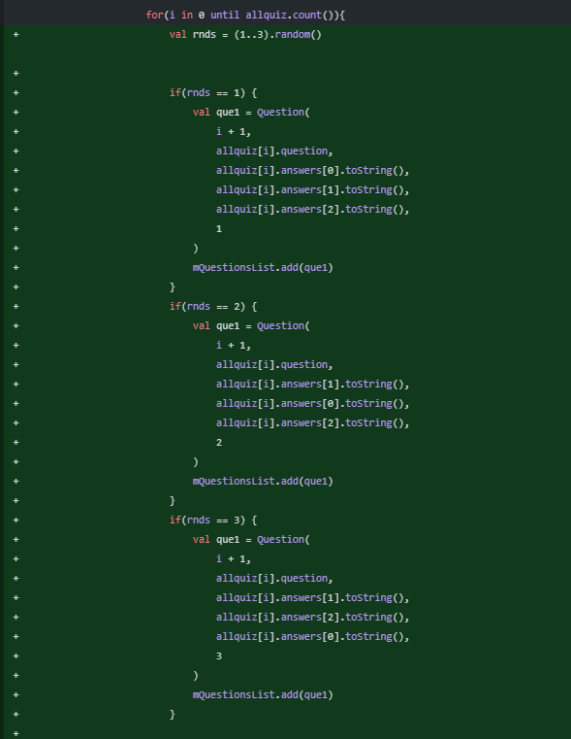

## **Task #20.** fixed a bug that allowed user to change his answer before going to next question.

Description of the implementation (3-5 sentences).

Added a check so people do not try to change answer after checking the correct answer by “spam-clicking” on all available answers and checking if its correct.

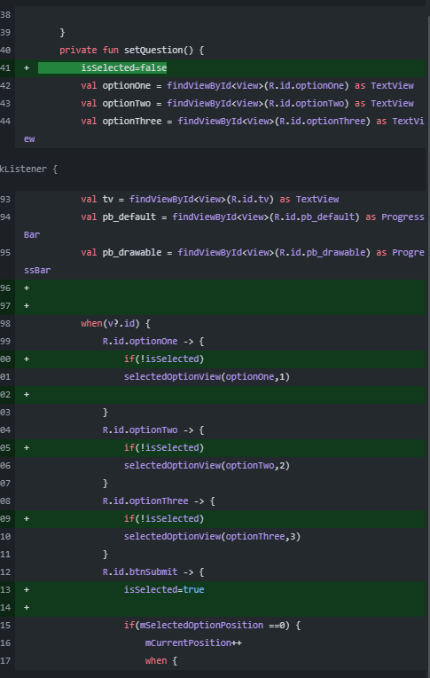

## **Task #21.** Changed answer list from 2 to 3

Description of the implementation (3-5 sentences).

Made the question-answer game harder by adding more variations to answers.



## **Task #22.** fixed progress bar loading

Description of the implementation (3-5 sentences)

progress bar now will be visible only after question is set.

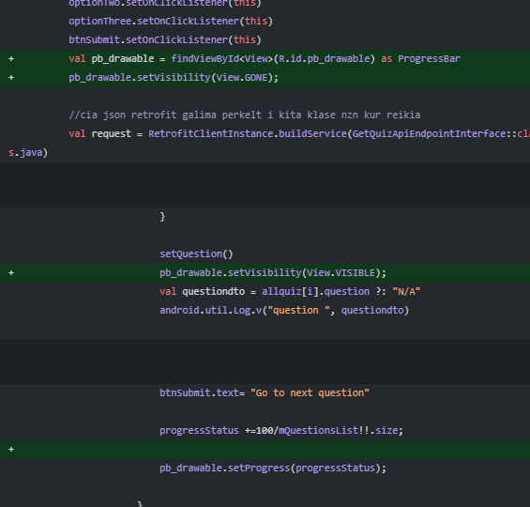

## **Task #23.** Questions and answers are now visible only after fully loading

Description of the implementation (3-5 sentences)

Fixed so in front-end questions are fully visible after loading them fully from api, also added a text that “quiz is loading up” before showing question and answers.

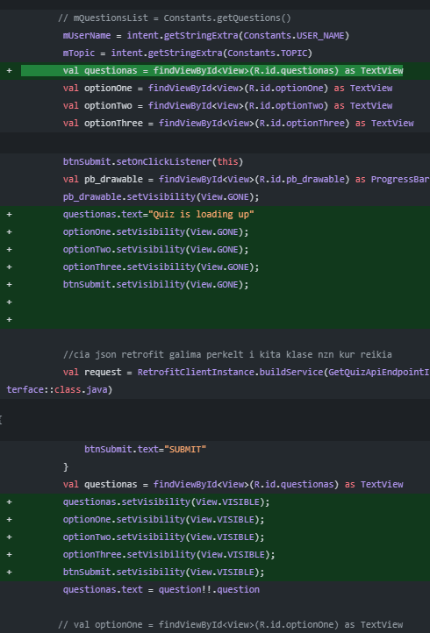

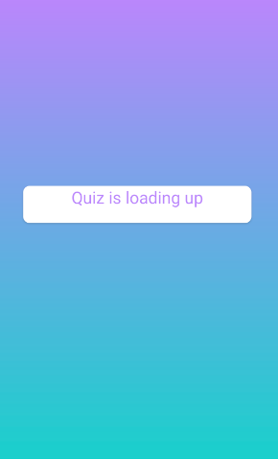

## **Task #24.** Defence task – added share button

Description of the implementation (3-5 sentences)

Added simple plain text share button – username, score. You can share to many different social websites/apps.

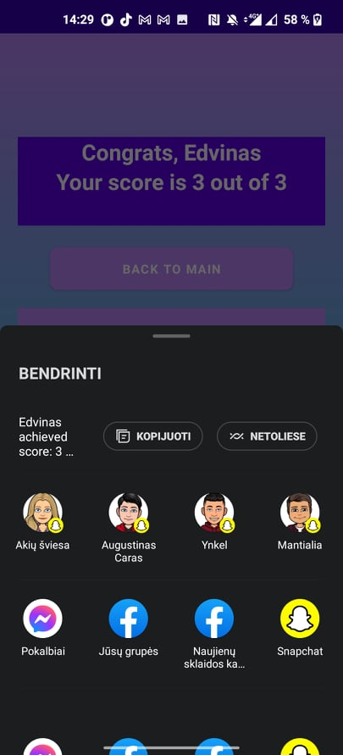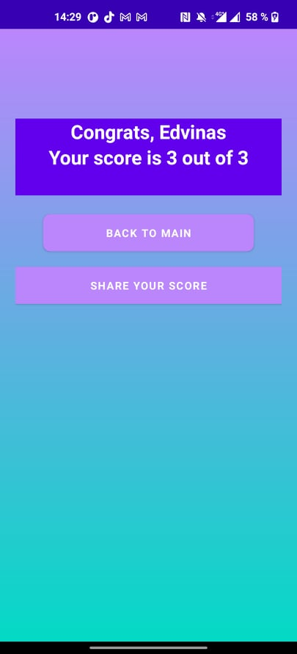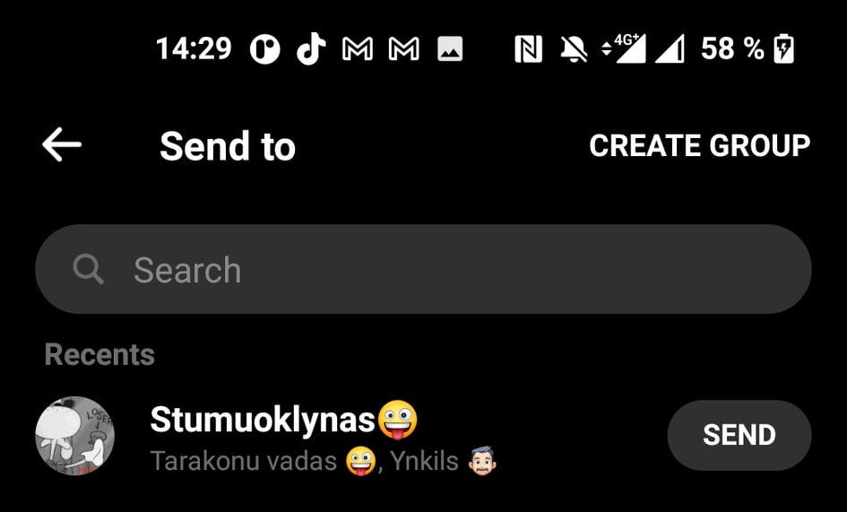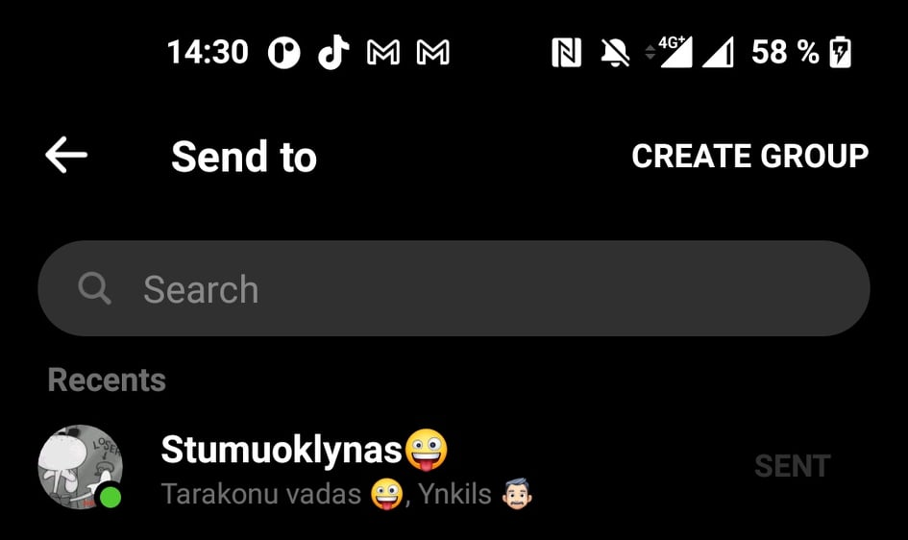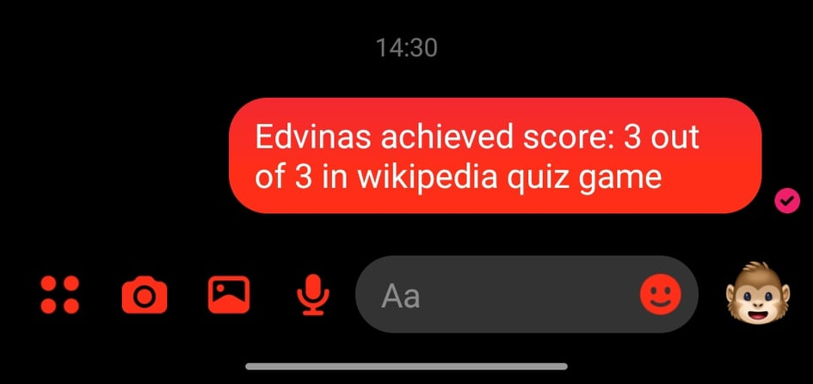

Figure 2. Source code #1

If you have used any external content or resources, make sure to refer to it [1]. Otherwise it will count as plagiarism.

# **Reference list**

1. <https://www.geeksforgeeks.org/android-tablelayout-in-kotlin/>
2. <https://developer.android.com/guide/topics/ui/layout/grid>
3. <https://stackoverflow.com/questions/49094964/programmatically-set-text-alignment-in-a-textview>
4. <https://stackoverflow.com/questions/1957831/center-a-button-in-a-linear-layout>
5. <https://developer.android.com/reference/androidx/cardview/widget/CardView>
6. <https://code.tutsplus.com/tutorials/how-to-code-a-navigation-drawer-in-an-android-app--cms-30263>
7. <https://developer.android.com/guide/navigation/navigation-ui>
8. <https://www.youtube.com/playlist?list=PLonJJ3BVjZW6hYgvtkaWvwAVvOFB7fkLa>
9. <https://kotlinlang.org/>
10. <https://developer.android.com/kotlin>
11. <https://developer.android.com/>
12. <https://stackoverflow.com/questions/1748977/making-textview-scrollable-on-android/>