BTS·SYNTHETIC
INTERACTIVE EXPERIENCES STUDIO

RESPONSE TO REQUEST FOR PROPOSAL
Quacktastic Checkers Arena
A flagship rubber-duck checkers browser game for QuacktasticIndustries.com

PREPARED FOR | Quacktastic Industries — Marketing Technology Office
ATTENTION | Priyanka Osei, Marketing Technology Manager · Nate Callahan, Front-End Engineering Lead
RFP REFERENCE | rfp-11-quacktastic-checkers · issued 2026-02-04
RESPONSE DATE | 2026-02-18 (on deadline)
AWARD EXPECTED | 2026-03-10 · ahead of the post-IPO brand relaunch
PREPARED BY | BTS-Synthetic Interactive Experiences Studio — Deal Desk

“We’ve shipped your exact scenario — a real-time multiplayer game that held 100% uptime through a livestream spike — twice.”

CONFIDENTIAL — Prepared solely for Quacktastic Industries in response to the above RFP. Contains commercially sensitive pricing and proposed contract positions.

01 EXECUTIVE SUMMARY

Quacktastic Industries is putting a rubber-duck checkers game on the homepage as the flagship asset of its post-IPO brand relaunch — and it has to survive a 40,000-visitor livestream with a 100%-uptime window while quacking, bowing and fidgeting on cue. That is precisely the kind of real-time, high-visibility, campaign-critical interactive build our Studio ships. Three things to take away:
- We have already shipped your exact scenario — twice. Fizzwick Beverages ran a real-time multiplayer promo game on its homepage that held 100% uptime through a Super Bowl livestream at 32,000 concurrent on pre-warmed capacity with sub-200ms sync. Marlowe Board & Bar ran a browser board-game suite (shareable-link multiplayer + 3-tier AI) whose server-authoritative rules engine and reconnection beat an indie studio on reliability. Your IPO relaunch is our home turf.
- Full functional fit, with real-time quality to spare. Server-authoritative rules engine with server-side legal-move validation (mandatory and multi-jump chains), 3-tier AI including “Ruthless Duck”, shareable-link multiplayer with reconnect-to-the-same-state, p95 sync under 400ms against your 500ms bar, a clean sandboxed-iframe embed, and WCAG 2.2 AA with a genuinely colorblind-safe alternate duck skin — not a toggle, a real fallback.
- Transparent commercials and de-risked delivery. Our Flagship package includes the dedicated livestream war-room your 100%-uptime window demands. We meet your 20%-off-list requirement, price the full two years transparently ($828,000 across Years 1–2 in the recommended scenario), and deliver on a 12-week track engineered backward from your livestream date, with pre-warm and a game-day runbook for the 40K spike.
Bottom line
High technical fit, no functional gaps, proven livestream reliability, and a specialist track record the other bidders can’t match. The one dependency we ask you to lock early is the livestream date — it drives the pre-warm and rehearsal window that makes the 100%-uptime commitment safe.

02 OUR UNDERSTANDING OF YOUR NEED

This is a Marketing-owned campaign asset, not core infrastructure — which shapes every recommendation in this response, from the annual term to the commercial structure. As we read the RFP:
- Flagship homepage experience. A checkers game reskinned entirely with rubber ducks (Classic Yellow vs. Bath-Time Blue), embedded in an iframe on QuacktasticIndustries.com without disturbing your existing header and footer.
- Delight and correctness together. Quacks on every move, a triumphant quack on captures, a winner’s bow, ducks that fidget when the 30-second timer runs low — all on top of a rules engine that never lets a duck move illegally, “no matter how much the player insists it can fly.”
- Two ways to play. Single-player vs. a computer at three difficulties (Easy, Medium, and — final, per Marketing — “Ruthless Duck”), and real-time two-player over a shareable game link, resilient to a mid-game refresh.
- A hard, public moment. ~40,000 concurrent visitors during the IPO relaunch livestream, with a pre-announced 4-hour 100%-uptime window and 99.9% monthly the rest of the time.
- Accessibility that is real. Full keyboard navigation of the board and a colorblind-safe alternate skin as a true fallback — the default yellow/blue pairing is not CVD-safe, and you have told us you need the alternate to actually work.
- A clear division of labour. Quacktastic supplies the duck artwork; we rig it into a functioning, animated board. We are the engineering and reliability partner.
03 WHY BTS-SYNTHETIC IS THE RIGHT FIT

The RFP weights functional fit (35%), real-time quality (20%) and implementation risk (20%) far above headline price (15%). Those are exactly the axes where a specialist interactive studio pulls ahead of the alternatives in this field.
The competitive picture — and how we win it
Bidder | What they’ll pitch | Where they’re exposed | Our counter
Waterfowl Analytics Inc. | An existing relationship (they also bid your data-platform RFP) and a cross-sell story. | A data-analytics firm bidding out of its core area — no proven real-time game shipping, likely a third-party engine bolt-on that adds latency risk and triggers your subprocessor-consent clause. | We own the entire stack — rules engine, realtime sync, reconnection — with a measured p95 under 400ms.
Boutique indie studio | Beautiful ducks and authentic game feel (recommended by the CMO’s nephew). | Rarely battle-tested at 40K concurrent or a 100%-uptime livestream window; accessibility and contract/security maturity (SOC 2, ISO 27001, DPA, IP, subprocessors) are typically gaps. | You supply the art — so art isn’t the battleground. Marlowe shows we beat an indie studio on reliability.
Databricks | Nothing — they declined, citing “this is not really our area.” | Confirms generic data/AI vendors don’t fit interactive delivery. | Even Databricks says this needs a specialist. Nine years of browser games and real-time builds say we are it.

Our opening move
Lead with the Fizzwick livestream (100% uptime at 32K concurrent through a Super Bowl spike — directly analogous to your IPO window), pair it with Marlowe (“beat an indie studio on reliability”), and close on Verdant Parks (WCAG 2.2 AA with colorblind-safe palettes as a first-class fallback). We’ve shipped the exact scenario you’re facing — twice.

04 TECHNICAL PROPOSAL

Our fit assessment against the Studio capability map is HIGH, with no outright gaps across Sections 2.1–2.3 of the RFP. The table below is a requirement-by-requirement verdict; the architecture follows.
4.1 Requirement-by-requirement fit
RFP requirement | Verdict | How we meet it
8×8 board, 12 ducks/side, 2 colorways | Covered | Client-supplied duck art rigged onto our board; two skins configured.
Movement, mandatory jumps, multi-jump chains | Covered | Turn-based rules engine — standard board-game capability.
King promotion with rendered rubber crown | Covered | Promotion logic + art rigging and animation.
Server-side legal-move validation | Covered | Direct match — the client never adjudicates legality; server is authoritative.
Single-player, 3 difficulties incl. “Ruthless Duck” | Covered | Minimax/alpha-beta AI, 3 tunable tiers (reused Marlowe harness).
Real-time 2-player via shareable link | Covered | Built-in shareable-link matchmaking, no account required.
Turn indicator + 30s timer with low-time fidget | Covered | Per-turn countdown with low-time animation states.
SFX: quack on move, louder on capture | Covered | Per-event audio with mute + autoplay-policy handling.
Win/lose/draw + “ducks take a bow” animation | Covered | End-state detection with win/lose animation sequence.
Move-history panel (last 10+ moves) | Covered — note | Trivial derivative of the server-authoritative state log — minor scope add, no risk.
Mobile: drag-and-drop AND tap-to-select | Covered | Both input modes from one responsive codebase.
Full keyboard navigation of the board | Covered | Direct match — keyboard nav of the board is standard for us.
Colorblind-safe alternate skin (real fallback) | Covered | First-class tested CVD-safe pairing (Okabe–Ito), not a toggle.
5,000 concurrent games at launch | Covered | Routine tier for our platform.
40,000 peak during the livestream | Covered — note | Within our tested 50K envelope — requires scheduled pre-warm (see Risks).
Reconnect mid-game to the same state | Covered | Per-match persisted state; refresh rejoins the same match, same state.
Evergreen browsers, no plugin/download | Covered | Chrome, Firefox, Safari, Edge.
Real-time sync < 500ms round-trip | Covered | Median 120–180ms, p95 < 400ms — inside the bar with margin.
Clean iframe embed (no header/footer collision) | Covered | Sandboxed-iframe widget model, isolated from host CSS.
Analytics incl. abandonment-by-difficulty | Covered | Out-of-box funnel/abandonment by segment; only signup email is PII.

Verdict key:
Covered = direct capability match. Covered — note = delivered, with a scheduling or minor-scope note.
4.2 Proposed real-time architecture
The design is server-authoritative end to end: browsers render and send intents, and a single source of truth on our side validates, mutates and broadcasts state. The diagram shows the components and the two core data flows; the narrative beneath explains a single move and a reconnect.
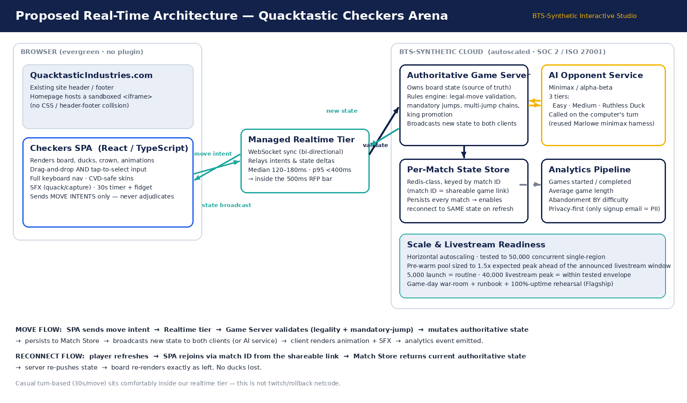
Figure 1 — Proposed real-time architecture for Quacktastic Checkers Arena.

Components.
- Client (React/TypeScript SPA in a sandboxed iframe). Renders the board, ducks, crown, animations and SFX; supports drag-and-drop and tap-to-select plus full keyboard navigation; sends move intents only — it never decides legality.
- Authoritative game server + rules engine. Owns board state as the single source of truth; enforces legal moves, mandatory jumps, multi-jump chains and king promotion; broadcasts the new state after every accepted move.
- Managed WebSocket realtime tier. Bi-directional sync relaying intents and state deltas between clients and server — median 120–180ms, p95 under 400ms on typical broadband.
- Per-match state store (Redis-class). Keyed by the match ID embedded in the shareable game link; persists every match so a dropped or refreshed player rejoins the same match in the same state.
- AI opponent service. Minimax/alpha-beta search with three difficulty configurations (Easy, Medium, Ruthless Duck), invoked on the computer’s turn.
- Scale + analytics. Horizontal autoscaling with a pre-warm pool sized to ~1.5× expected peak ahead of the livestream, plus a privacy-first analytics pipeline (games started/completed, average length, abandonment by difficulty).
Move flow.
The SPA sends a move intent → the realtime tier forwards it → the game server validates it (legality + mandatory-jump enforcement) → mutates the authoritative state → persists to the match store → broadcasts the new state to both clients (or the AI service) → clients render the animation and SFX → an analytics event is emitted.
Reconnect flow.
A player refreshes → the SPA rejoins via the match ID from the shareable link → the match store returns the current authoritative state → the server re-pushes it → the board re-renders exactly as left. No ducks lost.
Latency & netcode note
Checkers at 30 seconds per move is casual turn-based and sits comfortably inside our realtime tier. This is deliberately not twitch/rollback e-sports netcode — so our p95-under-400ms figure carries real margin against your 500ms requirement even during the livestream spike.

4.3 Scale, latency & livestream readiness
Our platform is production-tested to 50,000 concurrent sessions in a single region with horizontal autoscaling. 5,000 concurrent at launch is routine; the ~40,000 livestream peak is inside that envelope provided we pre-warm capacity to roughly 1.5× expected peak ahead of the announced window — the same playbook that carried Fizzwick’s Super Bowl spike to 100% uptime. The Flagship package wraps this in a game-day war-room, a runbook and a 100%-uptime rehearsal for the pre-announced 4-hour window.
4.4 Accessibility
Accessibility is built in, not bolted on: a WCAG 2.2 AA target, full keyboard navigation of the board, screen-reader move announcements, reduced-motion support, and — critically for you — a tested colorblind-safe alternate duck skin (an Okabe–Ito orange/sky-blue pairing with dark outlines and shape cues) shipped as a genuine fallback. This is the same first-class accessibility approach that won us Verdant Parks Authority.
05 BOARD & DUCK-PIECE MOCKUP

The RFP invites an indicative mockup of the board and a single duck piece at proposal stage. The wireframe below shows the full playing surface (Classic Yellow vs. Bath-Time Blue), a selected piece with its legal-move targets highlighted, an in-play king with a rendered rubber crown, and the surrounding UI — turn indicator, the 30-second timer in its low-time state, and the move-history panel. The right column shows the single-piece detail (regular “man” and crowned “king”) and the colorblind-safe alternate skin as a real fallback.
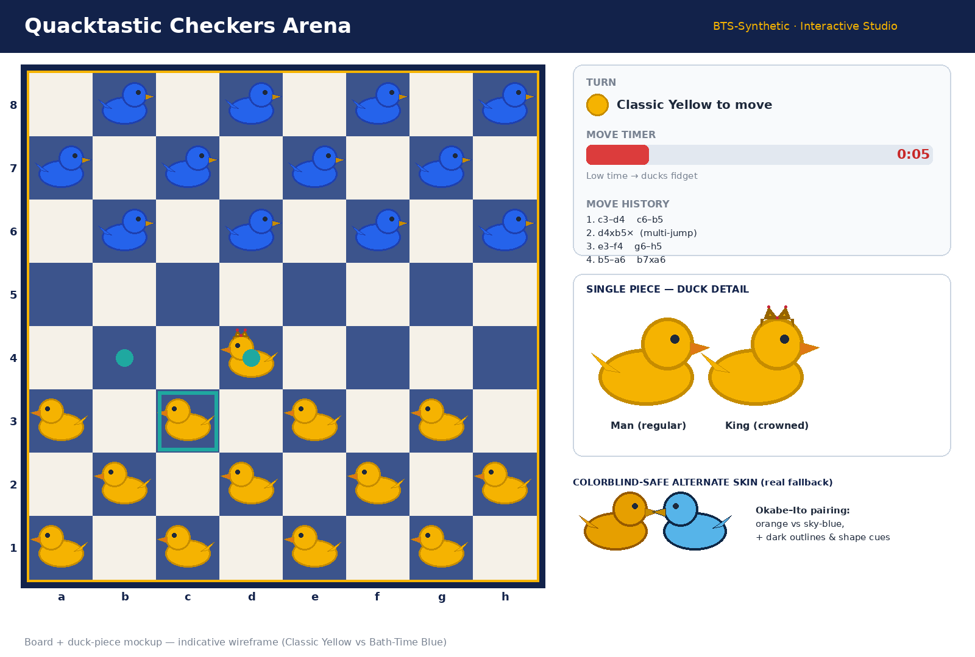
Figure 2 — Indicative board and duck-piece mockup (wireframe).
A note on the mockup
This is an indicative wireframe produced by our team to illustrate layout, states and the accessibility fallback — it is not final art. Final visuals will be rigged from the duck artwork Quacktastic supplies at kickoff; our role is to bring your ducks to life on a correct, reliable board, including the crowned-king treatment and the tested CVD-safe alternate pairing.

06 COMMERCIAL PROPOSAL — TWO-YEAR TRANSPARENCY

We recommend the Flagship package at $360,000 annual list. Your requirement — 100% uptime for a pre-announced 4-hour livestream at 40K concurrent — is the specific trigger for Flagship rather than Campaign Pro: Pro covers 40K load-testing and 24/7 launch support, but only Flagship adds the dedicated war-room and 100%-uptime rehearsal that de-risk your exact scenario (the same tier that carried Fizzwick’s Super Bowl livestream). A Campaign Pro + war-room add-on is available as a fallback if budget requires.
6.1 Pricing terms
- Discount — 20% off list. Your ≥20% requirement is met. At this deal size (>$300K) 20% is our standard maximum, so no strategic exception is needed. We grant it tied to the full 1-year + 1-year term and a public reference/case study; a firm two-year commitment would unlock a further 3%.
- One-time build fee — $252,000 (0.70× the annual run fee), reflecting the war-room and custom art rigging, and offset by our reusable turn-based rules engine and minimax harness. Creditable toward Year 1 on a signed multi-year.
- Payment — Net 60, billed in advance. Accepted as requested (consistent with the Fizzwick precedent); we do not extend beyond Net 60.
- Term — 1 year + 1-year renewal option. Appropriate for a Marketing-owned campaign asset on an annual budget cycle.
- MFN — excluded. Not requested; we confirm it stays out of the agreement.
6.2 Recommended two-year pricing (20% off, public reference)
Line item | Year 1 | Year 2
Annual list (run / license) | $360,000 | $360,000
Discount applied | 20% | 20%
Discounted run fee | $288,000 | $288,000
One-time build fee (creditable) | $252,000 | $0
Total per year | $540,000 | $288,000

Two-year total (recommended): $828,000 — fully transparent, no hidden run-rate escalators.
6.3 Alternative scenarios (for planning transparency)
Scenario | Discount | Year 1 | Year 2 | 2-year total
Recommended — 20% off + public reference | 20% | $540,000 | $288,000 | $828,000
Best case — firm 2-year commit | 23% | $529,200 | $277,200 | $806,400
Downside — no reference (open at 15%) | 15% | $558,000 | $306,000 | $864,000

All figures include the one-time $252,000 build fee in Year 1. The build fee is creditable toward Year 1 on a signed multi-year, and we structure it up-front to protect the war-room investment against the 30-day termination-for-convenience right (see Contract Approach).
07 IMPLEMENTATION PLAN — WORKING BACKWARD FROM THE LIVESTREAM

We plan against your livestream — call it L-day — not against a generic start date, because the 100%-uptime window is the moment everything is engineered to survive. The award is fixed at 2026-03-10; the exact livestream date is “TBD at kickoff.” Our track needs a full 12 weeks from kickoff to L-day so the pre-warm and rehearsal buffer is real rather than nominal — locking the date early is the single most important thing we ask of you (see Risks).
Milestone | Timing vs. livestream (L) | Deliverables
Kickoff | L − 12 weeks | SOW signed, environments stood up, duck-art delivery scheduled, livestream date locked.
Art & assets in | L − 10 to 11 weeks | Quacktastic-supplied duck artwork delivered; skins configured (default + CVD-safe).
“Playable on the homepage” | L − 6 weeks | Single-player + local play, art rigged, embeddable iframe live on the page, analytics wired.
Feature-complete | L − 2 weeks | Real-time multiplayer (shareable link) + reconnection, 3-tier AI incl. Ruthless Duck, full accessibility pass, load-tested to launch concurrency.
Livestream-readiness | L − 1 week | Hardening, load test to 40K, 100%-uptime rehearsal for the announced window, game-day runbook, security-review support.
Game day | L − 0 | War-room live; pre-warm to ~1.5× expected peak (~60K); go/no-go; the 4-hour 100%-uptime window.

Why this sequence
It mirrors the exact cadence behind our reference builds: an early “playable” milestone to get the experience in front of stakeholders, a feature-complete build with the accessibility pass baked in, then a dedicated hardening-and-rehearsal window so the 40K/100%-uptime moment is rehearsed, not hoped for.

08 CONTRACT APPROACH

We have reviewed Section 4 against our standard positions. Most terms are acceptable as written; three need a redline before signature, and each has a clean, market-standard counter. None is a deal-breaker.
Term | RFP position | Severity | Our position / counter
Liability (§4.1) | 12-month cap, but uncapped for player-data breaches | BLOCKER | Uncapped voids our cyber cover. Counter: 12-month cap generally; a bounded 24-month super-cap for signup-email data; mutual carve-outs for gross negligence and IP.
IP (§4.4) | All work product vests in Quacktastic | BLOCKER | Assigning the bespoke game deliverable + rigged art is fine; sweeping in our reusable rules engine/realtime platform is not. Counter: assign the custom work product; we retain and perpetually license our pre-existing platform IP.
Subprocessors (§4.5) | Prior written consent for every subprocessor | BLOCKER | Pre-approval of each is operationally unworkable. Counter: named hosting/realtime subprocessors disclosed and deemed accepted at signature; 30-day notice for changes with a right to object → we substitute or you terminate the affected scope.
Audit (§4.2) | Single annual security review | ACCEPTABLE | Matches our standard. Add 30-day notice, mutual confidentiality, and clarify you audit us — we audit our subprocessors.
Termination (§4.3-comm.) | 30-day for convenience, no penalty | NEGOTIABLE | No penalty is fine. We’ll accept 30 days (would prefer 60) and add a pro-rated refund of prepaid, unused fees.
Service levels (§4.3) | 99.9% monthly + 100% during 4-hr window | ACCEPTABLE | 99.9% monthly is within standard; 100% for the bounded window as a commercially-reasonable target with pre-warm/war-room. Sole remedy = service credits capped at 30%. We will reject any terminate-on-single-miss or >30% credit.

- Data protection. Signup emails are PII, so a GDPR-aligned DPA is required; we propose breach notification within 72 hours and can commit to 24 hours if you prefer.
- MFN. Confirmed out of scope by the RFP; it stays out of the final paper.
Severity key:
BLOCKER = redline before signature (clean counter offered). NEGOTIABLE ACCEPTABLE = as written, minor guardrails.
09 REFERENCES — INTERACTIVE & GAME BUILDS

Two directly relevant references are below; a third is included as accessibility proof.
Reference 1 — Fizzwick Beverages — most analogous to your IPO livestream
Engagement “Spin-to-Win” real-time multiplayer promo game embedded on the brand homepage.
The moment Super Bowl ad tie-in livestream — 32,000 concurrent at peak.
Why it’s relevant Hit 100% uptime through the ad window on pre-warmed capacity with sub-200ms sync — the exact playbook we bring to your 40K/100%-uptime window.
Commercials $240,000 · 1 year + 1-year renewal · annual upfront, Net 60 · closed 2025-10-02.

Reference 2 — Marlowe Board & Bar — most analogous to the game engine itself
Engagement Browser chess + backgammon suite with shareable-link multiplayer and 3-tier AI.
Why it’s relevant Server-authoritative rules engine + reconnection that beat an indie studio on reliability; the reusable turn-based engine and minimax harness are directly reusable for checkers.
Commercials $180,000 · 2 years · annual upfront, Net 30 · closed 2025-06-18.

Supporting proof — Verdant Parks Authority — accessibility as a first-class citizen
Engagement Accessible public-facing interactive map + mini-game, WCAG 2.2 AA.
Why it’s relevant Full keyboard navigation and tested colorblind-safe palettes shipped as a first-class fallback — exactly the CVD-safe requirement you flagged.
Commercials $130,000 · 1 year · annual upfront, Net 30 · closed 2026-01-20.

10 RISKS & HOW WE MITIGATE THEM

Risk | Impact | Mitigation
Livestream date is “TBD” while award is fixed | Too little lead time compresses the pre-warm/rehearsal buffer that makes 100% uptime safe. | Make an early, firm livestream date (≥12 weeks’ lead) a contractual dependency at kickoff; if compressed, we escalate pre-warm and war-room coverage.
40K spike / 100%-uptime window | A public failure at the brand’s biggest moment. | Pre-warm to ~1.5× expected peak, game-day runbook, dedicated war-room, and a full 100%-uptime rehearsal — the Fizzwick playbook.
Client-supplied art dependency | Late or off-spec artwork delays rigging. | Art-delivery milestone in the SOW by L−10/11 weeks, with an asset spec/template provided up front; we rig, not originate.
Uncapped player-data liability (§4.1) | Voids cyber insurance if accepted as drafted. | Bounded 24-month super-cap for signup-email data; confirm no other PII is collected.
“All work product” IP sweep (§4.4) | Could claim our reusable platform IP. | Assign the bespoke deliverable; retain and license our pre-existing rules engine/realtime platform.
Per-subprocessor consent (§4.5) | Operationally unworkable, blocks routine ops. | Pre-disclose named subprocessors at signature; 30-day notice + object/substitute for changes.
30-day termination exposes build investment | War-room/build cost stranded before Year 2. | Build fee billed up-front and credited on multi-year; pro-rated refund of prepaid unused fees only.
Default palette isn’t colorblind-safe | Accessibility requirement unmet for CVD users. | Ship the tested Okabe–Ito alternate skin as a genuine first-class fallback (already in scope).
11 ASSUMPTIONS & NEXT STEPS

- Assumption. Quacktastic supplies duck artwork at kickoff; only signup emails are collected as PII; hosting and real-time messaging run on our named, cloud-managed subprocessors.
- Next step 1. On award (targeted 2026-03-10), hold a kickoff to sign the SOW, lock the livestream date with ≥12 weeks’ lead, and schedule art delivery.
- Next step 2. Redline the three contract items (liability super-cap, IP carve-out, subprocessor notice) using the counters above, and execute the DPA.
- Next step 3. Confirm package (Flagship) and the 20%-off + public-reference commercial structure; stand up environments and begin the 12-week track.

Contact
BTS-Synthetic Interactive Experiences Studio — Deal Desk. This response is submitted to procurement@quacktastic-synthetic.example for the attention of Priyanka Osei (Marketing Technology Manager), with technical questions welcomed by Nate Callahan (Front-End Engineering Lead). We’re ready to bring your ducks to life — reliably, accessibly, and live through the livestream.

