Name: Punit rana

Enrollment: 23115118

Branch : electrical engg.

Eec practical 2

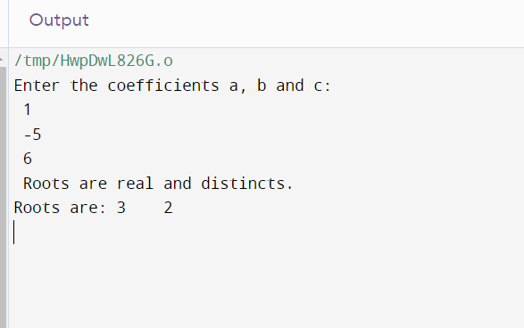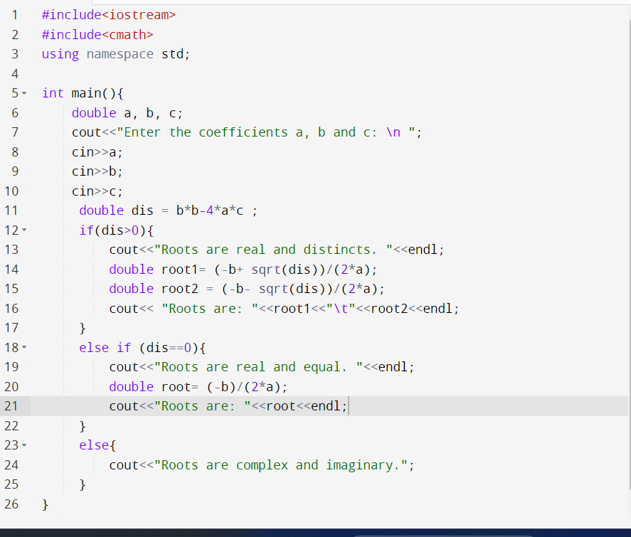Ques1. Roots of quadratic equation ax2+bx+c=0.

Ques2. Area and Circumference of a circle.

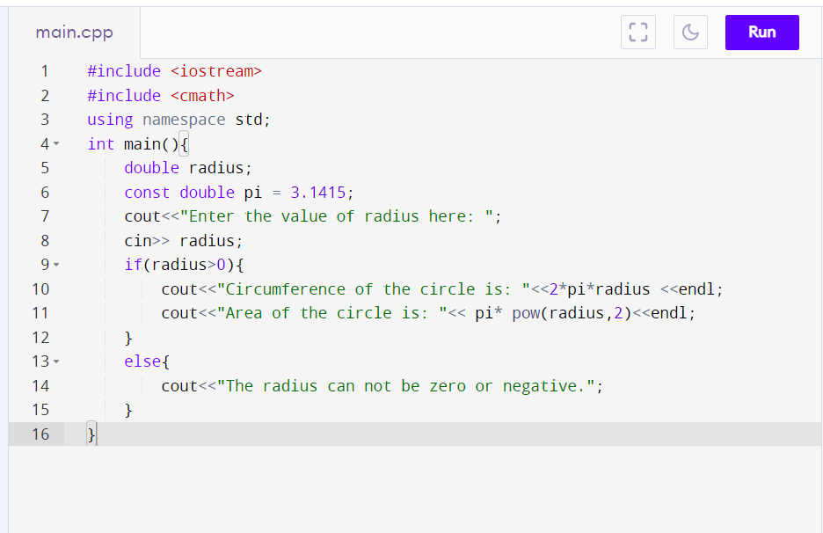

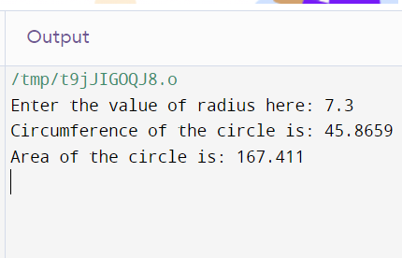

Ques4. WAP a program to print integers. It should print first five, skip next five….

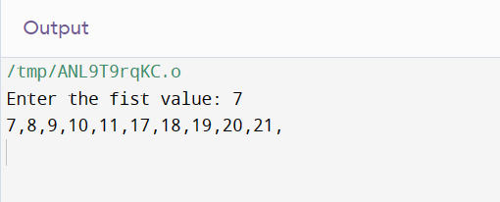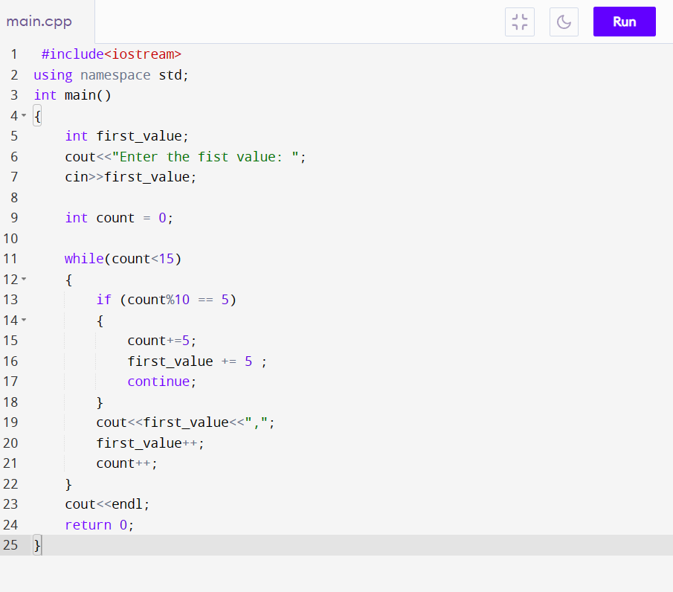

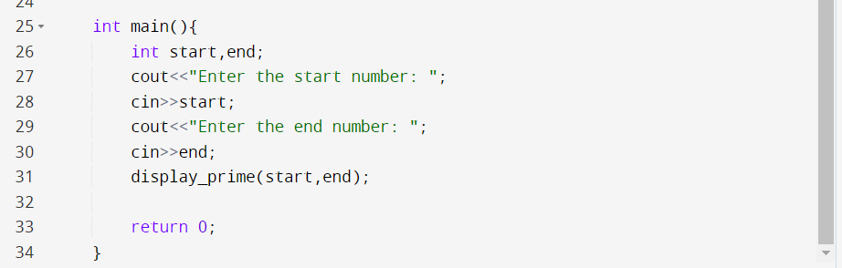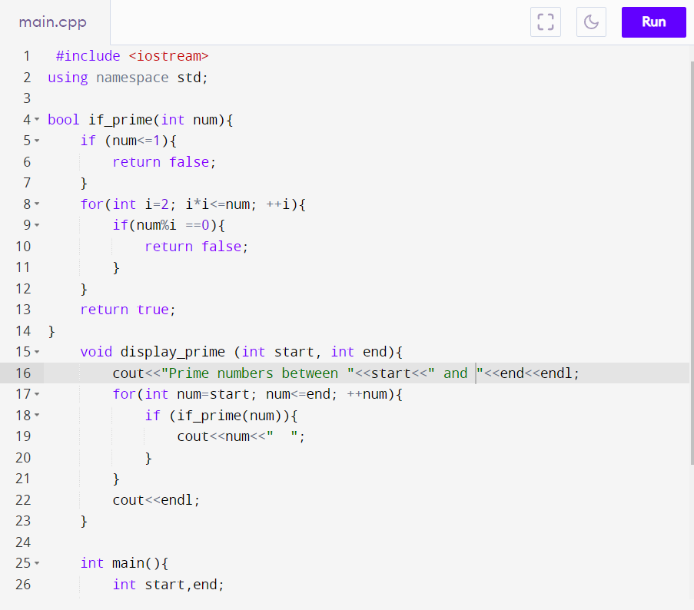Ques5. Write a program that receives two numbers and displays all prime numbers between them.

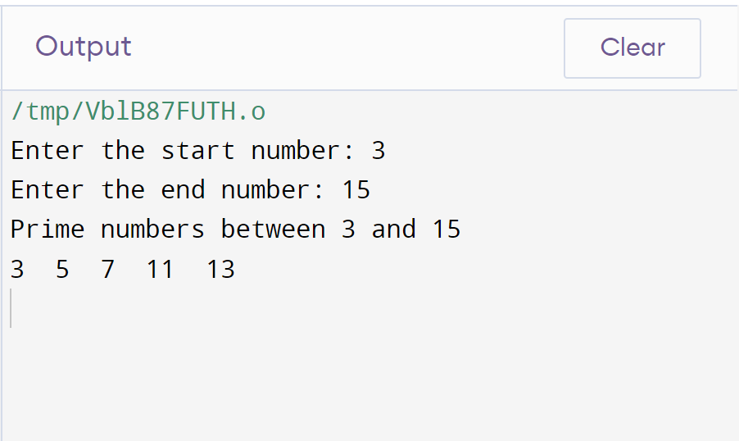

Ques6. Write a program that let user to operate arithmetic operations on two number.

