Core Java:

- Why Java? And Java is platform dependent or independent?
- JDK, JRE, JVM (JDK ---> JRE--->JVM ---->)
- What are the basic OOPs concept and it's features?
- What is Abstraction, Inheritance(Types of inheritance in java), Polymorphism and it’s types, Encapsulation?
- What are the must important features in Java 8? (Lambda expression, Stream API, Data API, default methods in the interface, Optional, Functional interface, JavaScript engine)
- Does Java support pointer concept? Why?
- Does Java work as a "pass by value" or "pass by reference" phenomenon?
- What gives Java its 'write once and run anywhere' nature?
- What happens when the main() isn't declared as static?
(When the main method is not declared as static, then the program may be compiled correctly but ends up with a severe ambiguity and throws a run time error that reads "NoSuchMethodError.")
- What are the differences between constructor and method of a class in Java?
- What do you understand by an instance variable and a local variable?
- Can the main method be overloaded?
- Access modifier and non access modifier
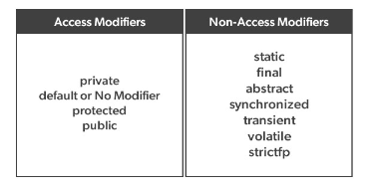

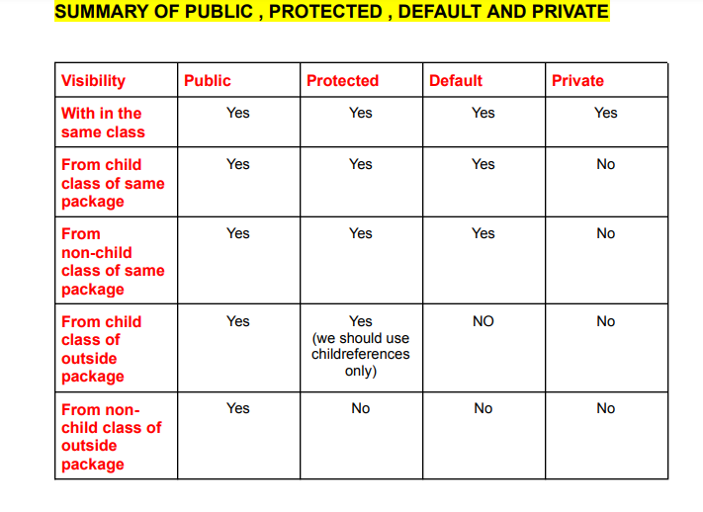

- what is the main() method represent in a program. public static void main (String [] args)

- what are the differences between final finally and finalize in Java?
(final is a keyword used in Java to restrict the modification of a variable, method, or class. finally is a block used in Java to ensure that a section of code is always executed, even if an exception is thrown. finalize is a method in Java used to perform clean-up processing on an object before it is garbage collected.)
- What is the final variable, final blank variable, final method and final class?
- What is the constructor and it’s use?
- Explain ‘super’ and ‘this’ keyword in Java.
- How many types of constructors are used in Java? (parametrised , non-para, default, copy)
- What is Inheritance?
- What is method overloading(Compile-time polymorphism) and method overriding (run-time polymorphism)?
- What is the use of key word like:- void, abstract, this, interface, instanceof, final, super, extends, implements? (variable will not abstract, class and method can abstract)
- String, StringBuilder, StringBuffer, Mutable, Immutable
- Can you tell the difference between equals() method and equality operator (==) in Java?
- When to use StringBuffer and StringBuilder?
- Difference between length and length()?
- What are shallow copy and deep copy in Java?
(shallow copy creates a new object with the same values as the original object, while deep copy creates a new object with new values.)
- difference between import and static import in Java?
- What is Exception Handling (Unwanted or unexpected event that disturbs the normal flow of program, is called "Exception".Always in run time only.)
- What is the difference between the ‘throw' and ‘throws' keyword in Java?
- Can we use try catch block inside try block?
- What are the different types of exception?
- Why we close the session, connection etc. in final block?
- What is the main objective of Garbage collection?
(The main goal of using garbage collection is to free the heap memory by eliminating unnecessary objects.)
- What is enum? What is Regex?
- What do you mean by Multithreading? And different inbuilt methods?
- What are the advantages of multithreading?
- What is Synchronization and what’s the use of it? (If multiple threads are trying to operate simultaneously on the same Java "object" then there may be a chance of “Data inconsistency problem”, so for overcome this problem we should go for “synchronized” keyword.
- What is the use of Streams?
- Java Collections
- Java Date
- Java JDBC
- What is a .jar file?
- What is the difference between REST API and SOAP API.
- What is the difference between Iterator and ListIterator?

Collection: (prefer the collection file document)

Hibernate:
- What is Hibernate? (Hibernate is a Java framework that simplifies the development of Java application to interact with database. Hibernate is a ORM (Object Relational Mapping) tool.)
- How to build DB connection using hibernate (.xml file, session)?

Spring Boot:
- What is Spring? And What is the difference between Spring and Spring Boot?
- What are the embedded features in Spring Boot frame work?
- What is Annotation? And give some example of annotations?
- How We get the .jar file which are depended for our application, What is pom.xml, What is dependeccy.

- What is the purpose of the @SpringBootApplication annotation in a Spring Boot application?
- What is the purpose of the @PostConstruct annotation in a Spring boot?
- What is Spring Boot, and how does it differ from the traditional Spring framework?
- Explain the advantages of using Spring Boot for application development.
- How does Spring Boot support auto-configuration?
- What is the use of @Value, @Configuration, @EnableJpaRepositories, @Bean, @JsonAlias, @SuppressWarnings, @JsonInclude?
- How we can connect DB using spring boot application? (Using JPA repository)
- Explain the concept of Spring Boot Profiles and how they are useful.
- Describe the steps involved in creating a RESTful web service using Spring Boot.
- What are Spring Boot Data JPA? How do they simplify database access?
- What is Spring Boot Security, and how can you configure it to secure your application?
- Explain the differences between Spring Boot's embedded servers: Tomcat, Jetty, and Undertow.
- Annotations Like: @RequestMapping, @PostMapping, @RestController , @Valid, @Autowired, @Override, @JsonAlias, @Data, @toString , @getter, @setter, @Slf4j, @Value, @RequestBody, @RequestParam, @RequestHeader,@SpringBootApplication, @JsonIgnoreProperties(ignoreUnknown=true), @Component, @Aspect, @AllArgsConstructor, @NoArgsConstructor, @Valid, @NotNull, @NotBlank, @Before, @AfterReturning,@EnableAsync

Programming Questions:
- Insert a new node at a given position in the Linked List
- Arrays ascending order, Arrays descening orderunn
- Reverse a linked list
- pre-increment and post-increment , output question.
- Write a program to find the square root of a number. (for sqrt which class have to use, java.lang package means by default available Math class)
- Find second largest number in an array?
- Find the even number without using if() block?
- Write a Program to remove duplicates in an ArrayList.
- Write a program that detects the duplicate characters in a string.
- Write a method to return the maximum value from an integer array passed as an input parameter.
- Write a method to remove duplicate values from an array list passed as an input parameter.
- Write a method to reverse an integer array passed as an input parameter.
- Write a Java program to print a Fibonacci sequence using recursion.

Answer:
4.
public class Main {
public static void main(String[] args) {
int[] arr = {5, 3, 8, 2, 1, 9, 4};

// Bubble sort algorithm
int n = arr.length;
for (int i = 0; i < n-1; i++) {
for (int j = 0; j < n-i-1; j++) {
if (arr[j] > arr[j+1]) {
int temp = arr[j];
arr[j] = arr[j+1];
arr[j+1] = temp;
}
}
}

for (int i = 0; i < n; i++) {
System.out.print(arr[i] + " ");
}
}
}

