

Neural Network

Technical Report - TextKD-GAN

Submitted by : Zubair Baqai (1849940)
Arsalan Arshad (1861810)

Introduction

We are Implementing TextKD-GAN , which is an improvement for IWGAN to generate texts. This project is on Character level instead of Word level , We are using just the dataset provided by the Google (statmt.org) , since the Dataset was huge and this is for experimental purposes , I am using just 1 of 100 datafiles provided for training . Furthermore to Evaluate our generations from GAN , we are using JSD(Jensen-Shannon Distance) to evaluate 1,2,3 and 4 n-gram words generated . We are using most frequently used 100 characters to make our dictionary and add <PAD> and <s> extra characters , and lastly we set the length of inputs to a fixed length(32 characters) for each sentences

NN Architecture
IWGAN Uses One-hot Encoding of Characters as True inputs to represent the sentences , Due to this issue Discriminator could easily identify the inputs from IWGAN and Generator(Softmax) , so To improve the mode, We introduce new technique, I.e , to use Encoder-Decoder mode, which takes inputs and outputs a softmax Vector which makes difficult for generator to discriminate between real and fake data .

Real Data Representation

To represent out real Data ,We Take a Vector of length 32 (representing each character ) ,feed into Input of Encoder layer, which goes to single LSTM layer having 512 unit . Decoder then Decodes the output from LSTM layer into the Dense Layer which has 102 units(labels) . Diagram is shown below

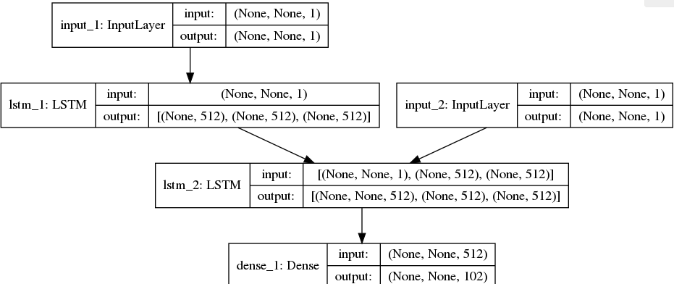

GAN Model

We keep the same CNN-based generator and discriminator with 5 residual blocks as in IWGAN .

Experimental Results

After running the Model for 120,000 iterations on just single Dataset file amongst the 100 files , following are the results for JS4 .
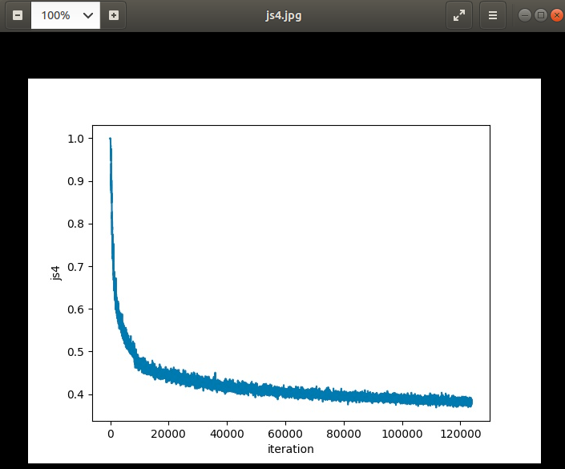
Clearly from the results , we can see the Model drastically improved till 20,000 iterations , then the convergence slowed till but still it could have improved with more epochs .

Sample results

1)”most leader the chiare really by”
2)”the company was faked to shwat s”
3)”under said that official expertt”
4)”we got even an american gold “
5”minister resigned after news”

There were many Sentences which made senses, but many were noisy as well which didnt make any sense, above are the few of the good once which I got from just 1 batch of generator out of

How to Run

1)To Train the Encoder-Decoder we can just Encoder-Decoder.py , which will Output and save necessary files for gan .
i)EncoderDecoder.h5 is the Model file for encoder-decoder
ii)SoftOutputs.pickle is the Softmax representation of the TrainingData . This will be used by gan as input
iii)we have dictionary and inverse dictionary as well that will be used by gan’s generator to show what the model outputted

2)Once Encoder-decoder is trained and we have necessary outputs , we can then run TextKD.py inside the TextKD folder, which will run the Gan mode , After every 10 epochs we get a new generated graph and generated text by generator .

3)To Test – Run Generator.py , which will give you a file TESTING.txt

Improvements
1)Run the Model with complete Dataset will be a major improvement, as currently I am using only 1/100th of dataset

2)In the Research paper it has been mentioned that the Google dataset gave very low results compared to stanford dataset , as Google’s dataset had many complicated sentence and not many occurances which made hard for model to learn the pattern . So using other dataset apart from google’s would be another big improvement here

3)as we saw from the Graph , that the model was still improving, we can let model run for as long as it keep improving to generate high scored JSD for sentences .

References
1)https://arxiv.org/pdf/1905.01976.pdf
2)https://arxiv.org/abs/1704.00028
3)https://papers.nips.cc/paper/5346-sequence-to-sequence-learning-with-neural-networks.pdf

