A [Git repository](https://bitbucket.org/product/code-repository) is a virtual storage of your project. It allows you to save versions of your code, which you can access when needed. hub is a repository where you can save the documents you have made for the project and keep on updating them

To save the latest code on git hub you need to first

Create a folder in local and create a document in local path 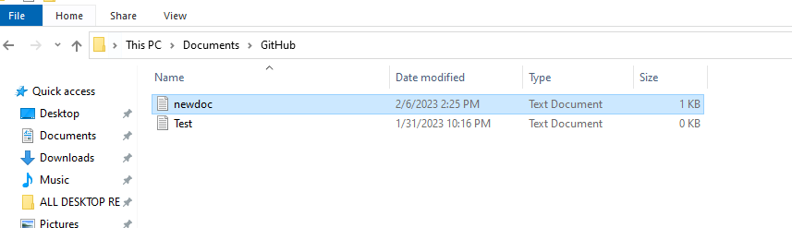

Now open the command prompt from that location >>windows R

Now to know the status of Git –type **Git Status**

**Initialising a new repo in your local.** Type **git init** – this will initiate a git repository inlocal



To create and switchto a new branch type **git checkout -b newtree**

**Or** create a new branch **git branch new tree** & to switch **git checkout newtree**

Make changes in the local file created and save it , now in the cmd type git status it will show the changes made.

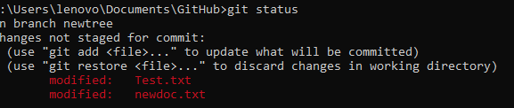

Commit the file that you need to add to the main – Type git commit -m “new tree branch created”

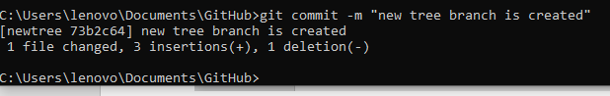

Now we push the code to GIT HUB by git remote add newtree https://github.com/PrLu/Automation-Corner.git

Git push newtree

