Analysis of Forest Fires through Complex Systems.

Srinivas Kasturi, Student no: 3078674, Applied Computer Sciences, University Of Winnipeg.

*Abstract*— Fire influences global ecosystem patterns and processes, including vegetation distribution and structure, the carbon cycle, and climate. Although humans and fire have always coexisted, our capacity to manage fire remains imperfect and may become more difficult in the future as climate change alters fire regimes. This risk is difficult to assess, however, because fires are still poorly represented in global models. One of the major challenges in forestry is to learn how to use these concepts to facilitate the ability of forest systems to self-organize and adapt in the face of global change in order for the forest to continue to fulfill human needs for ecosystem goods and services. Here in this paper we apply the science of complex systems to the forest & fire system and we’ll be focusing on the behaviors, predictability of the system and modelling challenges to contrast the differences between our view and viewing forest as a Complex Adaptive System.

[1]

# Introduction

F

## ire is an important tool for all the human beings throughout the history. As a tool of nature it fire is being suppressed and controlled throughout the majority of human history. Controlling and extinguishing the wildfires was mostly started in 20th century. Forest fires are very complex problems that are effecting many parts across the globe. Starting from the 1960’s there is a great change in the fire management and people began to recognize fire’s utility and function as the tool of the nature. People also began to guide research and fire science to better understand just how fire spreads in the forest and other environments. In order to control these forest fires many of the factors which are supporting the fire and opposing the fire should be studied briefly and then we should carry out through the simulation basing on those factors. The management of forest fires is a complex activity because requires the deep study of the parameters such as organizational, individual, social and dimensions. This study of forest fires shows both the normal and abnormal events. It helps us to analyze how we can stop the spreading of these fires and how we can support the fire and it is burning directions by using some factors.

# RELATED WORKS

**Fire Danger Prediction**- The prediction of the fire danger can be can be initiated from the values of the fire weather index system, by using the daily values of meteorological parameters from the representative’s stations during the fire seasons with respect to the region. It gets statistical data of fire occurrence with in a period of five to ten years depending upon the capacity of each system to estimate fire danger.

**Fuel Status Estimation**-The Moisture content of the fuel particles is the major factor that affecting the flammability and combustion of the forest fuels. This moisture content can be measured by using the FFMC (Fine Fuel Moisture Code)/ DC (Drought Code) of dead fuel sources or live shrubs.

**Slope and Wind Effects on Fire Spread-**Slope and Wind are the also recognized as the two relevant factors of the Fire. I slopes the fire will not spread uniformly and it acts according to the direction of the slope. As previously said Fire will act according to the wind. The frequency of fire will be depending upon the favorable wind or opposing wind.

This dynamic analysis of forest fires allows us to calculate the radius of the fires and angle co- ordinates in which the fires were spreading. This dynamic analysis includes the concept of mutual information. This mutual information comes from the information theory and has been adopted in the study of complex systems from diverse fields, namely in experimental time series analysis, in DNA and symbol sequencing and providing theoretical basis for the complexity. In this dynamic analysis, Hierarchical clustering algorithm is used for the representation of fires. Here they build a hierarchy of clusters (fires) in such a way that objects are in same cluster and some sense and similar to each other. This algorithm is used to study/achieve metric, quantifying the distances and linkage etc. These tools allow low different perspectives over forest fires that may be used to better understand the dynamics emerging in the supporting and opposing phenomenon’s that occur in forest fires. In this model Fire Spread Decomposition Schemes were also explained on depending upon their behavior towards the Direction to Direction. In which they explained that the fire spreading is faster in these schemes due to the neighbor cell interactions. This Fire model also supports the fire suppression simulation. There will be an interaction in between the firefighting agents and wildfire behavior models allows for studying the effectiveness of different strategies and different wildfire behavior scenarios

These kinds if Fire models are designed to be integrated with a stochastic optimization model that uses the scenarios results from the simulation to determine the firefighting resources to work on providing a containment wildfire. Here fuel, terrain, weather has a dynamic influence on wild life behavior. The moisture content in the fuels also dynamically changes with respect to the weather as shown in the Fire line intensity.

Seeing forest as a complex system and studying ecological factors will provide a practical application to the forest fires and other problems. This assessment of the ecosystems after the occurrence of issue will impact the management practices.

These impacts will of practices on the ecosystems will be shown in the form of changes in the desired level of eco systems goods. As eco systems are fundamentally considered as network of interacting elements, the next generation of models and approaches will represent in space and time. In these mean times a complex system will be represented in the spatially explicit manner. Complexity theory also implies that it is not possible to simulate the whole stands as modelling agents because there are no interacting elements are present.

## Agent-Based Modeling:

This Agent based model explains that the fire ignition begins with the start of spreading in between the tree cells in their neighborhood. These fire agents will be spreading the fire across the landscape in a different manner by creating the random fire/ new fires with any other tree cell in neighborhood. In this model fire spread continues in both discretely and continuously. This model uses the property of self-organization that present in dynamical systems to describe the spreading of fire. As there is a linear increase in the amount of the density then amount of forest burned will be increasing and this pattern starts to emerge slightly at different places in exponential trend by exhibiting Emergence. Stochasticity in this model is explained by distributing trees and empty cells randomly and this model does not consists of any feedbacks, path dependences or decision making. In this model the low-level and simple interactions between fire agents and their tree or empty cells will produce an unexpected emergent pattern of threshold forest densities and produce drastically different outcomes of the percentage of forest burned.

# Methodology

A forest-fire model is comprising of a number of dynamical systems in it and by itself it is a self- organized model. Here in this model, the burning rules were obtained from the model of Drossel and Schwabl (1992) and it is defined by four rules which are executed simultaneously in each and every forest fire related models,

1. A burning cell turns into an empty cell/red cells

2. A tree will burn if at least one neighbor tree is burning

3. A tree ignites with probability f even if no neighbor is burning.

4. At an empty site, a tree grows with probability p.

The first condition allows large structures to develop, while the second condition keeps trees from popping up alongside a cluster while burning.

The second relation says that the mean number of growing trees equals the mean number of burning trees in the steady state. Depending on the magnitude of the parameters, a variety of large-scale structures arise.

f<< p << Tsmax

The controlling parameter of the model is p/f which gives the average number of trees planted with respect to the density. In order to exhibit a fractal frequency-size distribution of clusters, a double separation of time scales is necessary

If the system size L is large enough the properties of the steady state are also independent of the boundary conditions. Let ρe, ρt , and ρf be the mean density of empty sites, of trees, and of burning trees in the steady state. These densities are related by the equations

ρe + ρt + ρf = 1 and

ρf = pρe.

where Tsmax is the burn time of the largest cluster. The scaling behavior is not simple A cluster is defined as a coherent set of cells, all of which have the same state. Cells are coherent if they can reach each other via nearest neighbor relations. In most cases, the von Neumann neighborhood (four adjacent cells) is considered.

In landscape ecology, the forest fire model is used to illustrate the role of the supporting and opposing for the fire in the wildfire regime. The importance of these factors on wildfire spread is debated. Parsimonious models such as the forest fire model can help to explore the role of the factors and its limitations in explaining observed patterns.

In this model, we have divided the entire square of experimental setup into the square patches and here we have declared two types of trees variables. They are initial-trees and burned-trees. The entire portion is divided into four quadrants and other than the density of the forest we have introduced two new variables which are also known as ‘supp and oppo’. **supp** is known as the supporting characters for the fire such as the wind, fossil fuels, and other environmental conditions. **supp-angle** is the wind angle that can be blown in same or opposite directions. **Oppo** is known as the opposing character of the fire such as rain, opposite directional wind, humidity in the trees/atmosphere. **oppo-chance** is the chance of occurrence of rain/ occurrence of humidity etc. which opposes the fire. These new variables will make the fire environment as the original forest and help us to carry out the simulations on the forest environment.

When the Density is set and model is ready to go then fire ignition takes place by checking the logic as when neighbors4 with pcolor=green, checks whether the oppo is on/off and then it checks the condition that random float 100< rain-chance. AT the same time if the supp is on then the fire will be moving in the direction of supp-angle. As we used the ask patch-at-heading-and-distance wind-angle 3 then atan x,y functionality is used here and the direction will be selected as in the format of the co-ordinates (wind, (min/max)-pycor (+/- 2)) and the burning starts after the validation of random-float 100 < rain chance and now set breed embers. This means the fire starts and trees will get burned according to the conditions set.

When the OPPO is active or on the color of the patches will go red darker very quickly because the ignited fire will be opposed by rain and burning tree will turn into darker ones easily. This phenomenon is obtained by achieving the color reduction quickly by setting color -0.3 when color < red -3.5. When the OPPO is off the color of the patches will go to red darker slowly because there is no opposing force acting and the fire will be burning until it turns down by itself. We are reducing the color here by setting color -0.05 in the loop when the color<red -3.5. Because of -0.05 the red changes into darker very slowly.

In this model, we are calculating the percent trees burned by the counting the number of trees that burned or by counting the patches that turned into red.

Percentage burned = ((count patched with [shade-of? Pcolor red])/initial trees)*100

Or

Percentage burned= (burned-trees/initial trees)*100

**EMERGENCE:**

The macro- or system-level behavior that emerges from the activities and behaviors of the component parts of the system, but which cannot be explained at the agent level alone. It can also be studied as the macro-level phenomenon, like the functioning of a complex system, as a result of its local interactions. Here understanding of the macro level phenomenon is done by studying of the micro level agents.

In this model emergence is the phenomenon where the final stage of forest obtained after applying all the opposing and supporting conditions. Here for this model we are different types of emergence behaviors when the density of the forest crosses 55% and you will observe that more than 90% of the forest will be burned at this stages. This is because of the increase in the contact with the neighbors because of the increase in the density. This increase in the density will decrease the distance between the agents. Due to this one burning agent can burn more than one neighbor agent and this this is the default case when there is no application of factors.

When the supp-angle is assigned as an initial condition, after varying it with different points of density, you’ll be seeing nearly more than 90% of the forest is burned after increasing the density more than 60% more quickly.

When the oppo-chance is assigned as an initial condition, after varying it with different points of density, you’ll be seeing nearly 75% of forest is burned even after 60% of density. We’ll be seeing the same percent of the forest is burned at the 99% of density too.

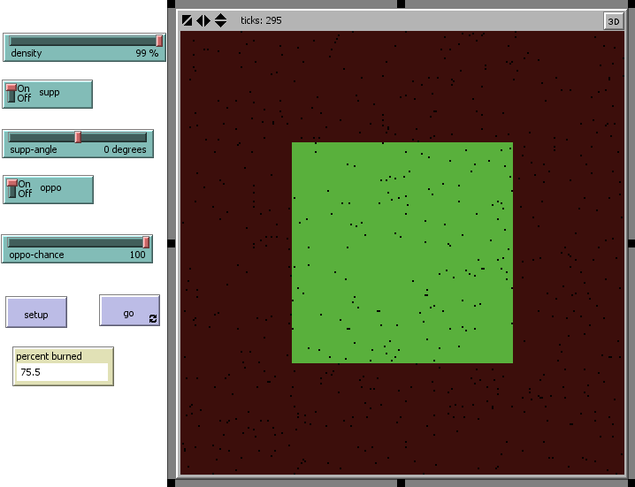

(Fig-1: Netlogo model screenshot when 75% of the forest is burned)

|  |  |  |
| --- | --- | --- |
| Density% | oppo-chance | Percentage-burned |
| 65% | 100 | 74.9% |
| 75% | 100 | 75.2% |
| 85% | 100 | 75.6% |
| 99% | 100 | 75.7% |

(Table-1: Comparison of the percentage-burned to show emergence)

**SELF ORGANIZATION:**

Self-organization is a process where a system reproduces itself with the help of its own attributes or components. Self-organization takes place in a system, in a coherent whole that has parts, interactions, structural relationships, behavior, state and a border that delimits it from its environment. The essence of self-organization is that system structure (at least in part) appears without explicit pressure or constraints from outside the system. In other words, the constraints on form are internal to the system and result from the interactions between the components, whilst being independent of the physical nature of those components. The organization can evolve either in time or space, can maintain a stable form or can show transient phenomena. General resource flows into or out of the system are permitted, but are not critical to the concept. The field of self-organization seeks to discover the general rules under which such structure appears, the forms which it can take, and methods of predicting the changes to the structure that will result from changes to the underlying system. The results are expected to be applicable to any system exhibiting the same network characteristics.

The Self organization behavior occurs when the supp, supp-angle, oppo, oppo-chance are is nonzero. We can see the self- organization behavior even if we are not using any of the sup or oppo functions. Below are the self-organizing behaviors observed in this model:

1) When there are no supp & oppo factors and soon after crossing the density of 50% you’ll be able to see amount of forest is burned because of the visibility and self –organization of agents.

2) At the point of supp-angle in the direction of fire then we can see self-organization between the fire and supp(wind) to burn the maximum amount of forest.

3) When the oppo-chance is more than the fire will be shifted in to the directions where there is no oppo i.e. rain and other area will be burned. Here self-organization is observed between the opposing force (rain) and the fire agents to burn the maximum available forest.

# Experiments

Here we are performing the experiments on this model at different conditions.

1) When the supp-angle is positive and oppo-chance is positive/more:

When the sup-angle is 90 degrees and the oppo-chance is 100 then there will be strong opposing forces for the fire and there will be only 75% of forest burned at the 60% of density. While 60% of the forest is considered as a duck point for the experiments. Here we’ll be comparing the conditions and percentage of forest burned and ticks taken to burn at that duck point. It took nearly 270 ticks to burn 75% of the forest at this conditions.

The density-burned trees graph of this conditions is below:

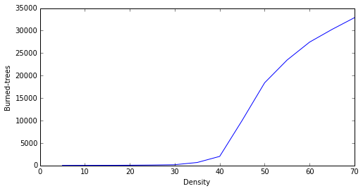

(Graph-1: Results of the simulations when the first set of conditions were applied.)

2) When the supp-angle is positive and oppo-chance is zero:

As the oppo-chance is zero the opposing forces for the fire is very less and the spreading capacity of the fire will be more. As the sup-angle is 90 degrees which was the same fire spreading direction then it will support the fire and the forest will burn in very less time and it took very fewer ticks i.e150 when compared to previous conditions. The percentage of forest burned is nearly 98.5 percent and very less amount of forest is still visible.

The density-burned trees graph of this conditions is below:

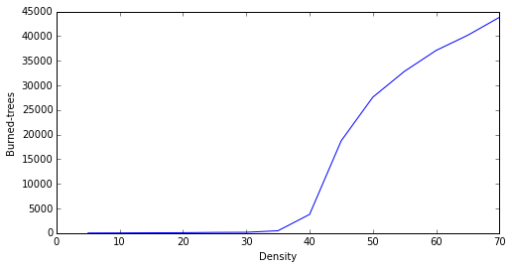

(Graph-2: Results of the simulations when the second set of conditions were applied.)

3) When the supp-angle is negative/zero and oppo-chance is positive/more:

As the supp-angle is -90 degrees the supporting wind will act as an opposing character here and the oppo-chance is 100 then the opposing forces will have a strong impact on the fire and very less amount of the forest will be burned. Coming to the results we will be seeing only 36% of the forest is burned at the duck point density of 60% and it took nearly 410 ticks to burn this forest.

The density-burned trees graph of this conditions is below:

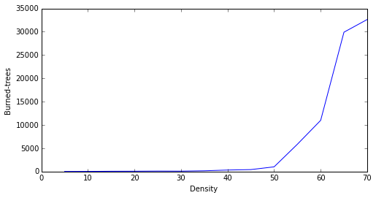

(Graph-3: Results of the simulations when the third set of conditions were applied.)

4) When the sup-angle is negative/zero and oppo-chance is zero:

As the oppo-chance is zero the opposing forces over the fire will not have any impact and though the sup-angle is -90 degrees but still it will be working as a supporting factor for fire and most of the forest will be burned. To burn the forest in this conditions it will take more no of ticks such as 710. The forest burned in this conditions at the duck-point of 60% density is nearly 98%.

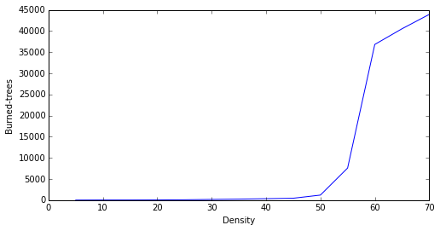

(Graph-4: Results of the simulations when the fourth set of conditions were applied.)

Comparing the conditions, the density of the forest, no of ticks, percentage burned.

|  |  |  |  |
| --- | --- | --- | --- |
| Conditions | Density | Percentage Burned | No. of Ticks |
| SUPP +(90)  OPPO +(100) | 60% | 75% | 270 |
| SUPP +(90)  OPPO (0) | 60% | 98.5% | 150 |
| SUPP -(90)  OPPO +(100) | 60% | 36% | 410 |
| SUPP -(90)  OPPO (0) | 60% | 98% | 710 |

(Table-2 comparing all the experiments performed)

# DISCUSSION

In this model we added the attributes such as oppo, oppo-chance will resemble the opposing forces. supp, supp-angle will be the supporting forces for the model.From the above experiments, it is clear that when sup-angle is negative then it should act against the fire and it should oppose it, but this will be done only when there is some acting oppo-chance. If there is no oppo-chance then it will be opposing only up to some extent and some of it will be a supporting character and it’ll boost the fire to burn.

When the supp-angle is +90 degrees then the supporting force will be in the fire’s burning direction and the forest will be burned very quickly when compared to the other conditions. Even when the oppo-chance is more at this condition the amount of forest burned will be less but it’ll be done with in the similar ticks. As the amount of opposing chance increases the amount of fire/burned percentage will be decreased, this can be explained by relating the opposing chance to the rain. As the rain increases the fire burned trees number will be decreased. In the same way by relating the supp-angle to the wind as the wind is in supporting angle to the fire then more no of trees will burn otherwise less no of trees will be burned.

# CONCLUSION

This paper has presented a method for simulating fire spread by utilizing a forest-fires and environmental factors with the supporting and opposing simulation. This simulation model has been proposed which will allow for interaction between the fire and the environment, taking into account all major environmental factors such as wind, wind-angle, rain, opposing condition that may affect fire growth and spread. These factors have undergone testing under some initial conditions, and as a consequence of their combined effect, the fire-spread behavior at the different levels can be observed to mimic the phenomena of fire spread in nature.

In the future, other environmental factors such as radiation, convection (radiation from and convection into the advanced flame tends to speed up the movement of flames immediately adjacent to it) and spotting may be incorporated into the current model. More experiments will be conducted to investigate what will impact these factors might have on fire spread behavior. Another possible extension is to integrate the model with a Forest type’s mechanism and multiple fires mechanism, probabilities of supporting and opposing factors. This could allow the model to conduct experiments on different kinds of forests with in different conditions. This will allow us to study forest-fires in a single model.

References

1. Albano, 1995 ,E.V. Albano Spreading analysis and finite-size scaling study of the critical behavior of a forest-fire model with immune trees. Physica A, 216 (1995), pp. 213–226
2. B. Drossel and F. Schwabl, 1992, Self-Organized Critical Forest-Fire Model ,Ecological Modelling , Phys. Rev. Lett. 69, 1629–1632.
3. Weiguo Song, , Fan Weicheng, Wang Binghong, Zhou Jianjun.,2000, Self-organized criticality of forest fire in China, Ecological Modelling, Volume 145, Issue 1.
4. Richard D. Zinck,1,2,* Mercedes Pascual,1 and Volker Grimm2,2011, Understanding Shifts in Wildfire Regimes asEmergent Threshold Phenomena,vol. 178, no. 6 the american naturalist.
5. Anand M., Gonzalez A., Guichard F., Kolasa J.,Parrott L., 2010 – Ecological systems as complex systems:challenges for an emerging science. Diversity, 2:395-410. doi:10.3390/d2030395
6. James P., Fortin M.J., Fall A., Kneeshaw D., Messier C., 2007 – The effects of spatial legacies following shifting management practices and fire on boreal forest age structure. Ecosystems, 10: 1261-1277. doi:10.1007/s10021-007-9095-y
7. Chao Li, 2000, Reconstruction of natural fire regimes through ecological

modelling, C. Li / Ecological Modelling 134 (2000) 129–144

1. Siegfried Clar, Barbara Drossel and Franz Schwabl, 1996, Forest fires and other examples of self-organized criticality, 1996 J. Phys.: Condens. Matter 8 6803 (http://iopscience.iop.org/0953-8984/8/37/004)

1.