create database xyz;

--- Tables ---

Create table parking_lot (id numeric PRIMARY KEY, number_of_blocks numeric, address varchar(500), zip varchar(10), operating_company_na varchar(100));

Create table block_(id numeric PRIMARY KEY , parking_lot_id numeric , block_code varchar(3), number_of_floo numeric, CONSTRAINT fk_block_parking_lot FOREIGN KEY (parking_lot_id) REFERENCES parking_lot(id));

desc block_ ;

Create table floor_(id numeric PRIMARY KEY ,block_id numeric,floor_number numeric,number_of_wings numeric , CONSTRAINT fk_floor_block FOREIGN KEY (block_id) REFERENCES block_(id));

Create table parking_slot(id numeric PRIMARY KEY,floor_id numeric ,slot_number numeric,wing_code char(1), CONSTRAINT fk_parking_slot_floor FOREIGN KEY (floor_id) REFERENCES floor_(id));

Create table customer(id numeric PRIMARY KEY,name varchar(10),vehical_number varchar(20),registration_date date,contact_number numeric,cost numeric(10,2));

desc customer;

Create table parking_slot_reservation(id numeric PRIMARY KEY,customer_id,start_timestamp varchar(5),duration_in_minutes numeric,booking_date date,parking_slot_id numeric, CONSTRAINT fk_psr_customer FOREIGN KEY (customer_id) REFERENCES customer(id),CONSTRAINT fk_psr_parking_slot FOREIGN KEY (parking_slot_id) REFERENCES parking_slot(id));

Create table parking_slip(id numeric PRIMARY KEY,parking_slot_reservatio numeric,actual_entry_time varchar(5),actual_exit_time varchar(5),basic_cost numeric(10,2),penalty numeric(10,2),total_cost numeric(10,2),CONSTRAINT fk_pslip_psr FOREIGN KEY (parking_slot_reservatio) REFERENCES parking_slot_reservation(id));

--- Insertion ---

insert into parking_lot values(201,5,'Pratiksha nagar,Sion,Mumbai,Maharashtra','400022','P1 Services');

select * from parking_lot;



insert into block_ values(01,201,'A-1',1);

insert into block_ values(03,201,'A-2',1);

insert into block_ values(05,201,'A-3',1);

insert into block_ values(07,201,'B-1',2);

insert into block_ values(09,201,'B-2',2);

select * from block_;

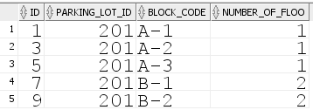

insert into floor_ values(101,01,1,3);

insert into floor_ values(102,03,1,3);

insert into floor_ values(103,05,1,3);

insert into floor_ values(201,07,2,2);

insert into floor_ values(202,09,2,2);

select * from floor_;

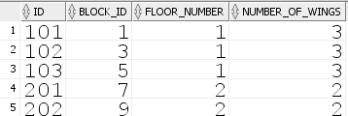

insert into parking_slot values(01,101,01,'A');

insert into parking_slot values(02,101,02,'A');

insert into parking_slot values(03,102,03,'A');

insert into parking_slot values(04,102,04,'A');

insert into parking_slot values(05,103,05,'A');

insert into parking_slot values(06,103,06,'A');

insert into parking_slot values(07,201,07,'B');

insert into parking_slot values(08,201,08,'B');

insert into parking_slot values(09,202,09,'B');

insert into parking_slot values(10,202,10,'B');

insert into parking_slot values(11,202,11,'B');

select * from parking_slot;

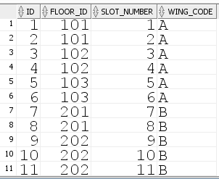

insert into customer values(01,'bhavya','MH100200','06/10/2022','932745372',100);

insert into customer values(02,'mansi','GJ100200','08/11/2022','9743834845',200);

insert into customer values(03,'ishwari','UP100200','06/09/2022','8948989998',100);

insert into customer values(04,'prachi','DL100200','10/10/2021','9848409858',100);

insert into customer values(05,'saumya','MH100321','03/10/2022','9893898349',200);

insert into customer values(06,'shreya','GJ100675','09/11/2022','9489483943',200);

insert into customer values(07,'muskan','UP100887','09/09/2022','7832883988',300);

insert into customer values(08,'gargi','DL100432','01/05/2022','9876543210',300);

insert into customer values(09,'khushi','DL100274','07/11/2022','8984838848',100);

insert into customer values(10,'niketa','MH100900','05/12/2022','883889849',200);

insert into customer values(11,'bhavya','MH100200','11/10/2022','932745372',200);

select * from customer;

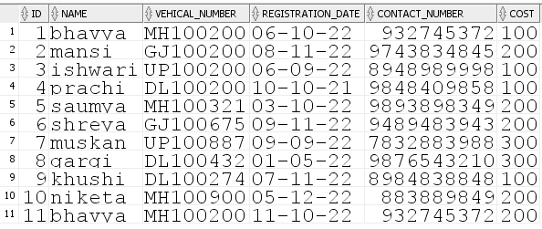

insert into parking_slot_reservation values(201,01,'01:00',60,'06/10/2022',01);

insert into parking_slot_reservation values(202,02,'02:30',120,'08/11/2022',02);

insert into parking_slot_reservation values(203,03,'03:30',60,'06/09/2022',03);

insert into parking_slot_reservation values(204,04,'04:00',60,'10/10/2021',04);

insert into parking_slot_reservation values(205,05,'05:00',120,'03/10/2022',05);

insert into parking_slot_reservation values(206,06,'06:00',120,'09/11/2022',06);

insert into parking_slot_reservation values(207,07,'07:00',180,'09/09/2022',07);

insert into parking_slot_reservation values(208,08,'08:00',180,'01/05/2022',08);

insert into parking_slot_reservation values(209,09,'09:30',60,'07/11/2022',09);

insert into parking_slot_reservation values(210,10,'10:00',120,'05/12/2022',10);

insert into parking_slot_reservation values(211,11,'11:00',120,'11/10/2022',11);

select * from parking_slot_reservation;

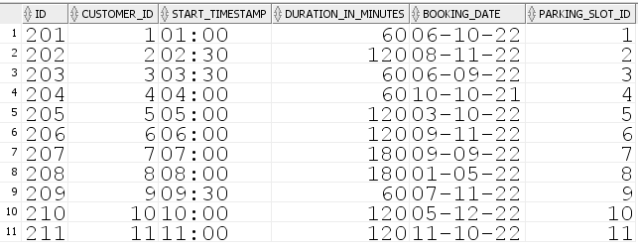

insert into parking_slip values(01,201,'01:00','02:00',100,NULL,100);

insert into parking_slip values(02,202,'02:30','4:30',200,NULL,200);

insert into parking_slip values(03,203,'3:30','4:30',100,NULL,100);

insert into parking_slip values(04,204,'4:00','5:00',100,NULL,100);

insert into parking_slip values(05,205,'5:00','7:00',200,NULL,200);

insert into parking_slip values(06,206,'6:00','8:00',200,NULL,200);

insert into parking_slip values(07,207,'7:00','10:00',300,NULL,300);

insert into parking_slip values(08,208,'8:00','11:00',300,NULL,300);

insert into parking_slip values(09,209,'9:00','10:30',100,NULL,100);

insert into parking_slip values(10,210,'10:00','12:00',200,NULL,200);

insert into parking_slip values(11,211,'11:00','12:00',200,NULL,200);

select * from parking_slip;

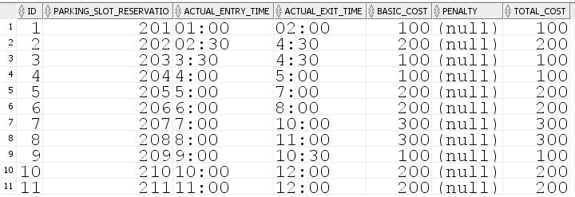

--- PL SQL Blocks ---

-- trigger calculting the total cost after adding penalty and placing the value in parking_slip

create or replace trigger after_insert_parking_slip

after insert on parking_slip

for each row

declare

v_total_cost number(10,2);

begin

v_total_cost := :new.basic_cost + coalesce(:new.penalty, 0);

update parking_slip

set total_cost = v_total_cost

where id = :new.id;

commit;

end;

/

DROP TRIGGER after_insert_parking_slip;

-- raise alert for updating the registartion after 1 year

create or replace trigger b_u_registration_date

before update of registration_date on customer

for each row

begin

if months_between(sysdate, :new.registration_date) > 12 then

raise_application_error(-20002, 'Cannot update registration date for records older than a year');

end if;

end;

/

-- trigger on block table after updating the id of parking slot

create or replace trigger A_U_BLOCK

after update of PARKING_LOT_ID on BLOCK_

for each row

declare

V_OPERATING_COMPANY_NA PARKING_LOT.OPERATING_COMPANY_NA%type;

begin

select OPERATING_COMPANY_NA into V_OPERATING_COMPANY_NA

from PARKING_LOT

where id = :new.PARKING_LOT_ID;

update PARKING_LOT

set OPERATING_COMPANY_NA = V_OPERATING_COMPANY_NA

where id = :new.PARKING_LOT_ID;

end;

/

-- trigger on parking_lot before deleting te parking lot it check if the paraking slot is empty or not

create or replace trigger before_delete_parking_lot

before delete on parking_lot

for each row

declare

v_count number;

begin

select count(*)

into v_count

from parking_slot

where floor_id in (select id from floor_ where block_id in (select id from block_ where parking_lot_id = :old.id));

if v_count > 0 then

raise_application_error(-20003, 'Cannot delete parking lot with associated parking slots');

end if;

end;

/

-- trigger in order to update the parking lot once a block is deleted.

create or replace trigger AFTER_DELETE_BLOCK

after delete on BLOCK_

for each row

begin

update PARKING_LOT

set NUMBER_OF_BLOCKS = NUMBER_OF_BLOCKS - 1

where id = :old.PARKING_LOT_ID;

end;

/

-- procedure

-- to check availability for car parking in parking slot

create or replace procedure check_parking_avl(parking_lot_id in number) as

v_count number;

begin

select count(*)

into v_count

from parking_slot

where floor_id in (select id from floor_ where block_id in (select id from block_ where parking_lot_id = parking_lot_id));

if v_count > 0 then

raise_application_error(-20003, 'Cannot delete parking lot with associated parking slots');

end if;

end check_parking_avl;

/

set serveroutput on;

declare

v_parking_lot_id number := 201;

begin

check_parking_avl(v_parking_lot_id);

end;

/

-- function

--Get information of customer based on customer ID

create or replace function get_customer_details(customer_id in number) return varchar2 is

v_details varchar2(4000);

begin

select 'Customer ID: ' || to_char(id) || chr(10) ||

'Name: ' || name || chr(10) ||

'Registration Date: ' || to_char(registration_date, 'DD/MM/YYYY') || chr(10) ||

'Contact Number: ' || to_char(contact_number) || chr(10) ||

'Cost: ' || to_char(cost, 'FM999999990.00') into v_details

from customer

where id = customer_id;

return v_details;

exception

when no_data_found then

return 'Customer with ID ' || to_char(customer_id) || ' not found.';

end get_customer_details;

/

set serveroutput on;

declare

customer_id number := 1;

customer_details varchar2(4000);

begin

customer_details := get_customer_details(customer_id);

dbms_output.put_line(customer_details);

end;

/

-- calculate the total amount obtained from each year

select sum(cost) as total_amount_2022

from customer

where extract(year from registration_date) = 2022;



-- which block has max no of reservations

select b.block_code, count(psr.id) as reservation_count

from block_ b

join floor_ f on b.id = f.block_id

join parking_slot ps on f.id = ps.floor_id

join parking_slot_reservation psr on ps.id = psr.parking_slot_id

group by b.block_code

order by reservation_count desc;

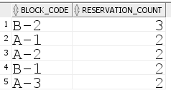

-- select a customer find the no of reservation

select c.name as customer_name, count(psr.id) as reservation_count

from customer c

left join parking_slot_reservation psr on c.id = psr.customer_id

where c.name = 'bhavya'

group by c.name;

