Practical 11

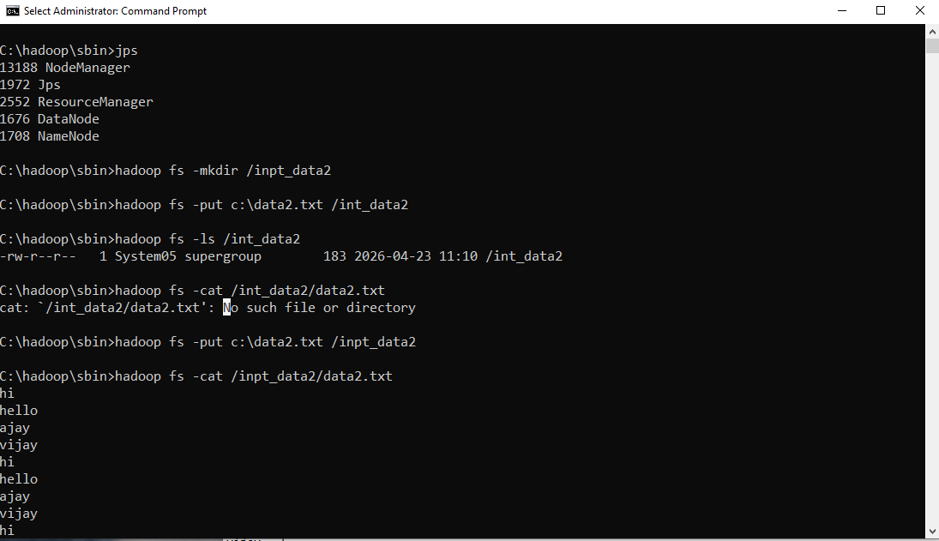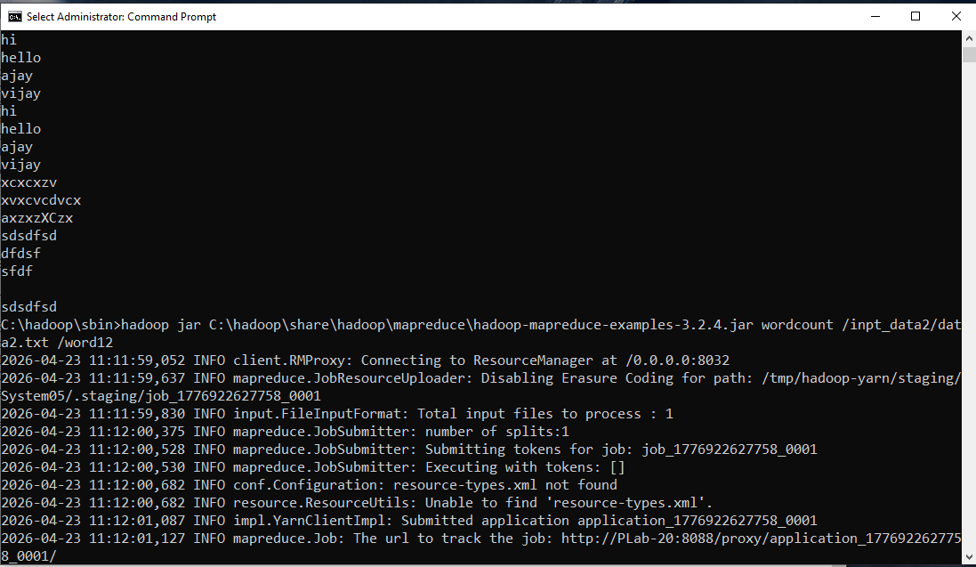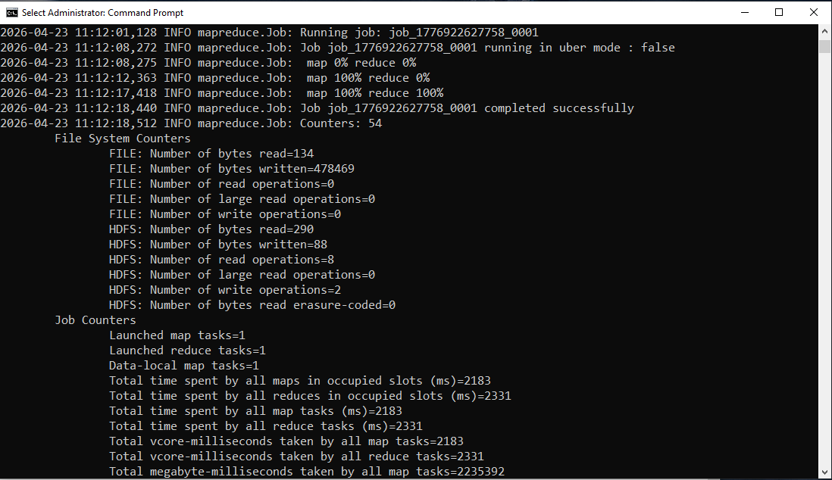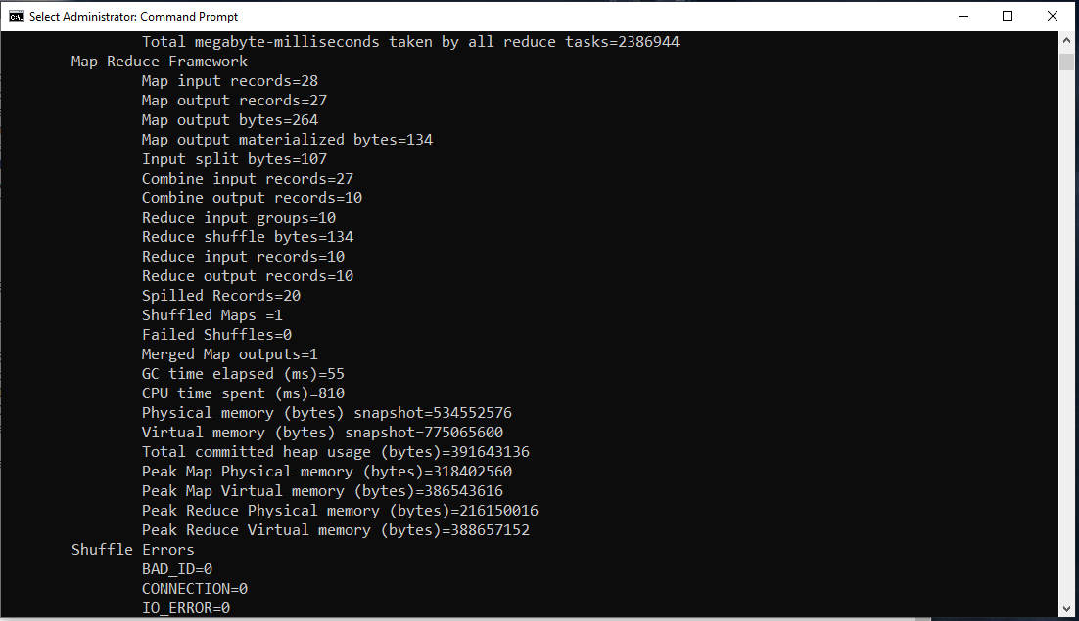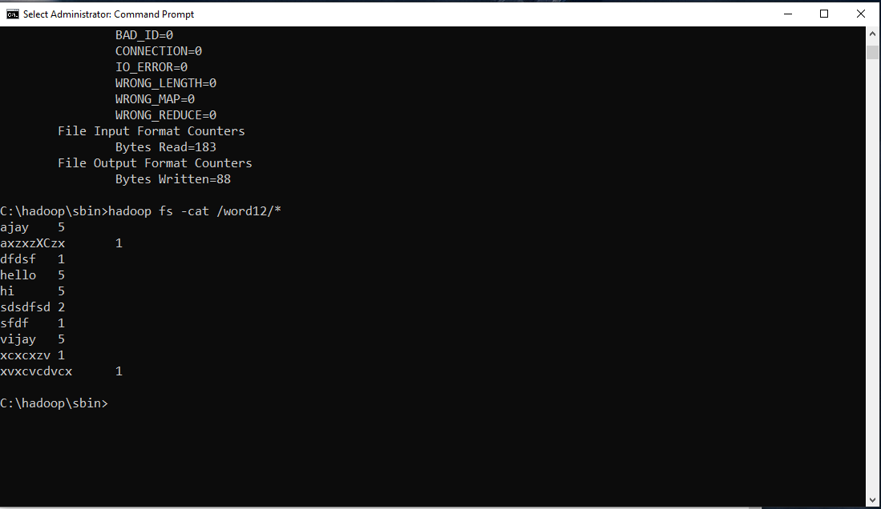

Output :
C:\hadoop\sbin>hadoop fs -cat /word12/*
ajay 5
axzxzXCzx 1
dfdsf 1
hello 5
hi 5
sdsdfsd 2
sfdf 1
vijay 5
xcxcxzv 1
xvxcvcdvcx 1

C:\hadoop\sbin>

