**PRACHI RANA**

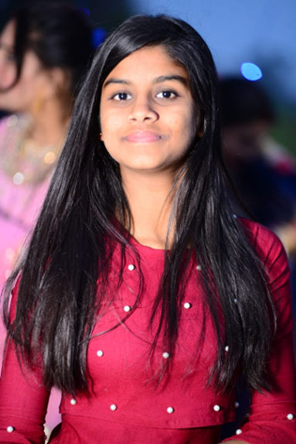

**Address:** Vill. Rattanpura, near Thermal plant

**P.**O Pansara,Jagadhri-135001.

**Mail ID:** [iamprachi04@gmail.com](mailto:iamprachi04@gmail.com)

**Mob:** 81683-68078

# CARRER OBJECTIVE

To secure a challenging position in a reputable organization to expand my learning, knowledge and skills.

# EDUCATION

|  |  |  |  |  |
| --- | --- | --- | --- | --- |
| **Degree/Course** | **Institute/School** | **University/Board** | **Percentage/CGPA** | **Passing Year** |
| Bachelor of Computer Application | Tilak Raj Chadha Institute of Management and Technology,  Yamunanagar | Kurukshetra University, Kurukshetra | 76  (upto 3rdSem.) | Pursuing |
| CLASS 12 | The Doon Valley Public School,Deoband  (UttarPardesh) | Central Board of Secondary Education, New  Delhi | 91.2% | 2020-21 |
| CLASS 10 | Montfort Senior Secondary School,  Roorkee  (Uttrakhand) | Central Board of Secondary Education, New  Delhi | 86% | 2019 |

**SKILLS**

* **Technical Skills:** MS-Office, C, C++, HTML, SQL
* **Other Skills:** Web development

# ACHIEVEMENTS

* Participated in 8th Science Olympiad Foundation(SOF)
* Participated in 5th International Mathematics Olympiad(IMO)
* Participated in Inter School Skit Competition at Quantum University

* Got certificate from udemy in “web development”.

# EXTRA/Co-Curricular Activities

* Undertaken many leadership responsibilities in college.
* Participated and won in several PDP activities.
* Attended various technical webinars and guest lectures.

# STRENGTHS

* Leadership Qualities
* Quick Learner
* Smart Working
* Positive Attitude

# HOBBIES

* Dancing
* Reading spiritual books

# PERSONAL INFORMATION

* **Father’s Name:** Mr. Surender Kumar
* **Mother’s Name:** Mrs. Sudha
* **Date of Birth:** April 1,2004
* **Languages Known:** English, Hindi
* **Nationality:** Indian

# DECLARATION

I do hereby declare that the above provided information is true to the best of my knowledge.

Prachi Rana