Prodigy-Task-1.R

Prachi Athalye

2023-10-16

##Create a bar graph and histogram to visualize the distribution of a categorical or continuous variable.  
##We have chosen "iris" dataset for the above task  
# Load the required library  
library(ggplot2)

## Warning: package 'ggplot2' was built under R version 4.2.3

# Create a bar chart for the categorical variable "Species"  
ggplot(iris, aes(x = Species)) +  
 geom_bar(fill = "skyblue") +  
 labs(title = "Distribution of Iris Species") +  
 xlab("Species") +  
 ylab("Count")

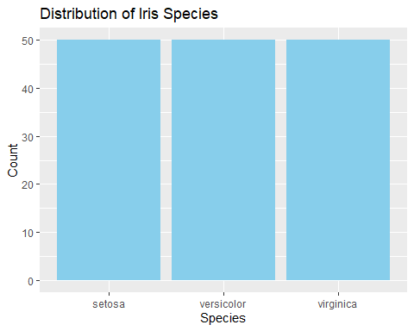

# Create a histogram for the continuous variable "Sepal.Length"  
ggplot(iris, aes(x = Sepal.Length)) +  
 geom_histogram(fill = "skyblue") +  
 labs(title = "Distribution of Sepal Length") +  
 xlab("Sepal Length") +  
 ylab("Frequency")

## `stat_bin()` using `bins = 30`. Pick better value with `binwidth`.

