**Securium Solutions**

**Assignment - 1**

**Installation of Toppo :-**

Step 1 :- Launch the VMware application and Click on “Create a New Virtual Machine”

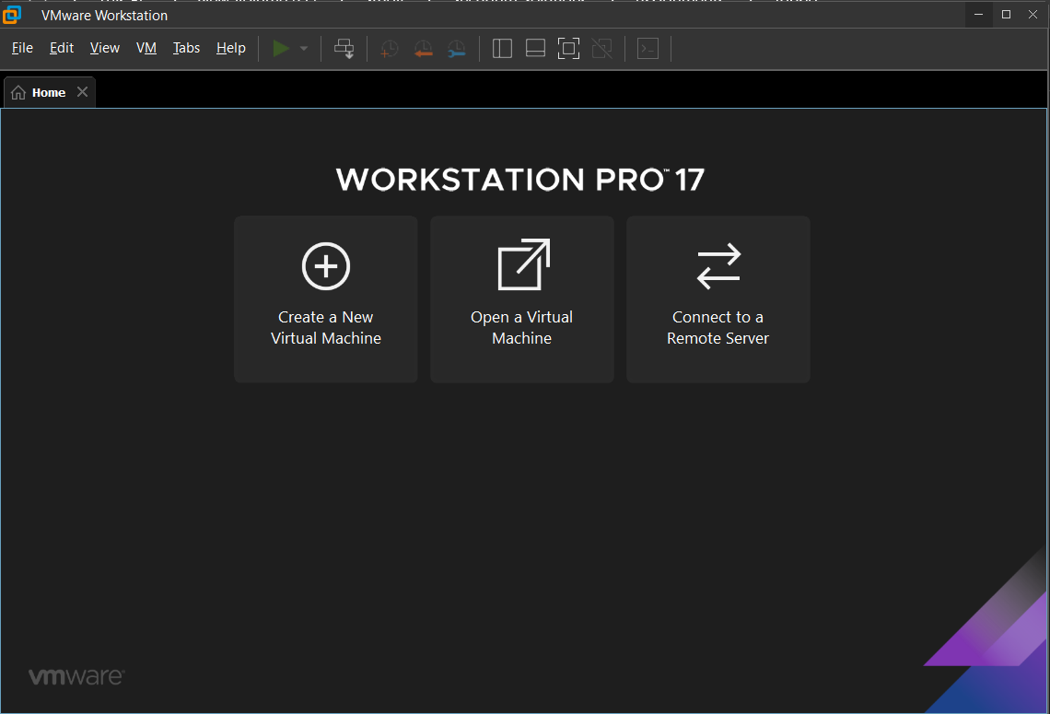

Step 2 :- Choose Configuration Type :- Select Typical (recommended) and click Next

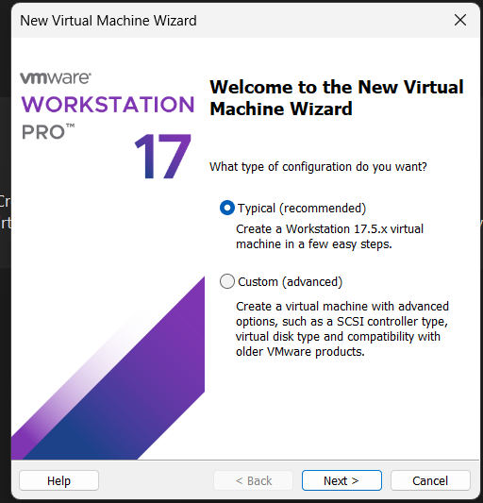

Step 3 :- Select “I will install the operating system later” and click Next.

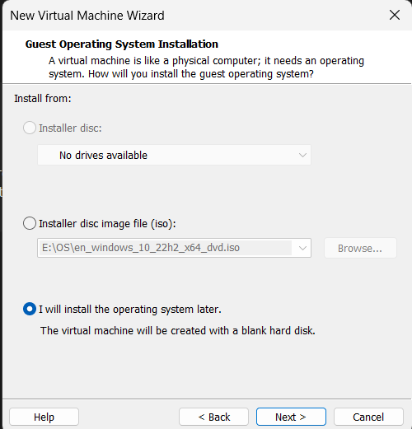

Step 4 :- Select Guest Operating System :- Linux

For the version, select “Debian 5” and click Next

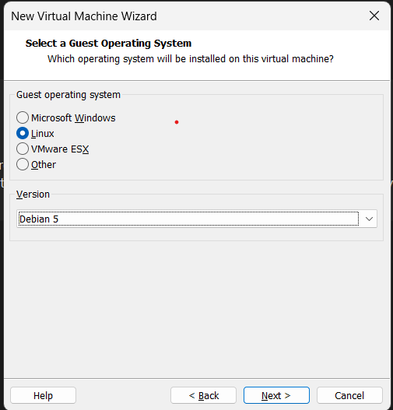

Step 5 :- Name the VM :- Give your virtual machine a name (e.g., “Toppo”) and choose a location to save it.

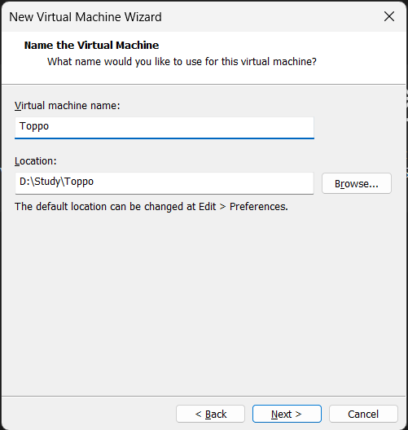

Step 6 :- Set the disk size according to your needs and select whether to store the virtual disk as a single file or multiple files. Click Next.

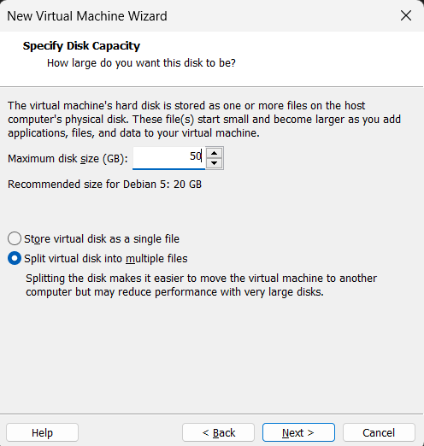

Step 7 :- Click Finish.

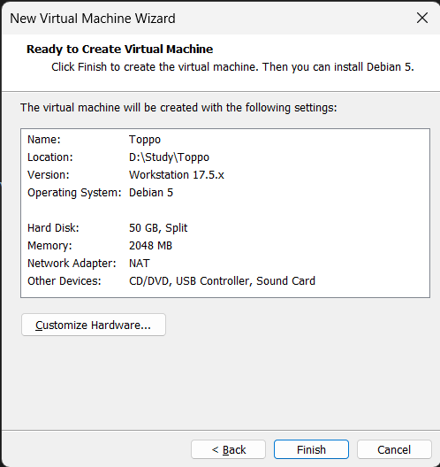

Now our VM is ready.

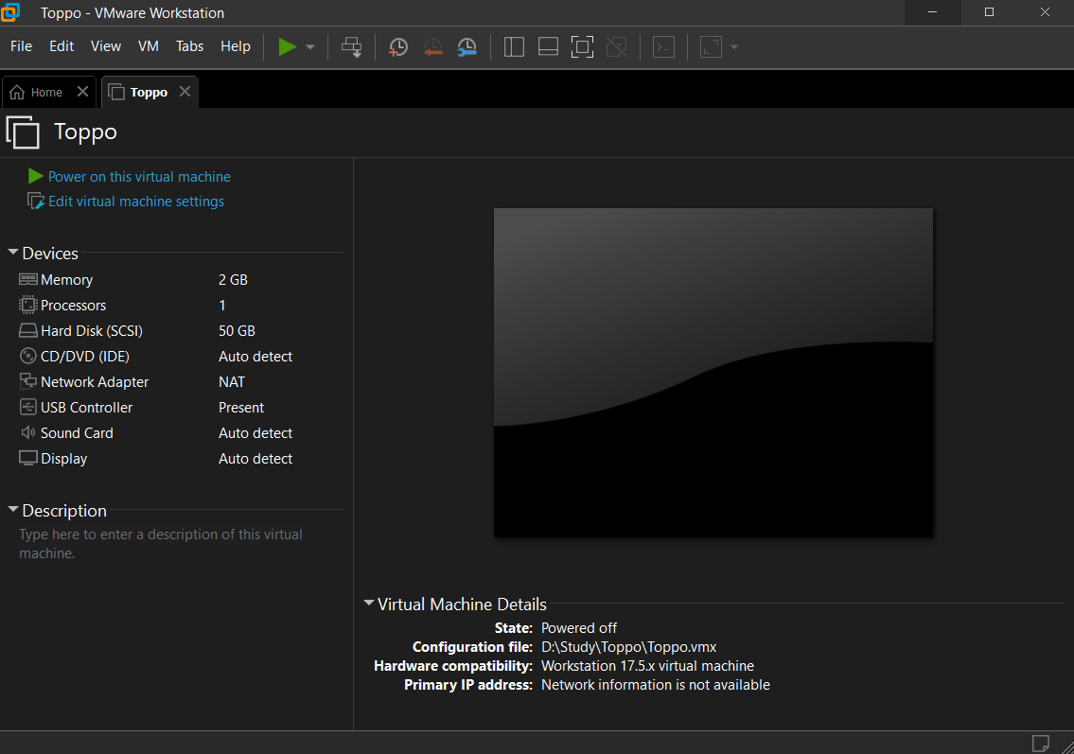

Step 8 :- Click on “Edit virtual machine settings” to add toppo vm file.

Click on Hard Disk(SCSI) and Remove it.

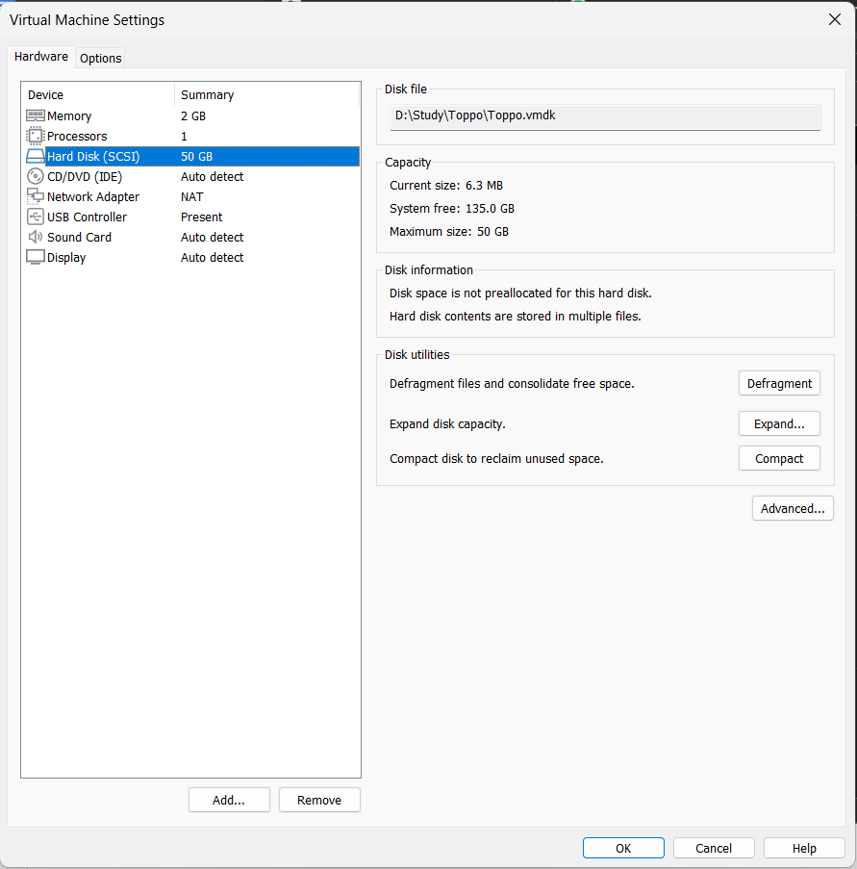

Step 9 :- Click on Add → Hard Disk → Next.

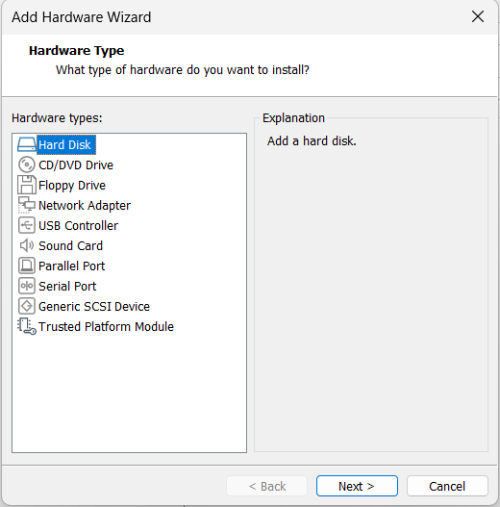

Step 10 :- Click on SCSI and the click Next.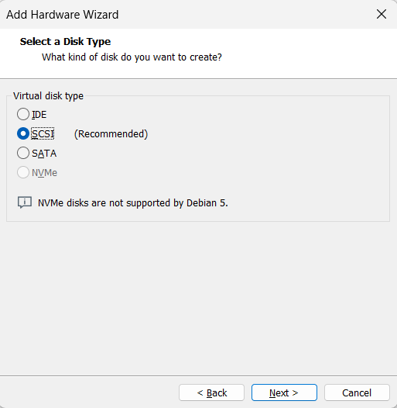

Step 11 :- Now Select use an existing virtual machine and then click Next.

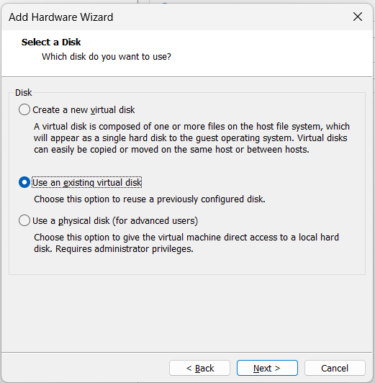

Step 12 :- Browse the downloaded toppo.vmdk file and Select it and then click Finish.

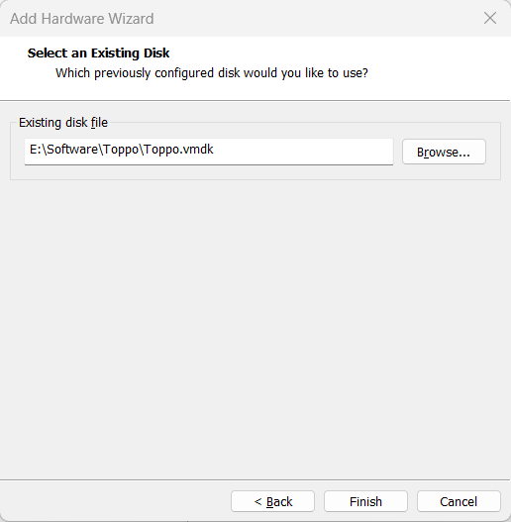

After these steps our Toppo virtual machine is ready.

Start the virtual machine :-

