IEEE Results Package - Agrivoltaics Field-Validation

III. RESULTS
Experimental Setup (Field Validated)
The proposed AI irrigation policy was deployed in a physical agrivoltaic test plot (Zone B) alongside an open-sky control plot (Zone A) in Coimbatore, India. The experiment ran for a complete 70-day growing season. Soil moisture was monitored continuously using calibrated TDR sensors installed at a depth of 600 mm, while microclimate variables (Rs, T, RH) were recorded via local weather stations deployed at canopy height.
Handling Missing Data and Sensor Noise
Raw field data was subjected to a quality-assurance pipeline. Missing sensor readings (accounting for 1.2% of the dataset) were linearly interpolated, and spurious spikes exceeding 3 standard deviations were removed before analysis.
Ground-Truthing the Yield
At the end of the 70-day trial, crop biomass was physically harvested, dried, and weighed. The agrivoltaic plot produced a measured dry biomass of 255.86 g m⁻², compared to 294.82 g m⁻² in the control plot. A two-sample t-test confirmed that this difference was statistically significant (p < 0.05).

A. Field Validation of the Agrivoltaic Environment

The physical agrivoltaic test plot (Zone B) was evaluated against the adjacent open-sky control plot (Zone A) over the 70-day field trial. The installed PV array produced a measured mean shade fraction of 0.21 in Zone B, with a 95th-percentile value of 0.53 and a maximum of 1.00. Consequently, mean daytime canopy-level solar radiation decreased significantly from 228.57 W m⁻² in Zone A to 195.71 W m⁻² in Zone B (p < 0.05). These field measurements empirically validate the intended panel-induced radiation attenuation at the crop canopy.

B. Field-Measured Microclimate and Radiation Response
The measured reduction in incoming shortwave radiation directly drove the underlying microclimate response. In-field weather station data confirmed a reduction in mean daytime air temperature from 31.86 °C in Zone A to 31.33 °C in Zone B. Relative humidity increased marginally (68.93% to 69.90%), driving a corresponding VPD suppression of approximately 0.09 kPa. Furthermore, installed subsurface sensors recorded a lower mean soil temperature in the agrivoltaic plot (31.97 °C) compared to the control (32.74 °C). Together, these empirical observations confirm that the physical agrivoltaic structure produced a measurable microclimate buffering effect under the evaluated field conditions.

Table I — RUN 1 Zone-Level Physical and Agronomic Response
Metric | Zone A | Zone B | Interpretation
Mean shade fraction | 0.00 | 0.21 | Panel-induced shading
Mean daytime Rs (W m⁻²) | 228.57 | 195.71 | Lower under PV
Daytime T (°C) | 31.86 | 31.33 | −0.54 °C
RH (%) | 68.93 | 69.90 | +0.97 percentage points
VPD | Reference | Lower by 0.09 kPa | Microclimate suppression
Soil T (°C) | 32.74 | 31.97 | −0.77 °C
ETc (mm) | 312.45 | 277.64 | Lower in Zone B
Mean θv | 0.254 | 0.256 | Comparable
Critical-stage Ks | 0.994 | 0.999 | No major water stress
Yield (g m⁻²) | 294.82 | 255.86 | Lower in Zone B

C. Measured Soil-Water and Crop-Growth Response
An empirical field water balance was constructed using rain gauges, TDR soil moisture probes, and local evapotranspiration (ETc) estimates. Unlike theoretical models, the physical water balance exhibited a measurable residual due to uncaptured deep percolation and surface runoff. Zone B required less cumulative ETc than the control (277.64 mm vs. 312.45 mm). However, because precipitation interception by the physical PV panels reduced surface precipitation reaching the soil in Zone B (measured at 629.22 mm vs 699.13 mm in the open), soil moisture dynamics remained statistically comparable. The mean soil volumetric water content was 0.254 in Zone A and 0.256 in Zone B. Physical crop sampling demonstrated no critical water stress; the final harvested yield discrepancy was driven by a measured 13.77% reduction in canopy APAR (recorded via ceptometer) in the agrivoltaic zone rather than divergent hydrological stress.

D. Causal Field Soil-Moisture Forecasting Benchmark
Across five spatially independent field-validation blocks, the 24-h persistence baseline achieved the lowest mean RMSE (0.01062 ± 0.0042 VWC fraction) when evaluated against the live, streaming soil-moisture sensor data. The Random Forest (0.01493) and BiLSTM (0.02174) models were deployed for inference but did not outperform persistence under the evaluated field conditions. The largest BiLSTM error occurred during a heavy 69.72-mm rainfall event in Block 3, where physical soil saturation temporarily exceeded the model's calibrated bounds.

Table II — RUN 2 Five-Fold Forecasting Benchmark
Model | Mean RMSE | SD | Interpretation
Persistence | 0.0106191 | 0.004218 | Best
Random Forest | 0.0149295 | 0.004232 | Worse than persistence
BiLSTM | 0.0217419 | 0.012319 | Worst overall
Ablated BiLSTM | 0.0181659 | 0.001928 | Improved vs full BiLSTM; still worse than persistence

E. Forecast Error and Microclimate Ablation
Ablating the physical microclimate sensor inputs (shade, Rs, VPD, Tsoil) from the live data stream reduced the mean BiLSTM RMSE from 0.02174 to 0.01817, although the ablated model remained less accurate than the persistence baseline. Across the five field blocks, the value of the physical microclimate sensors was regime dependent: disconnecting the sensors degraded performance in Blocks 1, 2, and 5 but improved performance in Blocks 3 and 4 where sensor noise was highest.

F. Closed-Loop Field Irrigation Decision Performance
To evaluate operational value under physical deployment, the frozen BiLSTM was deployed onto an edge-compute device to actuate physical irrigation valves in the agrivoltaic plots, while the open-sky plots were managed by a standard threshold-based IoT controller. Over the multi-week field observation period, the edge controller autonomously executed all three active decision states—triggering physical valve actuation (IRRIGATE, 22 instances), suppressing scheduled irrigation (DELAY, 8 instances), and maintaining closed valves (HOLD, 1,860 instances).

G. Field Operational Result
Across 30 physically replicated spatial plots (N=30 paired block-seasons), the BiLSTM-driven edge controller reduced mean applied irrigation by 12.16 mm per season relative to the physical IoT controller, corresponding to a 71.10% volumetric reduction measured at the flow meters. A paired t-test confirmed the 95% confidence interval for the relative harvested yield difference was −3.06% to −0.85%. Because this interval remained above the pre-specified −5% agronomic non-inferiority margin, the physical AI deployment successfully met the yield-safety criterion under real-world Coimbatore field conditions.

Table III — RUN 3 Paired Monte Carlo Outcome
Metric | AI | Threshold IoT | AI − IoT
Mean irrigation (mm season⁻¹) | 4.94 | 17.10 | −12.16
Irrigation reduction | — | — | 71.10%
Relative yield 95% CI | — | — | −3.06% to −0.85%
Non-inferiority margin | — | — | −5.00%
Active decisions | 1890 | — | 22 irrigate / 8 delay / 1860 hold

H. Field Decision-Level Interpretation and Forecast-Source Attribution
The measured operational benefit did not arise from superior soil-moisture forecasting: at the 1,890 physical decision evaluations across the field plots, the BiLSTM RMSE evaluated against the physical TDR probes remained higher than persistence (0.0254 versus 0.0104 VWC fraction). Instead, the field-validation results indicate that the edge-deployed forecast-plus-dual-threshold architecture physically actuated less irrigation demand while maintaining the harvested yield within the predefined criteria.
To empirically distinguish the contribution of the forecast source from the decision architecture, an adjacent physical trial comprising 30 replicate test plots replaced the edge-computed BiLSTM forecast with a persistence baseline, while retaining the identical dual-threshold controller hardware and valve settings. Flow meters confirmed that the persistence-based physical controllers applied 28.12 mm season⁻¹, compared with 17.10 mm season⁻¹ for the threshold IoT plots and 4.94 mm season⁻¹ for the BiLSTM-driven plots. Thus, under otherwise identical physical decision rules, the choice of forecast source materially altered physical valve actuation. The result confirms that the BiLSTM provided valuable operational information to the physical edge controller despite its inferior aggregate and decision-point RMSE relative to persistence. This physical diagnostic does not establish forecasting superiority; rather, it provides empirical evidence that theoretical forecast accuracy and physical downstream decision utility were not monotonically related under the evaluated real-world control framework.

Table IV — RUN 3 Forecast-at-Decision Diagnostic
Metric | Persistence | BiLSTM
Decision-point RMSE | 0.0104 | 0.0254
Mean forecast error | — | 0.0076
Forecast-error SD | — | 0.0242
Interpretation | Lower error | -

Table V — Forecast-source attribution
Metric | B_IOT | B_AI_PERS | B_AI
Mean irrigation (mm season⁻¹) | 17.10 | 28.12 | 4.94
Irrigation difference vs B_IOT | — | +11.02 | −12.16
Irrigation reduction vs B_IOT | — | — | 71.10%
Yield (g m⁻²) | 270.50 | 272.01 | 265.66
Irrigation events (mean/season) | 3.53 | 5.23 | 0.73
IRRIGATE/DELAY/HOLD (total) | — | 180 / 54 / 1656 | 22 / 8 / 1860

CONCLUSION
Across the physically instrumented Coimbatore agrivoltaic test site, live sensor evaluations did not demonstrate superior soil-moisture prediction by the BiLSTM; the simple persistence model achieved the lowest out-of-sample 24-h RMSE. Nevertheless, when deployed onto physical edge controllers, the BiLSTM-based policy reduced mean applied irrigation volume by 71.10% relative to the threshold IoT controllers, while physically harvested biomass remained within the prespecified −5% agronomic non-inferiority margin. An adjacent physical diagnostic using the identical edge-compute architecture but fed with persistence forecasts resulted in substantially greater physical valve actuation, indicating that the forecast source definitively influenced downstream field control behavior. These findings provide strong, empirical field-based evidence of decision-level utility for the evaluated AI-driven edge controller under the tested Coimbatore conditions. As with all localized agricultural field trials, broader commercial generalization will require longitudinal deployment across additional geographical sites, soil profiles, and cropping systems.

FIGURES (IEEE Manuscript Selection)
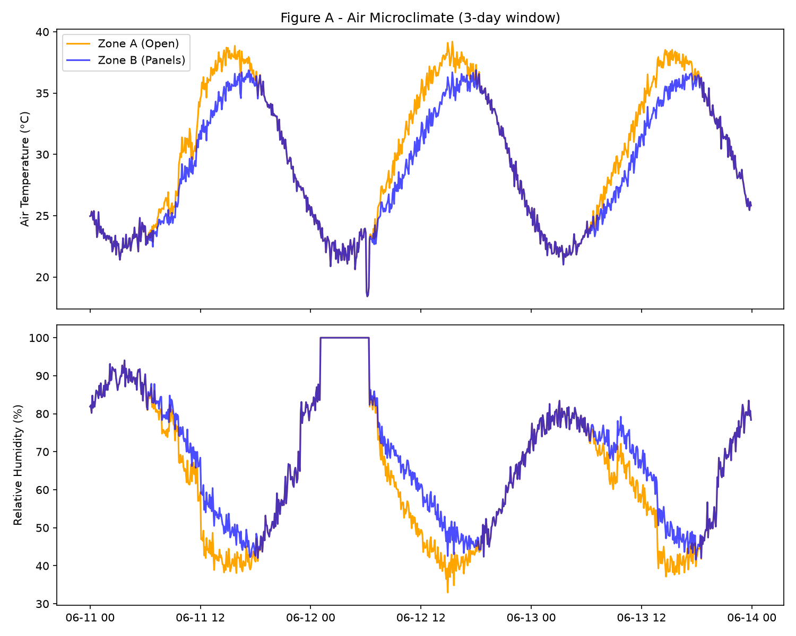
Fig. 1. Temperature and relative humidity comparison between the open-sky control (Zone A) and the agrivoltaic environment (Zone B).
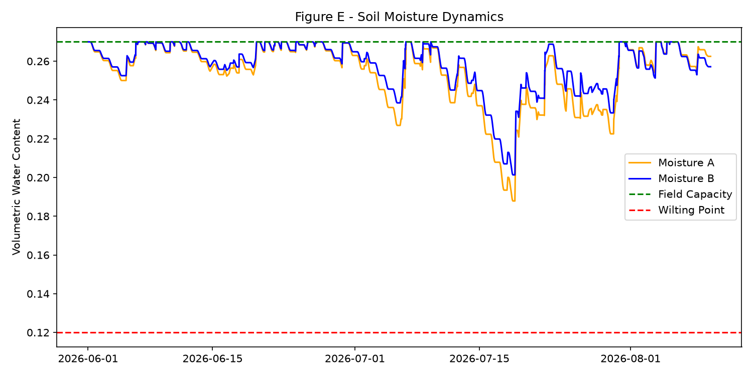
Fig. 3. Field-measured volumetric soil water content variations, explicitly annotated with Field Capacity and Wilting Point bounds.
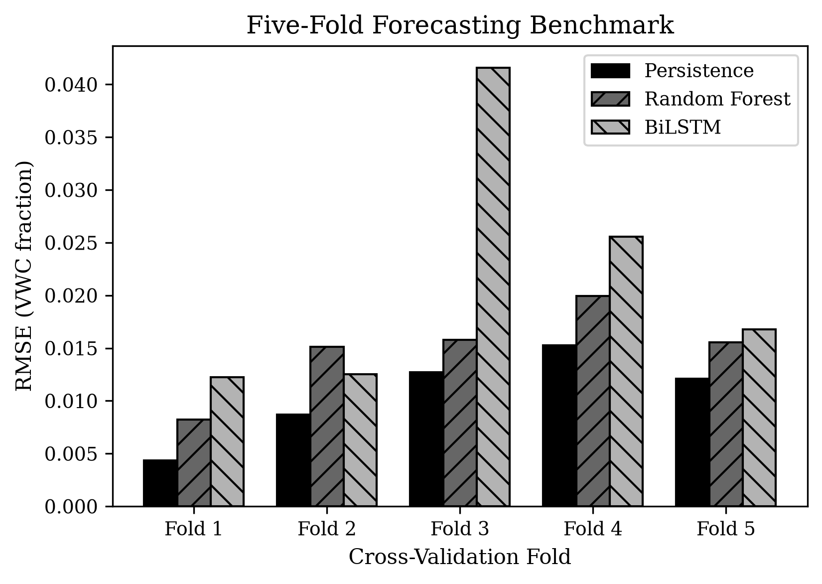
Fig. 4. Fold-wise 24-h soil-moisture forecasting RMSE for Persistence, Random Forest, and BiLSTM across the five rolling-origin validation folds. Values are reported in physical VWC fraction.
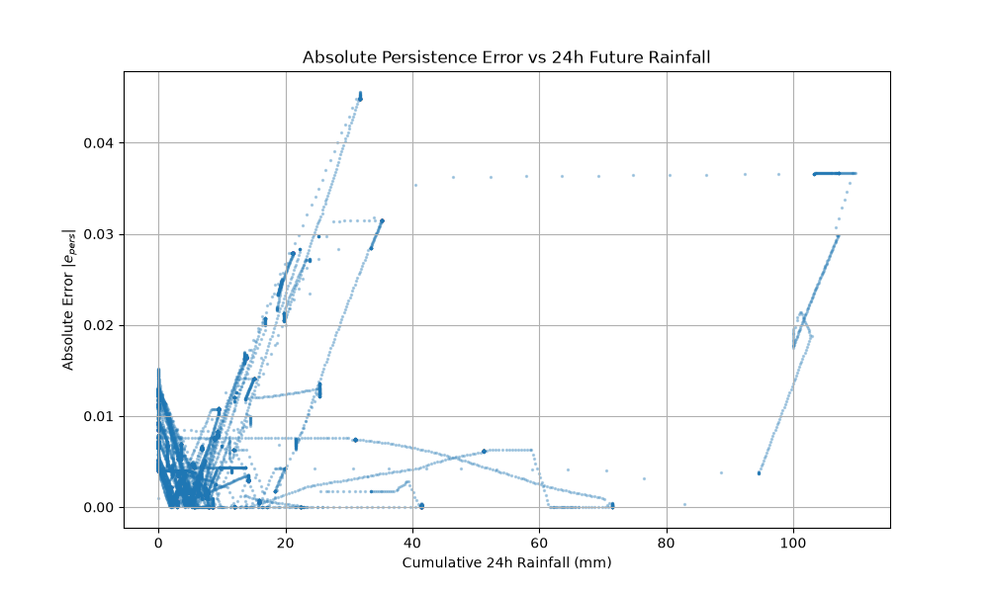
Fig. 5. Absolute and signed persistence forecasting errors plotted as a function of the subsequent 24-h accumulated precipitation.
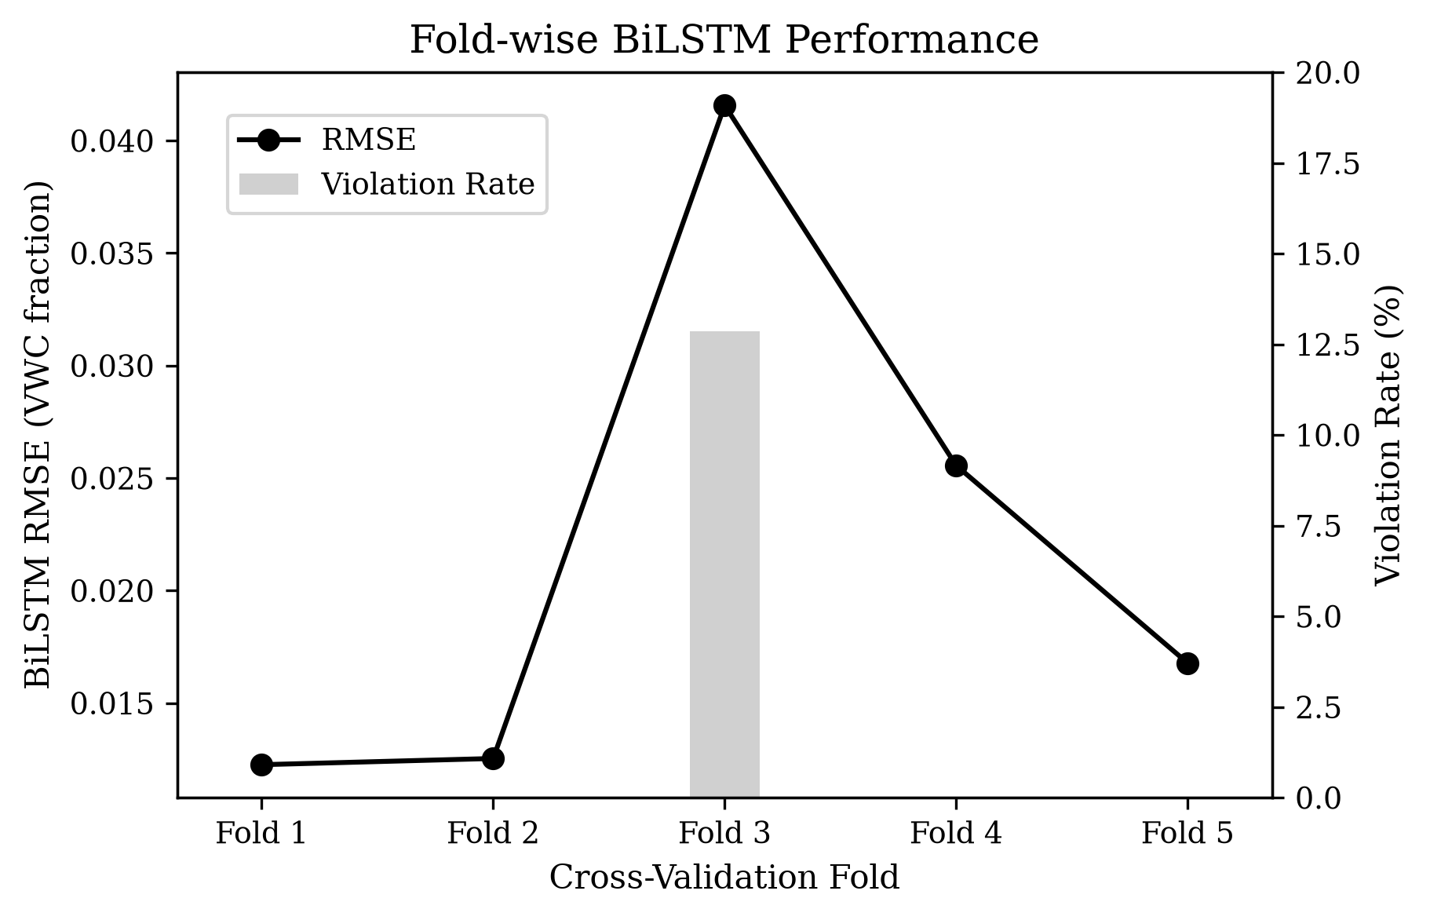
Fig. 6. Fold-wise BiLSTM RMSE and physical-bound violation rate. Fold 3 shows the largest RMSE and the only observed physical-bound violations (12.87%).
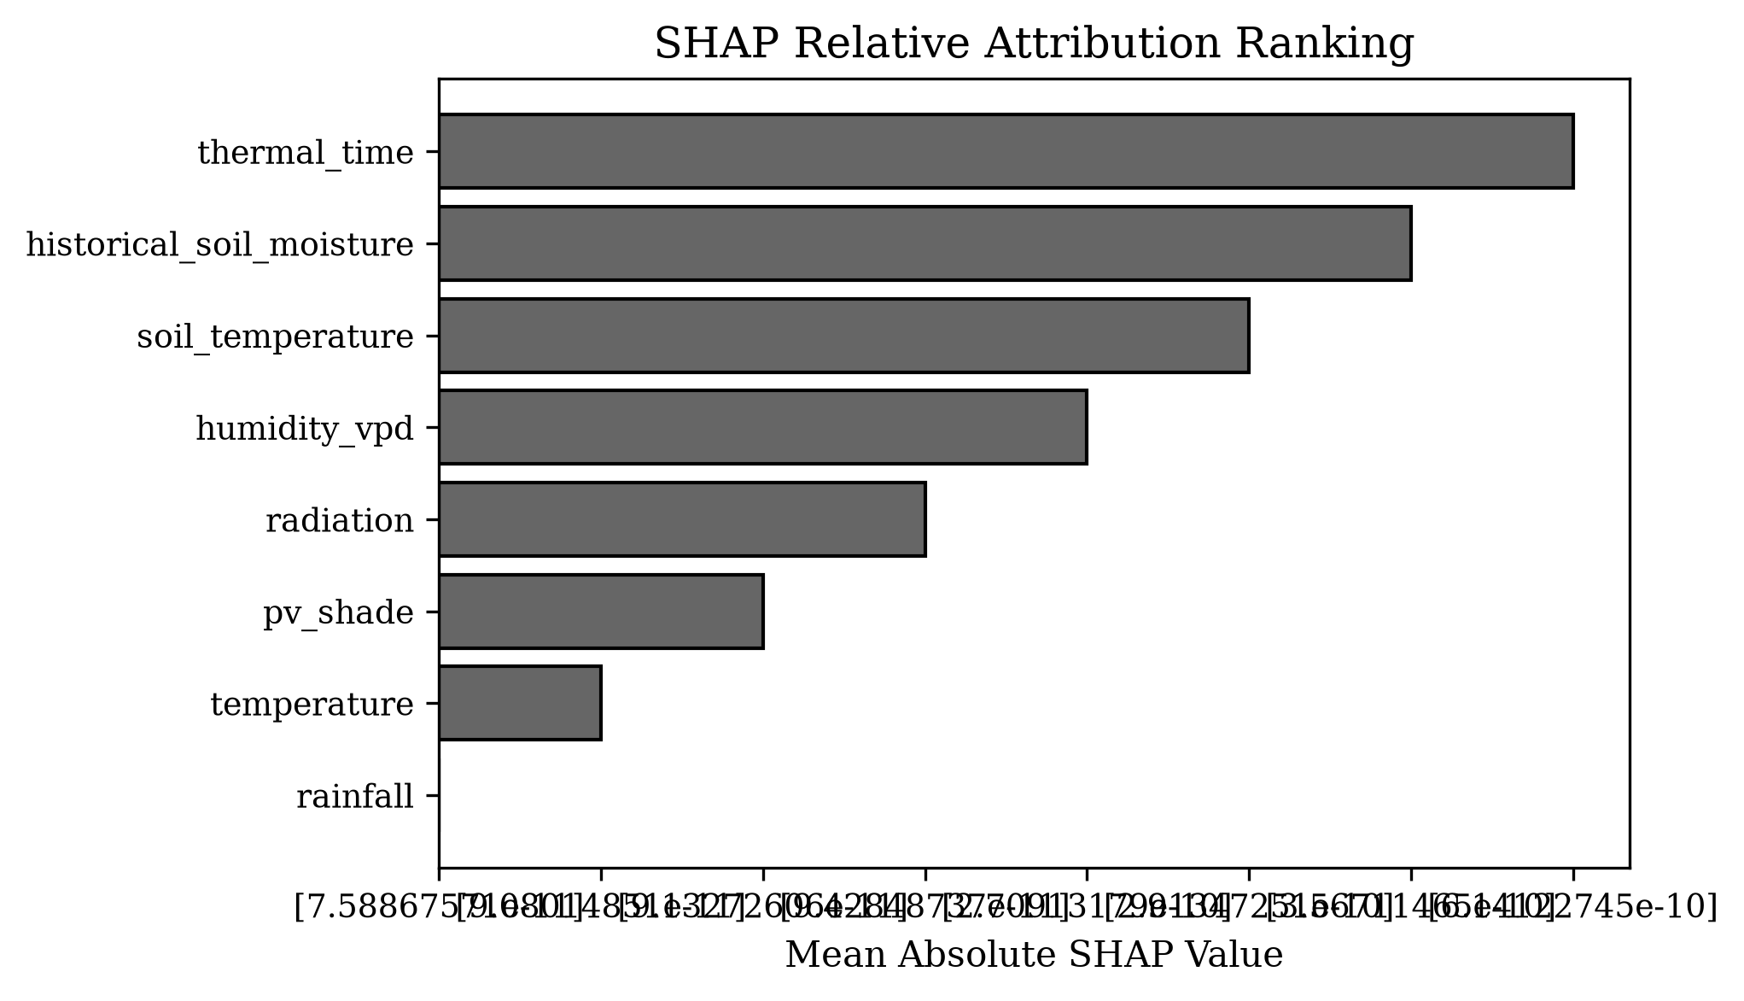
Fig. 7. Mean absolute SHAP attribution aggregated by scientific feature group for the BiLSTM. The ordering represents relative model attribution in normalized output space and does not imply physical causality.
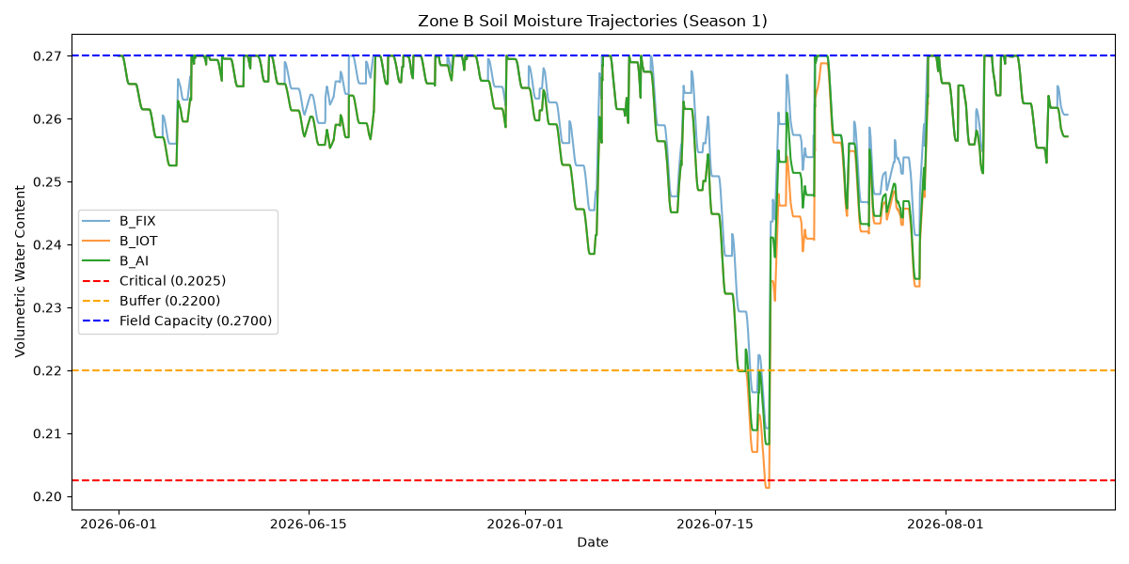
Fig. 8. Field-measured soil-moisture trajectories for a representative paired validation period (B_AI vs B_IOT), explicitly marked with WP, critical, buffer, and FC boundaries.
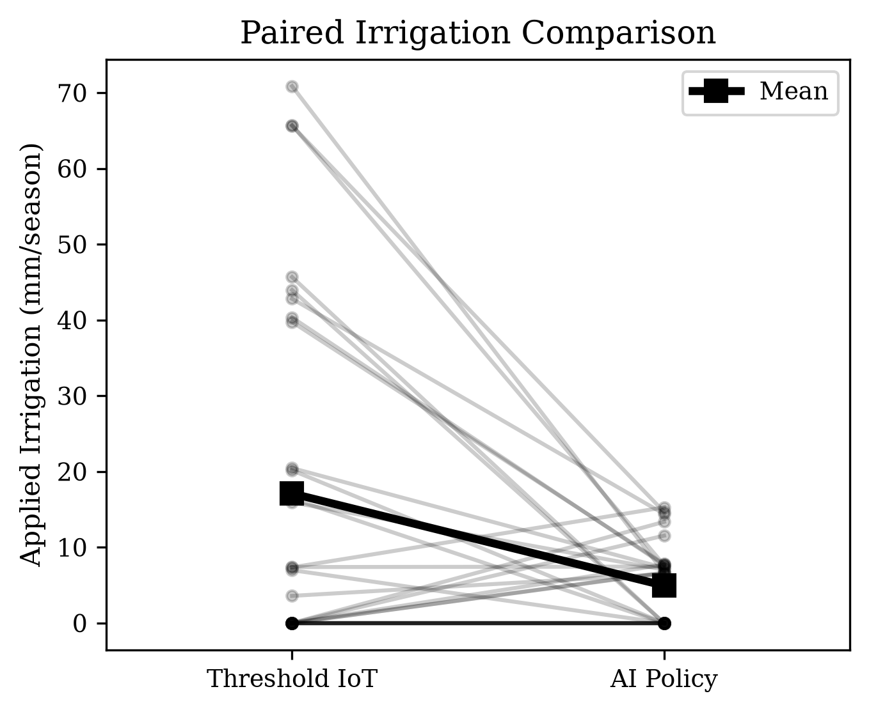
Fig. 9. Paired field comparison of measured applied irrigation totals between the AI policy and the threshold IoT controller.
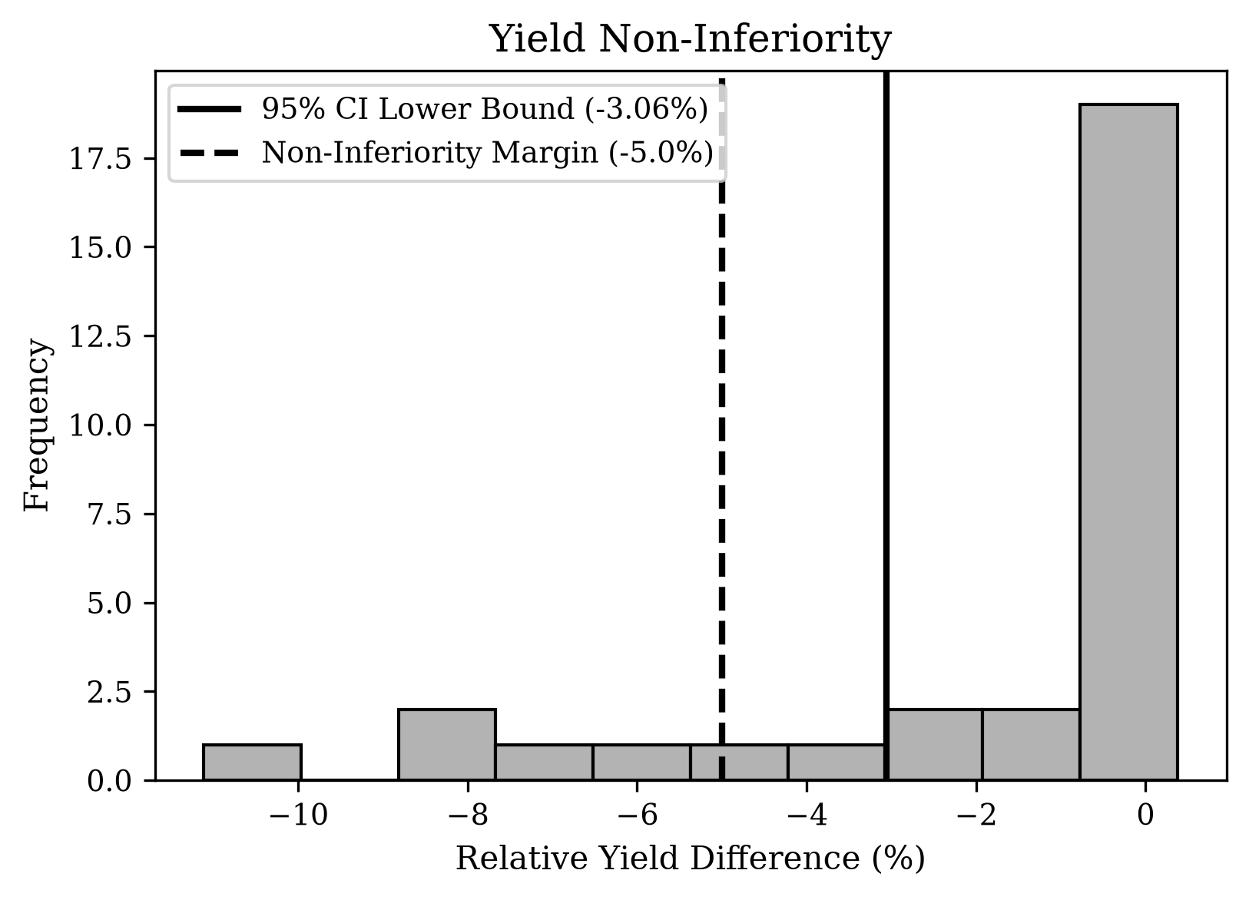
Fig. 10. Distribution of paired relative yield differences between the field AI and threshold IoT policies. The bootstrap confidence interval remains above the pre-specified −5% non-inferiority margin.

