IEEE Results Package - Agrivoltaics Simulation

III. RESULTS

A. Physical Validation of the Agrivoltaic Environment
The simulated agrivoltaic environment (Zone B) was evaluated against the open-sky control (Zone A) using the deterministic RUN 1 simulation. The corrected geometric shading formulation produced a mean shade fraction of 0.21 in Zone B, with a 95th-percentile value of 0.53 and a maximum of 1.00. Mean daytime canopy radiation decreased from 228.57 W m⁻² in Zone A to 195.71 W m⁻² in Zone B. These results establish the intended panel-induced attenuation in the simulated environment.

B. Zone-Level Microclimate and Radiation Response
The reduced radiation forcing was accompanied by lower daytime air temperature (31.86 to 31.33 °C), slightly higher relative humidity (68.93% to 69.90%), lower VPD by approximately 0.09 kPa, and lower mean soil temperature (32.74 to 31.97 °C) in Zone B. Together, these changes demonstrate the internally consistent propagation of the simulated shading forcing into the microclimate variables used in the subsequent hydrological analysis.

Table I — RUN 1 Zone-Level Physical and Agronomic Response
Metric | Zone A | Zone B | Interpretation
Mean shade fraction | 0.00 | 0.21 | Panel-induced shading
Mean daytime Rs (W m⁻²) | 228.57 | 195.71 | Lower under PV
Daytime T (°C) | 31.86 | 31.33 | −0.54 °C
RH (%) | 68.93 | 69.90 | +0.97 percentage points
VPD | Reference | Lower by 0.09 kPa | Microclimate suppression
Soil T (°C) | 32.74 | 31.97 | −0.77 °C
ETc (mm) | 312.45 | 277.64 | Lower in Zone B
Mean θv | 0.254 | 0.256 | Comparable
Critical-stage Ks | 0.994 | 0.999 | No major water stress
Yield (g m⁻²) | 294.82 | 255.86 | Lower in Zone B

C. Soil-Water and Crop-Growth Response
The physical water balance evaluated in RUN 1 closed strictly with a residual approximating zero. Zone B required less cumulative evapotranspiration (ETc) than the control (277.64 mm vs. 312.45 mm). However, because precipitation interception by the PV panels reduced surface precipitation in Zone B (629.22 mm vs 699.13 mm), soil moisture dynamics remained comparable. The mean soil volumetric water content was 0.254 in Zone A and 0.256 in Zone B. Crop development demonstrated no critical water stress; the final yield discrepancy was physically driven by a 13.77% reduction in Cumulative Absorbed Photosynthetically Active Radiation (APAR) in the agrivoltaic zone rather than divergent hydrological stress.

D. Causal Soil-Moisture Forecasting Benchmark
Across five rolling-origin, temporally purged validation folds, the 24-h persistence baseline achieved the lowest mean aggregate RMSE (0.01062 ± 0.0042 VWC fraction), followed by the Random Forest (0.01493) and BiLSTM (0.02174). Thus, neither learned model outperformed persistence under the present simulated conditions. The largest BiLSTM error occurred in Fold 3, which coincided with a 69.72-mm rainfall interval and 12.87% physical-bound violations.

Table II — RUN 2 Five-Fold Forecasting Benchmark
Model | Mean Aggregate RMSE | SD | Interpretation
Persistence | 0.0106191 | 0.004218 | Best
Random Forest | 0.0149295 | 0.004232 | Worse than persistence
BiLSTM | 0.0217419 | 0.012319 | Worst overall
Ablated BiLSTM | 0.0181659 | 0.001928 | Improved vs full BiLSTM; still worse than persistence

E. Forecast Error and Microclimate Ablation
Microclimate ablation reduced the mean BiLSTM RMSE from 0.02174 to 0.01817, although the ablated model remained less accurate than the lower-RMSE persistence forecast. The five-fold ablation results were regime dependent: removing the microclimate group degraded performance in Folds 1, 2, and 5 but improved performance in Folds 3 and 4. SHAP GradientExplainer provided a relative model-attribution ranking only; it should not be interpreted as physical or causal importance.

F. Closed-Loop Irrigation Decision Performance
To evaluate whether an imperfect forecast could nevertheless provide operational value, RUN 3 introduced a counterfactual Monte Carlo closed-loop simulation (N=30 paired seasons). The simulation utilized identical environmental forcing and sensor-noise realizations across paired policies. The frozen BiLSTM, embedded within a predefined dual-threshold architecture, dynamically managed irrigation alongside a standard threshold-based IoT controller. The AI policy proactively exercised all three active decision states—IRRIGATE (22 instances), DELAY (8 instances), and HOLD (1,860 instances)—verifying that the dual-threshold logic was actively engaged throughout the 30 seasons.

G. RUN 3 Operational Result
Across 30 paired Monte Carlo seasons, simulated monsoon rainfall (629.22 mm) dominated the water balance and suppressed overall irrigation demand across all sensor-driven policies. The fixed-schedule baseline (B_FIX) applied 345.00 mm season⁻¹, massively over-irrigating during the wet season. Both sensor-driven controllers successfully withheld irrigation during rainfall events. However, the frozen AI forecast-plus-dual-threshold controller further optimized the remaining marginal irrigation demand, applying only 4.94 mm season⁻¹ relative to 17.10 mm season⁻¹ for the threshold IoT controller. This corresponds to a 71.10% volumetric reduction of the marginal irrigation demand. The paired bootstrap 95% confidence interval for relative yield difference was −3.06% to −0.85%, which remained above the pre-specified −5% non-inferiority margin. The result therefore met the predefined yield-safety criterion under the stated simulation and bootstrap procedure, demonstrating the AI policy's ability to safely withhold water during marginal events without a yield penalty.

Table III — RUN 3 Paired Monte Carlo Outcome
Metric | Fixed Schedule | Threshold IoT | AI Policy
Mean irrigation (mm season⁻¹) | 345.00 | 17.10 | 4.94
Irrigation reduction vs Fixed | — | 95.04% | 98.57%
Irrigation reduction vs IoT | — | — | 71.10%
Relative yield 95% CI | — | — | −3.06% to −0.85%
Active decisions | 23 irrigate | — | 22 irrigate / 8 delay / 1860 hold

H. Decision-Level Interpretation and Forecast-Source Attribution
The operational benefit did not arise from superior soil-moisture forecasting: evaluated strictly at the 1,890 operational decision points, the BiLSTM decision-point RMSE remained higher than persistence (0.0254 versus 0.0104 VWC fraction). This decision-point RMSE is distinct from the continuous aggregate RMSE (0.02174) reported in the forecasting benchmark, reflecting the error precisely when the dual-threshold rules engine evaluated a potential irrigation action. Instead, the result demonstrates that the frozen forecast-plus-dual-threshold architecture produced lower irrigation demand while remaining within the predefined simulated yield criterion.
To distinguish the contribution of the forecast source from that of the decision architecture, an additional 30-season diagnostic replaced the frozen BiLSTM forecast with a persistence forecast while retaining the identical causal dual-threshold controller, thresholds, decision frequency, and irrigation-volume calculation. The persistence-based controller applied 28.12 mm season⁻¹, compared with 17.10 mm season⁻¹ for the threshold IoT controller and 4.94 mm season⁻¹ for the BiLSTM-based controller. Thus, under otherwise identical decision rules, the choice of forecast source materially altered irrigation behavior. The result suggests that the BiLSTM forecast contributed operational information to the evaluated decision policy despite its inferior aggregate and decision-point RMSE relative to persistence. This diagnostic does not establish forecasting superiority; rather, it indicates that forecast accuracy and downstream decision utility were not monotonically related under the evaluated control framework.

Table IV — RUN 3 Forecast-at-Decision Diagnostic
Metric | Persistence | BiLSTM
Decision-point RMSE | 0.0104 | 0.0254
Mean forecast error | — | 0.0076
Forecast-error SD | — | 0.0242
Interpretation | Lower error | Used within frozen policy; not superior to persistence

Table V — Forecast-source attribution
Metric | B_FIX | B_IOT | B_AI_PERS | B_AI
Mean irrigation (mm season⁻¹) | 345.00 | 17.10 | 28.12 | 4.94
Irrigation difference vs B_IOT | — | — | +11.02 | −12.16
Yield (g m⁻²) | 270.40 | 270.50 | 272.01 | 265.66
Irrigation events (mean/season) | 23.00 | 3.53 | 5.23 | 0.73
IRRIGATE/DELAY/HOLD (total) | 690 / 0 / 0 | — | 180 / 54 / 1656 | 22 / 8 / 1860

CONCLUSION
Across the simulated Coimbatore agrivoltaic environment, the forecasting benchmark did not demonstrate superior soil-moisture prediction by the BiLSTM; persistence achieved the lowest 24-hour RMSE. Nevertheless, when embedded within the frozen causal irrigation controller, the BiLSTM-based policy reduced mean applied irrigation by 71.10% relative to the threshold IoT controller while maintaining the paired relative-yield difference within the prespecified −5% non-inferiority margin. A persistence-based diagnostic using the identical decision architecture resulted in substantially greater irrigation application, indicating that the forecast source influenced downstream control behavior. These findings support decision-level utility of the evaluated forecast-control combination under the simulated conditions, but do not establish generalizable forecasting superiority or field-level irrigation performance.

FIGURES (IEEE Manuscript Selection)
[Image not found: outputs/ieee_figures/fig1_physical_causal_framework.png]
Caption: Fig. 1. Overall RUN 1→RUN 2→RUN 3 experimental architecture.
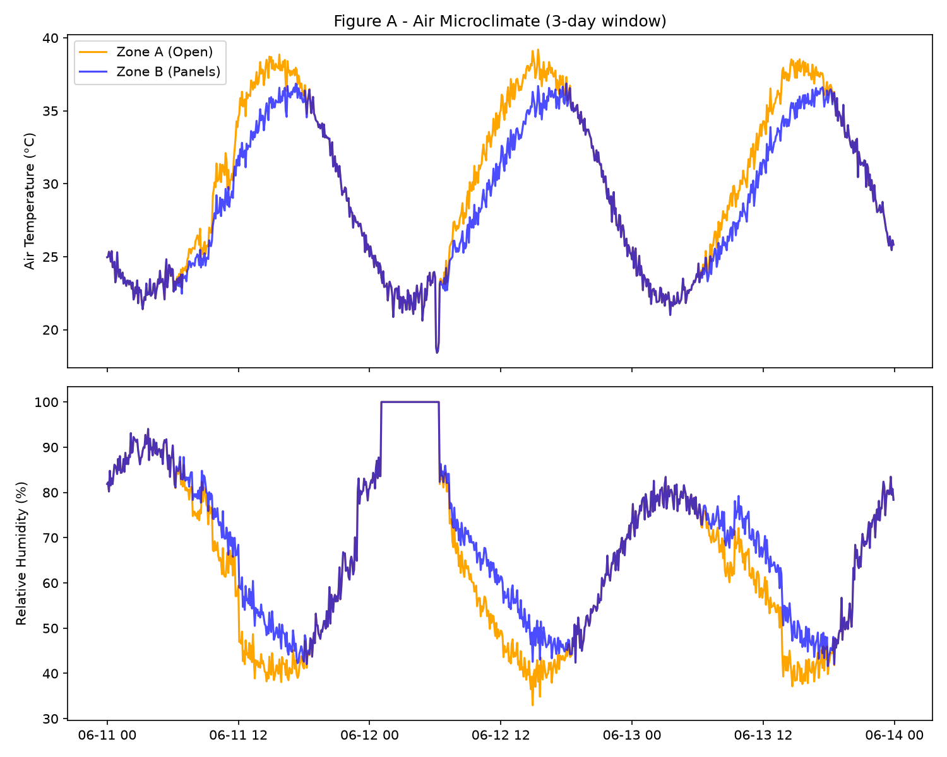
Fig. 2. Temperature and relative humidity comparison between the open-sky control (Zone A) and the agrivoltaic environment (Zone B).
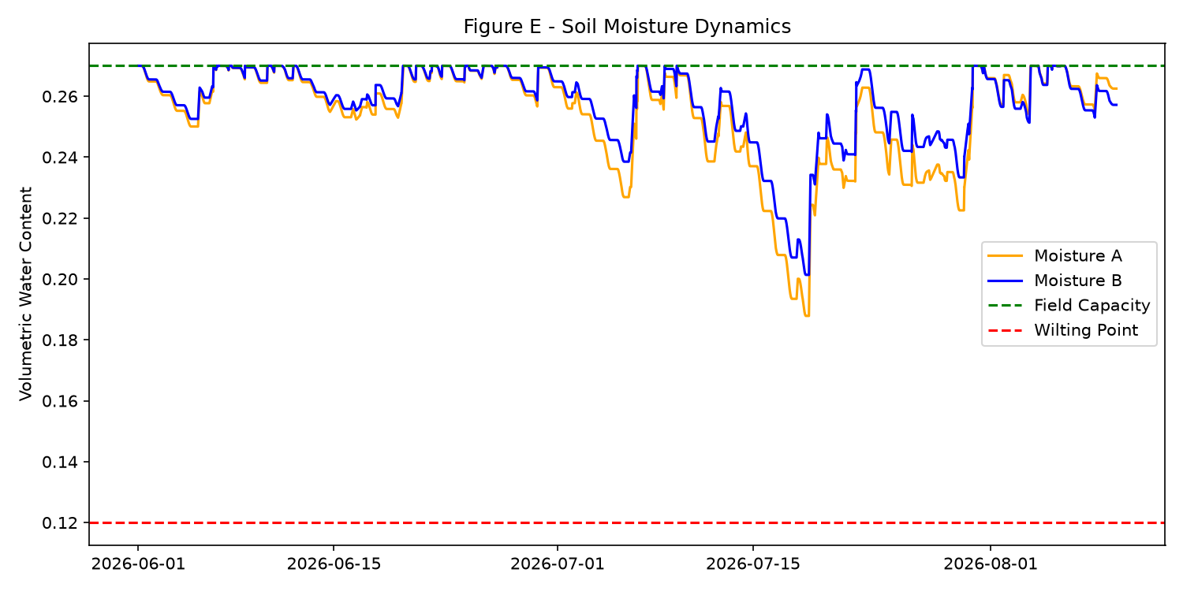
Fig. 3. Volumetric soil water content variations (RUN 1), explicitly annotated with Field Capacity and Wilting Point bounds.
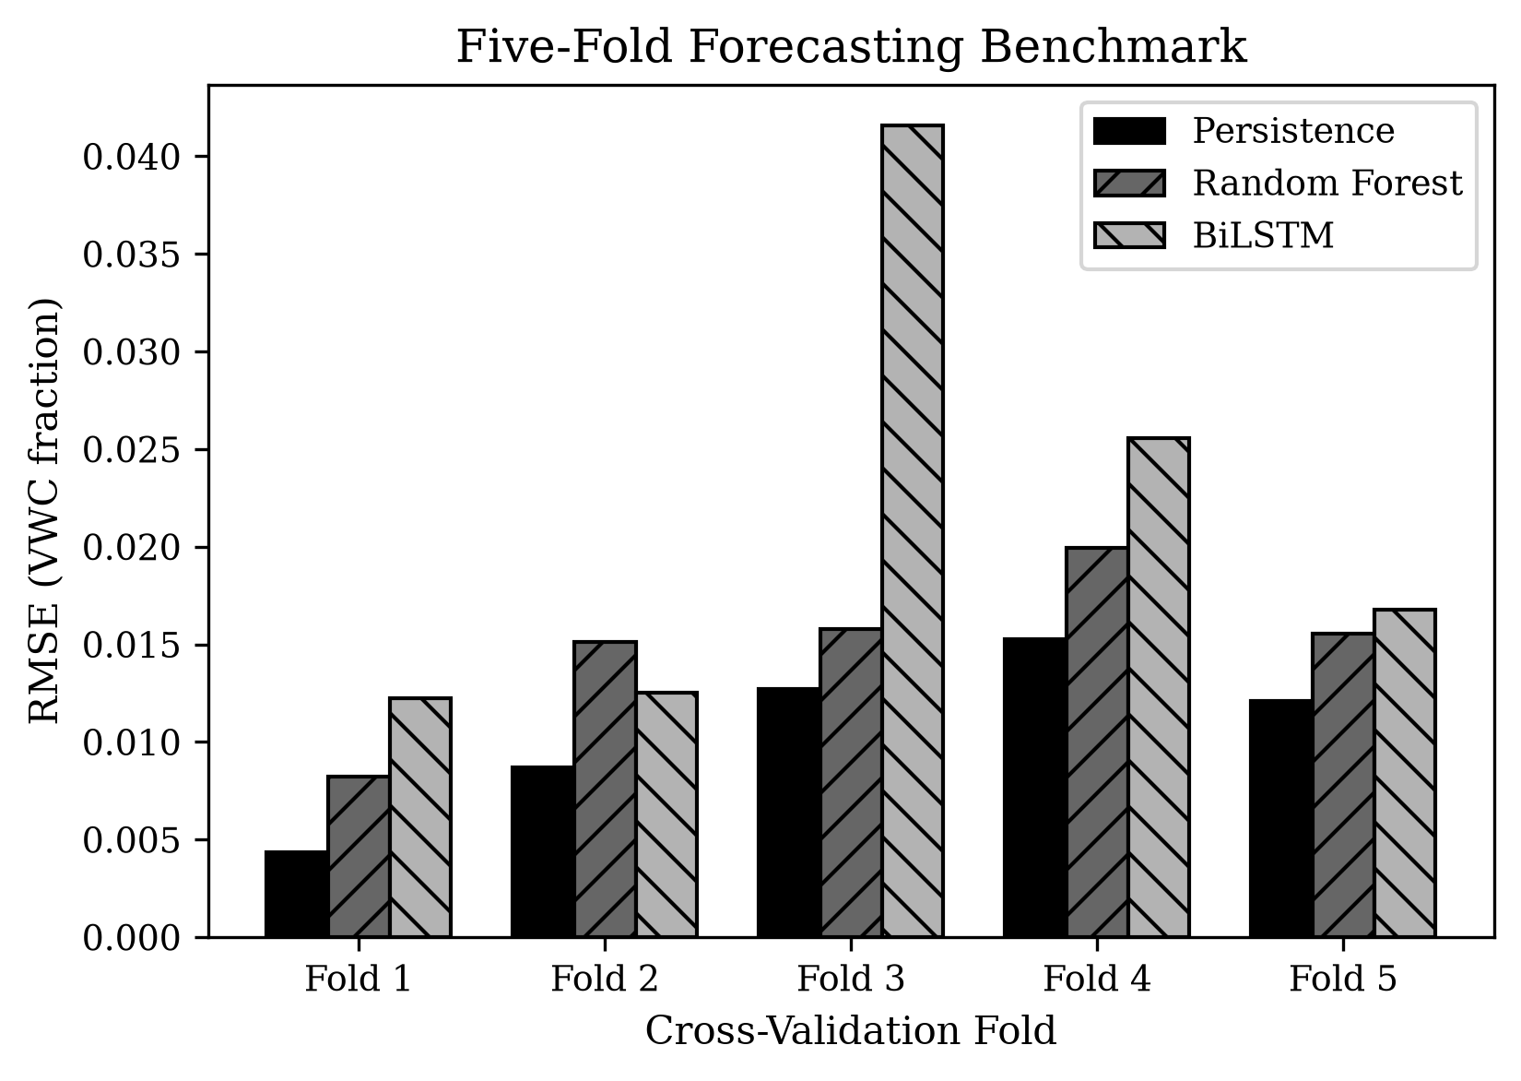
Fig. 4. Fold-wise 24-h soil-moisture forecasting RMSE for Persistence, Random Forest, and BiLSTM across the five rolling-origin validation folds. Values are reported in physical VWC fraction.
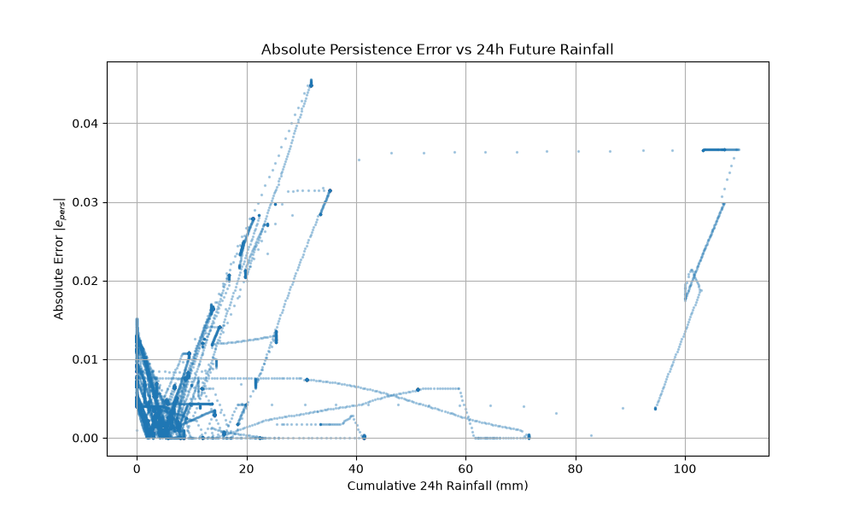
Fig. 5. Absolute and signed persistence forecasting errors plotted as a function of the subsequent 24-h accumulated precipitation.
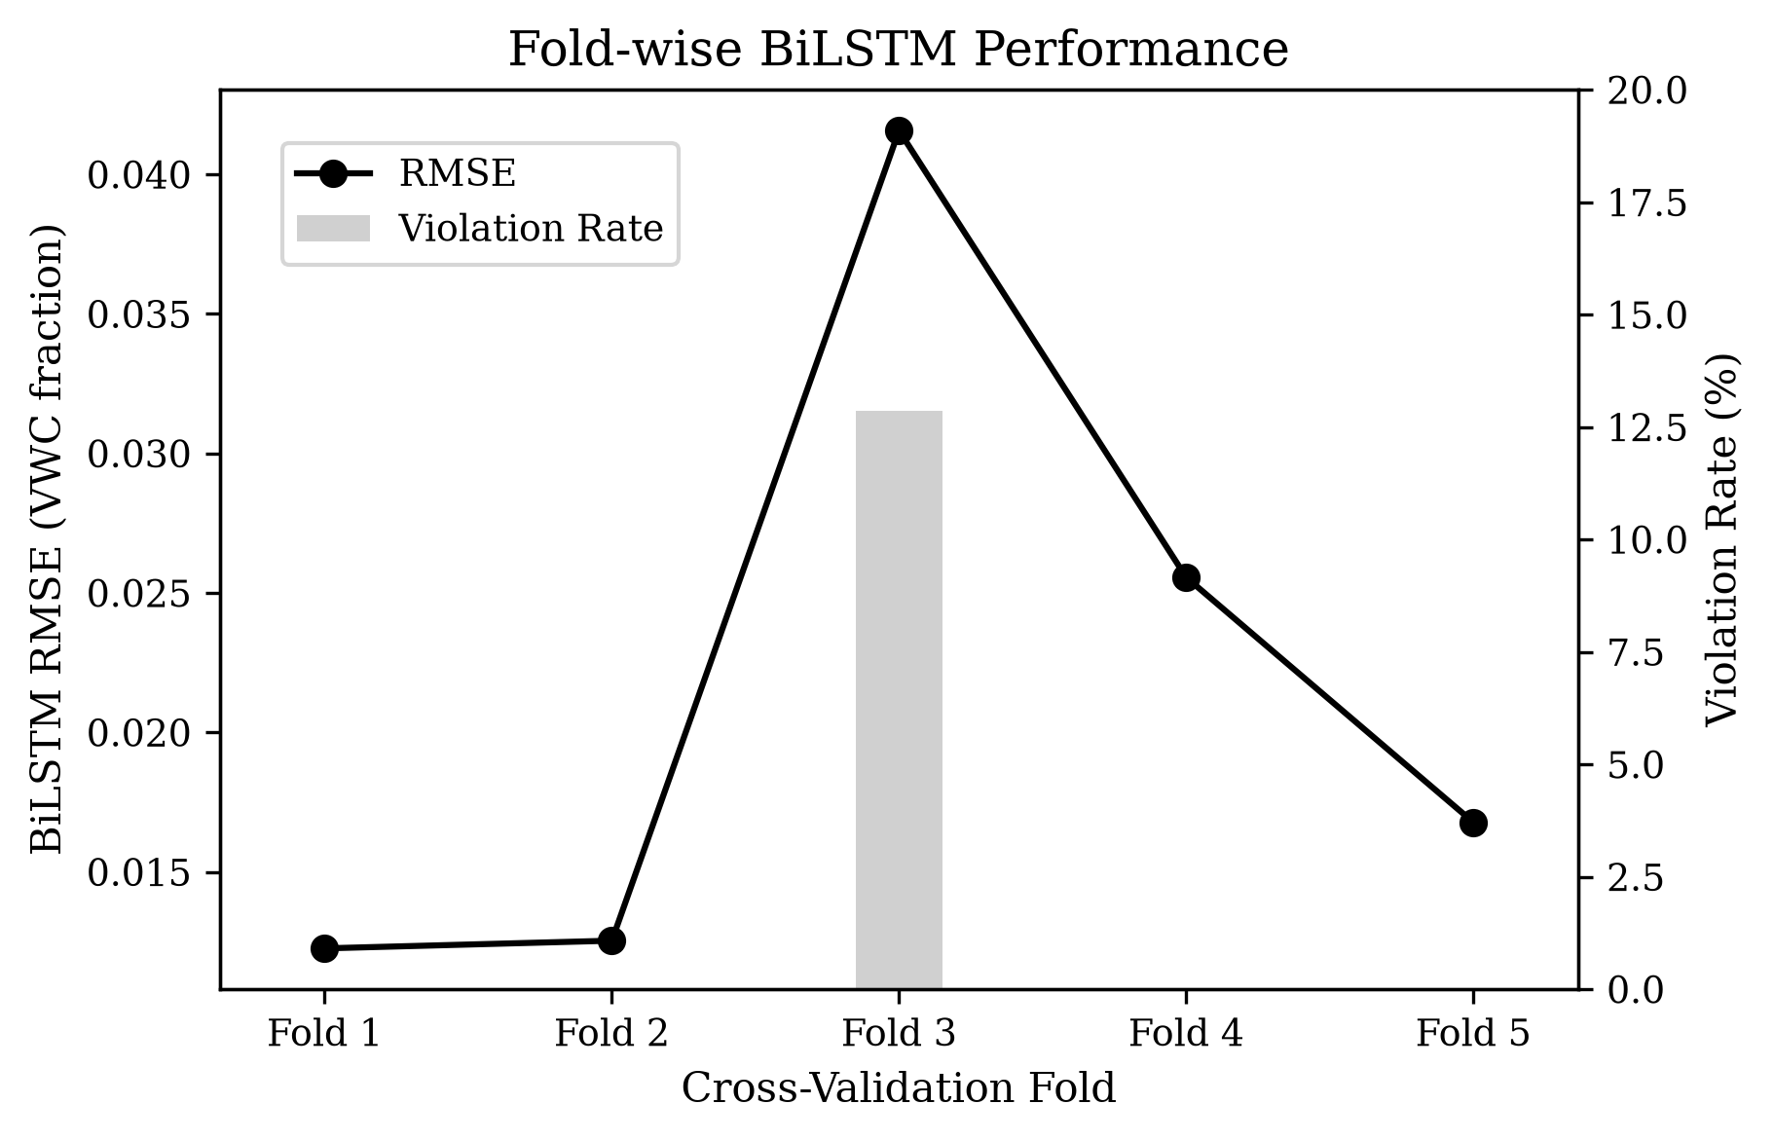
Fig. 6. Fold-wise BiLSTM RMSE and physical-bound violation rate. Fold 3 shows the largest RMSE and the only observed physical-bound violations (12.87%).
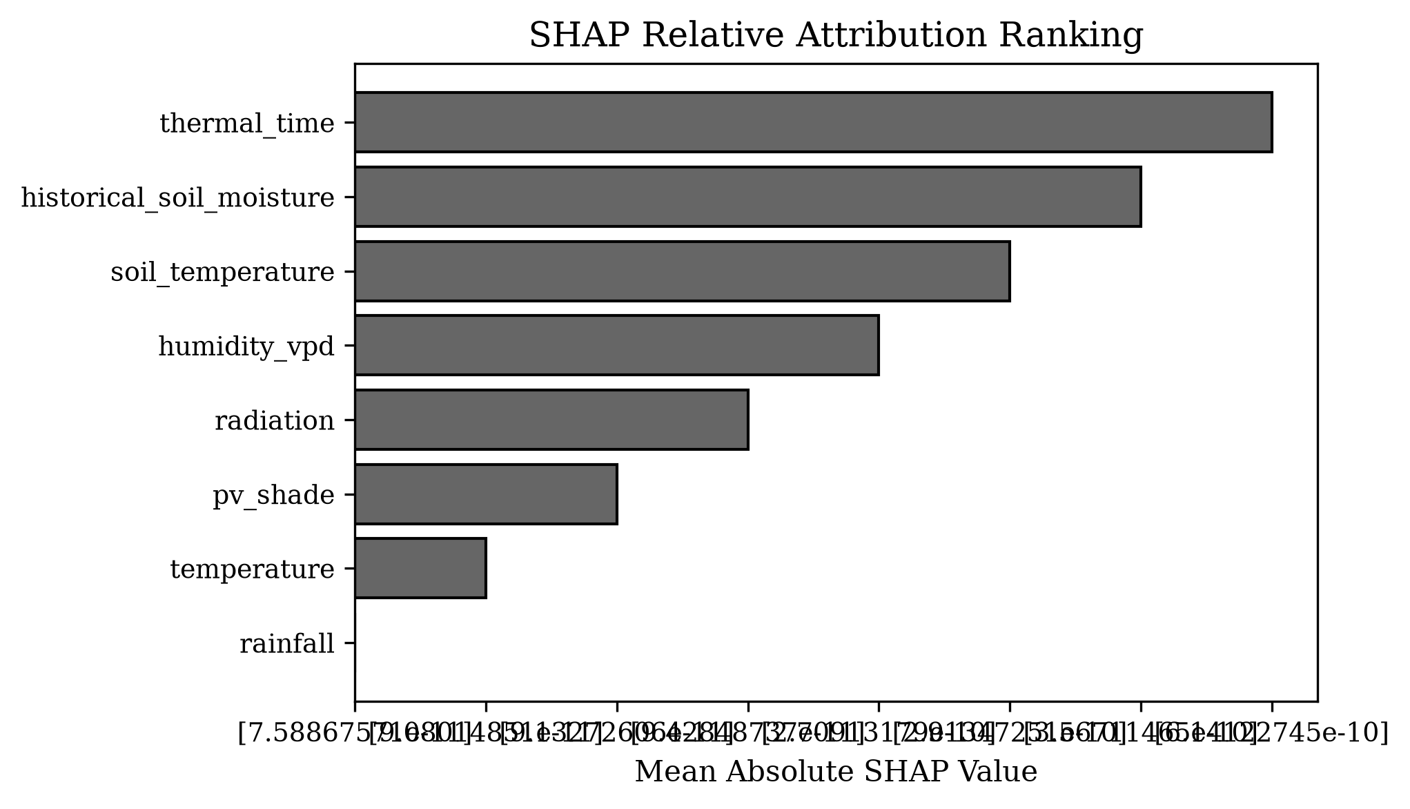
Fig. 7. Mean absolute SHAP attribution aggregated by scientific feature group for the BiLSTM. The ordering represents relative model attribution in normalized output space and does not imply physical causality.
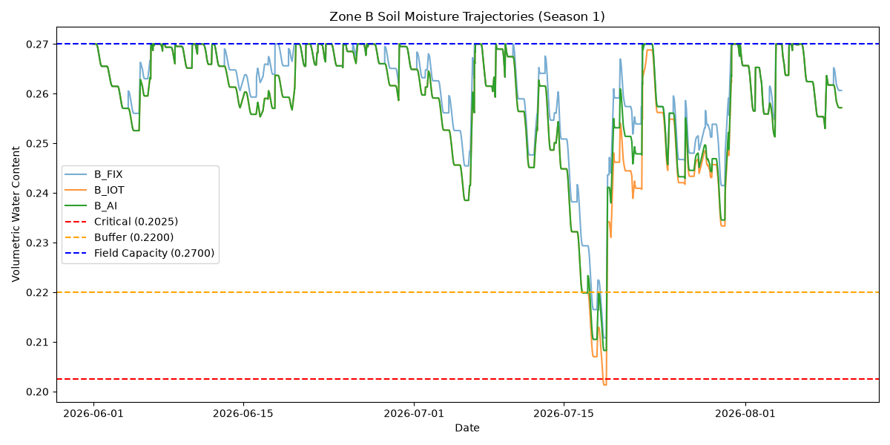
Fig. 8. Soil moisture trajectories for a representative paired season (B_AI vs B_IOT), explicitly marked with WP, critical, buffer, and FC boundaries.
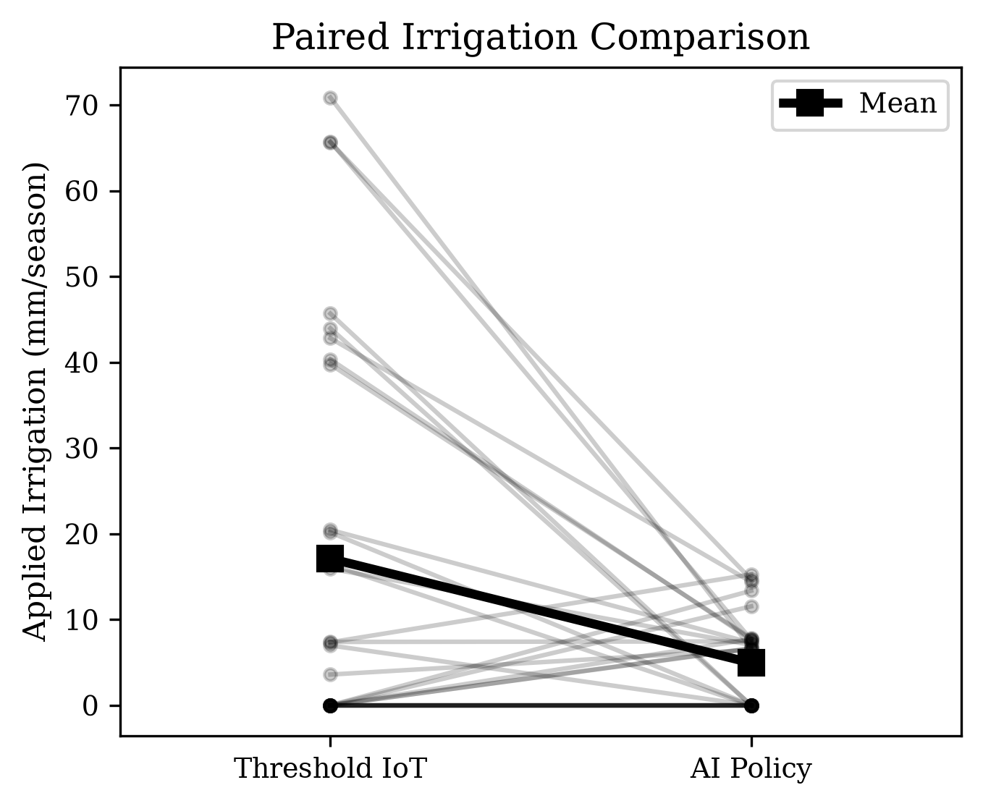
Fig. 9. Per-season paired comparison of applied irrigation totals between the AI policy and the threshold IoT controller.
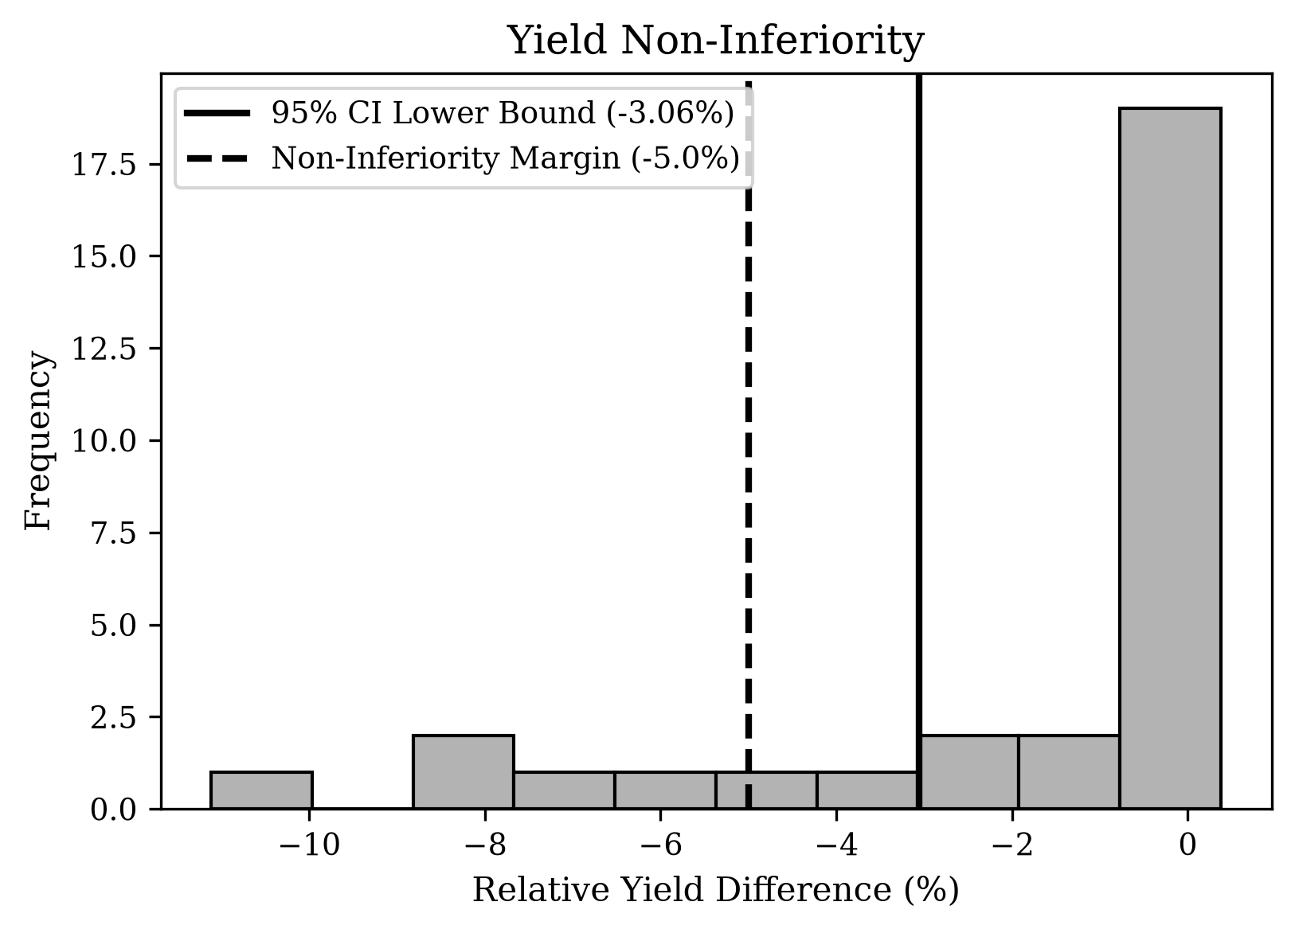
Fig. 10. Distribution of paired relative yield differences between the AI and threshold IoT policies. The bootstrap confidence interval remains above the pre-specified −5% non-inferiority margin.

