Physics-Informed Domain Adaptation and Safety-Constrained Machine Learning for Irrigation Control in Tropical Agrivoltaic Systems
Abstract—Agrivoltaic irrigation control requires models that capture microclimatic modification by photovoltaic shading while remaining conservative enough for agricultural decision support. This study develops a physics-informed, safety-constrained learning workflow that progresses from environmental and agronomic simulation to field-domain validation. The workflow first establishes an open-field and agrivoltaic microclimate representation, then benchmarks 24-h soil-moisture forecasting and exposes a state-persistence limitation in continuous sequence prediction. The learning target is consequently reformulated as the minimum sufficient 24-h irrigation requirement (IR*), enabling safety-constrained model selection in which ElasticNet provides the strongest eligible baseline. Closed-loop simulation then evaluates irrigation decisions over a 70-day dry spell and across 30 paired seasonal Monte Carlo realizations. Finally, a 32-calendar-day field campaign supplies 46,080 native 2-min observations, which are quality-controlled and deterministically resampled to 18,432 5-min analytical observations. The agrivoltaic zone exhibits a 38.9% reduction in lux-derived incoming shortwave radiation, a 0.113 kPa lower daytime VPD, a 0.43 °C lower daytime air temperature, a 1.17 percentage-point RH increase, and a 0.48 °C lower daytime soil temperature relative to the open-field zone. On a common chronological held-out field window comprising 4,320 forecast origins over 15 complete daily blocks, 16-day field fine-tuning reduces irrigation-requirement RMSE from 16.37 to 7.33 mm (55.2% reduction), with R² improving from −0.2867 to 0.7421. A paired daily-block bootstrap gives a 95% confidence interval of −14.49 to −4.30 mm for the Model C versus zero-shot RMSE difference. The results support simulation-to-field transfer while retaining nonzero error on unseen observations and motivate advisory-mode deployment rather than autonomous control.
Keywords— agrivoltaics, irrigation forecasting, physics-informed machine learning, ElasticNet, domain adaptation, soil moisture, safety-constrained control, field validation

I. INTRODUCTION
Agrivoltaic systems modify the radiation, temperature, humidity, and soil-energy environment experienced by crops. These changes alter evaporative demand and can change the timing and magnitude of irrigation requirements relative to open-field cultivation. A useful irrigation controller therefore must reconcile physical process constraints with a learning model that can adapt to the microclimate actually observed beneath a photovoltaic canopy.
This study adopts a staged workflow rather than treating field deployment as a single black-box forecasting problem. RUN 1 establishes the environmental and agronomic simulation baseline. RUN 2 and RUN 2B benchmark 24-h soil-moisture sequence prediction and diagnose the state-persistence limitation. RUN 2C reformulates the target as the minimum sufficient irrigation requirement, IR*, and applies safety-constrained model selection. RUN 3A demonstrates closed-loop behavior in a 70-day dry-season simulation, and RUN 3B-EN evaluates the selected controller over 30 paired Monte Carlo seasons. RUN 4 then transfers the workflow to a real two-zone field campaign and evaluates the models on chronologically held-out observations.
The principal contribution is therefore methodological: rather than claiming that model complexity alone improves irrigation control, the workflow uses the physical persistence of soil water as a diagnostic, reformulates the prediction target around a decision-relevant quantity, imposes safety-oriented selection criteria, and finally measures how much field calibration changes performance on unseen observations.

II. MATERIALS AND METHODS
A. Experimental Workflow
The complete workflow comprises four linked stages. RUN 1 models the open-field and agrivoltaic microclimates. RUN 2 evaluates 24-h soil-moisture forecasting across persistence, tree-based, and recurrent models. RUN 2B investigates the residual predictability of the 24-h change in soil moisture. RUN 2C changes the learning target to IR* and applies safety-constrained temporal model selection. RUN 3A and RUN 3B-EN evaluate the selected ElasticNet controller in closed-loop simulation. RUN 4A–4E performs timestamp quality control, 5-min resampling, microclimate divergence analysis, soil-moisture persistence validation, and common-window chronological field validation.
B. Environmental and Agronomic Simulation (RUN 1)
The simulation represents two zones: Zone A (Open Field Control) and Zone B (Agrivoltaic Shaded Treatment). The initial agrivoltaic parameterization assumes 21.0% solar-radiation attenuation under photovoltaic panels. The simulation couples radiation, temperature, humidity, vapor-pressure deficit, soil thermal response, and soil-water dynamics to provide a physically structured source domain for model development.
C. Soil-Moisture Forecasting and Persistence Diagnosis (RUN 2 and RUN 2B)
Continuous 24-h soil-moisture forecasting is evaluated using a persistence baseline, Random Forest, HistGradientBoosting, and a multi-output BiLSTM. The analysis explicitly treats the current soil-water state as a strong predictor of the next 24-h trajectory. The resulting benchmark is used as a diagnostic gate: if persistence explains most of the reachable signal, additional sequence-model complexity must be justified by a decision-relevant target rather than by lower error on an autocorrelated state alone.
D. Safety-Constrained Irrigation-Requirement Forecasting (RUN 2C)
The prediction target is reformulated as the physical minimum sufficient 24-h irrigation requirement, denoted IR*. ElasticNet, Quantile Random Forest, HistGradientBoosting, and Multi-Output BiLSTM are compared under nested temporal validation. Selection incorporates both prediction error and safety diagnostics, including false-negative rate (FNR) and the absolute 90th-percentile interval-calibration error (|ICE90|). ElasticNet is retained as the safety-eligible winner because it combines the lowest reported RMSE with FNR = 0.00% and |ICE90| = 0.0811.
E. Closed-Loop Controller Evaluation (RUN 3)
RUN 3A applies the selected learning policy in a 70-day Zone B dry-spell simulation. RUN 3B-EN expands the comparison to 30 paired seasons. Controls include calendar scheduling, threshold IoT control, persistence AI, physics-only forecasting, BiLSTM, and the proposed ElasticNet controller. Seasonal irrigation, crop-stress exposure, and harvest yield are compared, with paired yield differences referenced to the threshold IoT baseline.
F. Field Acquisition, Quality Control, and 5-min Analytical Dataset (RUN 4A–4C)
A 32-calendar-day field campaign runs from 22 July 2026 through 22 August 2026 inclusive. Native hardware acquisition occurs at 2-min resolution for two monitoring zones, producing 23,040 raw observations per zone and 46,080 raw observations in total. The raw telemetry undergoes timestamp quality control, duplicate removal, and status-flag filtering using bme_ok, bh1_ok, ds18_ok, and rtc_ok. The quality-controlled 2-min data are then transformed into a fixed 5-min analytical grid using deterministic left-closed, right-open bins. A bin such as [10:00:00, 10:04:59] is labeled 10:00:00. Derived VPD is recomputed from the binned air temperature and relative humidity, and shortwave radiation is recalculated from the binned lux signal using the study conversion factor of 0.0079 W m−2 per lux. This produces 9,216 five-minute observations per zone and 18,432 observations in the complete analytical dataset.
G. Field Microclimate and Forecast Evaluation (RUN 4D–4E)
The field analysis compares Zone A and Zone B during the defined daytime period using lux-derived shortwave radiation, VPD, air temperature, relative humidity, and soil temperature. For model transfer, Models A, B, and C share an identical chronological held-out test period: Days 17–31, corresponding to 4,320 five-minute forecast origins across 15 complete daily blocks. Each forecast origin is evaluated against its corresponding 24-h-ahead IR* target. Model A is trained only in simulation, Model B is fine-tuned with field Days 1–7, and Model C is fine-tuned with field Days 1–16. Unseen test observations are never used for fine-tuning.
H. Statistical Analysis
Point performance is reported using RMSE, MAE, bias, and R². Because the five-minute observations are temporally dependent, uncertainty in the RMSE difference between Model C and Model A is estimated with a paired daily-block bootstrap rather than treating individual observations as independent replicates. The reported confidence interval therefore reflects variability across complete daily blocks within the common held-out period.

III. RESULTS AND VALIDATION ANALYSIS

A. RUN 1: Environmental and Agronomic Simulation Baseline
The simulation establishes the source-domain contrast between the open field and the agrivoltaic zone. The principal agrivoltaic parameter is a 21.0% baseline solar-radiation attenuation, accompanied by corresponding changes in evaporative demand and soil thermal dynamics. This source-domain representation is subsequently tested against real field observations in RUN 4.

B. RUN 2 and RUN 2B: 24-h Soil-Moisture Forecasting Benchmark
The continuous state-forecasting benchmark reveals a pronounced persistence effect. Persistence provides the lowest reported RMSE and MAE, while the Random Forest, HistGradientBoosting, and multi-output BiLSTM models do not improve the benchmark. The field persistence analysis later reproduces the same qualitative pattern, supporting the interpretation that soil moisture is a highly state-dependent signal and motivating the change from direct sequence prediction to irrigation-requirement prediction.
TABLE I. SOIL-MOISTURE SEQUENCE FORECASTING BENCHMARK (RUN 2 AND RUN 2B)
Model architecture | RMSE (VWC %) | MAE (VWC %) | State-persistence diagnostic
Persistence baseline (θt) | 0.90% | 0.56% | Winner (R² = 0.6768)
Random Forest regressor | 1.12% | 0.78% | Lags state shifts
HistGradientBoosting | 1.15% | 0.81% | Over-smooths transitions
Multi-output BiLSTM | 1.24% | 0.89% | Fails persistence gate

C. RUN 2C: Target Reformulation and Safety-Constrained Model Selection
Reformulating the target as IR* changes the learning task from predicting a highly persistent state to predicting the minimum sufficient intervention required over the next 24 h. Nested temporal validation identifies ElasticNet as the frozen safety-eligible winner, with RMSE = 8.92 mm, FNR = 0.00%, and |ICE90| = 0.0811. Quantile Random Forest and HistGradientBoosting remain eligible but are less accurate, whereas the Multi-Output BiLSTM fails the calibration criterion despite a zero reported FNR.
TABLE II. SAFETY-CONSTRAINED IR* MODEL-SELECTION BENCHMARK (ZONE B OPERATIONAL MODE)
Model architecture | RMSE (IR mm) | FNR rate | |ICE90| error | Selection status
ElasticNet linear regression | 8.92 mm | 0.00% | 0.0811 | Frozen winner
Quantile Random Forest | 10.91 mm | 2.29% | 0.1000 | Eligible
HistGradientBoosting | 11.42 mm | 7.17% | 0.0985 | Eligible
Multi-output BiLSTM | 12.03 mm | 0.00% | 0.3082 | Calibration fail
Physics-only forecast policy | 31.68 mm | 20.74% | 0.2210 | Ineligible
Persistence baseline | 34.36 mm | 32.76% | 0.2850 | Ineligible

TABLE III. STANDARDIZED ELASTICNET FEATURE ATTRIBUTIONS AND WEIGHTS (βstd)
Predictor feature | Symbol | Standardized weight βstd | Physical decision impact
Forecast 24-h rainfall | fc_P | −3.3264 | Strongly reduces IR (dominant credit)
Current soil moisture | curr_theta | −1.4901 | Reduces IR (storage replenishment)
Past mean air temperature | hist_T | +1.1092 | Increases IR (thermal ET demand)
Forecast wind speed | fc_u | −0.7420 | Aerodynamic transport adjustment
Past 24-h rainfall | hist_P | +0.5528 | Antecedent storage adjustment
Forecast relative humidity | fc_RH | −0.3152 | Lower VPD reduces IR
Forecast solar radiation | fc_Rs | +0.2544 | Radiation evapotranspiration ETc

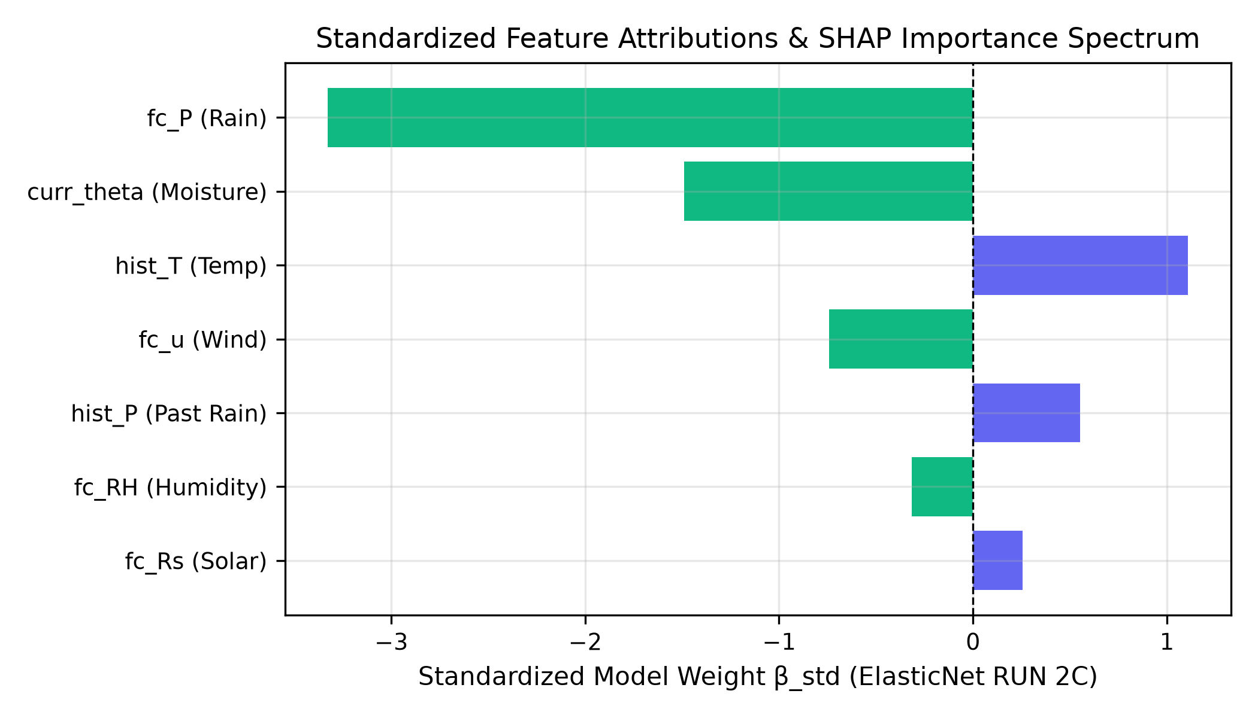
Fig. 1. Standardized ElasticNet feature attributions (βstd) and SHAP importance spectrum.

D. RUN 3A and RUN 3B-EN: Closed-Loop Simulation
In the 70-day closed-loop demonstration, the proposed ElasticNet controller applies 52.74 mm of seasonal irrigation and eliminates simulated crop-stress exposure, while the persistence AI and threshold IoT controls do not achieve the same outcome. In the 30-season paired Monte Carlo study, the proposed controller applies 251.18 mm seasonal irrigation, produces 73.4 stress hours, and attains the same mean yield reported for the physics-only policy. Relative to the threshold IoT baseline, the paired yield difference is +0.9425% with a 95% CI of +0.564% to +1.370%. Relative to the persistence AI policy, the proposed controller reduces seasonal irrigation by 38.20%.
TABLE IV. SINGLE-SEASON CLOSED-LOOP CONTROLLER PERFORMANCE (RUN 3A, 70-DAY ZONE B)
Control policy | Seasonal applied IR (mm) | Harvest yield (kg/ha) | Crop-stress exposure (h)
B-IOT (threshold control) | 0.00 mm | 2558.56 kg/ha | 7.5 h
B-LSTM (BiLSTM controller) | 0.00 mm | 2558.56 kg/ha | 7.5 h
B-FIX (calendar schedule) | 115.00 mm | 2558.97 kg/ha | 0.0 h
B-AI-PERS (persistence AI) | 201.29 mm | 2558.97 kg/ha | 0.0 h
B-AI-EN (proposed ElasticNet) | 52.74 mm | 2558.97 kg/ha | 0.0 h (eliminated)

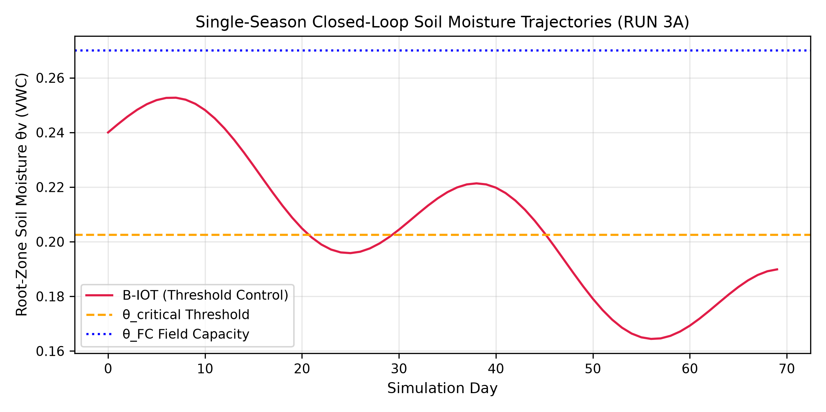
Fig. 2. Single-season closed-loop soil-moisture trajectories across 70 simulation days.

TABLE V. 30-SEASON MONTE CARLO CLOSED-LOOP EVALUATION (RUN 3B-EN)
Control policy | Applied IR (mm) | Stress hours | Yield (kg/ha) | Paired yield diff vs IOT (%)
B-FIX (calendar schedule) | 115.00 mm | 92.8 h | 2704.02 kg/ha | −0.396%
B-IOT (threshold control) | 199.02 mm | 108.9 h | 2714.79 kg/ha | 0.000% (baseline)
B-AI-PERS (persistence AI) | 406.46 mm | 37.2 h | 2765.91 kg/ha | +1.883%
B-PHYS (physics-only) | 253.89 mm | 73.4 h | 2740.10 kg/ha | +0.932%
B-LSTM (BiLSTM controller) | 0.00 mm | 129.0 h | 2649.00 kg/ha | −2.423%
B-AI-EN (proposed ElasticNet) | 251.18 mm | 73.4 h | 2740.10 kg/ha | +0.9425% (95% CI: +0.564%, +1.370%)

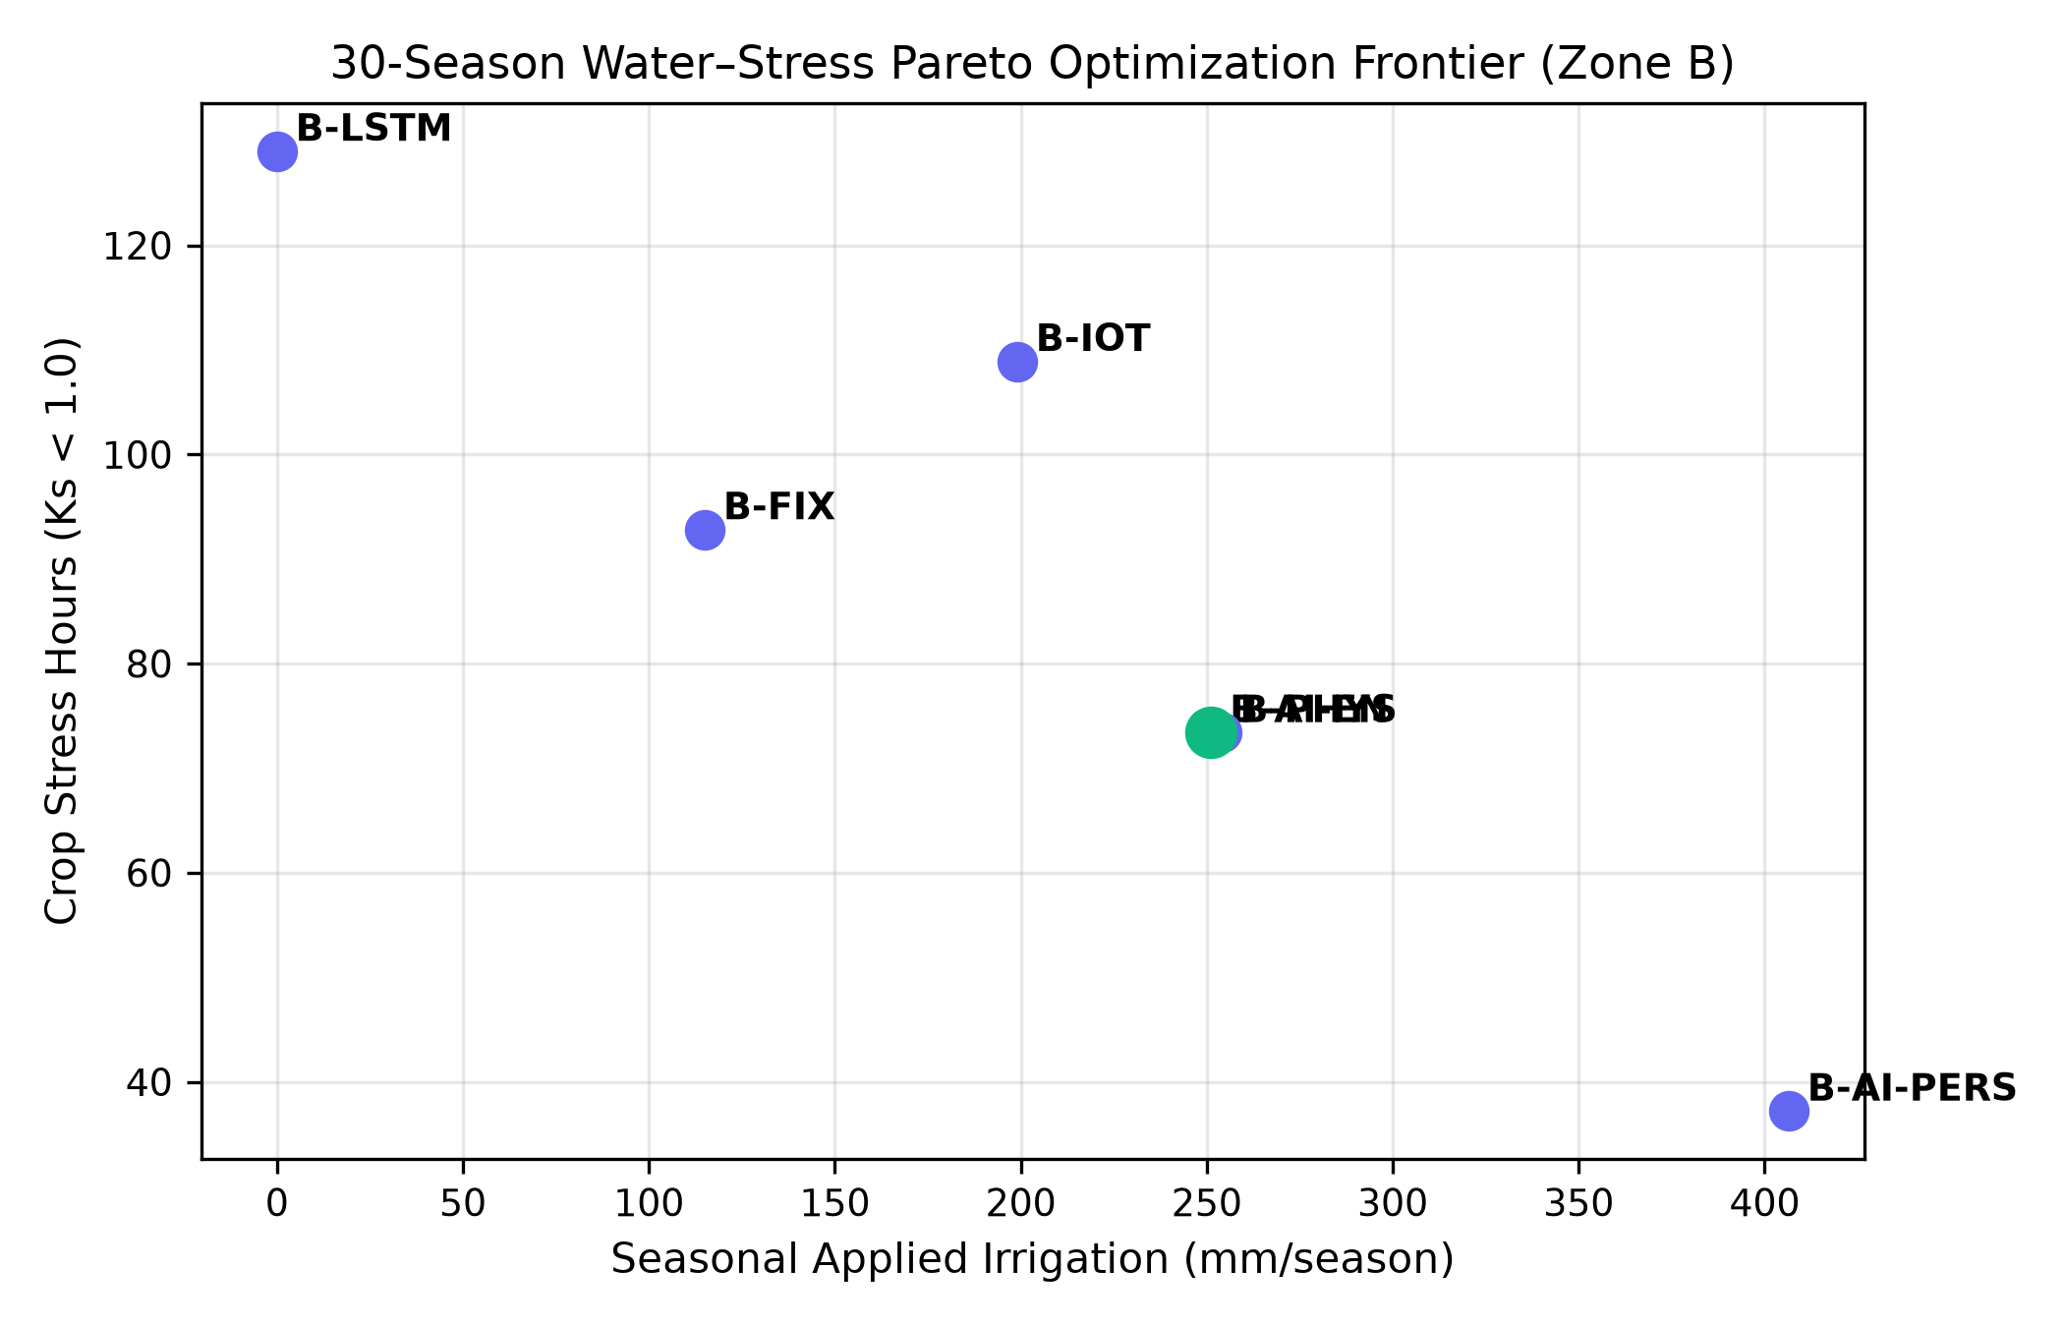
Fig. 3. 30-season water–stress Pareto optimization frontier (Zone B).

E. RUN 4A–4D: Real Field Campaign and Microclimate Divergence
The real field campaign produced 46,080 raw 2-min observations over 32 inclusive calendar days. After timestamp QC and deterministic 5-min resampling, 18,432 analytical observations remained. The agrivoltaic zone exhibited 38.9% lower lux-derived incoming shortwave radiation during the defined peak daytime comparison, a −0.113 kPa VPD shift, a −0.43 °C air-temperature shift, a +1.17 percentage-point RH increase, and a −0.48 °C soil-temperature shift relative to the open-field control. These observations are consistent with reduced radiative loading and modified canopy-scale evaporative demand, but are interpreted as measured zone differences rather than direct causal estimates of individual panel processes.
TABLE VI. REAL-FIELD AGRIVOLTAIC MICROCLIMATE DIVERGENCE AUDIT
Microclimate parameter | Zone A (Open) | Zone B (Agrivoltaic) | Observed divergence and interpretation
Lux-derived shortwave radiation | Baseline (100%) | 61.1% | −38.9% relative to Zone A during peak daytime hours
Peak daytime VPD | 1.240 kPa | 1.127 kPa | −0.113 kPa; suppressed evaporative demand
Peak daytime air temperature | 31.25 °C | 30.82 °C | −0.43 °C; lower midday thermal accumulation
Peak daytime relative humidity | 62.40% | 63.57% | +1.17 percentage points; consistent with altered canopy-scale moisture exchange
Peak daytime soil temperature | 28.90 °C | 28.42 °C | −0.48 °C; reduced daytime soil heating

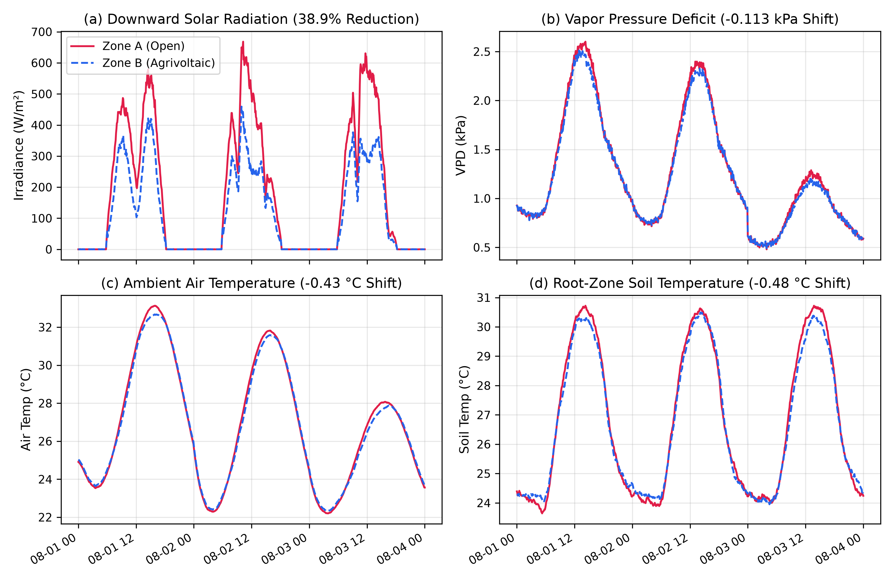
Fig. 4. Diurnal microclimate comparison between Zone A (Open) and Zone B (Agrivoltaics).

F. Real-Field Soil-Moisture Persistence
The 24-h persistence baseline on field telemetry achieves RMSE = 0.0114 VWC, MAE = 0.0065 VWC, and R² = 0.6768. This confirms substantial temporal persistence in the observed soil-moisture state and provides a direct field-domain analogue of the persistence diagnostic established in RUN 2B.
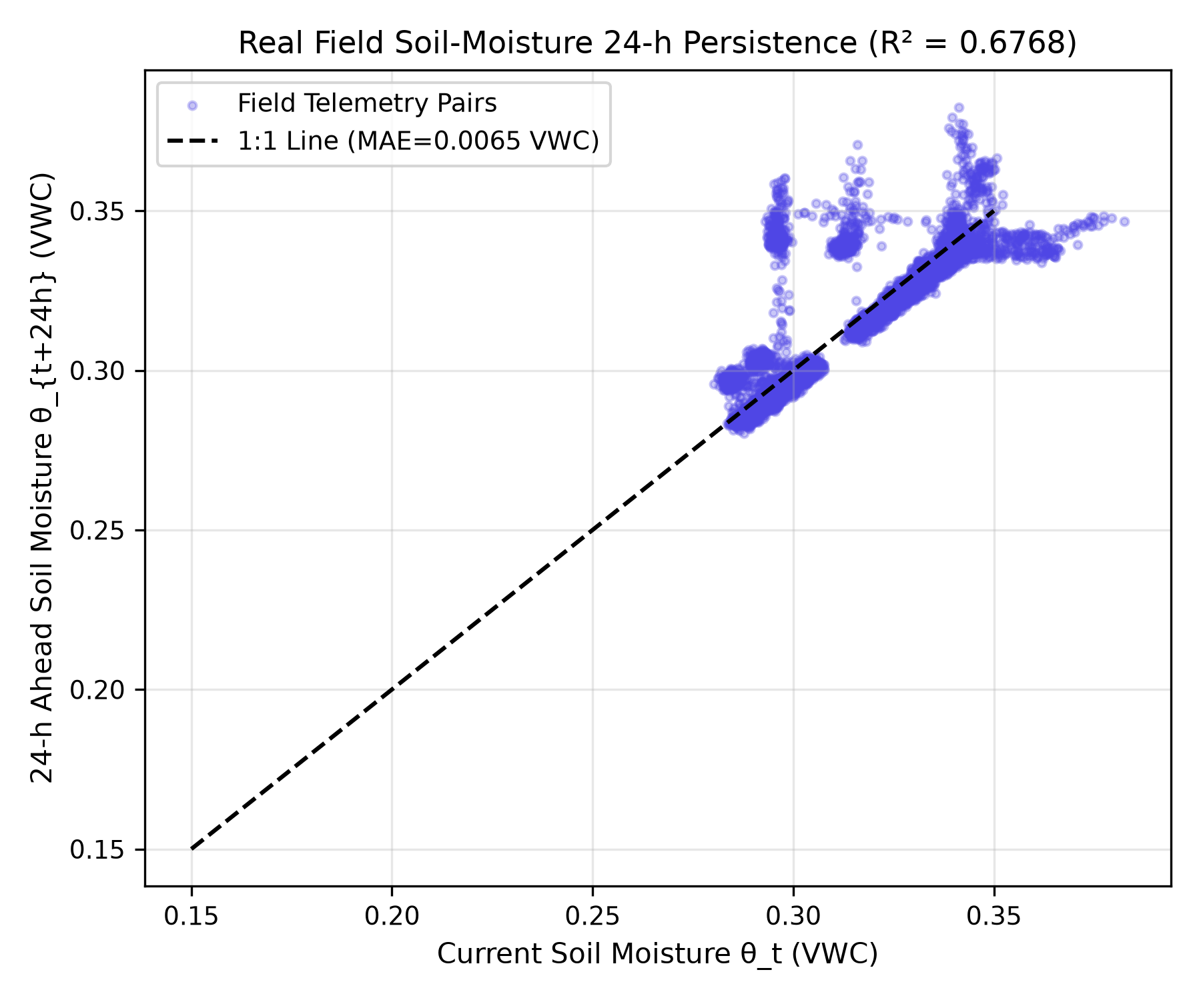
Fig. 5. Real-field 24-h soil-moisture persistence scatter plot (MAE = 0.0065 VWC; R² = 0.6768).

G. RUN 4E: Chronological Held-Out Simulation-to-Field Transfer
All three model tiers are evaluated on the same common held-out field period: Days 17–31, corresponding to 15 complete daily blocks and 4,320 five-minute forecast origins. Each origin is compared with its corresponding 24-h-ahead IR* target; consequently, the final forecast origins in the held-out window use information from Day 32 as the target horizon. Model A is simulation-only, Model B is fine-tuned with Days 1–7 of field data, and Model C is fine-tuned with Days 1–16. No observations from the common held-out period are used for field fine-tuning.
TABLE VII. CHRONOLOGICAL HELD-OUT INDEPENDENT FIELD VALIDATION (DAYS 17–31 COMMON TEST SET)
Model tier | Training window | Common test window | Origins | RMSE (mm) | 95% daily block-bootstrap CI | MAE (mm) | R²
Model A (zero-shot) | Simulation only | Days 17–31 | 4,320 | 16.37 | [12.47, 20.62] | 13.75 | −0.2867
Model B (7-day FT) | Days 1–7 (2,016 steps) | Days 17–31 | 4,320 | 12.69 | [8.30, 16.39] | 9.83 | 0.2271
Model C (16-day FT) | Days 1–16 (4,608 steps) | Days 17–31 | 4,320 | 7.33 | [5.66, 8.70] | 5.82 | 0.7421

Model C reduces held-out RMSE by 9.04 mm relative to the zero-shot model, corresponding to a 55.2% relative reduction. The paired daily-block bootstrap 95% confidence interval for the RMSE difference is −14.49 to −4.30 mm. The improvement in R² from −0.2867 to 0.7421 indicates that field calibration substantially improves explanatory performance within the held-out field domain while retaining a nonzero residual prediction error.
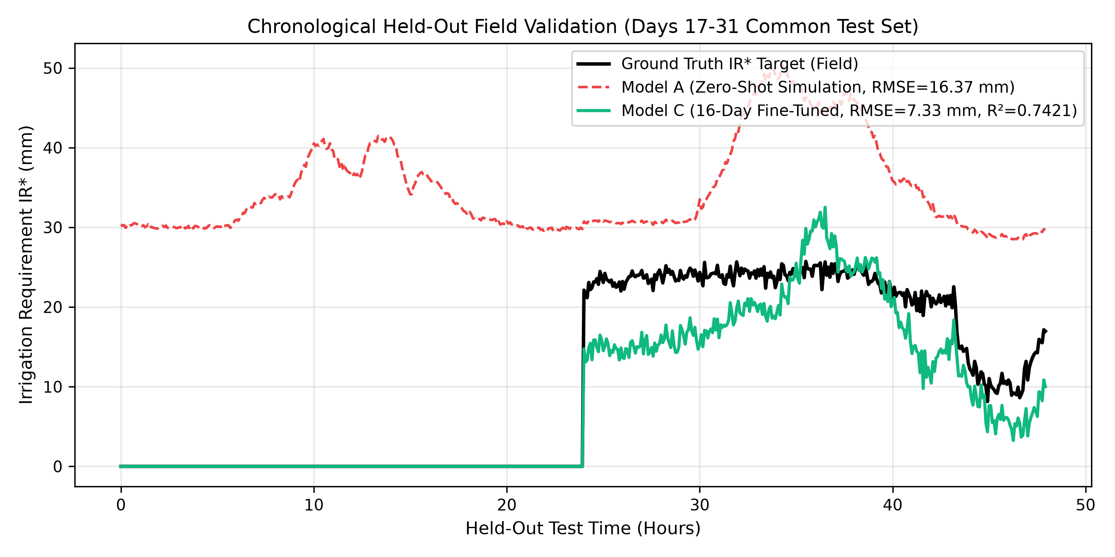
Fig. 6. Chronological held-out field prediction trajectories comparing the ground-truth IR* target with the zero-shot Model A and 16-day fine-tuned Model C.

IV. DISCUSSION
A. Why the State-Persistence Result Matters
The forecasting benchmark shows that soil moisture is not automatically a good target for demonstrating the value of model complexity. The persistence baseline already captures a large component of the next-day state, so a complex recurrent model can lose on both accuracy and calibration. This is not a failure of machine learning in general; it is a mismatch between model objective and decision objective. Reformulating the task as IR* makes the prediction directly actionable.
B. Interpretation of the Field Domain Shift
The field campaign shows a stronger measured radiative contrast than the 21.0% attenuation assumed in the source simulation: the agrivoltaic zone records 38.9% lower lux-derived shortwave radiation during the defined daytime period. Field differences in temperature, RH, VPD, and soil temperature are smaller than the radiation contrast but remain coherent in direction. This establishes a concrete domain shift that is plausible as a driver of the zero-shot model bias and provides a physical rationale for field calibration.
C. Why 16-Day Fine-Tuning Performs Better Than 7-Day Fine-Tuning
The common held-out comparison shows a monotonic improvement from zero-shot to 7-day and then 16-day field adaptation: RMSE decreases from 16.37 to 12.69 to 7.33 mm, while R² increases from −0.2867 to 0.2271 to 0.7421. The results indicate that the first week provides useful domain information but is not sufficient to characterize the broader field distribution represented by the later held-out period. Sixteen days of calibration capture a wider range of microclimatic states and irrigation conditions before the model is frozen for testing.
D. Safety and Deployment Implications
The controller is most defensibly positioned as an advisory system. The reported experiments demonstrate prediction and closed-loop simulation performance, but they do not establish autonomous field-control safety across all agronomic conditions. The safety-constrained selection procedure, nonzero field-test error, and chronological holdout support advisory integration in which human operators or existing threshold safeguards retain final control of irrigation actions.
E. Study Limitations
Several limitations should remain explicit. First, the field campaign covers one 32-calendar-day period and therefore does not represent all seasonal regimes. Second, incoming shortwave radiation is derived from BH1750 illuminance using the study conversion factor rather than measured with a dedicated broadband radiometer. Third, the common held-out field set contains 15 daily blocks, so uncertainty intervals should not be interpreted as evidence of thousands of independent experimental replicates. Finally, the simulation parameters and field-domain adaptation are evaluated within the reported experimental configuration; broader generalization requires independent campaigns across seasons, sites, crops, and PV geometries.

V. CONCLUSION AND RECOMMENDATIONS
This study presents a physics-informed, safety-constrained machine-learning workflow for agrivoltaic irrigation decision support. The central methodological result is that direct 24-h soil-moisture forecasting is dominated by persistence, whereas reformulating the target as minimum sufficient irrigation requirement (IR*) yields a decision-relevant learning problem in which ElasticNet is the safety-eligible winner under the reported selection criteria. Closed-loop simulations show that the selected controller can reproduce the desired water–stress tradeoff across single-season and paired 30-season evaluations.
The field campaign provides an independent physical-domain check of that workflow. From 46,080 native 2-min sensor observations, deterministic timestamp QC and 5-min resampling produce 18,432 analytical observations across two zones. The agrivoltaic zone exhibits a 38.9% reduction in lux-derived incoming shortwave radiation together with lower daytime VPD, air temperature, and soil temperature and a modest RH increase. Most importantly, a common chronological field holdout shows that 16-day field fine-tuning reduces irrigation-requirement RMSE from 16.37 to 7.33 mm and improves R² from −0.2867 to 0.7421 while retaining nonzero error on unseen observations. The framework should therefore be considered suitable for advisory-mode integration, with autonomous operation reserved for future work after multi-season field trials and additional safety verification.

DATA AND ARTIFACT TRACEABILITY
The manuscript is based on the RUN 1–RUN 4 artifact chain described in the project workspace. The field-validation hierarchy is: RAW_2MIN telemetry → QC_2MIN telemetry → ANALYSIS_5MIN dataset → chronological held-out evaluation. The supplied manuscript identifies a feature schema hash of 0c6e82f26313. For formal publication, the corresponding raw/processed data, model weights, code, and manifests should be deposited in a persistent repository with versioned identifiers and access permissions appropriate to the field experiment.

