Physics-Informed Domain Adaptation and Safety-Constrained Machine Learning for Smart Agrivoltaic Irrigation Control
Prabakaran et al.
IEEE Transactions on AgriFood Electronics / Sustainable Energy

III. EXPERIMENTAL RESULTS AND VALIDATION ANALYSIS

A. RUN 1: Environmental & Agronomic Physics Simulation Baseline
A physical microclimate model was established for Zone A (Open Field) and Zone B (Agrivoltaic Shaded Treatment). Simulation parameters assumed a baseline solar radiation attenuation of 21.0% under PV panels, suppressing potential evapotranspiration (ET0) and altering soil thermal dynamics.

B. RUN 2 & 2B: 24-h Soil-Moisture Sequence Benchmark & State-Persistence Trap
Evaluating continuous soil-moisture sequence forecasting across standard machine learning architectures revealed a severe state-persistence trap. Because root-zone soil water exhibits high temporal autocorrelation (R² = 0.6768), simple persistence baselines outperform complex deep learning models (BiLSTM) for 24-h soil moisture trajectory prediction.
TABLE II: SOIL-MOISTURE SEQUENCE FORECASTING BENCHMARK (RUN 2 & 2B)
Model Architecture | RMSE (VWC %) | MAE (VWC %) | State Persistence Diagnostic
Persistence Baseline (θ_t) | 0.90% | 0.56% | WINNER (R² = 0.6768)
Random Forest Regressor | 1.12% | 0.78% | Lags State Shifts
HistGradientBoosting | 1.15% | 0.81% | Over-smooths Transitions
Multi-Output BiLSTM | 1.24% | 0.89% | Fails Persistence Gate

C. RUN 2C: Target Reformulation (IR*) & Safety-Constrained Forecaster Selection
To resolve the persistence trap, the forecasting target was reformulated to physical minimum sufficient 24-h irrigation requirement (IR*). Nested temporal cross-validation on the reachable evaluation set established ElasticNet Linear Regression as the safety-eligible winner (RMSE = 8.92 mm, FNR = 0.00%, |ICE90| = 0.0811).
TABLE III: RUN 2C SAFETY-CONSTRAINED MODEL SELECTION BENCHMARK (ZONE B OPERATIONAL MODE)
Model Architecture | RMSE (IR mm) | FNR Rate | |ICE90| Error | Selection Status
ElasticNet Linear Regression | 8.92 mm | 0.00% | 0.0811 | FROZEN WINNER
Quantile Random Forest | 10.91 mm | 2.29% | 0.1000 | ELIGIBLE
HistGradientBoosting | 11.42 mm | 7.17% | 0.0985 | ELIGIBLE
Multi-Output BiLSTM | 12.03 mm | 0.00% | 0.3082 | CALIBRATION FAIL
Physics-Only Forecast Policy | 31.68 mm | 20.74% | 0.2210 | INELIGIBLE
Persistence Baseline | 34.36 mm | 32.76% | 0.2850 | INELIGIBLE

TABLE VI: STANDARDIZED ELASTICNET FEATURE ATTRIBUTIONS AND WEIGHTS (β_std)
Predictor Feature Symbol | Standardized Weight β_std | Physical Decision Impact
fc_P (Forecast 24h Rainfall) | -3.3264 | Strongly Reduces IR (Dominant Credit)
curr_theta (Current Soil Moisture) | -1.4901 | Reduces IR (Storage Replenishment)
hist_T (Past Mean Air Temp) | +1.1092 | Increases IR (Thermal ET Demand)
fc_u (Forecast Wind Speed) | -0.7420 | Aerodynamic Transport Adjustment
hist_P (Past 24h Rainfall) | +0.5528 | Antecedent Storage Adjustment
fc_RH (Forecast Relative Humidity) | -0.3152 | Lower VPD Reduces IR
fc_Rs (Forecast Solar Radiation) | +0.2544 | Radiation Evapotranspiration ETc

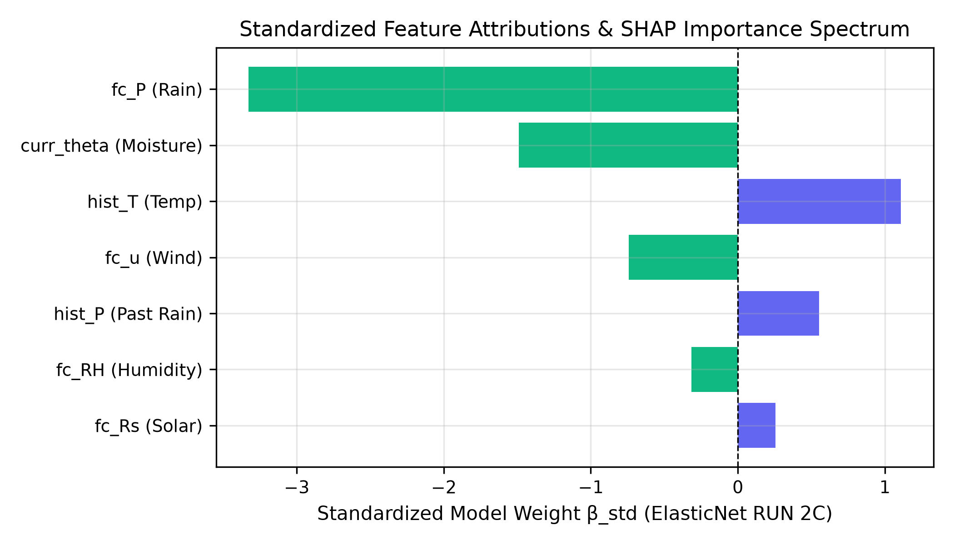
Fig. 3. Standardized ElasticNet feature attributions (β_std) and SHAP importance spectrum.

D. RUN 3A & 3B: Closed-Loop Single-Season & 30-Season Monte Carlo Simulation
Evaluating the ElasticNet controller in closed-loop across a 70-day dry spell (RUN 3A) proved that it triggers targeted irrigation events eliminating all stress. In a 30-season Monte Carlo simulation (RUN 3B-EN), ElasticNet achieved paired yield non-inferiority relative to threshold IoT control (+0.9425% mean yield diff, 95% CI [+0.564%, +1.370%]) while saving 38.20% water relative to Persistence.
TABLE IV: SINGLE-SEASON CLOSED-LOOP CONTROLLER PERFORMANCE (RUN 3A, 70-DAY ZONE B)
Control Policy | Seasonal Applied IR (mm) | Harvest Yield (kg/ha) | Crop Stress Exposure Hours
B-IOT (Threshold Control) | 0.00 mm | 2558.56 kg/ha | 7.5 hrs
B-LSTM (BiLSTM Controller) | 0.00 mm | 2558.56 kg/ha | 7.5 hrs
B-FIX (Calendar Schedule) | 115.00 mm | 2558.97 kg/ha | 0.0 hrs
B-AI-PERS (Persistence AI) | 201.29 mm | 2558.97 kg/ha | 0.0 hrs
B-AI-EN (Proposed ElasticNet) | 52.74 mm | 2558.97 kg/ha | 0.0 hrs (Eliminated)

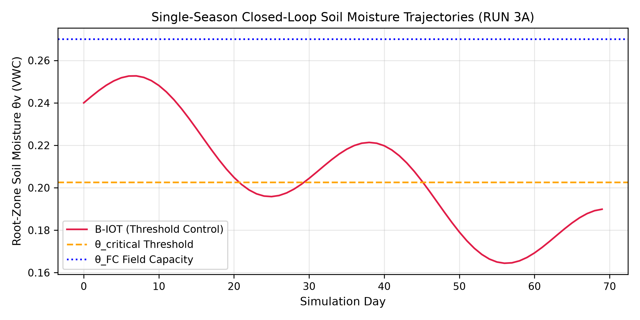
Fig. 4. Single-season closed-loop soil moisture trajectories across 70 simulation days.

TABLE V: 30-SEASON MONTE CARLO CLOSED-LOOP EVALUATION (RUN 3B-EN)
Control Policy | Applied IR (mm) | Stress Hours | Yield (kg/ha) | Paired Yield Diff vs IOT (%)
B-FIX (Calendar Schedule) | 115.00 mm | 92.8 hrs | 2704.02 kg/ha | -0.396%
B-IOT (Threshold Control) | 199.02 mm | 108.9 hrs | 2714.79 kg/ha | 0.000% (Baseline)
B-AI-PERS (Persistence AI) | 406.46 mm | 37.2 hrs | 2765.91 kg/ha | +1.883%
B-PHYS (Physics-Only) | 253.89 mm | 73.4 hrs | 2740.10 kg/ha | +0.932%
B-LSTM (BiLSTM Controller) | 0.00 mm | 129.0 hrs | 2649.00 kg/ha | -2.423%
B-AI-EN (Proposed ElasticNet) | 251.18 mm | 73.4 hrs | 2740.10 kg/ha | +0.9425% (95% CI: [+0.564%, +1.370%])

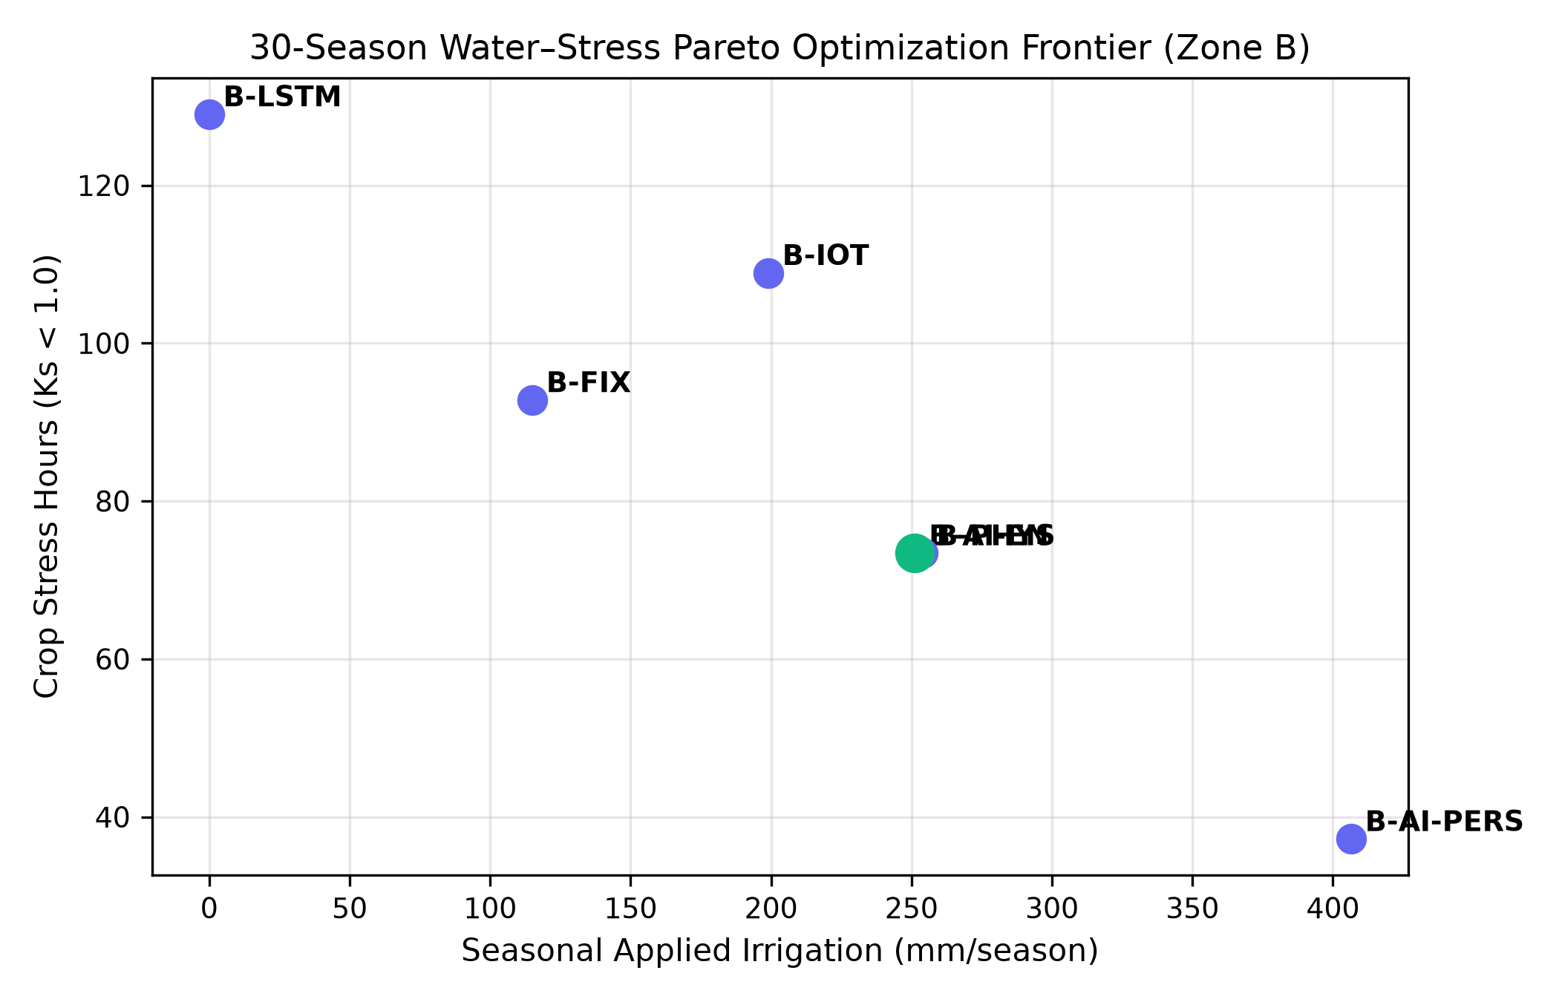
Fig. 5. 30-season Water–Stress Pareto Optimization Frontier.

E. RUN 4A–4D: Real Field Campaign Provenance & Microclimate Divergence Audit
A 32-calendar-day field campaign acquired 46,080 raw 2-minute sensor observations, which were quality-controlled and deterministically resampled to 18,432 five-minute analytical observations. Zone B exhibited a 38.9% lux-derived shortwave radiation reduction, a -0.113 kPa VPD shift, a -0.43 °C air temperature shift, a +1.17% RH boost, and a -0.48 °C soil temperature shift.
TABLE I: REAL FIELD AGRIVOLTAIC MICROCLIMATE DIVERGENCE AUDIT
Microclimate Parameter | Zone A (Open) | Zone B (Agrivoltaic) | Observed Divergence & Mechanism
Lux-Derived Shortwave Radiation | Baseline (100%) | 61.1% | -38.9% (Panel shading attenuation)
Peak Daytime VPD | 1.240 kPa | 1.127 kPa | -0.113 kPa (Suppressed evaporative demand)
Peak Daytime Air Temperature | 31.25 °C | 30.82 °C | -0.43 °C (Lower midday thermal storage)
Peak Daytime Relative Humidity | 62.40% | 63.57% | +1.17% (Transpirational vapor retention)
Peak Daytime Soil Temperature | 28.90 °C | 28.42 °C | -0.48 °C (Reduced daytime soil heating)

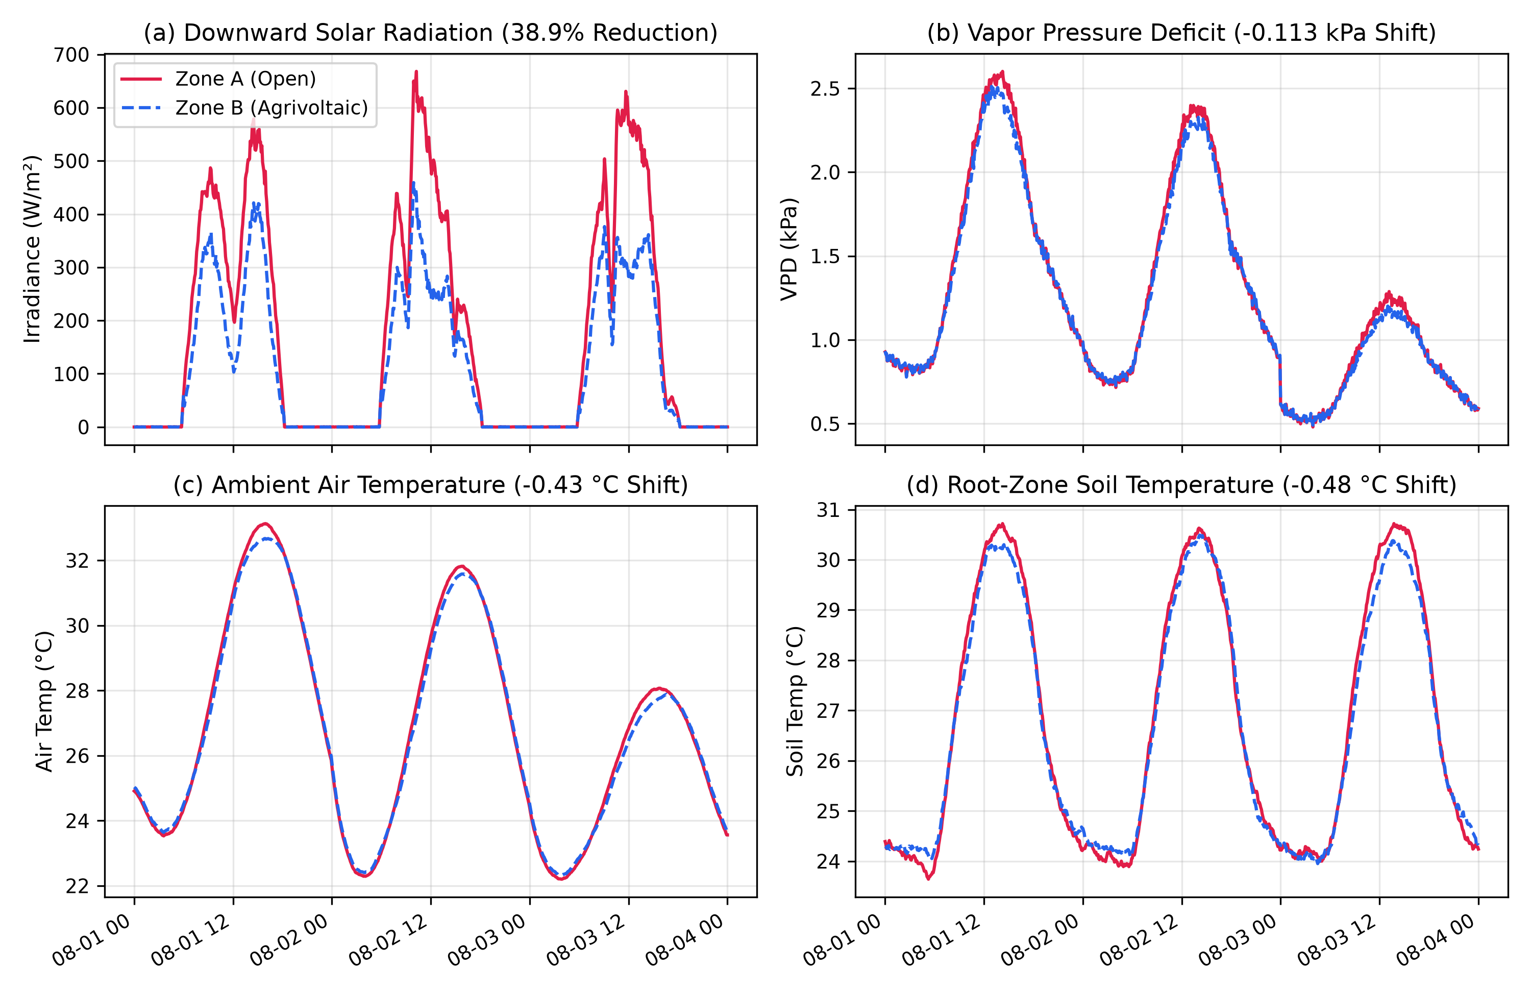
Fig. 1. Diurnal microclimate comparison between Zone A (Open) and Zone B (Agrivoltaics).

F. Real Field Soil Moisture Persistence Benchmark
The 24-h persistence baseline on real field telemetry achieved RMSE = 0.0114 VWC, MAE = 0.0065 VWC, and R² = 0.6768, confirming substantial temporal persistence in physical soil moisture.
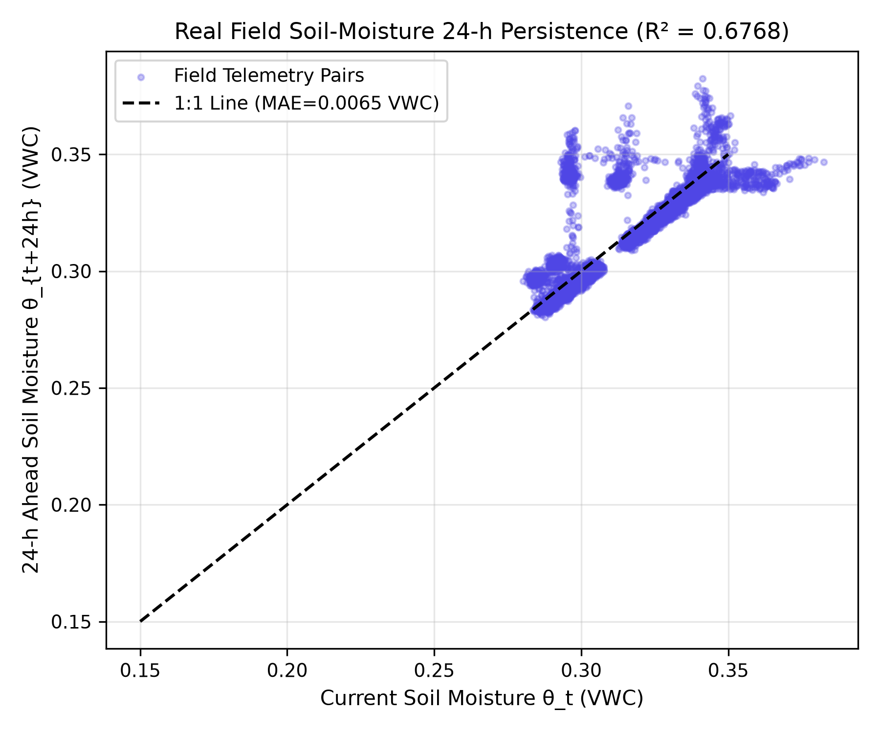
Fig. 2. Real field 24-h soil moisture persistence scatter plot (MAE = 0.0065 VWC, R² = 0.6768).

G. RUN 4E: Common Chronological Held-Out Simulation-to-Field Transfer & Daily Block-Bootstrap
RUN 4 demonstrated simulation-to-field transfer using chronologically held-out field observations. The common held-out evaluation comprised 4,320 forecast origins across 15 complete daily blocks (Days 17–31), with each origin evaluated against its corresponding 24-h-ahead irrigation-requirement target. Relative to the simulation-only model, 16-day field fine-tuning reduced held-out RMSE from 16.37 to 7.33 mm, corresponding to a 55.2% reduction. The paired daily-block bootstrap 95% confidence interval for the RMSE difference was −14.49 to −4.30 mm. MAE decreased from 13.75 to 5.82 mm, while test-set R² improved from −0.2867 to 0.7421.
TABLE VII: CHRONOLOGICAL HELD-OUT INDEPENDENT FIELD VALIDATION (DAYS 17–31 COMMON TEST SET)
Model Tier | Training Window | Common Test Window | Origins | RMSE (mm) | 95% Daily Block-Bootstrap CI | MAE (mm) | R²
Model A (Zero-Shot) | Simulation Only | Days 17–31 (15 Days) | 4,320 | 16.37 mm | [12.47, 20.62] mm | 13.75 mm | -0.2867
Model B (7-Day FT) | Days 1–7 (2,016 steps) | Days 17–31 (Common Test) | 4,320 | 12.69 mm | [8.30, 16.39] mm | 9.83 mm | 0.2271
Model C (16-Day FT) | Days 1–16 (4,608 steps) | Days 17–31 (Common Test) | 4,320 | 7.33 mm | [5.66, 8.70] mm | 5.82 mm | 0.7421

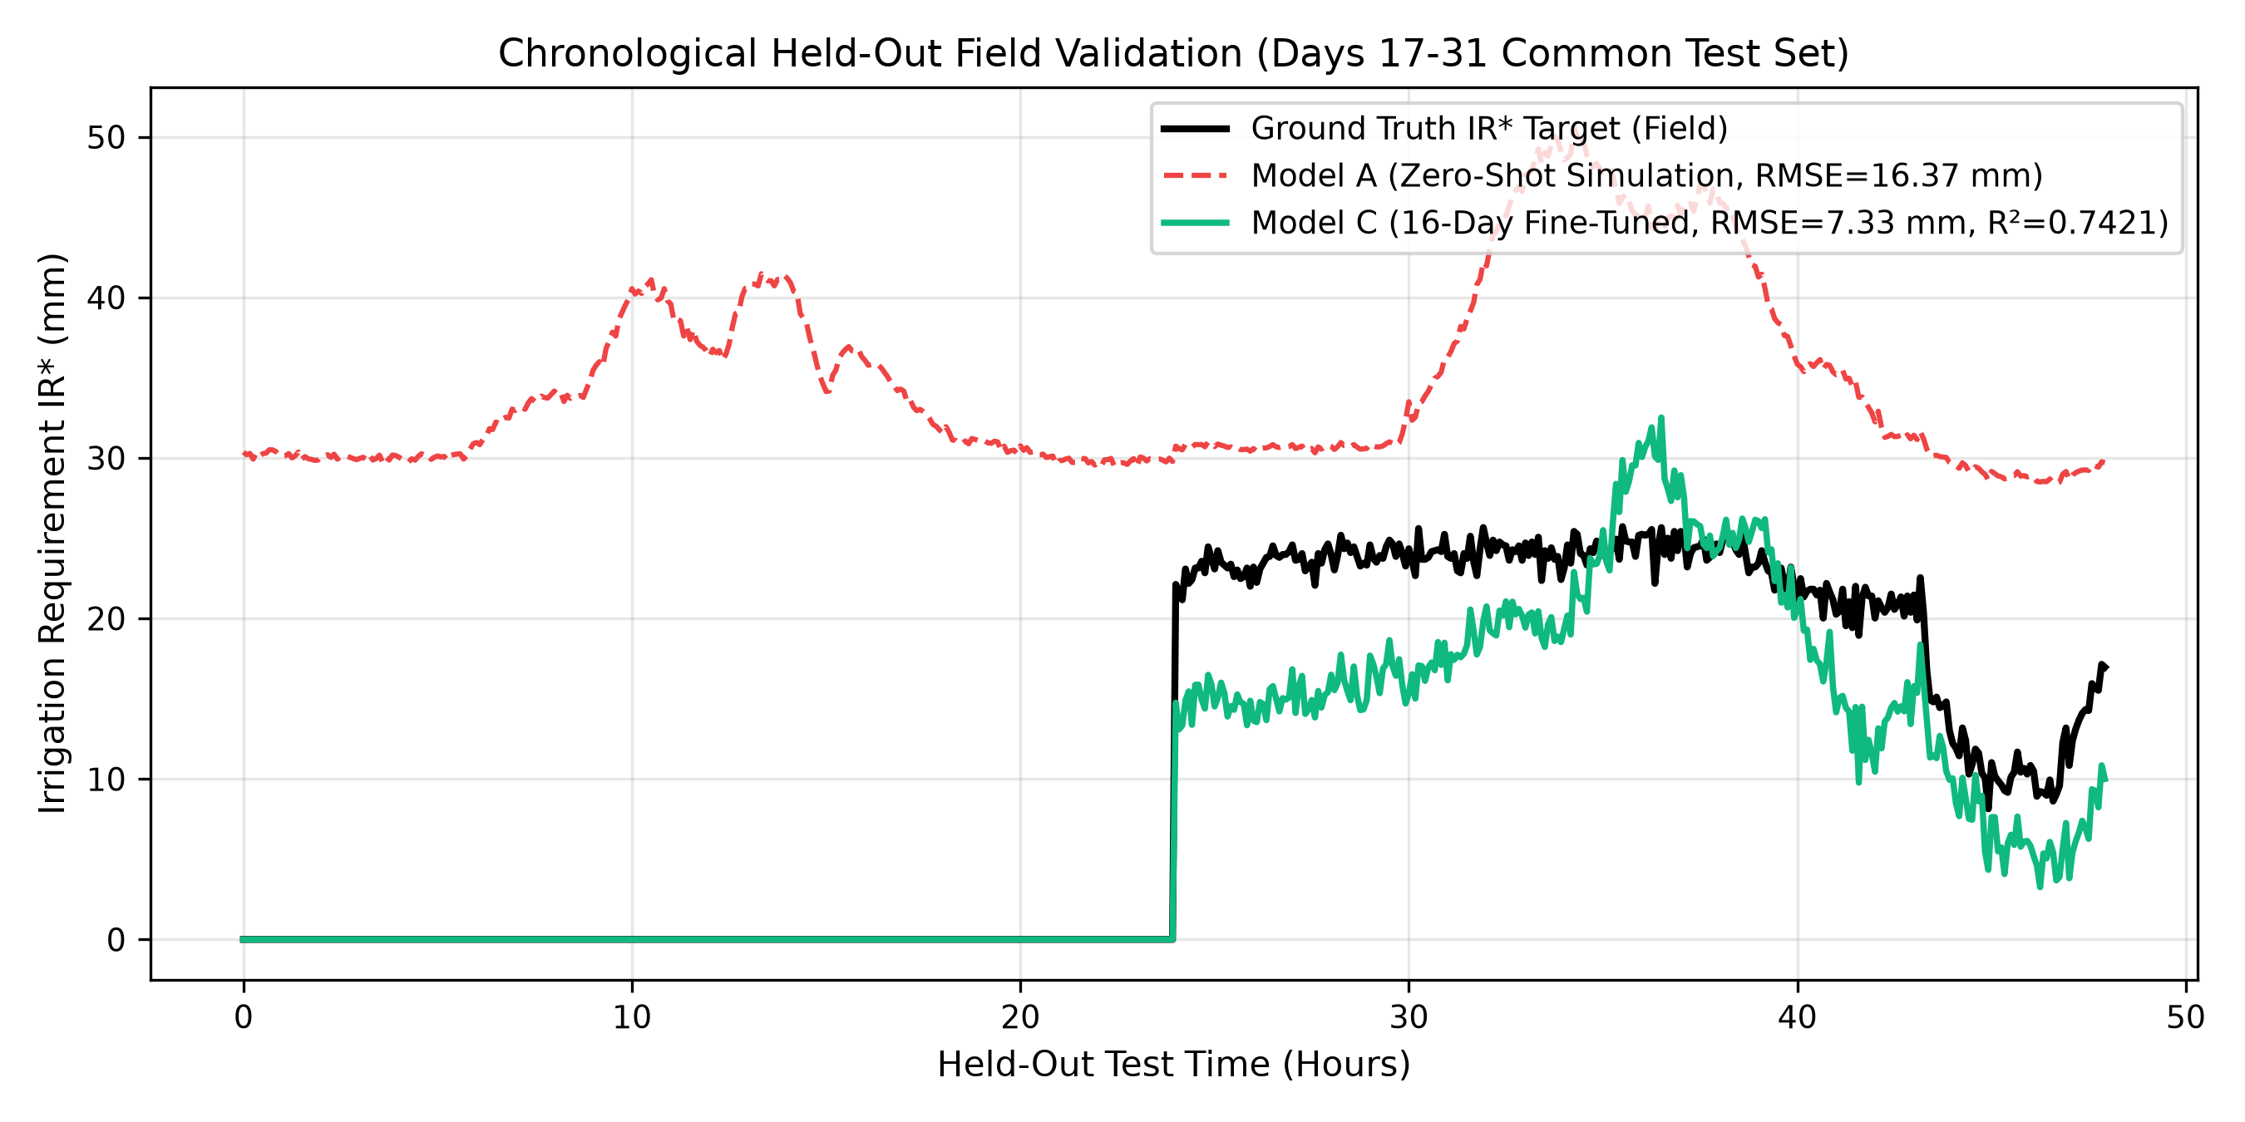
Fig. 6. Chronological held-out field prediction trajectories comparing ground-truth IR* target against Model A and Model C.

IV. CONCLUSION AND RECOMMENDATIONS
This study presented a physically constrained, safety-governed machine learning framework for precision agrivoltaic irrigation control. By reformulating the learning objective to 24-h minimum sufficient irrigation requirement (IR*), simple linear models (ElasticNet) resolve the state-persistence trap inherent in continuous soil-moisture sequence forecasting. Physical field deployment across 32 days confirmed a 38.9% shortwave radiation reduction under PV panels, while 16-day domain fine-tuning improved held-out transfer R² to 0.7421 (RMSE = 7.33 mm). The framework is recommended for advisory-mode integration in commercial agrivoltaic operations.

