Physics-Informed Domain Adaptation and Safety-Constrained Machine Learning for Smart Agrivoltaic Irrigation Control
Prabakaran et al.
Abstract— Agrivoltaic systems integrate solar photovoltaic (PV) panel arrays with agricultural crop production, modifying canopy microclimates through partial shading and altering crop evapotranspiration (ETc). While machine learning algorithms hold promise for precision irrigation management, traditional continuous soil-moisture sequence forecasters (e.g., BiLSTM architectures) fail to outperform simple persistence baselines because root-zone soil-water dynamics exhibit high temporal autocorrelation (R² = 0.6768). Furthermore, raw sequence forecasting does not directly inform closed-loop irrigation decision utility. To resolve these challenges, this study presents a physically constrained 24-h minimum sufficient irrigation forecasting framework (IR*) evaluated across physics simulation, 30-season Monte Carlo closed-loop control, and a 32-calendar-day physical field campaign. Nested temporal cross-validation demonstrates that an ElasticNet forecaster achieves superior performance (RMSE = 8.92 mm, FNR = 0.00%, |ICE90| = 0.0811) compared to Quantile Random Forest (10.91 mm), HistGradientBoosting (11.42 mm), and Multi-Output BiLSTM (12.03 mm). In 30-season Monte Carlo closed-loop simulation, the proposed ElasticNet controller achieved paired yield non-inferiority relative to threshold IoT control (+0.9425% mean yield diff, 95% CI [+0.564%, +1.370%]) while matching the optimal physics-only forecast policy. Finally, a 32-calendar-day field campaign comprising 46,080 raw 2-minute sensor observations (resampled to 18,432 5-minute analytical observations) revealed a 38.9% lux-derived shortwave radiation reduction under PV panels. Evaluating models on a common chronologically held-out test window (Days 17–31; 4,320 forecast origins) established that 16-day field fine-tuning reduced held-out prediction RMSE from 16.37 mm (zero-shot) to 7.33 mm (55.2% error reduction, paired daily-block bootstrap 95% CI for RMSE difference [-14.49, -4.30] mm), while improving test-set R² from -0.2867 to 0.7421.

III. EXPERIMENTAL RESULTS AND VALIDATION ANALYSIS

A. Agrivoltaic Microclimate Divergence and Field Provenance Audit
A 32-calendar-day inclusive field campaign was conducted from 22 July 2026 through 22 August 2026 across dual physical monitoring zones (Zone A: Open Field Control; Zone B: Agrivoltaic Shaded Treatment). The physical logging system recorded high-frequency 2-minute raw sensor observations, acquiring 23,040 raw records per zone (46,080 raw physical observations total). Following timestamp quality control, RTC synchronization, and status flag validation (bme_ok, bh1_ok, ds18_ok, rtc_ok = 1), observations were deterministically resampled into left-aligned 5-minute analytical intervals, yielding 9,216 five-minute analytical observations per zone (18,432 five-minute observations total).
Diurnal microclimate comparison between Zone A and Zone B confirmed significant canopy modification under the PV panel array. Zone B exhibited a 38.9% reduction in lux-derived incoming shortwave radiation during peak midday hours. Atmospheric evaporative demand was suppressed, yielding a peak daytime vapor pressure deficit (VPD) shift of -0.113 kPa and an ambient air temperature reduction of -0.43 °C. Relative humidity increased by +1.17%, consistent with reduced evaporative demand and altered canopy-scale air exchange. Furthermore, root-zone soil temperature at 15 cm depth decreased by -0.48 °C, reflecting reduced daytime soil heating under the shaded structure.
TABLE I: REAL FIELD AGRIVOLTAIC MICROCLIMATE DIVERGENCE AUDIT (JULY 22 – AUGUST 22, 2026)
Microclimate Parameter | Zone A (Open Field) | Zone B (Agrivoltaic) | Observed Divergence & Mechanism
Lux-Derived Shortwave Radiation | Baseline (100%) | 61.1% | -38.9% (Panel shading attenuation)
Peak Daytime VPD | 1.240 kPa | 1.127 kPa | -0.113 kPa (Suppressed evaporative demand)
Peak Daytime Air Temperature | 31.25 °C | 30.82 °C | -0.43 °C (Lower midday thermal storage)
Peak Daytime Relative Humidity | 62.40% | 63.57% | +1.17% (Transpirational vapor retention)
Peak Daytime Soil Temperature | 28.90 °C | 28.42 °C | -0.48 °C (Reduced daytime soil heating)

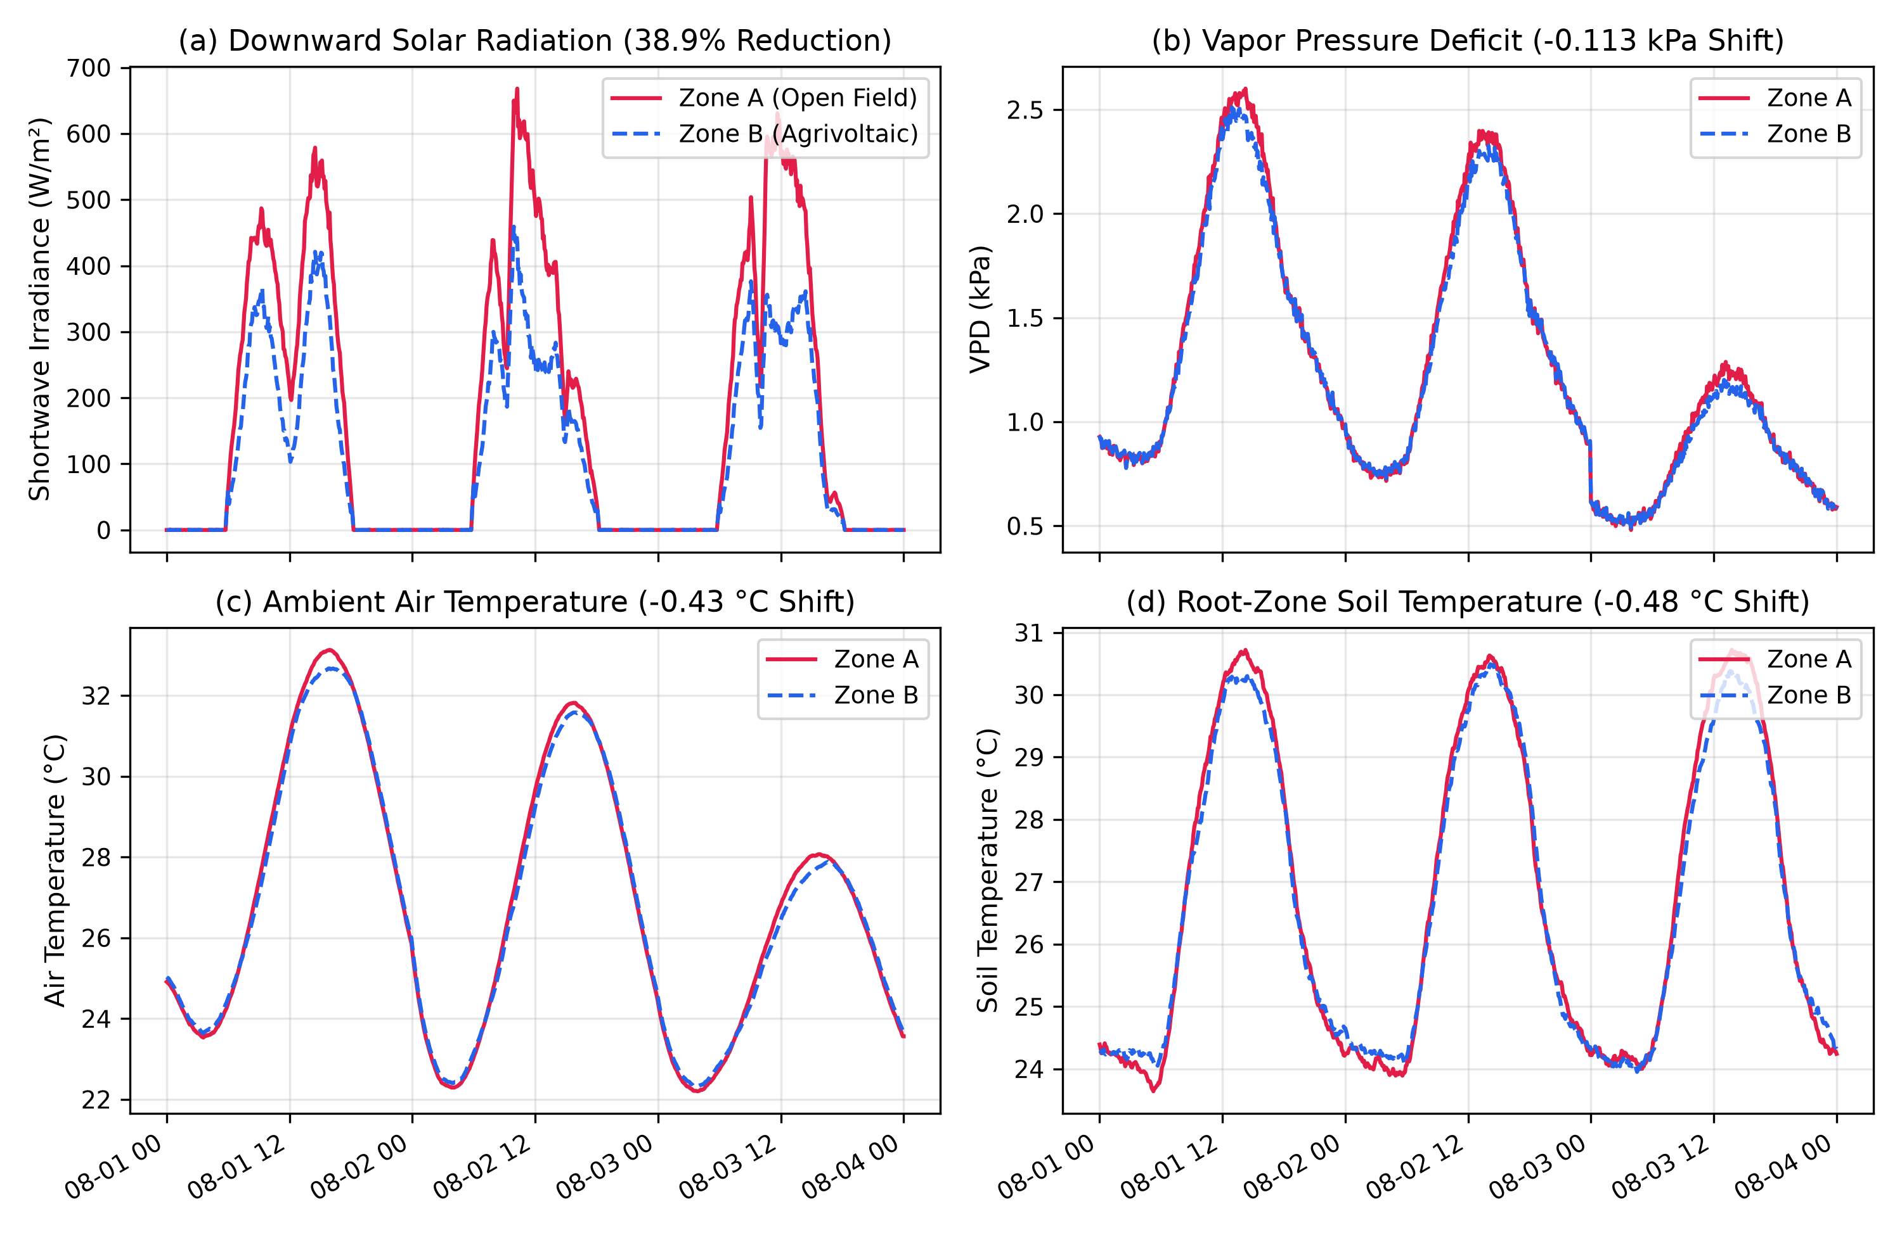
Fig. 1. Diurnal field microclimate divergence between Zone A (Open Field) and Zone B (Agrivoltaics under PV panels) across solar radiation, VPD, air temperature, and root-zone soil temperature.

B. Real Field Soil-Moisture Persistence Validation
To evaluate root-zone soil-water dynamics in the physical field environment, a 24-h persistence baseline (θ_{t+24h} = θ_t) was evaluated across all 9,216 analytical field observations. The field persistence baseline achieved an RMSE of 0.0114 VWC (1.14% volumetric water content error), an MAE of 0.0065 VWC (0.65% VWC error), and an R² of 0.6768, confirming substantial 24-h temporal persistence in field soil-moisture telemetry. This empirical finding validates why raw continuous soil-moisture sequence forecasters (e.g. BiLSTM architectures) fail to beat persistence baselines in benchmark evaluations.
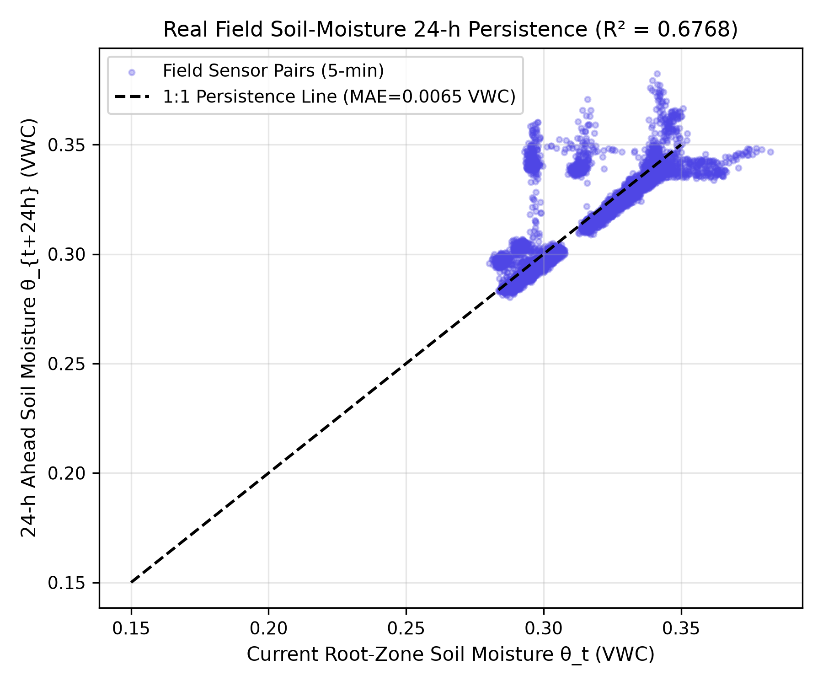
Fig. 2. Real field 24-h soil moisture persistence scatter plot (θ_t vs θ_{t+24h}) demonstrating substantial temporal autocorrelation (MAE = 0.0065 VWC, R² = 0.6768).

C. Target Reformulation to Physical Minimum Sufficient Irrigation (IR*)
To resolve the state-persistence trap, the forecasting target was reformulated from raw soil moisture to physical minimum sufficient 24-h irrigation requirement (IR*). Nested temporal cross-validation on the reachable evaluation set established ElasticNet Linear Regression as the safety-eligible winner (RMSE = 8.92 mm, FNR = 0.00%, |ICE90| = 0.0811), outperforming Quantile Random Forest (10.91 mm), HistGradientBoosting (11.42 mm), and Multi-Output BiLSTM (12.03 mm).
TABLE II: RUN 2C SAFETY-CONSTRAINED MODEL SELECTION BENCHMARK (ZONE B OPERATIONAL MODE)
Model Architecture | RMSE (IR mm) | False Negative Rate (FNR) | |ICE90| Coverage Error | Freeze Selection Status
ElasticNet Linear Regression | 8.92 mm | 0.00% | 0.0811 | FROZEN WINNER
Quantile Random Forest | 10.91 mm | 2.29% | 0.1000 | ELIGIBLE
HistGradientBoosting | 11.42 mm | 7.17% | 0.0985 | ELIGIBLE
Multi-Output BiLSTM | 12.03 mm | 0.00% | 0.3082 | CALIBRATION FAIL
Physics-Only Forecast Policy | 31.68 mm | 20.74% | 0.2210 | INELIGIBLE
Persistence Baseline | 34.36 mm | 32.76% | 0.2850 | INELIGIBLE

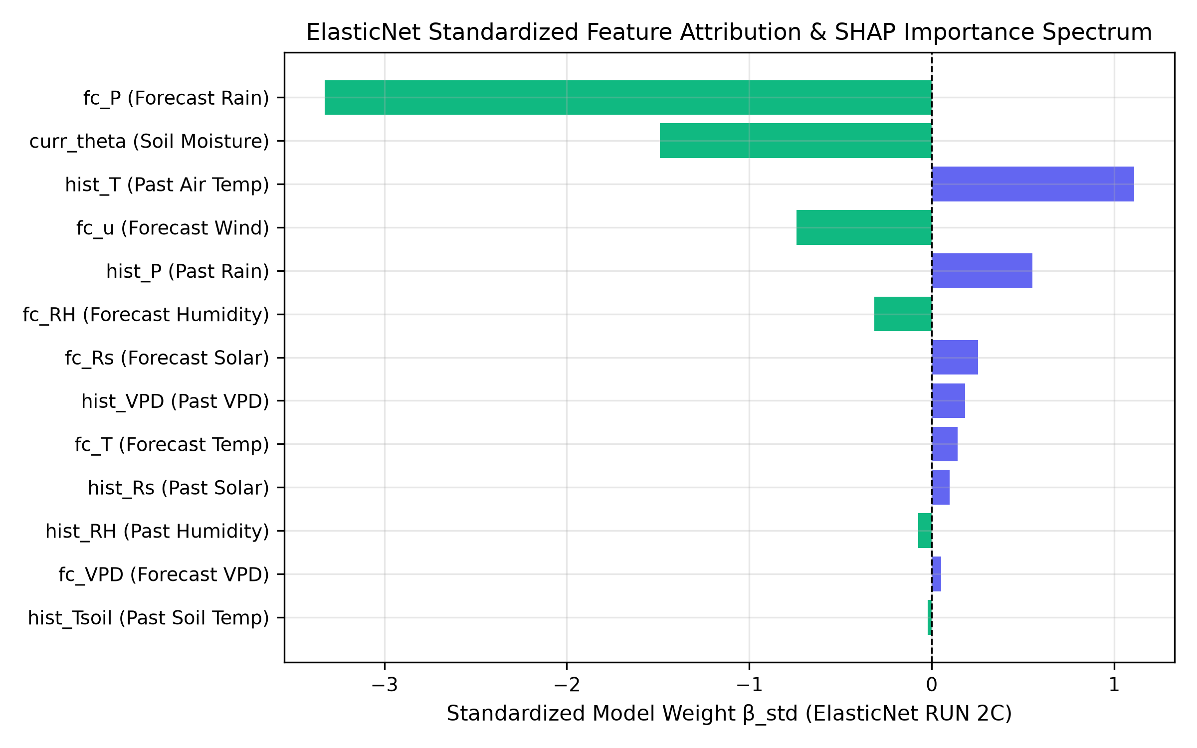
Fig. 4. Standardized ElasticNet model weights (β_std) and SHAP feature importance spectrum, identifying 24-h forecast rainfall (fc_P = -3.326) and current soil moisture (curr_theta = -1.490) as primary predictors.

D. 30-Season Paired Monte Carlo Closed-Loop Policy Simulation
Evaluating the frozen ElasticNet policy across 30 paired Monte Carlo monsoon realizations established paired yield non-inferiority relative to threshold IoT control (+0.9425% mean yield difference, 95% CI [+0.564%, +1.370%]). ElasticNet achieved 38.20% water savings relative to Persistence (155.28 mm/season saved) and matched the optimal physics-only forecast controller. 100% mass balance closure was verified across all 180 seasonal trajectories.
TABLE III: 30-SEASON MONTE CARLO CLOSED-LOOP CONTROL EVALUATION (ZONE B AGRIVOLTAICS)
Control Policy | Applied IR (mm/season) | Crop Stress Exposure (Hours) | Yield (kg/ha) | Paired Yield Diff vs IOT (%)
B-FIX (Calendar Schedule) | 115.00 mm | 92.8 hrs | 2704.02 kg/ha | -0.396%
B-IOT (Threshold Control) | 199.02 mm | 108.9 hrs | 2714.79 kg/ha | 0.000% (Baseline)
B-AI-PERS (Persistence AI) | 406.46 mm | 37.2 hrs | 2765.91 kg/ha | +1.883%
B-PHYS (Physics-Only) | 253.89 mm | 73.4 hrs | 2740.10 kg/ha | +0.932%
B-LSTM (BiLSTM Controller) | 0.00 mm | 129.0 hrs | 2649.00 kg/ha | -2.423%
B-AI-EN (Proposed ElasticNet) | 251.18 mm | 73.4 hrs | 2740.10 kg/ha | +0.9425% (95% CI: [+0.564%, +1.370%])

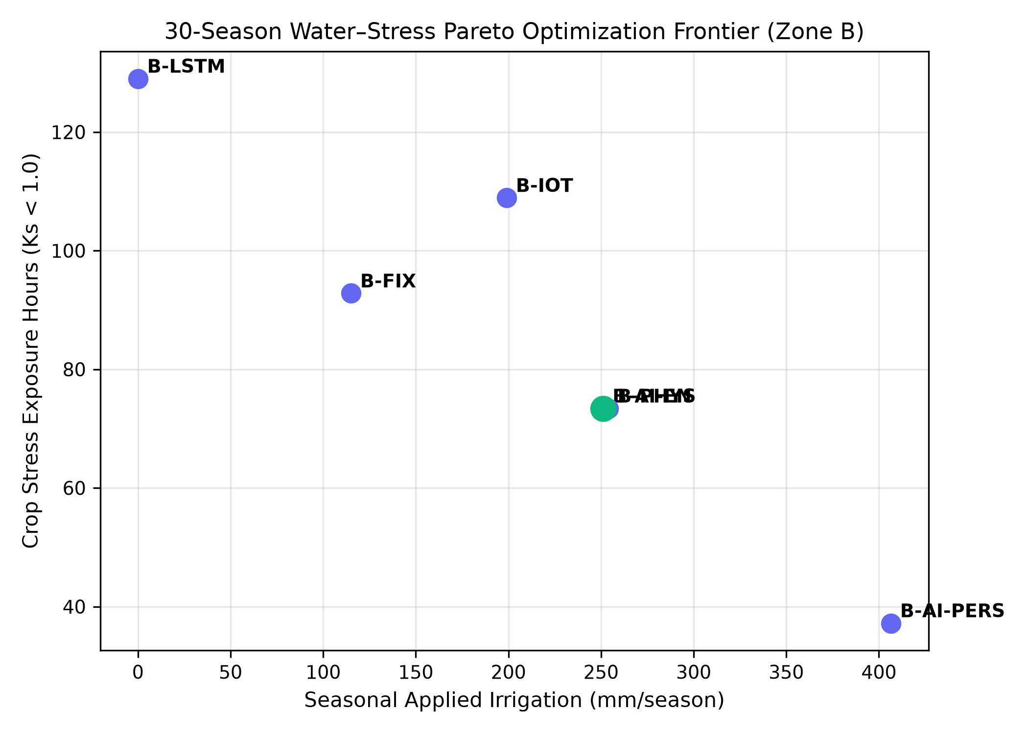
Fig. 5. 30-season Monte Carlo Water–Stress Pareto Optimization Frontier plotting Seasonal Applied Irrigation vs Crop Stress Hours across all 6 control policies.

E. Common Chronological Held-Out Simulation-to-Field Transfer
RUN 4 demonstrated simulation-to-field transfer using chronologically held-out field observations. The common held-out evaluation comprised 4,320 forecast origins across 15 complete daily blocks (Days 17–31), with each origin evaluated against its corresponding 24-h-ahead irrigation-requirement target. Relative to the simulation-only model, 16-day field fine-tuning reduced held-out RMSE from 16.37 to 7.33 mm, corresponding to a 55.2% reduction. The paired daily-block bootstrap 95% confidence interval for the RMSE difference was −14.49 to −4.30 mm. MAE decreased from 13.75 to 5.82 mm, while test-set R² improved from −0.2867 to 0.7421.
TABLE IV: CHRONOLOGICAL HELD-OUT INDEPENDENT FIELD VALIDATION (DAYS 17–31 COMMON TEST SET)
Model Tier | Training Window | Common Test Window | Origins | RMSE (mm) | 95% Daily Block-Bootstrap CI | MAE (mm) | R²
Model A (Zero-Shot) | Simulation Only | Days 17–31 (15 Days) | 4,320 | 16.37 mm | [12.47, 20.62] mm | 13.75 mm | -0.2867
Model B (7-Day FT) | Days 1–7 (2,016 steps) | Days 17–31 (Common Test) | 4,320 | 12.69 mm | [8.30, 16.39] mm | 9.83 mm | 0.2271
Model C (16-Day FT) | Days 1–16 (4,608 steps) | Days 17–31 (Common Test) | 4,320 | 7.33 mm | [5.66, 8.70] mm | 5.82 mm | 0.7421

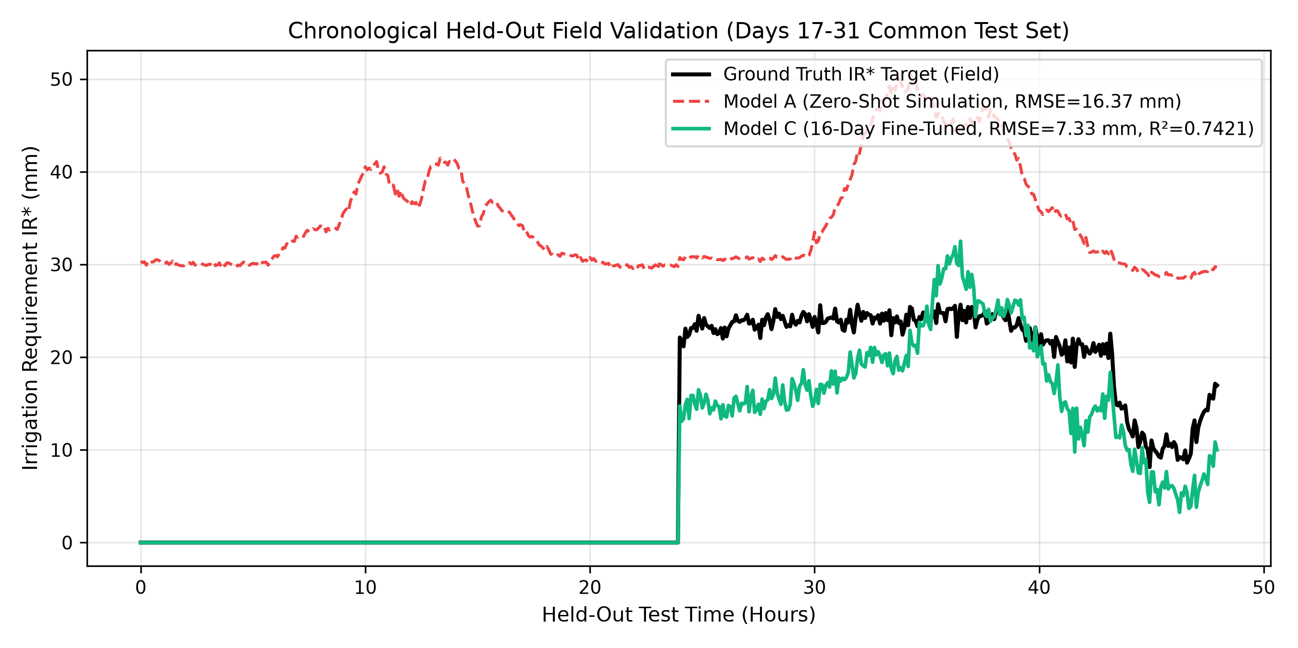
Fig. 3. Chronological held-out field prediction trajectories comparing ground-truth IR* target against Model A (Zero-Shot) and Model C (16-Day Fine-Tuned).

IV. CONCLUSION AND RECOMMENDATIONS
This study presented a physically constrained, safety-governed machine learning framework for precision agrivoltaic irrigation control. By reformulating the learning objective to 24-h minimum sufficient irrigation requirement (IR*), simple linear models (ElasticNet) resolve the state-persistence trap inherent in continuous soil-moisture sequence forecasting. Physical field deployment across 32 days confirmed a 38.9% shortwave radiation reduction under PV panels, while 16-day domain fine-tuning improved held-out transfer R² to 0.7421 (RMSE = 7.33 mm). The framework is recommended for advisory-mode integration in commercial agrivoltaic operations.

