| Internship Project Title | Operations Management - Inventory Module using MERN Stack |
| --- | --- |
| Name of the Company | TCS iON |
| Name of the Industry Mentor | Debashis Roy |
| Name of the Institute | Madras Institute of Technology, Anna University |

| Start Date | End Date | | Total Effort (hrs.) | | Project Environment | Tools used |
| --- | --- | --- | --- | --- | --- | --- |
| 12-07-2022 | 10-08-2022 | | 125 | | VS Code, Windows, Firefox | NodeJS with Express, MongoDB Atlas, React, several npm packages |

**TABLE OF CONTENT**

* Acknowledgements
* Objective
* Introduction / Description of Internship
* Internship Activities
* Approach / Methodology
* Flow Diagram
* Reflections on the Internship
* Enhancement Scope
* Link to code and executable file

# Acknowledgements

I thank TCS iON and the industry mentor for their guidance and for providing necessary information regarding the project.

# Objective

The objective of this project is to develop an automated software for Inventory Management module of Operations Management using MERN Stack.

# Introduction/Description of Internship

The method through which you keep track of your products across the whole supply chain, from purchase to manufacture to final sales, is known as an inventory management system .

An inventory management system combines varying software packages to track stock levels and stock movements.

An inventory management system optimizes inventory levels and ensures product availability across multiple channels.

It helps in managing your company's inventory.It gives us the real time details of the company’s inventory. There are three Main components in this project Item,Sales,Purchase.

The goal of this project is to create software using MERN Stack for the Operations Management Inventory Management module.

We make use of MongoDB to store information about the required modules such as items, sales and vendor information in the mongo database. We retrieve the information when a request arises from the client with the help of express, which is a package that is used to create the backend for the application.We create Backend API s for the CRUD process using node Express.

We make use of React to create the front end for the application.

# Internship Activities

Some of the activities to be done during the internship include Pre-project test, activity report, interim project reports, final project report, project test.

# Approach / Methodology

1. Initially we decide the data models in the project using ER Diagram
2. we create Mongo db clusters for the data using mongoose
3. We create a backend node app using Express and we create Backend API s for fetch, create , update and delete on various clusters in Mongo DB
4. For this project I have used MongoDB Local Server hosted in my computer and used Mongo DB compass to visualize and perform various operations in it
5. We make separate models for sales ,purchases,items
6. We make models for the items in submodules sales and purchases.
7. The models are made for customers, sales orders, packages, delivery challans, invoices, payments received, sales returns and credit notes in the sales submodule.
8. The models are made for vendors, purchase orders, bills and payments and vendor credit in the purchase’s submodule.
9. We create controllers for these models and we use the functions from controllers and map them to specific routes
10. The frontend is made with React, a java script library for building user interfaces.
11. The frontend communicates with the backend by using the API s created
12. We can add new customers and vendors and create orders generate bills
13. Different Mongo DB clusters are connected using Mongo DB populate method
14. We can see and filter the existing details in the form of a table
15. The dashboard page has various reports such as inventory summary report, inventory aging summary report, product sales report and sales by item/customer
16. There is a sidebar to go to all other pages

# Flow diagram

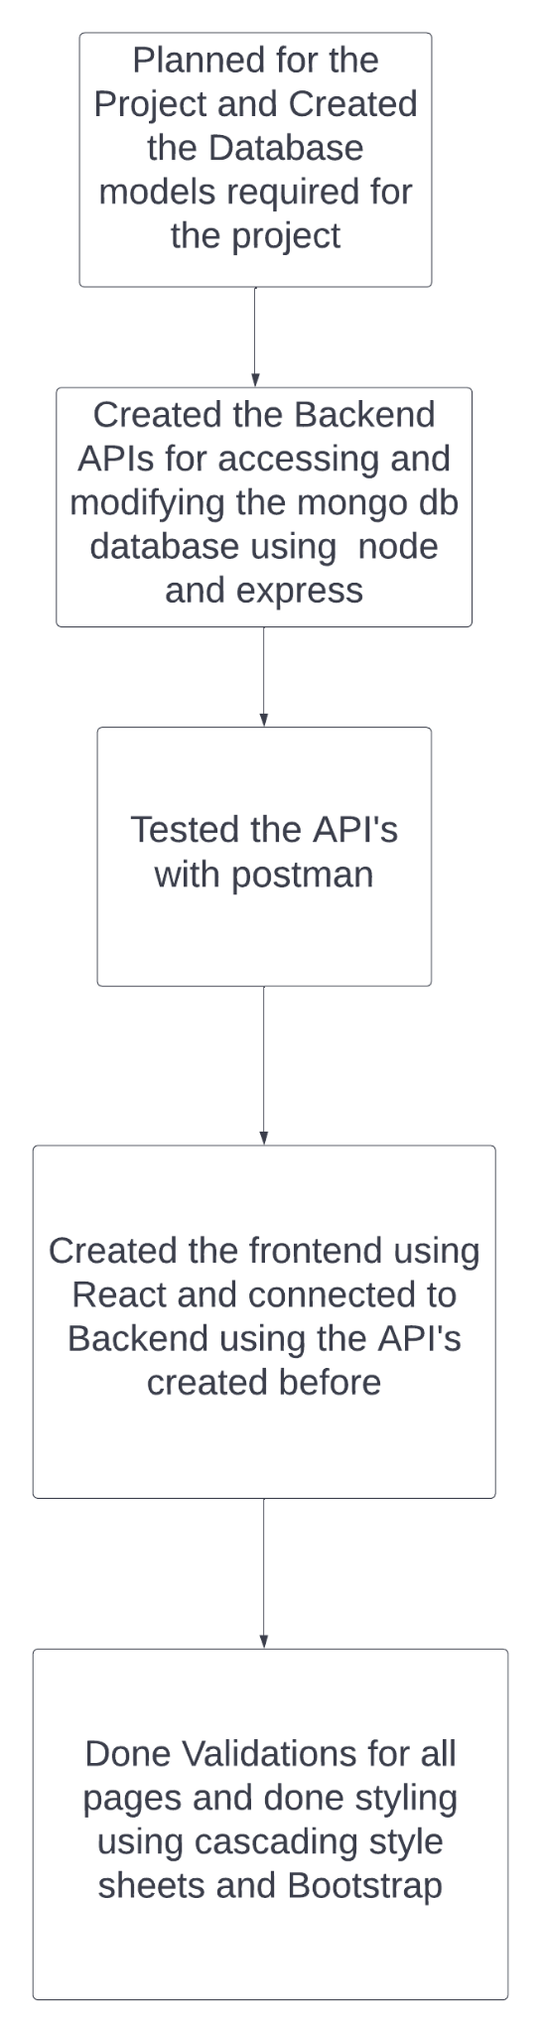

# Algorithms

Used some inbuilt sorting algorithms in MongoDB for sorting and searching

Used some calculations for filtering

Reflections on the Internship

I'm hoping that working as an intern with TCS ion will allow me gain practical'experience in the MERN Stack. I hope at the end of the Internship I’ll be able to create any product using the MERN Stack

# Enhancement scope

There is a lot of scope for improvement of this inventory module.

We can automate the data entry using some devices.

# Screenshots

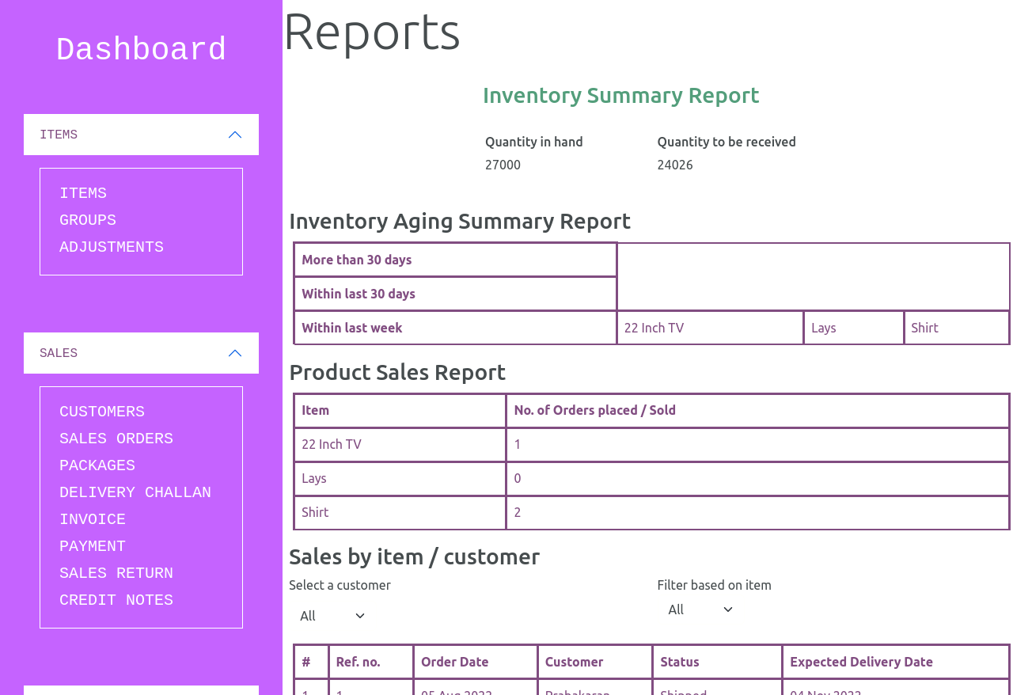

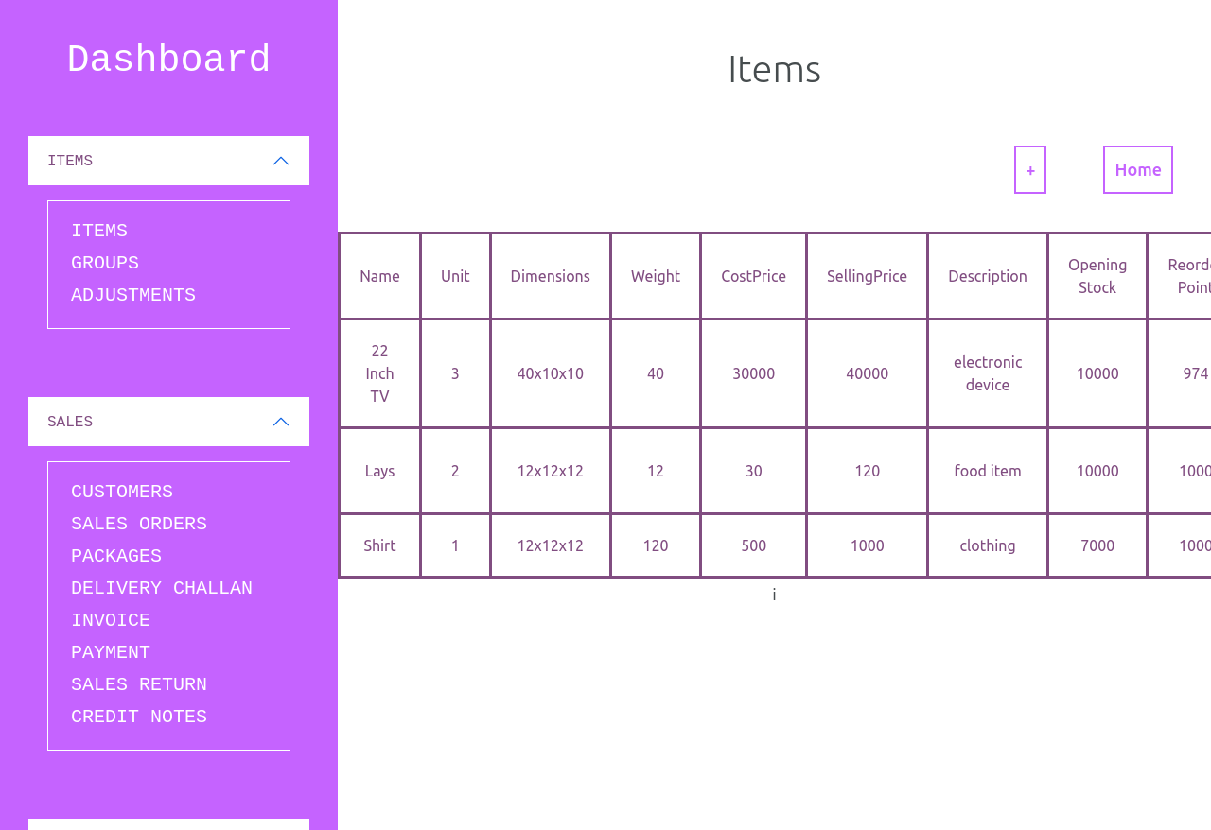

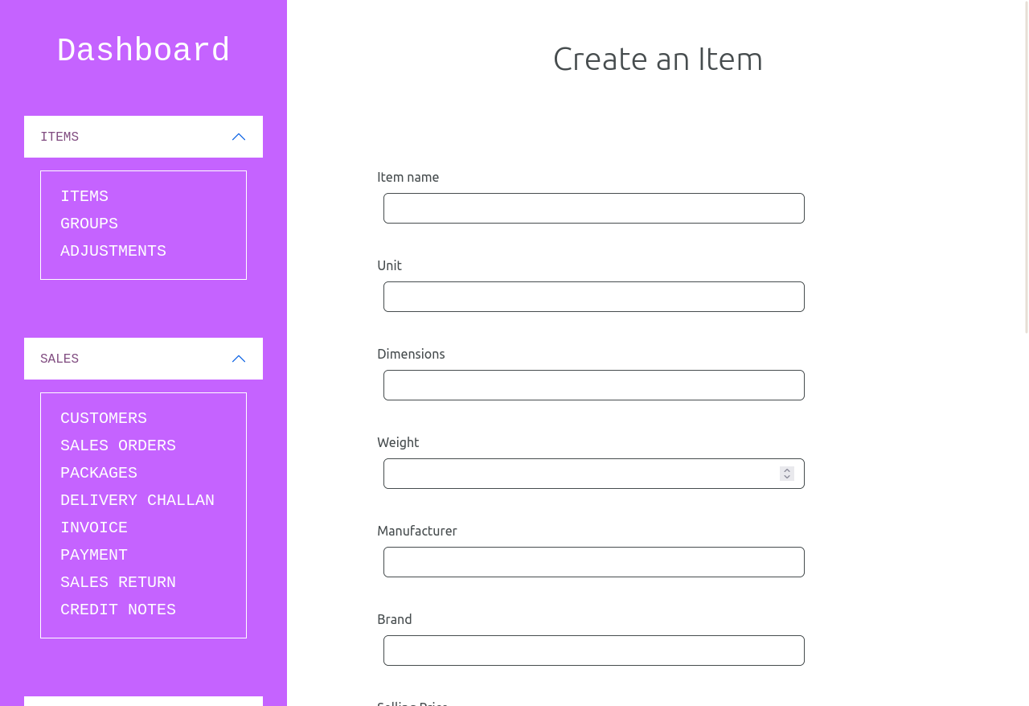

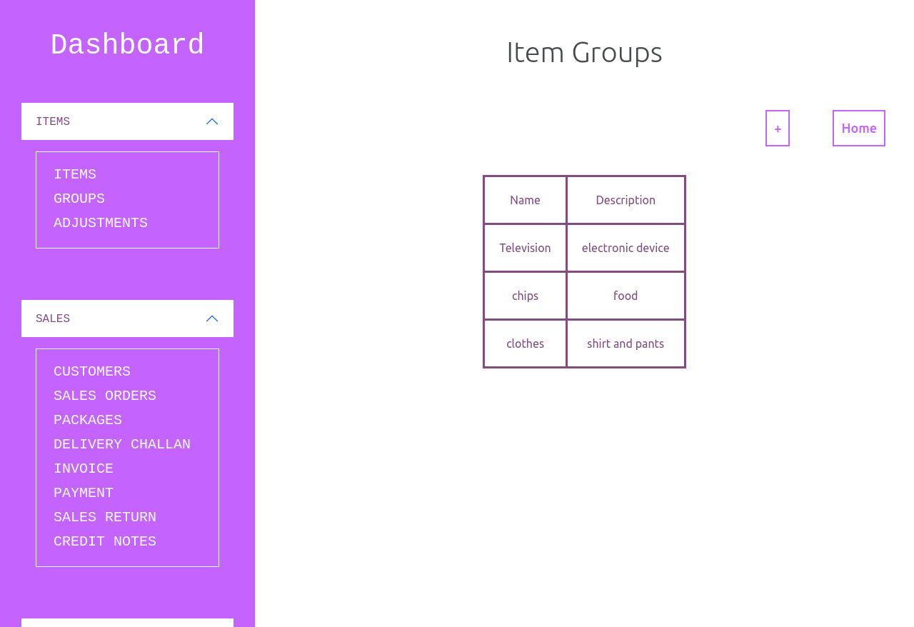

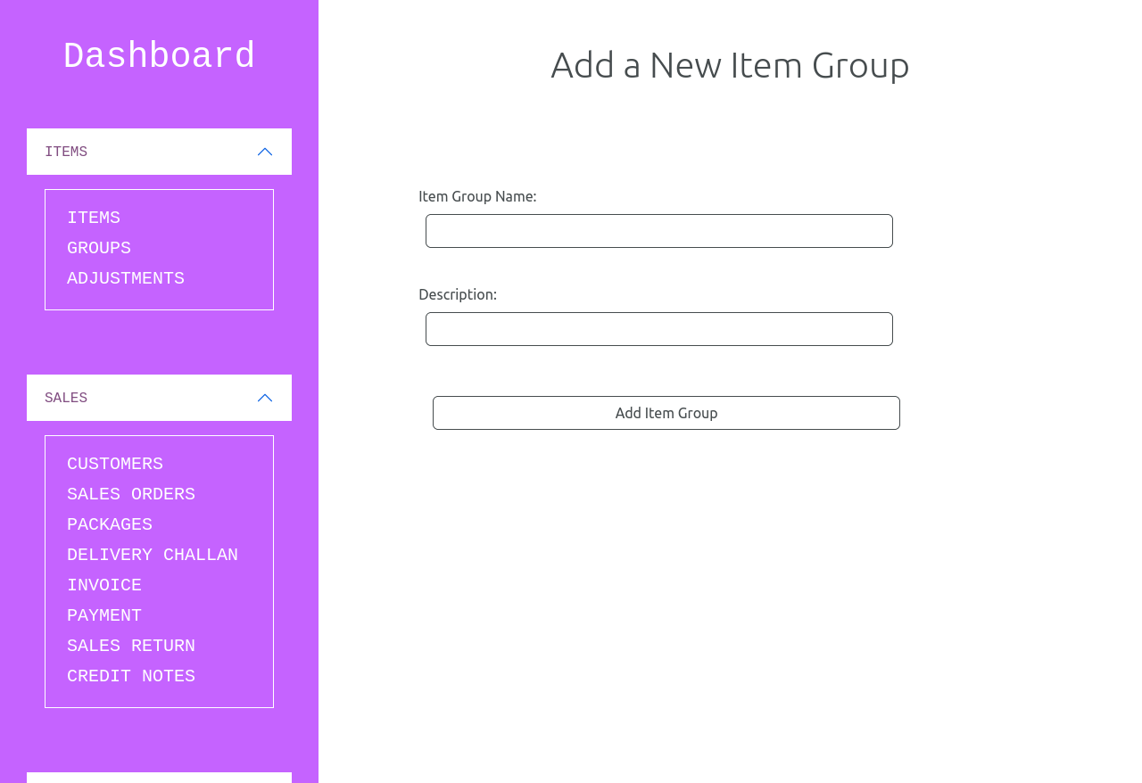

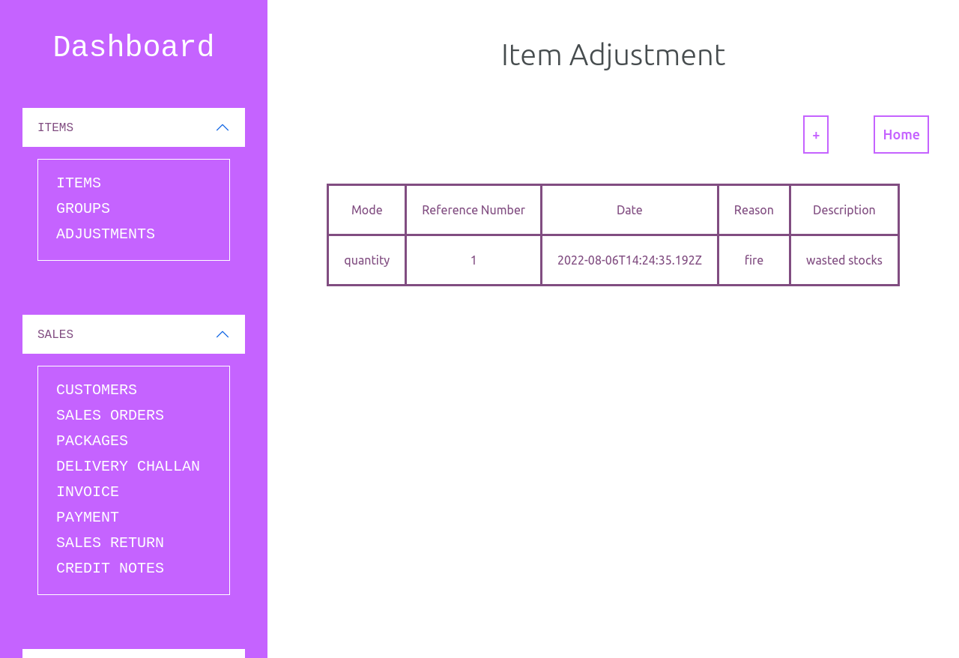

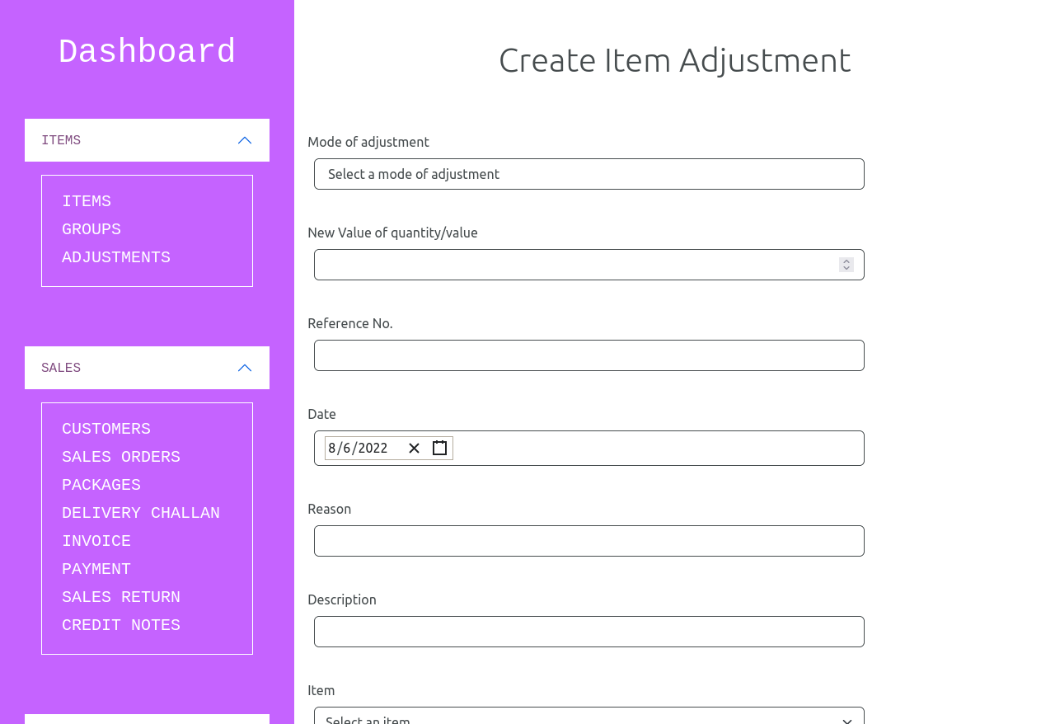

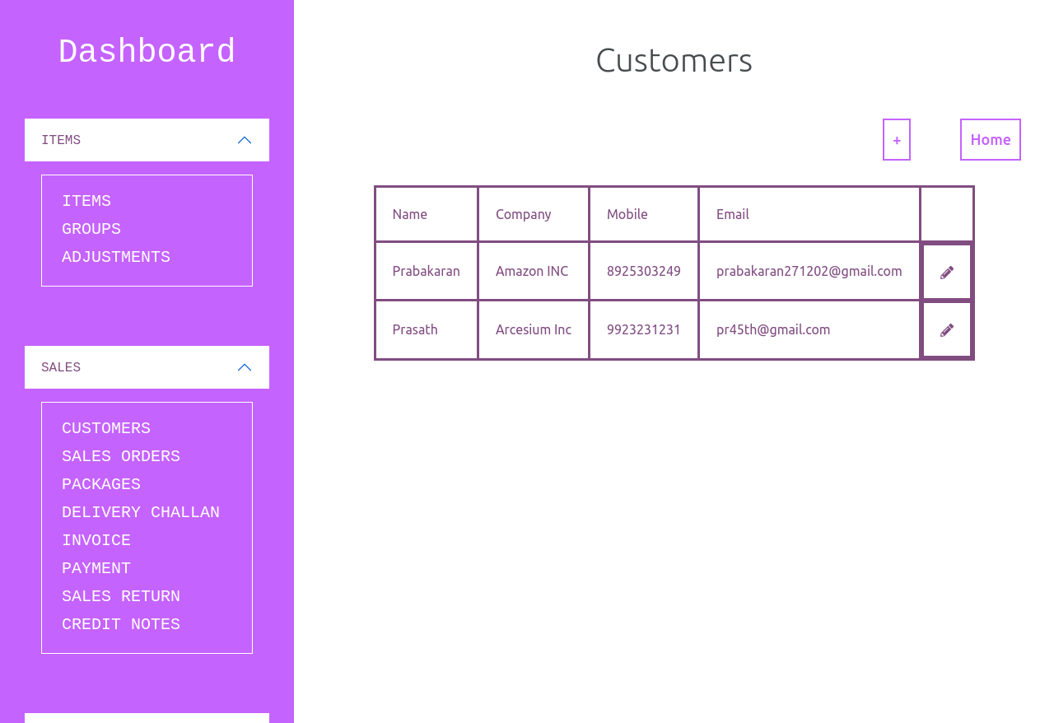

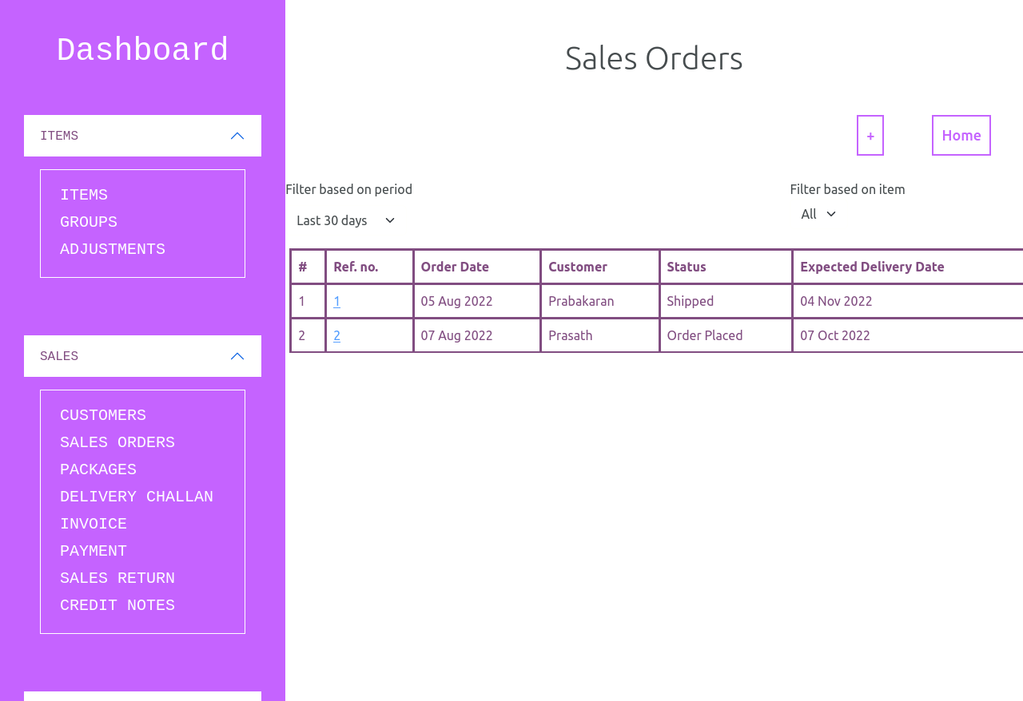

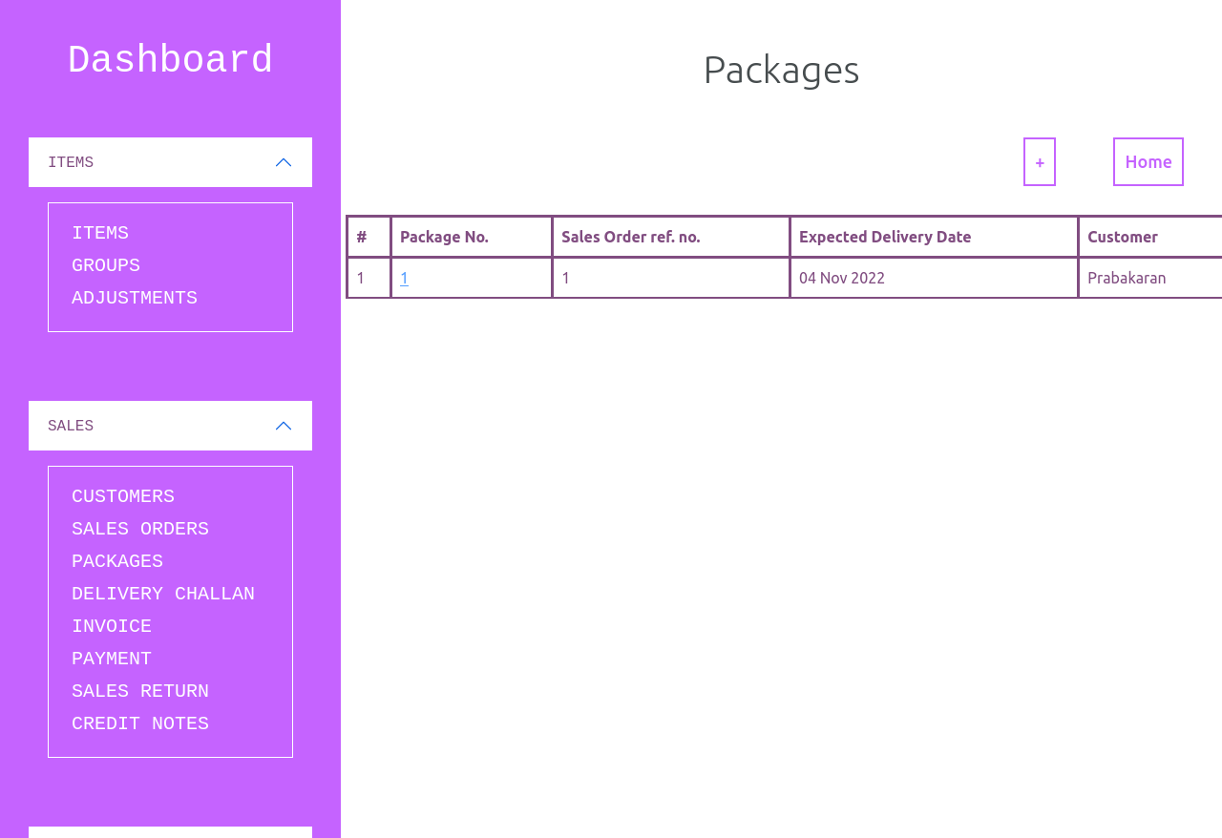

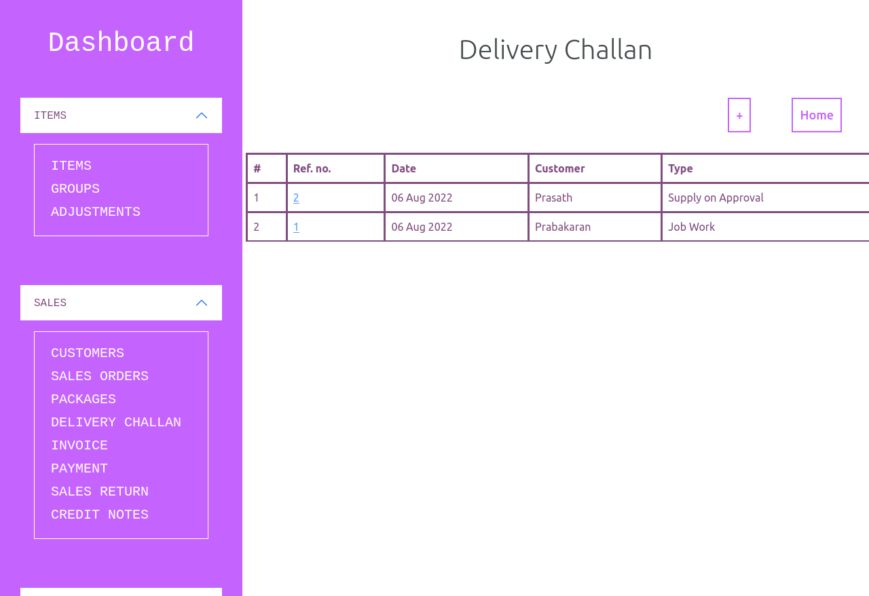

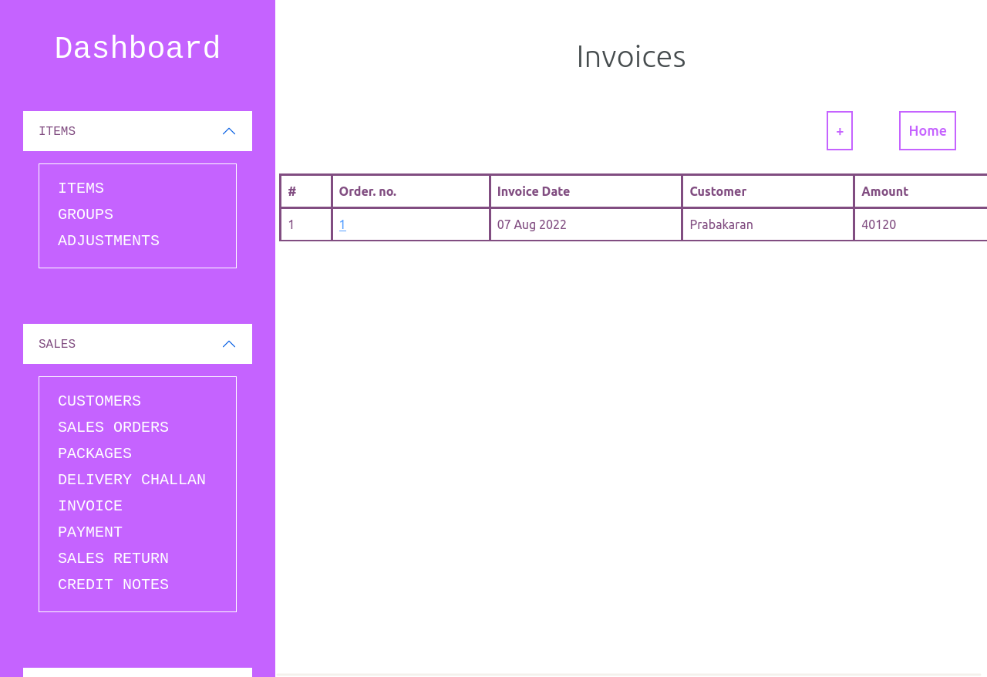

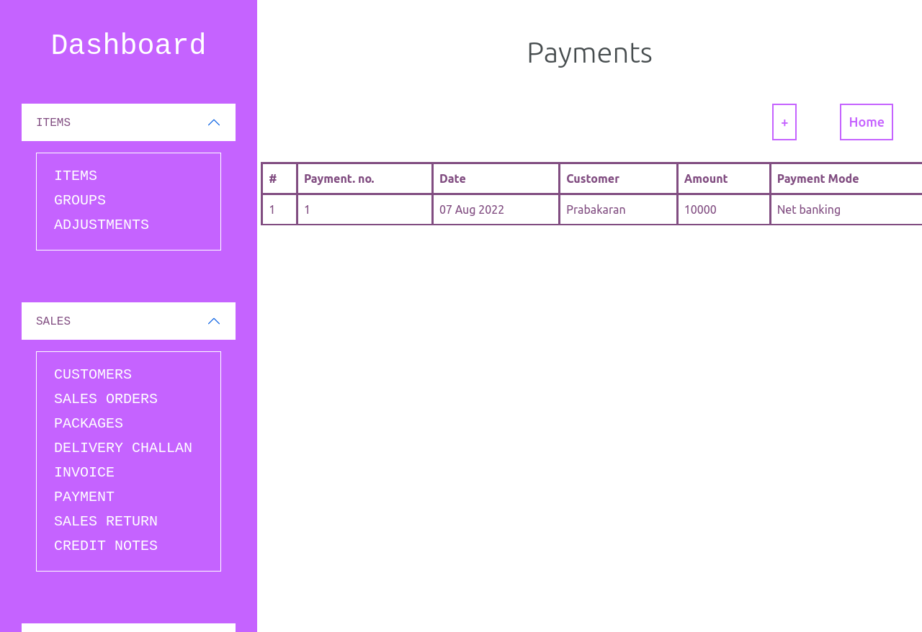

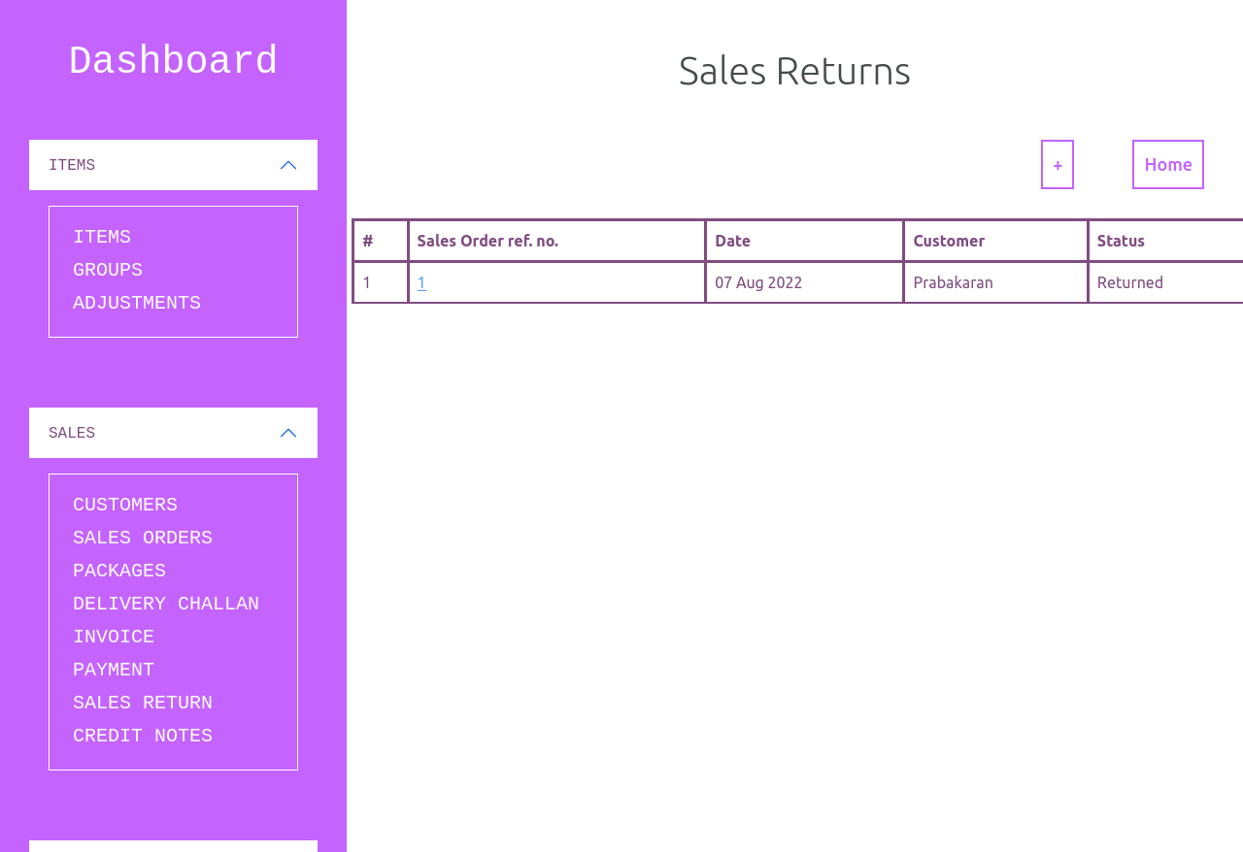

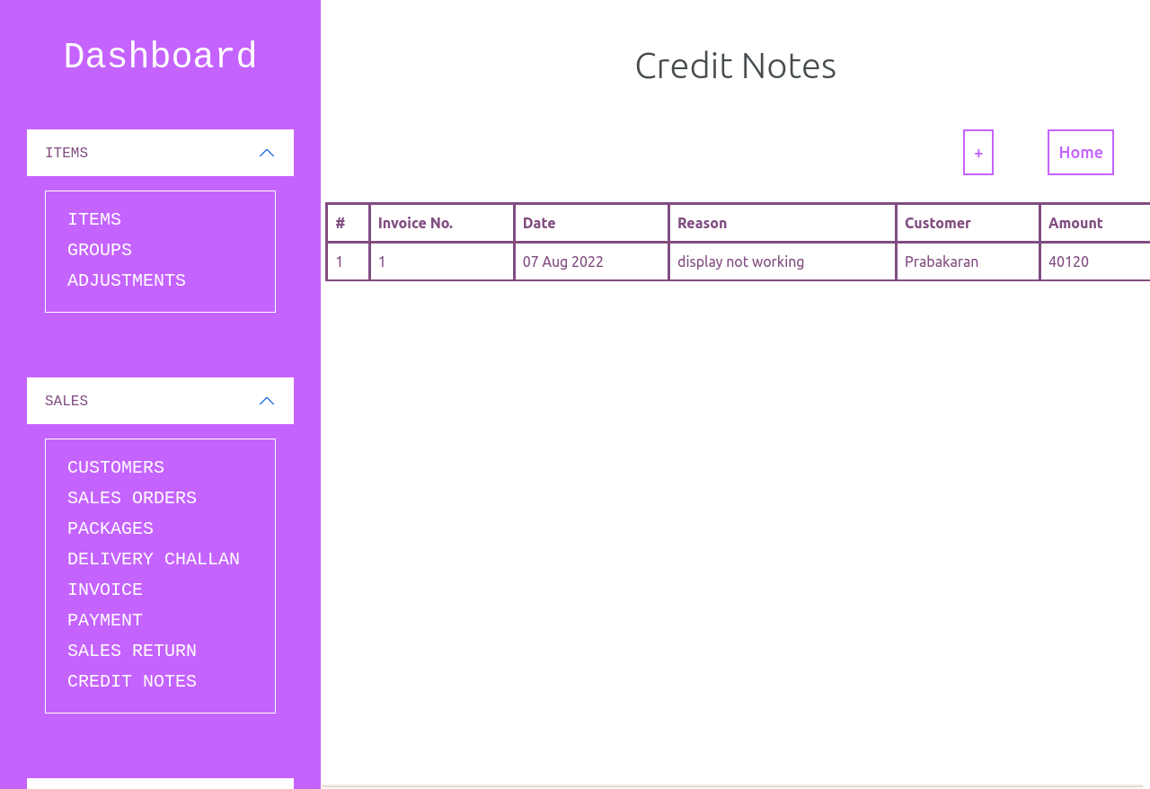

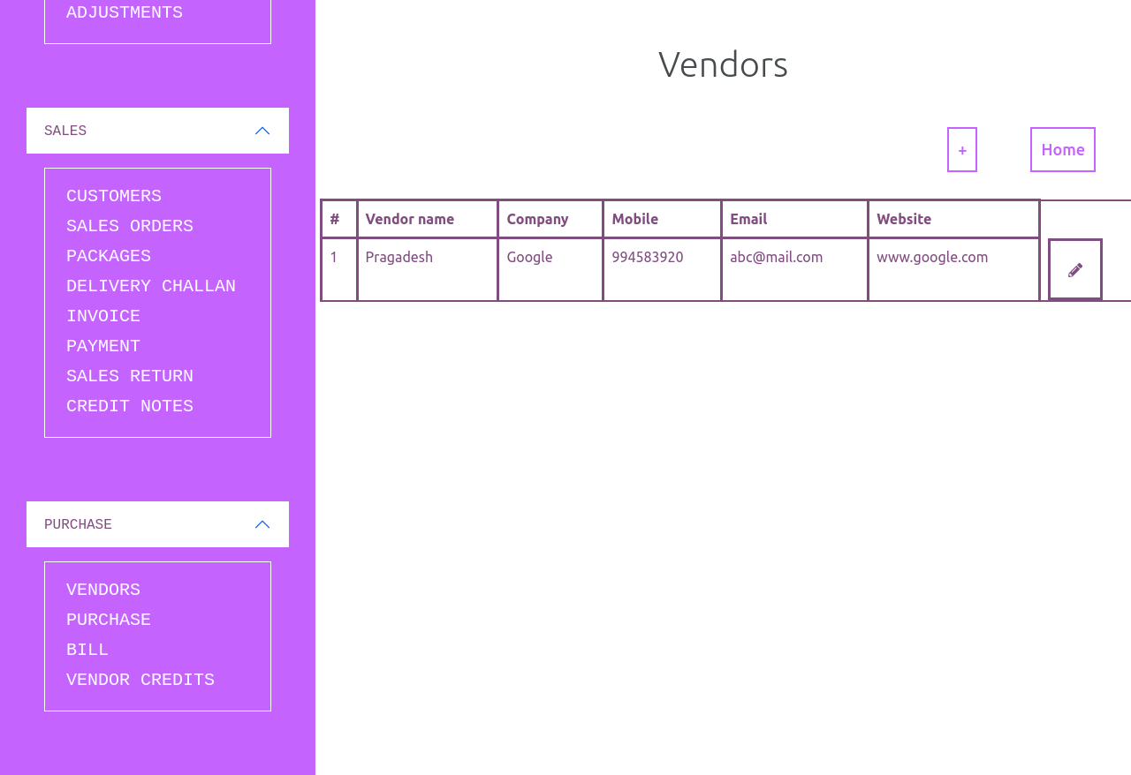

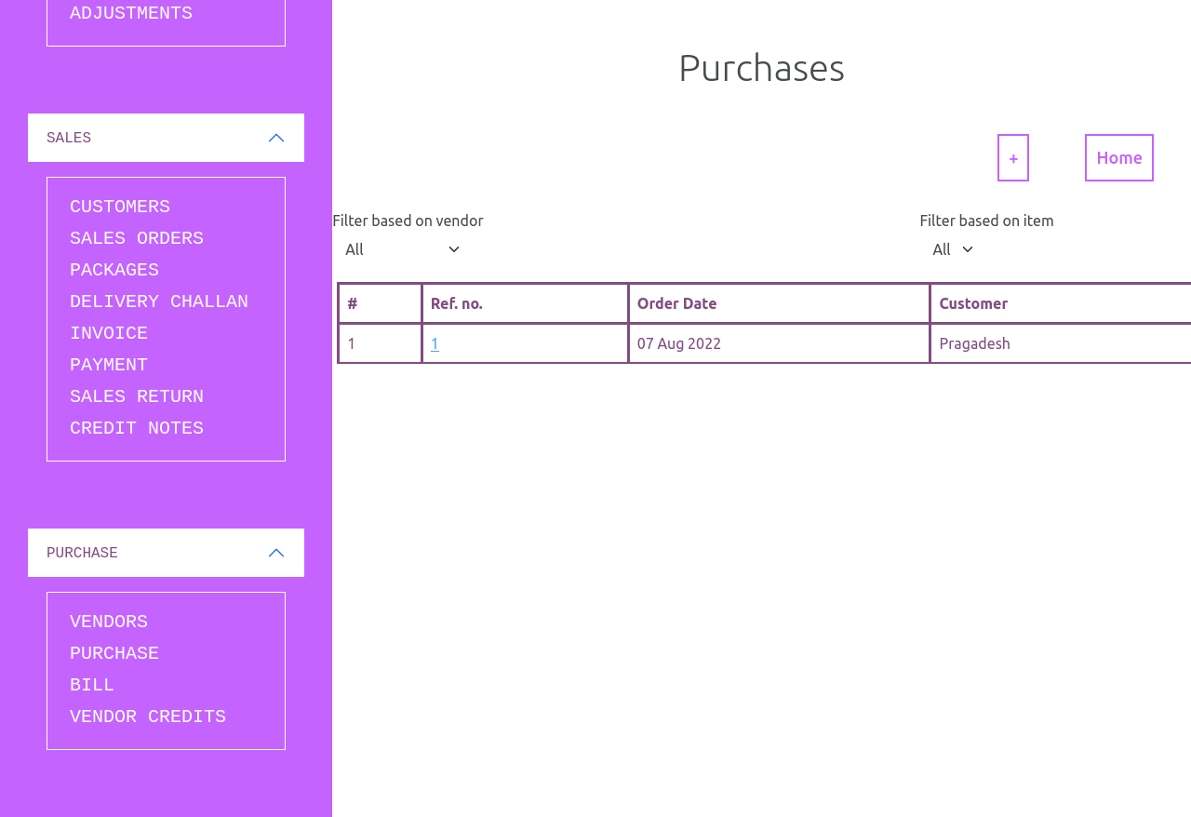

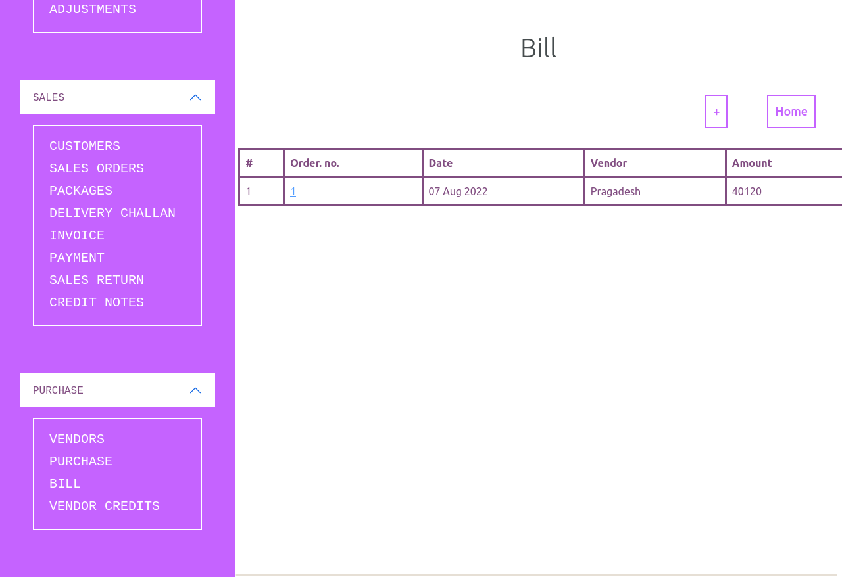

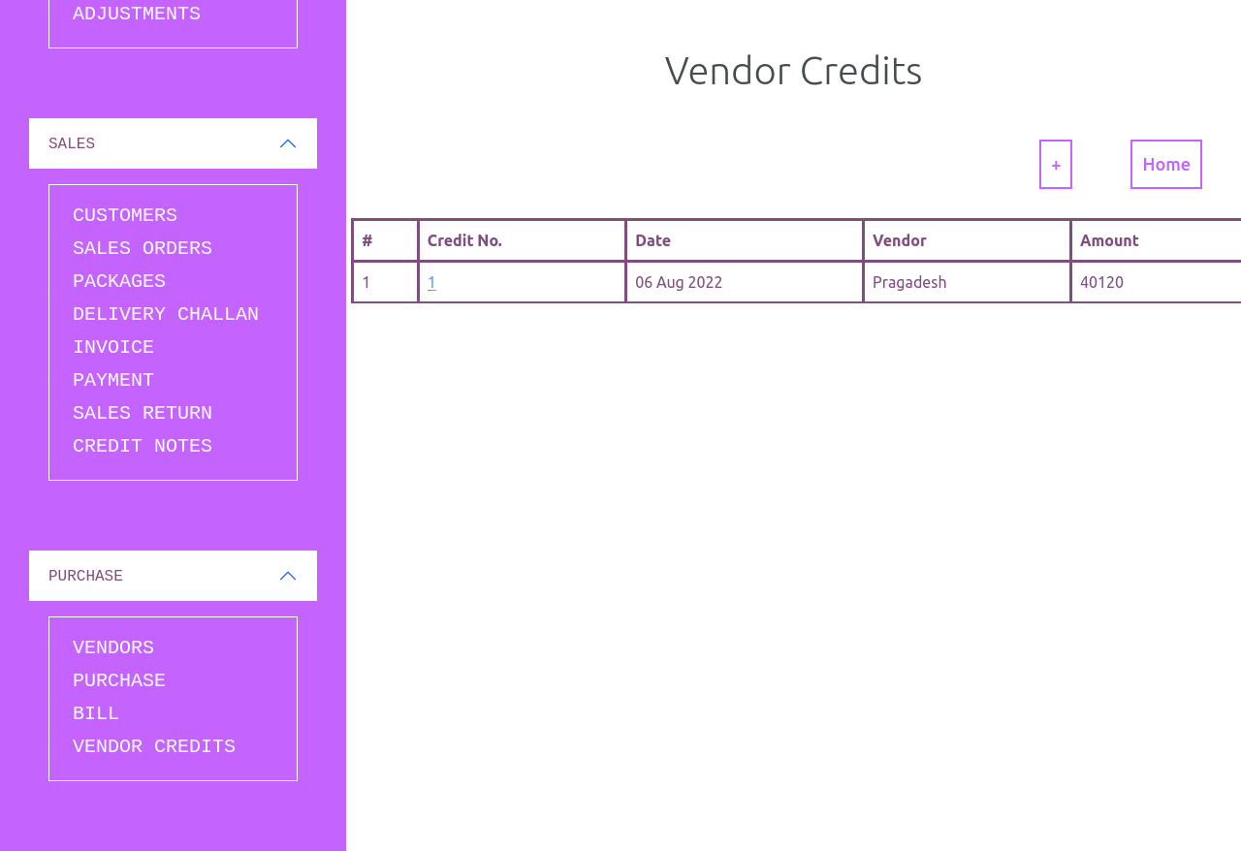

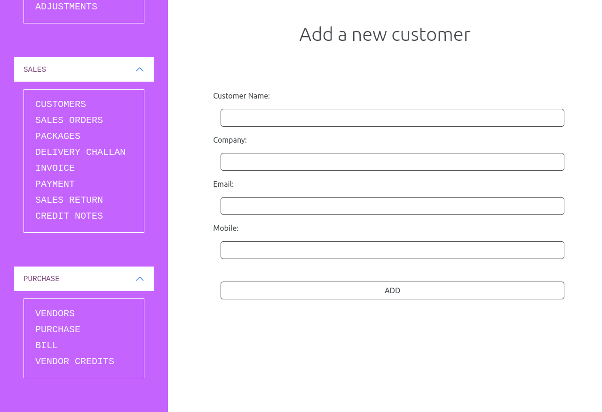

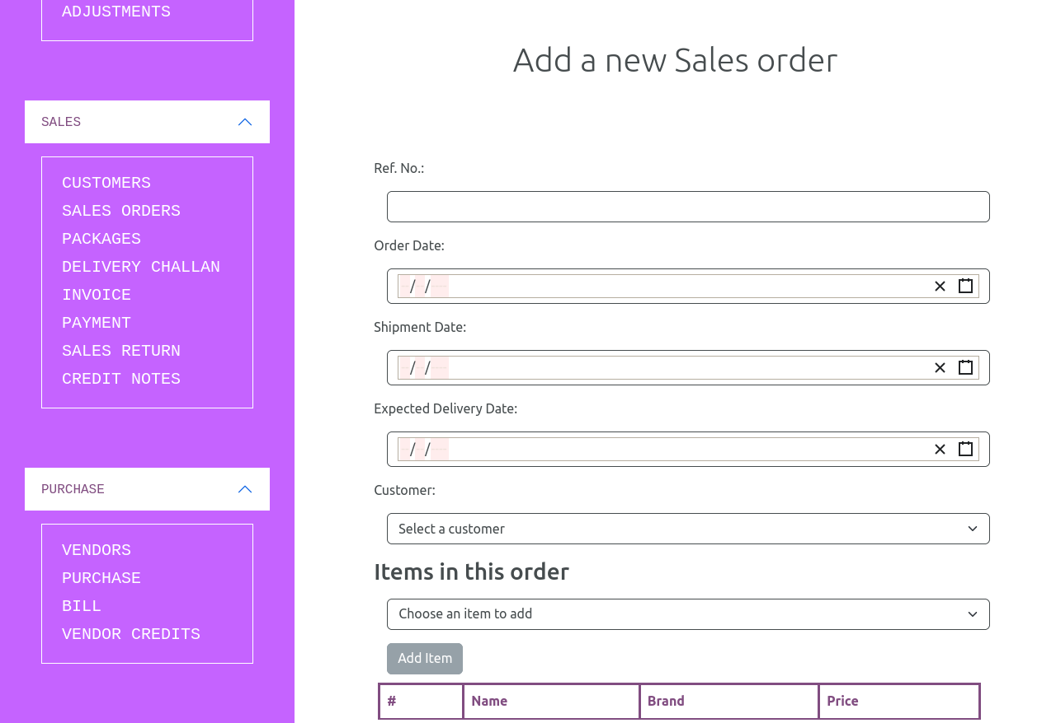

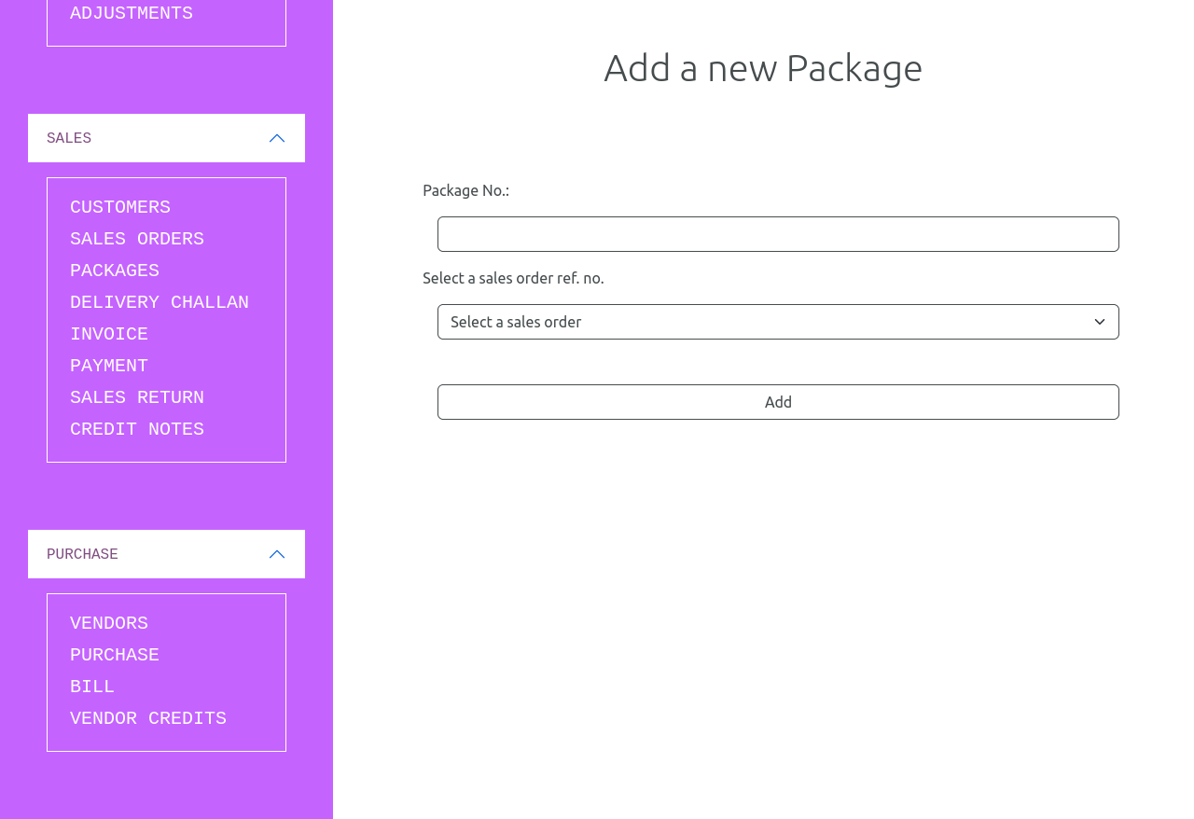

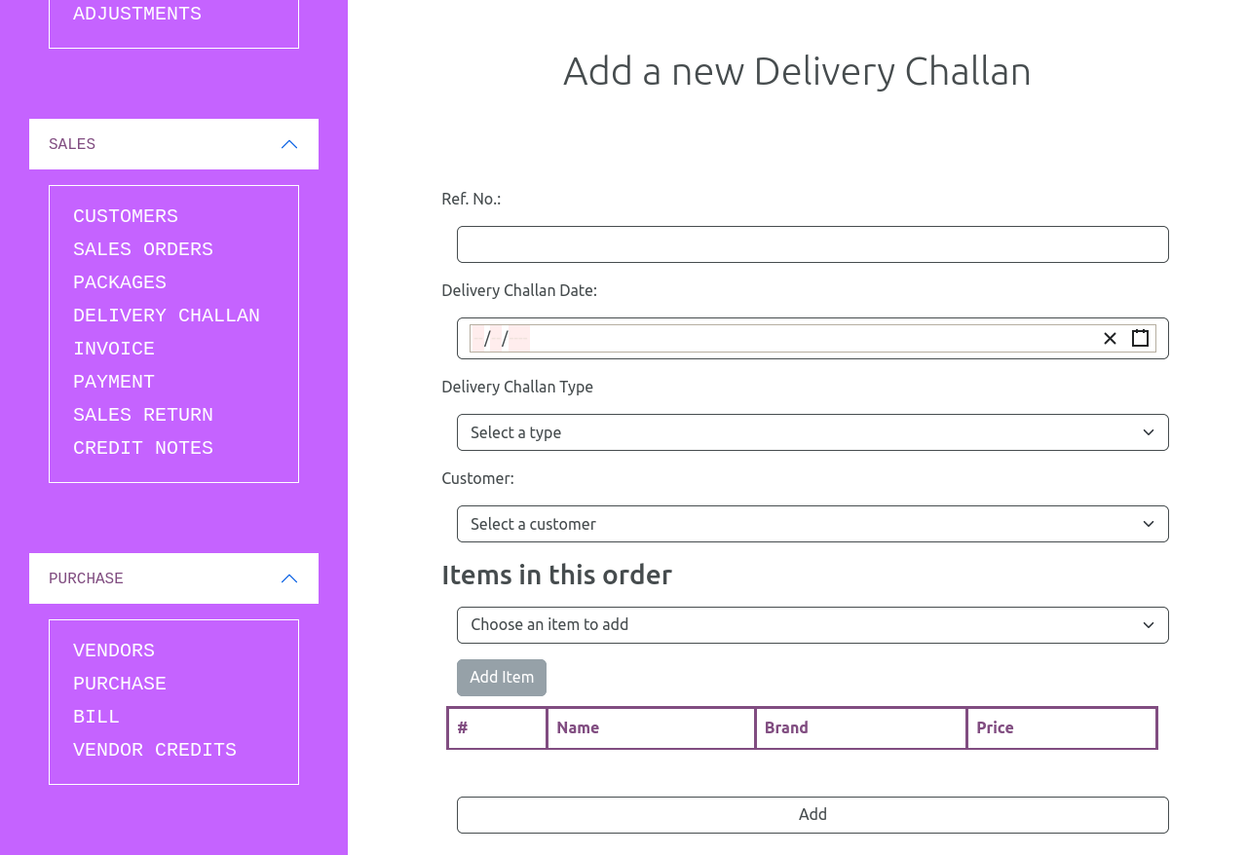

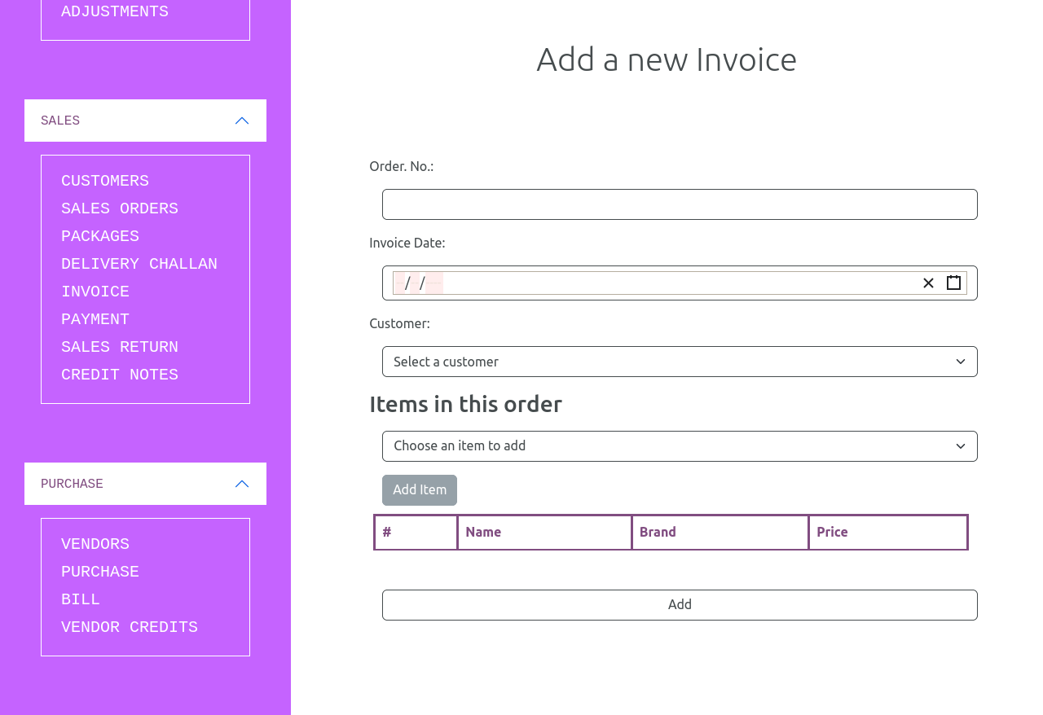

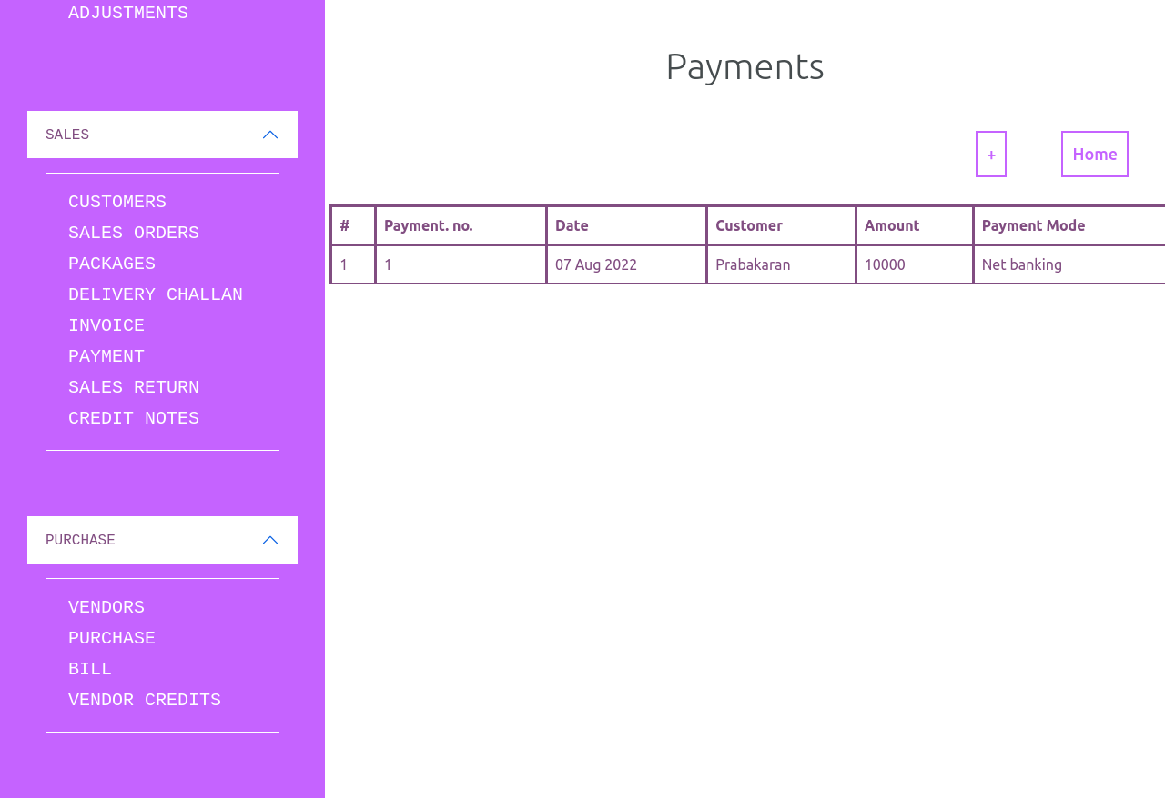

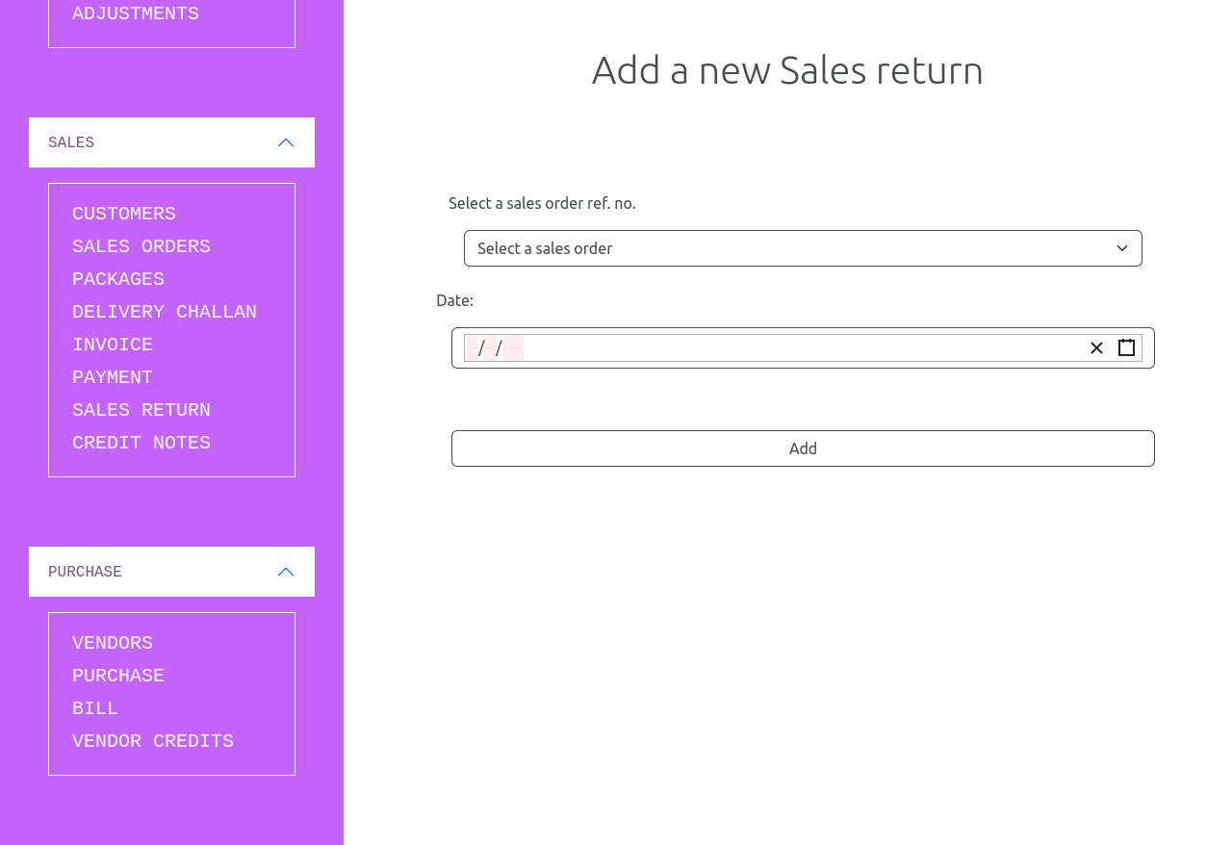

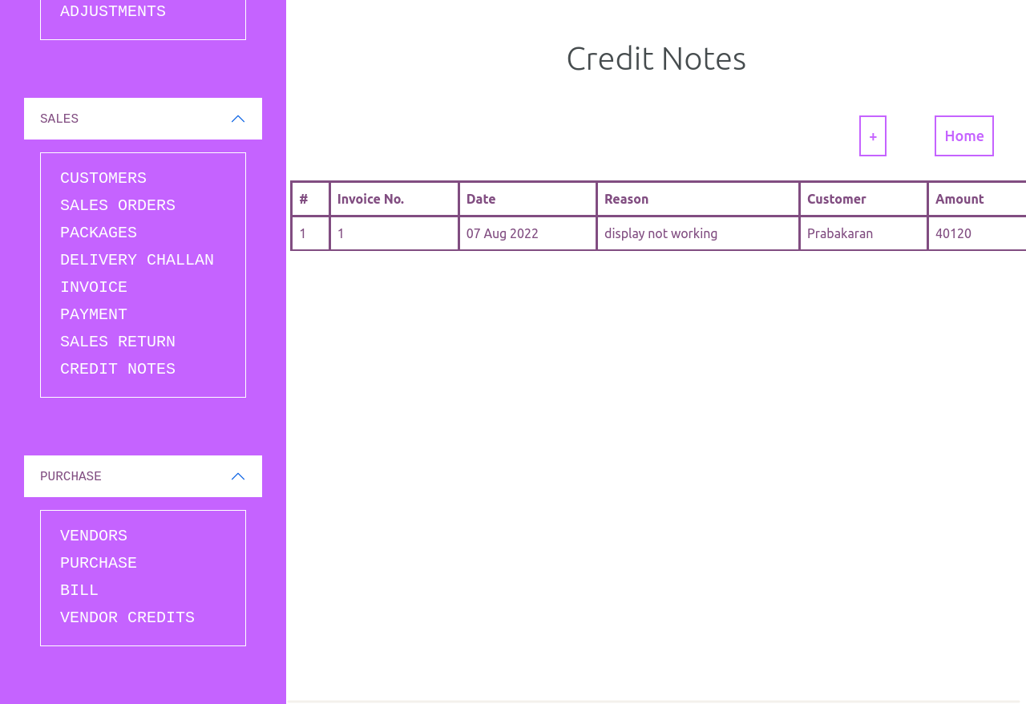

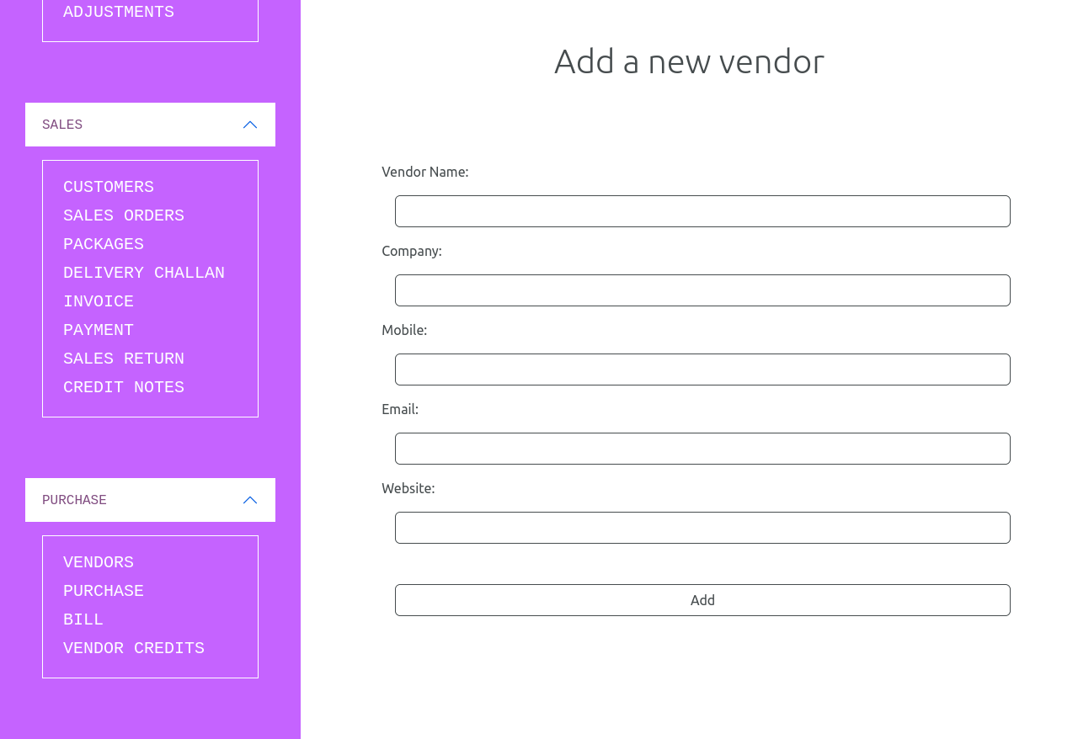

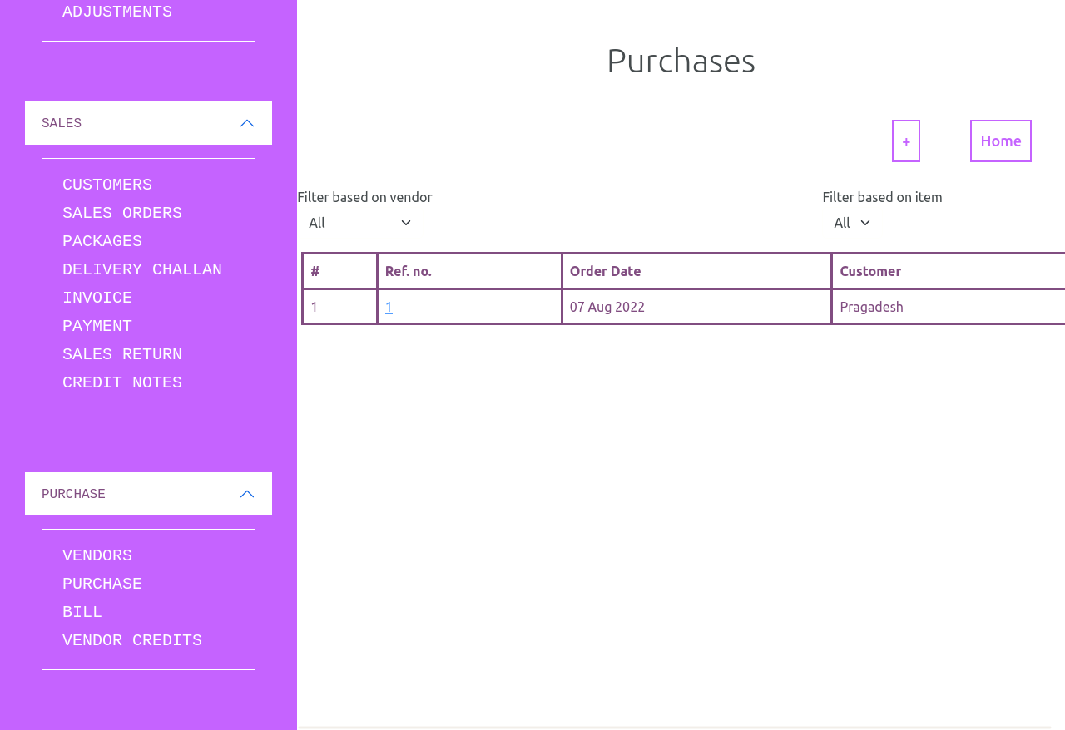

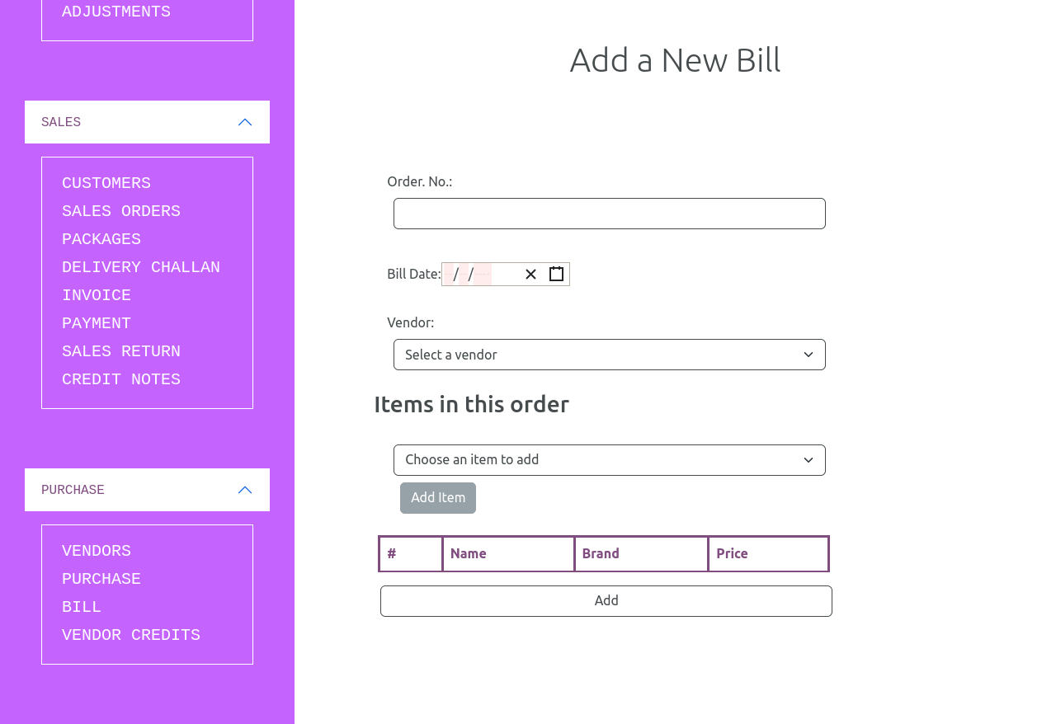



# Link to video

The demo video of the project

<https://youtu.be/8Ma7_3haxr8>

# Link to code

GitHub repository with documents submitted till now and also the code for the project: <https://github.com/Prabakaran2712/TCS-ion-intern>