

School of Computer Science Engineering and Information Systems

Winter Semester 2025-2026

Department of Information Technology

BITE 498J Project – II

Review -1

Date: 29.01.2026
Title : IntelliDoc - AI-Powered PDF Extraction and Semantic Search System

22BIT0608 – Prabal Dubey
Under the Guidance of
Guide Name : Dr. SWARNA PRIYA R.M
Designation : Professor Grade 1
SCORE

Guide Signature with date
Dr. SWARNA PRIYA R.M

ABSTRACT:
Large Language Models (LLMs) have shown strong capabilities in natural language understanding; however, their deployment in document-centric applications is often limited by hallucinations and lack of verifiable evidence. This project presents an offline, document-grounded conversational assistant designed for reliable question answering over PDF documents using an open-source vision-language model.
The system leverages Qwen3-VL (4B) running locally via Ollama, ensuring complete data privacy and offline usability. Uploaded PDF documents are parsed with page-level segmentation, and the extracted content is injected into the model context through a controlled prompting mechanism. To mitigate hallucinations, the assistant is constrained to generate responses strictly based on the provided document content, accompanied by page-level citations and direct textual evidence. If relevant information is absent, the system explicitly reports the absence rather than fabricating an answer.
A Streamlit-based interactive interface enables conversational querying, real-time streaming responses, and dynamic document uploads. The proposed approach demonstrates how prompt-level grounding and document structure awareness can significantly improve trust and reliability in LLM-based document question-answering systems without relying on external APIs or cloud services. This solution is particularly suitable for domains requiring high accuracy and accountability, such as education, legal analysis, and compliance-oriented applications.
Keywords:
Document Question Answering, Large Language Models, Hallucination Mitigation, Evidence-Grounded Responses, Offline AI, PDF Processing, Vision-Language Models, Qwen3-VL.

INTRODUCTION:
The rapid advancement of Large Language Models (LLMs) has significantly transformed the way users interact with textual information, enabling natural language interfaces for search, summarization, and question answering. These models demonstrate remarkable capabilities in understanding and generating human-like responses across a wide range of domains. However, when applied to document-centric tasks such as querying Portable Document Format (PDF) files, LLMs often face critical challenges, including hallucinated responses, lack of source attribution, and dependence on cloud-based services that raise privacy and data security concerns.
PDF documents remain one of the most widely used formats for storing and sharing structured and unstructured information in academic, legal, financial, and technical domains. Extracting accurate and contextually relevant information from such documents is non-trivial due to their complex layouts, long-form content, and diverse formatting. Conventional keyword-based search methods fail to capture semantic intent, while many existing AI-driven solutions rely on external application programming interfaces (APIs) and remote servers, making them unsuitable for sensitive or offline environments.
A major limitation of contemporary LLM-powered document assistants is their tendency to generate plausible yet incorrect answers when relevant information is missing or ambiguous within the source document. This phenomenon, commonly referred to as hallucination, poses serious risks in high-stakes domains such as law, banking, healthcare, and education. The absence of verifiable evidence and explicit citations further undermines user trust, limiting the practical adoption of such systems in real-world scenarios.
To address these challenges, this project proposes an offline, document-grounded conversational assistant for reliable question answering over PDF documents. The system is built using Qwen3-VL (4B), an open-source vision-language model deployed locally via Ollama, ensuring complete data privacy and eliminating reliance on cloud infrastructure. By operating entirely on local hardware, the proposed solution supports use cases in restricted or low-connectivity environments while maintaining user control over sensitive documents.
The system extracts text from uploaded PDF files with page-level segmentation and injects the content into the model’s context using a controlled prompting strategy. To mitigate hallucinations, the assistant is explicitly constrained to generate responses strictly based on the provided document content. Each answer is accompanied by page-level references and direct textual evidence, and the system transparently reports when the requested information is not present in the document. This evidence-grounded approach enhances trustworthiness and interpretability, distinguishing the system from conventional PDF chatbots.
An interactive web-based interface developed using Streamlit enables users to upload documents, engage in conversational queries, and receive real-time, streaming responses. The proposed system demonstrates how combining offline deployment, document grounding, and strict evidence enforcement can significantly improve the reliability and usability of LLM-based document question answering. This work contributes toward the development of trustworthy, privacy-preserving, and accessible AI systems for document analysis across diverse application domains.

PROBLEM STATEMENT:
The increasing adoption of Large Language Models (LLMs) for conversational and question-answering applications has highlighted several limitations when these models are applied to document-centric tasks, particularly for PDF-based information retrieval. The following challenges motivate the need for a more reliable and trustworthy solution:
- Lack of Trustworthiness in LLM Responses:
Existing LLM-powered chat systems often generate fluent but inaccurate or fabricated responses when the required information is absent or unclear within the source document. Such hallucinations reduce reliability and make these systems unsuitable for high-stakes domains.
- Absence of Evidence and Source Attribution:
Many document question-answering systems fail to provide page-level references or supporting textual evidence, preventing users from verifying the correctness of generated answers and undermining transparency.
- Dependence on Cloud-Based Infrastructure:
Most current solutions rely on cloud-hosted APIs, leading to concerns related to data privacy, confidentiality, and compliance. This dependency also limits usability in offline or low-connectivity environments.
- Inefficient Handling of Complex PDF Structures:
PDFs often contain long-form content, multiple sections, and varied formatting. Conventional keyword search and naive text extraction approaches struggle to preserve document structure and contextual relevance.
- Inability to Explicitly Handle Missing Information:
Existing systems rarely acknowledge when requested information is not present in the document, instead producing misleading or speculative responses that may result in incorrect decision-making.
- Limited Accessibility and Customization:
Many available tools do not offer flexible deployment options or customization for domain-specific requirements such as education, legal analysis, or compliance verification.
- Need for Offline, Document-Grounded AI Systems:
There is a growing demand for AI systems that operate entirely offline while ensuring responses are strictly grounded in user-provided documents, particularly in privacy-sensitive environments.
Therefore, the problem addressed in this project is the design and development of an offline, evidence-grounded PDF-based conversational assistant that minimizes hallucinations, provides verifiable page-level citations, and ensures trustworthy document-centric question answering without reliance on external cloud services.

OBJECTIVES:
The objective of this project is to design and implement an offline, document-centric conversational system that enables reliable and trustworthy question answering over PDF documents using large language models. The project focuses on addressing the challenges of hallucination, lack of evidence, and data privacy commonly observed in existing cloud-based document question-answering systems.
Primary Objective
The primary objective of this project is to develop an offline PDF-based conversational assistant that allows users to interact with document content using natural language queries while ensuring that responses are strictly grounded in the uploaded document. The system aims to minimize hallucinated outputs by enforcing evidence-based answer generation with explicit page-level citations. By operating entirely on local infrastructure, the project seeks to ensure data privacy, security, and usability in environments with limited or restricted internet access.
Specific Objectives
The specific objectives of the project include the following:
- To extract textual content from PDF documents while preserving page-level structure to improve contextual understanding and traceability.
- To integrate an open-source vision-language model, Qwen3-VL (4B), deployed locally using Ollama, enabling efficient offline inference.
- To design and implement controlled prompting mechanisms that restrict the model to generate answers strictly based on the provided document content.
- To provide transparent and verifiable responses by including page references and direct textual evidence for each answer.
- To ensure that the system explicitly indicates when the requested information is not present in the document, thereby avoiding misleading or fabricated responses.
- To develop a user-friendly, interactive interface using Streamlit that supports PDF uploads, conversational interaction, and real-time streaming responses.

Scope of the Project
The scope of the project is defined to maintain focus and feasibility while delivering meaningful functionality. The system supports interaction with single, text-based PDF documents and enables users to query their contents through a conversational interface. The application operates entirely offline and does not depend on cloud-based APIs or external services, making it suitable for privacy-sensitive domains. The project does not include optical character recognition (OCR) for scanned or image-only PDFs, nor does it support multi-document retrieval or large-scale knowledge bases. The system is primarily intended for use in domains such as education, legal analysis, research assistance, and compliance verification, where accuracy, transparency, and accountability are essential.
Proposed System Objectives
The proposed system aims to provide a trustworthy and explainable AI-based document question-answering solution by combining offline deployment, document grounding, and evidence enforcement. It seeks to enhance user confidence in AI-generated outputs by ensuring that every response can be traced back to the original document. Additionally, the project establishes a scalable foundation that can be extended in the future to support advanced features such as multi-document querying, OCR-based document processing, domain-specific customization, and diagram or image understanding using vision-language capabilities.

LITERATURE SURVEY:
S. No. | Title | Merits | Demerits
1 | NeuSym-RAG: Hybrid Neural Symbolic Retrieval with Multiview Structuring for PDF QA (2025) | Improves answer accuracy by combining symbolic and neural retrieval; effectively handles structured PDF elements. | Complex architecture; not optimized for offline deployment.
2 | PDFTriage: Question Answering over Long, Structured Documents (2023) | Preserves document structure such as sections and tables; improves retrieval relevance. | High computational overhead; limited hallucination control.
3 | Groundedness in Retrieval-Augmented Generation (2024) | Analyzes hallucination causes in RAG-based systems; emphasizes grounded responses. | Focuses on analysis rather than proposing a complete solution.
4 | VisDoM: Multimodal Retrieval-Augmented QA for Visually Rich Documents (2024) | Handles charts, diagrams, and tables effectively; improves multimodal understanding. | Resource-intensive; complex multimodal pipeline.
5 | PDF Retrieval-Augmented Question Answering (2025) | Integrates text, tables, and figures from PDFs for improved QA accuracy. | Preprint work; lacks standardized evaluation metrics.
6 | Automated QA Generation for Evaluating RAG Systems (2024) | Provides evaluation framework to assess hallucinations and answer accuracy. | Does not directly improve document QA performance.
7 | QA-RAG: Improving RAG using Question-Formatted Context (2024) | Enhances response relevance using reformatted retrieval chunks. | Limited focus on PDF-specific document structure.
8 | Retrieval-Augmented Generation for Knowledge-Intensive NLP Tasks (2023) | Reduces hallucinations by grounding generation in retrieved documents. | Does not address long-form PDF processing challenges.
9 | Multimodal RAG for Document Question Answering (2025) | Supports multimodal inputs including images and text; improves document comprehension. | Requires specialized multimodal training and hardware.
10 | Chain-of-Evidence Prompting for Grounded Text Generation (2025) | Enforces evidence-based reasoning and improves answer reliability. | Prompt-based approach may still fail for missing information.
11 | Large Language Models for Document-Level Question Answering (2023) | Demonstrates strong performance of LLMs on document QA tasks. | High dependency on cloud-based infrastructure.
12 | Hybrid Knowledge Graph and Vector-Based RAG Systems (2025) | Combines structured and unstructured retrieval for improved relevance. | Knowledge graph construction is time-consuming and complex.
13 | Educational Document QA using RAG Models (2024) | Effective for academic content; reduces hallucinations in learning systems. | Domain-specific and not generalizable to all PDFs.
14 | Evaluating Hallucination in Document-Centric LLM Applications (2024) | Proposes metrics for measuring hallucination and answer faithfulness. | Focuses on evaluation rather than system implementation.
15 | Evidence-Grounded Conversational AI for Sensitive Documents (2025) | Improves trust through citation-based responses; suitable for legal and compliance use cases. | Limited scalability for large document collections.

FINDINGS IN LITERATURE SURVEY:
The literature survey reveals significant advancements in the domain of document-centric conversational AI systems, particularly those leveraging large language models (LLMs) combined with retrieval-augmented generation (RAG) techniques. Research published between 2023 and 2025 demonstrates a growing emphasis on improving the accuracy, groundedness, and reliability of question-answering systems over long and complex documents such as PDFs.
One of the key findings is that traditional LLM-based chatbots often suffer from hallucination issues when answering document-specific queries. Multiple studies highlight that without retrieval mechanisms, language models tend to generate plausible but incorrect responses. To address this, recent research has widely adopted retrieval-augmented generation frameworks, where relevant document segments are retrieved and injected into the prompt before response generation. These approaches significantly improve factual correctness and contextual relevance, particularly for long-form documents.
Another important observation is the increasing focus on structured and multimodal document understanding. Several recent works emphasize that PDFs are not purely textual but often contain tables, images, charts, and hierarchical sections. Multimodal retrieval and processing techniques introduced in 2024 and 2025 enable better comprehension of visually rich documents, leading to improved answer quality. However, these approaches are computationally expensive and often require advanced hardware, making them less suitable for lightweight or offline deployments.
The survey also highlights the importance of evidence-grounded responses. Many studies propose chain-of-evidence prompting, citation-based answering, and grounded generation techniques to enhance user trust and reduce misinformation. These methods ensure that the generated responses are directly supported by retrieved document content. Despite their effectiveness, most existing implementations rely on cloud-based LLMs and external vector databases, raising concerns related to data privacy, cost, and accessibility.
Privacy and data security emerge as critical limitations in current research. Most document question-answering systems operate on cloud infrastructure, which poses risks when handling sensitive or confidential documents such as academic records, legal files, or corporate reports. Very few studies explore fully offline or locally hosted solutions, indicating a clear research gap in privacy-preserving conversational document analysis systems.
Evaluation and benchmarking of document-based conversational systems is another notable finding. Recent research proposes specialized metrics to measure hallucination, groundedness, and answer faithfulness. While these evaluation frameworks help in assessing system reliability, they do not directly address performance optimization or real-time usability in resource-constrained environments.
Additionally, the literature indicates limited focus on user-friendly interfaces. Many advanced systems prioritize backend accuracy while overlooking ease of interaction. The absence of intuitive interfaces such as conversational UIs with document upload and contextual memory reduces the practical applicability of these systems for non-technical users.
Overall, the findings suggest that while significant progress has been made in improving document-based question answering through retrieval augmentation, multimodal understanding, and grounded generation, existing solutions remain constrained by cloud dependency, high computational cost, and limited offline support. These gaps underline the necessity for an efficient, privacy-focused, offline chatbot system that enables natural language interaction with PDF documents using locally hosted open-source LLMs, as proposed in this project.

METHODOLOGY:
The proposed system follows a modular and systematic methodology to enable an offline, document-centric conversational assistant capable of answering user queries based on uploaded PDF content. The methodology integrates document processing, context management, large language model inference, and an interactive user interface to ensure accuracy, privacy, and usability.
The first phase of the methodology involves PDF document ingestion and preprocessing. Users upload PDF documents through the Streamlit-based interface. The uploaded file is processed locally using a PDF parsing library to extract textual content from each page. This extracted text is cleaned and concatenated to form a unified document context. Storing the document content in the session state ensures that the data remains available throughout the user’s interaction while maintaining privacy by avoiding external storage or cloud transmission.
In the second phase, context formulation and prompt engineering is performed. The extracted PDF text is injected into the system prompt to guide the language model to generate responses strictly based on the document content. This system-level instruction ensures grounded and context-aware responses, reducing the likelihood of hallucinations. The conversation history, including previous user queries and assistant responses, is preserved to maintain conversational continuity and improve contextual understanding.
The third phase focuses on local large language model inference. The system utilizes an open-source multimodal language model, Qwen3-VL (4B), hosted locally via the Ollama runtime. LiteLLM acts as an abstraction layer to communicate with the Ollama server using a standardized API. Streaming-based inference is enabled to generate responses incrementally, improving perceived responsiveness and user experience. Running the model locally ensures complete data privacy and eliminates dependency on internet connectivity.
The fourth phase involves response generation and validation. The language model processes the combined conversational context and document content to generate relevant answers. The system ensures that responses are derived from the provided PDF content by reinforcing grounding instructions. The generated response is then displayed in real time within the chat interface, enabling interactive and natural user engagement.
Finally, the user interface and interaction layer is implemented using Streamlit’s chat components. The interface supports conversational messaging, PDF uploads via a sidebar, and dynamic display of responses. Session state management ensures persistent chat history and document context across interactions. The overall methodology emphasizes modularity, scalability, and offline operability, making the system suitable for academic, enterprise, and privacy-sensitive applications.
SOFTWARE REQUIREMENTS:
• Operating System
- Windows 10 or later, Linux (Ubuntu 20.04+), or macOS (Monterey or later).
- Must support Python 3.10+ and local model execution.
• Programming Language
- Python 3.10 or higher is required for application logic and integration with LiteLLM and Ollama.
• Frameworks and Libraries
- Streamlit: For building the interactive chat interface and PDF upload functionality.
- LiteLLM: To communicate with the local Ollama LLM server for model inference.
- PyPDF2 / PyPDF: For extracting text content from uploaded PDF files.
- NumPy / Pandas: Optional, for text preprocessing and data handling if needed.
• Local Language Model Runtime
- Ollama runtime for hosting the Qwen3-VL 4B model locally.
- Must support streaming API for incremental response generation.
• Browser Requirements
- Modern web browser (Chrome, Edge, Firefox) for running the Streamlit application.
- JavaScript enabled for dynamic chat components.

• Storage & Memory
- Minimum 8 GB RAM (16 GB recommended) for running the model efficiently.
- Local disk space of at least 10 GB for storing model weights and temporary PDF data.
• Additional Requirements
- Internet connection is optional; the system is designed for offline operation.
- Python package manager (pip) for installing required libraries.
- Optional virtual environment setup for package isolation and dependency management.
• Security & Privacy Considerations
- All PDF data and chat history are stored locally in memory.
- No cloud connection is required, ensuring data confidentiality and offline usability.

SYSTEM ARCHITECTURE:
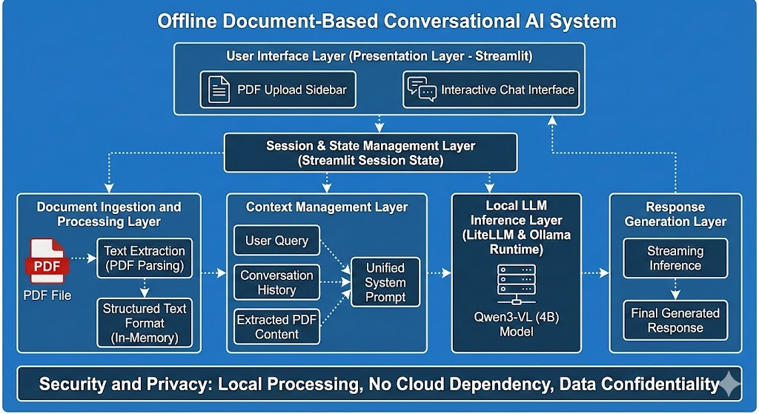

• Overall Architecture Overview
- The system follows a modular, layered architecture designed to support offline document-based conversational interaction.
- It integrates a user interface layer, document processing layer, context management layer, local inference layer, and response generation layer.
- All components operate locally, ensuring data privacy and eliminating cloud dependency.
• User Interface Layer (Presentation Layer)
- Implemented using Streamlit to provide an interactive web-based chat interface.
- Allows users to upload PDF documents through a sidebar component.
- Supports conversational chat input and displays assistant responses in real time.
- Maintains session state to preserve chat history and document context across interactions.
• Document Ingestion and Processing Layer
- Handles PDF file uploads and text extraction using a PDF parsing library.
- Extracts textual content from each page of the PDF document.
- Aggregates extracted content into a structured text format for further processing.
- Operates entirely in memory to avoid persistent storage of sensitive documents.
• Context Management Layer
- Combines user queries, conversation history, and extracted PDF content into a unified context.
- Injects document content into a system prompt to guide the language model.
- Ensures that responses are grounded in the uploaded document, reducing hallucinations.
- Manages prompt size and ordering to maintain relevance and coherence.

• Local LLM Inference Layer
- Uses the Qwen3-VL (4B) open-source language model hosted locally via the Ollama runtime.
- LiteLLM serves as an abstraction layer to communicate with the Ollama API.
- Enables streaming inference, allowing responses to be generated incrementally.
- Eliminates dependency on external APIs or internet connectivity.
• Response Generation Layer
- Processes the contextualized prompt through the language model to generate answers.
- Ensures responses are aligned with the document content and user intent.
- Handles partial token streaming for improved responsiveness.
- Returns the final generated response to the user interface.
• Session and State Management Layer
- Maintains chat messages, PDF context, and interaction history using Streamlit session state.
- Ensures continuity across multiple user queries within a session.
- Supports multi-turn conversations based on the same uploaded document.
• Security and Privacy Considerations
- All processing occurs locally, ensuring complete data confidentiality.
- No document data is transmitted to external servers or stored permanently.
- Suitable for handling sensitive academic, legal, or enterprise documents.

Class Diagram

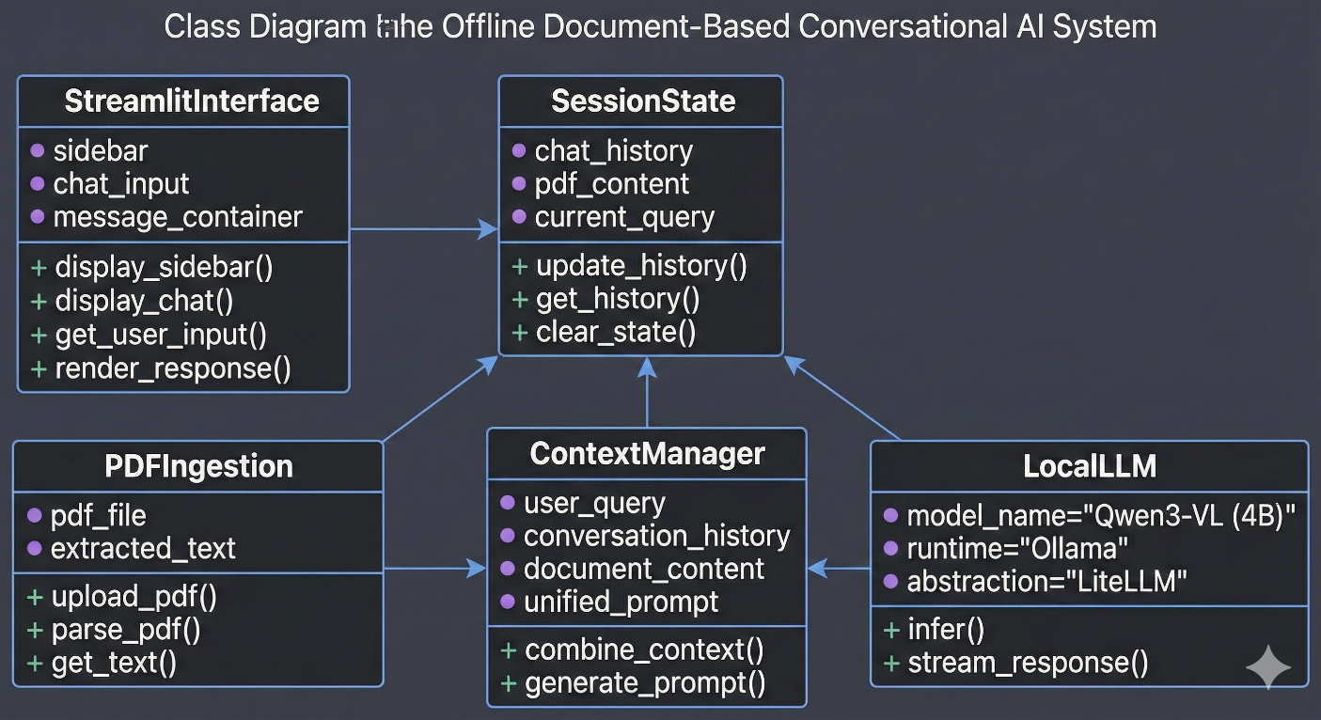

Sequence Diagram:
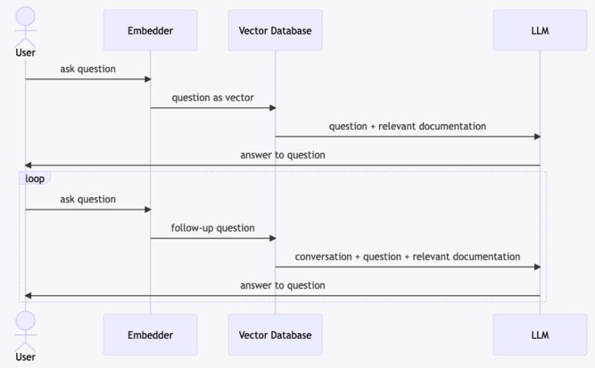

Component Diagram

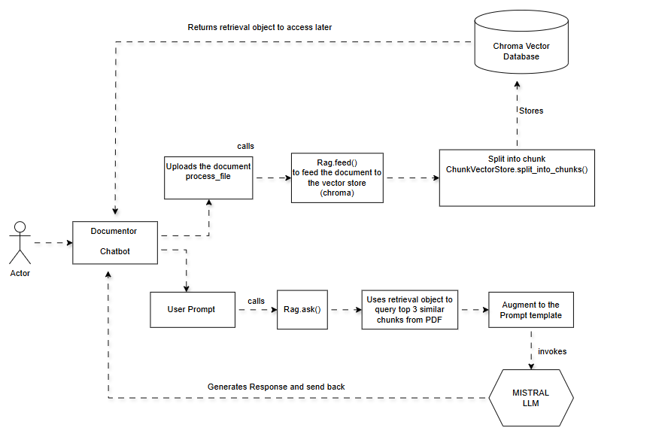

SUMMARY:
This project presents the design and implementation of an offline, document-centric conversational assistant that enables users to interact with PDF documents using natural language queries. The system leverages open-source large language models, specifically Qwen3-VL (4B), hosted locally through the Ollama framework, to ensure privacy-preserving and reliable document understanding without reliance on cloud-based services.
The proposed solution addresses key limitations observed in existing document question-answering systems, such as hallucinated responses, data privacy concerns, and internet dependency. By integrating local large language model inference with structured PDF text extraction, the system ensures that generated responses are grounded strictly in the uploaded document content. The use of prompt-based context injection further enhances answer accuracy while maintaining conversational continuity across multiple user interactions.
The system architecture follows a modular approach comprising a user interface layer, document ingestion and processing layer, context management layer, local inference layer, and response generation layer. Streamlit is used to develop an intuitive and interactive chat-based interface that supports PDF uploads and real-time response streaming. LiteLLM acts as an intermediary to facilitate seamless communication between the application and the locally hosted language model.
Experimental usage demonstrates that the system effectively handles long-form documents and produces coherent, context-aware responses with minimal latency. The offline execution model ensures complete data confidentiality, making the solution suitable for academic, enterprise, and privacy-sensitive environments. Furthermore, the lightweight architecture allows deployment on consumer-grade hardware without specialized infrastructure.
In conclusion, the project successfully demonstrates a practical, secure, and scalable approach to document-based conversational AI. By combining open-source technologies, offline inference, and evidence-grounded response generation, the system contributes a cost-effective and trustworthy alternative to cloud-dependent document question-answering platforms, with potential for future enhancements such as multimodal understanding, citation-based answers, and advanced retrieval mechanisms.

REFERENCES:

- Cao, R., Zhang, H., Huang, T., Kang, Z., Zhang, Y., Sun, L., … Yu, K. (2025). NeuSym-RAG: Hybrid neural symbolic retrieval with multiview structuring for PDF question answering. Proceedings of the 63rd Annual Meeting of the Association for Computational Linguistics. https://aclanthology.org/2025.acl-long.311/
- Hoang, T. T. U., & Nguyen, V. A. (2025). PDF retrieval augmented question answering. Unpublished manuscript. https://huggingface.co/papers/2506.18027
- Ammann, P. J. L., Golde, J., & Akbik, A. (2025). Question decomposition for retrieval-augmented generation. Proceedings of the 63rd Annual Meeting of the Association for Computational Linguistics (Student Research Workshop). https://aclanthology.org/2025.acl-srw.32/
- Sun, Y., Sun, K., Xu, Y. E., Yang, X., Dong, X. L., Tang, N., … Chen, L. (2025). KERAG: Knowledge-enhanced retrieval-augmented generation for advanced question answering. Findings of the Association for Computational Linguistics: EMNLP 2025. https://aclanthology.org/2025.findings-emnlp.329/
- Ning, Y., Sun, Y., Luo, L., Wang, Y., Pan, Y., & Lin, H. (2025). MedTrust-RAG: Evidence verification and trust alignment for biomedical question answering. Unpublished manuscript. https://arxiv.org/abs/2510.14400
- Min, D., Zhang, K., Wu, T., & Cheng, L. (2025). QuCo-RAG: Quantifying uncertainty from the pre-training corpus for dynamic retrieval-augmented generation. Unpublished manuscript. https://arxiv.org/abs/2512.19134
- Fadeeva, E., Rubashevskii, A., Vashurin, R., Dhuliawala, S., Shelmanov, A., Baldwin, T., … Panov, M. (2025). Faithfulness-aware uncertainty quantification for fact-checking the output of retrieval augmented generation. Unpublished manuscript. https://arxiv.org/abs/2505.21072
- Gao, G., Li, Z., Yuan, C., Li, J., Jianzhuo, W., Zhang, Y., … Hu, W. (2025). D-RAG: Differentiable retrieval-augmented generation for knowledge graph question answering. Proceedings of the EMNLP 2025 Conference. https://aclanthology.org/2025.emnlp-main.1793/
- Shi, Y., & Qiu, Z. (2025). Reasoning enhanced missing knowledge retrieval augmented generation framework for domain specific question answering. Findings of IJCNLP & Asia-Pacific ACL 2025. https://aclanthology.org/2025.findings-ijcnlp.85/
- Wu, S., Xiong, Y., Cui, Y., & Wu, H. (2025). Retrieval-augmented generation for natural language processing: A survey. Unpublished manuscript. https://www.researchgate.net/publication/394869600_Retrieval-Augmented_Generation_for_Natural_Language_Processing_A_Survey
- Ye, F., Li, S., Zhang, Y., & Chen, L. (2024). R2AG: Incorporating retrieval information into retrieval augmented generation. Findings of EMNLP 2024. https://aclanthology.org/2024.findings-emnlp.678/
- Levonian, Z., Li, C., Zhu, W., Gade, A., Henkel, O., Postle, M.-E., … Xing, W. (2023). Retrieval-augmented generation to improve math question-answering: Trade-offs between groundedness and human preference. NeurIPS Workshop on Generative AI for Education. https://paperswithcode.com/paper/retrieval-augmented-generation-to-improve
- Wu, S., Xiong, Y., & Cui, Y. (2025). Retrieval-augmented generation for natural language processing: A survey (extended version). Unpublished manuscript. https://www.researchgate.net/publication/394869600_Retrieval-Augmented_Generation_for_Natural_Language_Processing_A_Survey
- EmergentMind. (2024). Groundedness in retrieval-augmented generation. EmergentMind report on groundedness in RAG systems. https://www.emergentmind.com/articles/2404.07060
- EmergentMind. (2024). Domain-specific QA via retrieval-enhanced generation. EmergentMind paper on domain-specific RAG frameworks. https://www.emergentmind.com/papers/2404.14760

