::Steps to compile, run and test the program.

For Linux

1. First go to the folder location
cd path/to/Java_Assignment3

2. Run this exact command. It will compile, run the program, and automatically delete the .class files the moment you close the program.

javac BirthPlace/*.java && java BirthPlace.MainFrame; rm BirthPlace/*.class

For Windows

1. First go to the folder location
cd path/to/Java_Assignment3

2. Commmand to compile all the java files in the BirthPlace package at once and run the code.
javac BirthPlace\*.java && java BirthPlace.MainFrame & del BirthPlace\*.class

:: Overview of the design and GUI layout.
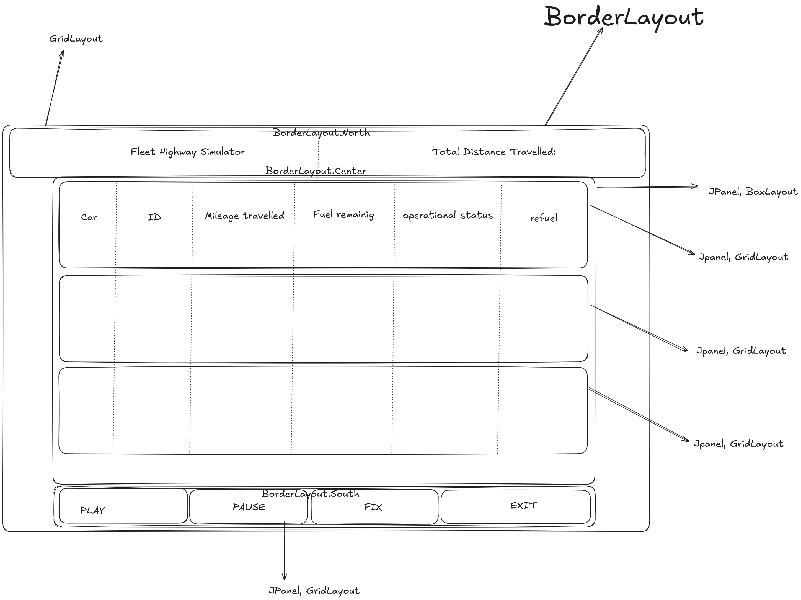

Main Frame: JFrame (BorderLayout)
│
├── NORTH: pHeader (GridLayout 1x3)
│ ├── l0 (Title)
│ ├── l1 (Label: "Total Distance Travelled:")
│ └── l2 (Distance Value)
│
├── CENTER: JScrollPane → p0 (BoxLayout Y_AXIS)
│ ├── p1 (GridLayout 1x6) - Vehicle 1 Row
│ │ ├── l11, l12, l13, l14, l15, bRefuel1
│ │
│ ├── p2 (GridLayout 1x6) - Vehicle 2 Row
│ │ ├── l21, l22, l23, l24, l25, bRefuel2
│ │
│ └── p3 (GridLayout 1x6) - Vehicle 3 Row
│ ├── l31, l32, l33, l34, l35, bRefuel3
│
└── SOUTH: pDown (GridLayout 1x4)
├── bPlay
├── bPause
├── bFix
└── bExit

:: Explanation of how the simulation threads were controlled via the GUI.

2 Places threads, for example Aeroplane, one in th threadHandle1 and MainFrame.
so 1st, in the MainFrame, new threadHandle1 runs which creates the thread process running for the Airplane
and after that in the MainFrame runGuiForAir thread creates.

threadHandler1 runs the value updating in the Airplane object,
and runGuiForAir handles printing the values to the textField.

:: Description of the race condition and synchronisation fix, accompanied by required screenshots/logs (before and after correction).

The race condition was happening in the in the global variable Total_distance_travelled_by_all,

1.Bcz the operationg of adding some value to this vairable Total_distance_travelled_by_all is not Atomic in the sense,
the step happens as follow,
First the current value of the variable is placed inside a register,
Second one is added to it,
Third, one is storing the updating value from register to varibale.

Problem: When assume only 2nd step has occurede and then the OS switches the process and the value isn't updated, so
for ex, variable value = 0; in register the 0 + 1 is stored but jsut before storing the os swithces process
so other process takes the value of the variable and sees 0, so adds and stores 1 and then the first thread runs and also stores 1.
so here the problem comes two thread added +1 values but the final output was 1

2. Solution, using syncronized(Object), syntax, it only allows only one thread to access the object at a time.

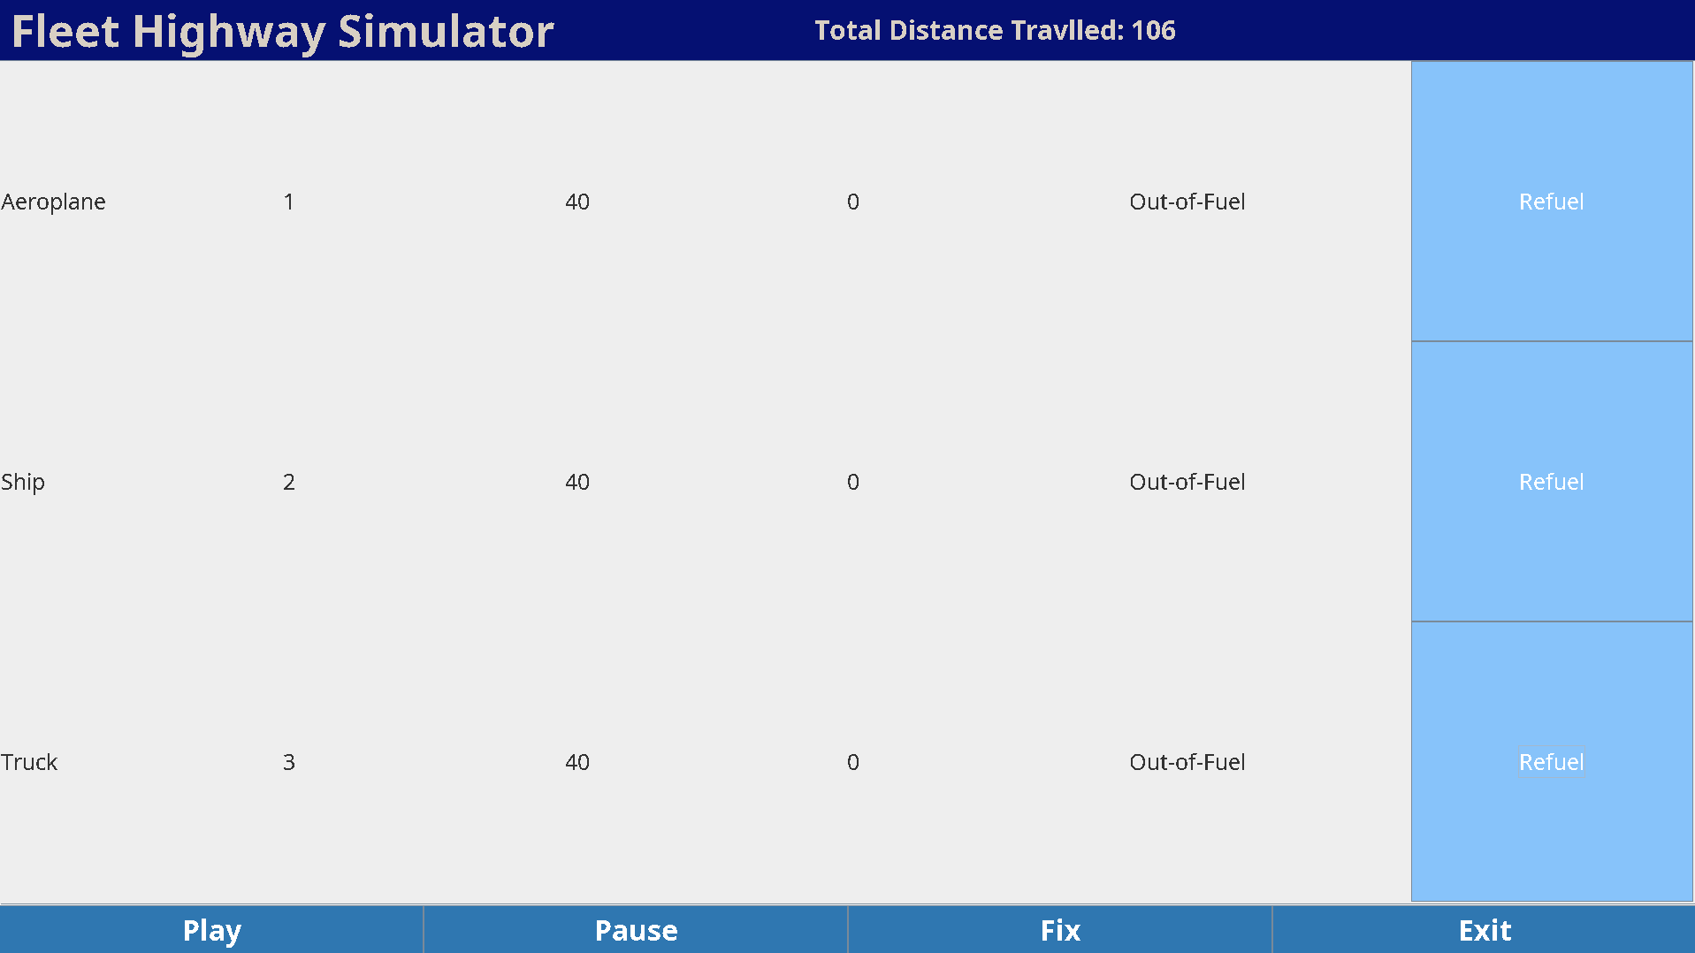
Error:
Total distance: 106,
Total distance by each
= 40+40+40 = 120

120 NOT EQUALS 106

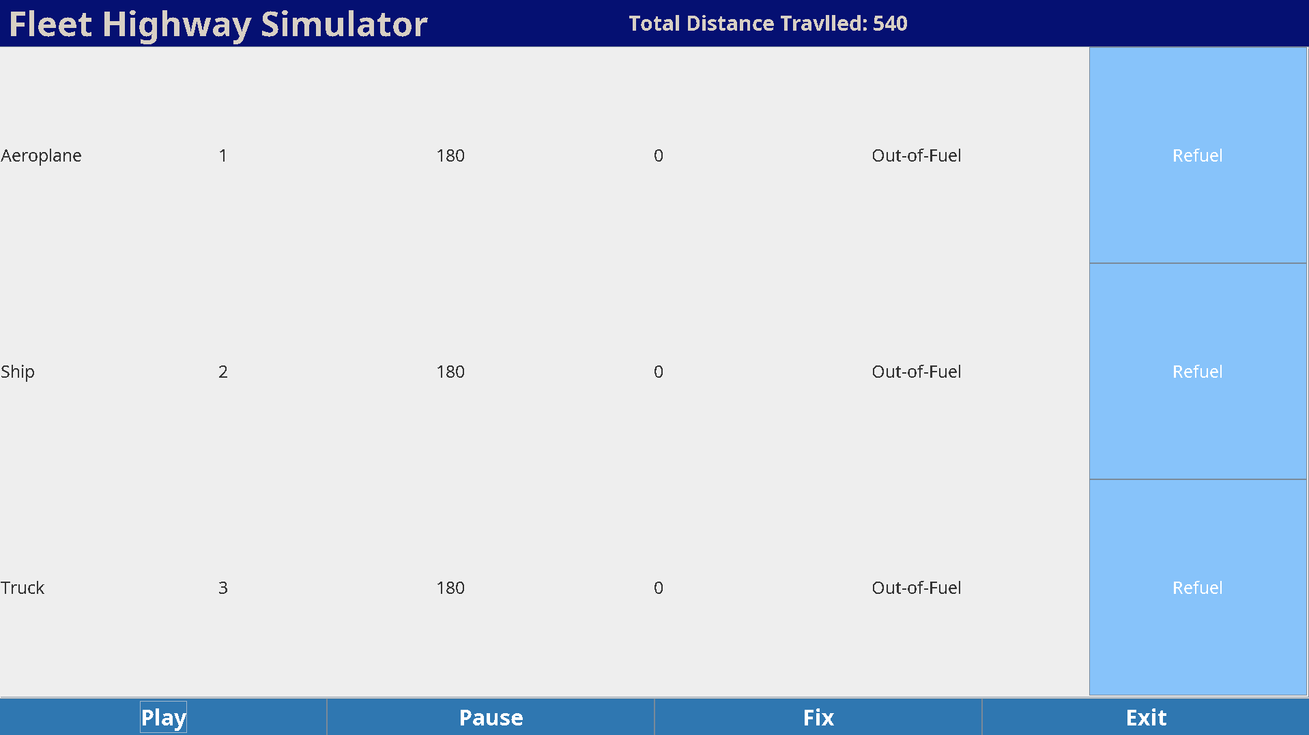

After Pressing Fix:
Total distance travelled: 540
Total distance by each
= 180+180+180 = 540

540 = 540 Fixed by using syncronized()

:: A brief note on GUI thread-safety considerations, such as the importance of the Event Dispatch Thread (if Swing is used).

Used SwingUtilites.invokeLater(() → {}) method, bcz the swing is not Thread Safe so the this method puts the UI updation codes inside the () in a queue called Event Dispatch Thread Handler which makes it thread safe.

Without it many errors like freezing, glitching, breakdown of the UI can occur, our this assignment is light so by luck we didn’t had those errors but in like real world big projects heavy UI this will like definitely most likely to occur and breaking there cannot be aceptable at all so,
Thats why its use wherever we need to update the UI from threads.

