**NUTRITION LITERATURE ANALYSIS**

**Assessment task 1**



Submitted By: Sangam Shrestha

Student Id: S00388813

Submitted on: March 24, 2024

|  |  |
| --- | --- |
| First Author | N. Wright |
| Year of Publication | 2017 |
| Journal Name | Nutrition & Diabetes |
| Study Design | Randomized controlled trial (RCT) |

# Part 1: Journal, author information, and study design

# Part 2: Peer-review

The BROAD study, a reviewed article, checks how a plant-based diet cause many problem like obesity, diabetes, heart disease etc. It makes sure that study is of good quality and reliable as it assesses research methods, data analysis and soundness overall.

# Part 3: Introduction

The background literature of the article "The BROAD study" indicates the insufficiency of randomized controlled studies concerning the impact of whole food plant-based (WFPB) diet as a treatment for higher levels of BMI or dyslipidemia. Although prior research suggests the benefits of following a plant-based diet, there have been fewer robust randomized controlled trials on this topic. (Wright et al., 2017)

The rationale for the study stems from this gap in existing research. In the absence of randomized evidence, there is no clear indication whether the WFPB diets can successfully address obesity, ischemic heart disease, or diabetes. Hence, the study aims to bridge the knowledge gap by setting off to research the efficacy of a community-oriented diet plan built around a WFPB diet in reducing BMI and cholesterol levels among people with obesity and the related comorbidities.

The goal of the research is to estimate the impact of the WFPB dietary intervention in reaching the main targets of BMI and lipid level lowering in the course of a 6-month period as well as extending the research. The results reveal the perspective of the benefits of the WFPB diet for people with obesity, ischemic heart disease, or diabetes.

# Part 4: Study design

The randomized controlled trials (RCT) are considered the strongest research tool due to their high internal validity. Individuals in this trial are randomly assigned to an intervention group that will be receiving a particular treatment or a control group with standard care or a placebo (*National Institute of Diabetes and Digestive and Kidney Diseases (NIDDK)*, n.d.).

**Strengths:**

* **Causality:** RCTs helps in establishing the causality of the intervention and outcomes. It reduces bias and confounders, consequently making it easier to establish causality (Altman & Doré, 1990).
* **Controlled Conditions:** RCTs provide the opportunity for researchers to control variables and keep the conditions uniform across treatment groups. This control increases the reliability of the results (Grimes & Schulz, 2002).
* **Generalizability:** Effective RCTs with representative samples improves validity of the study and makes the results more useful in real situations (Rothwell, 2005).

**Weaknesses:**

* **Ethical Considerations:** Some RCTs may face ethical issues, especially when omitting treatments from the control group that have proven useful to treated participants. (Miller & Joffe, 2009).
* **Feasibility and Cost:** RCTs can be very resource-consuming and time-consuming. They need huge budgets, infrastructure, and specialists for planning, implementing and finally interpreting them. (Rothwell, 2005).

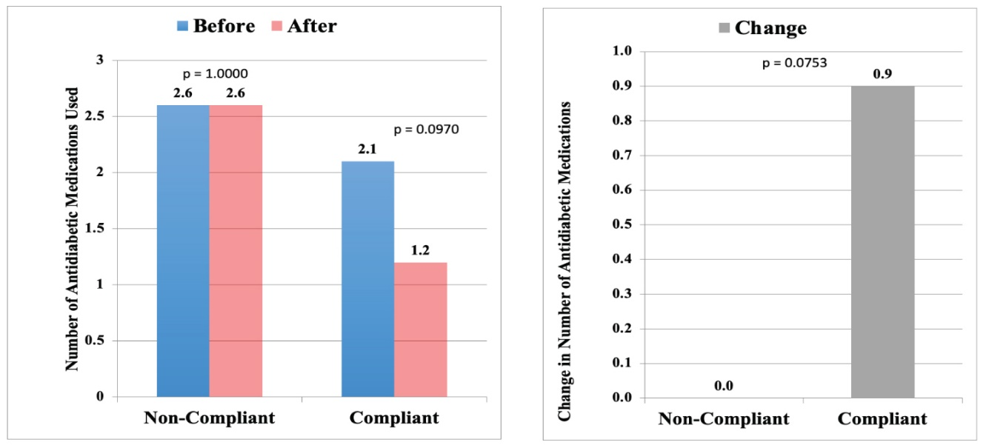

Figure 1: Dietary impact on reduction of anti-diabetic medications and change in the number of medications between the two groups: non-compliant vs. compliant (Panigrahi, 2021)

Non-Compliant Group = without dietary change

Compliant Group = with dietary change

The diagram shows the changes in two key health markers: body mass index (BMI) and the number of medications used for antidiabetic control. It compares the effects in the control group and that of the intervention group who followed a whole food, plant-based diet (WFPB) for six months. There was a mean reduction of 0.9 antidiabetic medications per person in the dietary compliant group whereas there was no change in the dietary non-compliant group. (Panigrahi, 2021).

# ****Part 5: Methods****

The study was conducted including participants with obesity or overweight and at least one of several health conditions that are often associated with one's diet including type 2 diabetes and coronary heart disease or metabolic syndrome (Wright et al., 2017). These conditions are regarded as such by credible organizations such as the American Heart Association (2023) and the National Institute of Diabetes and Digestive and Kidney Diseases (2023) as being potential contributors to dietary patterns.

Participants were divided into either:

* **Intervention Group:** This group followed a low-fat, whole-food, plant-based diet for 18 weeks.
* **Control Group**: This group continued with their usual care from their doctor or other healthcare provider.

Researchers tracked health outcomes like weight, blood pressure, cholesterol, and blood glucose. Data came from medical records, self-reports, and lab tests. BMI was measured, and cholesterol levels were analyzed. Additional data on heart and metabolic health were collected during clinical visits.

# Part 6: Results

The main findings of the study, "The BROAD study," indicate significant improvements in both body mass index (BMI) and cholesterol levels among participants following a whole food plant-based (WFPB) diet intervention compared to those receiving normal care.

It was observed that the 6-month point in the study showed a significantly greater reduction in the mean of BMI among participants following the WFPB diet compared to those receiving normal care. The change in BMI between the two groups was statistically noteworthy, implying the efficiency of the WFPB diet in weight loss. The statistical results showed a significant decline in the average cholesterol level of the WFPB diet group relative to the normal care group after the dropouts were excluded (p< .05). In addition, those in WFPB diet group demonstrated persisting decreases in both BMI and cholesterol levels at 12-month after (Wright et al., 2017).

# Part 7: Reflection

The findings of "The BROAD study" offer valuable perceptions into the impact of a whole food plant-based (WFPB) diet on health consequences, particularly in individuals with obesity, ischaemic heart disease, or diabetes. Reflecting on these findings has prompted me to reconsider certain aspects of my understanding of nutrition.

The RCT design minimizes bias and enhances the study's persuasiveness. Targeting individuals with specific health issues increases the relevance of the results. However, limitations include a small sample size and single-location setting, which may limit generalizability. Additionally, the control group receiving only usual care may introduce disparity, complicating the assessment of the plant-based diet's effect. This research study complements other studies that are being conducted which show that plant-based diet contributes to weight-loss and a better cardiovascular health. Several researches have proved the association of plant-based dietary regimes to lower cholesterol, blood pressure, and visceral weight (American Heart Association, 2023).

My personal experience does contribute to raising my awareness of the fact that plant-based diets are a solution to weight and heart health issues. It does not mean we have to stop eating animal products, it only highlights the main importance of whole plant-based foods in our life.

# Conclusion

In conclusion, I recommend eating more whole foods of plant origin and less fats to achieve optimal health, especially for people suffering from obesity, ischaemic heart disease, or diabetes. While suggesting the increased intake of fruits, vegetables, legumes, and whole grains, it is essential to consider individual differences and the long-term sustainability of the approach.

# REFERENCES

Altman, D. G. & Doré, C. J. (1990). Randomisation and baseline comparisons in clinical trials. *Lancet (London, England)*, *335*(8682), 149–153. https://doi.org/10.1016/0140-6736(90)90014-V

Grimes, D. A. & Schulz, K. F. (2002). An overview of clinical research: the lay of the land. *Lancet (London, England)*, *359*(9300), 57–61. https://doi.org/10.1016/S0140-6736(02)07283-5

Miller, F. G. & Joffe, S. (2009). Limits to research risks. *Journal of Medical Ethics*, *35*(7), 445–449. https://doi.org/10.1136/JME.2008.026062

*National Institute of Diabetes and Digestive and Kidney Diseases (NIDDK)*. (n.d.). Retrieved March 21, 2024, from https://www.niddk.nih.gov/

Panigrahi, G. (2021). Coronary Risk Factors and its Reduction by Plant-Based Diet with Emphasis on Diabetes: A Preliminary Report. *International Journal of Clinical Cardiology*, *8*(1). https://doi.org/10.23937/2378-2951/1410216

Rothwell, P. M. (2005). External validity of randomised controlled trials: “to whom do the results of this trial apply?” *Lancet (London, England)*, *365*(9453), 82–93. https://doi.org/10.1016/S0140-6736(04)17670-8

Wright, N., Wilson, L., Smith, M., Duncan, B. & McHugh, P. (2017). The BROAD study: A randomised controlled trial using a whole food plant-based diet in the community for obesity, ischaemic heart disease or diabetes. *Nutrition and Diabetes*, *7*(3). https://doi.org/10.1038/nutd.2017.3