Functional Decomposition Diagram(FDD):

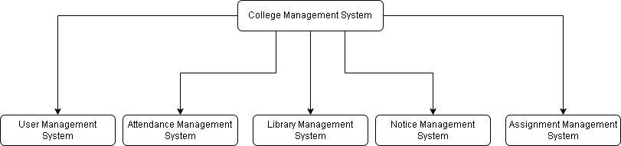

Legend:



UM

S

-

F

-

1.0



Sub systems.

UMS

:

User Management System

A

T

M

S

Attendance Management System

:

LMS

Library Management System

:

NMS

:

Notice Management System

AMS

:

Assignment

Management System



Types of Requirements:

F

:

Functional Requirements

NF

:

Non

-

Functional Requirements

UR

:

Usability Requirements



Numbering

User Management System (UMS):

**.**

|  |  |  |
| --- | --- | --- |
| **Req.**  **Code** | **Req. Desc** | **Use Case** |
| UMS-F-  1.0 | The system should allow admin to add new users (Teacher , Student, or new admin). | Create new user |
| UMS-F-  1.1 | After adding new user system should provide the email and password via Gmail to the respective emails of teacher, student, or admin | Send email to user |
| UMS-  NF-1.0 | While adding the user the email of the new user should not match with the email of already added users. | Checking for email registered or not. |
| UMS-F-  2.0 | After user being added by admin the user should be able to login with the email and password provided by admin. | User should be able to login. |
| UMS-F-  2.0 | After the user entered email and password, they should be shown with a form to change the password. (Security) | Change password by user after login. |
| UMS-F-  2.1 | After changing password, the user should be directed to their respective dashboards. | Redirecting to dashboard. |
| UMS-  UR-1.0 | The users should be able to view the password at the time of typing for better usability. | Show password feature in form. |
| UMS-  UR-1.1 | Login page should be responsive for both large and small device. | Responsive login page. |
| UMS-  NF-2.0 | The user should be able to change their password any time they want. | Change password any time. |
| UMS-  NF-2.1 | The user should be able to add picture as their main profile picture. | Add photo as profile picture. |
| UMS-F-  3.0 | Admin should be able to add, delete and update the details of the users. | Add, delete, and update the details of users. |
| UMS-  UR-2.0 | The dashboard for the users should be responsive for both large and small devices. | Responsive dashboard. |
| UMS-F-  3.0 | Teachers should be able to see the details of students. | Teacher could view student’s details. |

Activity Diagram

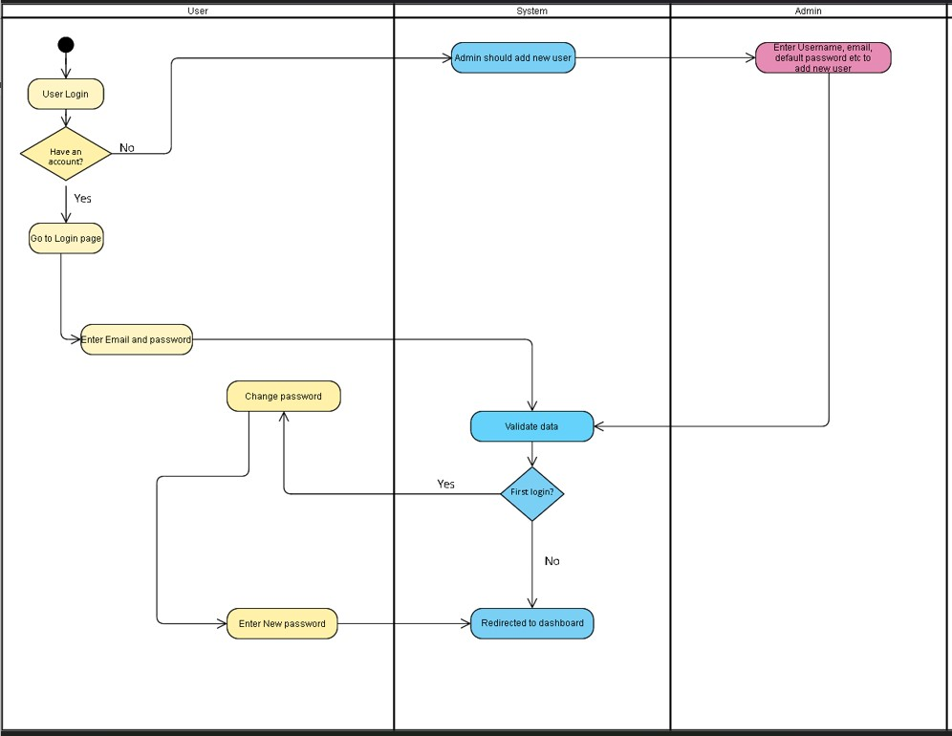

## Attendance Management System(AMS):

|  |  |  |
| --- | --- | --- |
| **Req.**  **Code** | **Req. Desc** | **Use Case** |
| AMS-F-  1.0 | Teacher should be allocated with the sections by admin at the time of adding new user and based on that sections, teacher should be able to take attendance of those sections only. | Taking attendance of allocated sections. |
| AMS-F-  1.1 | After allocating the sections, the teacher should be able to take the attendance of those sections, view the past attendance taken and also update them if needed. | Post new attendance , view old attendances, and update attendance. |
| AMS-  F-1.2 | While posting new attendance system checks the schedule , where class start time and end time is given and based on that time period the attendance can be taken, i.e. if current time is >= start time and current time is <= end time then only new attendance can be taken. | Validation based on the scheduled time of class. |
| UMS-F-  1.3 | Students can see their overall attendance percentage. | View attendance percentage by students. |
| UMS-F-  2.0 | Admin can see the past attendance, taken by which teacher , at what time and other information’s. | View attendance information’s by admin |
| UMS-F-  2.1 | After changing password, the user should be directed to their respective dashboards. | Redirecting to dashboard. |
| UMS-  UR-1.0 | The users should be able to view the password at the time of typing for better usability. | Show password feature in form. |
| UMS-  UR-1.1 | Login page should be responsive for both large and small device. | Responsive login page. |
| UMS-  NF-2.0 | The user should be able to change their password any time they want. | Change password any time. |
| UMS-  NF-2.1 | The user should be able to add picture as their main profile picture. | Add photo as profile picture. |
| UMS-F-  3.0 | Admin should be able to add, delete and update the details of the users. | Add, delete, and update the details of users. |
| UMS-  UR-2.0 | The dashboard for the users should be responsive for both large and small devices. | Responsive dashboard. |
| UMS-F-  3.0 | Teachers should be able to see the details of students. | Teacher could view student’s details. |