## hdfs dfs -mkdir -p /user/hdoop

## hdfs dfs -ls /user/hdoop

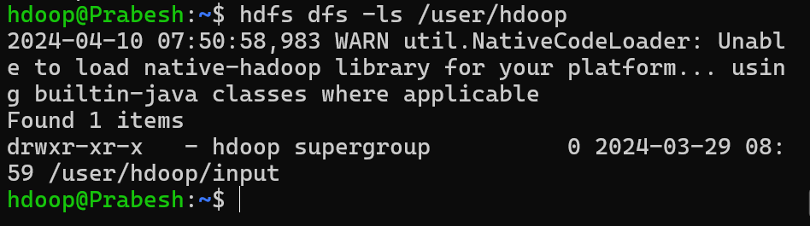

## hdfs dfs -mkdir input

