Lab-1 Report

What is Linux?  
  
Linux, akin to Windows, iOS, and Mac OS, stands as an operating system, wielding significant influence globally. Notably, the ubiquitous Android platform draws its strength from the Linux infrastructure. Functioning as the intermediary between software and hardware, an operating system orchestrates the allocation of hardware resources within desktops or laptops, facilitating seamless communication between the two realms. In its absence, software operations would falter.

The Linux operating system comprises several integral components:

**Bootloader**: Facilitating the boot process, the bootloader typically presents a splash screen before seamlessly transitioning into the operating system.

**Kernel**: The heart of the system, the kernel—aptly named 'Linux'—oversees CPU, memory, and peripheral device management, constituting the OS's foundational layer.

**Init** **System**: Responsible for initiating the user space and governing daemons, the init system, exemplified by system, guides the boot process following handover from the bootloader.

**Daemons**: These background services, encompassing printing, sound, and scheduling, commence either during boot or post-login, ensuring essential functionalities.

**Graphical** **Server**: Operating as the graphics display subsystem, the X server, or X, renders visual content on the monitor.

**Desktop** **Environment**: Serving as the user interface, various desktop environments like GNOME, Cinnamon, and KDE provide distinct interaction frameworks, complete with integrated applications such as file managers and web browsers.

**Applications**: Complementing desktop environments, Linux hosts a vast repository of high-quality software, akin to Windows and macOS. Modern Linux distributions streamline application acquisition through App Store-like tools, such as Ubuntu's Software Center, simplifying the search and installation process.

Through this intricate assembly, Linux empowers users with a versatile and robust operating environment, fostering productivity and innovation across diverse computing landscapes.

**Linux Commands:**

1. **cd** (Change Directory):
   * Description: Used to change the current working directory.
   * Syntax: cd [directory]
   * Example:

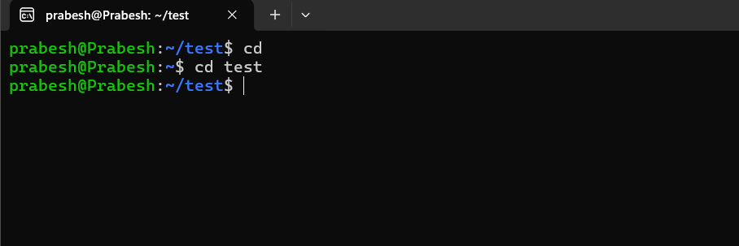

1. **mkdir** (Make Directory):
   * Description: Creates a new directory.
   * Syntax: mkdir [directory_name]
   * Example:
     + mkdir new_folder

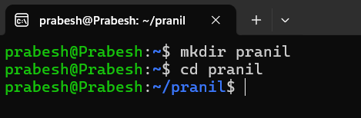

1. **nano**:
   * Description: A simple text editor for creating and editing files.
   * Syntax: nano [filename]
   * Example:
     + nano textfile.txt
   * Saving and Exiting:
     + Press Ctrl + O to save.
     + Press Enter to confirm the filename.

Press Ctrl + X to exit.

1. **rm** (Remove):
   * Description: Removes files or directories.
   * Syntax: rm [file_or_directory]
   * Example:
     + rm file.txt
     + rm -r directory

1. (List):
   * Description: Lists files and directories in long format.
   * Syntax: ls -l [directory]
   * Example:
     + ls -l

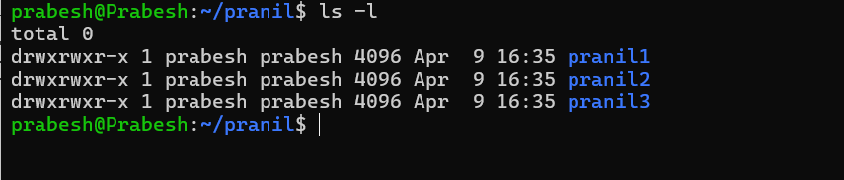

1. **cat**
   * Description: The cat command in Linux is more than just a simple tool; it’s a versatile companion for various file-related operations, allowing users to view, concatenate, create, copy, merge, and manipulate file contents.
   * Syntax: cat [file]
   * Example:
     + cat text.txt

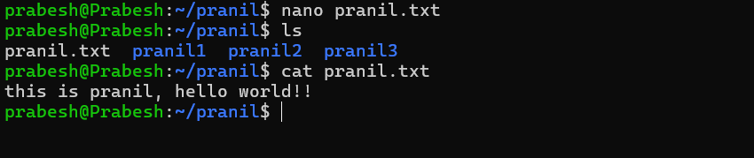

1. **mv**
   * Description: Used to move a file.
   * Syntax: mv file_name destination_directory
   * Example
     + Mv text.txt new_dir

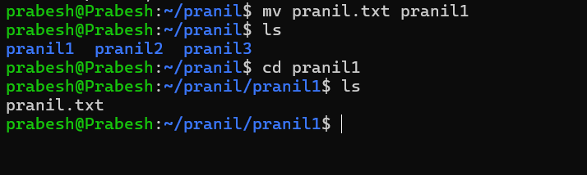

1. **cp**
   * Description: used for copying a file
   * Syntax: cp filename destination
   * Example
     + Cp text.txt new_dir

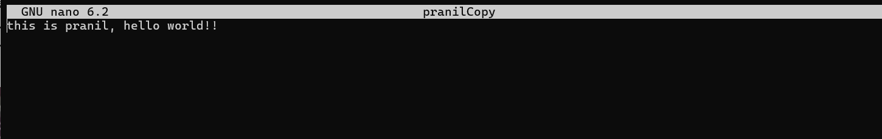

1. **Pwd**
   * Description: used to print the current directory
   * Syntax: pwd

