

Final Year Project

(6CS007)

College Management System

Student Id : 2227938

Student Name : Prabesh Raj Chalise

Group : L6CG3

Supervisor : Mr. Santosh Sapkota

Reader : Mr. Biraj Dulal

Word Count :

Abstract

In this project I will be making a College Management System (CMS).I will be making a complete college management system including all the important aspects that are required in a college management system. This system will make the task of teacher and student more efficient and easier. There will be mainly three users in the system: Admin, Teacher, and Student all will get the necessary functionality which can be accessed by them. Most powerful user will be admin who can access all the functionality of the system. Admin can have control of both teacher and student and can operate CRUD operation over all the functionality in system. Teacher will be another user who may have control over some of the functionality like providing assignment, attendance of students and more. Student will be the third user who can have the limited functionality like viewing the assignment, submitting the assignment, and so on.

Acknowledgement

I would like to thank our reader, supervisor, and module leader for providing the opportunity to make this project. Without the supervision of the honorable teachers and supervisor I will not be able to complete this project. Finally, I would like to thank Herald College Kathmandu and University of Wolverhampton for providing such an important module in our course. This project would help in self-development and improving my coding skills.

Contents

Introduction 5

Aims and Objective: 5

Aim: 5

Objective: 5

Artifacts: 6

Functional Decomposition Diagram(FDD): 6

User Management System (UMS): 7

Attendance Management System(ATMS): 9

Library Management System(LMS): 11

Assignment Management System(AMS): 13

Scope and limitations 15

Scope: 15

Limitations: 15

Literature Review: 15

1. TEACHMINT APPLICATION: A LEARNING MANAGEMENT SYSTEM TO ACCESSIBILITY AND PERFORMANCE IN INFORMATION AND COMMUNICATION TECHNOLOGY (I.C.T): (Yunus, 2020) 15

2. GOOGLE CLASSROOM AS LEARNING PLATFORM IN TEACHING WRITING: (Quinto, 2023) 17

3. CANVAS LMS: OPPORTUNITIES AND FEATURES: (Oleksii Nalyvaiko, 2021) 19

Moodle – An Effective Learning Management System for 21st Century Learners (Dr. K Syamala Devi, 2020) (Rabiman Rabiman, 2020) 21

Evaluation of Learning Management Systems A Comparative Study Between Blackboard and Brightspace: (Hanaa A. Yamani, 2022) 22

Comparison between TEACHMINT and Our system: 22

Comparison between Google classroom and our system: 23

Comparison between Canvas and Our system: 23

Comparison between Moodle and Our system: 24

Comparison between Blackboard, Brightspace and Our system: 25

## Table of figures

Figure 1-Activity diagram- User management system 8

Figure 2 Activity Diagram-Attendance Management System 10

Figure 3- Activity Diagram-Library Management System 12

Figure 4- Activity Diagram - Assignment Management System 14

# Introduction

This is a College Management System (CMS). This system will help overall college departments do their tasks more efficiently and easily. There will be mainly three users including Admin, Teacher, and Student. Admin will have the most control over the system they can perform all the CRUD operation of all the fields. There will be all the fields of college included in this system like Classroom, Attendance, Events and so on. And in each field, there can be two or more users depending on the situation of that field. But the most powerful user having all the access will be the admin in all the fields. Then the second user will be Teacher who may perform some functionality in the systems like attendance of students, CRUD operation in assignments, making result , providing notices, and so on. Then the final user will be a student who will have limited functionality in the system. For students they can view the assignments posted by the teacher, view their attendance status, take book from library, view result and so on.

## Aims and Objective:

### Aim:

The major aim of this project will be to make the task of all departments in college more efficient and easier. Teachers and Students can have the use of the entire college just from the device they have. Students can be updated with all the information that teachers want to provide to their students.

### Objective:

1. Admin will add, delete, update the details, and view the details of students and teachers. Admin will perform all the CRUD operations in all the fields. Admin is considered as the backbone of this system which can have control over the entire system.
2. Teachers can easily perform CRUD operation to the assignment they want to provide to the students. And students can view and submit the assignments.
3. Teachers can take the attendance of the students , and students can see their overall attendance status.
4. Teachers will post the notice for the students like upcoming viva, examinations and so on and students may view the notice.
5. Students will provide a review to the teacher which can be viewed by admin.

## Artifacts:

### Functional Decomposition Diagram(FDD):

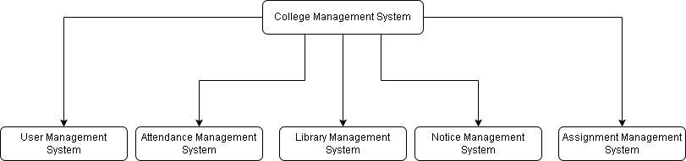

Legend:

### User Management System (UMS):

**.**

|  |  |  |
| --- | --- | --- |
| **Req.**  **Code** | **Req. Desc** | **Use Case** |
| UMS-F-  1.0 | The system should allow admin to add new users (Teacher , Student, or new admin). | Create new user |
| UMS-F-  1.1 | After adding new user system should provide the email and password via Gmail to the respective emails of teacher, student, or admin | Send email to user |
| UMS-  NF-1.0 | While adding the user the email of the new user should not match with the email of already added users. | Checking for email registered or not. |
| UMS-F-  2.0 | After user being added by admin the user should be able to login with the email and password provided by admin. | User should be able to login. |
| UMS-F-  2.0 | After the user entered email and password, they should be shown with a form to change the password. (Security) | Change password by user after login. |
| UMS-F-  2.1 | After changing password, the user should be directed to their respective dashboards. | Redirecting to dashboard. |
| UMS-  UR-1.0 | The users should be able to view the password at the time of typing for better usability. | Show password feature in form. |
| UMS-  UR-1.1 | Login page should be responsive for both large and small device. | Responsive login page. |
| UMS-  NF-2.0 | The user should be able to change their password any time they want. | Change password any time. |
| UMS-  NF-2.1 | The user should be able to add picture as their main profile picture. | Add photo as profile picture. |
| UMS-F-  3.0 | Admin should be able to add, delete and update the details of the users. | Add, delete, and update the details of users. |
| UMS-  UR-2.0 | The dashboard for the users should be responsive for both large and small devices. | Responsive dashboard. |
| UMS-F-  3.0 | Teachers should be able to see the details of students. | Teacher could view student’s details. |

#### Activity Diagram

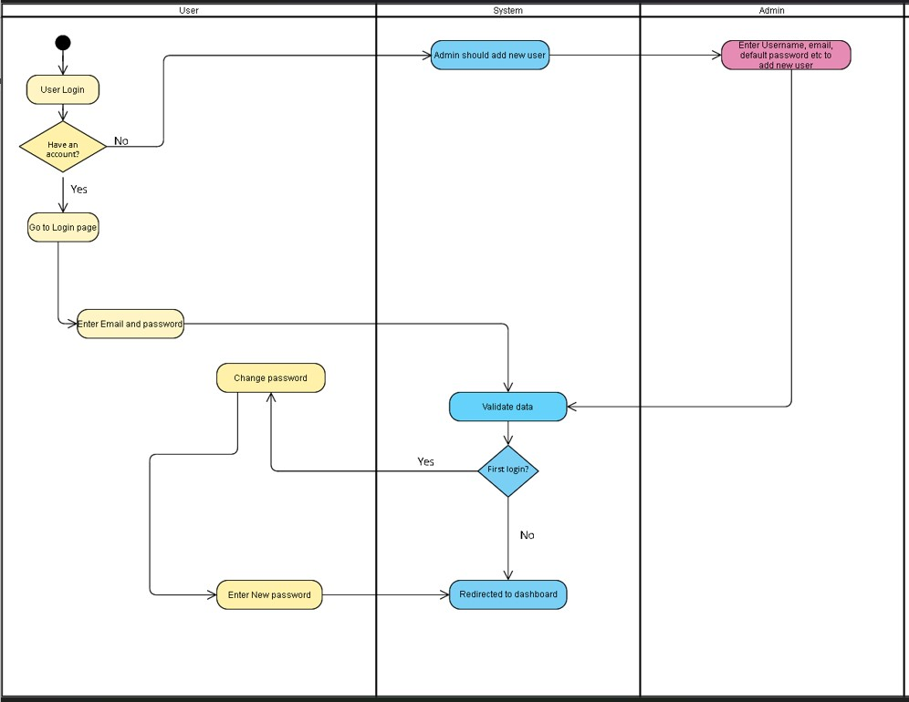

Figure 1-Activity diagram- User management system

### Attendance Management System(ATMS):

|  |  |  |
| --- | --- | --- |
| **Req.**  **Code** | **Req. Desc** | **Use Case** |
| ATMS-F-  1.0 | Teacher should be allocated with the sections by admin at the time of adding new user and based on those sections, teacher should be able to take attendance of those sections only. | Taking attendance of allocated sections. |
| ATMS-F-  1.1 | After allocating the sections, the teacher should be able to take the attendance of those sections, view the past attendance taken and also update them if needed. | Post new attendance , view old attendances, and update attendance. |
| ATMS-  F-1.2 | While posting new attendance system checks the schedule , where class start time and end time is given and based on that time period the attendance can be taken, i.e. if current time is >= start time and current time is <= end time then only new attendance can be taken. | Validation based on the scheduled time of class. |
| ATMS-F-  1.3 | Students can see their overall attendance percentage. | View attendance percentage by students. |
| ATMS-F-  2.0 | Admin can see the past attendance, taken by which teacher , at what time and other information’s. | View attendance information’s by admin |
| ATMS-UR-  1.0 | Students can see their graph or pie chart of attendance which may help them in better visualization of their attendance status. | Graph or pie chart for visualization. |

#### Activity diagram(Attendance management system)

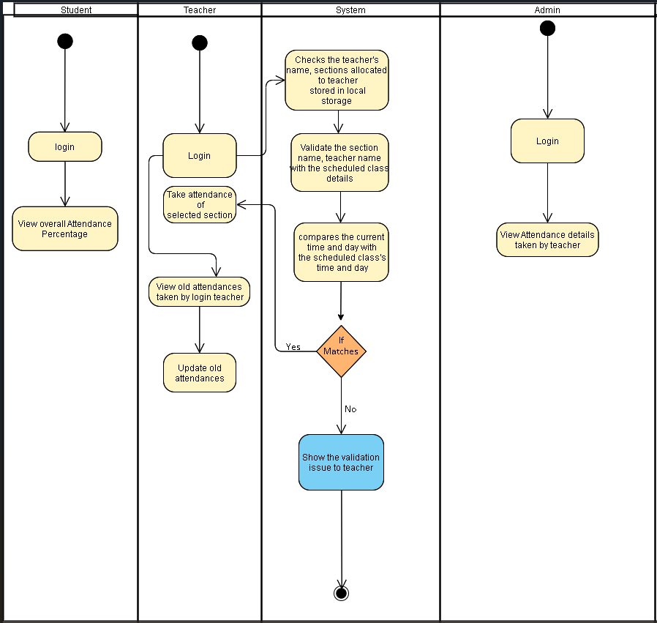

Figure 2 Activity Diagram-Attendance Management System

### Library Management System(LMS):

**.**

|  |  |  |
| --- | --- | --- |
| **Req.**  **Code** | **Req. Desc** | **Use Case** |
| LMS-F-  1.0 | Admin can add the books to the library inserting details like book name, category, description and so on. | Add new book |
| LMS-F-  1.1 | Admin can view the books, edit the books details, and delete the book if needed | View, update, delete the books details. |
| LMS-  F-1.2 | Teacher can view the books in the library | View books in library by teacher. |
| LMS-F-  1.3 | Students can view the books in the library | View books in library by students. |
| UMS-UR-  1.0 | Responsive design for viewing the books in the library. | Responsive design. |
| UMS-UR-  1.1 | Searching for books in the library | Search option to search the books. |

Activity diagram(Library Management System):  
  
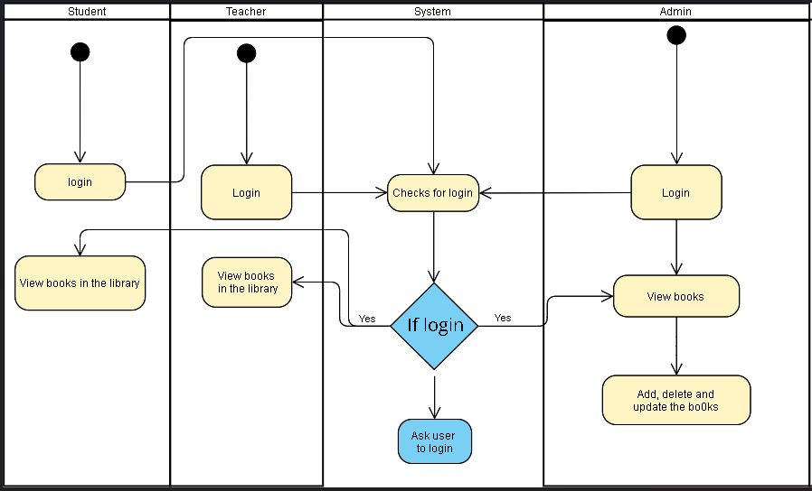

Figure 3- Activity Diagram-Library Management System

### Assignment Management System(AMS):

|  |  |  |
| --- | --- | --- |
| **Req.**  **Code** | **Req. Desc** | **Use Case** |
| AMS-F-  1.0 | Teacher can post the assignment by entering the details like, section name, assignment title, assignment description, assignment portal starts date & time and end date & time. | Posting assignment details by teacher. |
| AMS-F-  1.1 | View, delete and update the assignment by teacher | View, delete and update the assignment by teacher. |
| AMS-  F-1.2 | Admin can view the assignment posted by teacher. | View assignment by teacher. |
| AMS-F-  1.3 | If current date and time is between the start and end date & time of the posted assignment then portal should be visible to the selected section, else it should not be visible. | Validation for the assignment portal. |
| AMS-F-  2.0 | Students can view the provided assignment and post the assignment through portal only if the portal is visible. | View and post assignment by students. |
| AMS-F-  2.1 | Teacher can then see the submitted assignment by students. | View the submitted assignment by students. |
| AMS-UR-1.0 | Responsive design for viewing the assignment. | Responsive design. |
| AMS-NF-1.0 | Many validations on date ,time , section ,teacher name and so on. | Validations on different fields |

#### Activity diagram (Assignment Management System):

Figure 4- Activity Diagram - Assignment Management System

## Scope and limitations

### 

### Scope:

Here are some of the scopes of the system listed below:

1. Students may get to see the assignments provided by the teachers and may submit the assignment via system. Teachers may provide the assignment to the students and mark the assignment provided by the students.
2. Teachers may provide the notice to the students and students may see the notice provided by the teacher.
3. Teacher may publish the result and students may see them.
4. Teacher may take the attendance of the students and students may see their overall attendance status.
5. Students may see upcoming events and teachers may edit the upcoming events.

### Limitations:

Here are some of the limitations of the system:

1. There is attendance of students in the system but there is no biometric for recording the attendance.
2. Students will see their respective marks but there may not be good security for such sensitive data.
3. Teacher will publish the upcoming classes but there is not any online class via the system.

# Literature Review:

## 1. TEACHMINT APPLICATION: A LEARNING MANAGEMENT SYSTEM TO ACCESSIBILITY AND PERFORMANCE IN INFORMATION AND COMMUNICATION TECHNOLOGY (I.C.T): (Yunus, 2020)

Innovative technology has kept an impact on almost every field. Similarly, in educational and learning fields technology has created a positive impact. (Quinto, 2023) Teach mint is one of the learning technologies. Teach mint is a simple management system which is used to present academic content, which can be used in different devices like mobile phones and laptop etc. (Quinto, 2023) This provides different tools to engage the students and teachers online outside class anytime and anywhere. (Quinto, 2023)

Teach mint has focused on different aspects to provide best academic facilities to students, teachers as well as the parents of students. The main features of the Teach mint includes learning management, skills assessment, training management, communication, and assignment management. (Quinto, 2023) This feature helps students, teachers, and student’s parents in following aspects:

1. Teachers will have the following features that can be used:
   1. Assessing students’ data.
   2. Giving activities to students.
   3. Enhanced teaching process. (Quinto, 2023)

1. Students will have the following features that can be used:
   1. Submission of assignments.
   2. Access to learning materials posted by teachers.
   3. Enhanced learning process. (Quinto, 2023)

1. Parents of students will have the following features that can be used:
   1. Student’s result (output).
   2. Student's activity performance (Quinto, 2023)

Depending on different features that can be used by teachers, students and parents here are some evaluations that has been found for this system:

**Note: The mean here indicates a medium to calculate the average of the scores obtained and level of accessibility of students and teachers in learning management. Whereas the standard deviation is used to find out the spread of the respondents. (Quinto, 2023)**

1. **Learning Management:** For learning management, the evaluation has been made and the remarks have been captured and found that the mean of the evaluation is 4.76 out of 5 and the standard deviation is 0.43 for students whereas for the teachers the mean of evaluation is 5 and standard deviation is 0. (Quinto, 2023)

1. **Assignment management:** For assignment management the evaluation has been made and the remarks have been captured and found that the mean of the teachers is 5 and standard deviation is 0 for monitoring the activities done by students , whereas for checking the submitted output the mean is 4.60 and standard deviation is 0.55. (Quinto, 2023)

1. **Communication management:** For communication management the evaluation has been made and the remarks have been captured and found that the mean of teachers for the communication management evaluation is 4.94 and standard deviation is 0.41 whereas for the students the evaluation of mean is 4.92 and standard deviation is 0.25. (Quinto, 2023)

1. **Skill management:** For skills management the evaluation has been made and the remarks have been captured and found that the mean of the teachers for the skills management evaluation is 5 and the standard deviation is 0, whereas the standard deviation for accessing the student’s skills and abilities is 0.5 whereas the mean is 4.60. (Quinto, 2023)

1. **Training management:** For training management the evaluation has been made and the remarks have been captured and found that the mean of the teachersevaluating the training management by training workshops that is included in app is 5 and the standard deviation is 0, whereas the evaluation for standard deviation to train students is 0.55 and the mean is 4.40. (Quinto, 2023)

## 2. GOOGLE CLASSROOM AS LEARNING PLATFORM IN TEACHING WRITING: (Quinto, 2023)

Nowadays the technology in education is rising very quickly. The raising of the technology in education helps in improving the way of learning and helps both teachers and students in providing and receiving academic materials. (Yunus, 2020)

One of the widely used learning management systems is google classroom from google.com. Google classroom was launched for public use in 2014. According to [www.support.google.com,](http://www.support.google.com/) google classroom was made to provide the facilities for providing the better education for students. Google classroom focuses on efficiently managing the assignments, increasing collaboration, and improving communication. (Yunus, 2020) Google classroom helps teachers to provide lessons, distribute assignments to students, provide feedback, through the system. (Yunus, 2020) Google classroom is being used to provide the teaching context to the students. Some of the features of google classroom includes, giving announcements to students, class discussions, Attach assignments for students, feedbacking, attendance tracking, score and evaluation of student’s assignments. (Yunus, 2020)

Google classroom is easy and simple to use still there can be different challenges that can affect the classroom activities. There are some greater problems that can occur while using the google classroom like impact on visual cues such as voice, and problem in face-to-face communication. There can also occur some other problems like google classroom can be used as the social media site rather than being used as the learning application. (Yunus, 2020) Since google classroom requires high internet speed, good device this can become a challenge in using this app. If students do not have a pc or smart phone, they will not be able to access this app. This is huge challenge of using this app or any other learning management system. If the students are only focused on online learning they can lack different other skills like communication skills, face-toface talking skills and so on. (Yunus, 2020)

Conducting the traditional classes or any other learning activity is not enough and efficient in today’s time. Instead using learning systems for providing academic facilities for students can be more efficient and easier. With the help of google classroom teachers can post the supporting materials , notices, assignments, and quizzes online without having face-to-face interactions with students.

Google classroom can’t be used as the only source for learning without using traditional approach of learning. Google classroom can be used as the means of learning efficiently, but the traditional approach should also be considered along with it. This will make the learning output of students better.

## 3. CANVAS LMS: OPPORTUNITIES AND FEATURES: (Oleksii Nalyvaiko, 2021)

The way of learning since Covid-19 pandemic has drastically changed. The attitude and approaches towards learning have been digitalized after Covid-19 pandemic. The traditional approach of learning has been modernized and both students and teachers are digitally involved in the learning management systems which has made the task of both students and teachers more efficient and easier. (Oleksii Nalyvaiko, 2021)

Canvas LMS is gradually taking one of the leading roles in online learning management systems. (Oleksii Nalyvaiko, 2021) In this journal the main aim of study was to explore the interactive online platform Canvas free-for-teacher and free-for-students, their opportunities as well as negative features. (Oleksii Nalyvaiko, 2021) The data for the study has been collected with the help of theoretical and experimental methods. (Oleksii Nalyvaiko, 2021) The experimental methods include questionnaires, surveys, and reviews.

Canvas Free-For-Students and Free-For-Teachers, available in online format for all the devices, android, windows as well as iOS. In order to become the canvas user, learner or teacher should register to the system. After registering the user can login to the system.

For research 50 university students at the School of Foreign Languages who have been using this system have been asked to fill up 10 google forms with different questions related to the study of the system. Here are the questions and answers from the students. (Oleksii Nalyvaiko, 2021)

1. Have you used both versions of canvas? (Oleksii Nalyvaiko, 2021)
   * The majority of the answer was yes , which means the canvas registration in both versions for smart phones and websites is easy to use. Almost 98% of students’ answer was “yes” whereas 2% student’s answer was “no, only one”. (Oleksii Nalyvaiko, 2021)

1. Did you have problems with logging in? (Oleksii Nalyvaiko, 2021)
   * When these questions were asked 90% of students had no problem in login process, 8% of students said after registration while logging in the system they experienced some complications. And 2% of responders found logging complicated. (Oleksii Nalyvaiko, 2021)

1. (Question for those who found logging in complicated) : Did you have typed your username instead of your email to re-enter the profile? (Oleksii Nalyvaiko, 2021)
   * The 100% output was “yes” , they have typed the username instead of email to reenter the profile. (Oleksii Nalyvaiko, 2021)

1. Were you satisfied with the platform interface in both versions? (Oleksii Nalyvaiko, 2021)
   * For this question 76% of users answer was “yes”, 16% of user’s response was “No, only with the PC version” , 4% of user’s response was “No, only with mobile version” and 4% of user’s response was “no“. This shows that the majority of the response is saying that both versions of canvas are good. (Oleksii Nalyvaiko, 2021)

1. Was it difficult to add personal information into your profile? (Oleksii Nalyvaiko, 2021)
   * For this the majority of user’s response was “no”. All the students enjoyed the simplicity of adding the personal information onto the canvas. Except for one respondent who had problem in uploading the photo to the canvas, for that the respondent had to decrease the size of the image and then keep it to the canvas. (Oleksii Nalyvaiko, 2021)

1. Did you manage to enroll in the course(s) you aimed at? (Oleksii Nalyvaiko, 2021)
   * For this the response was 100% “yes”, which means its easy to enroll to the course the respondent was aiming to. (Oleksii Nalyvaiko, 2021)

1. Was it possible for you to do tasks, upload files, take tests? (Oleksii Nalyvaiko, 2021)
   * For this 92% response was “yes” whereas 8% of response was “not all of them”. This means it’s easy to submit tasks, upload tasks and take tests from canvas. (Oleksii Nalyvaiko, 2021)

1. Was the format of studying convenient for you? (Oleksii Nalyvaiko, 2021)
   * For this 80% of the response was “yes, absolutely” whereas 14% of response was “only in a version for desktop” and 4% of the response was “only in mobile version” and rest of 2% was “no, its complicated”. (Oleksii Nalyvaiko, 2021)

1. Would you like to use Canvas as one of the main platforms for studying?
   * For this the response was 74% “yes”, 16% was “maybe for some classes”, 6% was “no, I didn’t like the platform” and remaining 5% was “no”.

1. Did you enroll in any public courses with open access?
   * For this 42% of response was “yes”, 32% of response was “no” and 26% of response was “no, I don’t want to”.

Here, with the help of these questions we can easily evaluate the usefulness of the Canvas Learning System for the students.

## Moodle – An Effective Learning Management System for 21st Century Learners (Dr. K Syamala Devi, 2020) (Rabiman Rabiman, 2020)

Traditional way of teaching where teachers give hours long lectures does not work with today’s students, for this use of online learning management systems is best alternative way to provide academic facilities to the students. (Dr. K Syamala Devi, 2020)

There are different popular open-source learning management systems. One of them is “Moodle”. Moodle is a software package that provides facilities to produce internet-based courses. (Dr. K Syamala Devi, 2020). The word MOODLE is an acronym for Object-Oriented Dynamic Learning Environment. (Dr. K Syamala Devi, 2020) There is various importance which makes the use of learning management system like Moodle more important. Some of the importance are Skill analysis, material development, learning , and evaluation. (Dr. K Syamala Devi, 2020)

Moodle is a great tool for teachers since it helps in creating and saving teaching materials easier. (Dr. K Syamala Devi, 2020) Moodle allows the integration of a wide range of resources from online books, online learning source and so on. (Dr. K Syamala Devi, 2020)Some of the applications of Moodle are, it provides materials for students, assessment for students, it is useful for both students and teachers, and so on. (Dr. K Syamala Devi, 2020)

Moodle have positive impact on the students. Some of the effects of Moodle are:

1. Improves academic skills of students. (Dr. K Syamala Devi, 2020)
2. Improves the self-development capacity of students. (Dr. K Syamala Devi, 2020)
3. Improves the communication skills of students. (Dr. K Syamala Devi, 2020)
4. Helps in promoting the content made by students. (Dr. K Syamala Devi, 2020)

## Evaluation of Learning Management Systems A Comparative Study Between Blackboard and Brightspace: (Hanaa A. Yamani, 2022)

The learning style in the 21st century has changed by a lot. Students are getting efficient and faster learning experiences using online learning management systems. (Hanaa A. Yamani, 2022) The digital evaluation in learning field has changed the way of learning. (Hanaa A. Yamani, 2022) There are many such online learning management systems that has helped to make the students learning mechanism more efficient and faster.

Blackboard and Brightspace are two famous learning management systems. Both of these LMS are used by a university named **Umm AI-Qura University**. The research has been made by this journal regarding the use of Blackboard and Brightspace. Research was done among 512 students. Among them it was found that 36% of students used Brightspace whereas 64%of students used Blackboard. When the result of the students was calculated who used Blackboard it was found that the mean of result was 37 and the standard deviation was 8.5. Whereas in context of Brightspace it was found that the mean of result was 40 and the standard deviation was 7.7. This means that the result of the students using Brightspace is better than the students using Blackboard. (Hanaa A. Yamani, 2022)

In order to provide students with a better learning process, LMS is not only the solution. (Hanaa A. Yamani, 2022) Both traditional way of learning and LMS should be taken side by side with good guidelines to students can be better way of providing better academic facilities to the students. (Hanaa A. Yamani, 2022)

## Comparison between TEACHMINT and Our system:

|  |  |  |
| --- | --- | --- |
| comparison of | TEACHMINT | Our system |
| Login system | ✓ | ✓ |
| Set role by admin | ✓ | ✓ |
| Attendance System | ✓ | ✓ |
| Assignment to students | ✓ | ✓ |
| Students submitting assignments | ✓ | ✓ |
| Based for multiple colleges | ✓ |  |
| Online sources for learning | ✓ |  |
| Send notices to students | ✓ | ✓ |
| Add view update delete users by admin | ✓ | ✓ |

## 

## Comparison between Google classroom and our system:

|  |  |  |
| --- | --- | --- |
| comparison of | Google classroom | Our system |
| Login system | ✓ | ✓ |
| Set role by admin | ✓ | ✓ |
| Attendance System | ✓ | ✓ |
| Assignment to students | ✓ | ✓ |
| Students submitting assignments | ✓ | ✓ |
| Based for multiple colleges | ✓ |  |
| Online sources for learning | ✓ |  |
| Send notices to students | ✓ | ✓ |
| Add view update delete users by admin | ✓ | ✓ |

## 

## Comparison between Canvas and Our system:

|  |  |  |
| --- | --- | --- |
| comparison of | Canvas | Our system |
| Login system | ✓ | ✓ |
| Set role by admin | ✓ | ✓ |
| Attendance System | ✓ | ✓ |
| Assignment to students | ✓ | ✓ |
| Students submitting assignments | ✓ | ✓ |
| Based for multiple colleges | ✓ |  |
| Online sources for learning | ✓ |  |
| Send notices to students | ✓ | ✓ |
| Add view update delete users by admin | ✓ | ✓ |

## Comparison between Moodle and Our system:

|  |  |  |
| --- | --- | --- |
| comparison of | Moodle | Our system |
| Login system | ✓ | ✓ |
| Set role by admin | ✓ | ✓ |
| Attendance System | ✓ | ✓ |
| Assignment to students | ✓ | ✓ |
| Students submitting assignments | ✓ | ✓ |
| Based for multiple colleges | ✓ |  |
| Online sources for learning | ✓ |  |
| Send notices to students | ✓ | ✓ |
| Add view update delete users by admin | ✓ | ✓ |

## Comparison between Blackboard, Brightspace and Our system:

|  |  |  |  |
| --- | --- | --- | --- |
| comparison of | Blackboard | Brightspace | Our system |
| Login system | ✓ | ✓ | ✓ |
| Set role by admin | ✓ | ✓ | ✓ |
| Attendance System | ✓ | ✓ | ✓ |
| Assignment to students | ✓ | ✓ | ✓ |
| Students submitting assignments | ✓ | ✓ | ✓ |
| Based for multiple colleges | ✓ | ✓ |  |
| Online sources for learning | ✓ | ✓ |  |
| Send notices to students | ✓ | ✓ | ✓ |
| Add view update delete users by admin | ✓ | ✓ | ✓ |