Part A:

A.1

Creating a GitLab and new branch named “Working”.

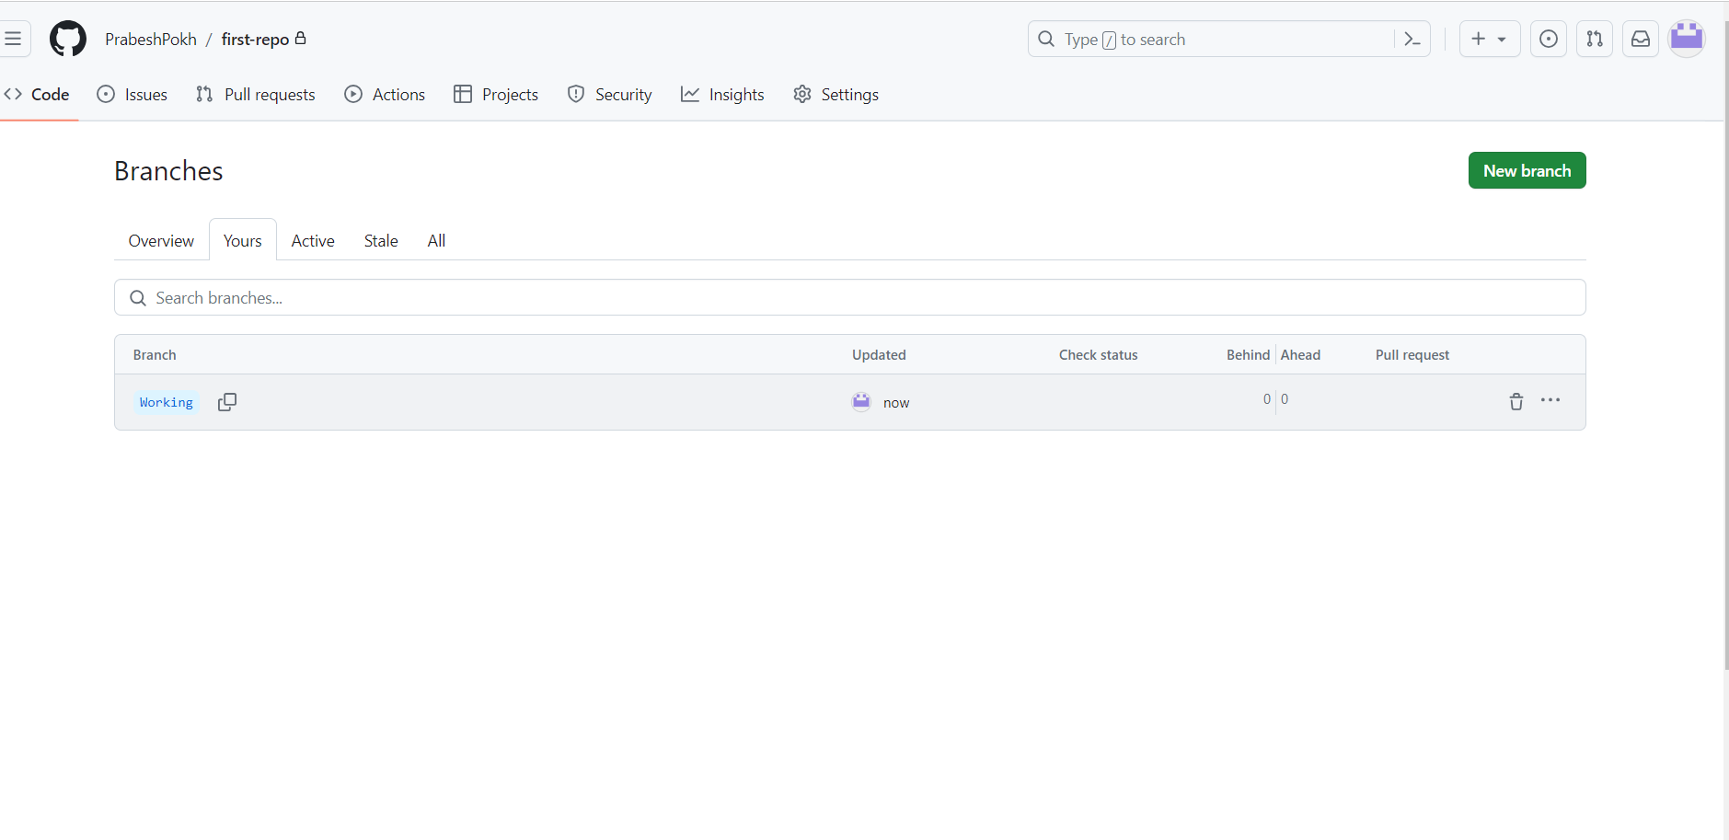

Part B

B.1

Cloning into local machine using command line

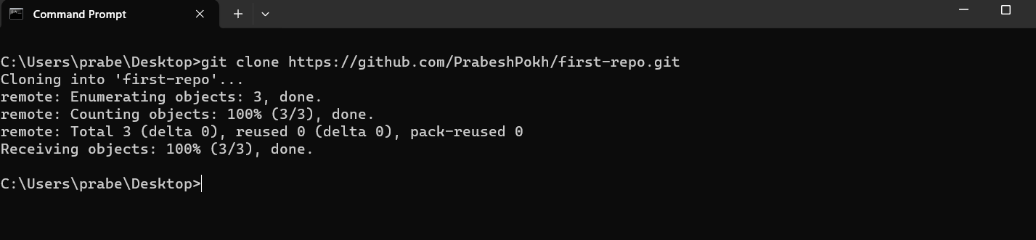

Part C

C.1

Modifying three HTML files on the Working branch.

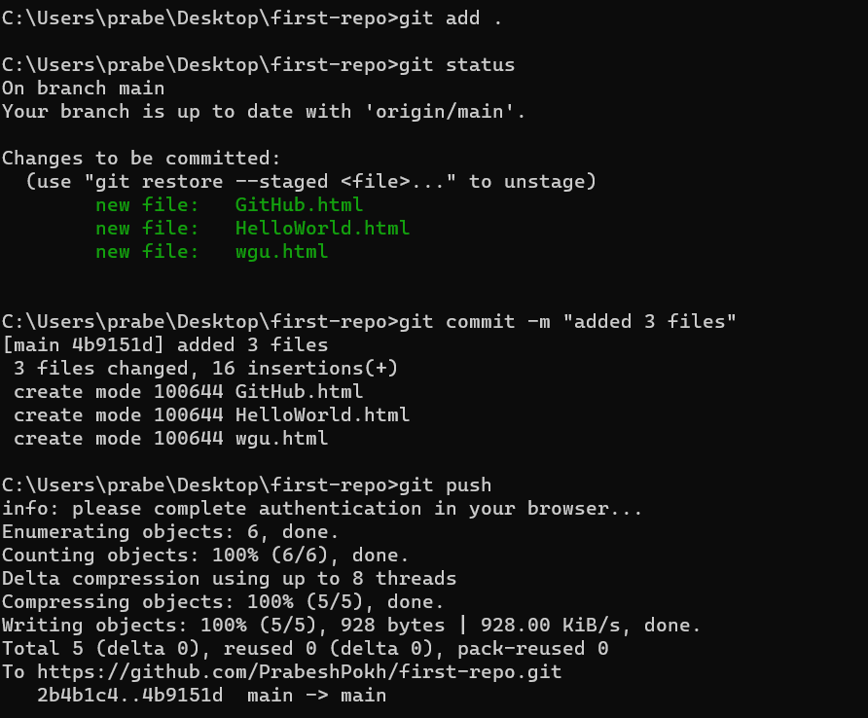

C.2

C.3

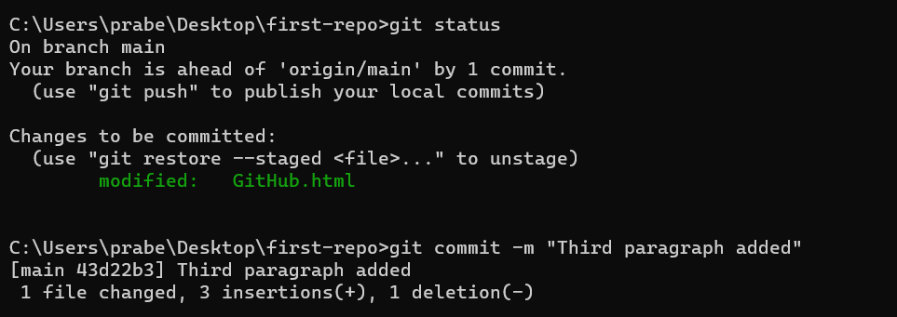

C.4

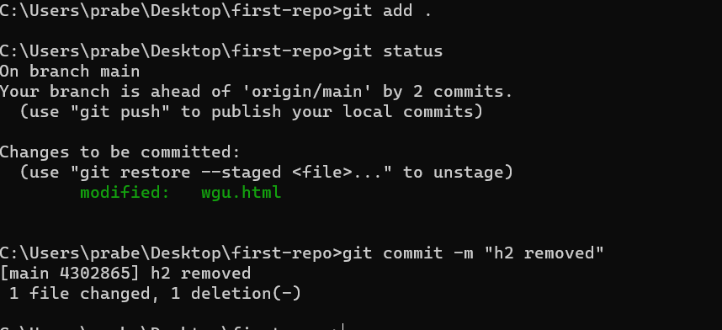

C.5

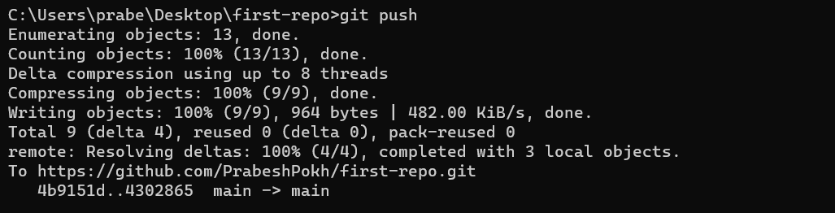

Part D: Creating new branch and making changes

D.1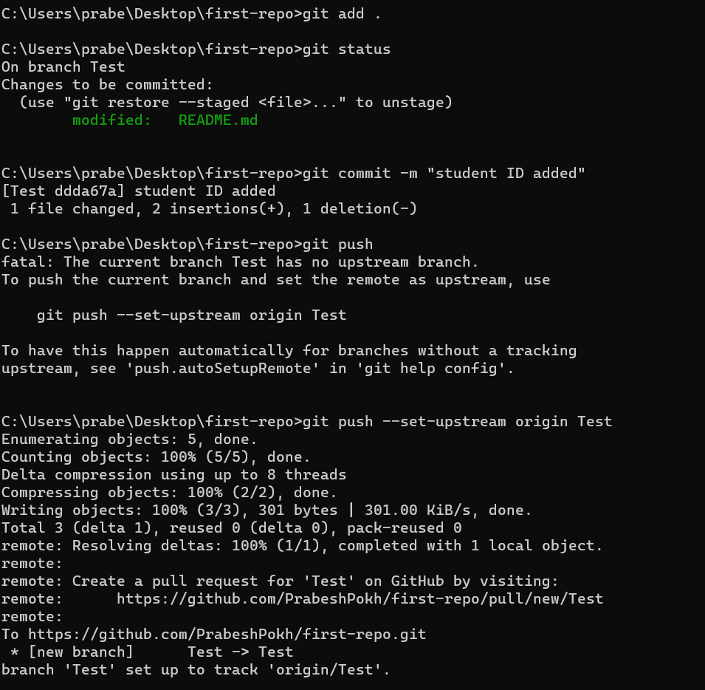

D.2

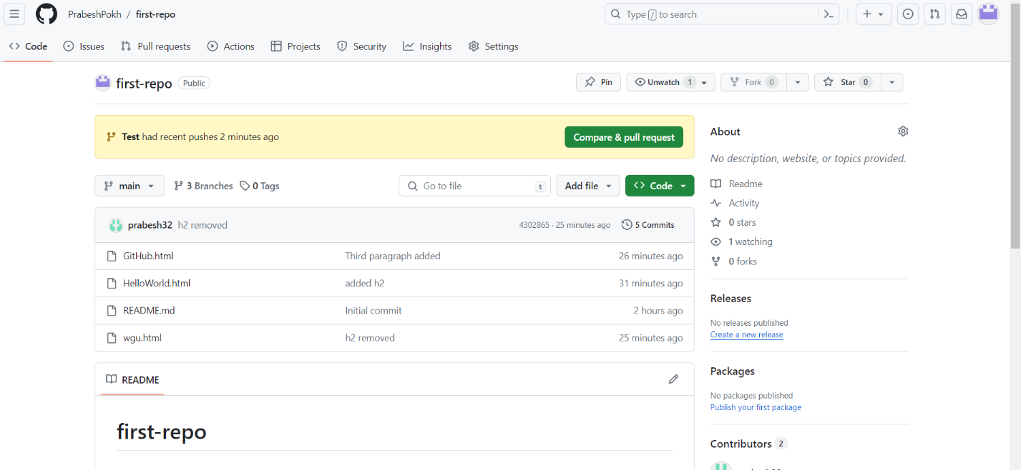

Part E

Stimulating a Merge Conflict and Resolving it.

E.1

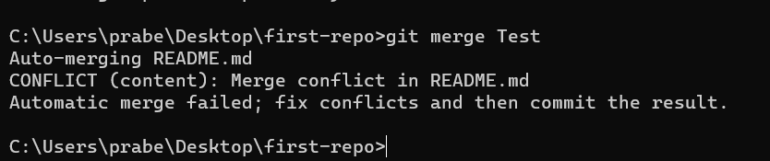

E.2

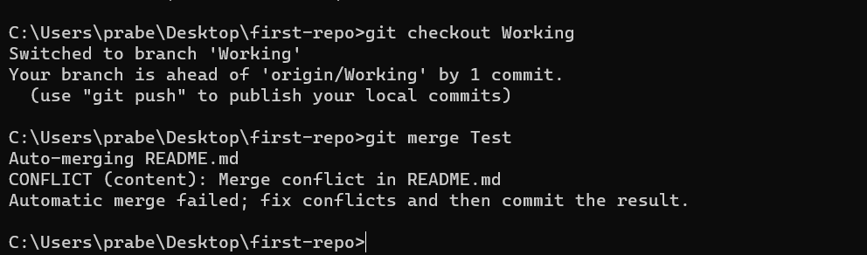

E.3

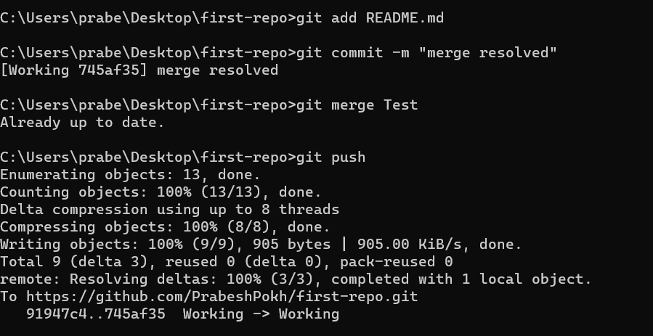

Part F

Tagging a branch.

F.1

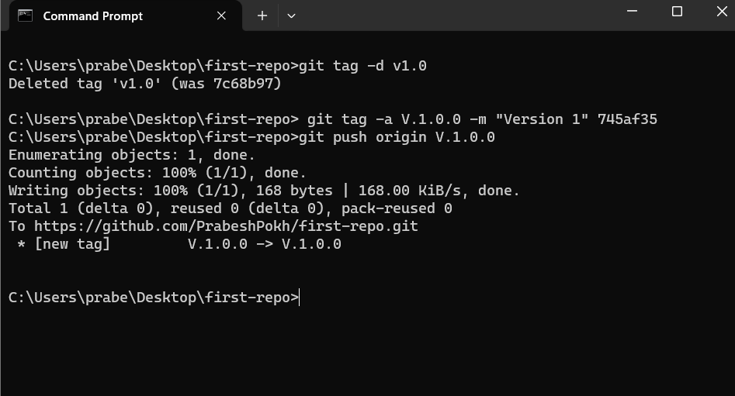

F.2

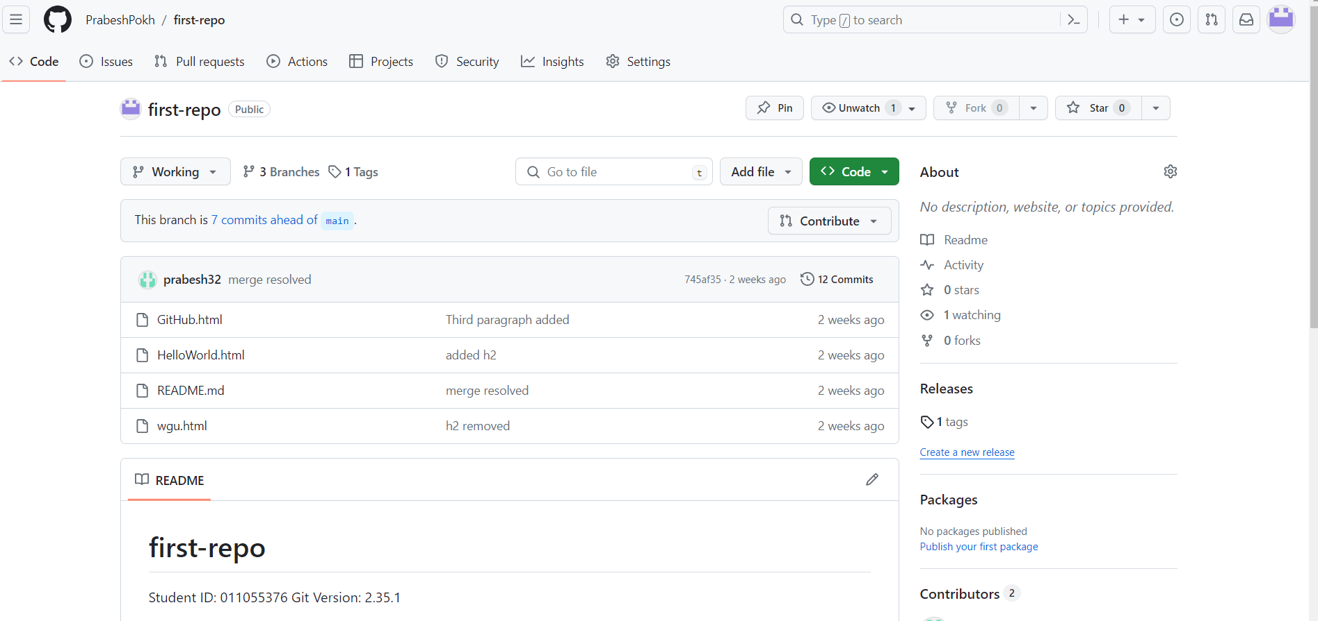

Part G

Adding a Retrospective Directory to Repository

G.1

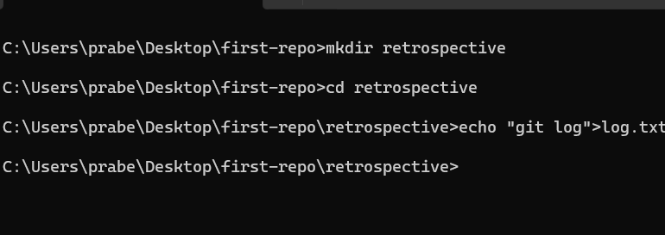

G.2

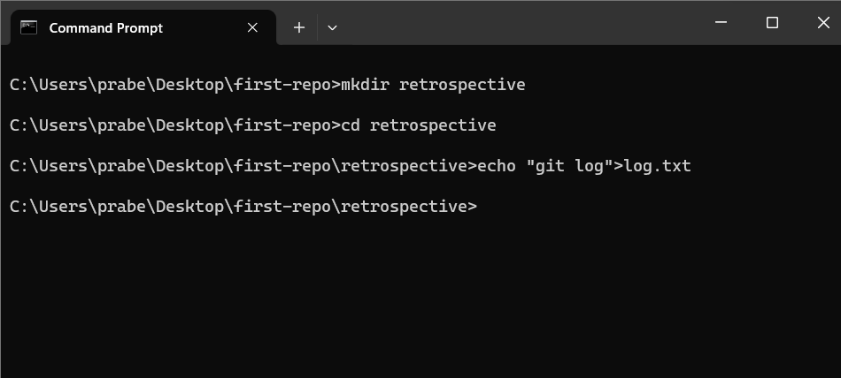

G.3

