# Privacy Policies

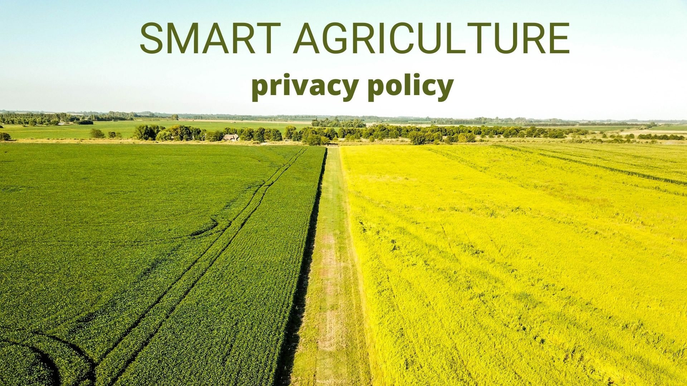

We at Smart Agriculture, agriculture goods sale and information about agriculture are committed towards protecting privacy of our users regarding the collection, usage and disclosure of the information provided by the users.

1. General user information (e.g., email, name, profile picture) will be treated as confidential information and will not be shared with any third parties at any cost, nor will it be used for analysis purpose without prior notification to the user.
2. You are automatically obliged to the privacy policy of third-party services used in smart agriculture.
3. Data shown in the Smart Agriculture may not always be 100% accurate to Smart Agriculture will not be held liable for any errors.

# ABOUT US

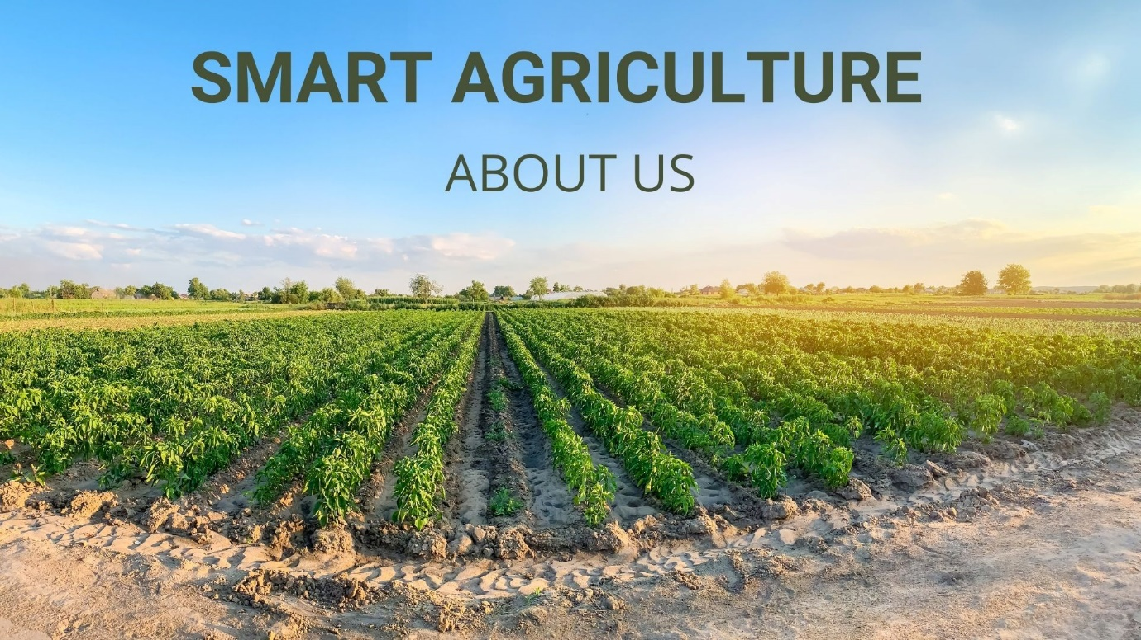

## Developed By

Prashant Adhikari

Kathmandu, Nepal

## Contact Us

Email Us

[Aprashant21@tbc.edu.np](mailto:Aprashant21@tbc.edu.np)

## Facebook

## <https://www.facebook.com/TheBigOcean3>