|  |  |
| --- | --- |
| COLLEGE NAME | SARANATHAN COLLEGE OF ENGINEERING |
| TITLE | HOW TO CREATE BRAND NAME, BRAND MAIL AND BRAND LOGO IN CANVA |
| NAME | R.ROSHNI |
| NM ID | 1E0C89A485541C38A1C4022FE3BA8DD6 |
| DATE | 27-10-2023 |

**CONTENT PAGE NO.**

INDENTIFY YOUR TARGET AUDIENCE 2

DEFINE YOUR BRAND PERSONALITY 3

MAKE A LIST OF BRAND NAME IDEAS 4

NARROW YOUR LIST 5

CHECK FOR AVAILABILITY 6

TEST YOUR SHORTLIST OF POTENTIAL BRAND NAMES 7

HOW TO CREATE A BRAND EMAIL 8

HOW TO CREATE A LOGO DESIGN USING CANVA 9

NAVIGATION 10

DESIGN PICKING 13

SELECT DIFFERENT STYLES AND CHOOSE IT 16

**INDENTIFY YOUR PROJECT AUDIENCE**

The target audience for sunglasses can encompass a wide range of individuals, with distinctions made based on various factors. Classic, timeless designs and neutral styles appeal to a broad demographic, attracting those who seek versatile eyewear suitable for everyday use. For consumers who prioritize staying on top of fashion trends and making a statement, trendy and fashionable sunglasses designed by renowned fashion brands might be particularly appealing. Athletes and sports enthusiasts represent another key target audience, with sports-specific sunglasses offering performance-enhancing features for various activities. Specialty sunglasses, such as those crafted from eco-friendly materials, draw in environmentally conscious consumers who value sustainability. Sunglasses emphasizing strong UV protection and eye health benefits target individuals who are committed to safeguarding their eyes from the sun's harmful rays. Geographic location also plays a role, with sunglasses designed for specific climate conditions, like polarized options for water sports, catering to customers in particular regions. Marketing strategies, such as leveraging social media influencers or forging partnerships with luxury brands, can further define the target audience. To effectively identify the precise target audience for a specific brand or product line of sunglasses, one must consider demographics, lifestyle choices, fashion preferences, and, in some cases, the local climate and UV exposure concerns.

**DEFINE YOUR BRAND PERSONALITY**

Cooler Shades exudes a vibrant and youthful brand personality. We are all about celebrating the sunny side of life. Our sunglasses are designed for the free-spirited, the adventurers, and the lovers of life. Our brand is characterized by a combination of traits:

* **Energetic:** We radiate energy and enthusiasm, reflecting a zest for life and a passion for outdoor activities and exploration.
* **Stylish:** We offer the latest trends in eyewear fashion, staying on the cutting edge of design and aesthetics. Our sunglasses are not just practical; they're a fashion statement.
* **Confident:** Our brand embodies a sense of confidence. When you wear Cooler Shades, you're ready to take on the world, to step out with assurance and style.
* **Innovative:** We embrace innovation in eyewear technology, offering high-quality lenses that protect your eyes while enhancing your visual experience.
* **Social and Community-Oriented:** We foster a sense of community and togetherness among our customers. Our sunglasses are designed for people who enjoy connecting with others, whether it's at the beach, a music festival, or a casual get-together.
* **Adventure-Seeking:** Cooler Shades are for those who seek adventure and are not afraid to step out of their comfort zones. We encourage our customers to explore the world with a spirit of adventure.

**MAKE A LIST OF BRAND NAME IDEAS**

* **Uniqueness:** Your brand name should be distinct and not easily confused with existing brands in the eyewear industry. Conduct thorough trademark searches to ensure the name is available for use.
* **Relevance:** The name should relate to the sunglasses and the image you want to portray. It can reflect the style, design, or target audience of your sunglasses.
* **Brand values:** Consider the core values and qualities you want your brand to represent. Your brand name should align with these values and give potential customers an idea of what to expect from your sunglasses.
* **Target audience:** Think about your ideal customers. Does the name resonate with their preferences, lifestyles, and aspirations? It should appeal to the demographic you're targeting.
* **International appeal:** If you plan to sell your sunglasses globally, ensure that the name has no negative or offensive connotations in other languages and cultures

.

* **Domain availability:** Check if the domain name (website URL) for your brand is available. In today's digital age, it's crucial to have a consistent online presence.

**NARROW YOUR LIST**

Narrow listing of sunglasses is a retail approach that entails offering a carefully curated and limited selection of eyewear products, meticulously chosen to cater to a specific and well-defined customer segment. Unlike stores with a wide array of sunglasses, a narrow listing store opts for a more selective and focused inventory. This strategy revolves around quality over quantity, where each pair of sunglasses is chosen for its exceptional design, premium materials, and alignment with the unique preferences and needs of a particular target audience. By embracing this approach, businesses can create a shopping experience that resonates with consumers seeking exclusivity, style, and functionality.

The advantages of a narrow listing strategy are manifold. It streamlines the decision-making process for customers, eliminating the overwhelming feeling often associated with sifting through an extensive range of options. Instead, shoppers are presented with a thoughtfully curated collection, making it easier to find sunglasses that match their distinct tastes, lifestyle, or fashion aspirations. This approach also fosters a sense of trust and expertise, as businesses showcasing a limited selection are typically perceived as specialists in their chosen niche. It becomes a testament to their deep understanding of the market, enabling them to focus on what truly matters to their target audience.

“**COOLER SHADES**”

**CHECK FOR AVAILABILITY**

Checking for social media availability is an important step when finalizing our boutique's brand name.

We will want to ensure that the name we have chosen is available on the major social media platforms, such as Instagram, Facebook, Twitter, and others that are relevant to our business.

Here's how to go about it,

1. Start with a Social Media Search.

2. Consider Using a Unique Handle.

3. Use a Social Media Name Checker Tool.

4. Secure the Handles.

5. Trademark Consideration.

**TEST YOUR SHORTLIST OF POTENTIAL BRAND NAMES**

* Testing your shortlist of potential brand names for sunglasses is a crucial and strategic step in the process of establishing a strong and memorable brand identity. A brand name is the face of your sunglasses business, the first point of contact for your customers, and a key element in how your brand is perceived in the market. To ensure that your chosen name resonates effectively, you should employ various testing methods..
* These participants can offer insights into how each brand name is perceived, the emotions and associations it triggers, and whether it aligns with the image you intend to convey. By analyzing the results, you can identify the brand name that best encapsulates your sunglasses' essence and appeals to your potential customers.
* Furthermore, it's essential to consider the uniqueness and trademark availability of the names, as legal issues can become problematic down the road. Checking for domain name and social media handle availability is also prudent, as this ensures a consistent online presence. Additionally, assessing the names for cultural and international connotations is essential if you plan to operate in global markets.

**HOW TO CREATE A BRAND EMAIL**

Creating a brand email for sunglasses is a strategic marketing endeavor that requires a well-thought-out approach. Begin by clarifying your objectives, whether it's announcing a new collection, promoting a sale, or building brand awareness.

Here's a step-by-step guide to help us set up a brand email for Cooler Shades

1. Choose a Domain Name

2. Select an Email Hosting Service

3. Set Up Your Email Account

4. Configure Your Inbox

5. Secure Your Email.

First initial + middle name + last name = coolershades04@gmail.com

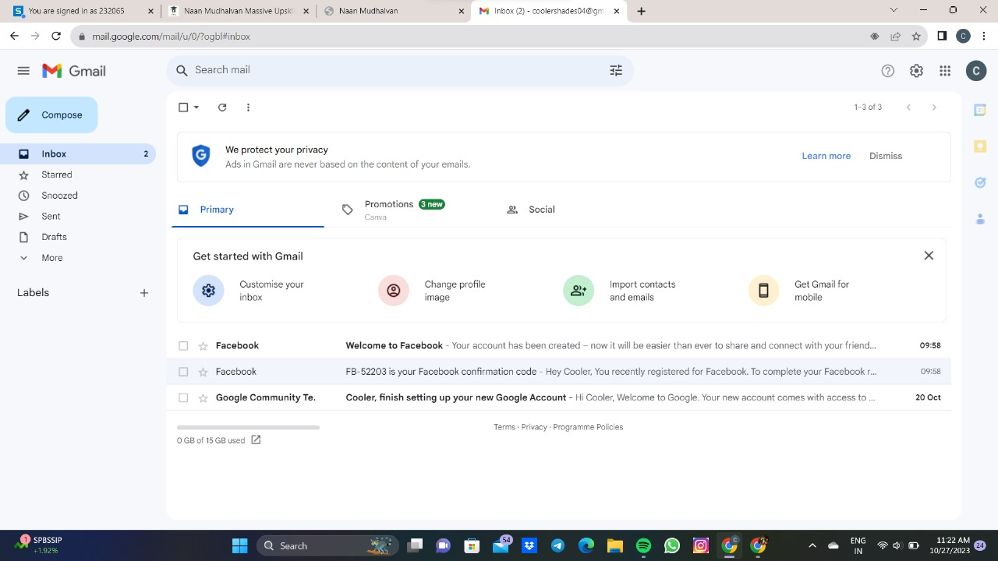

**HOW TO CREATE A LOGO DESIGN USING CANVA**

To create a sunglasses logo using Canva:

* Sign in to Canva or create an account.
* Start a custom-sized design ,e.g., 1000x1000 pixels.
* Use Canva's tools to add and customize sunglass-related icons or shapes.
* Add text with your brand name or slogan.
* Adjust colors, layout, and other design elements.
* Download your logo in PNG or JPG format.



**NAVIGATION**

CREATE A DESIGN:

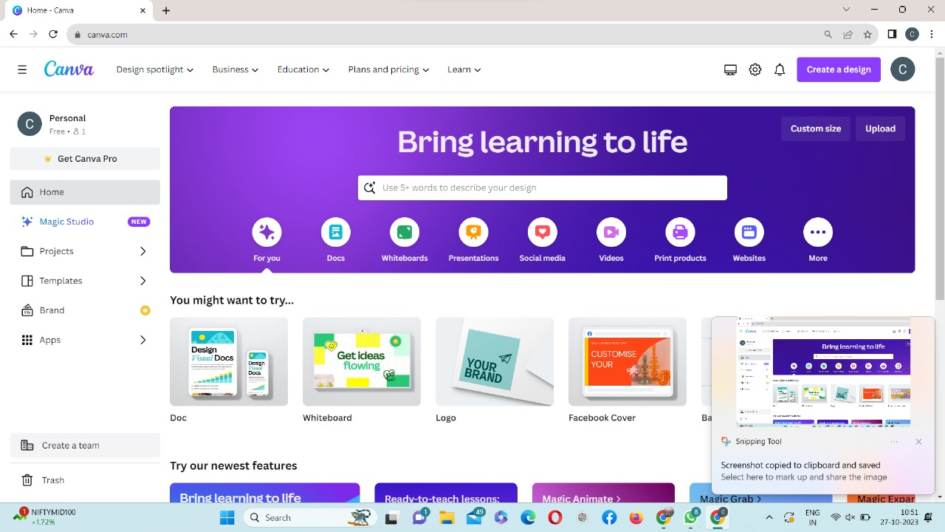

LOGO 500*500 Px:

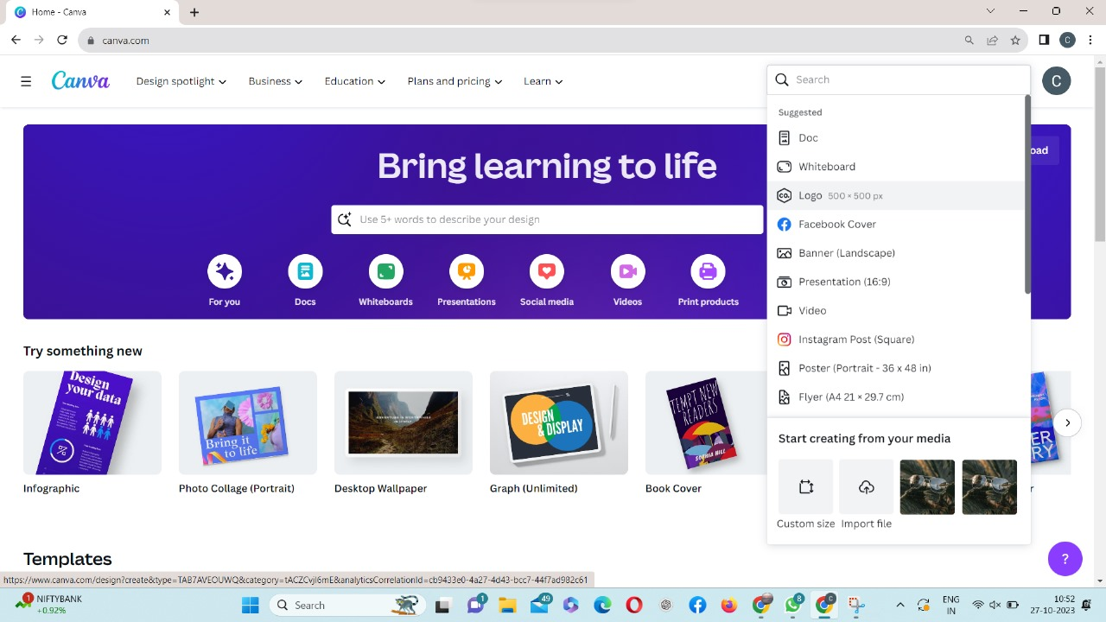

SEARCH TEMPLATE

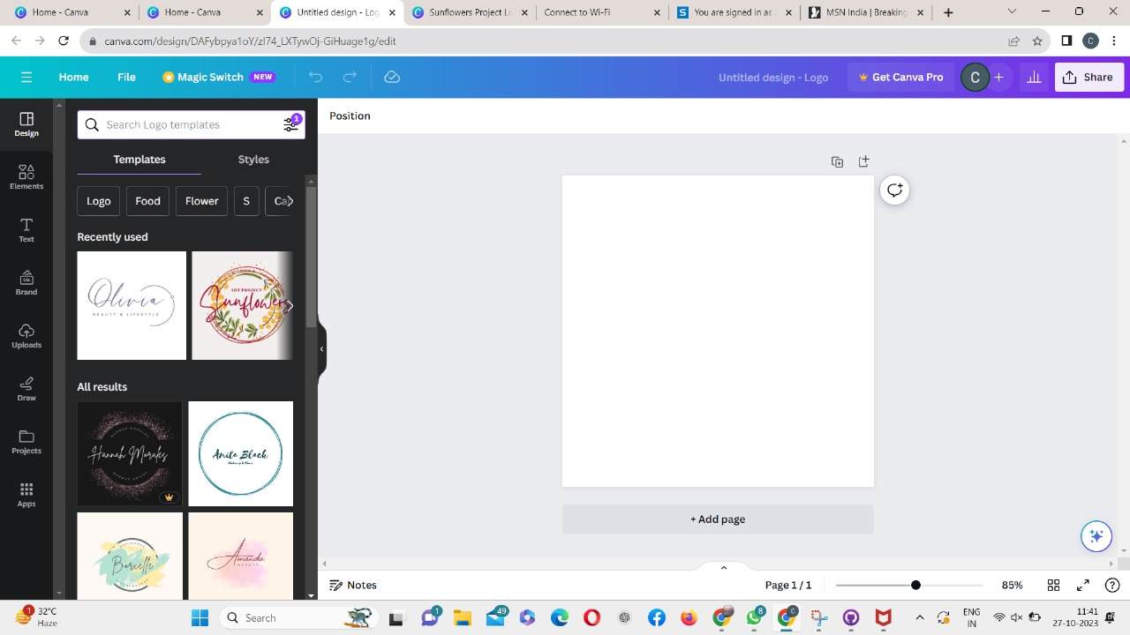

**DESIGN PICKING**

PICK A DESIGN



EDIT THE CONTENT

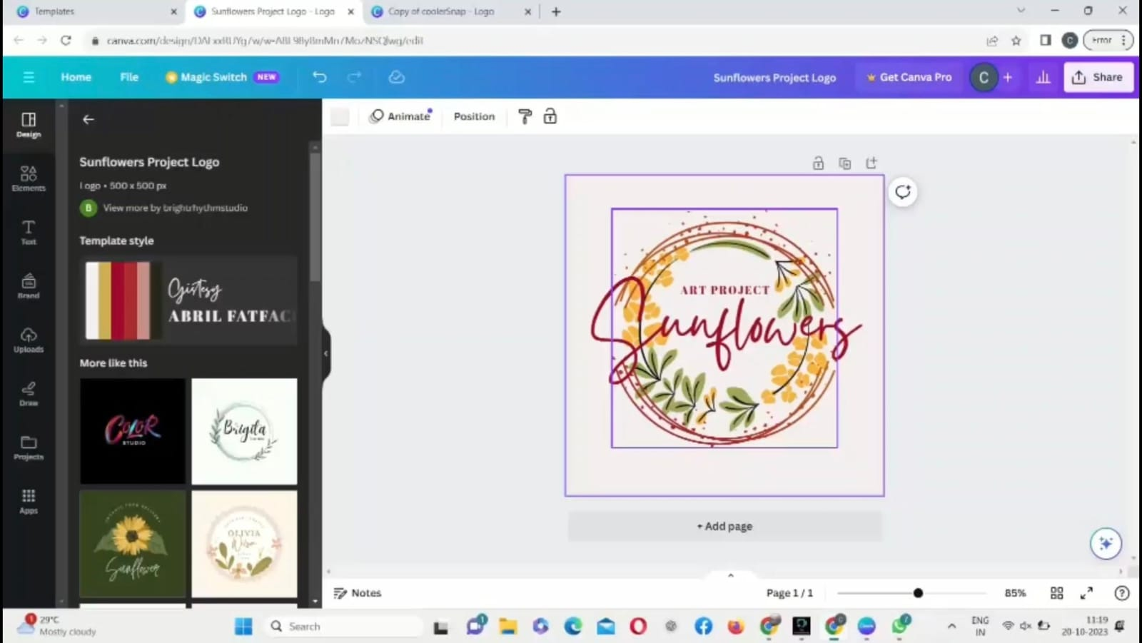

SELECTION AND EDITION

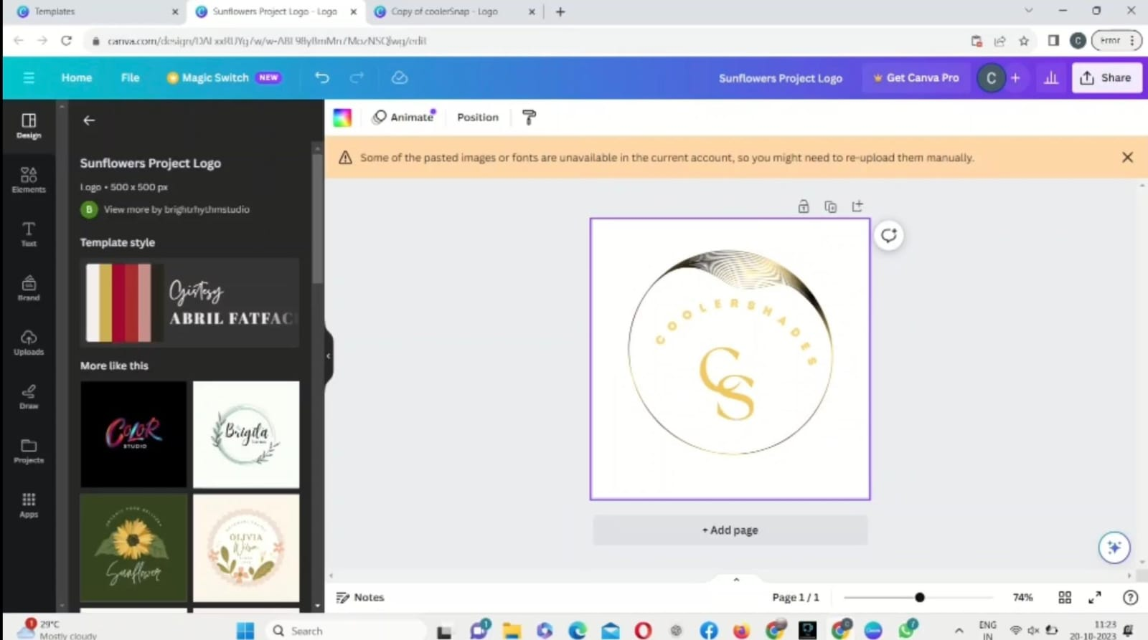

EFFECTS

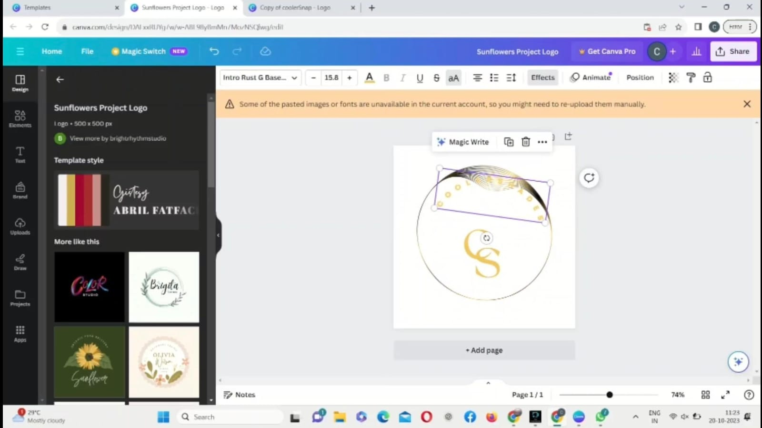

**SELECT DIFFERENT STYLES AND CHOOSE IT**

SELECT DIFFERENT STYLES

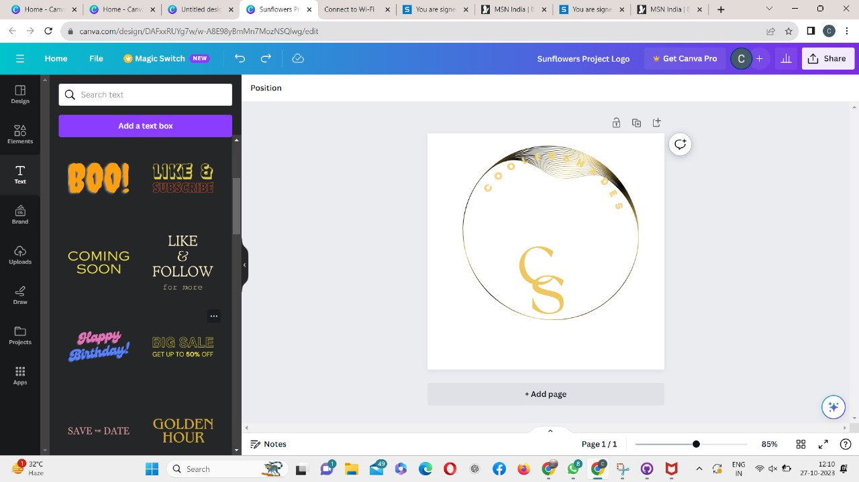

LETTER SPACING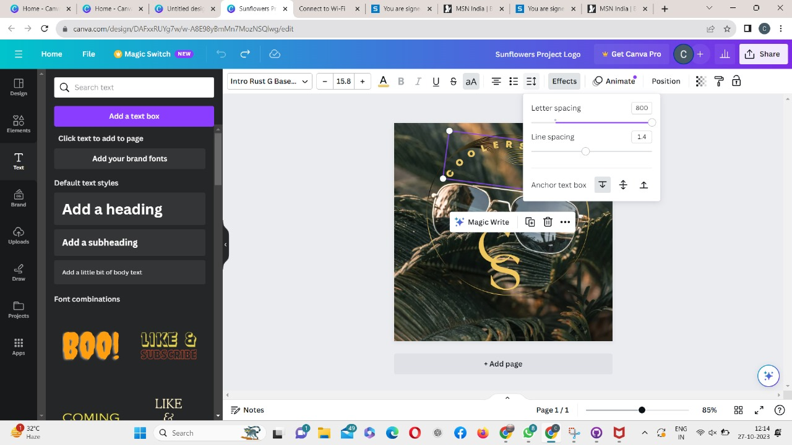

AFTER EDITING IT

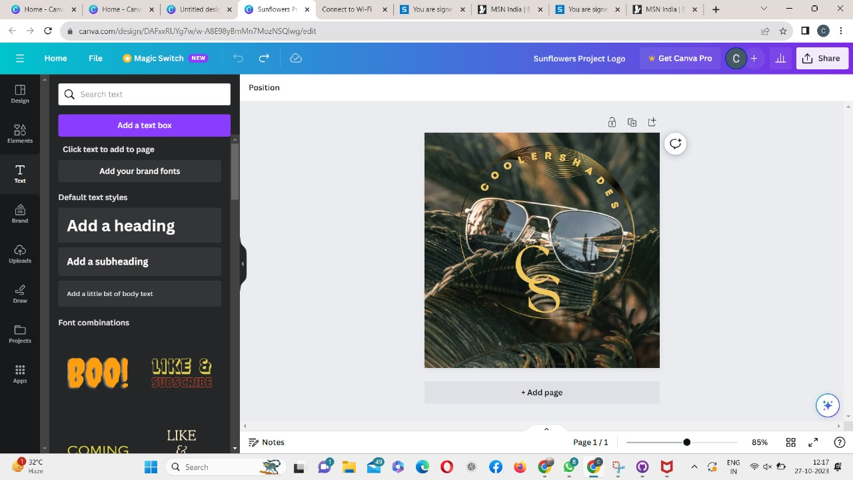

CLICK SHARE

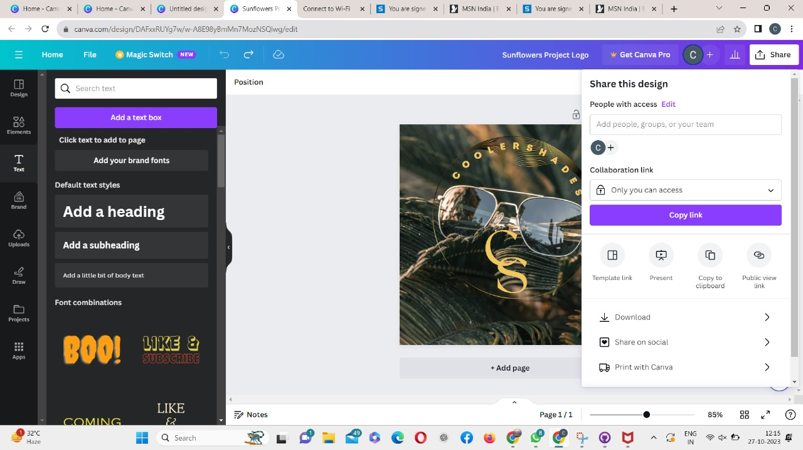

CLICK DOWNLOAD

