**CURRICULUM VITAE**

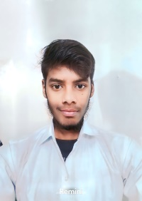**Prabhakar Rajput**

**Address:** Vill.- Kalyanpur, Post.- Ekdil, Dist.- Etawah,  
Uttar Pradesh 206126.

**Email:** [prabhakarrajput78824@gmail.com](mailto:prabhakarrajput78824@gmail.com)

**Mobile**: 8630049758.

**Career Objective**

* To start a career in a challenging and growth oriented organization to effectively use skills and excel as a professional to achieve greater heights and recognition in career.

**Educational Qualification**

|  |  |  |  |
| --- | --- | --- | --- |
| **Qualification** | **Institution** | **Year of Passing** | **Perscentage** |
| Diploma in CSE | Govt. Polytechnic Bijnor | Apearing | - |
| Intermediate | Sant b. d. c. Inter College | 2021 | 70 |
| 10th Class | Sant b. d. c. Inter College | 2019 | 64.3 |

**Technical Skills**

* Basic knowledge of Computer and typing skill.
* Basic knowledge of google docs, google sheets.
* Programming languages: C & C++, Python, Java.
* Web technologies: HTML, CSS, Java Script, Bootsrap.
* Web Servers: -----
* Database: ------
* Operating Systems: Windows.

**Work Experience**

* Fresher

**Declaration**

I do hereby declare that all the above furnished information is true to the best of my knowledge and belief.

Place: SPIRE LAB, IISc.

Date: 29/04/2023

Prabhakar.