LLD — iClinic AI Front Desk Assistant
Low Level Design: AI Front Desk Assistant (Healthcare)

Parent Epic: iClinic — AI Front Desk Assistant
Module: Appointment Booking via Voice & AI Outbound Calls
Status: In Design
Phase: Phase 1 (Voice + Outbound) | Phase 2 (Chat)
Last Updated: 2026-02-25

Problem Statement
Clinics often rely on manual front desk staff to handle appointment scheduling through phone calls or in-person visits. This process leads to long wait times, limited availability outside working hours, booking errors, missed appointments, and increased workload for staff.
The goal is to design and implement an AI-powered front desk assistant for iClinic that allows patients to schedule, modify, and confirm doctor appointments through natural voice conversations, AI outbound phone calls, and chat interfaces, while integrating with the clinic’s existing scheduling system.

User Story
As a patient, I want to book an appointment with my preferred doctor using a natural voice conversation or phone call, so that I receive instant confirmation without visiting or calling the front desk manually.

Business Impact
- Patient Experience: Faster booking with 24/7 availability via voice and outbound calls
- Front Desk Workload: Reduced routine scheduling calls handled by the AI assistant
- Slot Utilization: Alternate slot suggestions reduce no-slot-found abandonment
- Confirmation Accuracy: Automated SMS/Email reduces missed appointments
- Scalability: Outbound call campaigns enable proactive scheduling at scale

Functional Requirements

Requirements Summary
The iClinic AI Front Desk Assistant shall enable end-to-end conversational appointment booking through Voice Assistant, AI Outbound Calls, and Chat Interface. The system shall integrate with the clinic’s existing scheduling system or manual slot feed and manage the complete booking lifecycle — from greeting to confirmation and notification delivery.
Booking Channels
The system shall support appointment booking through the following channels:
• Voice Assistant
• AI Outbound Calls
• Chat Interface
Each channel must provide a consistent booking experience and interact with the same scheduling backend.
Conversational Booking Flow
The assistant shall manage a structured yet natural booking conversation that includes:
- Greeting the patient
- Capturing appointment intent or reason
- Identifying appointment type
- Asking provider preference (if applicable)
- Suggesting available slots
- Confirming selected date and time
- Reconfirming appointment details
- Finalizing booking
- Sending confirmation
The system must support natural conversational behavior, including:
• Interruptions
• Mid-flow corrections (date, time, provider, appointment type)
• Context retention without restarting the flow
Slot Management and Alternate Suggestions
Slot availability shall be retrieved from the clinic’s scheduling input (manual feed or integrated system).
The assistant shall:
• Suggest available slots based on user preference
• Offer nearest available alternatives if the requested slot is unavailable
• Suggest same-provider alternate timings
• Suggest next available provider (if patient permits)
Before final booking, the assistant shall reconfirm:
• Date and time
• Provider (if applicable)
• Location (if applicable)
• Appointment type
AI Outbound Calling Requirements
The system shall be capable of initiating outbound calls for appointment scheduling.
During outbound calls, the assistant shall:
- Initiate the call
- Perform basic patient identity confirmation (as per clinic policy)
- Conduct conversational booking
- Confirm appointment details
- Send confirmation notification
Booking Confirmation and Notifications
After successful booking, the assistant shall:
• Confirm appointment details within the active conversation
• Send confirmation via SMS and/or Email
Confirmation messages must include:
• Date and time
• Provider (if assigned)
• Location
• Appointment type
• Any applicable instructions
Chat-Based Context-Aware Booking
The chat interface shall operate using conversation state and user context.
The assistant shall capture, at minimum:
• Appointment reason
• Appointment type
• Preferred date and time
• Provider preference (if applicable)
• Basic patient identity confirmation (as per clinic policy)
The chat flow shall guide the user through booking while preserving conversation continuity and handling corrections seamlessly.
Non Functional Requirements

Reliability: The system targets 99.9% uptime, enforced through health checks, auto-restart policies, circuit breakers, and Kubernetes liveness probes.
Security: All data in transit is encrypted with TLS 1.3. Data at rest uses AES-256 encryption in line with HIPAA-aligned storage policies.
Observability: Full stack monitoring is implemented via CloudWatch logs, X-Ray traces, and a custom booking metrics dashboard.
Compliance: PII is handled per HIPAA requirements. Data retention policies are enforced at the database level.
Scalability: The system is designed to support 50 or more concurrent voice sessions using horizontal pod autoscaling. The telephony platform handles call-level concurrency.
Maintainability: The design uses service layer separation, dependency injection, and modular LangGraph flow definitions to support long-term maintainability.
Accessibility: Natural-sounding TTS voices are used throughout. The assistant supports interruptions and corrections at all flow steps.
Use Cases and Success Criteria
UC ID | Use Case | Success Criteria
UC-01 | Voice booking, preferred slot available | Patient completes booking end-to-end and receives SMS/Email confirmation.
UC-02 | Voice booking, preferred slot unavailable | Assistant offers alternate slots; patient selects one and booking completes.
UC-03 | Voice booking, mid-flow correction | Patient corrects date, time, or provider; assistant adjusts without restarting the flow.
UC-04 | AI Outbound Call, end-to-end booking | System initiates call, verifies identity, books appointment, and sends confirmation.
UC-05 | Chat booking, end-to-end | Patient books via chat with the same capability as voice/call.
UC-06 | Chat, alternate slot and correction | Chat handles alternate suggestion and mid-flow corrections seamlessly.

User Journeys and Flows

Voice Booking Flow
- Greeting — assistant introduces itself and the clinic
- Capture patient intent — determine if booking, reschedule, or inquiry
- Identify appointment type — based on reason provided
- Ask provider preference — preferred doctor or any available
- Suggest available slots — from the clinic scheduling system
- Confirm date/time — patient selects or requests alternate
- Reconfirm booking details — date, time, provider, type, and location
- Confirm booking — write record to the appointments system
- Send confirmation — SMS and/or Email dispatched to patient

AI Outbound Call Flow
- AI initiates call to patient from the outbound_call_tasks queue
- Identify patient — verify basic identity per clinic policy
- State purpose — inform patient about the scheduling need
- Offer available slots — suggest times from available_slots
- Book appointment — patient confirms; write appointment record to DB
- Send confirmation — SMS and/or Email dispatched to patient

Chat Booking Flow
- Greeting
- Ask reason
- Suggest appointment types
- Ask provider preference
- Suggest available slots
- Confirm date & time
- Reconfirm full details
- Create appointment record
- Send confirmation (SMS / Email)
- Provide final confirmation

In Scope
- Voice Assistant appointment booking, AI Outbound Call scheduling, slot suggestion with alternate slot recommendation, natural conversation handling (interruptions and corrections), in-conversation booking confirmation, and SMS/Email confirmation with appointment instructions and basic patient identity confirmation.
- Chat-based appointment booking.
- Calendar invite attachment and clinic staff notification.

Out of Scope
- Provider schedule setup, working hours, breaks, and time-off management (handled manually by front desk)
- Appointment slot generation and blocking (managed via manual/existing clinic system)
- Payment processing or insurance verification
- UI/UX changes outside this story's scope
- Performance optimization beyond baseline requirements

Assumptions & Constraints
Technical: The backend is built on FastAPI with async SQLAlchemy 2.0. The frontend uses React 19. LangGraph orchestrates the conversational flow in a background worker, call processing.
Business: Slot availability is pre-populated manually by the front desk into the available_slots table. Clinic appointment types and durations are pre-configured before the assistant goes live. Client rules are pre-configured before processing.
Data: PostgreSQL is the primary database with proper indexing across all tables.
Integration: Twilio or an equivalent telephony platform is used for voice and outbound calls.
Legal: All patient data handling complies with HIPAA and applicable privacy regulations.
Identity: Patient identity confirmation policy is defined by the clinic and is configurable per deployment.

API/Contracts

Internal APIs
Method | Endpoint | Description | Auth
GET | /api/v1/appointments | List appointments with filtering by patient, provider, date, and status | JWT Required
POST | /api/v1/appointments | Create a new appointment (booking) | JWT Required
PUT | /api/v1/appointments/{id} | Update an appointment (reschedule or cancel) | JWT Required
GET | /api/v1/available-slots | Query available slots by provider, date, and appointment type | JWT Required
GET | /api/v1/providers | List active providers with specializations | JWT Required
GET | /api/v1/appointment-types | List active appointment types and durations | JWT Required
POST | /api/v1/outbound-tasks | Create an outbound call task for a patient | JWT Required
GET | /api/v1/outbound-tasks/{id} | Get outbound call task status and attempts | JWT Required
POST | /api/v1/conversations/sessions | Initialize a new conversation session | JWT Required
PUT | /api/v1/conversations/sessions/{id} | Update session state (context, status) | JWT Required
POST | /api/v1/notifications | Dispatch an SMS or Email confirmation | JWT Required

Design

High Level Architecture
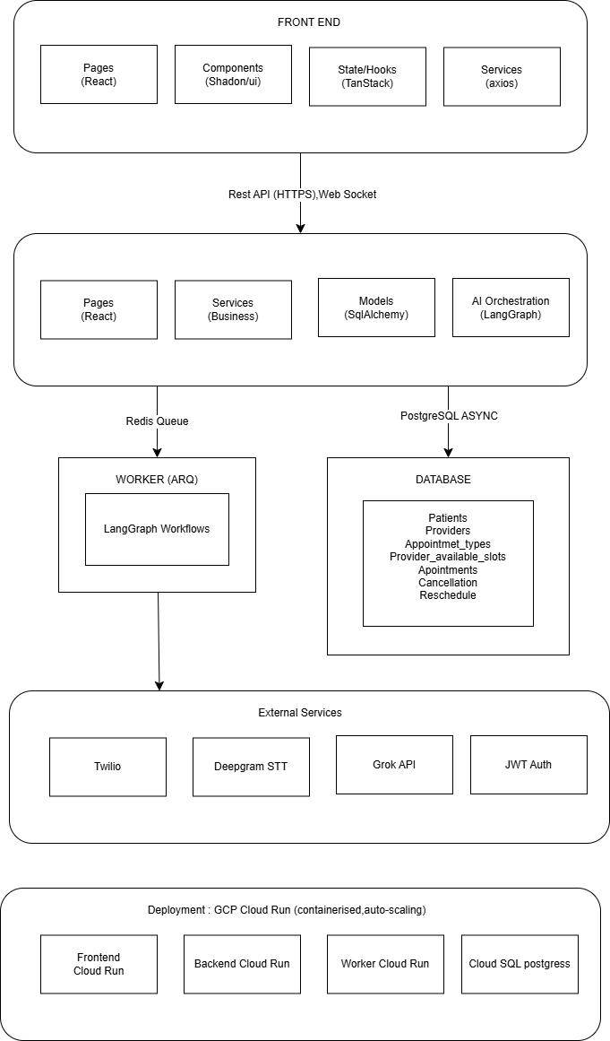

Low Level Design

Sequence Diagram

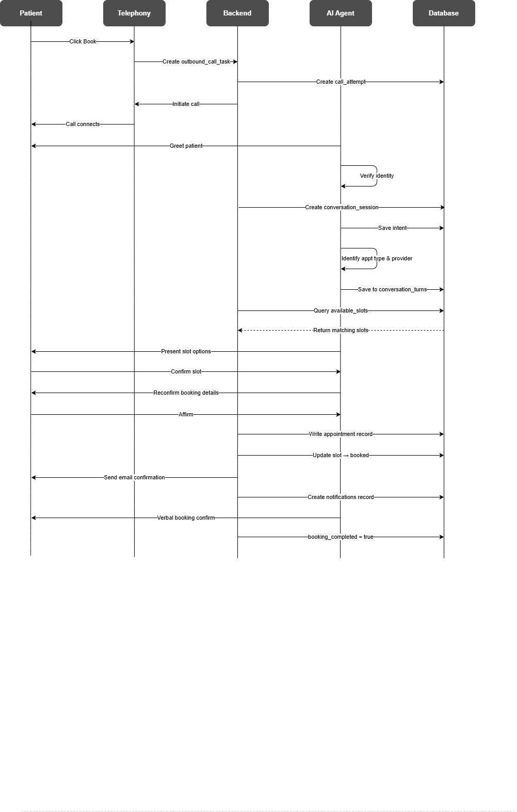

Technical Assumptions
- Async/await patterns are used throughout the FastAPI backend
- Database transactions are managed via SQLAlchemy async sessions
- All APIs follow RESTful conventions with versioned paths (/api/v1/)
- Authentication uses JWT Bearer tokens
- LangGraph orchestrates the multi-turn conversation state machine
- The telephony platform handles call initiation, audio streaming, and voice input
- Available slots are managed externally by the front desk; the assistant reads but does not write slot generation
- Conversation context is stored as JSONB in conversation_sessions.context_snapshot for LangGraph state recovery

Approach Analysis

- Telephony provider selection (Twilio vs. alternatives) and per-minute cost model
- Async/await patterns used throughout backend
- Database transactions managed via SQLAlchemy session
- API follows RESTful conventions
- Authentication via JWT tokens

Open Questions
- Telephony provider selection (Twilio vs. alternatives) and per-minute cost model
- Voice AI model selection (ElevenLabs, Google TTS, Twilio Voice) for natural-sounding responses
- Patient identity verification level — date of birth, name, phone match, or PIN — per clinic policy
- Max concurrent outbound call concurrency and rate-limiting rules
- Error retry policies fine-tuning for failed call attempts
- Performance benchmarks for production voice call load

Request / Response Schema

POST /api/v1/appointments — Request Example
{
"patient_id": 42,
"provider_id": 5,
"appointment_type_id": 2,
"availability_slot_id": 101,
"session_id": 88,
"reason_for_visit": "Annual checkup",
"booking_channel": "voice"
}

POST /api/v1/appointments — Response Example
{
"id": 220,
"status": "scheduled",
"scheduled_date": "2026-03-10",
"scheduled_start_time": "10:00:00",
"scheduled_end_time": "10:30:00",
"provider": "Dr. Sarah Lee",
"created_at": "2026-02-25T09:15:00Z",
"message": "Appointment booked successfully"
}

Authentication / Authorization
- Current: JWT Bearer token in the Authorization header
- Roles: admin, front_desk, patient, provider, viewer

Data Models

Database Tables
The following tables represent the full data model for the iClinic AI Front Desk Assistant. Only these tables are represented as structured tables in this document. PK = Primary Key, FK = Foreign Key, Y = Yes.

Users

Field Name | Data Type | Constraint | PK | FK | Description
id | INTEGER | PRIMARY KEY | Y |  | Auto-increment unique user ID
role_id | INTEGER | NOT NULL |  | Y | FK → roles.id
first_name | VARCHAR(100) | NOT NULL |  |  | User first name
last_name | VARCHAR(100) | NOT NULL |  |  | User last name
email | VARCHAR(255) | UNIQUE NOT NULL |  |  | Login email address
phone_no | VARCHAR(20) | NULLABLE |  |  | Contact phone number
password | VARCHAR(255) | NOT NULL |  |  | Hashed password (bcrypt)
created_at | TIMESTAMP | DEFAULT NOW() |  |  | Record creation timestamp

Roles

Field Name | Data Type | Constraint | PK | FK | Description
id | INTEGER | PRIMARY KEY | Y |  | Auto-increment role ID
role_name | VARCHAR(50) | UNIQUE NOT NULL |  |  | Role name e.g. admin, front_desk, patient
created_at | TIMESTAMP | DEFAULT NOW() |  |  | Record creation timestamp
updated_at | TIMESTAMP | DEFAULT NOW() |  |  | Last updated timestamp

Permissions

Field Name | Data Type | Constraint | PK | FK | Description
id | INTEGER | PRIMARY KEY | Y |  | Auto-increment permission ID
name | VARCHAR(100) | UNIQUE NOT NULL |  |  | Permission identifier e.g. appointments:create
description | VARCHAR(255) | NULLABLE |  |  | Human-readable description
module | VARCHAR(100) | NOT NULL |  |  | Module owning this permission
is_active | BOOLEAN | DEFAULT TRUE |  |  | Whether permission is active
created_at | TIMESTAMP | DEFAULT NOW() |  |  | Record creation timestamp
updated_at | TIMESTAMP | DEFAULT NOW() |  |  | Last updated timestamp

Role_permissions

Field Name | Data Type | Constraint | PK | FK | Description
id | INTEGER | PRIMARY KEY | Y |  | Auto-increment ID
role_id | INTEGER | NOT NULL |  | Y | FK → roles.id
permission_id | INTEGER | NOT NULL |  | Y | FK → permissions.id
created_at | TIMESTAMP | DEFAULT NOW() |  |  | Assignment timestamp

Refresh_tokens

Field Name | Data Type | Constraint | PK | FK | Description
id | INTEGER | PRIMARY KEY | Y |  | Auto-increment ID
token_id | UUID | UNIQUE NOT NULL |  |  | Unique token UUID
expire_at | TIMESTAMP WITH TIME ZONE | NOT NULL |  |  | Token expiry datetime
is_revoked | BOOLEAN | DEFAULT FALSE |  |  | Whether token has been revoked
created_at | TIMESTAMP | DEFAULT NOW() |  |  | Token creation timestamp

Patient_profiles

Field Name | Data Type | Constraint | PK | FK | Description
id | INTEGER | PRIMARY KEY | Y |  | Auto-increment patient profile ID
user_id | INTEGER | UNIQUE NOT NULL |  | Y | FK → users.id (1:1 relationship)
date_of_birth | DATE | NULLABLE |  |  | Patient date of birth
gender | VARCHAR(20) | NULLABLE |  |  | Patient gender
address | TEXT | NULLABLE |  |  | Patient home address
preferred_language | VARCHAR(50) | DEFAULT 'English' |  |  | Preferred language for communication
is_active | BOOLEAN | DEFAULT TRUE |  |  | Whether patient profile is active
last_login_at | TIMESTAMP | NULLABLE |  |  | Last login timestamp
created_at | TIMESTAMP | DEFAULT NOW() |  |  | Profile creation timestamp
updated_at | TIMESTAMP | DEFAULT NOW() |  |  | Last updated timestamp

Providers

Field Name | Data Type | Constraint | PK | FK | Description
id | INTEGER | PRIMARY KEY | Y |  | Auto-increment provider ID
full_name | VARCHAR(255) | NOT NULL |  |  | Doctor/provider full name
specialization | VARCHAR(255) | NOT NULL |  |  | Medical specialization e.g. Cardiology
qualification | VARCHAR(255) | NOT NULL |  |  | Degrees and qualifications
experience | INTEGER | NULLABLE |  |  | Years of experience
phone | VARCHAR(20) | NULLABLE |  |  | Provider contact phone
email | VARCHAR(255) | UNIQUE NULLABLE |  |  | Provider email address
bio | TEXT | NULLABLE |  |  | Provider biography and profile text
is_active | BOOLEAN | DEFAULT TRUE |  |  | Whether provider is currently active
created_at | TIMESTAMP | DEFAULT NOW() |  |  | Record creation timestamp
updated_at | TIMESTAMP | DEFAULT NOW() |  |  | Last updated timestamp

Appointment_types

Field Name | Data Type | Constraint | PK | FK | Description
id | INTEGER | PRIMARY KEY | Y |  | Auto-increment appointment type ID
name | VARCHAR(100) | UNIQUE NOT NULL |  |  | Type name e.g. General Consultation
description | TEXT | NULLABLE |  |  | Detailed description of appointment type
duration_minutes | INTEGER | NOT NULL |  |  | Default duration for this type in minutes
instructions | TEXT | NULLABLE |  |  | Pre-visit instructions sent in confirmation
is_active | BOOLEAN | DEFAULT TRUE |  |  | Whether this type is currently available
created_at | TIMESTAMP | DEFAULT NOW() |  |  | Record creation timestamp

Provider_appointment_types

Field Name | Data Type | Constraint | PK | FK | Description
id | INTEGER | PRIMARY KEY | Y |  | Auto-increment ID
provider_id | INTEGER | NOT NULL |  | Y | FK → providers.id
appointment_type_id | INTEGER | NOT NULL |  | Y | FK → appointment_types.id
is_active | BOOLEAN | DEFAULT TRUE |  |  | Whether this provider offers this appointment type
created_at | TIMESTAMP | DEFAULT NOW() |  |  | Record creation timestamp

Available_slots

Field Name | Data Type | Constraint | PK | FK | Description
id | INTEGER | PRIMARY KEY | Y |  | Auto-increment slot ID
provider_id | INTEGER | NOT NULL |  | Y | FK → providers.id
availability_date | DATE | NOT NULL |  |  | Date of the available slot
start_time | TIME | NOT NULL |  |  | Slot start time
end_time | TIME | NOT NULL |  |  | Slot end time
status | ENUM('available','booked','blocked','on_hold') | DEFAULT 'available' |  |  | Current slot status
created_by | INTEGER | NOT NULL |  | Y | FK → users.id (front desk user who created slot)
notes | TEXT | NULLABLE |  |  | Optional notes on the slot
created_at | TIMESTAMP | DEFAULT NOW() |  |  | Record creation timestamp
updated_at | TIMESTAMP | DEFAULT NOW() |  |  | Last updated timestamp

Appointments

Field Name | Data Type | Constraint | PK | FK | Description
id | INTEGER | PRIMARY KEY | Y |  | Auto-increment appointment ID
patient_id | INTEGER | NOT NULL |  | Y | FK → patient_profiles.id
provider_id | INTEGER | NOT NULL |  | Y | FK → providers.id
appointment_type_id | INTEGER | NOT NULL |  | Y | FK → appointment_types.id
availability_slot_id | INTEGER | UNIQUE NOT NULL |  | Y | FK → available_slots.id (unique to prevent double-booking)
session_id | INTEGER | NULLABLE |  | Y | FK → conversation_sessions.id (booking session)
scheduled_date | DATE | NOT NULL |  |  | Date of appointment
scheduled_start_time | TIME | NOT NULL |  |  | Appointment start time
scheduled_end_time | TIME | NOT NULL |  |  | Appointment end time
status | ENUM('scheduled','confirmed','cancelled','completed','no_show') | DEFAULT 'scheduled' |  |  | Appointment lifecycle status
reason_for_visit | TEXT | NULLABLE |  |  | Patient-stated reason for visit
notes | TEXT | NULLABLE |  |  | Internal notes on the appointment
booking_channel | ENUM('voice','outbound_call','chat','manual') | NOT NULL |  |  | Channel through which appointment was booked
instructions | TEXT | NULLABLE |  |  | Instructions sent to patient (overrides appointment_type instructions)
cancelled_at | TIMESTAMP | NULLABLE |  |  | Timestamp when appointment was cancelled
cancellation_reason | TEXT | NULLABLE |  |  | Reason for cancellation
created_at | TIMESTAMP | DEFAULT NOW() |  |  | Record creation timestamp
updated_at | TIMESTAMP | DEFAULT NOW() |  |  | Last updated timestamp

Conversation_sessions

Field Name | Data Type | Constraint | PK | FK | Description
id | INTEGER | PRIMARY KEY | Y |  | Auto-increment session ID
patient_id | INTEGER | NULLABLE |  | Y | FK → patient_profiles.id (null if unverified at session start)
channel | ENUM('voice','outbound_call','chat') | NOT NULL |  |  | Communication channel for session
phone_no | VARCHAR(20) | NULLABLE |  |  | Phone number used in this session
status | ENUM('active','completed','dropped','failed') | DEFAULT 'active' |  |  | Current session status
intent | TEXT | NULLABLE |  |  | Primary detected patient intent
last_flow_step | TEXT | NULLABLE |  |  | Last step in conversation flow for recovery
context_snapshot | JSONB | NULLABLE |  |  | LangGraph state snapshot for session recovery
started_at | TIMESTAMP | DEFAULT NOW() |  |  | Session start timestamp
ended_at | TIMESTAMP | NULLABLE |  |  | Session end timestamp
duration_seconds | INTEGER | NULLABLE |  |  | Total session duration in seconds
identity_verified | BOOLEAN | DEFAULT FALSE |  |  | Whether patient identity was confirmed
booking_completed | BOOLEAN | DEFAULT FALSE |  |  | Whether a booking was completed in this session
created_at | TIMESTAMP | DEFAULT NOW() |  |  | Record creation timestamp

Conversation_turns

Field Name | Data Type | Constraint | PK | FK | Description
id | INTEGER | PRIMARY KEY | Y |  | Auto-increment turn ID
session_id | INTEGER | NOT NULL |  | Y | FK → conversation_sessions.id
turn_order | INTEGER | NOT NULL |  |  | Sequential order of this turn within the session
speaker | ENUM('patient','assistant') | NOT NULL |  |  | Who spoke in this turn
message | TEXT | NOT NULL |  |  | Transcribed or generated message content
intent_detected | VARCHAR(100) | NULLABLE |  |  | NLU intent detected in this turn
entities | JSONB | NULLABLE |  |  | Entities extracted: date, time, provider, appointment type
confidence_score | DECIMAL(4,3) | NULLABLE |  |  | NLU confidence score (0.000 to 1.000)
created_at | TIMESTAMP | DEFAULT NOW() |  |  | Turn creation timestamp

Outbound_call_tasks

Field Name | Data Type | Constraint | PK | FK | Description
id | INTEGER | PRIMARY KEY | Y |  | Auto-increment task ID
patient_id | INTEGER | NOT NULL |  | Y | FK → patient_profiles.id
appointment_id | INTEGER | NULLABLE |  | Y | FK → appointments.id (if linked to existing appointment)
trigger_reason | ENUM('new_booking','reschedule','reminder','follow_up','no_show') | NOT NULL |  |  | Why this call was triggered
task_status | ENUM('pending','in_progress','completed','failed','cancelled') | DEFAULT 'pending' |  |  | Current task processing status
priority | INTEGER | DEFAULT 5 |  |  | Call priority (1 = highest, 10 = lowest)
max_retries | INTEGER | DEFAULT 3 |  |  | Maximum number of call attempts allowed
retry_interval_minutes | INTEGER | DEFAULT 60 |  |  | Minutes to wait between retry attempts
attempt_count | INTEGER | DEFAULT 0 |  |  | Current number of attempts made
scheduled_at | TIMESTAMP | NOT NULL |  |  | When this call should first be attempted
next_attempt_at | TIMESTAMP | NULLABLE |  |  | Scheduled timestamp for next retry
last_attempt_at | TIMESTAMP | NULLABLE |  |  | Timestamp of most recent attempt
completed_at | TIMESTAMP | NULLABLE |  |  | Timestamp when task was completed
notes | TEXT | NULLABLE |  |  | Internal notes on this task
created_by | INTEGER | NOT NULL |  | Y | FK → users.id (who created this task)2
created_at | TIMESTAMP | DEFAULT NOW() |  |  | Record creation timestamp
updated_at | TIMESTAMP | DEFAULT NOW() |  |  | Last updated timestamp

Call_attempts

Field Name | Data Type | Constraint | PK | FK | Description
id | INTEGER | PRIMARY KEY | Y |  | Auto-increment attempt ID
task_id | INTEGER | NOT NULL |  | Y | FK → outbound_call_tasks.id
session_id | INTEGER | NULLABLE |  | Y | FK → conversation_sessions.id (if call was answered)
attempt_number | INTEGER | NOT NULL |  |  | Sequential attempt number for this task
phone_dialed | VARCHAR(20) | NOT NULL |  |  | Phone number that was dialed
dialed_at | TIMESTAMP | NOT NULL |  |  | When the call was initiated
answered_at | TIMESTAMP | NULLABLE |  |  | When the call was answered (null if no answer)
ended_at | TIMESTAMP | NULLABLE |  |  | When the call ended
duration_seconds | INTEGER | NULLABLE |  |  | Total call duration in seconds
outcome | ENUM('answered','no_answer','voicemail','busy','failed','booked','declined') | NOT NULL |  |  | Outcome of this call attempt
disconnect_point | VARCHAR(100) | NULLABLE |  |  | Flow step at which call disconnected
voicemail_left | BOOLEAN | DEFAULT FALSE |  |  | Whether a voicemail message was left
error_code | VARCHAR(50) | NULLABLE |  |  | Telephony error code if call failed
error_message | TEXT | NULLABLE |  |  | Detailed error message
created_at | TIMESTAMP | DEFAULT NOW() |  |  | Record creation timestamp

Notifications

Field Name | Data Type | Constraint | PK | FK | Description
id | INTEGER | PRIMARY KEY | Y |  | Auto-increment notification ID
appointment_id | INTEGER | NULLABLE |  | Y | FK → appointments.id
patient_id | INTEGER | NOT NULL |  | Y | FK → patient_profiles.id
channel | ENUM('email','sms') | NOT NULL |  |  | Delivery channel for notification
type | ENUM('booking_confirmation','reminder','cancellation','reschedule') | NOT NULL |  |  | Notification event type
recipient_address | TEXT | NOT NULL |  |  | Email address or phone number of recipient
message_body | TEXT | NOT NULL |  |  | Rendered notification message content
status | ENUM('pending','sent','delivered','failed') | DEFAULT 'pending' |  |  | Delivery status of notification
payload | JSONB | NULLABLE |  |  | Full provider API payload and response for debugging
sent_at | TIMESTAMP | NULLABLE |  |  | Timestamp when notification was sent
delivered_at | TIMESTAMP | NULLABLE |  |  | Timestamp when delivery was confirmed
error_message | TEXT | NULLABLE |  |  | Error details if notification failed
created_at | TIMESTAMP | DEFAULT NOW() |  |  | Record creation timestamp

ER Diagram

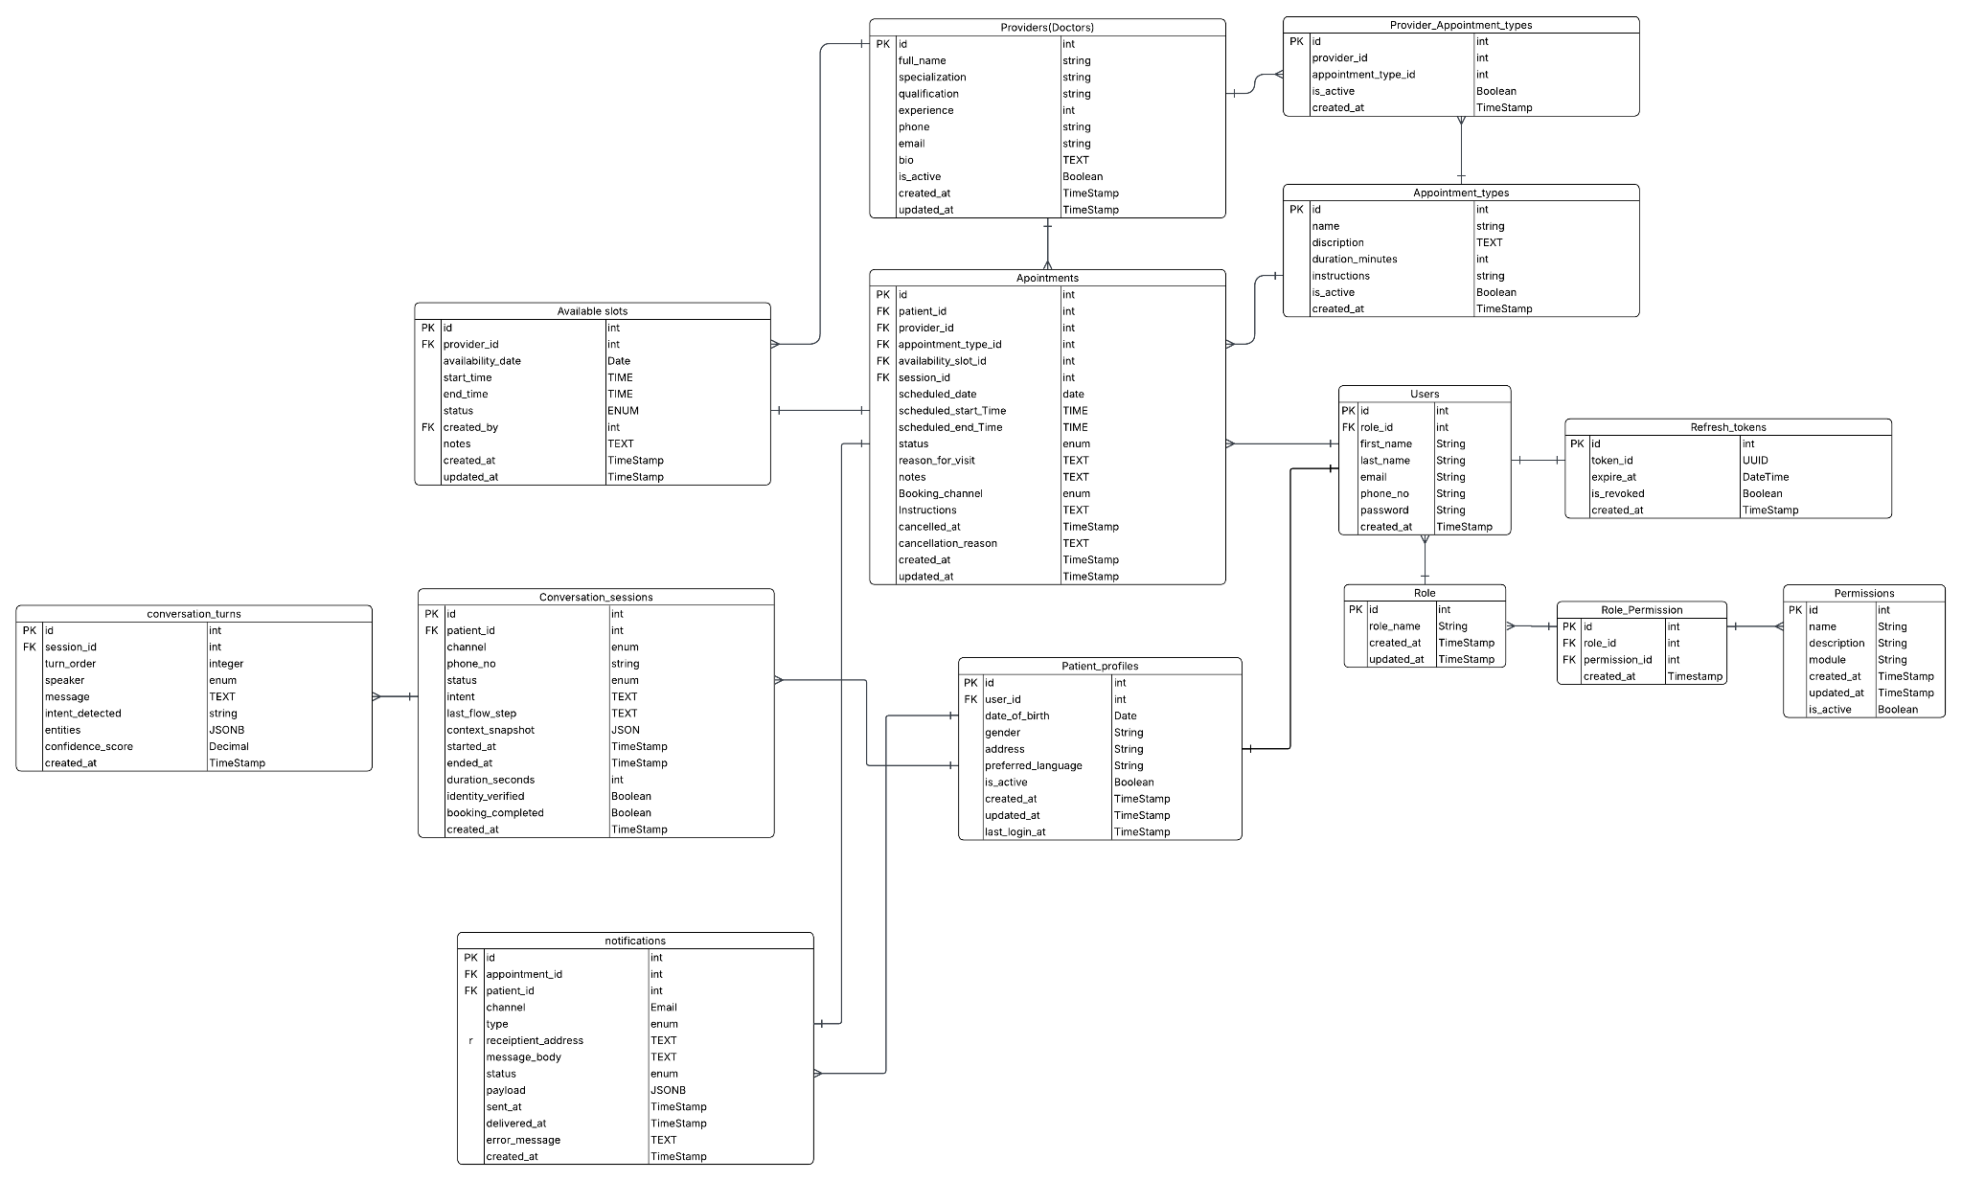

Relationships
- users (1) → (1) patient_profiles via user_id
- users (N) → (1) roles via role_id
- roles (M) ↔ (N) permissions via role_permissions
- patient_profiles (1) → (N) appointments via patient_id
- providers (1) → (N) available_slots via provider_id
- providers (M) ↔ (N) appointment_types via provider_appointment_types
- appointment_types (1) → (N) appointments via appointment_type_id
- available_slots (1) → (1) appointments via availability_slot_id (unique constraint prevents double-booking)
- conversation_sessions (1) → (N) conversation_turns via session_id
- conversation_sessions (1) → (0..1) appointments via session_id
- patient_profiles (1) → (N) outbound_call_tasks via patient_id
- outbound_call_tasks (1) → (N) call_attempts via task_id
- call_attempts (1) → (0..1) conversation_sessions via session_id
- appointments (1) → (N) notifications via appointment_id

Failure Handling
Failure Scenario | Detection | Recovery Action
API timeout | Request timeout > 30s | Retry with exponential backoff, max 3 attempts
Database connection lost | Connection pool exhausted | Circuit breaker activates; failover to read replica
Voice call drops mid-conversation | Telephony disconnect event | Session marked 'dropped'; context_snapshot preserved for re-initiation
Outbound call not answered | Outcome = no_answer or busy | next_attempt_at scheduled per retry_interval_minutes; max_retries enforced before marking failed
LangGraph worker crash | Worker heartbeat failure in Redis | Kubernetes restart policy triggers; session recoverable from context_snapshot
SMS/Email delivery failure | Provider returns non-2xx | Notification marked 'failed'; alert triggered; record queued for manual follow-up
Slot double-booking race condition | Unique constraint violation on availability_slot_id | Transaction rolled back; assistant notifies patient and offers next available slot
Invalid patient identity | Confidence below threshold after max attempts | Call escalated to front desk or session ended gracefully with instructions
NLU intent confidence low | confidence_score below 0.60 | Assistant asks clarifying question; turn logged with low confidence flag for review

