1.Write a script that takes a directory path as input and creates a new directory within it named "Backups_$(date +%Y-%m-%d)". Create a script that renames all files in a directory with the extension ".txt" to have a prefix of "report_".

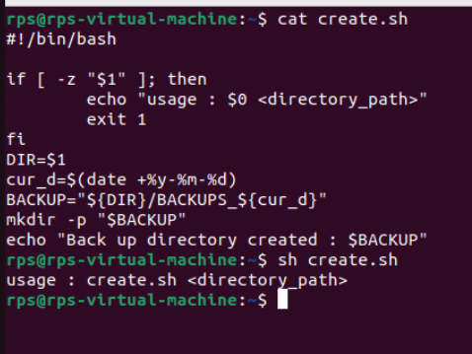

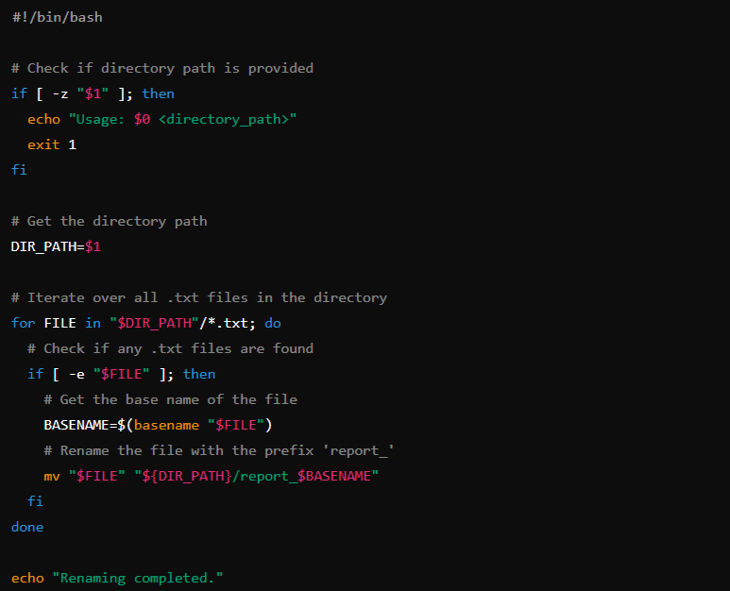

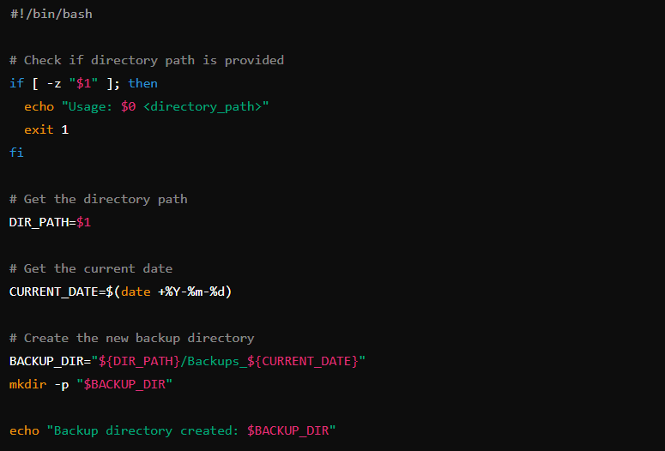

2. Write a script that prompts the user for their name and age, then greets them with a personalized message. Design a script that displays a menu with options like "List files," "Create directory," and "Exit." Allow the user to choose an option and perform the corresponding action.

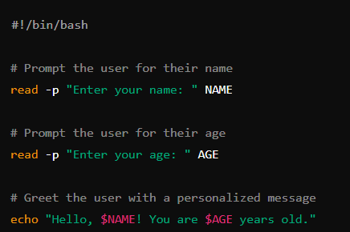

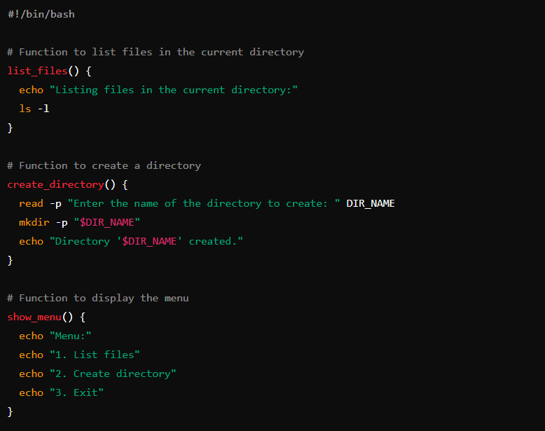

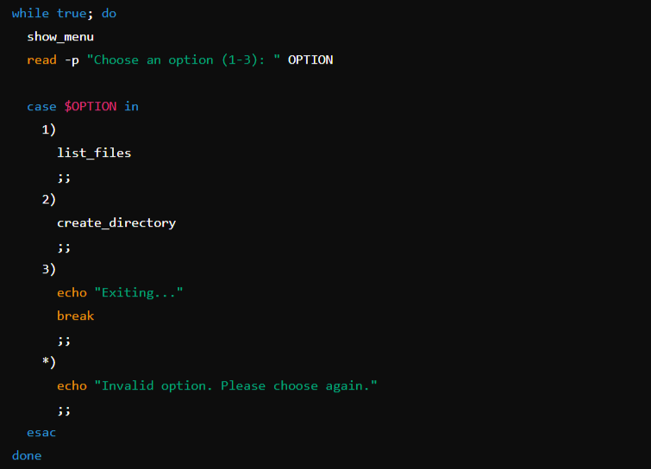

3. Write a script that reads the contents of a file line by line, counts the number of lines, and prints the total.Create a script that takes a text file as input and replaces all occurrences of a specific word with another word.

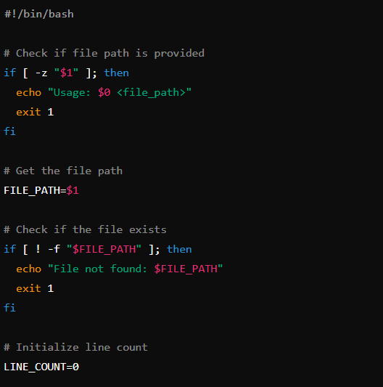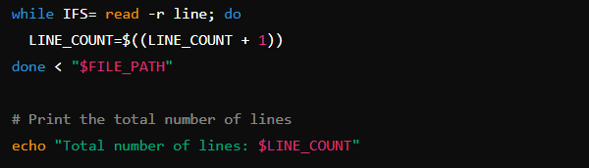

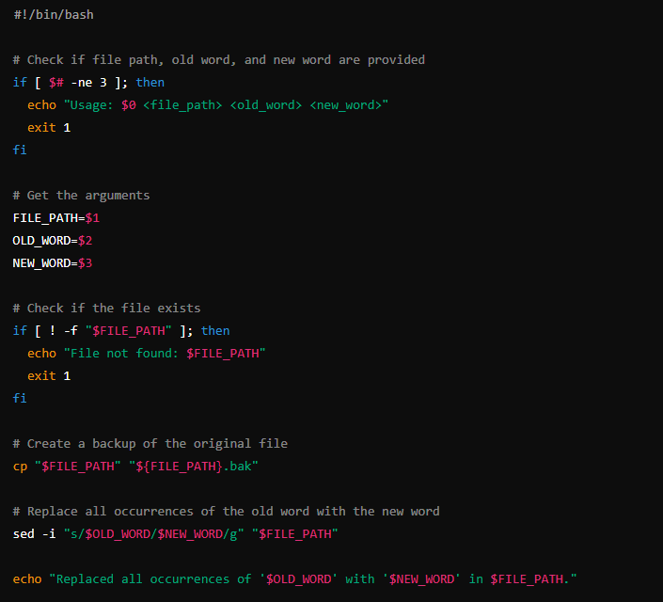

4.Write a script that checks if a specific package is installed and, if not, installs it using the appropriate package manager (e.g., apt-get, yum).Create a script that monitors disk usage and sends an email notification if it exceeds a certain threshold.

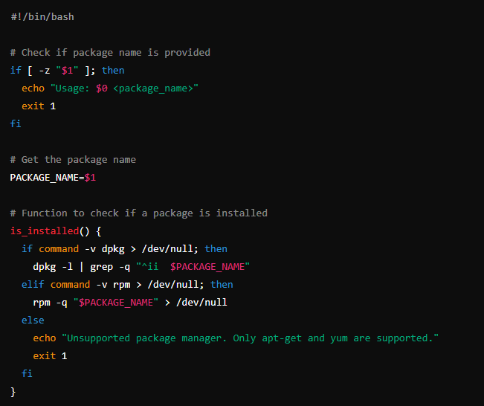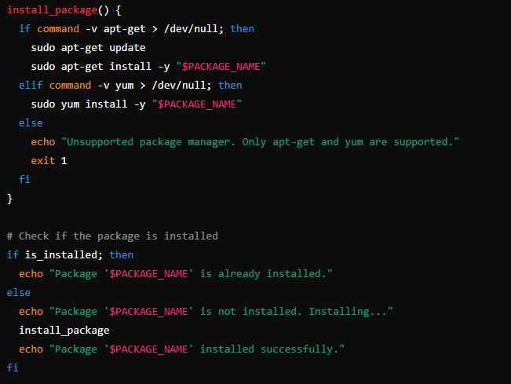

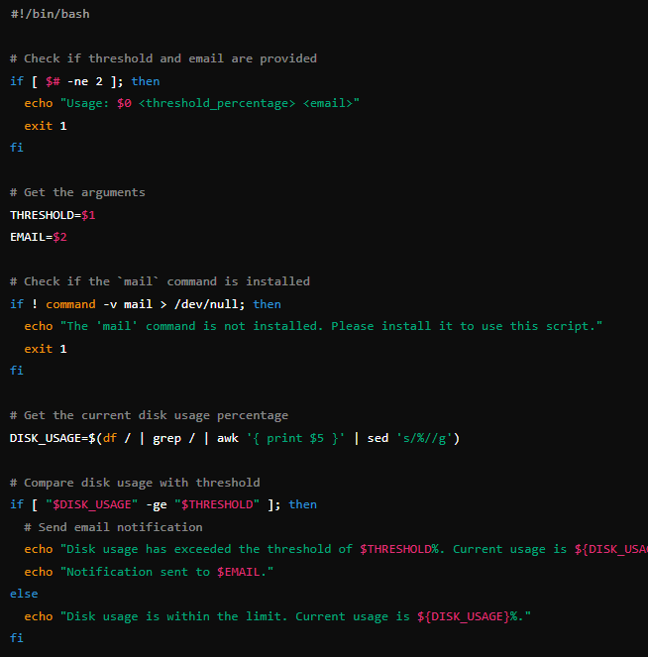

5. Write a script that reads a CSV file, calculates the average of a specific column, and prints the result. Create a script that generates a random password of a specified length, meeting certain criteria like uppercase, lowercase, numbers, and symbols.

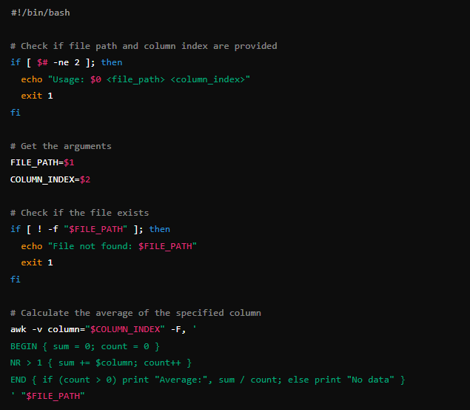

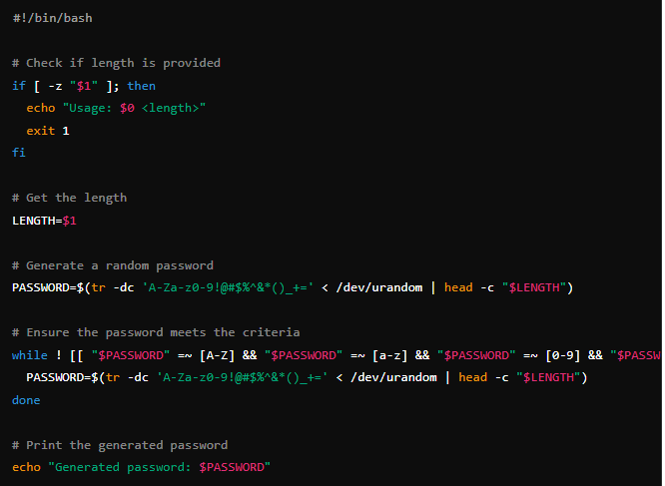

6. Write a script that pings a list of servers and reports if any are unreachable. Create a script that backs up a remote directory on another server to a local directory using tools like scp.

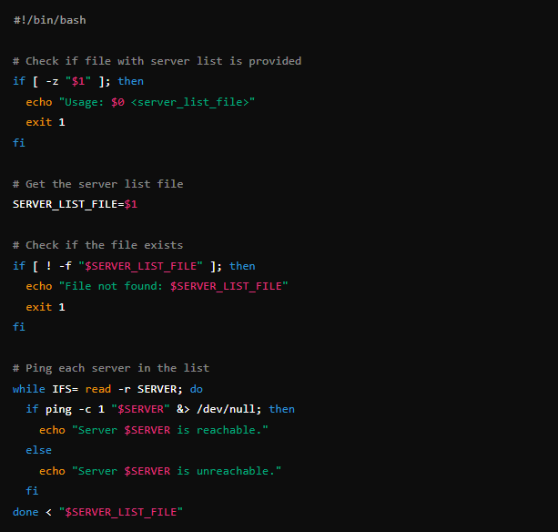

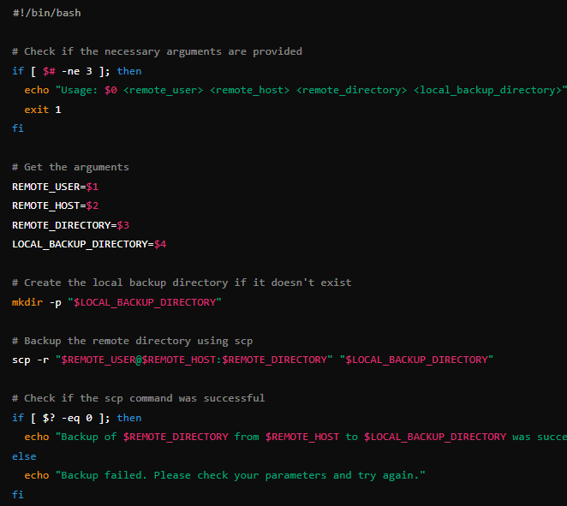

**Signal:**

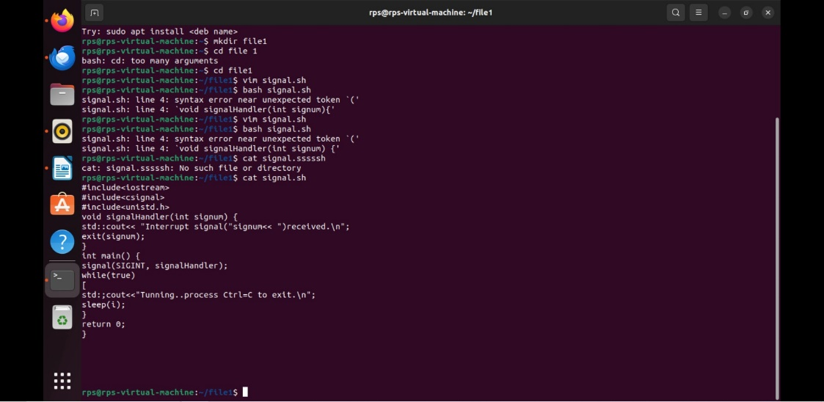

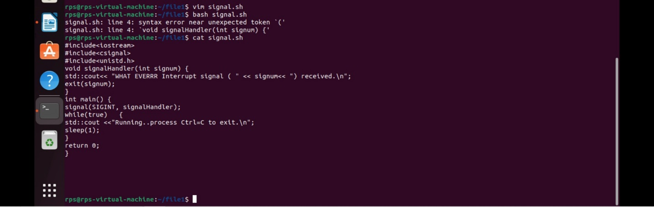

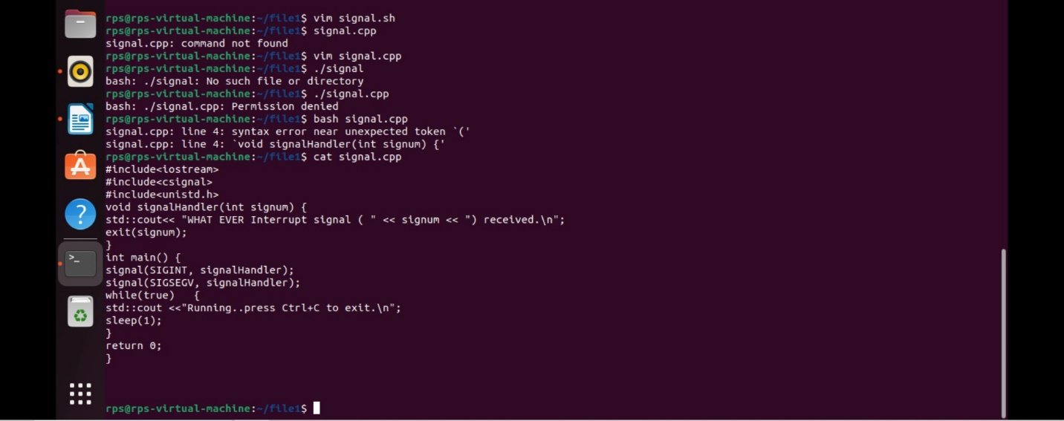

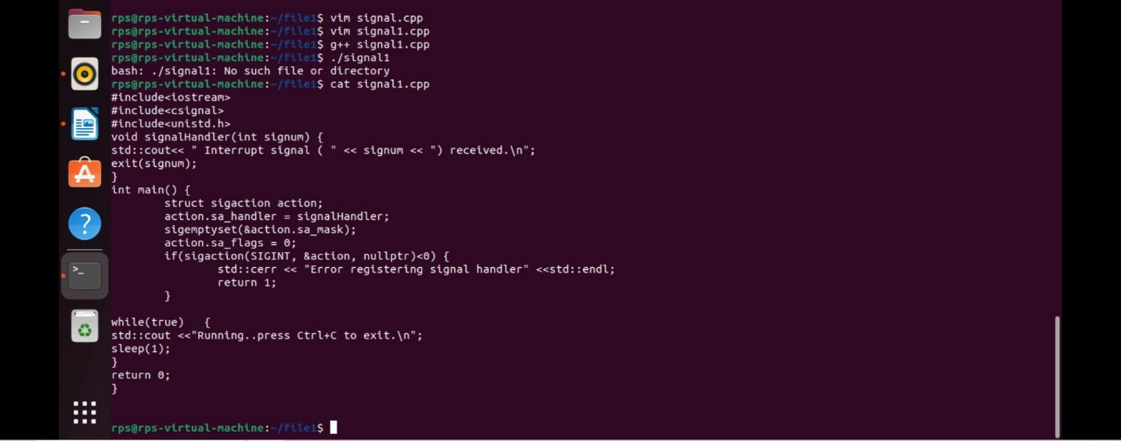

**Basic Handling vs. Advanced Control: Implement signal handling using both signal and sigaction (in separate program runs). Observe the behavior. Which API allows for more control over the signal handler? Explain the key difference in a comment within your code.**

#include <iostream>

#include <signal.h>

#include <unistd.h>

void handle_signal(int sig) {

std::cout << "Caught signal " << sig << std::endl;

}

int main() {

if (signal(SIGINT, handle_signal) == SIG_ERR) {

perror("signal");

return 1;

}

while (true) {

std::cout << "Running... Press Ctrl+C to send SIGINT" << std::endl;

sleep(1);

}

return 0;

}

#include <iostream>

#include <signal.h>

#include <unistd.h>

void handle_signal(int sig) {

std::cout << "Caught signal " << sig << std::endl;

}

int main() {

struct sigaction sa;

sa.sa_handler = handle_signal;

sa.sa_flags = 0;

sigemptyset(&sa.sa_mask);

if (sigaction(SIGINT, &sa, NULL) == -1) {

perror("sigaction");

return 1;

}

while (true) {

std::cout << "Running... Press Ctrl+C to send SIGINT" << std::endl;

sleep(1);

}

return 0;

}

**Example:**

