STEPS:

- Created 2 Jupiter notebook :

- In 1st one I have done all prepossessing and trained with different classification model
- In 2nd notebook, applied same prepossessing and created pipeline and applied only best model which I had decided in 1st notebook. Created joblib file

  - 1_JobTitle_Classification_Task2_Model:

- Here we applied different data prepossessing
- Data Analysis(EDA)/ Data Cleaning /Feature Engineering
- Tokenization
- Lower case convertion
- Digits Removal
- Unicodedata removal
- Lemmatization
- Stop word removal
- Single character word removal
- Rare word removal etc
- Label encoding to target field

- Converted Text to Numerical field
- BOW, TFIDF etc

- Model Building: Trained with different model

- SGDClassifier
- LogisticRegression
- LinearSVC
- RandomForestClassifier
- GaussianNBS

- Model Evaluation
This is Classification problem so used different Classification related evaluation matrix
- Accuracy
- Miss_class_rate
- Precision
- Recall
- f1

- Good accuracy model is used as the final model

- Apply same model to Test data and Create Final Submission file. Created X0PA_DS_TEST_RESULT.csv” file which having predicted type for test data

- 2_JobTitle_Classification_Task2_Joblib:

- Here we applied different data prepossessing
- Data Analysis(EDA)/ Data Cleaning /Feature Engineering
- Tokenization
- Lower case convertion
- Digits Removal
- Unicodedata removal
- Lemmatization
- Stop word removal
- Single character word removal
- Rare word removal etc

- Converted Text to Numerical field
- TFIDF etc

- Model Building: Trained with best model

- RandomForestClassifier

- Model Evaluation
This is Classification problem so used different Classification related evaluation matrix
- Accuracy
- Miss_class_rate
- Precision
- Recall
- f1

- Created text_classification.joblib BZ2 Archive file file

- FastAPI Build:

- Created app.py file and imported all necessary files
- Created supporting document like
    - Procfile (To deploy in Heroku)
    - Requirements (To install all necessary files)

- Created LOCAL environment and activated this

conda create -n role_prediction python=3.6

activate role_prediction

- Ran requirement.txt in local to install all library
pip3 install -r requirements.txt

- Ran app.py in local to test the code.

uvicorn app:app --reload

Copied below link to test app and input the string
http://127.0.0.1:8000/docs

Given Input as “NLP, Machine learning, Deeplearning” Got a predicted type as “ Data Science”

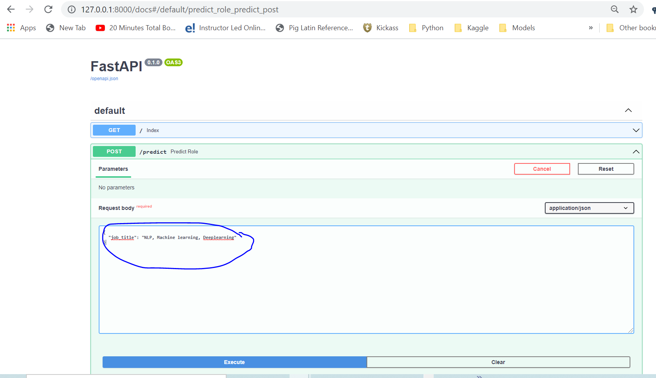

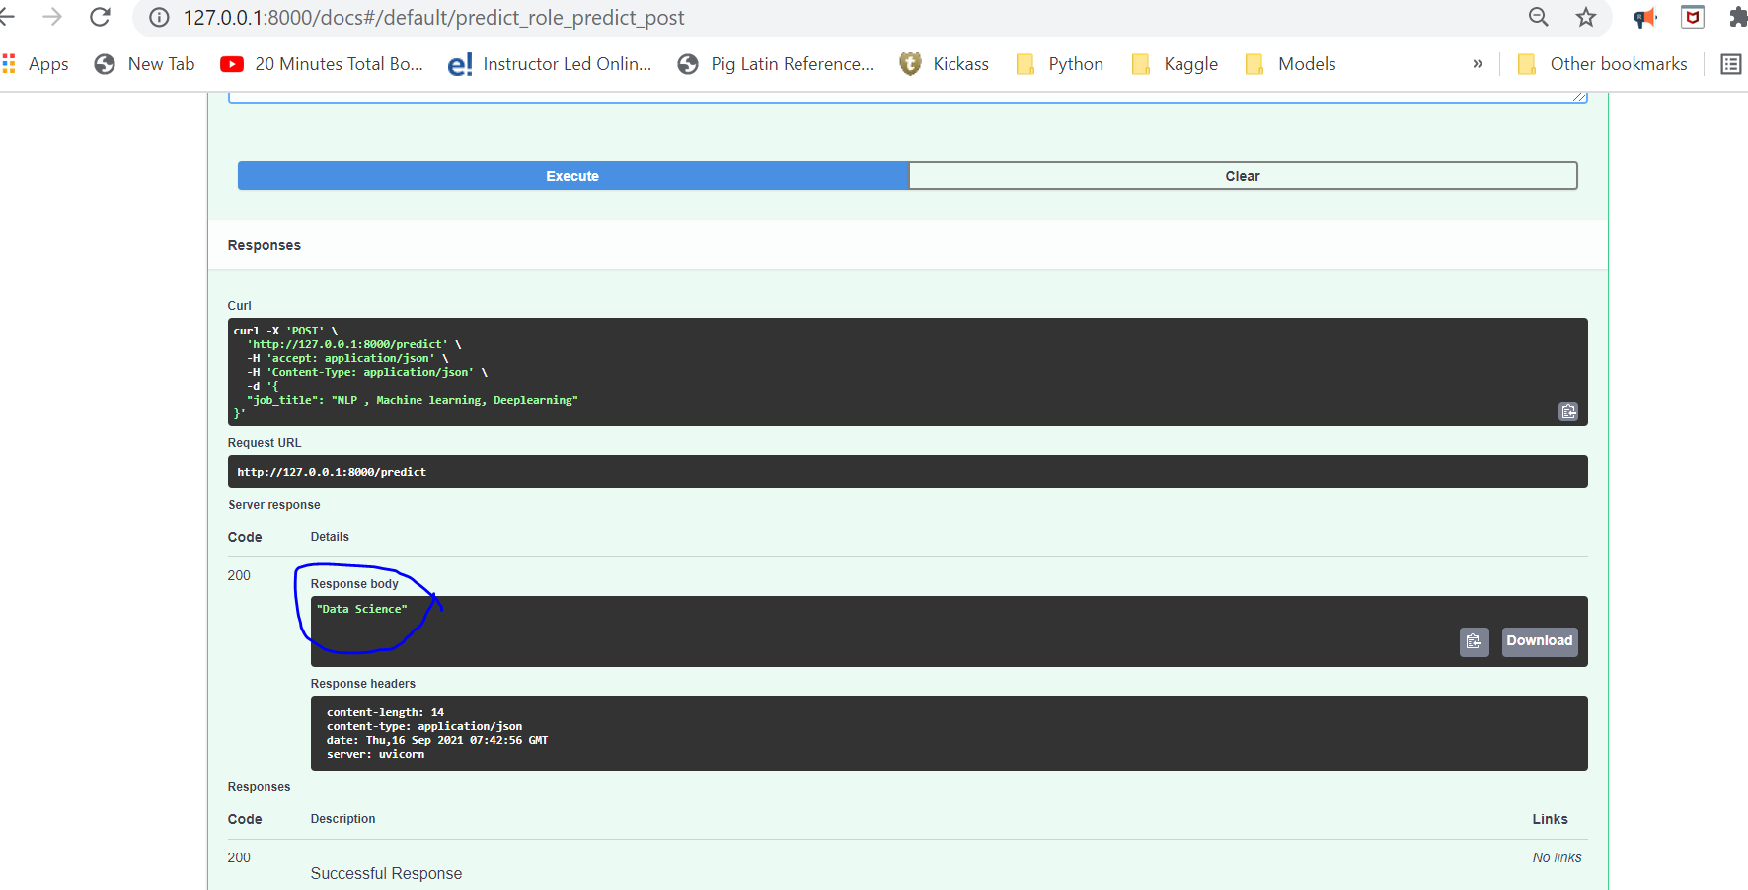

- Checked in all code in Github:

https://github.com/PrabhaBharadwaj/NLP-JobRole-Prediction

- Deployed code via Heroku :

"text_classification.joblib.BZ2" is huge file so Its not uploaded in github, Due to this missing joblib file, could not deploy whole code in Heroku. But can run this below file in local to see the API

