Output Data of every question

#q-1-1

True Positive: 1
True Negative: 1691
False Positive: 0
False Negative: 556

accuracy: 75.2669039146%
precision: 100.0%
recall: 0.179533213645%
f1 score: 0.358422939068

#q-1-2

True Positive: 478
True Negative: 1707
False Positive: 38
False Negative: 20

accuracy: 97.4141774409%
precision: 92.6356589147%
recall: 95.983935743%
f1 score: 94.2800788955

#q-1-3

Entropy:

True Positive: 478
True Negative: 1707
False Positive: 38
False Negative: 20

accuracy: 97.4141774409%
precision: 92.6356589147%
recall: 95.983935743%
f1 score: 94.2800788955

Gini Index:

True Positive: 417
True Negative: 1670
False Positive: 34
False Negative: 123

accuracy: 93.0035650624%
precision: 92.4611973392%
recall: 77.2222222222%
f1 score: 84.1574167508

Misclassification Rate:

True Positive: 415
True Negative: 1696
False Positive: 9
False Negative: 128

accuracy: 93.9056939502%
precision: 97.8773584906%
recall: 76.4272559853%
f1 score: 85.8324715615

#q-1-4

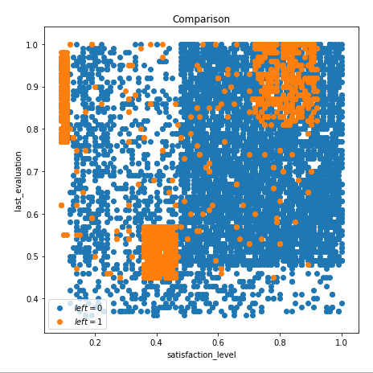

#q-1-5

Depth:

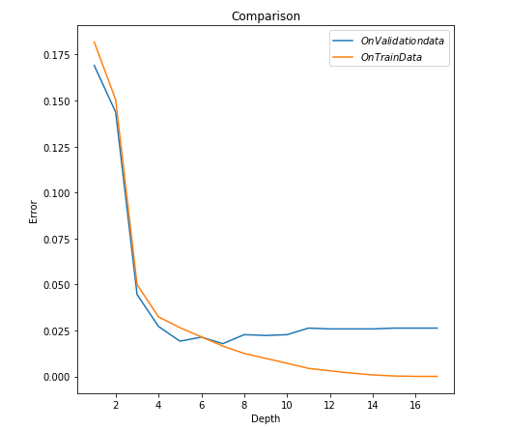

Nodes:
