**Name --- PRABHAKAR KUMAR**

**Roll --- IRM2017008**

**QUESTION 1**

The first question was a very straight forward question, where I used the python random function so that I generate age data randomly between 0 and 100. Then for each set of 20 data points, I calculated the mean and variance not only for each set, but also for whole of 10 sets, that had a total of 200 data points.

**QUESTION 2**

The second question was a very straight forward question since a very proper explanation of Box Muller transfer was given as a straight forward formula in the medium article. Firstly I used the numpy random function to generate two uniform distributions and then transform them to normal distribution using the following formula.

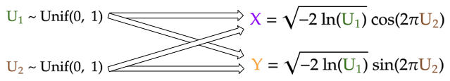

Once the data is produced I used the plotting function to print the distribution of data, from where the normal distribution can easily be seen.

REFERENCE - https://medium.com/mti-technology/how-to-generate-gaussian-samples-3951f2203ab0

**QUESTION 3**

One of the major issues that were faced while attempting this question was actually getting the classes of the html tags and trying to inspect the html page to get the correct data.

In the third question we were supposed to scrape the goibibo site, and for each hotel that we receive, we needed to generate the website that directs to the goibibo website for that hotel by recognising the format, but while scraping the website hence produced was always resulting in an error as below,

ERROR - getresponse() got an unexpected keyword argument 'buffering'

Due to this error, even though as asked I am able to produce the correct url that was redirecting to the correct webpage, but was not able to get the proper response from the requests API. Hence at the end, I had to scrape all the data that was available only in the hotels listing page, and was unable to get reviews of the user.

At the end I have saved all the data that was asked in the objective, other than the reviews that was also asked.

REFERENCE - https://www.analyticsvidhya.com/blog/2019/10/web-scraping-hands-on-introduction-python/