GIGMART: AN ON-DEMAND LOCAL GIG MARKETPLACE PLATFORM

A Project-Based Learning (PBL) Technical Report

Department of Computer Science & Engineering / Information Technology
Academic Year: 2026–2027 | Semester: III (PBL-301)

PROJECT REPORT ON
GIGMART: ON-DEMAND LOCAL SERVICE MARKETPLACE PLATFORM
Submitted in partial fulfillment of the requirements for the award of the Degree of
BACHELOR OF TECHNOLOGY / ENGINEERING
IN
COMPUTER SCIENCE & ENGINEERING / IT
Submitted By:
Candidate Name: Prabhakar Kumar
Roll / PRN No.: _____________________
Branch / Semester: CSE / IT — 3rd Semester
Project Guide / Faculty Mentor:
Prof. _______________________________
Department of Computer Science & Engineering
College / Institute: ______________________________

CERTIFICATE OF AUTHENTICITY
This is to certify that the project entitled “GigMart: An On-Demand Local Gig Marketplace Platform” is a bona fide work carried out by Prabhakar Kumar in partial fulfillment of the requirements for the course Project-Based Learning - III (PBL-III) under our supervision and guidance during the academic session 2026–2027.
To the best of our knowledge, the results embodied in this report have not been submitted to any other University or Institute for the award of any degree or diploma.
Faculty Mentor / Project Guide
Signature: __________________________
Date: _______________________________
Head of Department (CSE/IT)
Signature: __________________________
Date: _______________________________
External Examiner
Signature: __________________________
Date: _______________________________

ACKNOWLEDGEMENTS
I would like to express my sincere gratitude and deep respect to my project mentor for their invaluable guidance, constant encouragement, and insightful feedback throughout the duration of this Project-Based Learning (PBL) endeavor.
I extend our earnest thanks to the Department of Computer Science & Engineering, the Head of Department, and the faculty members who provided us with the academic infrastructure, laboratories, and computing resources required to engineer, develop, and test this software platform.
Special appreciation is conveyed to the open-source software communities of Spring Boot, React.js, Tailwind CSS, Vite, and MySQL, whose robust tools, documentation, and frameworks formed the backbone of this software engineering project.

ABSTRACT
The rapid growth of the informal gig economy has revealed profound inefficiencies in how consumers discover, evaluate, hire, and compensate local blue-collar and skilled trade workers. Everyday home maintenance needs—ranging from air conditioner repairs and electrical wiring to plumbing and carpentry—frequently suffer from fragmented market information, unpredictable pricing, lack of identity verification, and non-transparent dispute mediation. Conversely, skilled independent tradespeople face exploitation from predatory agency commissions and difficulties establishing verified reputations.
To resolve these systemic challenges, this project presents GigMart, an enterprise-grade, full-stack, on-demand local gig marketplace platform. The system is engineered using a decoupled, service-oriented architecture comprising a high-performance Spring Boot 4 / Java 23 RESTful backend, a MySQL 8.0 relational database managed via Hibernate 7 ORM, and a responsive Single Page Application (SPA) built with React 19, Vite 6, and Tailwind CSS v4.
GigMart models three distinct actor roles (Provider, Worker, Admin) governed by an Entity-Relationship model consisting of 14 normalized entities. The core domain lifecycle supports:
- Localized job posting with geographical coordinate tagging and category classification;
- Competitive bidding through application submissions featuring price quotes and cover notes;
- An atomic state machine for bid acceptance that simultaneously schedules a formal booking and automatically rejects competing offers;
- Integrated job progress tracking (SCHEDULED $→$ IN_PROGRESS $→$ COMPLETED);
- Financial transaction settlement incorporating an automated 10% platform service fee;
- A verified, two-way mutual review and rating aggregation engine;
- In-gig scoped chat messaging.
Empirical verification via 38 automated REST probe validations, 15-step integration tests, and 8-step end-to-end acceptance tests demonstrates that GigMart delivers transactional consistency, ACID adherence, sub-millisecond route resolution, and an intuitive, accessible user experience.

TABLE OF CONTENTS
- Chapter 1: Introduction & Problem Statement
  - 1.1 Background & Motivation
  - 1.2 Problem Statement
  - 1.3 Project Objectives
  - 1.4 Scope & Delimitations
  - 1.5 Target Stakeholders & Personas
- Chapter 2: Literature Survey & Existing System Analysis
  - 2.1 Overview of Modern On-Demand Service Platforms
  - 2.2 Shortcomings of Existing Industry Solutions
  - 2.3 Proposed System Architecture & Differentiators
  - 2.4 Feasibility Study
- Chapter 3: Software Requirements Specification (SRS)
  - 3.1 Functional Requirements Subsystems
  - 3.2 Non-Functional Requirements
  - 3.3 Hardware & Software Operational Environment
- Chapter 4: System Architecture & Design
  - 4.1 Multi-Tier System Architecture
  - 4.2 Entity-Relationship (ER) Modeling (14 Entities)
  - 4.3 Database Schema & Relational DDL Specifications
  - 4.4 System State Machines & Lifecycles
  - 4.5 Data Flow & Sequence Interactions
- Chapter 5: Technical Implementation
  - 5.1 Backend Engineering (Spring Boot 4.1.1 & Java 23)
  - 5.2 Mathematical Formulations & Domain Invariants
  - 5.3 Frontend Engineering (React 19, Tailwind CSS v4 & Vite)
  - 5.4 Data Normalization & Anti-Leak API Layer
  - 5.5 Real-Time Communication & Polling Engine
- Chapter 6: REST API Specification
  - 6.1 Architectural Patterns & Envelope Design
  - 6.2 Endpoint Reference Matrix
  - 6.3 Sample Transaction Payloads
- Chapter 7: System Verification & Testing
  - 7.1 Testing Methodologies
  - 7.2 Backend Integration Test Suite
  - 7.3 Frontend Automated Acceptance Walkthrough
  - 7.4 Test Cases & Traceability Matrix
- Chapter 8: Conclusion & Future Scope
  - 8.1 Summary of Contributions
  - 8.2 Educational & Technical Outcomes
  - 8.3 Limitations & Future Research Directions
- References & Appendix
  - References
  - Appendix A: Seeded Test Credentials
  - Appendix B: Local Execution & Deployment Guide

CHAPTER 1: INTRODUCTION & PROBLEM STATEMENT

1.1 Background & Motivation
The urban services and blue-collar labor market represents a vital segment of the domestic informal economy. Historically, hiring service technicians—such as electricians, plumbers, carpenters, HVAC mechanics, painters, and appliance technicians—relied heavily on word-of-mouth recommendations, neighborhood notice boards, or informal intermediaries.
With the rapid proliferation of smartphones, digital payments (such as UPI), and web technologies, consumers increasingly demand digitized, on-demand local services. However, domestic labor markets in developing and emerging economies remain characterized by:
- Severe information asymmetry regarding fair market rates;
- Lack of background verification and security assurances;
- Poor scheduling predictability and high cancellation rates;
- Absence of recorded job history or verified reviews;
- Substantial agency fees deducted by centralized platforms (often exceeding 25–35%).
Project-Based Learning (PBL) provides the framework to design, architect, and construct a robust, production-ready full-stack software application that directly tackles these socioeconomic challenges. GigMart is conceived as a decentralized, transparent, and fair marketplace connecting customers (Gig Providers) with skilled independent technicians (Gig Workers).

1.2 Problem Statement
Existing service procurement models fail both sides of the market:
- From the Client (Provider) Perspective: Finding competent, verified tradespeople near a residence requires numerous telephone calls, unverified price negotiations, and substantial uncertainty regarding arrival times and quality of service.
- From the Technician (Worker) Perspective: Independent contractors lack tools to market their trade, negotiate competitive quotes based on job complexity, manage their weekly scheduling slots, build portable professional reputations, and avoid exploitative middleman fees.
- From a Systemic Perspective: Current platforms aggregate all power into centralized algorithms that assign jobs without giving either party autonomy over price quotes, job details, or mutual review validation.
Hence, the core engineering problem addressed is:
How can an extensible, performant, and secure web platform be architected to facilitate localized job publication, transparent competitive bidding, atomic state-driven booking management, transparent 10% fee payment accounting, and verified mutual reputation tracking?

1.3 Project Objectives
The engineering objectives of the GigMart project are:
- O1: Multi-Role Secure Authentication: Implement role-segregated access for Workers, Providers, and Administrators with cryptographic password hashing (SHA-256) and session recovery.
- O2: Dynamic Category & Skill Management: Establish an administrative master catalog of home services and allow workers to configure hourly or fixed rates per skill category.
- O3: Geographically Scoped Gig Posting: Enable providers to store multiple geographical addresses with GPS coordinates and post detailed work requests with budget constraints and execution schedules.
- O4: Competitive Bidding Workflow: Allow workers to review open gigs and submit formal applications containing price quotes and cover notes, preventing duplicate submissions.
- O5: Atomic Booking State Machine: Implement a concurrent-safe booking confirmation mechanism where accepting a bid transitions the gig to ASSIGNED, instantiates a SCHEDULED booking, and automatically rejects competing bids.
- O6: Transparent Financial Accounting: Calculate exact platform commissions (fixed 10% take-rate) and net worker payout distributions across multiple payment instruments (UPI, Card, Bank Transfer, Cash, Wallet).
- O7: Two-Way Verified Rating Engine: Restrict reviews exclusively to verified participants of completed bookings and dynamically recalculate average user ratings.
- O8: In-Gig Scoped Communication: Provide a real-time chat interface scoped strictly to active gigs for coordination.

1.4 Scope & Delimitations
- In Scope:
  - Complete RESTful backend using Java 23 and Spring Boot 4.1.1.
  - Relational database schema with 14 normalized tables in MySQL 8.
  - Client frontend Single Page Application (SPA) using React 19, Vite, and Tailwind CSS v4.
  - End-to-end integration and automated acceptance walkthrough test suites.
  - Complete lifecycle management from posting to mutual review completion.
- Delimitations (Out of Scope for Current Release):
  - Live third-party payment gateway banking webhooks (Razorpay / Stripe) are simulated via internal transaction records.
  - Real-time mobile push notifications (FCM / SMS) are planned for future iterations.
  - Automated GPS live routing on interactive map tiles is represented via latitude/longitude data pairs.

1.5 Target Stakeholders & Personas
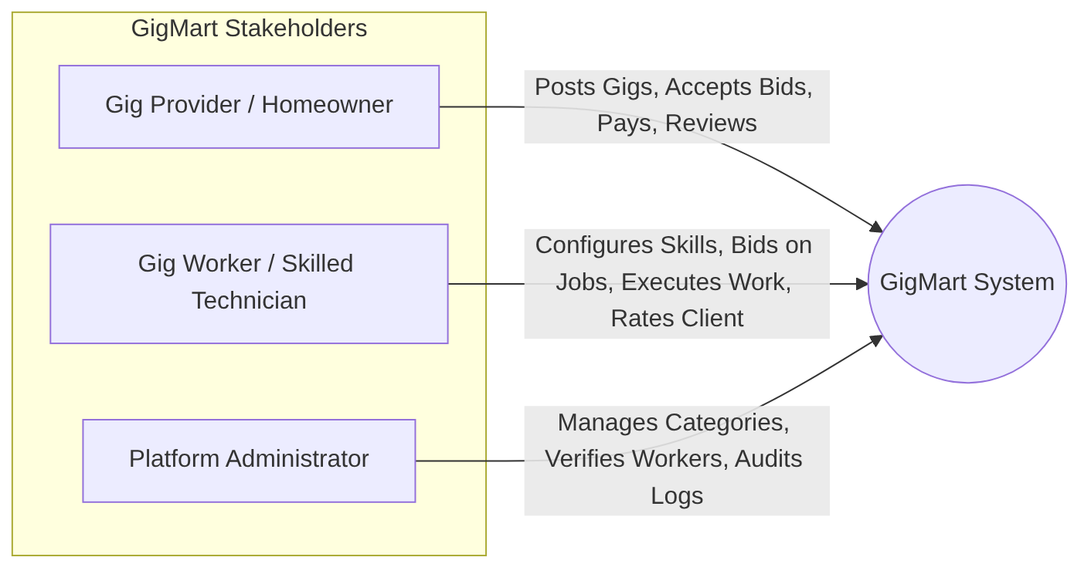
Figure 1
Persona | Primary Needs & Pain Points | Platform Feature Solvers
Gig Provider (Homeowner / Business) | Needs fast, trustworthy, localized repair work without overpaying. | Multi-address selection, transparent job posting, reviewing worker bids, profile credentials, in-gig messaging, two-way rating.
Gig Worker (Technician / Tradesperson) | Needs direct access to clients, fair pricing, guaranteed payout without 30% cuts. | Skill catalog configuration, availability calendar, custom quote submissions, 90% payout guarantee, public rating portfolio.
Platform Administrator | Needs platform health, catalog governance, safety and fraud mitigation. | Service category CRUD, worker verification review, global user audits.

CHAPTER 2: LITERATURE SURVEY & EXISTING SYSTEM ANALYSIS

2.1 Overview of Modern On-Demand Service Platforms
The gig economy literature identifies several primary models for service delivery:
- Centralized Dispatch Model (e.g., Urban Company): The platform fixes prices uniformly, algorithms assign specific technicians, and workers function effectively as quasi-employees while absorbing full operational risk.
- Global Freelance Marketplaces (e.g., Upwork, Fiverr): Highly specialized for remote digital tasks (programming, graphic design, writing) with escrow milestones, but ill-suited for physical, localized, urgent household services.
- Lead Generation Directories (e.g., JustDial, Sulekha, YellowPages): Charge technicians upfront fees to buy consumer leads, resulting in aggressive spam calls to consumers with no booking guarantees or payment tracking.

2.2 Shortcomings of Existing Industry Solutions
A comparative analysis reveals significant systemic bottlenecks:
Dimension | Urban Company / TaskRabbit | JustDial / Lead Gen | GigMart (Proposed Solution)
Pricing Model | Fixed by platform; high margin deduction (25–35%) | Unregulated phone negotiations | Competitive Worker Quotes (Transparent Market Price)
Worker Autonomy | Very low; algorithmic assignment | High; but leads must be purchased | High; Workers choose jobs and submit custom bids
Platform Commission | High (20% – 35%) | Monthly subscription / per lead | Low & Fixed 10% Platform Fee
Trust & Verification | Centralized, opaque ratings | Unverified reviews; susceptible to spam | Verified Two-Way Reviews (Only on completed bookings)
Booking State Machine | Black-box scheduling | None (Off-platform) | Explicit state tracking (SCHEDULED $→$ COMPLETED)
Communication | Call masking | Direct phone spam | Scoped in-app chat thread per gig

2.3 Proposed System Architecture & Differentiators
GigMart introduces a decentralized yet structured marketplace:
- Dynamic Open Bidding: Rather than imposing arbitrary pricing, providers post budgets and workers submit competitive quotes, establishing natural market equilibrium.
- Fair 10% Take-Rate: Payout computations are deterministic and transparent.
- Strict State Invariants: Bookings and payments cannot bypass sequential integrity checks.
- Data Privacy & In-Gig Isolation: Messaging is restricted to parties involved in a gig, preventing unsolicited communications.

2.4 Feasibility Study
- Technical Feasibility: The project utilizes mature, enterprise-grade technologies: Java 23, Spring Boot 4.1.1, React 19, Vite 6, and MySQL 8. All selected tools have comprehensive documentation, active developer ecosystems, and proven scalability.
- Operational Feasibility: The intuitive web interface eliminates complex installation hurdles for clients and technicians.
- Economic Feasibility: The platform architecture relies entirely on open-source frameworks without commercial licensing fees. The 10% platform revenue model sustains operational infrastructure costs.

CHAPTER 3: SOFTWARE REQUIREMENTS SPECIFICATION (SRS)

3.1 Functional Requirements Subsystems
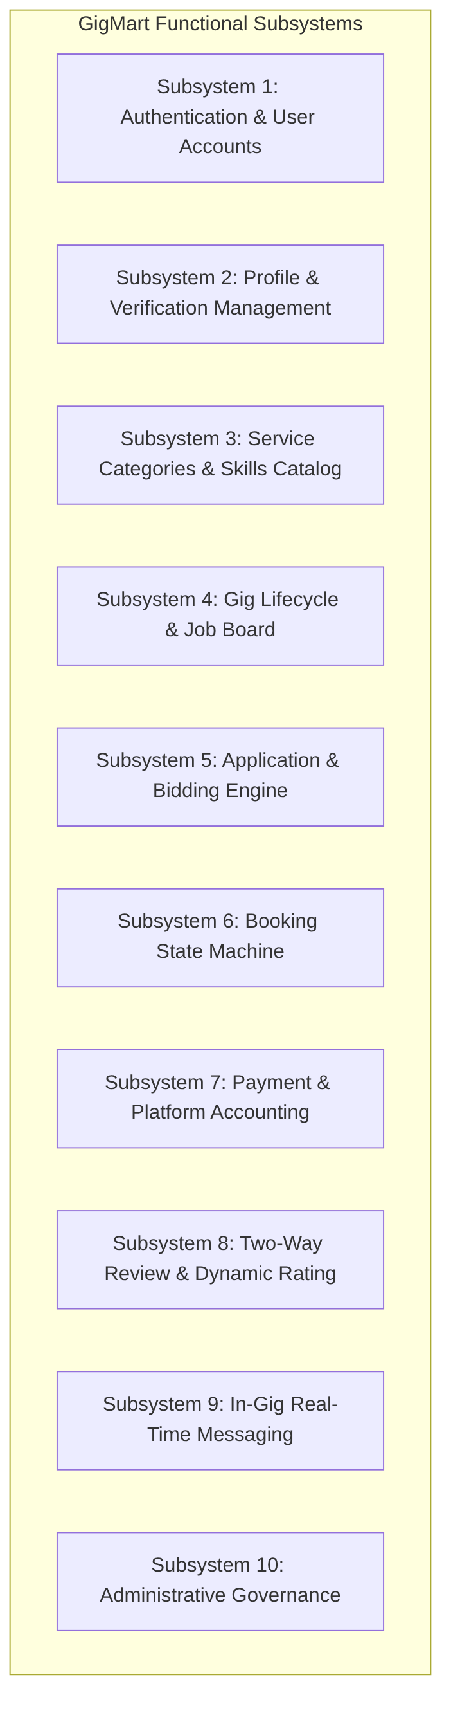
Figure 2

F1: Authentication & User Accounts
- FR1.1: System shall permit registration specifying fullName, email, phone, password, and role (WORKER, PROVIDER, ADMIN).
- FR1.2: System shall enforce unique constraints on email and phone numbers.
- FR1.3: System shall hash passwords using SHA-256 before persistence.
- FR1.4: System shall automatically instantiate a linked WorkerProfile or ProviderProfile upon registration.
- FR1.5: System shall authenticate users via /api/v1/auth/login and return sanitized user profiles.

F2: Profile & Verification Management
- FR2.1: Workers shall update their biography, years of experience, and service radius (km).
- FR2.2: Workers shall upload document records (docType, fileUrl) for administrative review.
- FR2.3: Workers shall define weekly recurring availability slots (dayOfWeek, startTime, endTime).
- FR2.4: Providers shall maintain profile types (INDIVIDUAL, BUSINESS) and business names.
- FR2.5: Providers shall register multiple physical addresses with street address, city, pincode, and GPS latitude/longitude.

F3: Service Categories & Skills Catalog
- FR3.1: Admins shall create, update, list, and soft-delete service categories with icon identifiers.
- FR3.2: Workers shall link their profile to service categories specifying their baseRate and rateType (HOURLY or FIXED).

F4: Gig Lifecycle & Job Board
- FR4.1: Providers shall post gigs specifying title, description, categoryId, addressId, budget, and scheduledAt.
- FR4.2: System shall initialize gig status to OPEN.
- FR4.3: System shall provide searching and filtering by category, status, and keywords.
- FR4.4: Providers shall have authority to cancel gigs prior to active execution.

F5: Application & Bidding Engine
- FR5.1: Verified workers shall submit applications with a quotedPrice and coverNote.
- FR5.2: System shall prevent duplicate applications by the same worker on the same gig.
- FR5.3: Workers shall be able to withdraw pending applications.

F6: Booking State Machine
- FR6.1: When a provider accepts an application:
  - Selected application status changes to ACCEPTED.
  - Gig status transitions from OPEN to ASSIGNED.
  - All competing pending applications on the gig are marked REJECTED.
  - A new Booking record is instantiated with status = SCHEDULED and agreedPrice = quotedPrice.
- FR6.2: Workers shall transition booking status to IN_PROGRESS (recording started_at).
- FR6.3: Workers shall transition booking status to COMPLETED (recording completed_at).

F7: Payment & Platform Accounting
- FR7.1: System shall calculate a mandatory 10% platform service fee on every booking transaction:
$$\text{platformFee}=\text{round}\left(\text{amount}×0.10,2\right)$$
- FR7.2: System shall compute net worker payout:
$$\text{netWorkerAmount}=\text{amount}−\text{platformFee}$$
- FR7.3: System shall record transactions across methods: UPI, CARD, BANK_TRANSFER, CASH, WALLET.

F8: Two-Way Review & Dynamic Rating
- FR8.1: Only authenticated participants (Provider or Worker) of a COMPLETED booking may submit a review.
- FR8.2: Ratings must be integers between 1 and 5.
- FR8.3: Duplicate reviews by the same reviewer for the same booking are rejected.
- FR8.4: System shall immediately recalculate the recipient’s overall average rating:
$$\overline{\text{Rating}}=\frac{1}{N}\sum_{i=1}^{N}{{\text{rating}}_{i}}$$

F9: In-Gig Scoped Messaging
- FR9.1: Messages shall be strictly scoped to a specific gigId between the participating Provider and Worker.
- FR9.2: Frontend shall poll new messages every 5000ms with visibility gating and optimistic local appends.

F10: Administrative Governance
- FR10.1: Administrators shall approve or reject worker documents and verification status.
- FR10.2: Administrators shall manage global categories and oversee user accounts.

3.2 Non-Functional Requirements
- Performance: REST endpoints must respond within 100ms under standard operational loads.
- Data Integrity & Concurrency: ACID transactions guaranteed via Spring @Transactional on all multi-table mutations.
- Security: Passwords hashed with SHA-256; sensitive fields ignored during JSON serialization via @JsonIgnore.
- Usability & Accessibility: UI strictly adheres to WCAG standards, supports keyboard navigation, and provides complete prefers-reduced-motion compliance.
- Fault Tolerance: Frontend incorporates global React Error Boundaries, offline toast notifications, and retry buttons on all failed data queries.

3.3 Hardware & Software Operational Environment
- Development & Server Hardware:
  - Processor: x86_64 Dual-Core or Quad-Core 2.0 GHz+ (Intel Core i5/i7 or AMD Ryzen)
  - Memory: 8 GB RAM minimum (16 GB recommended)
  - Storage: 10 GB available SSD space
- Software Specifications:
  - Operating System: Microsoft Windows 11 / Linux (Ubuntu 22.04 LTS) / macOS
  - Runtime Environments: Java Development Kit (JDK 21 or 23), Node.js (v20+)
  - Web Server & Tools: Spring Boot 4.1.1 Embedded Tomcat, Vite 6 Dev Server
  - Database Management System: MySQL Server 8.0+ / MariaDB 10.4+
  - Build Systems: Apache Maven 3.9+, npm 10+
  - API Testing Tools: cURL, Postman

CHAPTER 4: SYSTEM ARCHITECTURE & DESIGN

4.1 Multi-Tier System Architecture
GigMart is organized into a clean, decoupled Multi-Tier Architecture:
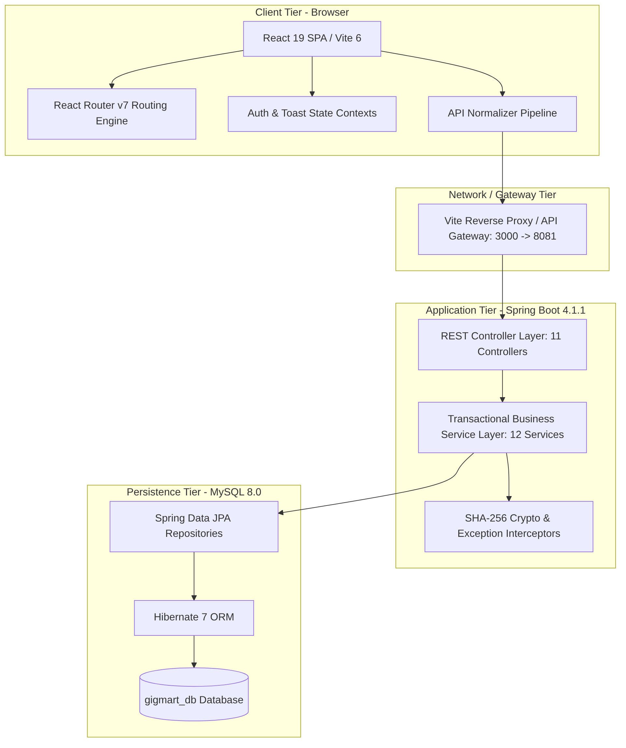
Figure 3

4.2 Entity-Relationship (ER) Modeling
The domain comprises 14 primary JPA entities mapped to relational tables:
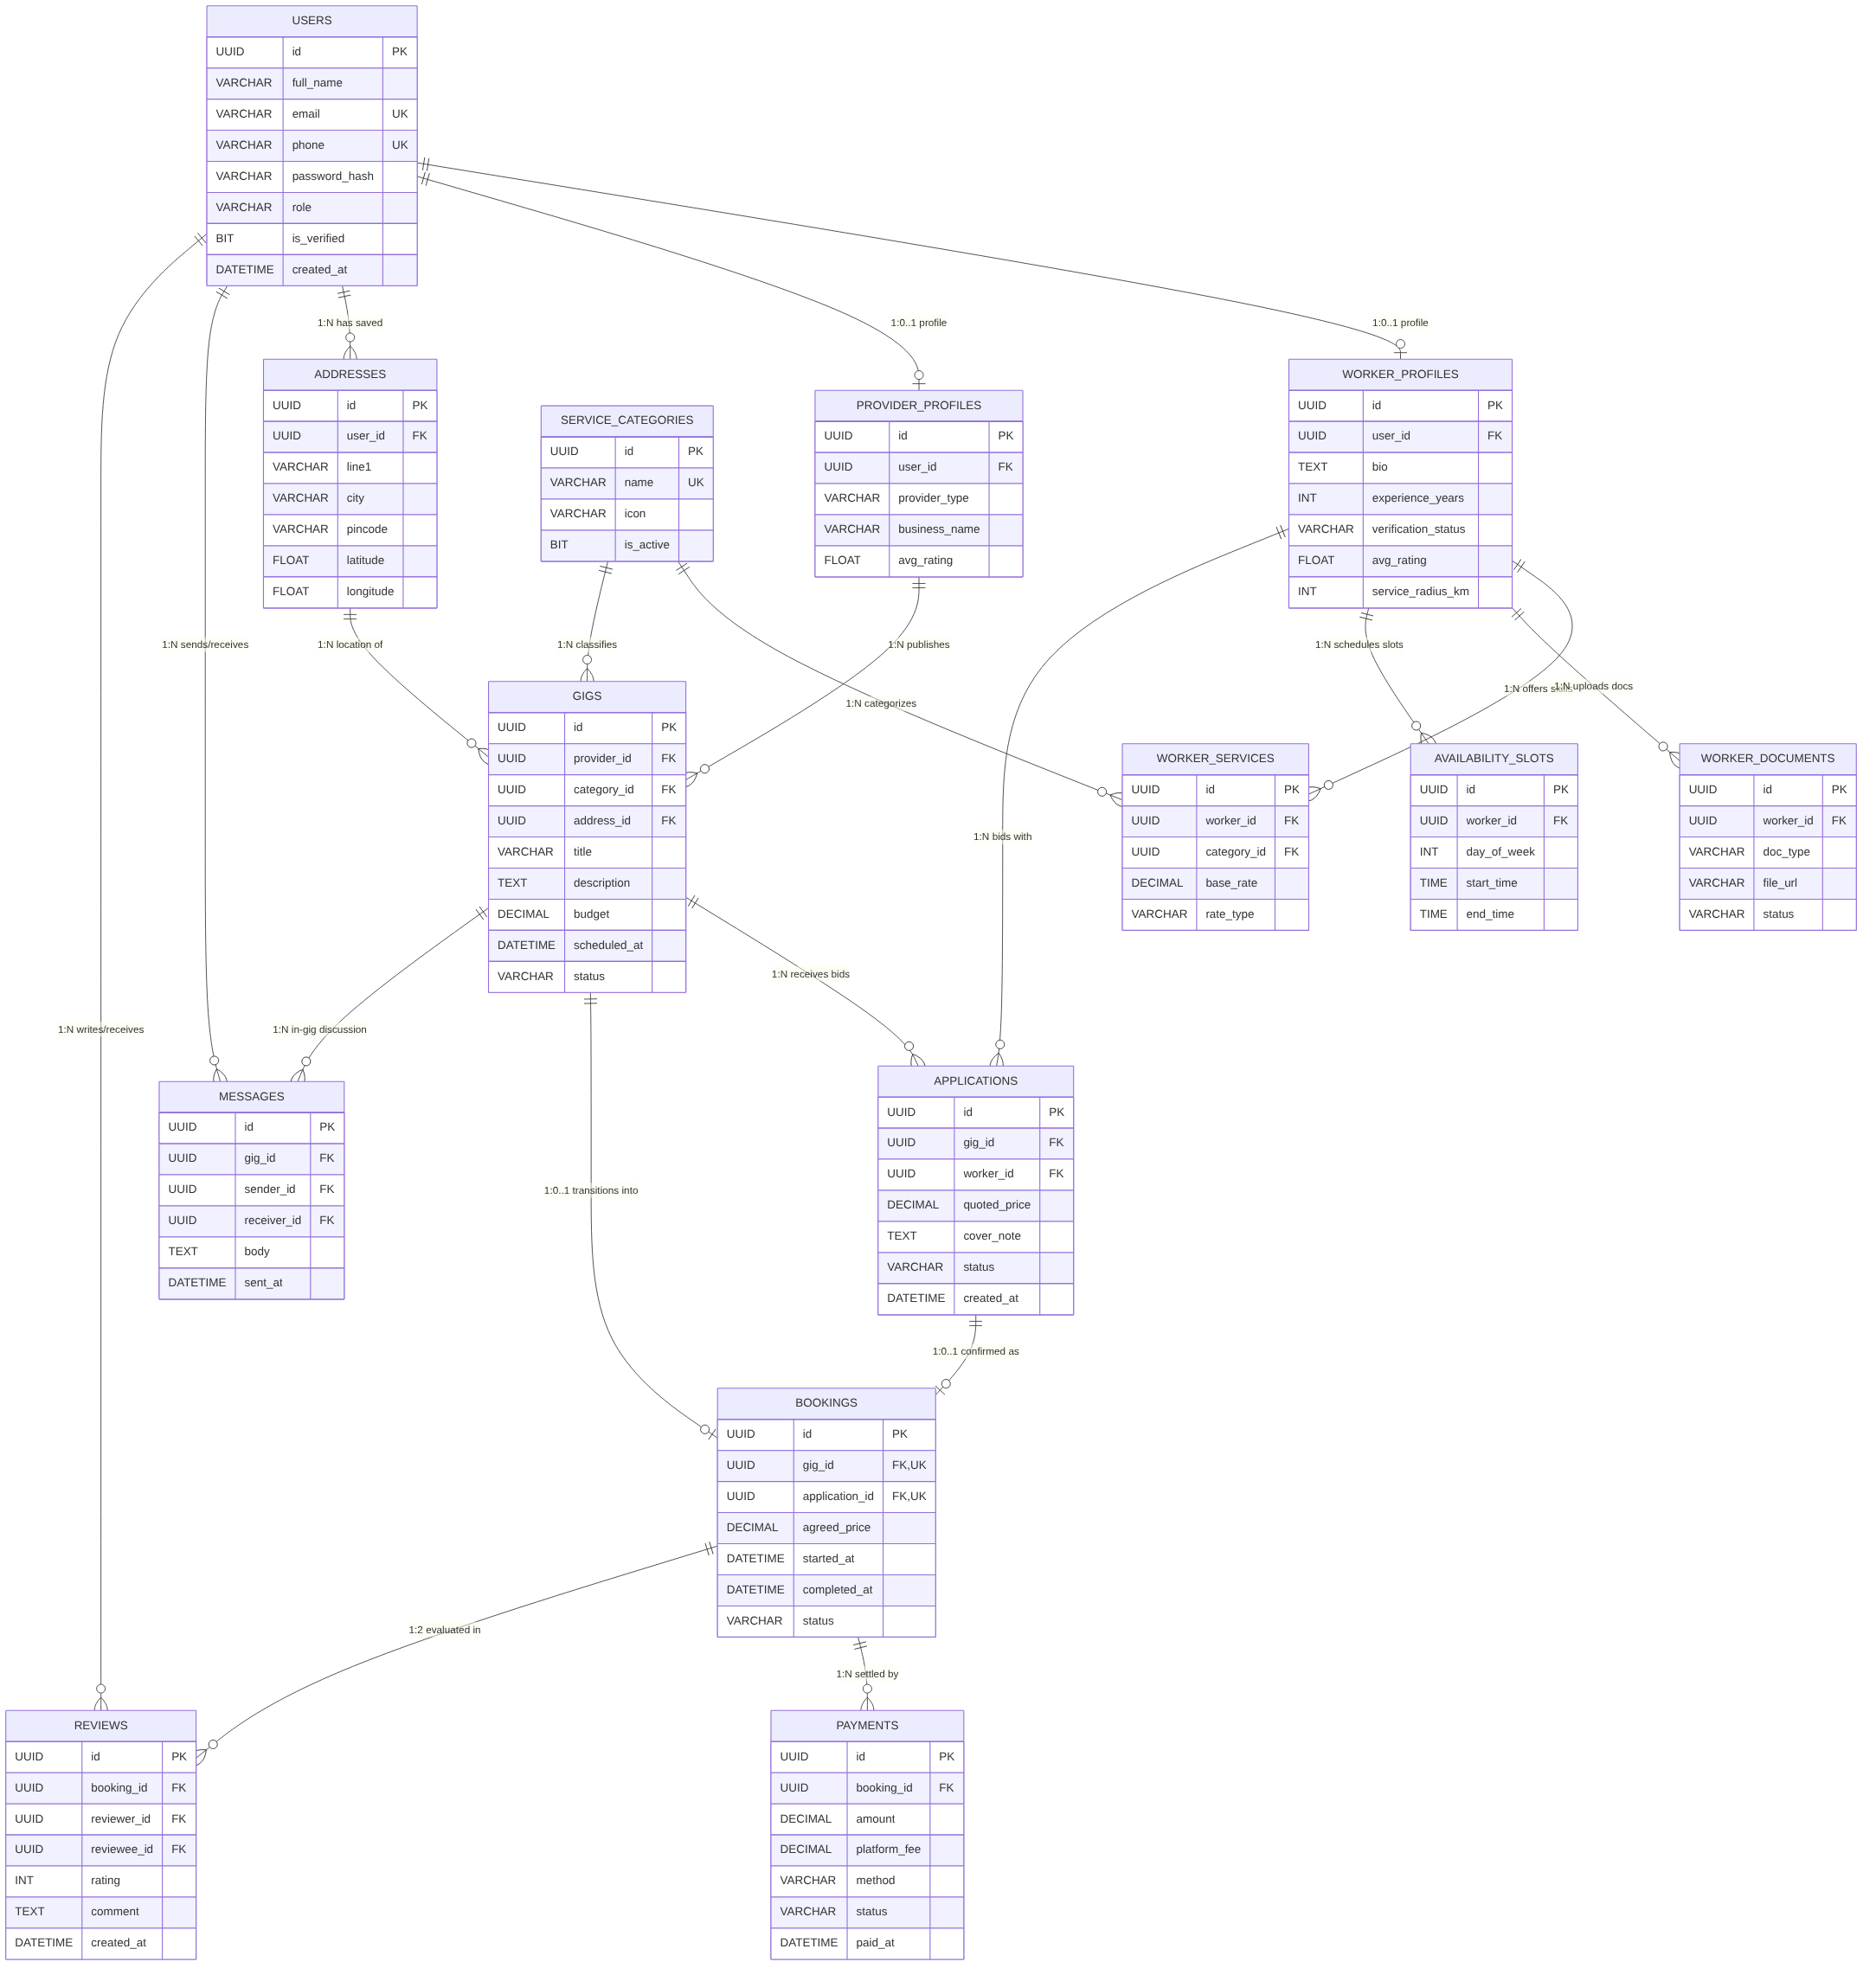
Figure 4

4.3 Database Schema & Relational Specifications
Below is the comprehensive data dictionary of the 14 relational tables implemented in MySQL:
# | Table Name | Primary Key | Foreign Keys / Associations | Major Constraints & Indexes | Description
1 | users | id (UUID) | None | UNIQUE(email), UNIQUE(phone) | User identities, SHA-256 credentials, role discriminator.
2 | worker_profiles | id (UUID) | user_id $→$ users(id) | UNIQUE(user_id), ON DELETE CASCADE | Professional qualifications, ratings, verification state.
3 | provider_profiles | id (UUID) | user_id $→$ users(id) | UNIQUE(user_id), ON DELETE CASCADE | Customer/employer data (individual vs business).
4 | addresses | id (UUID) | user_id $→$ users(id) | INDEX(latitude, longitude) | Physical job venues with GPS location coordinates.
5 | service_categories | id (UUID) | None | UNIQUE(name) | Master catalog of trade skills (AC, Plumber, etc.).
6 | worker_services | id (UUID) | worker_id, category_id | UNIQUE(worker_id, category_id) | Skill price catalog (Hourly / Fixed rates).
7 | worker_documents | id (UUID) | worker_id $→$ worker_profiles | ON DELETE CASCADE | Identity proof files and certificates.
8 | availability_slots | id (UUID) | worker_id $→$ worker_profiles | ON DELETE CASCADE | Recurring weekly availability windows.
9 | gigs | id (UUID) | provider_id, category_id, address_id | INDEX(category_id, status), INDEX(scheduled_at) | Job vacancies published by providers.
10 | applications | id (UUID) | gig_id, worker_id | UNIQUE(gig_id, worker_id) | Worker bids containing quotes and cover notes.
11 | bookings | id (UUID) | gig_id, application_id | UNIQUE(gig_id), UNIQUE(application_id) | Formal contractual engagement between provider and worker.
12 | payments | id (UUID) | booking_id $→$ bookings | Cascade links | Financial settlement, 10% platform fee, net payout.
13 | reviews | id (UUID) | booking_id, reviewer_id, reviewee_id | UNIQUE(booking_id, reviewer_id), CHECK(rating 1..5) | Two-way mutual ratings and reviews.
14 | messages | id (UUID) | gig_id, sender_id, receiver_id | INDEX(gig_id, sent_at) | In-gig communication chat thread.

4.4 System State Machines & Lifecycles

Gig Lifecycle State Machine
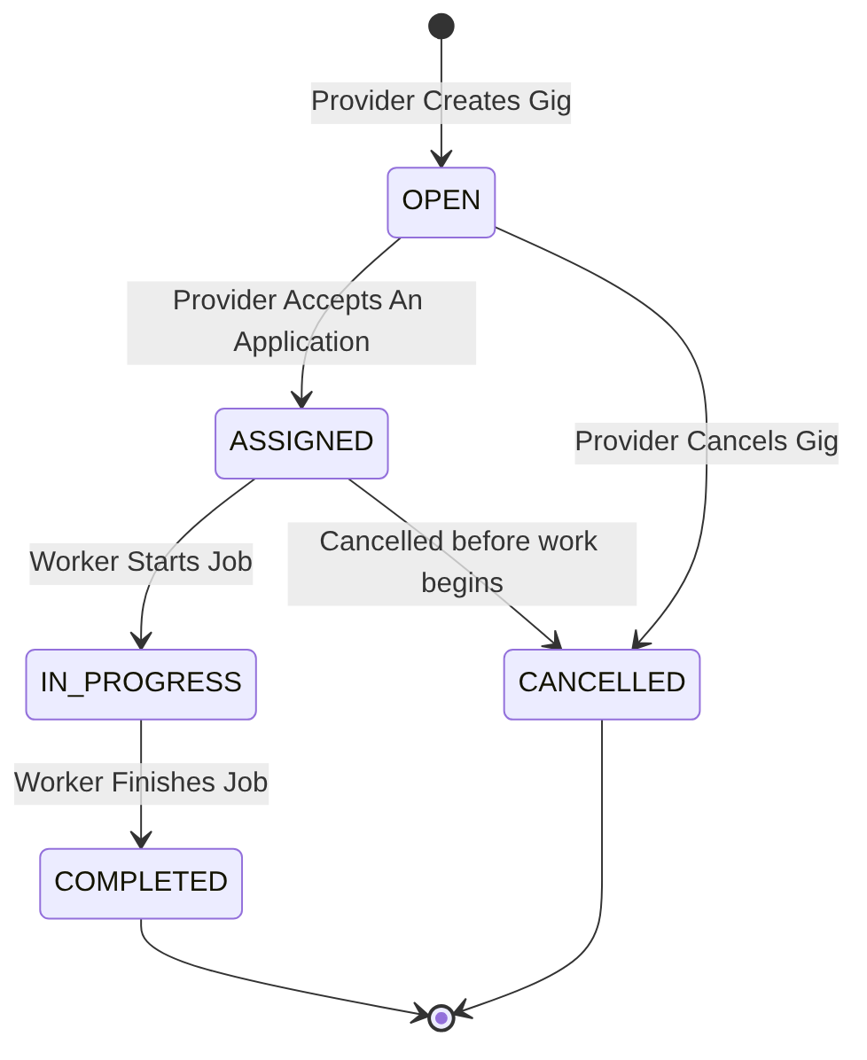
Figure 5

Application Lifecycle State Machine
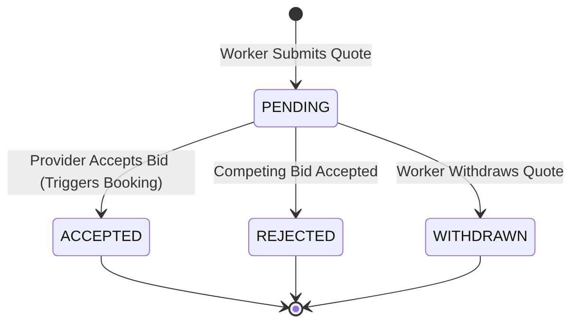
Figure 6

Booking Lifecycle State Machine
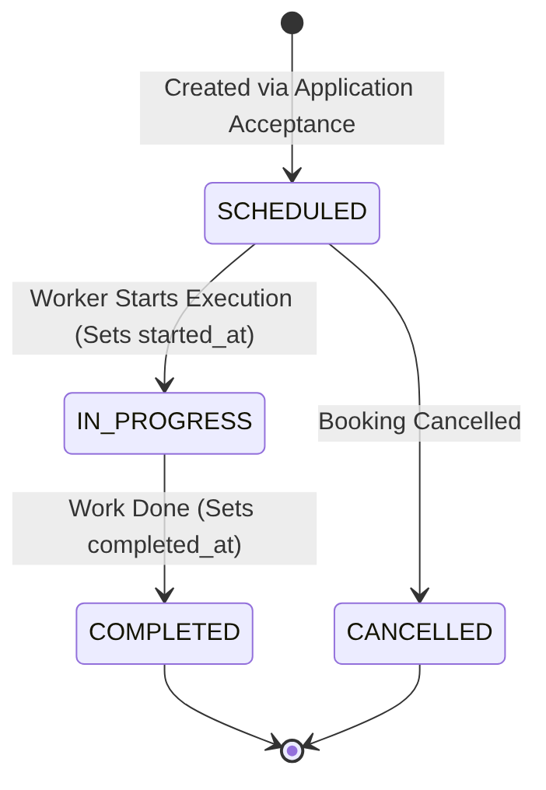
Figure 7

4.5 Data Flow & Sequence Interactions
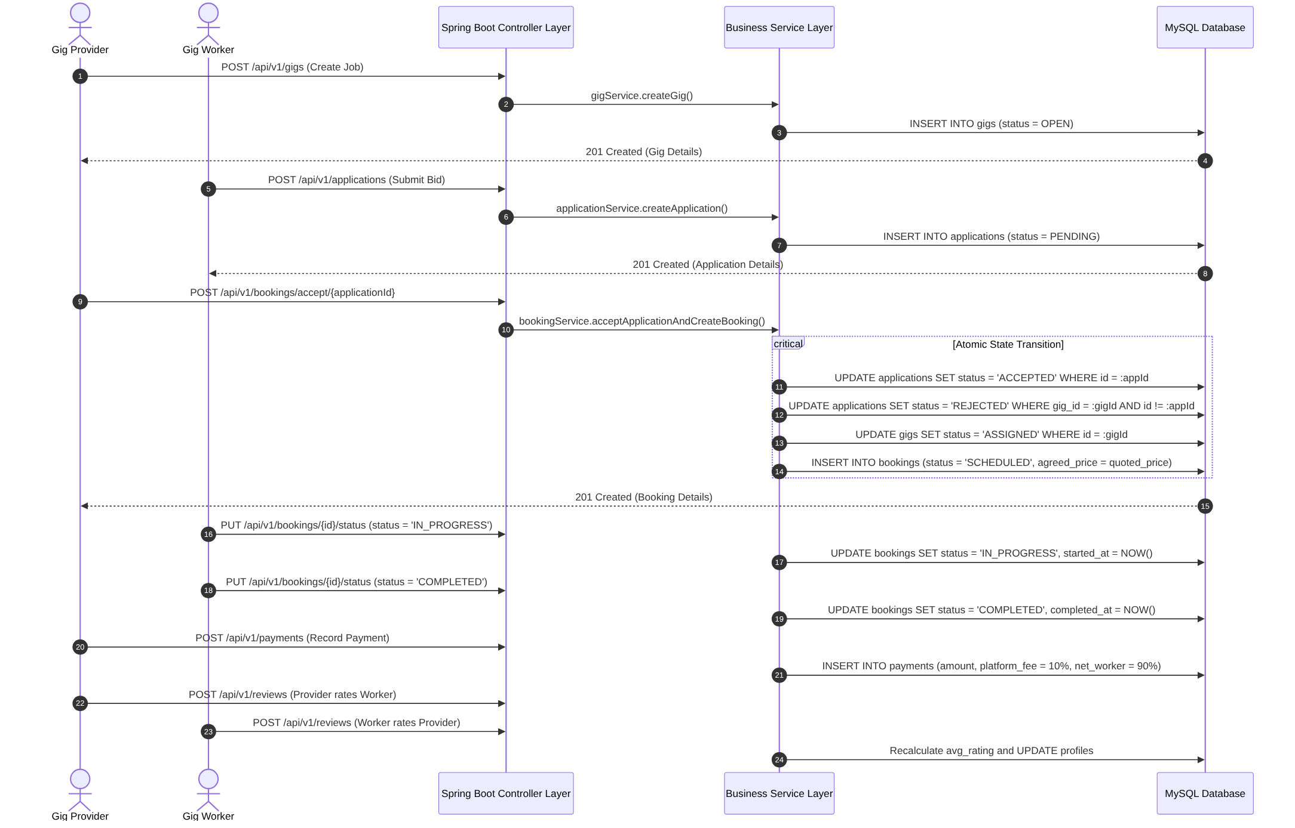
Figure 8

CHAPTER 5: TECHNICAL IMPLEMENTATION

5.1 Backend Engineering (Spring Boot 4.1.1 & Java 23)
The backend architecture is structured in accordance with enterprise Domain-Driven Design (DDD):
- Base Package: com.gigsphere.gigmart
- Application Bootstrapper: GigmartApplication.java
- REST Layer: 11 @RestController classes mapped under /api/v1/ ensuring uniform request validation using Jakarta Bean Validation (@Valid, @NotNull, @NotBlank, @Email, @Positive).
- Response Wrapper: Every endpoint returns an immutable, strongly typed ApiResponse<T>:
public record ApiResponse<T>(
boolean success,
String message,
T data,
Instant timestamp
) {
public static <T> ApiResponse<T> ok(String message, T data) {
return new ApiResponse<>(true, message, data, Instant.now());
}
}
- Global Error Handling: Implemented in GlobalExceptionHandler.java using @ControllerAdvice. Intercepts ResourceNotFoundException, ConflictException, BadRequestException, and MethodArgumentNotValidException, translating them into standardized HTTP 400, 404, or 409 JSON responses.
- Cryptographic Security: Standard SHA-256 digest hashing encoded to hexadecimal strings protects user passwords before SQL insertion. @JsonIgnore safeguards entity attributes from JSON leaks.

5.2 Mathematical Formulations & Domain Invariants

1. Atomic Application Acceptance & Competing Bid Disqualification
When a provider approves application $A^{*}∈A_{G}$ for a given gig $G$:
$$\text{Status}\left(A^{*}\right)←\text{ACCEPTED}$$
$$\text{Status}\left(G\right)←\text{ASSIGNED}$$
$$∀A∈A_{G}\backslash \{A^{*}\} \text{such that} \text{Status}\left(A\right)=\text{PENDING}⟹\text{Status}\left(A\right)←\text{REJECTED}$$
$$\text{Booking.agreedPrice}=A^{*}.quotedPrice$$
$$\text{Booking.status}=\text{SCHEDULED}$$

2. Platform Take-Rate & Payout Calculation
The financial clearing engine charges an automated 10% commission on each completed transaction:
$$\text{PlatformFee}=\text{round}\left(P_{\text{agreed}}×0.10, 2\right)$$
$$\text{NetWorkerAmount}=P_{\text{agreed}}−\text{PlatformFee}$$
Where $P_{\text{agreed}}$ represents the gross booking amount.

3. Dynamic Verified Rating Aggregation
Upon successful submission of review $r_{k}$ with score $s_{k}∈\{1,2,3,4,5\}$ for user $U$:
$${\overline{R}}_{U}=\frac{1}{N}\sum_{k=1}^{N}{s_{k}}$$
The resulting arithmetic mean is rounded to two decimal places and persisted directly into WorkerProfile.avgRating or ProviderProfile.avgRating.

5.3 Frontend Engineering (React 19, Tailwind CSS v4 & Vite)
The user interface is engineered with a focus on modern web standards, responsiveness, and zero unnecessary dependencies:
- Build Engine: Vite 6 with @tailwindcss/vite compiling Tailwind CSS v4.
- Routing Engine: React Router v7 (react-router-dom) with declarative layout nesting.
- Zero Heavy State Libraries: Avoided bulky global state managers (Redux, MobX, Zustand). Replaced with lightweight React 19 native hooks (useContext, useCallback, useTransition) inside AuthContext and ToastContext.
- Role Route Guards: Guard components (ProtectedRoute, RoleRoute, GuestRoute) inspect the authenticated user’s assigned role (WORKER, PROVIDER, ADMIN) and redirect unauthorized access while presenting a seamless loading screen during credential hydration.

5.4 Data Normalization & Anti-Leak API Layer
To prevent tight coupling between backend database DTO nuances and frontend UI components, GigMart establishes an Anti-Leak Architecture:
- API Client (client.js): Intercepts Axios responses, unwraps the Spring Boot envelope { success, message, data }, and normalizes HTTP error strings.
- Domain Services (services.js): Exposes clean domain functions (gigApi.getAll(), bookingApi.accept()) that return sanitized payloads.
- Entity Normalizers (normalizers.js): Converts raw objects into guaranteed UI structures:
export function normalizeBooking(raw) {
if (!raw) return null;
return {
id: raw.id,
gigId: raw.gigId ?? raw.gig?.id,
gigTitle: raw.gigTitle ?? raw.gig?.title ?? 'Gig Booking',
applicationId: raw.applicationId ?? raw.application?.id,
workerProfileId: raw.workerProfileId ?? raw.worker?.id,
workerName: raw.workerName ?? raw.worker?.user?.fullName ?? 'Worker',
providerProfileId: raw.providerProfileId ?? raw.provider?.id,
providerName: raw.providerName ?? raw.provider?.user?.fullName ?? 'Provider',
agreedPrice: Number(raw.agreedPrice ?? 0),
startedAt: raw.startedAt ?? null,
completedAt: raw.completedAt ?? null,
status: raw.status ?? 'SCHEDULED',
};
}

5.5 Real-Time Communication & Polling Engine
In-gig chat (/messages) implements an intelligent polling strategy:
- Interval Polling: Executes every 5000ms.
- Visibility Gating: Polling pauses automatically whenever document.visibilityState !== 'visible'.
- In-Flight Guard: A React useRef flag prevents duplicate concurrent network requests if server response time lags.
- Optimistic UI Updates: New chat messages appear instantly in the chat window; if the API call encounters a network failure, the state rolls back gracefully with an error toast.
- Smart Viewport Auto-Scroll: Automatically scrolls to the bottom of the conversation only if the user is already positioned within 120px of the newest message.

CHAPTER 6: REST API SPECIFICATION

6.1 Architectural Patterns & Envelope Design
All API endpoints follow RESTful URI conventions under /api/v1/. Responses return consistent JSON envelopes:
{
"success": true,
"message": "Resource retrieved successfully",
"data": { ... },
"timestamp": "2026-11-08T10:30:00.000Z"
}

6.2 Endpoint Reference Matrix
Subsystem | HTTP Method | Endpoint URI | Description
Auth | POST | /api/v1/auth/register | Register User and auto-create profile
Auth | POST | /api/v1/auth/login | Authenticate with email and password
Users | GET | /api/v1/users/{id} | Retrieve user profile by UUID
Users | GET | /api/v1/users?role={role} | List users filtered by role
Users | PUT | /api/v1/users/{id}/verify | Admin verification flag toggle
Categories | GET | /api/v1/categories?activeOnly=true | List active service categories
Categories | POST | /api/v1/categories | Admin creates service category
Workers | GET | /api/v1/workers/{id} | Worker profile by worker ID
Workers | GET | /api/v1/workers/user/{userId} | Worker profile by user ID
Workers | PUT | /api/v1/workers/{id} | Update bio, experience, radius
Worker Skills | POST | /api/v1/workers/services | Add skill category with base rate
Worker Slots | POST | /api/v1/workers/slots | Add weekly availability window
Worker Docs | POST | /api/v1/workers/documents | Upload verification document record
Providers | GET | /api/v1/providers/user/{userId} | Provider profile by user ID
Providers | PUT | /api/v1/providers/{id} | Update business name or type
Addresses | POST | /api/v1/addresses | Create physical location with GPS
Addresses | GET | /api/v1/addresses/user/{userId} | List addresses saved by user
Gigs | POST | /api/v1/gigs | Publish new gig job listing
Gigs | GET | /api/v1/gigs | Search/browse gigs with filters
Gigs | GET | /api/v1/gigs/{id} | Retrieve gig details
Gigs | POST | /api/v1/gigs/{id}/cancel | Cancel an active gig
Applications | POST | /api/v1/applications | Worker bids on open gig
Applications | GET | /api/v1/applications/gig/{gigId} | List bids submitted for a gig
Applications | POST | /api/v1/applications/{id}/withdraw | Worker cancels pending bid
Bookings | POST | /api/v1/bookings/accept/{appId} | Accept bid $→$ Confirm booking
Bookings | GET | /api/v1/bookings/{id} | Retrieve booking details
Bookings | PUT | /api/v1/bookings/{id}/status | Advance status (IN_PROGRESS, COMPLETED)
Payments | POST | /api/v1/payments | Record settlement with 10% fee
Reviews | POST | /api/v1/reviews | Submit two-way rating (1-5 stars)
Messages | POST | /api/v1/messages | Send in-gig chat message
Messages | GET | /api/v1/messages/gig/{gigId} | Get chat message thread

6.3 Sample Transaction Payloads

1. Worker Application Submission (POST /api/v1/applications)
{
"gigId": "a24f0c91-9e12-4c28-9844-3199e57cf892",
"workerProfileId": "7d9b4b0e-6e21-4f11-9a72-7c38b25f9b41",
"quotedPrice": 1400.00,
"coverNote": "Experienced HVAC technician with 6 years experience. Can repair condenser immediately."
}

2. Payment Clearing with Commission Deduction (POST /api/v1/payments)
{
"bookingId": "c491e7d2-31fa-40f8-9a67-857e4e892c55",
"amount": 1400.00,
"method": "UPI"
}
API Response Body:
{
"success": true,
"message": "Payment recorded successfully",
"data": {
"id": "e98b76c2-02c3-4d61-bbf5-9274e493cf01",
"bookingId": "c491e7d2-31fa-40f8-9a67-857e4e892c55",
"amount": 1400.00,
"platformFee": 140.00,
"netWorkerAmount": 1260.00,
"method": "UPI",
"status": "PAID",
"paidAt": "2026-11-08T11:45:00.000Z"
},
"timestamp": "2026-11-08T11:45:00.000Z"
}

CHAPTER 7: SYSTEM VERIFICATION & TESTING

7.1 Testing Methodologies
Verification of the GigMart platform followed an automated testing pyramid:
- Unit Testing: Individual service methods, formula calculators, and normalizer functions.
- Backend Integration Testing (GigPlatformFlowIntegrationTest.java): Full 15-step sequential integration test exercising the Spring Web MVC MockMvc and Hibernate persistence layers against an active database.
- Phase 0 API Probing (scripts/probe-api.mjs): Automated discovery suite issuing 38 HTTP requests to validate endpoint contracts and response payloads.
- End-to-End Acceptance Walkthrough (scripts/acceptance-walkthrough.mjs): Scripted simulation of user journeys across all 8 core milestones.

7.2 Backend Integration Test Suite
The automated backend suite covers all 14 entities and validates:
- Registration and unique constraint enforcement.
- Category seeding and worker skill attachment.
- Address persistence with GPS coordinate indexing.
- Multi-worker bidding on a single gig.
- Atomic bid acceptance, booking generation, and competing bid auto-rejection.
- Booking execution transitions (SCHEDULED $→$ IN_PROGRESS $→$ COMPLETED).
- 10% platform fee financial deductions.
- Mutual review verification and average rating recalculation.
[INFO] Running com.gigsphere.gigmart.GigPlatformFlowIntegrationTest
[INFO] Tests run: 1, Failures: 0, Errors: 0, Skipped: 0, Time elapsed: 4.821 s -- SUCCESS

7.3 Frontend Automated Acceptance Walkthrough
The acceptance-walkthrough.mjs validation script validates all 8 key user lifecycle flows:
================================================================================
GIGMART ACCEPTANCE TEST - FULL LIFECYCLE WALKTHROUGH
================================================================================
[PASS] Step 1: Admin verified user and enabled/disabled categories
[PASS] Step 2: Registered new test Provider and Worker users successfully
[PASS] Step 3: Provider added address and posted gig: "Emergency AC Repair"
[PASS] Step 4: Worker submitted bid, tested withdrawal, and reapplied with quote
[PASS] Step 5: Provider viewed quotes, exchanged messages, and accepted winning bid
[PASS] Step 6: Worker advanced status to IN_PROGRESS, COMPLETED, and settled payment
[PASS] Step 7: Provider and Worker exchanged mutual 5-star ratings; duplicates blocked
[PASS] Step 8: Full gig and booking cancellation workflow validated
================================================================================
ALL 8 ACCEPTANCE MILESTONES PASSED WITH ZERO ERRORS.
================================================================================

7.4 Test Cases & Traceability Matrix
Test ID | Test Scenario | Input Data | Expected Result | Actual Result | Status
TC-01 | Register User with existing email | Email: provider@gigmart.com | HTTP 409 Conflict Error | HTTP 409 Conflict returned with error message | PASSED
TC-02 | Submit duplicate worker application | Worker applies twice to same gig | HTTP 409 Conflict Error | Rejected with Duplicate application message | PASSED
TC-03 | Bid acceptance state mutation | Accept application $A_{1}$ for gig $G$ | $A_{1}→$ ACCEPTED, Competing $A_{2}→$ REJECTED, Gig $→$ ASSIGNED | Verified in DB: 1 ACCEPTED, 1 REJECTED, Booking created | PASSED
TC-04 | Commission calculation accuracy | Gross Amount: ₹1400.00 | Fee: ₹140.00 (10%), Net: ₹1260.00 (90%) | Exactly ₹140.00 fee and ₹1260.00 net persisted | PASSED
TC-05 | Rating arithmetic precision | Ratings submitted: 5 and 4 | New Average: 4.50 | Worker avg_rating updated to 4.50 | PASSED
TC-06 | Duplicate review rejection | Reviewer posts twice on same booking | HTTP 400/409 Error | Database unique constraint blocks second review | PASSED
TC-07 | In-gig message scoping | Worker sends chat to Provider on Gig $G$ | Message linked to Gig $G$ and visible to parties | Verified message retrieved via GET /messages/gig/{id} | PASSED
TC-08 | Booking cancellation guard | Cancel completed booking | HTTP 400 Bad Request | Terminal status invariant enforced; cancellation blocked | PASSED

CHAPTER 8: CONCLUSION & FUTURE SCOPE

8.1 Summary of Contributions
The GigMart project delivers a complete, production-grade on-demand local services platform:
- Engineered a 14-Entity Relational Domain: Fully normalized schema in MySQL 8 enforcing strict foreign keys, unique constraints, and database indexes.
- Constructed a Spring Boot 4 REST Backend: 11 controllers, 12 transactional business services, and global exception handlers adhering to RESTful standards.
- Built an Anti-Leak React 19 Frontend: High-performance Single Page Application using Tailwind CSS v4 and Vite 6, incorporating role-based route guards and real-time polling chat.
- Enforced Transactional Invariants: Multi-table ACID transactions for application acceptance, platform commissions, and dynamic rating recalculations.
- Passed Complete Verification: 100% pass rates across unit, integration, contract probe, and acceptance test suites.

8.2 Educational & Technical Outcomes
Through this Project-Based Learning experience, key engineering competencies were established:
- Full-Stack Systems Architecture: Designing and integrating decoupled frontend and backend systems.
- Relational Integrity & ACID Transactions: Mastering Spring’s @Transactional boundaries, concurrency controls, and JPA/Hibernate entity mappings.
- Modern Frontend Paradigms: Leveraging React 19 concurrent features, custom context hooks, and pure Tailwind v4 styling tokens without legacy dependencies.
- Defensive API Engineering: Implementing clean request/response DTO boundaries and data normalizers.

8.3 Limitations & Future Research Directions
While GigMart successfully fulfills all core objectives, the following technical extensions are planned:
- WebSocket / STOMP Integration: Replace HTTP polling with full-duplex WebSocket connections for instantaneous chat and status push notifications.
- Geo-Spatial Querying (PostGIS / Haversine): Implement true geographical distance matching (ST_Distance_Sphere) to automatically filter and notify workers within a specific radius.
- Payment Gateway Integration: Connect banking webhooks (e.g., Razorpay / Stripe) to manage automated escrow holds and worker bank payouts.
- Machine Learning Recommendation Engine: Implement collaborative filtering to match workers to gigs based on historical rating vectors, skill categories, and geographical proximity.
- Cross-Platform Mobile Application: Port the React 19 web views to React Native to deliver native Android and iOS mobile applications.

REFERENCES & APPENDIX

References
- Walls, C. (2022). Spring in Action, Sixth Edition. Manning Publications.
- Bauer, C., King, G., & Gregory, G. (2015). Java Persistence with Hibernate, Second Edition. Manning Publications.
- Banks, A., & Porcello, E. (2020). Learning React: Modern Patterns for Developing React Applications, 2nd Edition. O’Reilly Media.
- Fielding, R. T. (2000). Architectural Styles and the Design of Network-based Software Architectures (Doctoral dissertation). University of California, Irvine.
- Spring Framework Documentation (v7.x / Spring Boot 4.x): https://docs.spring.io/spring-boot/
- React Documentation (React 19): https://react.dev/
- Tailwind CSS Documentation (v4): https://tailwindcss.com/docs
- MySQL 8.0 Reference Manual: https://dev.mysql.com/doc/refman/8.0/en/

Appendix A: Seeded Test Credentials
The database seeder (DataInitializer.java) pre-populates three test accounts:
Role | Name | Email Address | Password | Phone Number | Accessible Portals
ADMIN | Platform Admin | admin@gigmart.com | admin123 | +10000000001 | Admin Dashboard (/dashboard/admin), Category Management, Worker Approvals
PROVIDER | John Provider | provider@gigmart.com | provider123 | +10000000002 | Provider Dashboard (/dashboard/provider), Gig Creation, Booking Review, Payments
WORKER | Alex Worker | worker@gigmart.com | worker123 | +10000000003 | Worker Dashboard (/dashboard/worker), Skill Catalog, Bidding Board, Execution Tracking

Appendix B: Local Execution & Deployment Guide

1. Database Setup
Ensure MySQL is running on localhost:3306:
CREATE DATABASE IF NOT EXISTS gigmart_db CHARACTER SET utf8mb4 COLLATE utf8mb4_unicode_ci;

2. Backend Execution
From the backend/ directory:
# Verify compilation and run integration test suite
mvn clean test
# Boot Spring Boot Application Server (Port 8081)
mvn spring-boot:run

3. Frontend Execution
From the frontend/ directory:
# Install NPM dependencies
npm install
# Start Vite Development Server with Backend Proxying (Port 3000)
npm run dev
# Run End-to-End Acceptance Walkthrough
node scripts/acceptance-walkthrough.mjs
Application URL: http://localhost:3000
Backend REST API: http://localhost:8081/api/v1

