### Effective Knowledge Management: From Article Creation to Approval

## Project Overview

Effective Knowledge Management (KM) is crucial for any organization that aims to streamline information sharing and ensure access to relevant knowledge for decision-making. This project focuses on designing, implementing, and validating a knowledge management solution that handles the entire lifecycle of knowledge articles—from creation to final approval—using ServiceNow as the core platform.

The solution leverages ServiceNow's KM capabilities to create, update, categorize, review, and approve articles systematically. The main goal is to improve knowledge accessibility, reduce the redundancy of information, and facilitate quicker resolution times by providing the right information at the right time

# Objectives

* **Streamline the Knowledge Article Process**: From creation to approval, automate and standardize workflows to ensure efficiency.
* **Enhance Accessibility**: Provide users with quick and easy access to validated and updated knowledge articles.
* **Improve Decision Making**: Equip employees and customers with reliable and timely information.
* **Minimize Redundancy**: Ensure that knowledge articles are accurate, relevant, and consolidated to reduce duplication.
* **Increase User Adoption**: Create an intuitive and user-friendly KM interface to encourage knowledge sharing and usage.

# 3.Key Features and Concepts Utilized

* + **Knowledge Article Lifecycle Management**: Automated workflows to handle creation, review, and approval processes.
  + **Role-based Access Control**: Define roles for authors, editors, reviewers, and approvers to control who can create, edit, and publish content.
  + **Content Categorization and Tagging**: Use categories, tags, and metadata to organize content and improve searchability.
  + **Search Optimization**: Implement advanced search features and filters to make finding relevant articles easier.
  + **Notifications and Alerts**: Set up automated notifications to inform stakeholders about required actions (e.g., review requests, approvals).
  + **Content Feedback and Analytics**: Collect user feedback on articles, and provide analytics to measure the usage, quality, and relevance of content.
  + **Content Archival and Expiry**: Implement policies for archiving out-dated content and maintaining an updated knowledge base.

# 4.Detailed Steps to Solution Desig

# Activity-1 : Create Users.

1. Open service now.
2. Click on All  >> search for users
3. Select Users under system security
4. Click on new
5. Fill the following details to create a new user
6. Click on Submit.

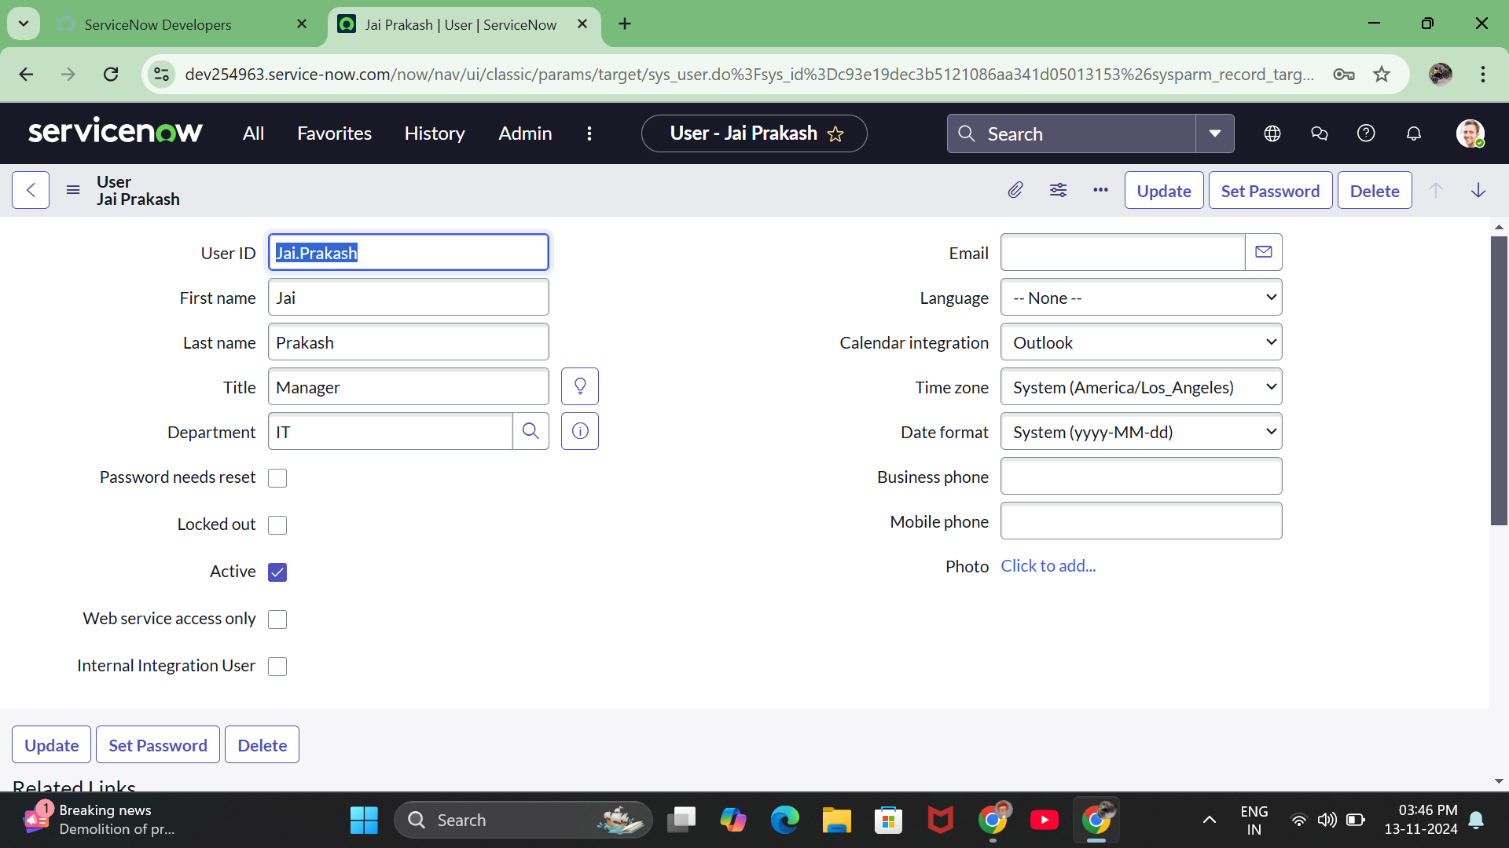

# Activity - 2: Create Groups.

1. Open service now.
2. Click on All  >> search for groups
3. Select groups under system security
4. Click on new
5. Fill the following details to create a new group.
6. Under Group Members, click on edit.
7. Add the user(Jai Prakash) to the Manager Group and click on Save.
8. Click on save.

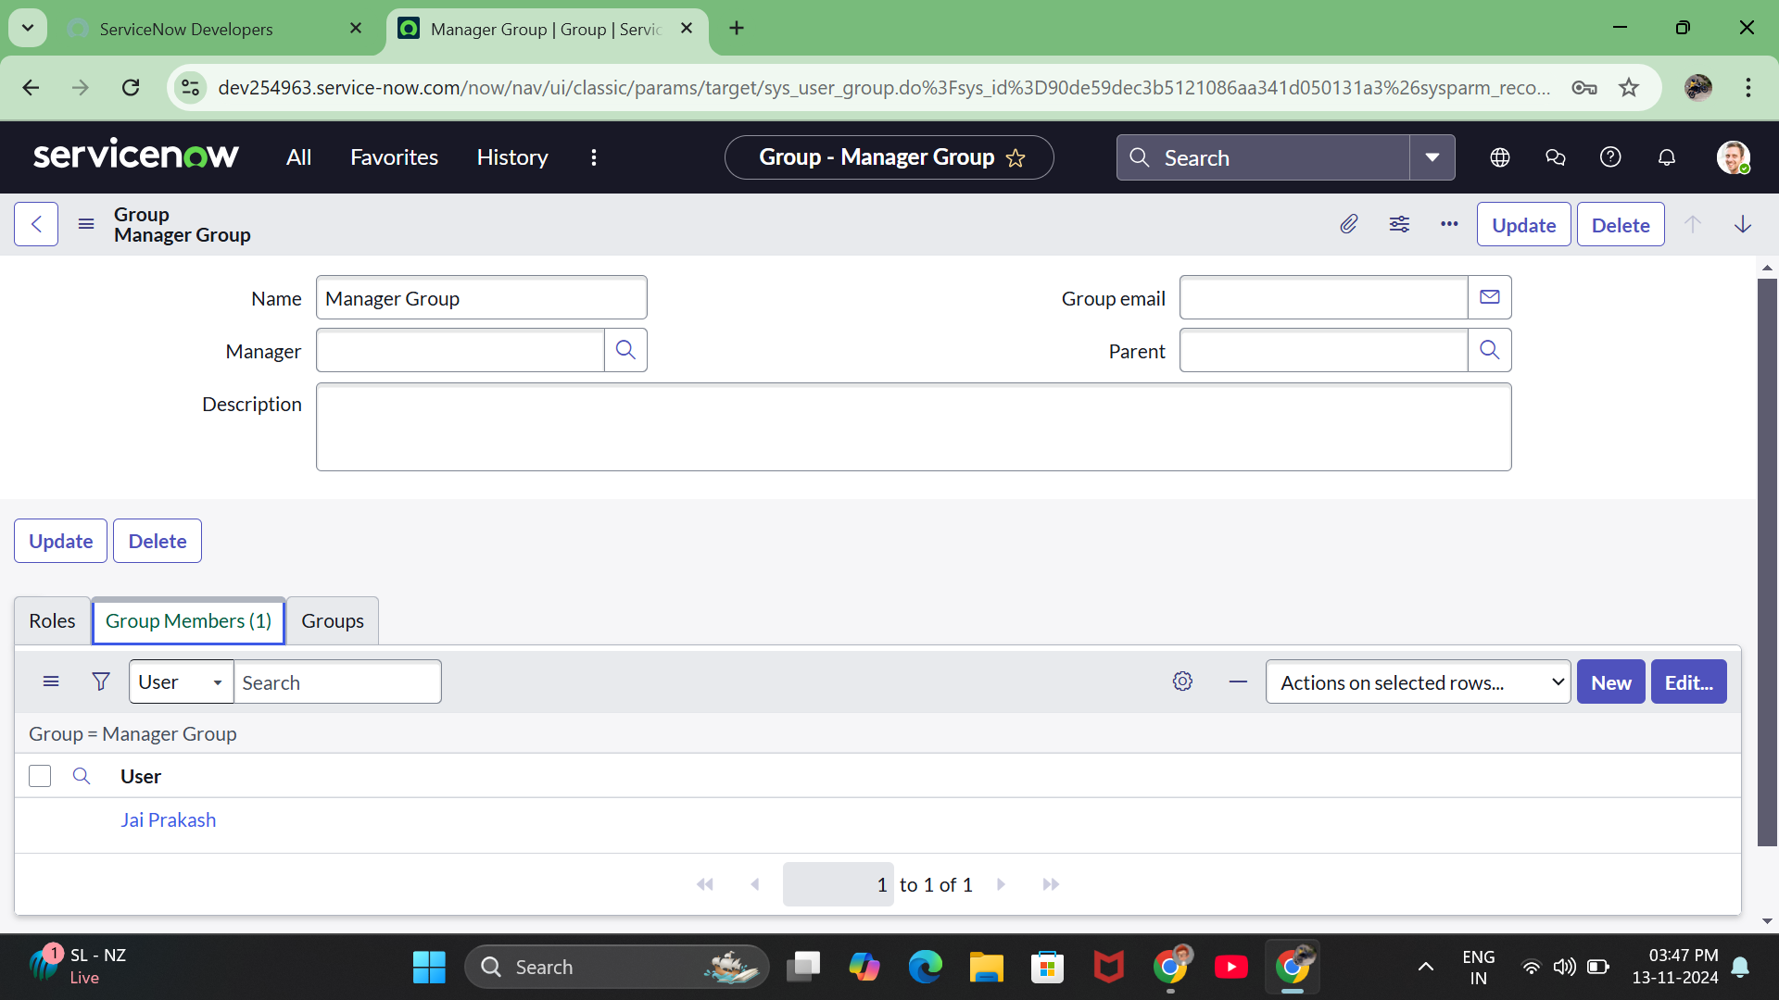

# Activity - 3: Create Roles.

1. Open service now.
2. Click on All  >> search for roles
3. Select roles under system security
4. Click on new
5. Fill the following details to create a new role
6. Click on submit.

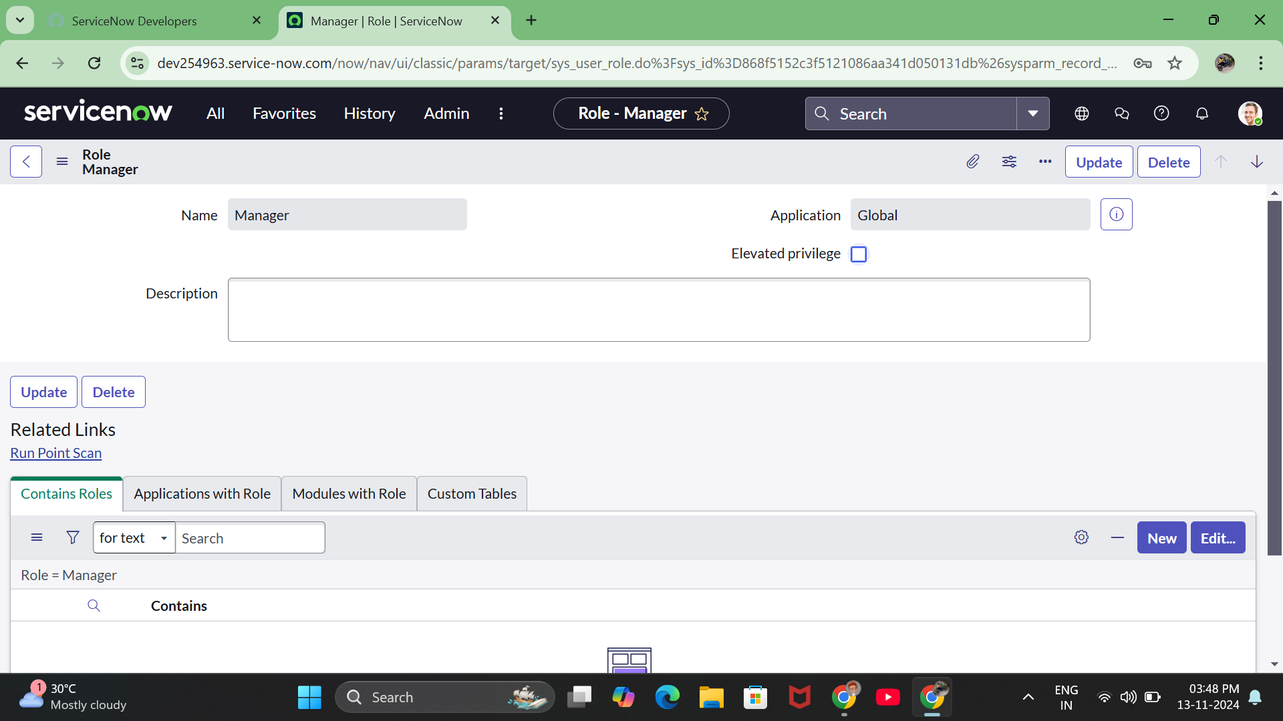

# 

# Activity - 4: Changing the Owner of the Knowledge Base.

1.Go to All >> Search for Knowledge Bases.

2.Open Knowledge bases and change the of IT from Bernard Laboy to Jai Prakash(To change Owner click on the Name and change it).

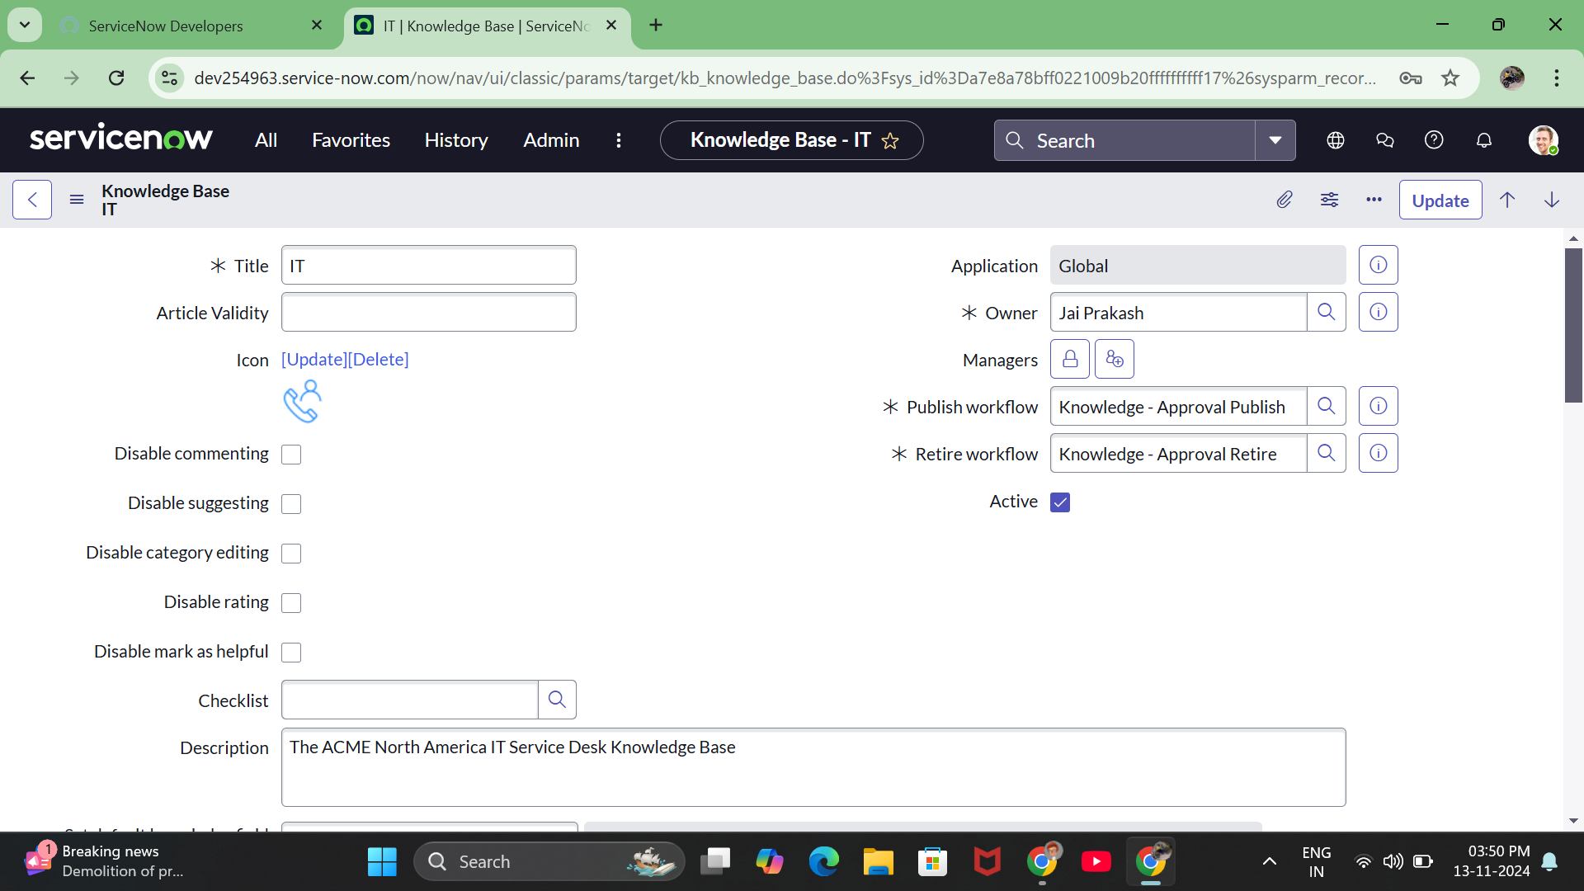

# Activity - 5: Creation of Knowledge Article.

1.Go to All >> Search for my knowledge Articles.

2.Open my knowledge Articles >> Click New.

3.Fill the details as below:

Number :Auto-generated.

Knowledge base :IT

Category :Select any category

Short description :Describes about Cloud Computing. (Give Short description as per  your requirement)

4.Click on Submit.

5.Click on Publish.

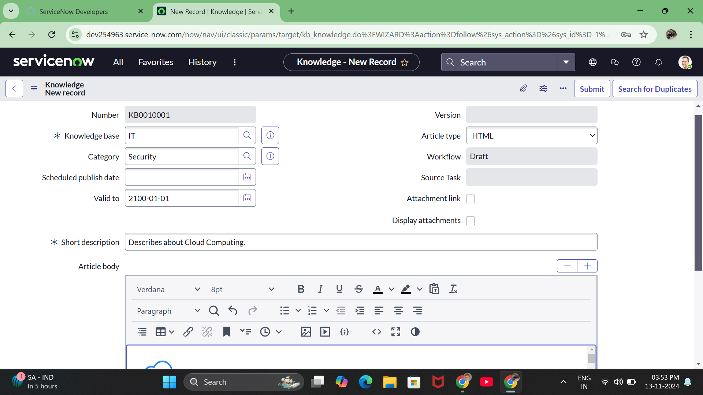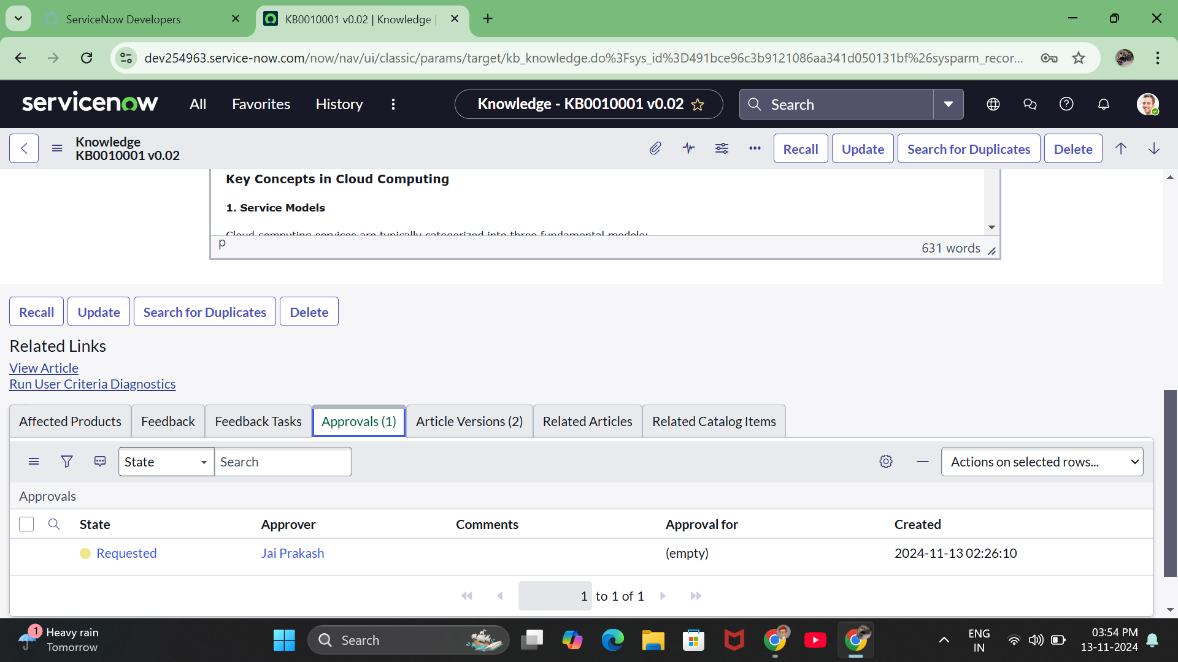

# 5.Testing and Validation:

**Unit Testing:**

Unit Testing in the context of a Knowledge Management (KM) solution focuses on verifying that each individual component within the system operates as expected. Each feature or module is tested independently to ensure functionality before integrating them with the broader system.

**User Interface Testing:**

User Interface (UI) Testing focuses on ensuring that the KM system is user-friendly, visually consistent, and behaves as expected when interacting with different elements. The goal is to validate that the end-user experience is smooth and intuitive.

## 6.Key Scenarios Addressed by ServiceNow in the Implementation Project:

**Knowledge Article Creation**: Users can submit new articles using pre-defined templates. Each article follows a specific workflow from draft to submission.

**Review and Approval Workflow**: Articles are routed to reviewers and approvers based on pre-defined workflows. Automated notifications remind stakeholders of pending actions.

**Content Update and Version Control**: Authors can update existing articles. A version history is maintained to track changes over time.

**Search and Access**: Users can quickly find articles through optimized search tools. Access is restricted based on user roles and permissions.

**Feedback and Rating**: Users can provide feedback on articles, helping authors and editors to keep content relevant and accurate.

**Archival and Expiry Management**: Outdated content is archived based on pre-defined rules, ensuring the knowledge base is up-to-date.

# 7.Conclusion

Implementing an effective knowledge management solution within ServiceNow can significantly improve the overall efficiency of information handling in an organization. By automating the lifecycle of knowledge articles, from creation to approval, the solution ensures that relevant, accurate, and updated information is readily accessible. This results in improved decision-making, better customer support, and more effective internal communication. Continuous monitoring, feedback, and content updates will be essential for sustaining the quality and relevance of the knowledge base. The successful implementation of this project can serve as a blueprint for other areas of information management and digital transformation efforts.



