#### Phase 2: Build an NLP model to differentiate real news from fake news

**Introduction:**

In this ambitious project, we aim to create an advanced Natural Language Processing (NLP) model  using scikit-learn. Our goal is to develop a web application that seamlessly integrates with popular  news sources via their APIs. This web application will offer real-time news predictions, empowering  users to evaluate the credibility of news articles as they emerge, thus promoting a more discerning  readership.

**Project Scope and Objectives:**

This project has a multi-faceted scope, including the development of a highly accurate news credibility  differentiation model and the creation of a user-friendly web application to make this technology  accessible to the public.

**Objectives**:

**1. Model Development for Credibility Differentiation:**

* Algorithm Exploration: We will experiment with various machine learning algorithms, such as  Random Forest and Naive Bayes, to build a model that excels in distinguishing real news from fake  news.
* High Accuracy: Our primary objective is to identify the algorithm or combination of algorithms that provides the highest accuracy in news credibility assessment.
* Model Optimization: We will fine-tune the selected algorithm(s) to ensure optimal performance.

**2. Web Application Development:**

* User-Friendly Interface: Our aim is to design and develop a user-friendly web application that  simplifies technical complexities, ensuring an intuitive user experience.
* Python with Django Rest Framework: We will implement the application using Python's Django  Rest Framework for efficient integration with our trained model.
* React.js Front-End: The front-end of the application will be constructed with React.js to deliver a  seamless and responsive user experience.

**3. Real-Time News Integration:**

* Integration with The Guardian API: We intend to leverage The Guardian news platform's free API to access real-time news articles, ensuring a continuous flow of data for our system.
* Dynamic Predictions: The system will dynamically predict the credibility of news articles as they  are retrieved in real-time.

**4. Database Management:**

* Prediction Storage: To prevent redundant predictions, we will implement a database system to store  the outcomes of previous news credibility assessments.
* Efficient Data Handling: The database will facilitate efficient data management, enabling the  avoidance of repetitive analysis.

**5. User-Facing Display:**

* Presentation of Predictions: The web application will present news articles along with the  predictions made by our model, clearly indicating whether the news is real or fake.
* User Accessibility: Our goal is to ensure that users can easily access and interpret the credibility  assessment without requiring an understanding of the underlying technical aspects.

**Flowchart:**

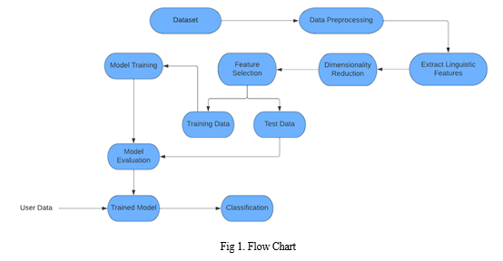

**Detailed Project Plan:**

**1. Model Training in Google Colab**

* Preprocess and clean the news dataset.
* Implement and test various machine learning algorithms (e.g., Random Forest, Naive Bayes).
* Analyze the performance metrics of each algorithm (e.g., accuracy, precision, recall).
* Choose the algorithm that demonstrates the highest accuracy for news credibility assessment.
* Save the trained model in Google Colab.
* Export the selected model from Google Colab to your local machine.

**2. Web Application Development**

* Set up a Django project for the web application.
* Develop the RESTful API to handle incoming news data and predictions.
* Begin developing the user interface using React.js.
* Establish communication with the Django REST API to fetch predictions.
* Integrate the web application with The Guardian's news API to retrieve real-time news articles.
* Implement logic for running background threads every 10 seconds to fetch new news.
* Develop functionality to check whether the news is already in the database.
* Set up a database system to store news articles and their predicted results.
* Establish database connectivity within the Django project.

**3. Testing, Deployment, and Monitoring**

* Conduct extensive testing, including unit testing and integration testing, to ensure the system  functions correctly.
* Verify the accuracy of news predictions.
* Address and resolve any issues or bugs that arise during testing.
* Plan for regular maintenance, updates, and scalability considerations.

**4. Project Evaluation**

* Continuously monitor the accuracy of news predictions.
* Stay updated with developments in machine learning and NLP to enhance the model's accuracy.

**Conclusion:**

Our project represents a fusion of advanced NLP model training with user-centric web application  development, signaling an innovative approach to combat misinformation. With a carefully selected  algorithm, real-time news predictions, and a commitment to user-friendliness, we are positioned to  empower individuals with reliable news assessments. As we move forward, our dedication to accuracy  and continuous improvement remains steadfast, marking the beginning of a new phase in our mission  to promote informed decision-making and accurate information dissemination.