COMPOSE INPUT –VALIDATION

# 1.INTRODUCTION

## Overview:

The app is a sample project that demonstrates how to use the Android Compose UI toolkit to build a survey app. The app allows the user to answer a series of questions. It showcases some of the key features of the Compose UI toolkit, data management, and user interactions.

• You’ll be able to work on Android studio and build an app.

• You’ll be able to integrate the database accordingly.

## Purpose:

The purpose of this project is to compose an input and validate it.

# LITERATURE SURVEY

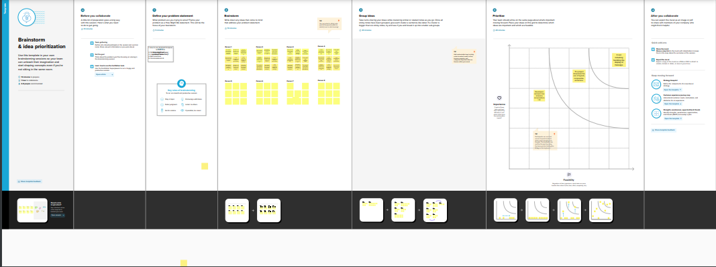

# THEORITICAL ANALYSIS

## Block diagram:

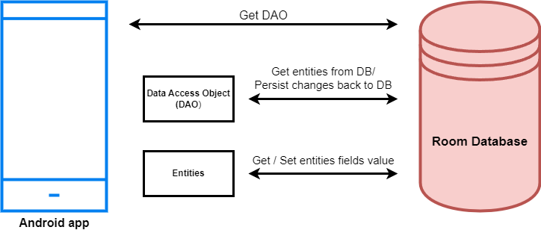

* 1. **Hardware / Software designing:**

Software: Android development kit

# FLOWCHART

# Control ﬂow of the solution

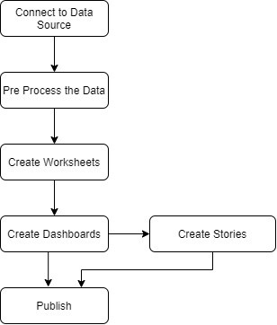

# RESULT

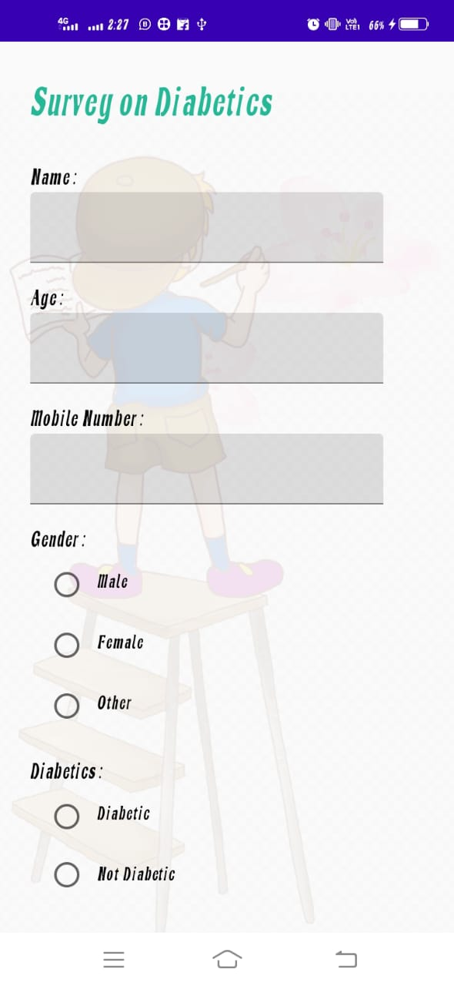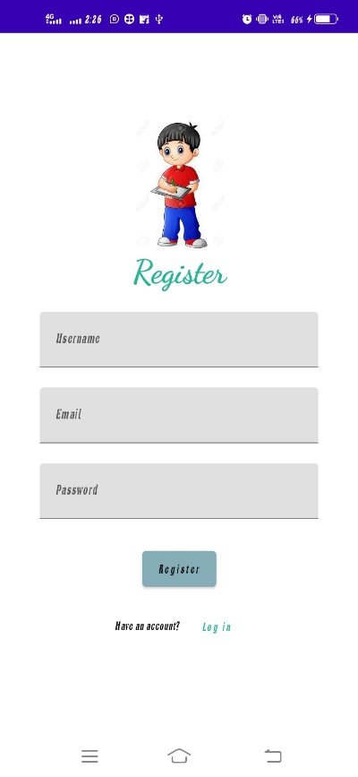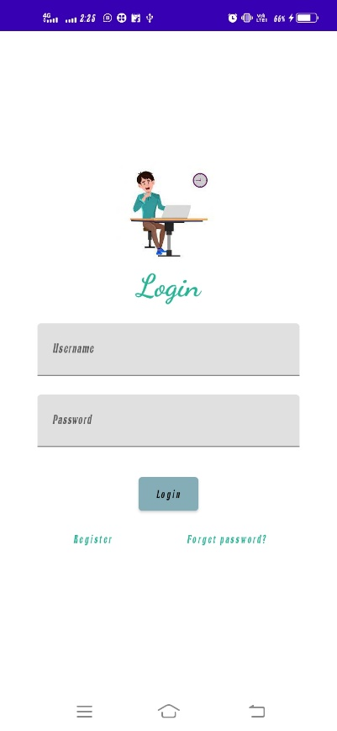

1. **ADVANTAGES & DISADVANTAGES**

Better solutions can be improvised to improve growth rate of the knowledge from different countries using a quick and user friendly visualization.

More data is needed to give accurate results of each and every commune from different countries.

# APPLICATIONS

* Compose input and validation.
* This App can be used for fill the blanks place.
* It can also be used in filling application.

# CONCLUSION

The above project has been made considering topics taught in the boot camp and other previous experiences.This visualization is user friendly and can be understood by anyone without previous programming knowledge and can implemented in a effective way.

# FUTURE SCOPE

Prediction of future growth rates can be made using few algorithms in kotlin. Accordingly many decisions can be made. Since there was a 5 day boot camp related to the challenge, I have restricted my project only to visualization considering the topics that have been taught.