**GALGOTIAS UNIVERSITY**



**(UTTAR PRADESH)**

**HALL TICKET End term exam**

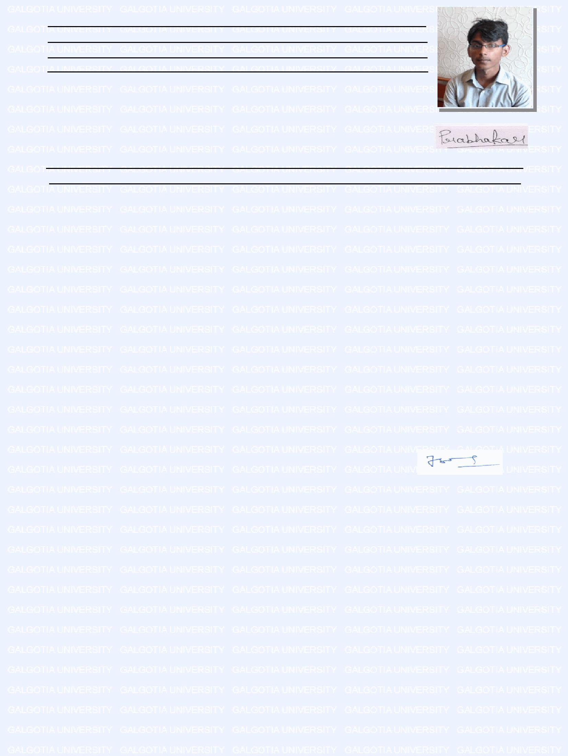

|  |  |  |  |  |  |  |  |  |  |  |  |  |  |  |
| --- | --- | --- | --- | --- | --- | --- | --- | --- | --- | --- | --- | --- | --- | --- |
|  |  |  | Surname |  | Name |  | Father's/Husband's | | |  |  |  |  |  |
|  |  |  |  |  |  |  |  |  |  |
|  |  |  |  |  |  |  | Name |  |  |  |  |  |  |  |
|  | Name of Student | | Yadav |  | Prabhakar |  | Shamsher |  |  |  |  |  |  |  |
|  | Father's Name | | Yadav |  | Shamsher |  |  |  |  |  |  |  |  |  |
|  | Mother's Name | |  |  | Manbhavati |  | Shamsher |  |  |  |  |  |  |  |
|  | Admission | | 15SCSE105183 | |  | | |  |  |  |  |  |  |  |
|  | Enrolment No. | | 1513105109 | |  |  |  |  |  |  |  |
|  | Program |  | B.Tech(CSE) in Cloud Computing & | | | |  |  |  |  |  |  |  |  |
|  |  |  |  |  |  | Student's Signature |  |  |  |
|  |  |  | Virtualization | |  |  |  |  |  |  |  |  |  |  |
|  | Month/Year of the Examination | | | May - 2017 |  |  |  |  |  |  |  |  |  |  |
|  | Semester/Session | | Sem IV/2015-16 | |  |  |  |  |  |  |  |  |  |  |
|  | Course(s) in which student is appearing | | | |  |  |  | Print Date 28/04/2017 7:47:55PM | | | |  |  |  |
|  |  |  |  |  |  |  |
|  | **SNo. Subject Code Subject Name** | | | |  |  |  |  | | | |  |  |  |
|  | 1 | CSE-242P | Operating System Lab(CSE-242P) | | | |  |  |  |  | Not Debarred |  |  |  |
|  | 2 | CSE-213 | Computer Architecture and Organization(CSE-213) | | | | |  |  |  | Not Debarred |  |  |  |
|  | 3 | CSE-354P | Data Communication & Computer Networks Lab(CSE-354P) | | | | |  |  |  | Not Debarred |  |  |  |
|  | 4 | CSE-381 | Data Communication & Computer Networks(CSE-381) | | | | |  |  |  | Not Debarred |  |  |  |
|  | 5 | CSE-241P | Dynamic Paradigm 2 Lab (CSE-241P) | | | |  |  |  |  | Not Debarred |  |  |  |
|  | 6 | LLL-222P | English Proficiency and Aptitude Building-3(LLL-222P) | | | | |  |  |  | Not Debarred |  |  |  |
|  | 7 | MGT-302 | Industrial Economics and Management(MGT-302) | | | | |  |  |  | Not Debarred |  |  |  |
|  | 8 | CSE-227 | INTRODUCTION TO VIRTUALIZATION & CLOUD | | | |  |  |  |  | Not Debarred |  |  |  |
|  | 9 | CSE-247P | COMPUTING(CSE-227) | |  |  |  |  |  |  | Not Debarred |  |  |  |
|  | Introduction to Virtualization and Cloud Computing | | | | |  |  |  |  |  |  |
|  | 10 | CSE-247P | Lab(CSE-247P) | |  |  |  |  |  |  | Not Debarred |  |  |  |
|  | Introduction to Virtualization and Cloud Computing | | | | |  |  |  |  |  |  |
|  | 11 | CSE-222 | PBL(CSE-247P) | |  |  |  |  |  |  | Not Debarred |  |  |  |
|  | Operating System(CSE-222) | | | |  |  |  |  |  |  |  |
|  | 12 | CSE-221 | Theory of Automata and Formal language(CSE-221) | | | | |  |  |  | Not Debarred |  |  |  |
|  |  | | | | | |  |  |  |  |  |  |  |  |
|  | Note: Please bring to our notice discrepancy ,if any, for correction. | | | | | |  |  |  |  |  |  |  |  |
|  |  | **Controller of Examinations** | | |  |  |  |
|  |  |  |  |  |  |  |  |  |  |  |  |
| **Instructions for the Students** | | | |  |  |  |  |  |  |  |  |  |  |  |
|  |  |  |  |  |  |  |  |  |  |  |

1. All the students are advised to be seated in the Exam Hall/Room 15 minutes before the scheduled time of the exam.
2. All the students must carry their University Identity Card and Hall Ticket along with them. Without Identity Card and Hall Ticket, no student will be permitted to enter the Exam Hall/Room.
3. It is the responsibility of the student to fill all the particulars in the answer booklet correctly.
4. Students are required to enter the correct answer booklet number against their name in the attendance sheet.
5. No Supplementary sheet will be provided under any circumstances.
6. Students coming 30 minutes after the commencement of the examination will not be permitted to enter the examination hall to write the exam.
7. No student shall loiter around stairs, verandah and in front of the Exam Hall after the commencement of the examination.
8. Students are not allowed to leave the Examination Hall before half of the time is over. After this, they are allowed only with permission of the invigilator.
9. Students are allowed to carry only writing instruments, University Identity Card, Hall Ticket and board along with them into examination hall.
10. Malpractice is a serious offence and strict action will be taken against those indulging the same.
11. Writing anything on the desks or walls of the Examination Hall/Room is also considered as malpractice.
12. Writing anything on the question paper except Name and Enrolment No. will also be treated as malpractice.
13. Carrying programmable calculators, electronic gadgets, mobile phone & books into the examination hall is also considered as malpractice.
14. Any other activity hindering the smooth conduct of the exam will be dealt with as per University norms.
15. Students who have less than 75% attendance are not eligible to appear in the exam.

CONTROLLER OF EXAMINATIONS