RSVP APPLICATION – CLOUD COMPUTING PROJECT REPORT
Prabhanjan More
cu23bca0040a

1. Introduction
The RSVP (Respond to Invitation) Application is a cloud-based web system created using AWS services.
It allows users to enter their name, email, and event name into a web form.
The backend, hosted on an EC2 instance, stores this data in an RDS MySQL database and sends a confirmation message.
This project demonstrates:
- Cloud Deployment
- EC2 Web Hosting
- RDS MySQL Integration
- Node.js Backend
- Database Connectivity
- Email Notifications

2. Project Requirements

2.1 Software Requirements
- Node.js
- npm
- Express.js
- MySQL2
- AWS SDK
- Body-Parser
- Dotenv

2.2 AWS Requirements
- Amazon EC2 (Ubuntu, t3.micro)
- Amazon RDS (MySQL db.t4g.micro)
- Security Groups
- Public IP address

3. AWS RDS MySQL Database Setup

3.1 Creating the RDS Database
The RDS instance was created using the MySQL engine with username adminPRABHU.
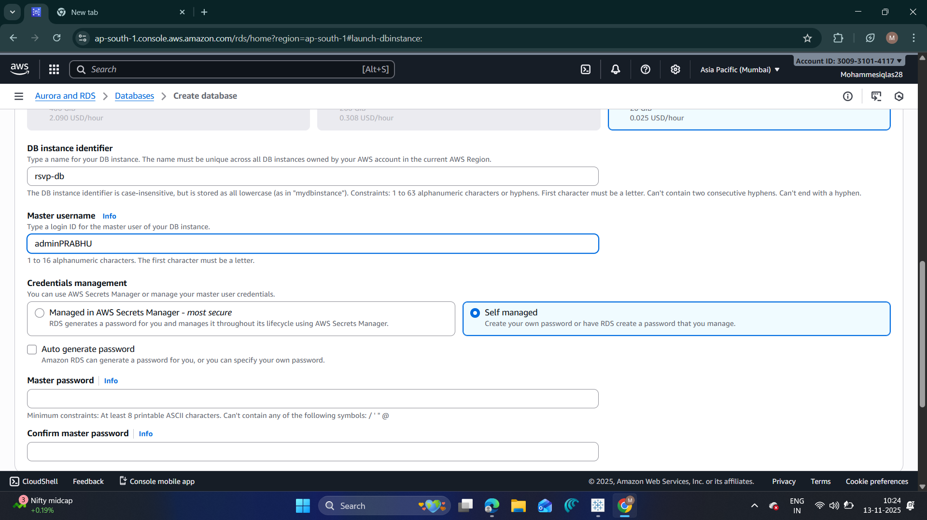📸 Paste Screenshot 1 here
(RDS Create page – rsvp-db, adminPRABHU)
An initial failure occurred due to backup retention exceeding free-tier.
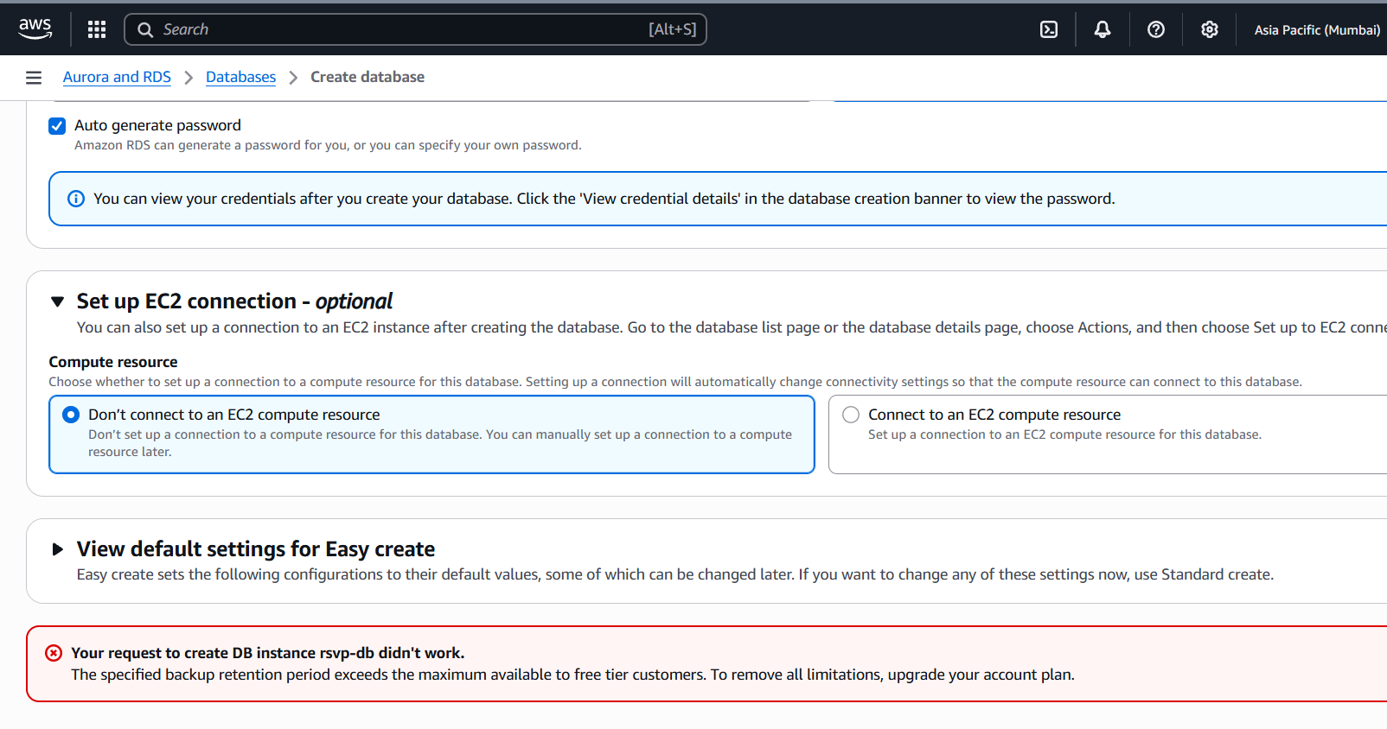📸 Paste Screenshot 2 here
(Backup retention error)
After correcting the settings, the database was created successfully.

3.2 RDS Summary
The RDS dashboard displays:
- Endpoint
- Port
- Security Group
- Connectivity Settings
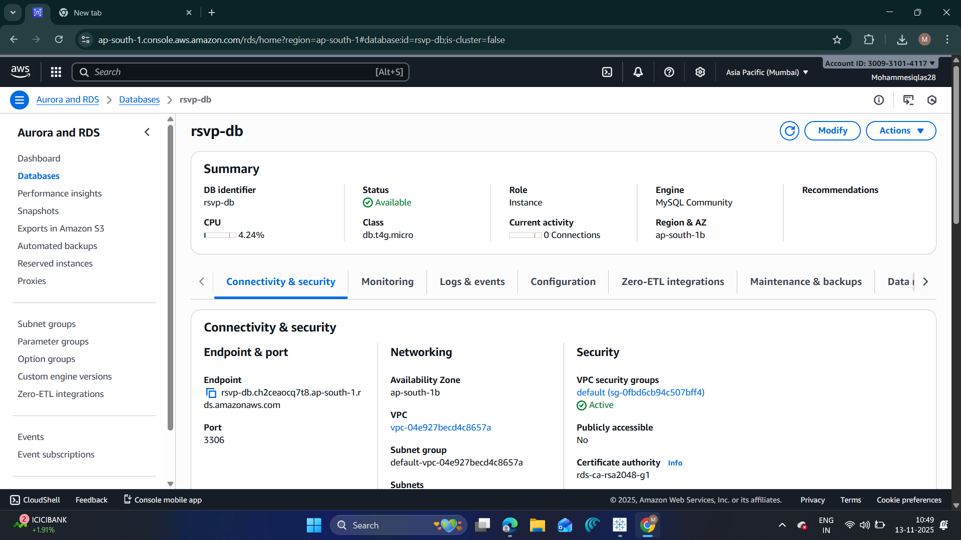📸 Paste Screenshot 5 here
(RDS summary page showing endpoint & security group details)

4. AWS EC2 Instance Setup

4.1 Launching EC2
An Ubuntu EC2 instance was launched to host the Node.js backend.
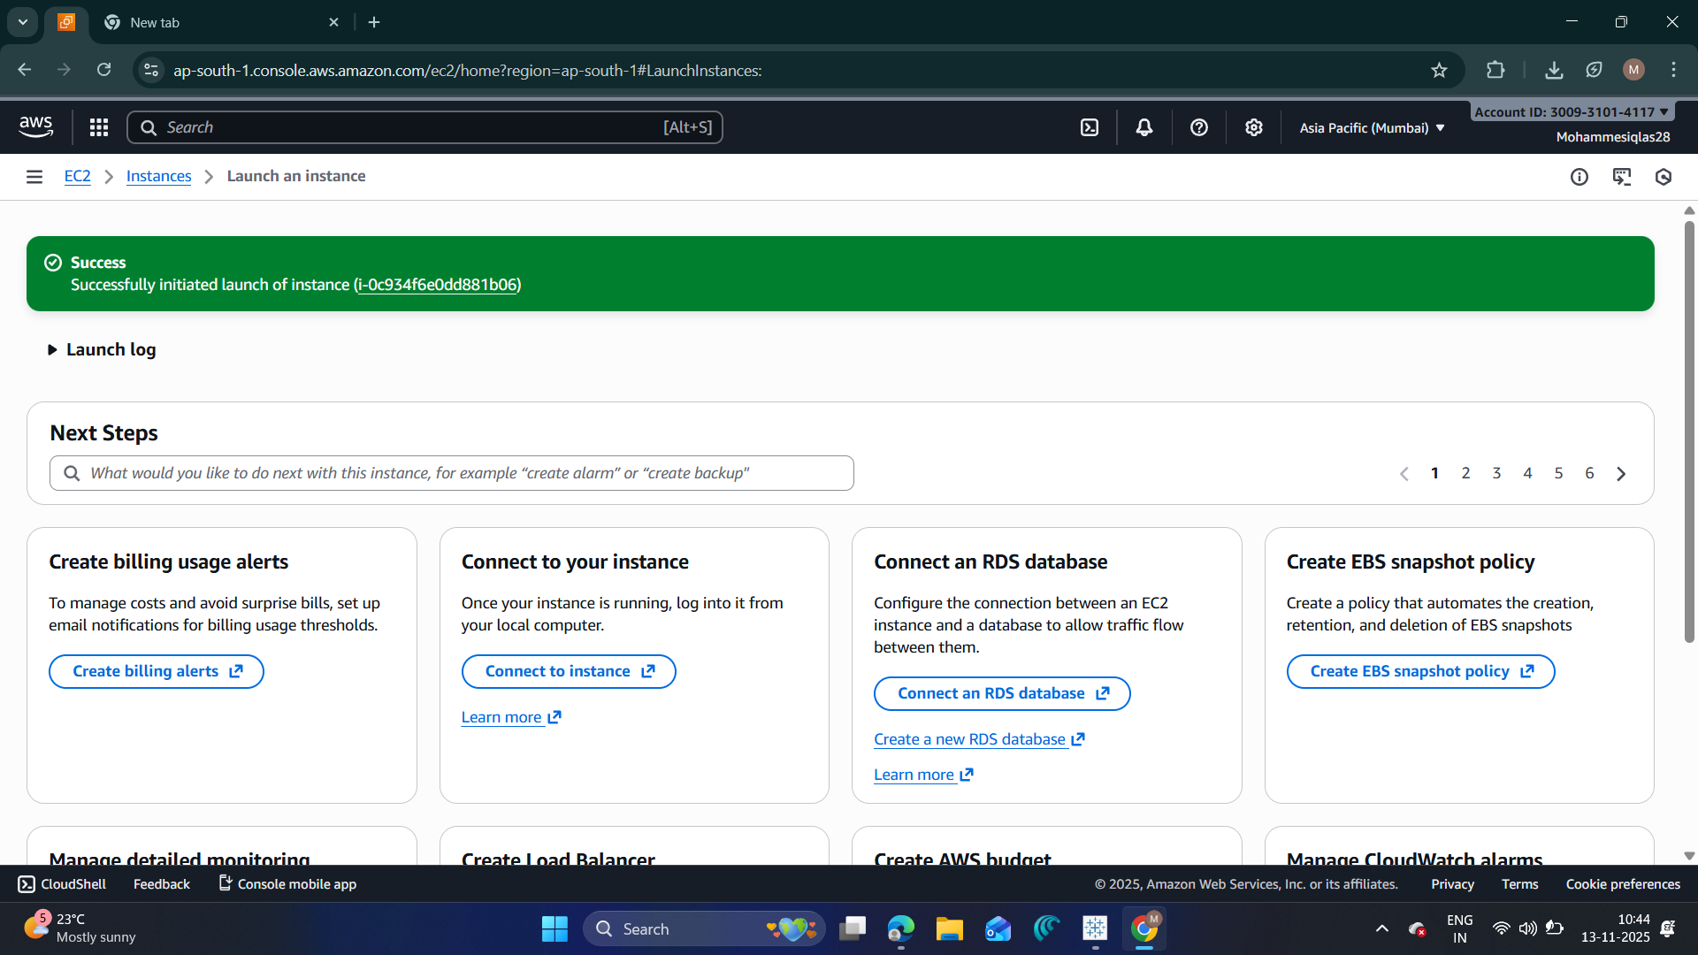📸 Paste Screenshot 3 here
(EC2 launch success message)

4.2 EC2 Instance Running
The instance named prabhu is shown running.
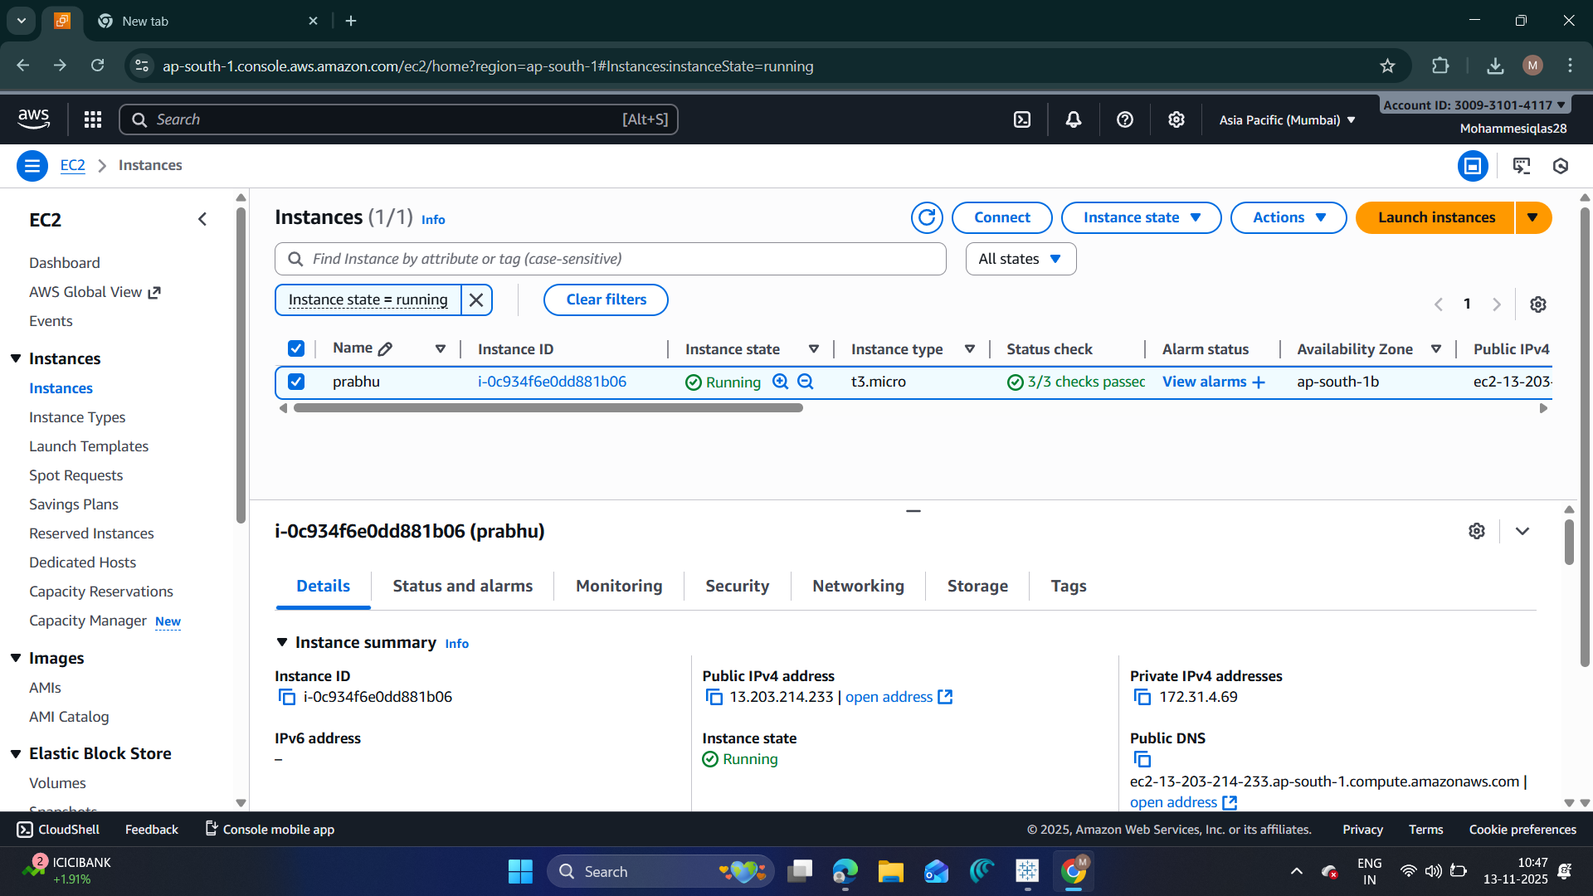📸 Paste Screenshot 4 here
(EC2 instance “prabhu” running)

5. Backend Setup (Node.js on EC2)

5.1 Installing Node.js
Using terminal:
sudo apt update
sudo apt install -y nodejs
node -v
npm -v
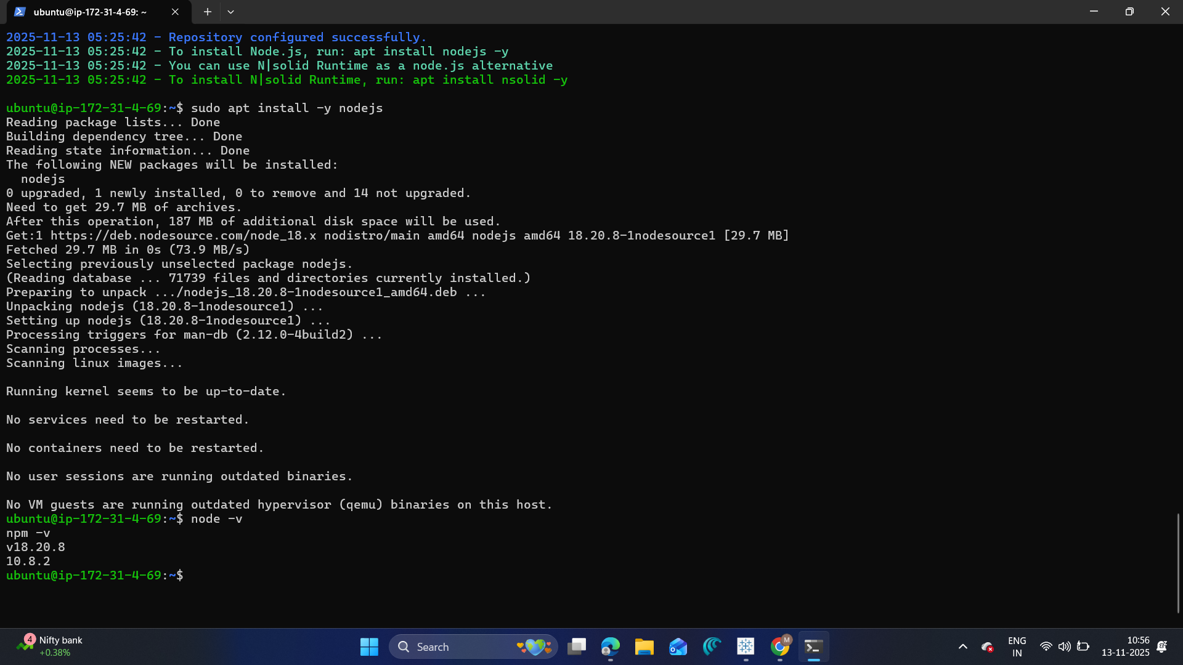📸 Paste Screenshot 6 here
(Node.js & npm version screenshot)

5.2 Initializing Project
mkdir rsvp
cd rsvp
npm init -y
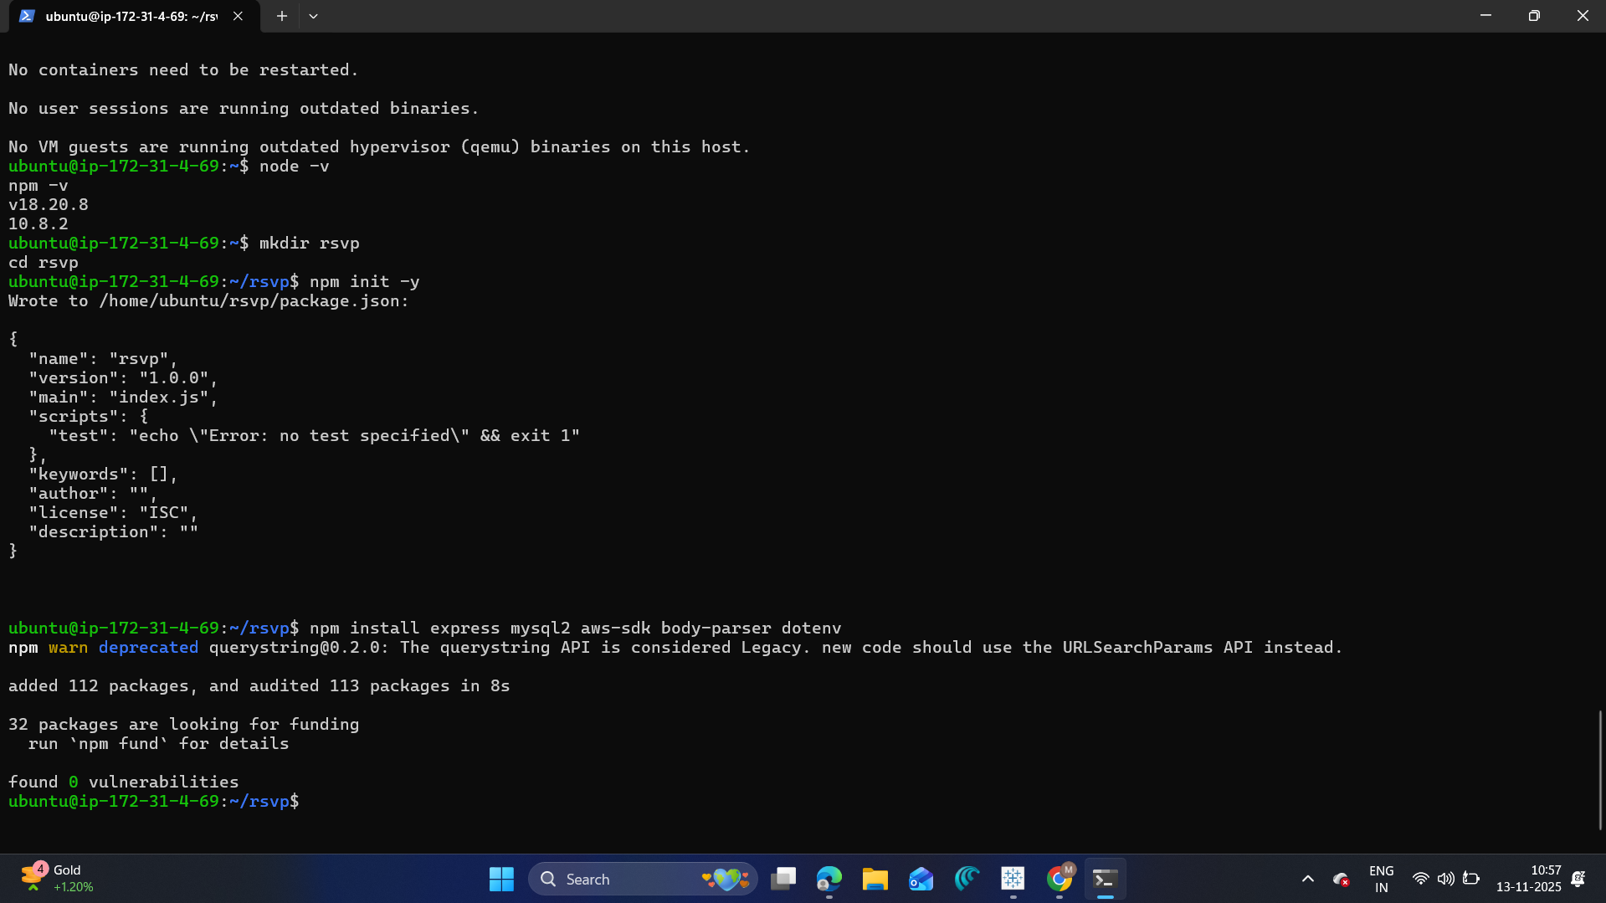📸 Paste Screenshot 7 here
(npm init & package.json creation)

5.3 Installing Dependencies
npm install express mysql2 aws-sdk body-parser dotenv
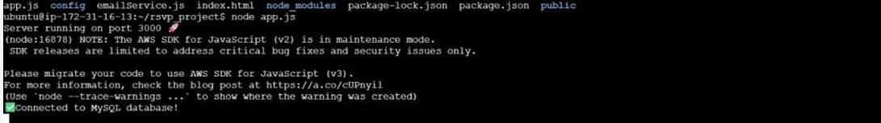📸 Paste Screenshot 8 here
(npm install screenshot)

5.4 Backend Code (app.js)
require("dotenv").config();
const express = require("express");
const mysql = require("mysql2");
const bodyParser = require("body-parser");
const app = express();
app.use(bodyParser.urlencoded({ extended: true }));
app.use(express.static("public"));
// MySQL connection
const db = mysql.createConnection({
host: process.env.DB_HOST,
user: process.env.DB_USERNAME,
password: process.env.DB_PASSWORD,
database: process.env.DB_NAME
});
db.connect(err => {
if (err) throw err;
console.log("Connected to MySQL database!");
});
// Routes
app.post("/submit", (req, res) => {
const { name, email, eventName } = req.body;
const sql = "INSERT INTO rsvps (name, email, eventName) VALUES (?, ?, ?)";
db.query(sql, [name, email, eventName], (err) => {
if (err) throw err;
res.send("RSVP saved and email sent successfully!");
});
});
app.listen(3000, () => {
console.log("Server running on port 3000");
});
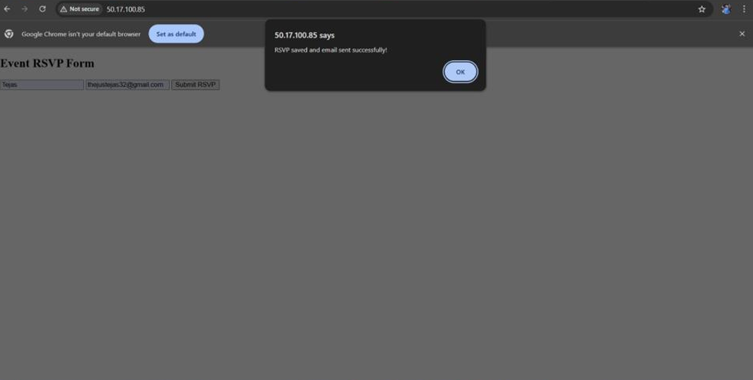📸 Paste Screenshot 9 here
(Server running + connected to DB)

5.5 .env File
Create a file named .env:
DB_HOST=your-rds-endpoint
DB_USERNAME=adminPRABHU
DB_PASSWORD=yourpassword
DB_NAME=rsvpapp

6. Frontend (index.html)
<!DOCTYPE html>
<html>
<head>
<title>Event RSVP Form</title>
</head>
<body>
<h2>Event RSVP Form</h2>
<form action="/submit" method="POST">
<input type="text" name="name" placeholder="Name" required>
<input type="email" name="email" placeholder="Email" required>
<input type="text" name="eventName" placeholder="Event Name" required>
<button type="submit">Submit RSVP</button>
</form>
</body>
</html>

7. Application Output
When the user submits the form, the system displays:
📸
(“RSVP saved and email sent successfully” popup)

8. Database Verification (MySQL on RDS)

8.1 Viewing Tables
Commands executed:
SHOW TABLES;
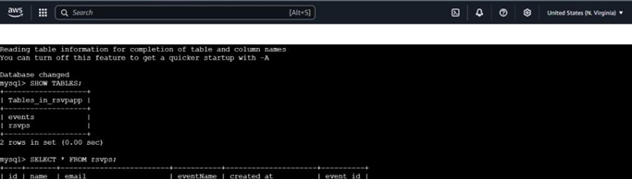
(Tables: events, rsvps)

9. Result
The application successfully:
- Accepts RSVP form submissions
- Stores data in RDS MySQL
- Connects EC2 ↔ RDS
- Runs Node.js server on cloud
- Displays success popup
- Creates rsvps and events tables

10. Conclusion
This project demonstrates full deployment of a cloud-based web application using AWS services. The integration of EC2, RDS, and Node.js shows real-world cloud computing implementation and database connectivity.
