
DIT 264 – Project Project Proposal

Student Accommodation Finder

DIT/2026/05/E/090
K.A.D.N.P. Weerasinghe
22 October 2026

Diploma in Information Technology Department of ICT
Faculty of Humanities and Social Sciences University of Sri Jayewardenepura

ACKNOWLEDGEMENT

I would like to sincerely thank all the lecturers of the Diploma in Information Technology, Department of ICT, Faculty of Humanities and Social Sciences, University of Sri Jayewardenepura, who taught me everything I have learned from the basic level up to now. I am especially grateful for the guidance given to me during the project progress sessions, where my questions were answered in real time and improvements to my project were suggested. I also thank my friends who shared their ideas about what makes a good boarding place.

Table of Contents
1. INTRODUCTION 3
1.1 Background 3
1.2 Problem Statement 3
1.3 Objectives 3
1.4 Scope and Limitations 3
2. REQUIREMENTS SPECIFICATION 4
2.1 Functional Requirements 4
2.2 Non-Functional Requirements 4
3. SYSTEM DESIGN 5
3.1 Design Philosophy 5
3.2 Use Case Diagram 5
3.3 Activity Diagram 6
3.4 Entity-Relationship (ER) Diagram 7
4. WEBSITE DESIGN & INTERFACE 8
4.1 User Interface Screenshots 8
4.2 Color Scheme and Typography 12
4.3 Responsive Design 13
5. IMPLEMENTATION DETAILS 15
5.1 Technologies Used 15
5.2 Technical Functionalities 16
6. TESTING AND EVALUATION 17
7. CONCLUSION 18
7.1 Achievements 18
7.2 Challenges Faced 18
7.3 Future Enhancements 19
8. REFERENCES 19

INTRODUCTION

Background
Many students who are selected to universities in and around Colombo come from far away parts of the country, and they have to find a boarding place near their campus. Most of them do not know the area. They search by asking seniors and friends, looking at notice boards and social media posts, or visiting places physically and walking lane by lane to find a suitable house. This takes a lot of time, effort and money, and the information they find is often incomplete or out of date. Student Accommodation Finder is a database-driven website that brings accommodation details, photos, prices, facilities and student reviews into one place for students of universities such as the University of Sri Jayewardenepura, the University of Colombo, the University of Moratuwa and the Kotelawala Defence University.

Problem Statement
There is no single, trusted place where students can compare boarding houses by price, distance, room type and facilities. Information is scattered, can be out of date, and cannot be checked by other students. Students also have no easy way to send a booking request or to share an honest rating of a place after staying there.

Objectives
    - Provide a searchable list of student accommodation with live filtering and sorting.
    - Show full details, photos and facilities for each accommodation.
    - Allow students to register, log in and send booking requests that are saved in a database.
    - Let registered students rate accommodation so that other students can choose with confidence.

Scope and Limitations
The system covers searching, viewing, booking requests, student registration and login, and ratings, using HTML, CSS, JavaScript, PHP and a MySQL (MariaDB) database. The following are outside the scope of this version:
    - There is no owner or admin panel. Accommodation records are added directly in the database; phpMyAdmin.
    - Booking requests are stored in the database only. No emails or SMS messages are sent, and there is no online payment.
    - The sample accommodation data is fictional and used for demonstration. The website runs on a local XAMPP server.

REQUIREMENTS SPECIFICATION

Functional Requirements
The system shall allow the user to:
    - View a home page with the top-rated accommodation.
    - Search accommodation by name or area and filter it by university, location, maximum price, room type, boys/girls/mixed, distance, facilities and availability.
    - Sort the results by name, price, rating or distance.
    - Open a details page showing photos, price, location, capacity, availability, facilities, description and student reviews.
    - Register as a student and log in and out securely.
    - Send a booking request when logged in, and view own requests on the “My Bookings” page, also only registered and logged in students only can sent a booking request.
    - Rate an accommodation from 1 to 5 stars with comment, once per accommodation and student can update the rating later.
    - Can read the “How It Works’ page that explains the steps of using the system.

Non-Functional Requirements
Quality attributes of the system:
- Performance: Pages should load quickly and respond immediately when the user searches or filters. This was achieved by compressing all photos to a width of 1200 px (about 70 KB - 170 KB each instead of several MB), using only one stylesheet and one JavaScript file, and keeping each page to one or two database queries. The search filters run in the browser with JavaScript, so the results update instantly without reloading the page.
- Usability: Clear navigation on every page, labelled form fields, instant search results, messages that explain errors and successes, a skip link, visible keyboard focus, descriptive button text, alt text on images and good colour contrast.
- Security: PDO prepared statements (protection against SQL injection), htmlspecialchars output escaping (protection against XSS), password hash () for passwords, session ID regeneration on login, server-side validation of every form, and redirects limited to the website’s own pages.
- Responsiveness: CSS Grid, Flexbox and a media query for screens up to 800 px wide. The menu becomes a toggle button on small screens

SYSTEM DESIGN

Design Philosophy
A user-centered design approach was used. The target users are university students who are usually on a budget, in a hurry and using a phone from selected universities in Colombo district. The interface is therefore simple and consistent: one navigation bar on every page, a clear search form, cards that show the most important facts such as price, location, rating, availability, and one main action button on each page. The same colours, fonts and button style are used everywhere. Reusable PHP include files for header, footer and card keep the layout consistent and the code easy to maintain.

Use Case Diagram
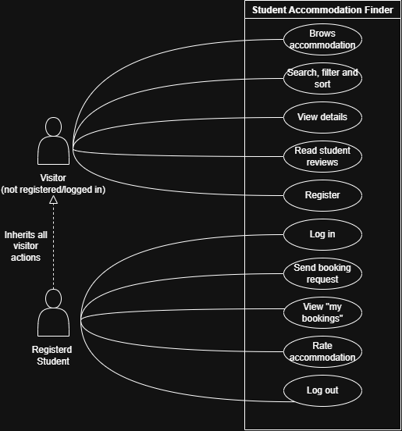

Activity Diagram
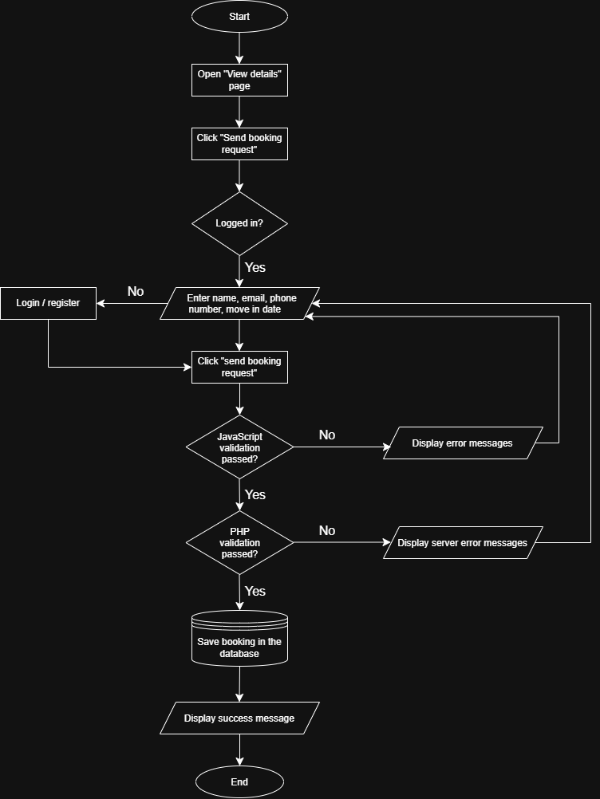

Entity-Relationship (ER) Diagram
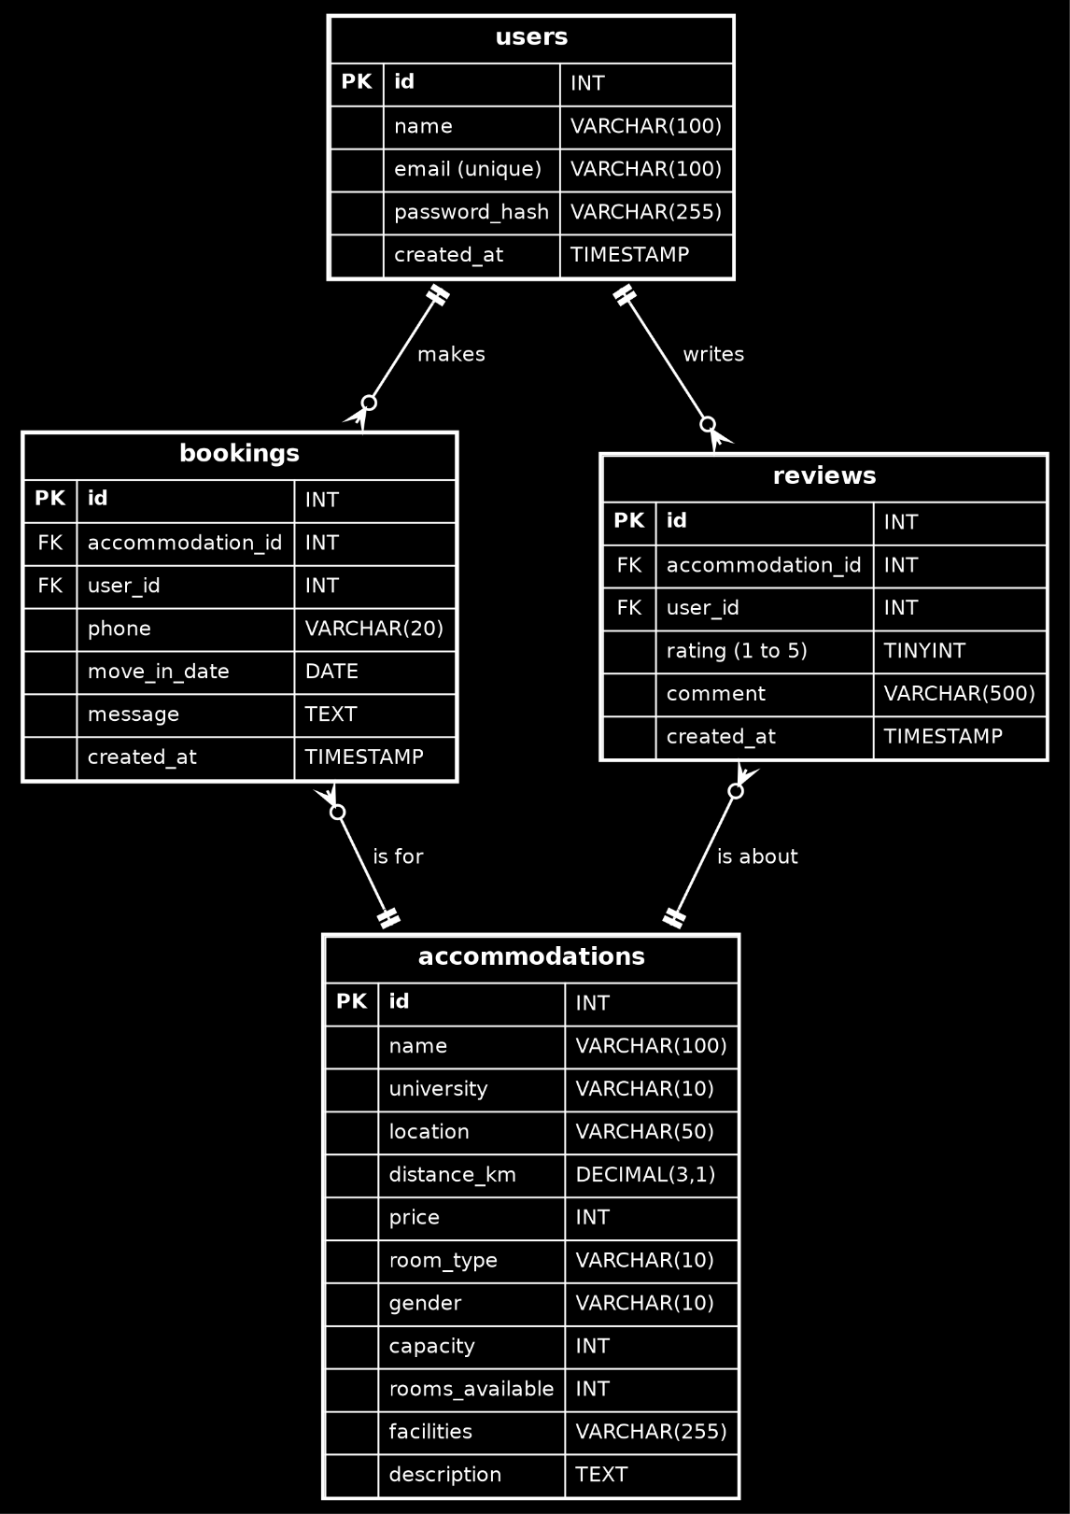
The database has four tables. Users store student accounts. Accommodations store the boarding places. Bookings link a student to an accommodation is one student can make many bookings and one accommodation can receive many bookings. Reviews also link a student to an accommodation and have a unique key so that a student can have only one review for each accommodation. The average rating shown on the website is calculated from the reviews table using AVG () and a LEFT JOIN.

WEBSITE DESIGN & INTERFACE

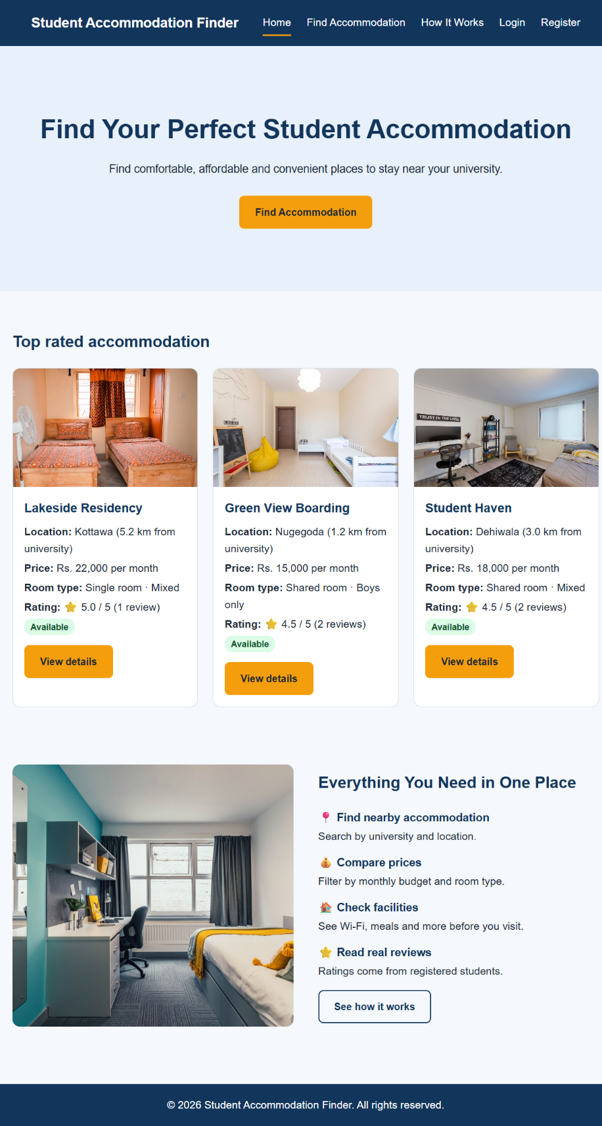
User Interface Screenshots

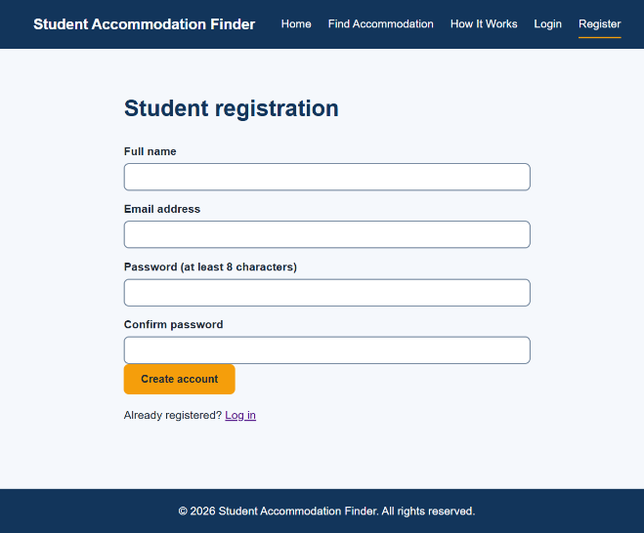
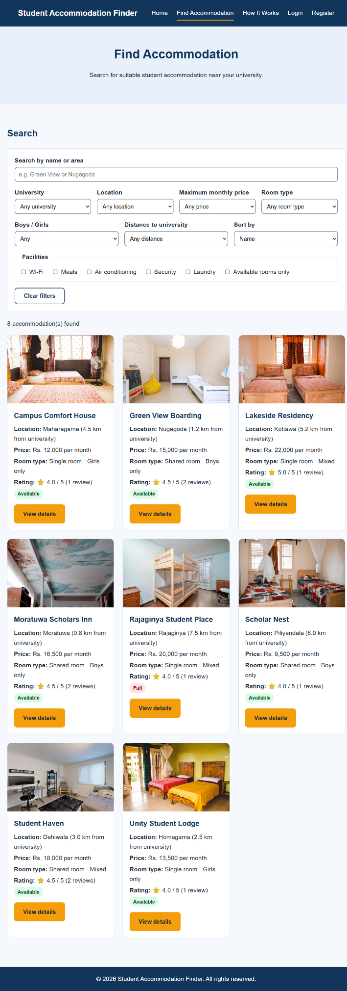
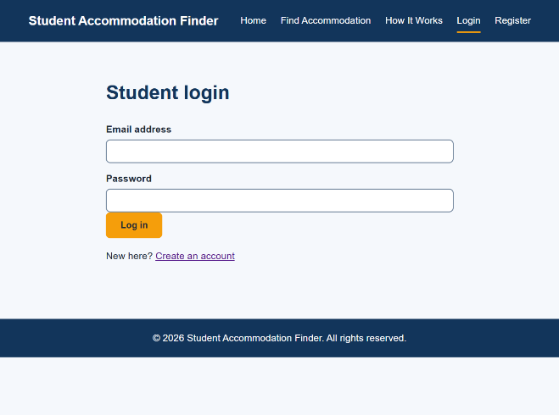
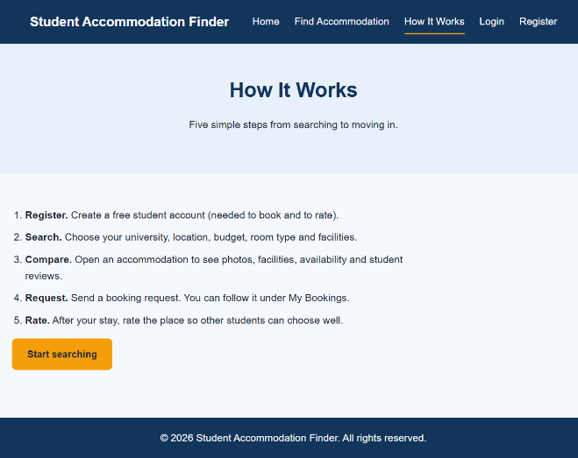
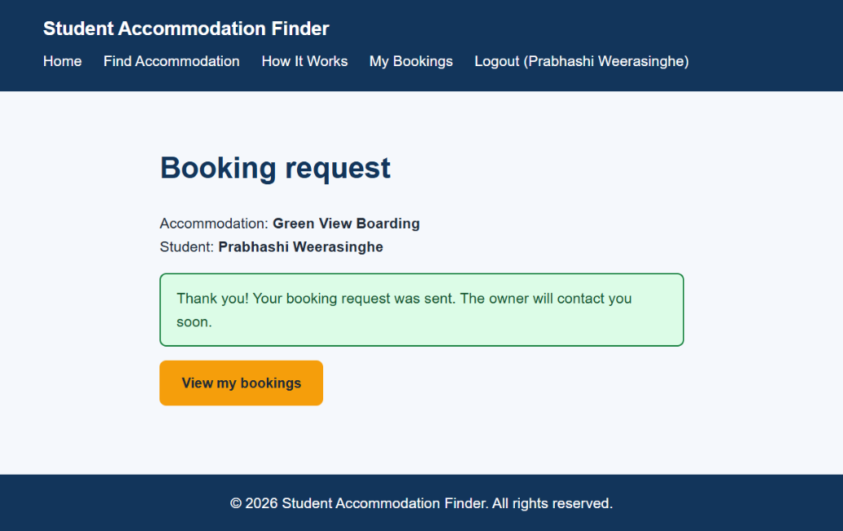
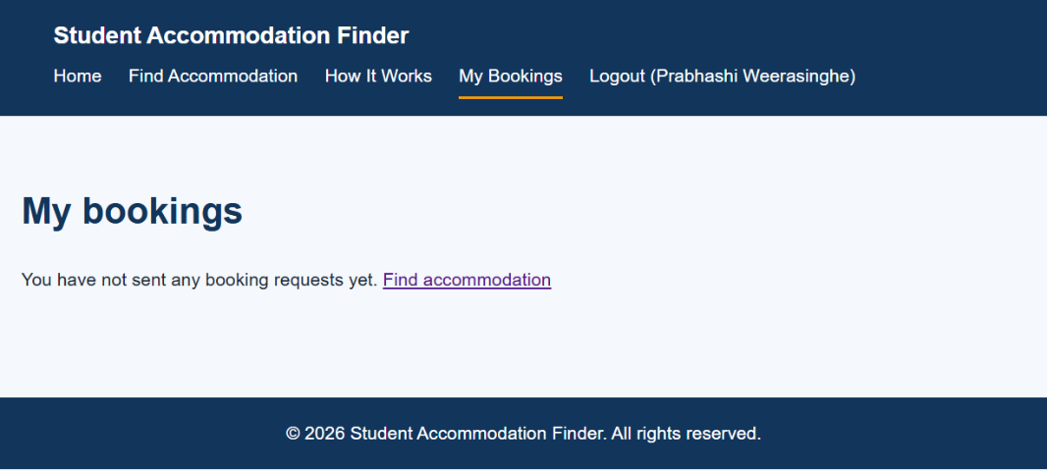
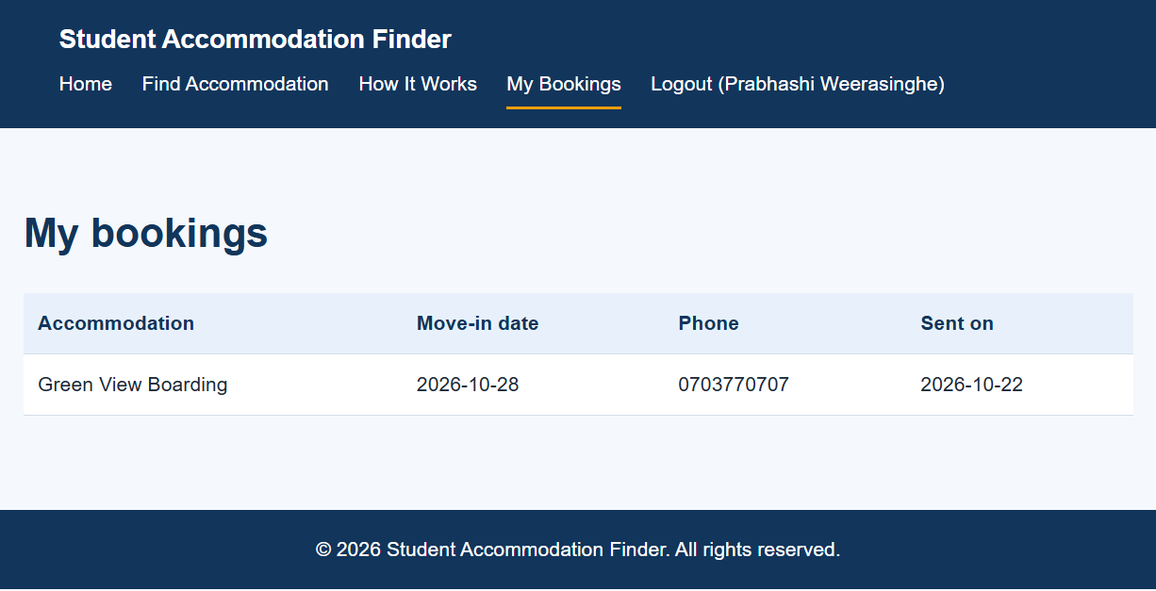

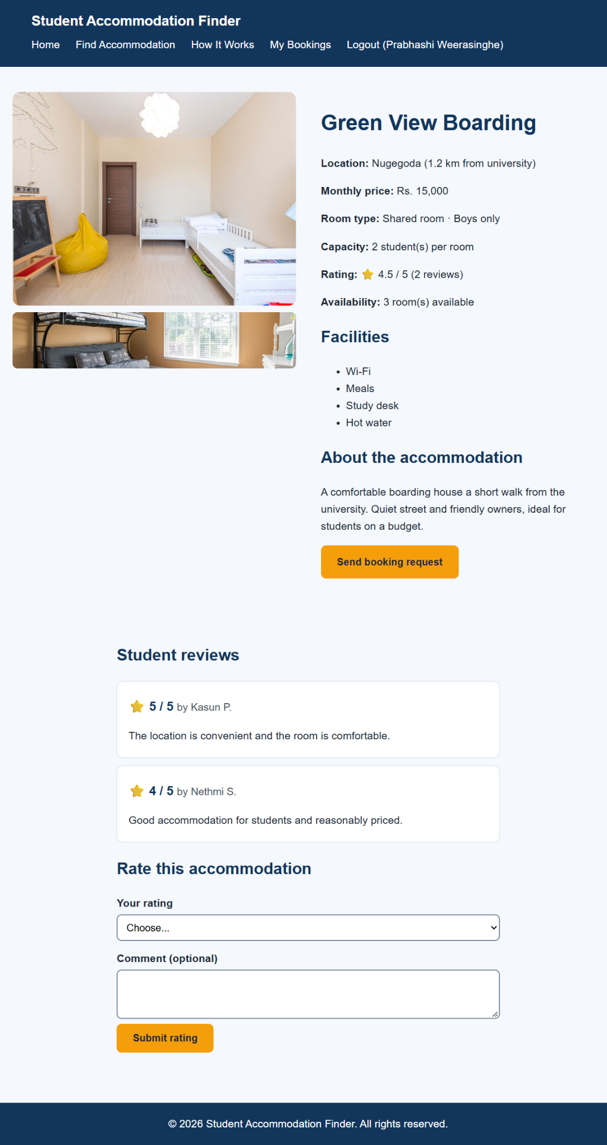

Color Scheme and Typography
The website uses a navy blue and amber colour scheme. The text colours give strong contrast on the light backgrounds. All colours are stored as CSS variables so they can be changed in one place.
Color Scheme:
Use | Color | Hex code
Primary (navigation bar, headings, footer) | Navy blue | #12355B
Accent (buttons, current page marker) | Amber | #F59E0B
Light background (hero, table headers) | Light blue | #E8F1FB
Page background | Very light blue | #F5F8FC
Body text | Dark gray | #1F2937

Typography: Arial (with the sans-serif fallback) is used for all text. The body text is 17 px with a line height of 1.6 for easy reading. Headings use the same font in navy blue and are sized with h1, h2 and h3 tags in a clear order.

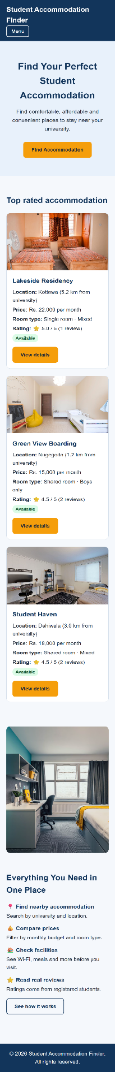
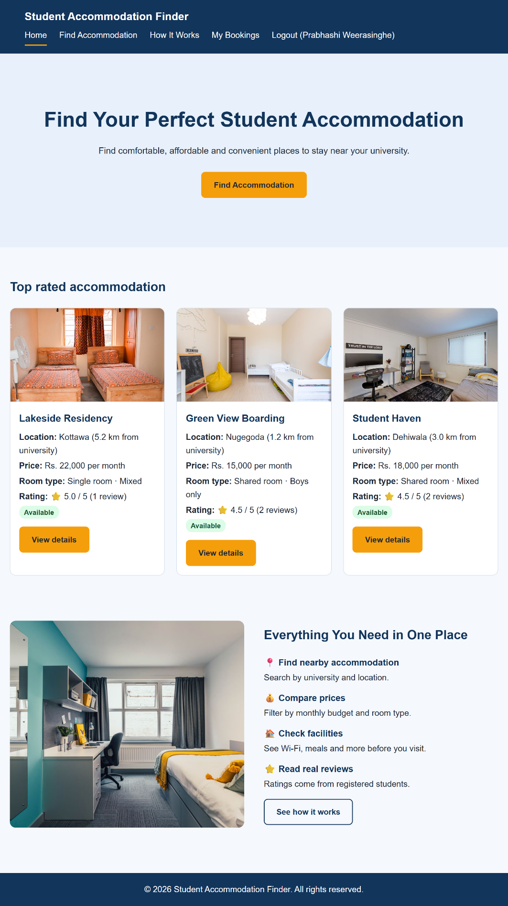
Responsive Design

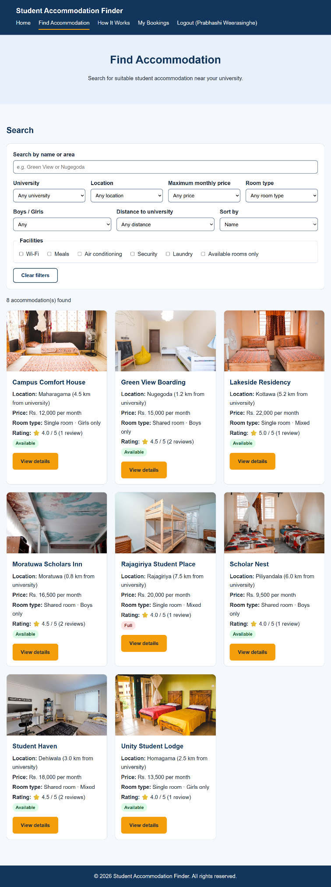

IMPLEMENTATION DETAILS

Technologies Used
The following technologies and tools were used:
    - Frontend: HTML5 (semantic elements), CSS3 (Grid, Flexbox, variables, media queries) and JavaScript (ES6).
    - Backend: PHP 8.2 with PDO for database access and PHP sessions for login.
    - Database: MySQL / MariaDB 10.4, managed with phpMyAdmin.
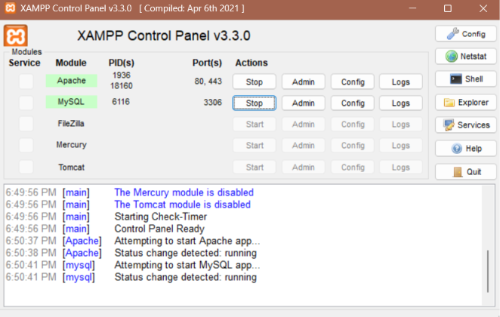
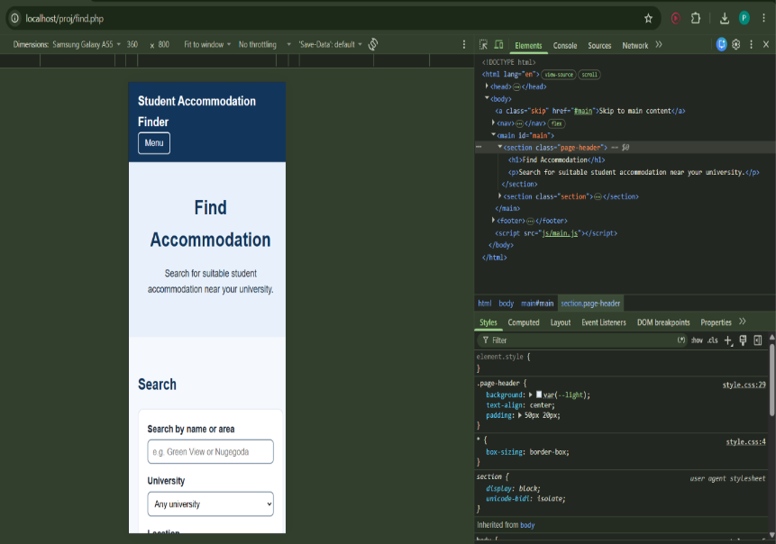
    - Server and tools: XAMPP (Apache), Visual Studio Code, Google Chrome Developer Tools (responsive testing).

    - Design assets: free stock photographs (Pexels), compressed before use.
    - AI assistance: Claude (Anthropic) was used as a learning and coding assistant.

Technical Functionalities
    - Live search, filter and sort (JavaScript): every accommodation card stores its details in data attributes (data-price, data-university and so on). When a filter changes, JavaScript compares these values, hides the cards that do not match with the hidden property, updates the result count and re-orders the cards using sort().
    - Form validation: forms are first checked in the browser with JavaScript (empty fields, e-mail format, phone format, password length, matching passwords, no past dates) and then checked again on the server with PHP, because browser checks can be bypassed.
    - Registration and login (PHP sessions): passwords are stored with password_hash() and checked with password_verify(). The logged-in student is kept in $_SESSION, and booking and My Bookings pages are protected with a require_login() function.
    - Database access: all queries use PDO prepared statements. Bookings and reviews are saved with INSERT statements, and a student can update an existing rating using ON DUPLICATE KEY UPDATE.
    - Ratings: the average rating and number of reviews are calculated with AVG() and COUNT() on a LEFT JOIN, so the rating is always up to date.
    - Photos: the details page finds all photos named after the accommodation id (for example 3-1.jpg and 3-2.jpg) with the PHP glob() function and shows them as a gallery. A default photo is used if none exists.
    - Reusable code: header.php, footer.php and card.php are included on every page, so the navigation and card layout are written only once.

TESTING AND EVALUATION
The system was tested manually in Google Chrome and Microsoft Edge on a local XAMPP server. Each feature was tested with valid and invalid input. Responsive behaviour was checked with the Chrome Developer Tools device toolbar at phone, tablet and desktop widths, and keyboard navigation was checked using the Tab key.
No. | Feature | Test | Expected result | Result
1 | Navigation | Click every menu link | Correct page opens, current page is marked | Pass
2 | Search filter | Select USJ and price up to Rs. 15,000 | Only matching cards are shown, count updates | Pass
3 | Facilities filter | Tick Wi-Fi and Meals | Only places with both facilities remain | Pass
4 | Sort | Sort by price low to high | Cards are reordered by price | Pass
5 | No results | Search for a name that does not exist | “No accommodation matches” message appears | Pass
6 | Register | Register with valid details | Account is created and user is logged in | Pass
7 | Register (invalid) | Use a short password or a used e-mail | Error message is shown, no account created | Pass
8 | Login | Log in with correct, then wrong password | Correct: logged in. Wrong: error message | Pass
9 | Protected page | Open booking page while logged out | Redirected to the login page | Pass
10 | Booking request | Submit valid form | Success message, row saved in bookings table | Pass
11 | Booking (invalid) | Submit an empty phone or a past date | Error message, nothing saved | Pass
12 | My Bookings | Open My Bookings after booking | The new booking is listed | Pass
13 | Rating | Submit a 4-star rating | Rating saved, average rating updates | Pass
14 | Security | Type <script> in a text box | Text is shown as plain text, not run | Pass
15 | Responsive | View at 375 px and 768 px wide | Layout fits, Menu button works, no sideways scrolling | Pass
16 | Keyboard | Use only Tab and Enter | All links and buttons reachable, focus visible | Pass

Usability was considered from the start by asking friends who are university students what makes a good boarding place (price, distance to the campus, facilities, safety and honest reviews). Their ideas were used to design the filters, the details page and the student rating feature.

CONCLUSION

Achievements
A complete database-driven website was built using HTML, CSS, JavaScript, PHP and MySQL. Students can search and filter accommodation, view details and photos, register and log in, send booking requests and rate the places they have used. The website is responsive, follows basic accessibility practices and uses secure coding techniques such as prepared statements, output escaping and password hashing.

Challenges Faced
Using many filters at the same time was solved by storing each card’s values in data attributes and checking all conditions together in one JavaScript function. A large image pushed the text outside the screen in the home page benefits section. It was fixed by using CSS Grid with min-width: 0 and a fixed image height. User input must never be placed directly in SQL. Prepared statements were used for every query. A file naming rule (id-number.jpg) with PHP glob() was used, so no extra database column is needed.

Future Enhancements
- An owner/admin panel to add, edit and delete accommodation and to manage booking requests.
- E-mail or SMS notifications for booking requests and owner replies.
- A map view with distance to the university, and photo upload by owners.
- Saved favourites, and a booking status (pending, accepted, rejected).
- Hosting online with a PHP hosting service and HTTPS, and adding CSRF protection to forms.

REFERENCES
Apache Friends. (n.d.). XAMPP. https://www.apachefriends.org/
Department of ICT, University of Sri Jayewardenepura. (2026). DIT 264 project guidelines and templates.
MariaDB Foundation. (n.d.). MariaDB documentation. https://mariadb.org/
Mozilla. (n.d.). MDN Web Docs. https://developer.mozilla.org/
Pexels. (n.d.). Pexels: Free stock photos. https://www.pexels.com/
PHP Group. (n.d.). PHP manual. https://www.php.net/manual/
World Wide Web Consortium. (n.d.). Web Content Accessibility Guidelines (WCAG). Web Accessibility Initiative. https://www.w3.org/WAI/

