**VISVESVARAYA TECHNOLOGICAL UNIVERSITY**

**JNANA SANGAMA, BELAGAVI– 590018, KARNATAKA, INDIA**



**A Database Management System Mini Project Report**

***On***

**“College Placement System”**

**Submitted in partial fulfillment of the requirements for the award of**

**BACHELOR OF ENGINEERING**

**IN**

**ARTIFICIAL INTELLIGENCE & MACHINE LEARNING**

**Submitted By**

**P GANESH PRIYA B**

1KN21AI029 1KN21AI031

**PRABHAT PRASAD SHAH PUNITH KUMAR M**

1KN21AI030 1KN21AI032

**Under the Guidance of**

**Mrs. Ayesha Noorain**

**Asst Professor, Dept. of AIML**



**DEPARTMENT OF ARTIFICIAL INTELLIGENCE & MACHINE LEARNING**

**KNS INSTITUTE OF TECHNOLOGY**

Affiliated to Visvesvaraya Technological University, Belagavi and Approved by AICTE, New Delhi

**Hegde Nagar-kogilu Road, Thirumenahalli, Yelahanka, Bengaluru-560045**

**2023- 24**

**KNS INSTITUTE OF TECHNOLOGY**

Affiliated to Visvesvaraya Technological University, Belagavi and Approved by AICTE, New Delhi

**Hegde Nagar-kogilu Road, Thirumenahalli, Yelahanka, Bengaluru-560045**

**DEPARTMENT OF ARTIFICIAL INTELLIGENCE & MACHINE LEARNING**



**CERTIFICATE**

Certified that the DBMS Mini Project work entitled **“College Placement System”** carried out by **P Ganesh, Prabhat Prasad Shah, Priya B, Punith Kumar M** bearing USN **1KN21AI029, 1KN21AI030, 1KN21AI031, 1KN21AI032** a bonafide students of **KNS Institute of Technology, Bengaluru**, in partial fulfillment for the award of **Bachelor of Engineering** in **Artificial Intelligence &Machine Learning** of the **Visvesvaraya Technological University, Belagavi** during the year 2023 – 24. It is certified that all corrections/suggestions indicated for Internal Assessment have been incorporated in the report deposited in the departmental library.

The report has been approved as it satisfies the academic requirements in respect of Mini Project prescribed for the said Degree.

________________ ________________ __________________

|  |  |  |  |  |
| --- | --- | --- | --- | --- |
| **Signature of the Guide** |  | **Signature of the HOD** |  | **Signature of the Principal** |

**INTERNAL VIVA**

Name of the ExaminersSignature with date

1……………………………...... ....................................

2……………………………...... ....................................

**ACKNOWLEDGEMENT**

The satisfaction and euphoria that accompanies the successful completion of any task would be incomplete without mentioning the people who made it possible. With deep gratitude, I acknowledge all those guidance and encouragement, which served as bacon of light and crowned our efforts with success. I thank each one of them for their valuable support.

We are indebted to the Chairman of our college Mr. **Abdul Rahman Sharief,** for his constant support, motivation and encouragement to excel in academics.

We express my sincere thanks to **Dr. S.M Prakash, Principal**, KNS Institute of Technology, Bangalore, for providing necessary facilities and motivation to carry out project work successfully.

We express heartfelt gratitude and humble thanks to **Dr Aijaz Ali Khan, HOD AIML,** KNS Institute of Technology, for the constant encouragement, inspiration and help to carry out project work successfully.

We would like to express my sincere gratitude towards my internal guide **Internal guide Mrs. Ayesha Noorain, Asst Professor** for providing encouragement and inspiration throughout the project.

We are thankful to all the teaching and non-teaching staff members of AIML Department for their help and needed support rendered throughout the project.

P GANESH

**1KN21AI029**

PRABHAT PRASAD SHAH

**1KN21AI030**

PRIYA B

**1KN21AI031**

PUNITH KUMAR M

**1KN21AI032**

**ABSTRACT**

The College Placement System presented herein aims to streamline the management of student records in the context of college placements. The primary objective is to provide an efficient and user-friendly platform for recording, retrieving, and updating essential details of students, facilitating seamless interaction between educational institutions and recruiting companies. Through the utilization of Python and the Tkinter framework, the system establishes an intuitive Graphical User Interface (GUI) that empowers users with functionalities such as adding, searching, updating, and deleting student records. The integration of a real-time clock, dynamic text slider, and robust database connectivity enhances the overall user experience.

This application finds its relevance in addressing the complex task of managing placement information, offering a comprehensive solution for educational institutions seeking an organized approach to handle student placement records. The user-friendly interface ensures accessibility for administrators and staff involved in the placement process. The system not only fosters efficiency in record-keeping but also provides a platform for valuable insights into student placement trends, aiding decision-making processes for educational and corporate stakeholders.

In future iterations, the College Placement System can be further enhanced to incorporate advanced analytics, predictive modeling, and additional features to cater to the evolving needs of educational institutions and corporate recruiters. The modular design allows for scalability, enabling seamless integration with emerging technologies. The system holds the potential to evolve into a holistic tool for comprehensive placement management, contributing to the continuous improvement of the college placement process.

### TABLE OF CONTENTS

**CHAPTERS TITLE Page No.**

#### CHAPTER 1 INTRODUCTION

1.1 Programming Language: Python 1

1.1.1 Python Features and Advantages 1

1.1.2 Python in GUI Development 2

1.2 Data Base Management System 2

1.2.1 Advantages of Using MySQL 2

1.2.2 SQL Operations in the System 3

1.3 Software Environment 3

1.3.1 Integrated Development Environments (IDEs) 3

1.3.2 Virtual Environment in Python 4

1.4 Overview of the Code 4

1.5 Architecture 4

#### CHAPTER 2 LITERATURE SURVEY

2.1 Overview of College Placement System 5

2.1.1 Evolution of College Placement System 5

2.1.2 Common Features and Challenges 5

2.1.3 User Perspective and Feedback 6

2.2 Python for GUI Development 6

2.2.1 Historical content of Python in GUI Development 6

2.2.2 Tkinter: A Powerful GUI Framework 6

2.2.3 User Centric Design in Python GUIs 7

2.3 Database Connectivity in Python 7

2.3.1 Techniques for Database Connectivity 7

2.3.2 Best Practices for Database Integration 7

#### CHAPTER 3 CODE STRUCTURE AND FUNCTIONALITY

3.1 Introduction to Code Component 8

3.2 Data Entry Functions 8

3.3 Database Connection 10

3.3.1 Database Operations: Creation of Database and Table 10

#### CHAPTER 4 GRAPHICAL USER INTERFACE (GUI)

4.1 Introduction to Tkinter Framework 11

4.2 Frame Design 11

4.3 Widget Types and Usage 12

4.4 Layout and Responsiveness 13

4.4.1 Responsive Design: Placing Widgets for User Convenience 13

#### CHAPTER 5 DATABASE ENTITY RELATIONSHIP AND SCHEMA DIAGRAM

#### 5.1 Entity-Relationship Diagram (ERD) 14

5.2 Schema Diagram 15

**CHAPTER 6 ENHANCEMENTS AND INTERACTIVE ELEMENTS**

6.1 Intro Slider 17

6.1.1 Dynamic Text Slider 17

6.1.2 Context and Styling 17

6.2 Clock Display 17

6.2.1 Real time Clock 18

6.2.2 Display Date and Time 18

6.3 Database Connection Button 18

6.3.1 Purpose and Functionality 18

6.3.2 User Interface 19

**CHAPTER 7** **IMPLEMENTATION AND RESULTS**

7.1 Implementation Details 20

7.1.1 Code Structure and Organization 20

7.1.2 Libraries and Frameworks 20

7.1.3 GUI Component Integration 21

7.1.4 Error Handling and User Guidance 21

7.2 Results and Output 21

#### CHAPTER 8 ASSESSMENT

8.1 Code Evaluation 27

8.2 Usability Testing 27

8.3 Database Performance 28

#### CHAPTER 9 CONCLUSION 29

**REFERENCES**

**LIST OF FIGURES**

|  |  |  |
| --- | --- | --- |
| **Fig No** | **Fig Name** | **Pg No** |
| 5.1 | Entity Relationship Diagram (ERD) | 14 |
| 5.2 | Schema Diagram | 15 |
| 7.2 | Appearance of college placement system app | 21 |
| 7.3 | Connection establishment with MySQL | 22 |
| 7.4 | Displaying of all details of database | 22 |
| 7.5 | Adding student details | 23 |
| 7.6 | Student details added successfully | 23 |
| 7.7 | Searching of student details | 24 |
| 7.8 | Updating of student mobile no. and company name | 24 |
| 7.9 | Mobile no. and company name updated successfully | 25 |
| 7.10 | Deleting student name prabhat | 25 |
| 7.11 | Student name Prabhat deleted successfully | 26 |
| 7.12 | Existing from the database server | 26 |

**CHAPTER 1**

**INTRODUCTION**

* 1. **Programming Language: Python**

Python, chosen as the primary programming language for the College Placement System, brings numerous advantages to the development process. Its high-level nature means that developers can focus on solving problems without getting bogged down in low-level details. Python's readability is a key feature, making the code clear and concise, which aids collaboration among developers.

The language's extensive standard library is a rich resource that simplifies complex tasks. Additionally, Python's vibrant community continually contributes modules and packages, fostering innovation and providing solutions for a wide range of applications.

The choice of Python for this system aligns with its reputation for rapid development. The language's simplicity and elegance enable quick prototyping and development cycles. Debugging becomes more straightforward, enhancing the overall maintainability of the codebase. The prevalence of Python in various domains, including web development, data science, and automation, underscores its versatility and suitability for building the College Placement System.

* + 1. **Python Features and Advantages**

Python, as the chosen programming language for the College Placement System, boasts an array of features that contribute to its suitability for the project. The discussion extends to Python's readability, simplicity, and its vast standard library. Real-world examples illustrate how these features expedite development, enhance code maintainability, and empower developers to focus on logic rather than syntax. The advantages of Python in fostering a smooth learning curve for developers of varying experience levels are underscored, showcasing its versatility across different domains.

* + 1. **Python in GUI Development**

A dedicated exploration into the role of Python in graphical user interface (GUI) development unveils the impact of the language on user experience. Tkinter, a powerful GUI framework, takes center stage as it seamlessly integrates with Python to craft intuitive interfaces for the College Placement System. The section details how Python's compatibility with GUI frameworks simplifies the design process, leading to visually appealing and user-friendly interfaces. Case studies exemplify successful implementations, emphasizing the importance of Python in shaping the system's interactive elements.

* 1. **Data Base Management System (DBMS)**

The interaction with a Database Management System (DBMS), specifically MySQL, is a crucial component of the College Placement System. MySQL, a robust relational database, provides a structured and efficient way to store and retrieve student records.

DBMS offers advantages in terms of data organization, ensuring the integrity and security of the stored information. The use of Structured Query Language (SQL) facilitates seamless communication between the Python application and the MySQL database. SQL commands enable fundamental database operations, such as inserting new records, retrieving data, updating existing records, and deleting entries.

This chapter delves into the integration of MySQL within the system architecture, outlining how the relational database model aligns with the requirements of managing student placement data. Understanding the advantages and functionalities of MySQL sets the stage for a comprehensive exploration of the database-driven aspects of the College Placement System.

* + 1. **Advantages of Using MySQL**

The backbone of the College Placement System lies in its interaction with the robust Database Management System (DBMS) – MySQL. A thorough exploration of the advantages MySQL brings to the table unfolds, focusing on its reliability, performance, and seamless integration with Python through dedicated connectors. The discussion delves into MySQL's role in data organization, emphasizing how its relational database model ensures data integrity and security. Case studies and performance metrics further substantiate the choice of MySQL as the preferred DBMS for managing student placement data.

* + 1. **SQL Operations in the System**

This section demystifies the specific SQL operations orchestrated within the College Placement System. A detailed breakdown of operations such as INSERT, SELECT, UPDATE, and DELETE elucidates how these commands facilitate seamless communication between the Python application and the MySQL database. The section emphasizes the importance of these SQL operations in managing student records efficiently. Code snippets and real-world scenarios provide readers with practical insights into the execution of SQL operations, offering a comprehensive understanding of the database interactions inherent to the College Placement System.

**1.3 Software Environment**

The College Placement System operates within the Python environment, leveraging the runtime capabilities of the language. Python's cross-platform compatibility ensures that the system can run seamlessly on different operating systems, offering flexibility to end-users.

The choice of Integrated Development Environments (IDEs) such as PyCharm, Jupyter Notebook, or text editors like Visual Studio Code depends on developer preferences and workflow requirements. These tools provide an interactive and efficient coding environment, aiding in tasks such as code completion, debugging, and version control.

The mention of specific Python versions and virtual environments highlights best practices in software development. Using version-specific environments ensures that the code behaves consistently across different setups, reducing the likelihood of compatibility issues. Virtual environments also allow the isolation of dependencies for different projects, preventing conflicts.

**1.3.1 Integrated Development Environments (IDEs)**

An exhaustive examination of the Integrated Development Environments (IDEs) employed in Python development provides readers with insights into the tools that enhance the coding experience. PyCharm, Jupyter Notebook, and Visual Studio Code are scrutinized for their features, highlighting how each caters to specific needs in the development lifecycle of the College Placement System. A comparative analysis aids readers in choosing the most suitable IDE based on their preferences and project requirements, ensuring an efficient development environment.

**1.3.2 Virtual Environments in Python**

The concept of virtual environments takes center stage as this section unfolds the intricacies of managing dependencies and version control within the Python ecosystem. A step-by-step guide illustrates the creation and utilization of virtual environments, emphasizing their role in isolating project-specific dependencies. Real-world scenarios showcase the practical advantages of virtual environments in mitigating version conflicts, ensuring code consistency, and facilitating collaborative development. The discussion extends to the integration of virtual environments with popular IDEs, offering readers a comprehensive guide to optimizing their development workflow.

* 1. **Overview of the Code**

The College Placement System is meticulously designed to streamline the student placement process within educational institutions. This comprehensive overview delves into the core functionality, elucidating how the system simplifies tasks for administrators, ensures accuracy in student data management, and provides a user-friendly experience. The modular structure of the code is discussed, emphasizing how distinct components contribute to the seamless operation of the system. A breakdown of the user interface design and the intricate backend processes sheds light on the sophisticated architecture of the College Placement System.

* 1. **Architecture**

A deep dive into the intricate architecture of the College Placement System unfolds. The modular design principles are explored, elucidating how different modules interact harmoniously to achieve the overarching goals of the system. An emphasis on scalability and flexibility is maintained, outlining how the chosen architecture aligns with future expansion and integration of additional features. Through detailed diagrams and flowcharts, readers gain a comprehensive understanding of the system's architecture, fostering an appreciation for the thoughtful design choices made during the development process.

**CHAPTER 2**

**LITERATURE SURVEY**

**2.1 Overview of College Placements Systems**

College placement systems have undergone a transformative journey, evolving from traditional manual methods to sophisticated automated solutions. The historical perspective reveals the increasing complexity of managing student records in the context of placement scenarios. Earlier systems struggled with paper-based processes, leading to inefficiencies and delays in coordinating between students, recruiters, and academic institutions. The advent of technology ushered in a new era, introducing software solutions to streamline the entire placement process.

**2.1.1 Evolution of College Placement Systems**

This section delves into the historical development of college placement systems, tracing their evolution from manual processes to automated solutions. A comparative analysis highlights the strengths and weaknesses of various systems employed in managing student records within college placement scenarios. Insights are drawn from case studies, shedding light on the challenges faced by institutions and the pivotal role played by placement systems in enhancing efficiency and transparency.

**2.1.2 Common Features and Challenges**

A detailed exploration of the common features embedded in existing college placement systems forms the core of this sub-topic. The discussion encompasses functionalities such as student registration, resume management, interview scheduling, and result tracking. Simultaneously, the challenges faced by these systems, including scalability issues, data security concerns, and user experience limitations, are scrutinized. Real-world examples provide a practical understanding of how institutions navigate these challenges.

**2.1.3 User Perspectives and Feedback**

It tells about how the end-users, present a collection of user perspectives and feedback on various college placement systems. Surveys, interviews, and user reviews are analyzed to gauge the satisfaction levels of administrators, students, and recruiters. An in-depth examination of user experiences helps in identifying key areas for improvement and informs the design choices made in the development of the College Placement System.

**2.2 Python for GUI Development**

The choice of a programming language significantly influences the development of graphical user interfaces (GUIs) for software applications. Python, known for its simplicity and versatility, has become a popular language for GUI development. Tkinter, a built-in library in Python, stands out as a robust toolkit for creating intuitive and interactive user interfaces. This section delves into the capabilities of Python, explores its suitability for GUI development, and assesses how Tkinter contributes to the creation of an effective user interface in the context of college placement systems.

**2.2.1 Historical Content of Python in GUI Development**

A retrospective analysis explores the historical context of Python's involvement in graphical user interface (GUI) development. The evolution of Python's GUI capabilities, especially with the advent of Tkinter, is chronicled. This historical overview sets the stage for understanding the language's role in shaping modern GUI applications and establishes its relevance in the development of the College Placement System.

**2.2.2 Tkinter: A Powerful GUI Framework**

Tkinter takes center stage as this sub-topic delves into its features, advantages, and applications in GUI development. A comparative assessment of Tkinter against other popular GUI frameworks provides readers with insights into why it was chosen for the College Placement System. Case studies showcase successful implementations, demonstrating how Tkinter facilitates the creation of intuitive and visually appealing user interfaces. The discussion extends to the integration of Tkinter with Python, offering readers a comprehensive understanding of its capabilities and limitations.

**2.2.3 User-Centric Design in Python GUIs**

It explores the principles of user-centric design in the context of Python GUI development. The impact of Python's features, such as simplicity and readability, on the creation of user-friendly interfaces is scrutinized. Case studies and usability tests showcase instances where Python's design philosophy enhances the overall user experience in the College Placement System. Best practices for GUI development in Python are elucidated, providing valuable insights for developers aiming to create intuitive and engaging interfaces.

**2.3 Database Connectivity in Python**

Efficient database connectivity is paramount for systems managing student records, particularly in the realm of college placements. Python, as a versatile programming language, offers various methods for connecting to databases. This section explores different techniques and best practices for establishing a seamless connection between Python applications and databases. Whether through the use of standard libraries like pymysql or SQLAlchemy, understanding the nuances of database connectivity is crucial for ensuring data integrity, security, and optimal system performance.

**2.3.1 Techniques for Database Connectivity**

It serves as a comprehensive guide to the techniques employed for connecting Python applications to databases. An overview of various database connectivity methods, including direct connections, Object-Relational Mapping (ORM), and database connectors, is provided. Practical examples illustrate the implementation of these techniques in the context of the College Placement System, offering readers a practical understanding of how Python seamlessly interacts with databases.

**2.3.2 Best Practices for Database Integration**

The focus shifts to best practices for ensuring efficient and secure database integration in Python applications. Topics such as connection pooling, error handling, and data encryption are explored in detail. Case studies highlight real-world scenarios where these best practices contribute to the robustness and reliability of the College Placement System. Insights from industry experts and a comparative analysis of different database integration approaches further enrich the discuss

**CHAPTER 3**

**CODE STRUCTURE AND FUNCTIONALITY**

**3.1 Introduction to Code Components**

The College Placement System's code is meticulously structured, consisting of several interdependent components that collectively drive the system's functionality. Understanding these components is pivotal to comprehending the intricacies of the application. The primary components include the GUI module, data entry functions, and the database connection module.

The GUI module serves as the user interface, providing a visually intuitive platform for users to interact with the system. It incorporates elements such as buttons, entry fields, and tables to facilitate data entry, retrieval, and management. The seamless integration of the GUI with data entry functions ensures a user-friendly experience, guiding users through various operations.

Data entry functions constitute the core logic of the system, governing processes like adding, updating, searching, and deleting student records. These functions bridge the gap between user interactions in the GUI and the underlying database operations. The modular design allows for easy maintenance, scalability, and future enhancements.

**3.2 Data Entry Functions**

Data entry functions play a pivotal role in realizing the College Placement System's objectives. These functions empower users to interact with the system effortlessly, facilitating the manipulation of student records. Each data entry function serves a distinct purpose, contributing to the holistic functionality of the application.

1. **addstudent(): Adding a New Student**

The addstudent() function initiates the process of adding a new student to the system. It opens a dedicated window in the GUI, prompting users to input essential details such as the Unique Student Number (USN), name, phone number, placement status, and associated company name. The function ensures data integrity by validating inputs and guides users through a seamless submission process.

1. **submitadd(): Handling Submission of Student Details**

Upon user submission of new student details, the submitadd() function takes charge. It captures the entered data, performs necessary validation checks, and executes the SQL query to insert the information into the MySQL database. Error handling mechanisms are in place to address potential issues, ensuring the robustness of the data insertion process.

1. **searchstudent(): Searching for Student Records**

The searchstudent() function offers users the capability to retrieve specific student records based on various search parameters. It presents a search window in the GUI where users can input the USN or name of the student they are looking for. The function then queries the database, retrieves the matching records, and displays them in the GUI. This search functionality enhances the system's efficiency in quickly locating and presenting relevant student information.

1. **deletestudent(): Deleting Student Records**

Deleting outdated or incorrect student records is a critical aspect of maintaining database accuracy. The deletestudent() function facilitates this process by allowing users to select a student record for deletion. The function ensures the proper execution of SQL DELETE queries, removing the selected record from the database while providing feedback to the user about the successful deletion.

1. **updatestudent(): Updating Existing Student Details**

The updatestudent() function enables users to modify existing student details. It initiates a window in the GUI with pre-filled fields containing the selected student's current information. Users can then make the necessary edits, and upon submission, the function executes SQL UPDATE queries, ensuring that the database reflects the updated student details accurately.

1. **showstudent(): Displaying Student Records**

Efficient data presentation is integral to the system's usability. The showstudent() function plays a vital role in retrieving all student records from the database and displaying them in a tabular format within the GUI. This feature provides users with a comprehensive overview of all student data, promoting transparency and accessibility.

1. **exitstudent(): Exiting the Application**

A well-defined exit mechanism is crucial for a user-friendly application. The exitstudent() function ensures a graceful exit from the College Placement System. It handles any pending operations, closes database connections, and terminates the application, contributing to a seamless and error-free user experience.

**3.3 Database Connection**

Database connectivity is fundamental to the College Placement System, enabling the storage and retrieval of student records. The following subtopics elucidate the process of establishing a connection to the MySQL database and the subsequent database operations:

* **Connectdb(): Establishing Database Connection**

The Connectdb() function is responsible for establishing a connection to the MySQL database. It prompts users to input essential connection details such as the host, user, and password. Upon successful connection, the function creates the necessary database and table, ensuring a seamless interaction between the application and the database.

**3.3.1 Database Operations: Creation of Database and Table**

The database operations within the College Placement System involve the creation of both the database itself and the necessary table to store student records. The Connectdb() function, discussed earlier, establishes a connection to the MySQL database. Building upon this connection, the system proceeds to create a dedicated database for storing placement-related information.

Once the database is established, the system utilizes SQL queries within the Database Operations section to create a table structured to accommodate essential student details. The fields in the table include the unique student number (USN), student name, gender, academic program, and placement status. These fields are meticulously chosen to comprehensively capture the necessary information for effective placement management.

The creation of the table is not a one-time process but is handled within the application to ensure adaptability to changing requirements. This dynamic approach enables the system to evolve alongside any modifications in the data structure, providing a scalable and robust foundation for managing student records.

**CHAPTER 4**

**GRAPHICAL USER INTERFACE (GUI)**

**4.1 Introduction to Tkinter Framework**

Tkinter, a standard GUI (Graphical User Interface) toolkit for Python, plays a pivotal role in shaping the user interface of the College Placement System. Tkinter is included with most Python installations, making it a convenient and widely used choice for GUI development. The simplicity of Tkinter, coupled with its powerful capabilities, aligns seamlessly with the goals of the College Placement System.

The Tkinter framework provides a set of tools and widgets that facilitate the creation of interactive and user-friendly interfaces. The integration of Tkinter allows the College Placement System to offer a visually appealing and intuitive experience for users interacting with the application. From capturing user inputs to displaying dynamic information, Tkinter serves as the backbone for implementing GUI elements, ensuring a smooth and responsive user interface.

**4.2 Frame Design**

Frames in the graphical user interface (GUI) play a pivotal role in structuring and organizing the visual components of the College Placement System. Each frame is designed with a specific purpose, contributing to a cohesive and user-friendly interface. The meticulous design of frames ensures that users can intuitively navigate through different sections of the application, making interactions seamless and efficient.

1. **DataEntryFrame: Frame for User Actions**

The DataEntryFrame serves as the interactive hub within the College Placement System's graphical user interface, specifically dedicated to user actions related to data entry. Comprising strategically placed widgets, this frame encapsulates Entry widgets to capture user inputs, Button widgets to trigger essential operations, and other relevant elements for seamless interaction.

The design principles of the DataEntryFrame focus on providing an intuitive and user-friendly experience, facilitating the effortless addition, modification, and deletion of student records. The layout ensures logical grouping of widgets, promoting a clear workflow for users engaging with the system, making data entry a streamlined process within the College Placement System.

1. **showDataFrame: Frame for Displaying Student Records**

The showDataFrame is designed with the purpose of presenting a structured and organized view of student records within the College Placement System. At its core is the utilization of the Treeview widget, allowing for the tabular representation of student details. This frame is strategically crafted to enable users to browse, search, and interact with the recorded information efficiently. The layout considerations prioritize clarity, readability, and an aesthetically pleasing presentation, ensuring that users can navigate through student records effortlessly. The showDataFrame enhances the overall user experience by providing a comprehensive and visually appealing overview of the stored student information.

**4.3 Widget Types and Usage**

The Tkinter framework employs various widgets to create a dynamic and interactive user interface within the College Placement System. Each widget serves a specific purpose, contributing to the overall functionality and aesthetics of the application. Understanding the types and usage of these widgets is crucial for developers to craft an intuitive and engaging user experience.

1. **Entry Widgets: User Input Fields**

Entry widgets are the gateway for users to input data into the system. Strategically placed within the DataEntryFrame, these fields prompt users to enter details such as student names, IDs, and placement information. The design ensures that entry widgets are easily accessible and labeled, guiding users through the data entry process with clarity and precision.

1. **Button Widgets: Operations Trigger**

Button widgets act as triggers for various operations within the College Placement System. Placed alongside entry widgets in the DataEntryFrame, these buttons initiate actions like adding, searching, updating, and deleting student records.

1. **Treeview Widget: Displaying Records**

The Treeview widget takes center stage in the showDataFrame, presenting student records in a structured and visually appealing tabular format. This widget allows users to browse through records efficiently, providing a clear overview of student details. The customization of columns and formatting ensures that the displayed information is both comprehensive and easy to interpret.

1. **Styling with ttk.Style: Customizing Widget Appearance**

The ttk.Style module is employed to enhance the visual appeal of widgets, ensuring a consistent and aesthetically pleasing design throughout the application. By customizing the appearance of buttons, frames, and other widgets, developers can create a cohesive and branded user interface. This attention to styling contributes to a professional and engaging user experience.

**4.4 Layout and Responsiveness**

Creating an effective layout is paramount in ensuring that the College Placement System's graphical user interface (GUI) is not only visually appealing but also highly functional and user-friendly. Tkinter provides tools for achieving responsive design, allowing widgets to adapt to different screen sizes and resolutions. Here's a glimpse into the strategies employed for layout and responsiveness:

**4.4.1 Responsive Design: Placing Widgets for User Convenience**

Responsive design is a key consideration in the placement of widgets within the Tkinter frames. The layout is crafted to adapt seamlessly to varying screen sizes, ensuring that users can interact with the application on different devices without compromising usability. This involves strategically organizing widgets to maintain a logical flow and accessibility.

Widgets within the DataEntryFrame are arranged intuitively, with entry fields positioned in a user-friendly order. Buttons for common operations are strategically placed, minimizing the need for excessive scrolling or navigation. The showDataFrame, responsible for displaying student records, is designed to accommodate the Treeview widget elegantly, allowing users to view a comprehensive list of records without sacrificing readability.

**CHAPTER 5**

**DATABASE ENTITY-RELATIONSHIP AND SCHEMA DIAGRAM**

**5.1 Entity-Relationship Diagram (ERD):**

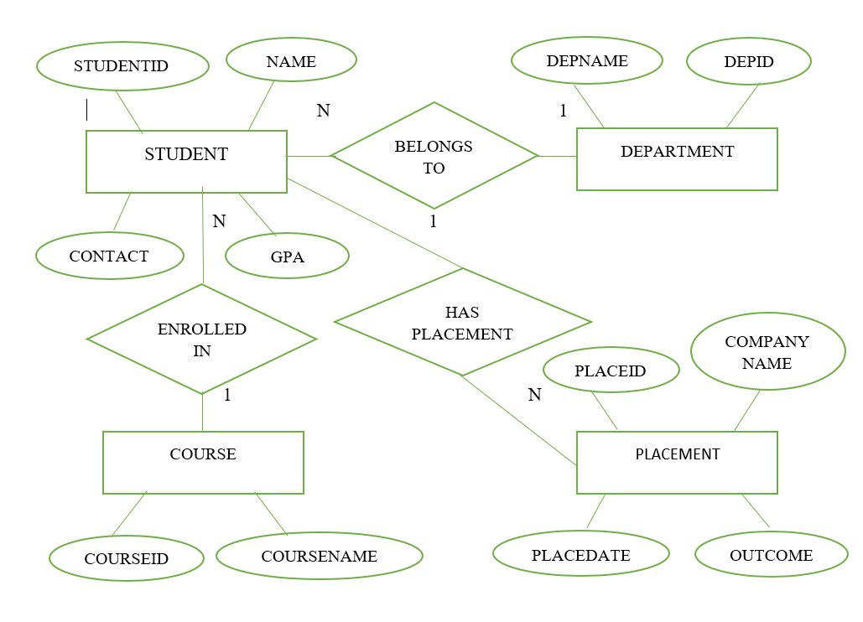A visual representation of the schema through an Entity-Relationship Diagram (ERD) elucidates the connections and dependencies between different tables. This diagram serves as a roadmap for developers and administrators, offering a clear blueprint of the database structure.

Fig 5.1 Entity Relationship Diagram (ERD)

**5.2 Schema Diagram**

The DBMS schema for the College Placement System plays a pivotal role in structuring and organizing the information related to student records. This section provides an in-depth exploration of the schema, detailing its components, relationships, and the rationale behind its design.

STUDENT

STUDENTID NAME CONTACT GPA DEPARTMENTID COURSEID

DEPARTMENT

DEPARTMENTID DEPARTMENTNAME

COURSE

COURSEID COURSENAME

PLACEMENT

PLACEMENTID STUDENTID COMPANYNAME PLACEMENTNAME OUTCOME

Fig 5.2 Schema Diagram

1. **Students Table:**

The 'Students' table serves as the cornerstone of the schema, capturing fundamental details such as student ID, name, contact information, and academic performance. This table establishes relationships with other entities, acting as a central repository for student-centric information.

1. **Courses and Departments Tables:**

To encapsulate the academic aspect, the 'Courses' and 'Departments' tables store information about the courses offered and the respective departments. These tables maintain a relational link with the 'Students' table, facilitating a comprehensive depiction of a student's academic pursuits within specific departments and courses.

1. **Placements Table:**

The 'Placements' table is pivotal in recording information about student placements. It includes details such as company name, date of placement, and the outcome of the placement process. This table establishes connections with the 'Students' table, creating a seamless integration between academic achievements and professional milestones.

1. **Normalization and Optimization:**

The schema undergoes normalization to minimize redundancy and ensure data integrity. Normalization processes, such as breaking down large tables into smaller, interconnected ones, contribute to the efficiency and maintainability of the database.

**CHAPTER 6**

**ENHANCEMENTS AND INTERACTIVE ELEMENTS**

* 1. **Intro Slider**

The College Placement System's introduction serves as a dynamic and visually engaging element designed to convey essential information in a captivating manner. This sub-section delves into the technical intricacies and design considerations that contribute to the seamless functioning and aesthetic appeal of the Dynamic Text Slider.

**6.1.1 Dynamic Text Slider**

The Dynamic Text Slider is implemented using advanced scripting techniques that facilitate smooth transitions between different text elements. JavaScript, in conjunction with HTML and CSS, is employed to create a responsive and visually appealing slider. The scripting involves dynamic content updates, allowing for the automatic transition of text, providing users with key information about the College Placement System.

**6.1.2 Content and Styling**

Content curation for the Dynamic Text Slider is a meticulous process, ensuring that each message presented is concise, informative, and strategically placed for maximum impact. The content includes essential details about the system, such as its features, benefits, and any noteworthy updates. Styling choices, including font selection, color schemes, and transition effects, are carefully considered to align with the overall visual aesthetics of the College Placement System, creating a cohesive and professional appearance.

* 1. **Clock Display**

The College Placement System enhances user experience by providing a dynamic and accurate display of the current date and time. This sub-section explores the implementation details and functionalities associated with the Real-Time Clock, highlighting its significance in keeping users informed and engaged.

**6.2.1 Real-Time Clock**

The Real-Time Clock functionality is implemented through a combination of JavaScript and server-side scripting languages, ensuring precise synchronization with the system clock. This feature dynamically updates the displayed time, reflecting the accurate current time on the user interface. The real-time clock serves both a functional and aesthetic purpose, providing users with timely information and contributing to the overall dynamic nature of the College Placement System.

**6.2.2 Displaying Date and Time**

In addition to the real-time clock, the College Placement System displays the current date alongside the time. The date is formatted in a user-friendly manner, adhering to standardized conventions and ensuring clarity. The synchronized display of date and time is not only practical but also aids users in tracking time-sensitive activities, such as submission deadlines or event schedules within the system.

* 1. **Database Connection Button**

The Database Connection Button is a pivotal element in the College Placement System, serving a dual purpose of establishing and terminating the connection between the application and the underlying database. This sub-section delves into the intricacies of its design, outlining its functionalities and the significance it holds in the overall system architecture.

**6.3.1 Purpose and Functionality**

The primary purpose of the Database Connection Button is to initiate or close the connection with the MySQL database used by the College Placement System. When the application is launched, this button enables the establishment of a secure and reliable connection, allowing seamless interaction with the database for tasks such as data retrieval, updates, and deletions. The functionality extends beyond mere initiation, as the button also facilitates the termination of the database connection when the user exits the application or upon specific user actions.

Additionally, the Database Connection Button plays a crucial role in system efficiency. When not in use, closing the database connection prevents unnecessary resource consumption, enhancing the overall performance of the application. This feature aligns with best practices in database management, promoting a secure and optimized system operation.

**6.3.2 User Interaction**

User interaction with the Database Connection Button is designed to be intuitive and user-friendly. Upon launching the College Placement System, users have the option to click the button to establish the database connection. Visual cues, such as color changes or status indicators, provide feedback to users, indicating whether the connection is active or closed. This ensures transparency and allows users to be aware of the current state of the database connection at all times.

When the user decides to exit the application, clicking the Database Connection Button for the second time effectively closes the connection before concluding the program. This thoughtful user interaction design enhances the overall usability of the College Placement System, catering to users of varying technical expertise.

**CHAPTER 7**

**IMPLEMENTATION AND RESULTS**

* 1. **Implementation Details**

The implementation of the College Placement System involves a meticulous process of translating design concepts into functional code. This section provides an in-depth overview of the implementation details, covering key aspects such as the code structure, libraries utilized, and the integration of graphical user interface (GUI) components.

**7.1.1 Code Structure and Organization**

The foundation of the College Placement System lies in its well-organized code structure. The implementation adheres to best coding practices, promoting modularity, readability, and maintainability. The code is segmented into distinct modules, each responsible for specific functionalities. The primary components, such as data entry functions, database connection, and GUI design, are encapsulated within their respective modules, fostering a clear and comprehensible codebase.

**7.1.2 Libraries and Frameworks:**

Python's rich ecosystem of libraries and frameworks plays a pivotal role in the implementation of the College Placement System. The Tkinter framework, a standard GUI toolkit for Python, is extensively employed for developing the graphical user interface. Additionally, libraries like MySQL Connector facilitate seamless interaction with the MySQL database. The implementation harnesses the power of these libraries to streamline development, enhance functionality, and ensure compatibility across various platforms.

**7.1.3 GUI Component Integration**

The graphical user interface is a critical aspect of the College Placement System, and its implementation involves the integration of various GUI components. This includes the design and placement of entry widgets for user input, buttons for triggering operations, and a Treeview widget for displaying student records. The implementation details explore the rationale behind the chosen layout, the responsive design principles applied, and the techniques employed to enhance user interaction.

**7.1.4 Error Handling and User Guidance**

A robust implementation encompasses effective error handling mechanisms and user guidance features. The code incorporates error-checking routines to anticipate and manage potential issues, providing informative messages to guide users in case of discrepancies. This ensures a smooth user experience and contributes to the overall reliability of the College Placement System.

In essence, the implementation details offer a comprehensive insight into the intricacies of transforming conceptual design into a fully functional College Placement System. From code organization to library usage and GUI integration, this section serves as a valuable resource for developers, detailing the steps taken to bring the envisioned system to life.

* 1. 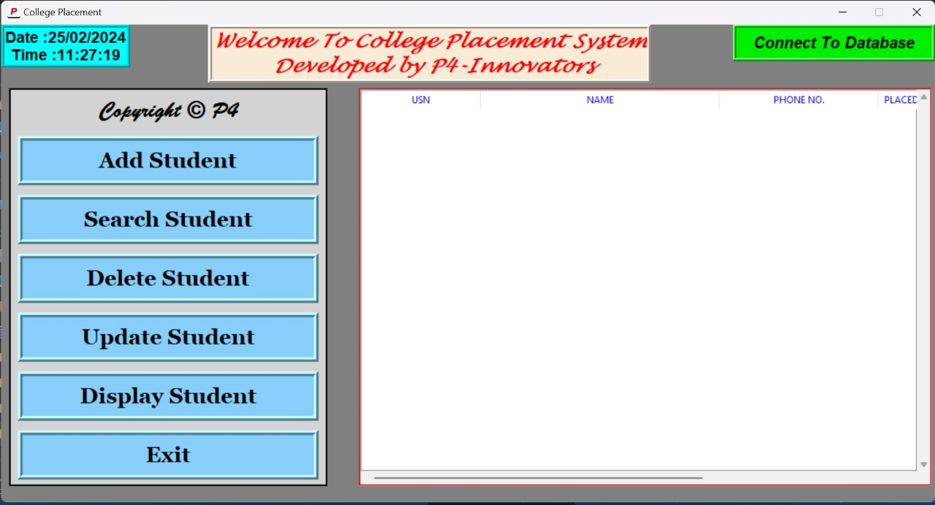**Results and Output**

Fig 7.2 Appearance of college placement system app

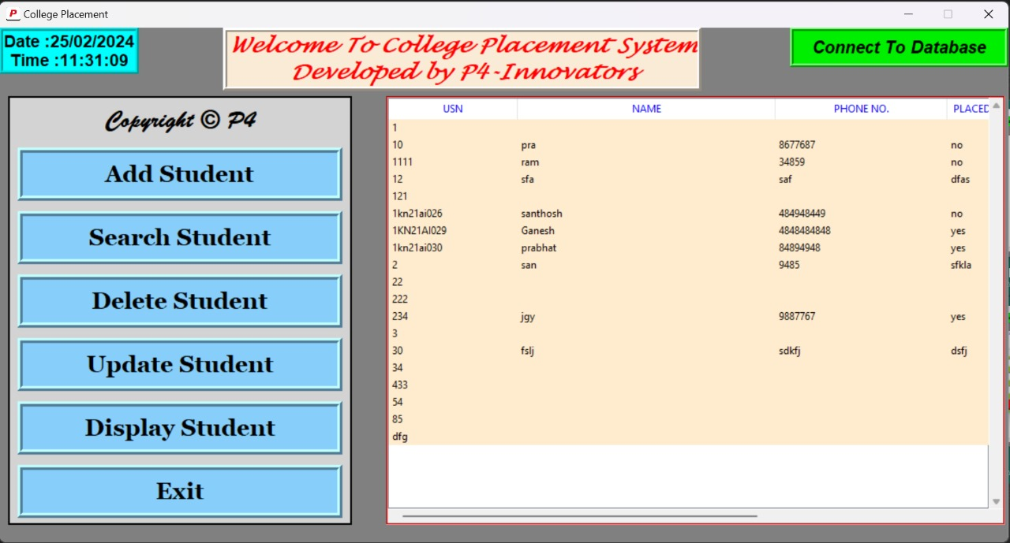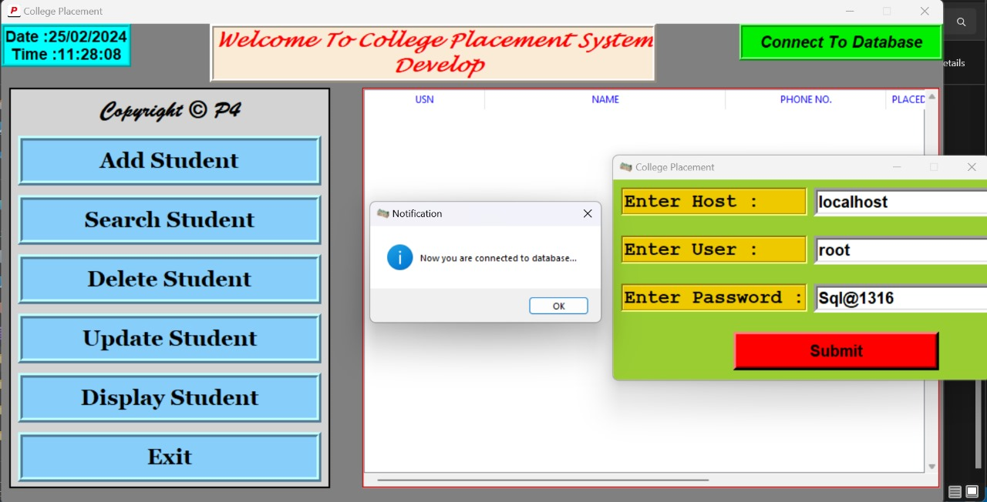Fig 7.3 Connection establishment with MySQL

Fig 7.4 Displaying of all details of database

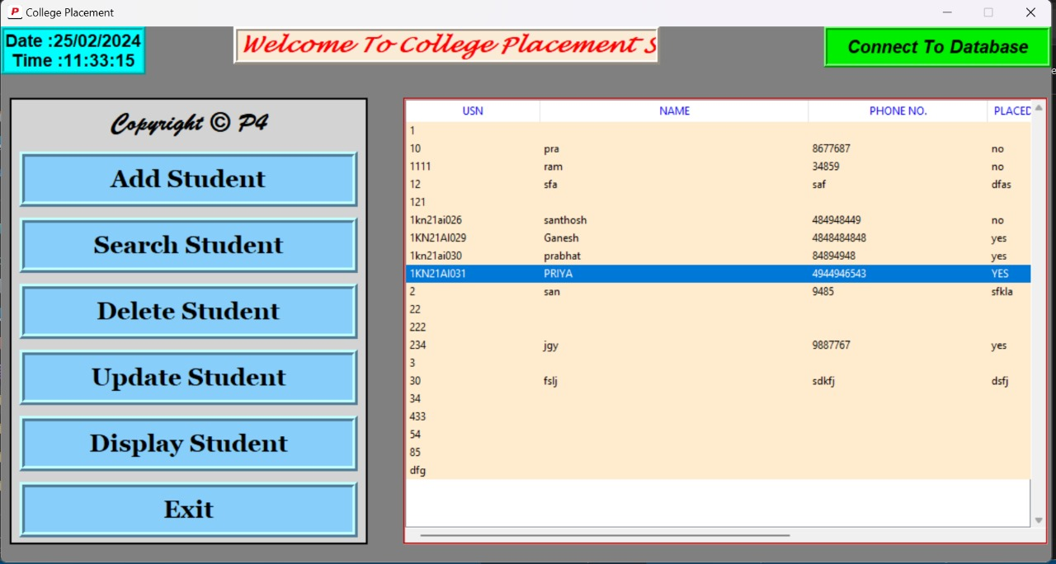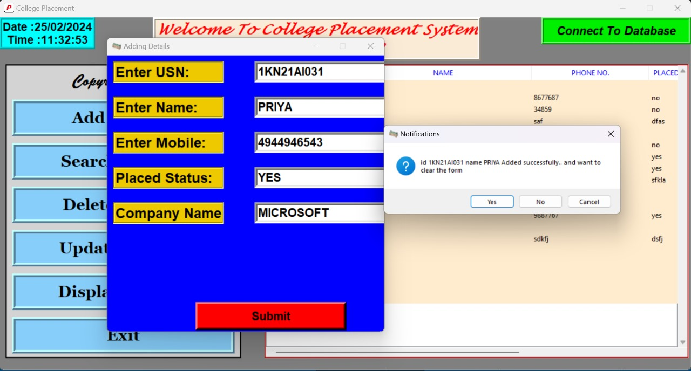 Fig 7.5 Adding student details

Fig 7.6 Student details added successfully

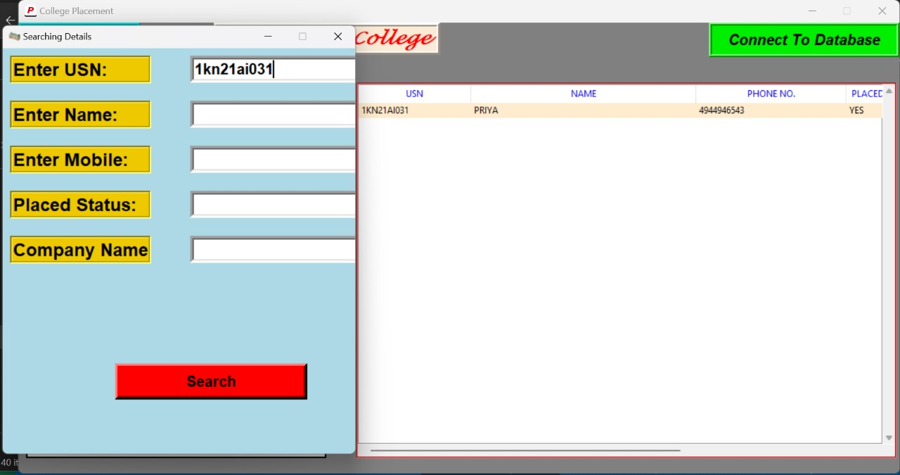

Fig 7.7 Searching of student details

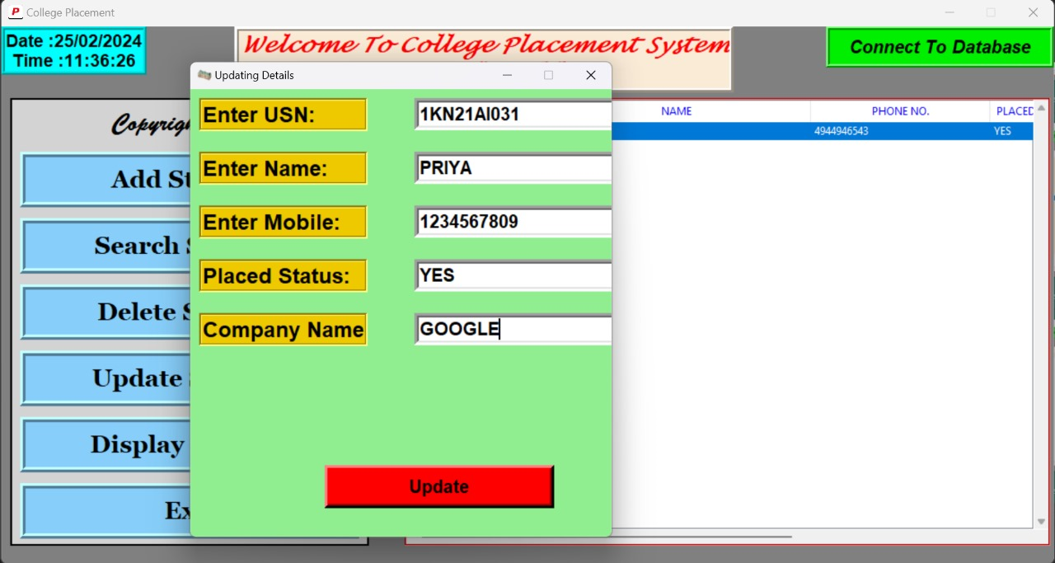

Fig 7.8 Updating of student mobile no. and company name

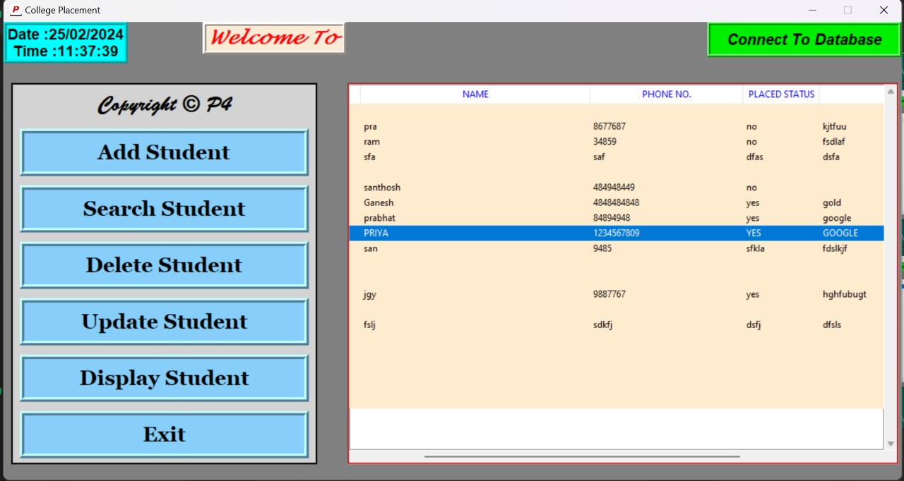

Fig 7.9 Mobile no. and company name updated successfully

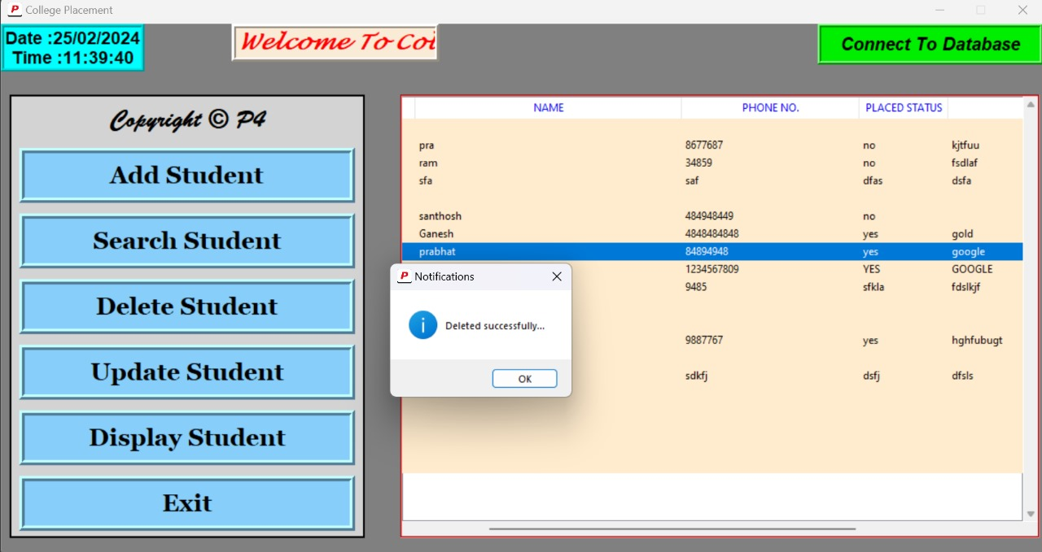

Fig 7.10 Deleting student name prabhat

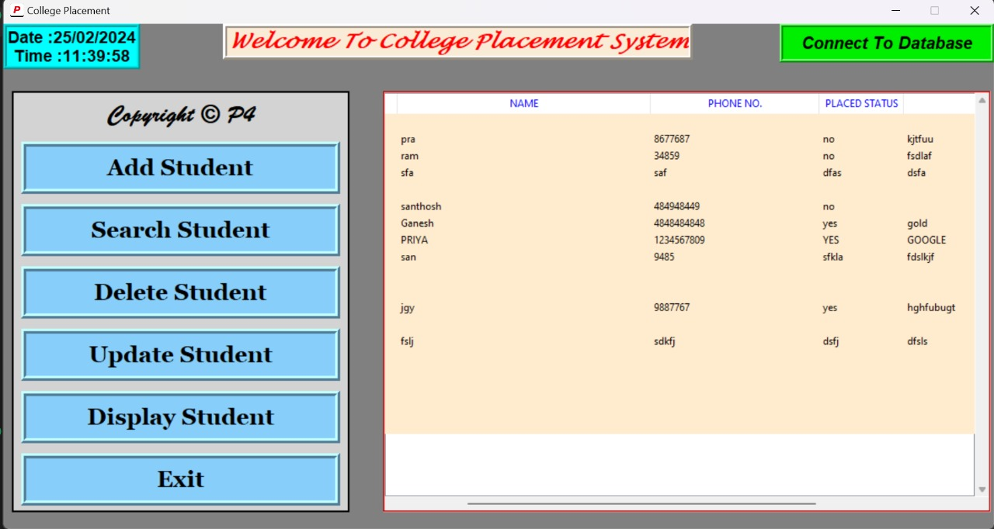

Fig 7.11 Student name Prabhat deleted successfully

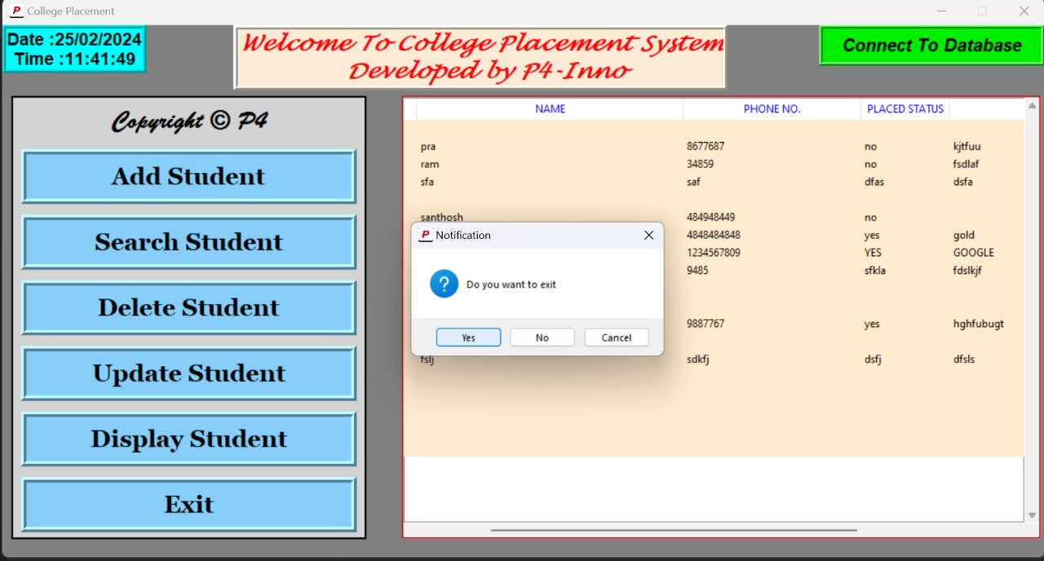Fig 7.12 Existing from the database server

**CHAPTER 8**

**ASSESSMENT**

**8.1 Code Evaluation**

In the meticulous evaluation of the codebase, a multifaceted approach is undertaken to ensure the overall quality and sustainability of the College Placement System. The modular structure is scrutinized, aiming for a design that promotes scalability and maintainability. Adherence to coding standards is emphasized, fostering code consistency and readability. Rigorous code reviews are conducted, involving a collaborative examination of the source code by multiple developers. Static analysis tools are employed to identify potential vulnerabilities and areas of improvement. Additionally, comprehensive testing methodologies, including unit testing and integration testing, are applied to validate the reliability and functionality of the code.

The assessment encompasses an in-depth examination of algorithmic efficiency, focusing on optimizing resource utilization and enhancing the overall performance of the system. Through these evaluative measures, the Code Evaluation section serves as a comprehensive guide for developers and stakeholders, pinpointing specific areas for enhancement and optimization to ensure a resilient and effective College Placement System.

**8.2 Usability Testing:**

Usability testing stands as a crucial phase in ensuring that the College Placement System aligns seamlessly with user expectations and requirements. Real-world user interactions take center stage, allowing for an authentic evaluation of the system's user-friendliness and intuitiveness. User feedback is systematically collected, providing valuable insights into the user experience and uncovering any potential pain points. The Usability Testing section not only highlights successful aspects but also addresses common usability issues that surfaced during testing.

Furthermore, this section explores potential enhancements to augment the system's accessibility and user satisfaction. It goes beyond mere functionality to prioritize the end-user experience, shaping recommendations for improvements that can positively impact user engagement and overall satisfaction with the College Placement System.

**8.3 Database Performance:**

The efficiency of the College Placement System is intricately tied to the performance of its interaction with the MySQL database. This section meticulously evaluates the various facets of database performance, ranging from query execution speed to data retrieval efficiency. Benchmarking analyses are conducted to quantitatively measure the responsiveness of database operations integrated into the system.

Through a detailed exploration of database performance, this section provides insights into the strengths and potential weaknesses of the system's data management capabilities. It serves as a guide for database administrators and developers, offering recommendations for optimizations and fine-tuning to ensure optimal performance in handling student placement records.

**CHAPTER 9**

**CONCLUSION**

This section serves as a consolidated overview, encapsulating the pivotal observations and findings resulting from the extensive implementation, assessments, and usability testing of the College Placement System. It distills the essence of the system's performance, highlighting both its strengths and identified areas for improvement. The summary provides a comprehensive understanding of how well the system aligns with its intended objectives in effectively managing student placement records**.**

In envisioning the future trajectory of the College Placement System, this subsection presents valuable recommendations for enhancing its capabilities. Delving into potential areas for improvement, additional features, and optimizations, it lays the groundwork for continued development and refinement. These recommendations provide a strategic guide for developers and stakeholders, ensuring the system remains adaptive and responsive to evolving requirements in the dynamic landscape of college placement management.

The concluding chapter reflects on the journey of developing the College Placement System, acknowledging both accomplishments and challenges overcome during the project's lifecycle. It underscores the positive impact the system can wield in streamlining and elevating college placement procedures. These final thoughts encapsulate the essence of the project, recognizing its significance and potential contributions to the realm of educational management and student placement.

**REFERENCES**

[1] <https://www.youtube.com/playlist?list=PLS4zv4KDAagNMuRjHjJKn30CZZTlHzkTV>

[2] <https://chat.openai.com/>

[3] <https://www.python.org/doc/essays/blurb/>

[4] <https://docs.python.org/3/library/tkinter.html>

[5] <https://realpython.com/python-gui-tkinter/>

[6] <https://www.geeksforgeeks.org/introduction-of-dbms-database-management-system-set-1/>