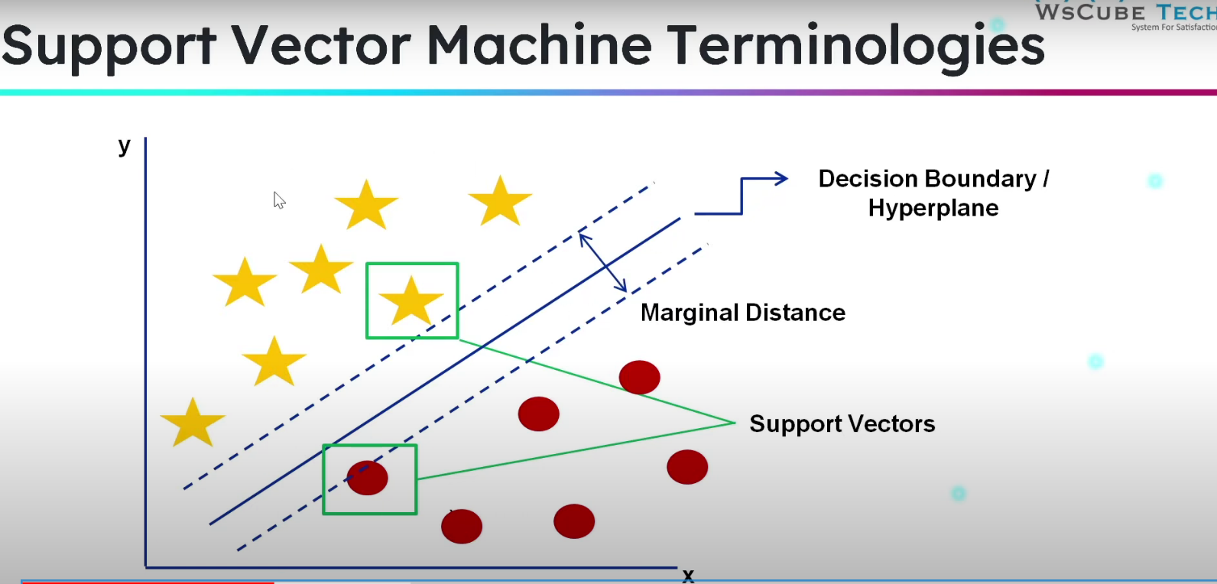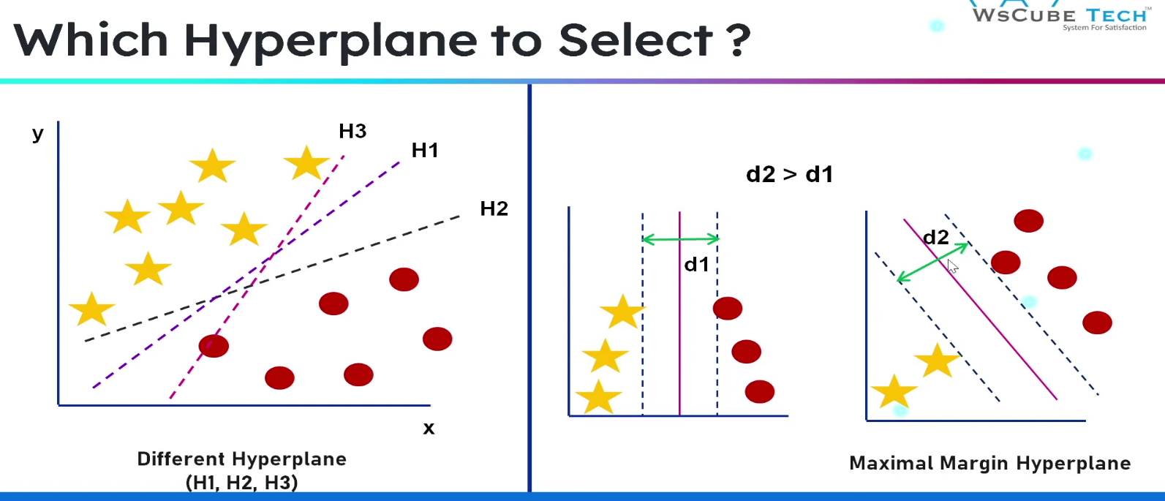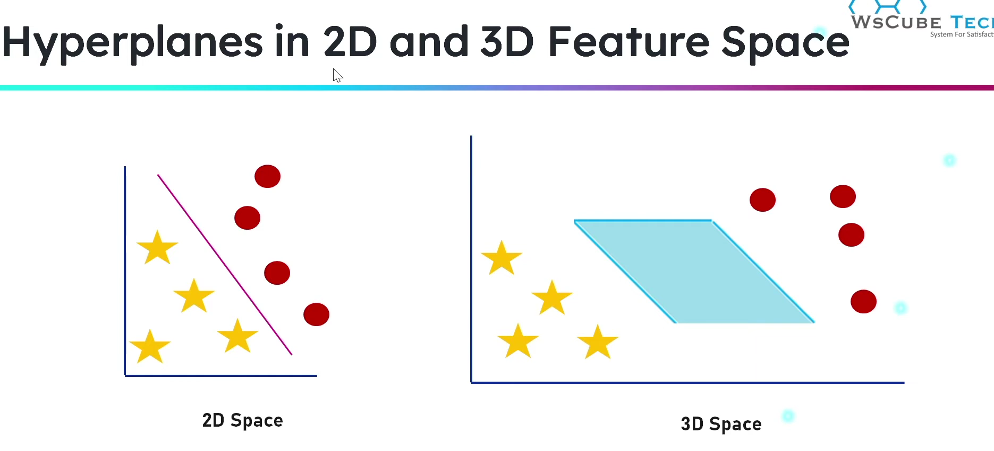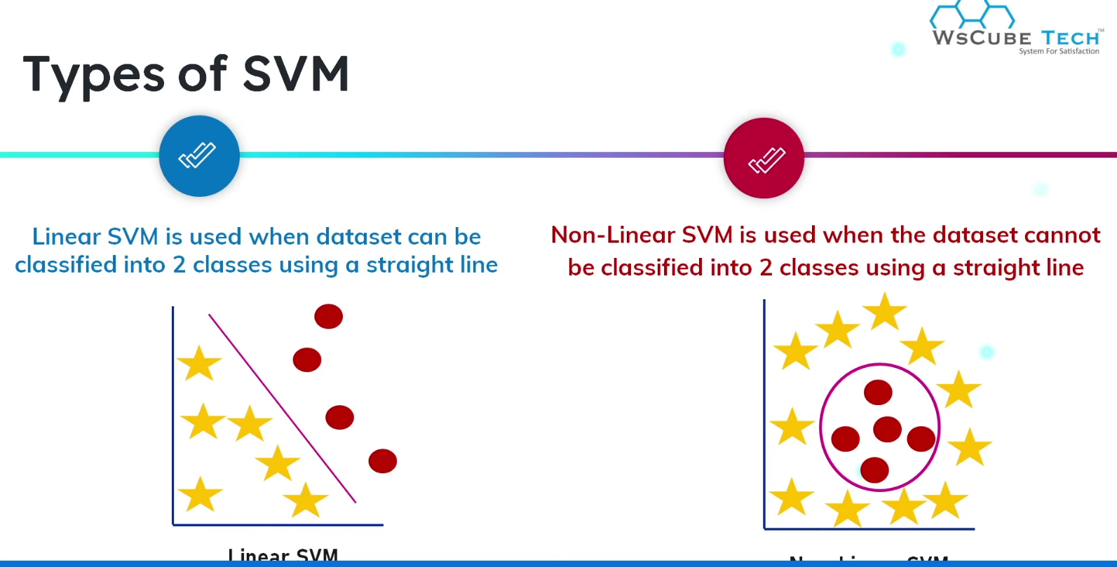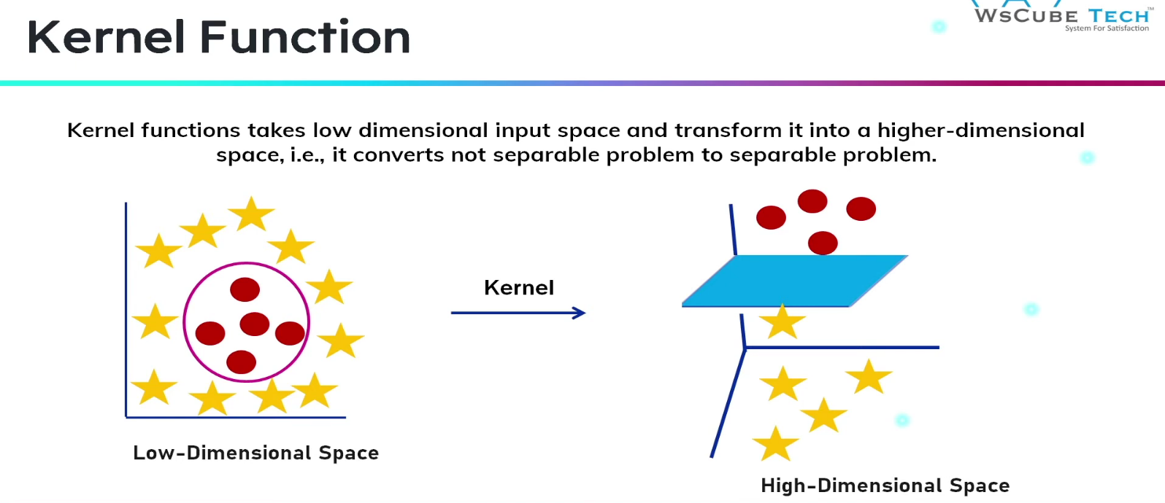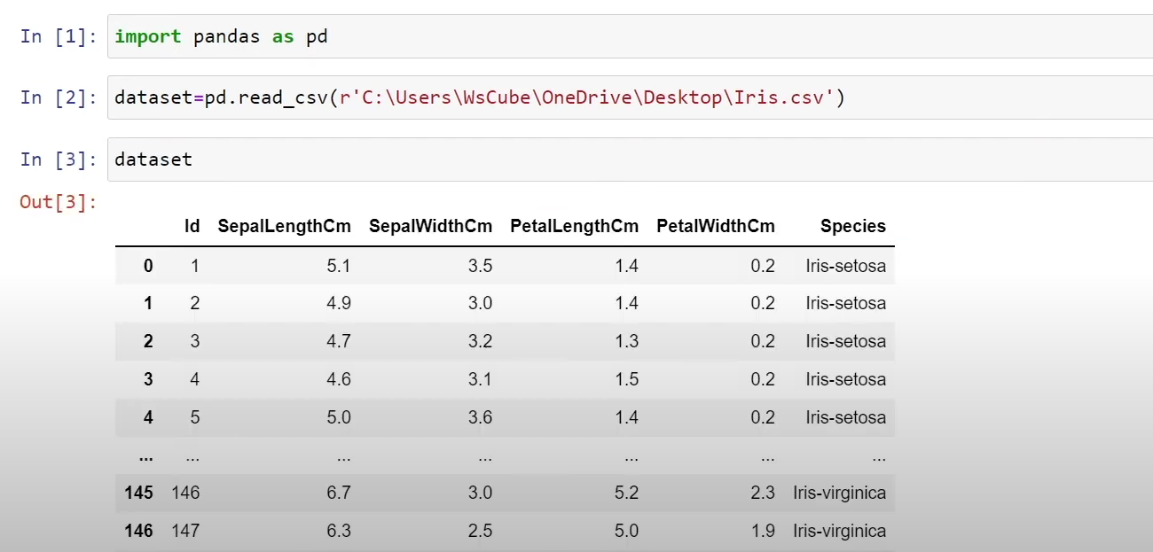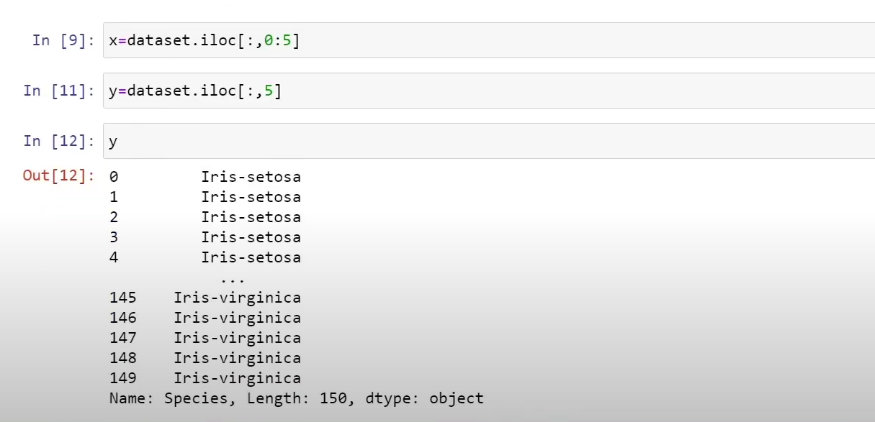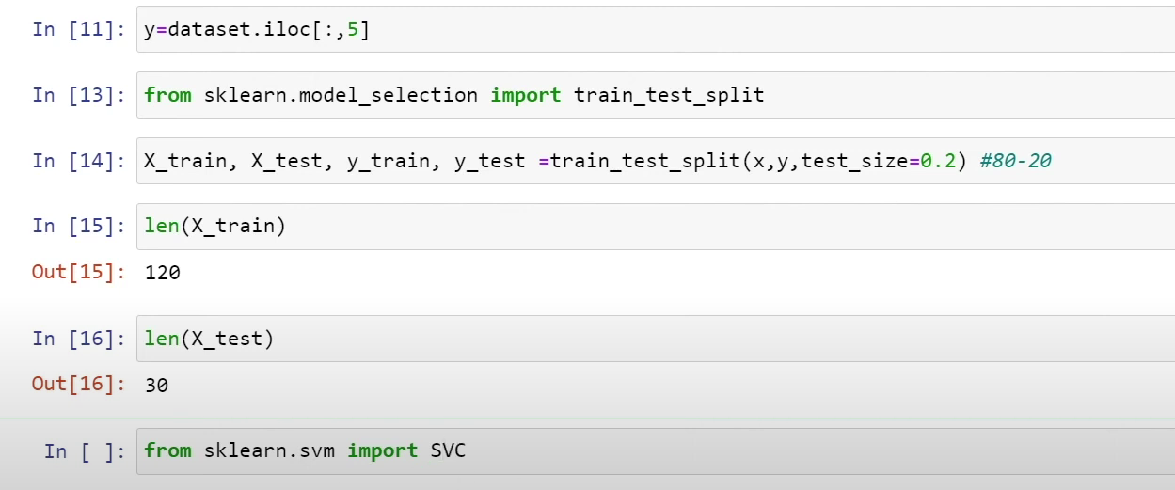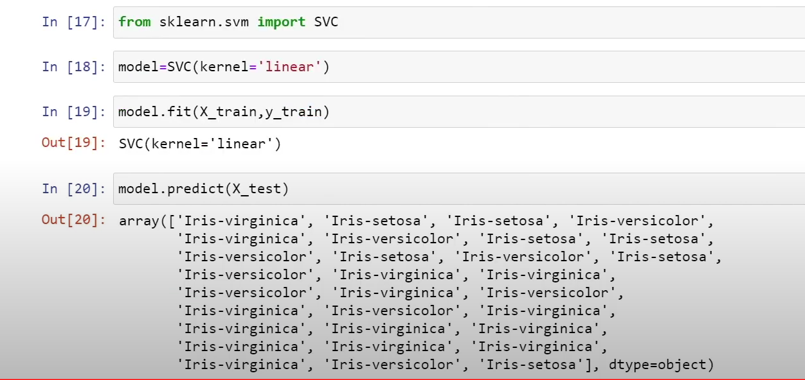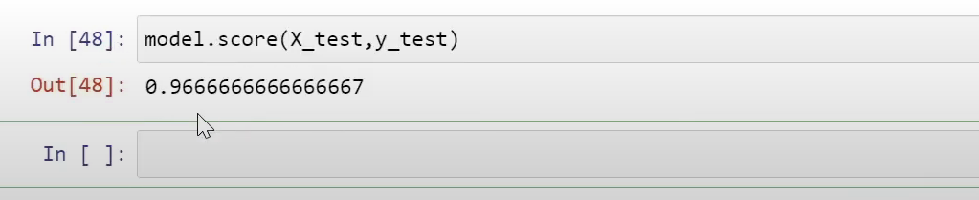

**Understanding the Kernel Parameter**

The kernel parameter defines the type of decision boundary that the SVM will use to separate the data points. Different types of kernels can model different types of decision boundaries. The main types of kernels are:

1. **Linear Kernel (kernel='linear')**:
   * The linear kernel is used when the data is linearly separable, meaning that a straight line (or hyperplane in higher dimensions) can separate the classes.
   * In this case, the SVM will find the optimal hyperplane that maximizes the margin between the classes.
   * The linear kernel is simple and computationally efficient.
2. **Polynomial Kernel (kernel='poly')**:
   * The polynomial kernel can model more complex, curved decision boundaries.
   * It is defined by the degree of the polynomial, which is a hyperparameter that you can tune.
   * For example, a degree of 2 will model quadratic decision boundaries.
3. **Radial Basis Function (RBF) Kernel (kernel='rbf')**:
   * The RBF kernel, also known as the Gaussian kernel, is very powerful and can model complex decision boundaries that are not necessarily linear or polynomial.
   * It uses a parameter called gamma, which defines the influence of a single training example. Low gamma means far influence, and high gamma means close influence.
4. **Sigmoid Kernel (kernel='sigmoid')**:
   * The sigmoid kernel is similar to the activation function in neural networks and can be used for certain types of data, though it is less common than the other kernels.

**See** *exp 10 SVM algorithm.pdf*