

**Tribhuvan University**

Institute Of Science and Technology

**A PROJECT REPORT**

ON

**“PureCart Ecommerce Website”**

Submitted to

**Department of Computer Science and Information Technology**

**Birendra Multiple Campus**

***In partial fulfillment of the requirements for the Bachelors of Science in Computer Science and Information Technology***

Submitted by

**Ankit Lamsal (Roll no:04/076)** (Registration no.: 5-2-19-106-2019) **(24850/076)**

**Anmol Lamichhane (Roll no:70/76)** (Registration no.: 5-2-19-107-2019) **(24851/076)**

**Prabhat Amgain (Roll no: 74/076)** (Registration no.: 5-2-19-130-2019) **(24876/076)**

MARCH, 2024



**Tribhuvan University**

**Institute Of Science & Technology**

**Birendra Multiple Campus**

# SUPERVISOR’S RECOMMENDATION

I hereby recommend that this project prepared under my supervision by **Ankit Lamsal, Anmol Lamichhane and Prabhat Amgain** entitled “**Ecommerce Website**” in partial fulfillment of the requirements for the degree of Bachelor of Science in Computer Science and Information Technology is recommended for the final evaluation.

**………………………….**

**Er. Binod Sharma**

**SUPERVISOR**

**Lecturer**

Central Department of Computer Science and Information Technology

Birendra Multiple Campus

Bharatpur, Nepal

Date:

# APPROVAL LETTER

This is to testify to the depth of the research done into the “**PureCart Ecommerce**” project by **Ankit Lamsal, Anmol Lamichhane and Prabhat Amgain** which was completed as a requirement for the Bachelors of Science in Computer Science and Information Technology. It is acceptable in terms of quality and scope as a project for the required degree, in our opinion.

|  |  |
| --- | --- |
| Head / Program Coordinator  ………………………………….  Er. Binod Sharma  Birendra Multiple Campus | Supervisor  ………………………………….  Er. Binod Sharma  Birendra Multiple Campus |
| Internal Examiner  ………………………………….  Er. Binod Sharma  Birendra Multiple Campus | External Examiner  …………………………………. |

# ACKNOWLEDGEMENT

This project was undertaken with the explicit consent of fulfilling a part of the requirements set forth by Tribhuvan University, which is a prerequisite for the completion of the Bachelor in Computer Science and Information Technology (B.Sc. CSIT) seventh semester.

We extend our profound gratitude to Mr. Binod Sharma for his invaluable guidance and support throughout the entire span of this project. His unwavering support and constant encouragement were pivotal in our project's success. Furthermore, we are deeply appreciative of our supervisor, Mr. Binod Sharma, for his unconditional backing and motivation. His supervision, coupled with his continuous motivation, played a crucial role in the successful execution of our project.

Our heartfelt thanks go to our project manager, Mr. Binod Sharma, for his unwavering assistance, guidance, and continuous encouragement. His willingness to dedicate time from his busy schedule for the project's review was invaluable. His consistent monitoring, despite his busy schedule, significantly contributed to the project's success.

# ABSTRACT

In today’s world, the internet has become an integral part of our lives. As the living standard improve, people’s expectations for quality and efficiency rise. This project “**PureCart Ecommerce Website**” is used for the buying and selling of different products online, which can be an efficient way for individuals in this busy life. Online stores represent a significant revolution within the business sector. The traditional store model had been disrupted by this modern method. With just a computer and internet access, customers can now browse and purchase any goods from anywhere, anytime. This not only saves time and effort but also significantly streamlines the business growth. The project is designed using React for frontend and Node for backend which works in any browsers. The coding language used is JavaScript and for CSS Tailwind is used.

Keywords: React, JavaScript, CSS, Node

**Table of Contents**

SUPERVISOR’S RECOMMENDATION I

APPROVAL LETTER II

ACKNOWLEDGEMENT III

ABSTRACT IV

LIST OF ABBREVIATION VII

LIST OF FIGURES VIII

LIST OF TABLES IX

Chapter 1: Introduction 1

1.1. Introduction 1

1.2. Problem Statement 1

1.3. Objectives 2

1.4. Scope and Limitation 2

1.5. Development Methodology 2

1.6. Report Organization 4

Chapter 2: Background Study and Literature Review 5

2.1. Background Study 5

2.2. Literature Review 10

Chapter 3: System Analysis 11

3.1. System Analysis 11

3.1.1. Requirement Analysis 11

3.1.2. Feasibility Analysis 13

3.1.3. Analysis (Structured) 14

Chapter 4: System Design 17

4.1 Design (Structured) 17

4.2 Algorithm Details 18

Chapter 5: Implementation and Testing 20

5.1. Implementation 20

5.1.1. Tools Used 20

5.1.2. Implementation Details of Modules (Description of procedures/functions) 21

5.2. Testing 21

5.2.1. Test Cases for Unit Testing 21

5.2.2. Test Cases for System Testing 22

Chapter 6: Conclusion and Future Recommendations 25

6.1. Conclusion 25

6.2. Future Recommendations 25

References 26

Appendices 27

# LIST OF ABBREVIATION

CSS Cascading Style Sheets

DFD Data Flow Diagram

ER Diagram Entity Relationship Diagram

GUI Graphical User Interface

Info Information

JS JavaScript

# LIST OF FIGURES

Fig 3.1: Use Case Diagram for E-commerce 12

Fig 3.3: Data Modeling (ER-Diagram) 15

Fig 3.4: Process Modeling Context/Level-0 DFD 15

Fig 3.5: Process Modeling Level-1 DFD 16

Fig 4.1: Architectural Design. 17

Fig 4.2: Database Schema Design 18

# LIST OF TABLES

Table 4.2.1.1: Test Cases for Unit Testing 22

Table 4.2.2.1: Test Cases for System Testing 23

# Chapter 1: Introduction

## 1.1. Introduction

E-commerce is an efficient and streamlined way of doing the business and handling the growth of it. The world of online shopping thrives on smooth digital transactions. But managing all the data behind those transactions can be a nightmare. That’s what our ecommerce platforms provides for making the task much handy.

The traditional methods of record-keeping and manual process slow business down. Platforms like our can tackle this challenge by offering a user-friendly interface that simplifies overall process. This will significantly reduce the burden associated with the paperwork, ultimately leading to increased operational efficiency.

The changing landscape of e-commerce demands a better and smarter solution for managing the online store. Our project empowers the business owner with a user-friendly interface. It offers the features like adding and editing products, cart system, editing user details, order tracking. This provides the owner with analytics of the business, which can help them to make informed decisions and flourish in the online marketplace.

## 1.2. Problem Statement

In the recent years the business market has gone through a massive success however there are some factors that can be catered for more success. Specially the offline market cannot fulfill all the requirements for the consumers. There are flaws in the time consumption and selection of the right materials, exchanging of the damaged products, maintaining the overall sales record, consumption analytics and many more. To tackle such problem, we have an e-commerce site that provides the business owners with all those features.

Moreover, the prevailing e-commerce lacks the custom user experience, that can enhance the user satisfaction and loyalty.

Some of the main problems that are prevalent in the market are:

1. Buying can be time consuming
2. Choosing the right product requires more hassle to move from shop to shop.
3. Maintaining records of sale is difficult.
4. Changing damaged products requires buyers to manually visit shop.

## 1.3. Objectives

The foremost objective of our e-commerce site is to create a seamless and satisfying user experience, positioning our platform as a go-to destination for online shopping.

1. To provide quality product photography
2. To provide fast and secure checkout
3. To create engaging content strategy
4. To perform A/B Testing for Optimization
5. To emphasize on Customer Feedback
6. To create custom shop branding

## 1.4. Scope and Limitation

Ecommerce sites in Nepal are higher in prices and are not offering a reasonable price to the consumer. The customer satisfaction and loyalty of online products are not well. To cater this problem e-commerce should be customized according to the audience.

Limitation

1. Nepali business is unmanaged in online platform.
2. Monopoly of the e-commerce platform.
3. Online fraud
4. Delivery takes time to reach consumer.

## 1.5. Development Methodology

The Agile methodology is a project management framework that emphasizes flexibility, collaboration, and customer satisfaction. It is particularly well-suited for the development of e-commerce sites due to its ability to adapt quickly to changes and deliver value to customers efficiently. Agile breaks down projects into manageable phases, allowing for continuous feedback and adjustments throughout the development process. This approach is ideal for e-commerce, where market demands and customer expectations can change rapidly.

Agile methodology also promotes collaboration among team members, encouraging daily interaction between business people and developers. This collaborative approach ensures that everyone is aligned on the project's goals and can work together to achieve them. Agile projects are built around highly motivated individuals, who are encouraged to maintain a constant pace and focus on technical quality and simplicity.

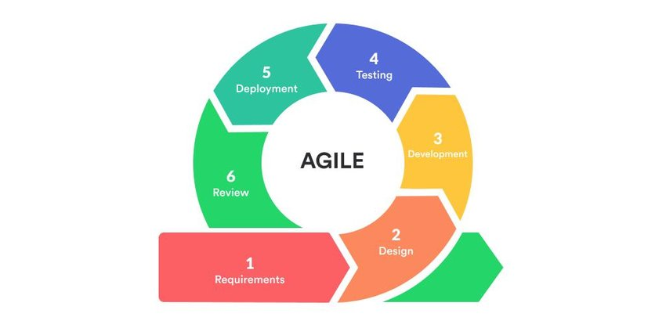

**Fig:Agile method**

In the context of e-commerce, Agile allows for the rapid development and updates of websites with new features or products, while reducing operational risks by improving code quality. Agile e-commerce practices enable digital retail companies to continuously evolve their websites and platforms to keep up with customer expectations. By combining Agile development with data-driven decision-making, e-commerce companies can respond quickly to changes in trends, markets, and consumer perceptions, ensuring they can evolve and maintain customer satisfaction even when faced with changing consumer trends.

In summary, Agile methodology is essential for e-commerce site development because it offers a flexible, collaborative, and customer-focused approach to project management. By breaking down projects into manageable phases, Agile allows for continuous feedback and adjustments, ensuring that the final product meets the evolving needs of the e-commerce market.

## 1.6. Report Organization

This project consists of five chapters. These chapters are classified to make documentation of the project more transparent. A brief description about the contents of each chapter is given in the following paragraphs:

**Chapter 1:** Introduces project, mentions statement of problem, point out objectives, development methodology and defines project scope and limitation.

**Chapter 2:**Provides the reader with an overview of the literature review or study of existing web sites and background study.

**Chapter 3:**Displays the requirements elicitation which includes (functional requirements, nonfunctional requirements). feasibility analysis. System Modelling which includes (structured approach) like Data flow diagram, Entity Relationship Diagram. System Design which also includes (structured approach) like architecture design database schema design, interface design, physical DFD.

**Chapter 4:**Describes overall system structure, database schemas.

**Chapter 5:** Defines implementation and testing.

**Chapter 6:** Displays conclusion, lesson learnt/outcome and future recommendation.

# Chapter 2: Background Study and Literature Review

## 2.1. Background Study

The internet's explosion has fueled the rise of e-commerce, with online electronics stores leading the charge. These virtual shops offer a win-win for both businesses and customers. Businesses benefit from reduced overhead costs thanks to the smaller footprint of online stores, while also offering 24/7 availability to improve service efficiency. Consumers gain access to a wealth of product information, allowing for informed choices, and enjoy the ultimate convenience of browsing and purchasing electronics from anywhere, anytime. This convenience is powered by the online store system, a central platform where customers can browse products, register, and complete their entire purchase – from selection and order submission to payment – all within a streamlined online experience.

Some of the popular e-commerce sites in Nepal are:

1. Daraz.com.np[1]

The best and most well-known ecommerce site in Nepal is Daraz Nepal. According to Daraz Nepal, it offers delivery on more than 200,000 parcels each month and gives customers access to almost 500,000 products across more than 100 categories, including food, fashion, electronics, furniture, home appliances, and other items. Alibaba Group acquired Daraz in May 2018.

Daraz is a multivendor marketplace that has more than 5,000 registered sellers. In fact, anyone may easily become a seller on Daraz and start working there.

Established: 2013

Business Model: B2C Marketplace

Website Link: <https://www.daraz.com.np/>

2. Sastodeal.com[1]

It is one of the top ecommerce platforms, with millions of users and tens of thousands of suppliers and partners nationwide. Founded in 2011, is currently among the most well-known e-commerce businesses in this market. Additionally, it recently worked with well-known Indian e-commerce websites Flipcart and Myntra.

Sastodeal gives its customers a huge selection of goods from thousands of vendors, including food, clothing, appliances, and gadgets.

With millions of satisfied consumers as of right now, it has emerged as one of Nepal’s top online shopping destinations.

Established: 2011

Business Model: B2C Marketplace

Website Link: <https://www.sastodeal.com/>

3. Thulo.com[1]

Thulo.com is another rapidly expanding e-commerce platform that provides users with a wide selection of goods. It contains thousands of items in hundreds of categories, including personal care, technology, clothing, sports and outdoors, office supplies, fashion, books, groceries, and more, much like Daraz.

This business was formerly known as Nepbay before changing its name to Thulo.

Established: 2007

Business Model: B2C Marketplace

Website Link: <https://thulo.com/>

4. Okdam.com[1]

Okdam.com is another top-notch online retailer where you may get a wide selection of goods in many categories. The purpose of OkDam, which was established in November 2017, is to become the most dependable and trusted portal in Nepal for online shopping. The website gives users a more enjoyable, easy, and speedy buying experience. For the maintenance of privacy and security, OkDam’s website incorporates secure and reliable portals.

The OkDam company, as the name suggests, thinks they are offering the most affordable pricing on all the things that are offered on their website. Customers can access anything from mobile, electronic, fashion apparel, home appliances, kitchen appliances, organic coffee, green tea items, and much more in addition to receiving high-quality goods at competitive prices.

Established: 2017

Business Model: B2C Marketplace

Website Link: <https://www.okdam.com/>

5. Gyapu.com

Gyapu is one of Nepal’s emerging online shopping platform. The best online shopping platform, GYAPU, is run by Nepali entrepreneurs with the goal of building a successful e-commerce business in Nepal and throughout South East Asia. Building the Nepali Global Brand and promoting domestic Nepali products in Nepal and around the world are the main goals of GYAPU. GYAPU promises to abolish the monopoly of intermediaries and current e-commerce industry trends. GYAPU hopes to improve Nepal’s local business community and economy as a whole while also generating job opportunities across the country.

Established: 2020

Business Model: B2C Marketplace

Website Link: <https://www.gyapu.com/>

6. Socheko.com

Socheko. com is one of Nepal’s most popular, fast, and trustworthy online retailers, offering the largest selection of 10,000+ items in 500 distinct categories. They offer goods from local, national, and even international brands. As per high internet market penetration today, many online E-commerce sites are emerging daily in Nepal. Socheko .com became another popular site in Nepal that aims to provide its customers one-stop solution for all products they need.

Established: 2018

Business Model: B2C Marketplace

Website Link: <https://www.socheko.com/>

7. Smartdoko.com

A new player in Nepal’s e-commerce market is SmartDoko. The platform is now in use and has undergone significant development. Quick delivery, a wide selection of goods, unbeatable prices, reward points, a high degree of responsiveness, consistency in marketing communication, and robust distribution networks are the strategies chosen by SmartDoko.

A reputable platform is SmartDoko, a division of IMS Group, one of Nepal’s most well-known corporate conglomerates. SmartDoko is a safe platform that makes it simple for buyers and sellers to communicate. Both buyers and sellers have the option of conducting business online. Your one-click option for doing all of your purchasing!

Established: 2017

Business Model: B2C Marketplace

Website Link: <https://smartdoko.com/>

8. Hamrobazar.com

A portal that links buyers and sellers is called Hamrobazar.com. It is extremely simple to use. Additionally, it is straightforward to explore the website thanks to the user interface.

One of the most popular shopping destinations in Nepal, it enables users to sell their goods. All you have to do is register for an account and post an advertisement for your stuff. It is the ideal answer for assisting with free product listing. Yes! There are no extra fees for listing products.

This online marketplace has established policies for buying and selling new and used things, as well as guidelines for placing ads and safety advice. The buying and selling processes at hamrobazaar.com are described individually below to make it simple for you all to grasp.

Online marketplace Hamrobazar, which was originally owned by the Saakha Group, was recently acquired by a new business.

Established: 2005

Business Model: Claassified Online Marketplace

Website Link: <https://hamrobazaar.com/>

9. Merokirana.com

One of the top online stores in Nepal for grocery shopping is Mero Kirana. It runs in Kathmandu and offers free delivery inside the city. Mero Kirana offers a variety of grocery products, including fruits, vegetables, and various vegetarian and non-vegetarian culinary items.

Established: 2017

Business Model: B2C Marketplace

Website Link: <https://merokirana.com/>

10. Meroshopping.com

For any online shopping in Kathmandu, Bhaktapur, Lalitpur, or any other significant city in Nepal, Meroshopping.com is the answer. Due to the convenience of shopping from home, meroshopping is growing in popularity.

The internet retailer wants to compete on dependability, price, and free home delivery. Customers and sellers come to the website from all of Nepal’s major cities, including Dharan, Pokhara, Butwal, Chitwan, Surkhet, Birgunj, Biratnagar, Jhapa, and Nepalgunj.

Established: 2013

Business Model: B2C Marketplace

Website Link: <https://www.meroshopping.com/>

## 2.2. Literature Review

The rise of e-commerce has dramatically transformed retail business sector. Research delves into various aspects of managing successful online stores, exploring how online shopping has shifted consumer behavior and revolutionized convenience. A key focus is creating a positive user experience. User-friendly interfaces, efficient navigation, and visually appealing designs are crucial for customer satisfaction and loyalty. Security is paramount, with scholars emphasizing secure payment gateways and encryption to build trust and protect customer information.

Mobile commerce (M-commerce) is also a growing field, with studies examining how mobile optimization impacts user engagement, sales conversions, and overall success. Social media integration plays a key role, with research analyzing how social commerce strategies like sharing, reviews, and influencer marketing influence buying decisions and brand awareness. Additionally, research explores supply chain and logistics management in e-commerce, investigating strategies like efficient inventory, order fulfillment, and last-mile delivery to meet customer expectations and stay competitive.

Big data analytics is another area of increasing interest. Researchers explore how data-driven insights on customer behavior inform personalized marketing and overall business decisions. Customer reviews and ratings are also important, as positive reviews, social proof, and online reputation management influence trust and purchasing decisions.

# Chapter 3: System Analysis

## 3.1. System Analysis

### 3.1.1. Requirement Analysis

1. **Functional Requirements**
2. User Registration and Authentication
3. Product List Management
4. Shopping Cart
5. Order Management
6. Payment Gateway Integration
7. User Account Management
8. Search and Filter Options
9. Product review and Ratings

**Use Case Diagram**

A Use Case Diagram is a visual representation that shows the interactions between a system and its environment in terms of the system's functionality. It helps in understanding and documenting the system's requirements by illustrating the system's functionalities and how it interacts with external entities. Use Case Diagrams consist of actors (entities that interact with the system), use cases (the system's functionalities), and relationships (how actors interact with the system). A use case diagram is usually simple. It does not show the detail of the use cases: It only summarizes some of the relationships between use cases, actors, and systems.

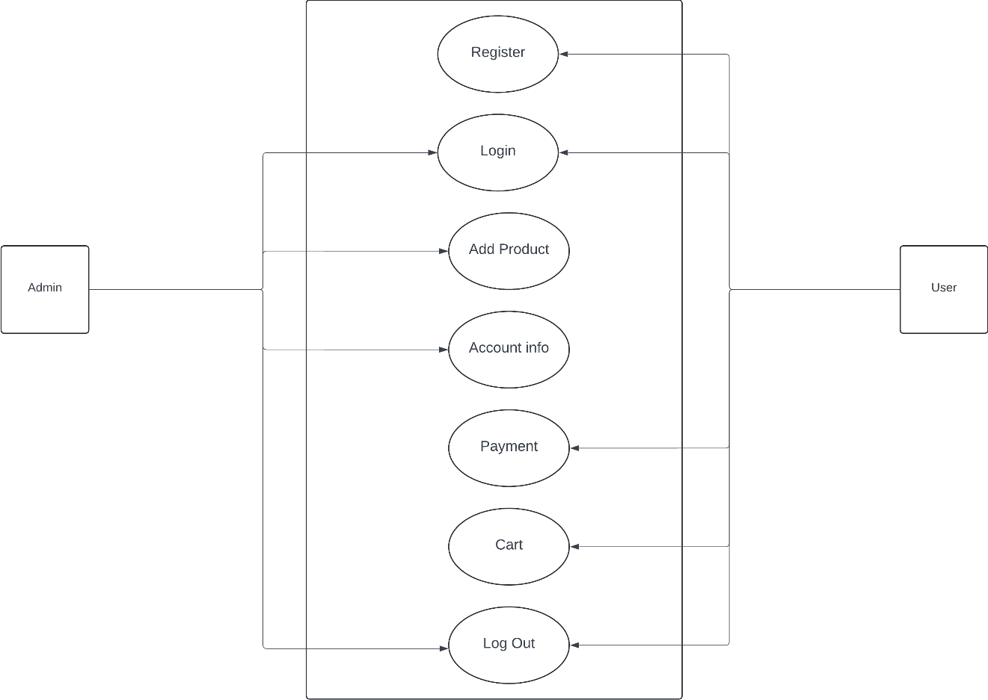

#### Fig 3.1: Use Case Diagram for E-commerce

1. **Non-Functional Requirements**
2. Performance: The system should be able to handle concurrent user requests without any delays or crashes.
3. Security: The system should ensure the confidentiality, integrity, and availability of data. The system should provide authentication and authorization mechanisms to prevent unauthorized access.
4. Reliability: The system should be reliable and available 24/7. The system should have failover mechanisms to ensure that the system is always available
5. Scalability: The system should be scalable, and it should be able to handle an increasing amount of data and users without any performance degradation.
6. Usability: The system should be easy to use, and the user interface should be intuitive and user-friendly.

### 3.1.2. Feasibility Analysis

1. **Technical:**

The system will be designed to work with existing hardware and software systems. This will be achieved by developing the system using programming languages and tools that are compatible. The system will be developed using open-source software such as HTML, CSS, JavaScript with its libraries and frameworks such as Node.js, Express.js, React.js, tailwind.css, and MongoDB, which are readily available and easy to install. Because this project is a web-based project this system will only require a minimum specs hardware and any operating system with a web browser and steady internet connection.

**Web development tool:** React, Node

**Tools used**: Visual Studio Code

**Hardware Requirement:** Normal working computer

1. **Operational:** The operational feasibility of the ecommerce site project will be evaluated based on its usability, reliability, and ease of integration with existing processes. The system will be designed to be user-friendly and easy to use. The interface will be simple and intuitive, and the system will be designed to minimize the need for extensive training.
2. **Economic:** This system can be implemented affordably. It doesn't need any extra hardware or software. There is minimal expense and the system is unquestionably economically feasible because the interface was developed using already available tools and technologies which are free to install. And, this system will be economically feasible for the organization too because it utilizes the organization's already-existing computers, technology and resources.
3. **Schedule:** The project will span a total of 10 weeks. The first 2 weeks are dedicated to study and analysis, during which the information and the project's requirements is gathered. The following 2 weeks will be used for system analysis and design. 11 The next 3 weeks will be devoted to the implementation phase of the project, where the system will be developed and integrated. After the implementation phase, 2 weeks will be spent conducting tests and ensuring that the system is functioning properly. Documentation will be done simultaneously throughout the entire project and 1 week is also allocated for it.

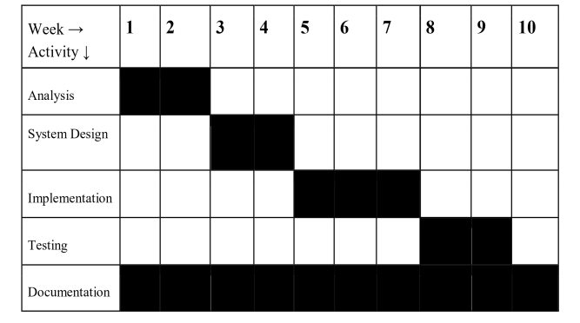

**Fig 3.2: Gantt chart for electronic E-commerce site.**

### 3.1.3. Analysis (Structured)

* **Data Modelling (ER-Diagram)**

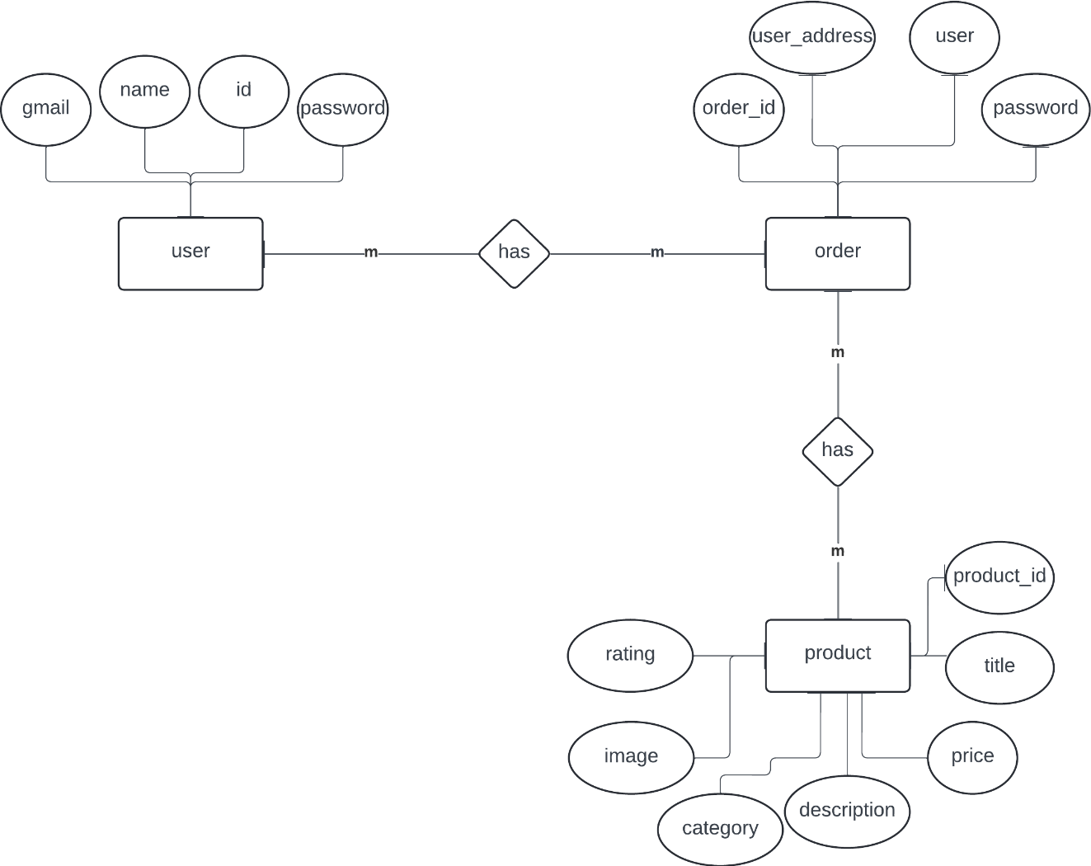

#### Fig 3.3: Data Modeling (ER-Diagram)

* **Process Modelling (DFD)**

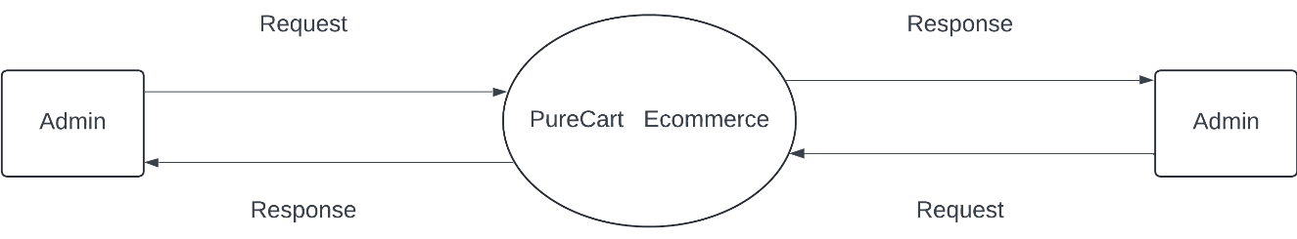

#### Fig 3.4: Process Modeling Context/Level-0 DFD

#### 

#### **Fig 3.5: Process Modeling Level-1 DFD**

# Chapter 4: System Design

## 4.1 Design (Structured)

* **Architectural Design**

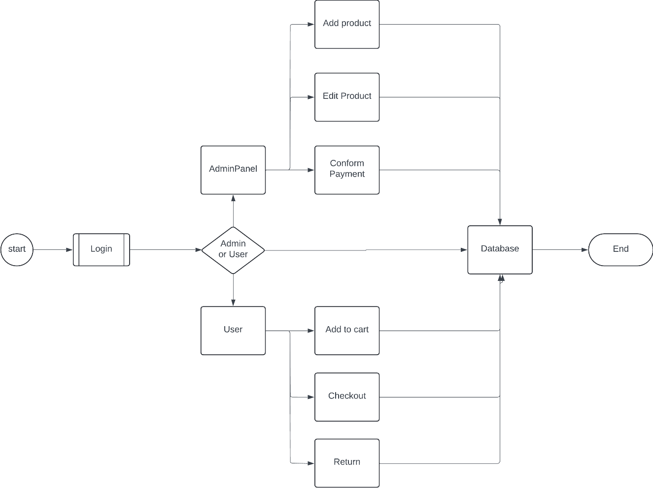

#### **Fig 4.1: Architectural Design.**

* **Database Schema Design**

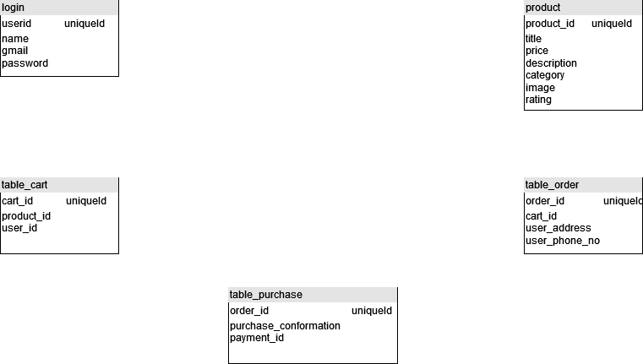

#### **Fig 4.2: Database Schema Design**

The database structure is divided mainly in 5 tables, each representing information relating to the table name respectively. When the user registers the details are saved in the login table. The product table contains the details of the product added by the admin. When the consumer adds the product, the data are saved on the table_cart. The order details from the users are saved to the

## 4.2 Algorithm Details

* **Search Algorithm:**

Implementing a modern ecommerce search algorithm is a complex task that requires a deep understanding of both the technical aspects and the user experience. A good search algorithm is composed of well-indexed data and effective search queries, which are often rare to find in ecommerce environments. Users typically search for brands or products with vague terms or adjectives, and these searches can include typos. Therefore, the algorithm must be capable of handling natural language queries, understanding semantic search, and learning from user behavior to improve search relevance over time. Additionally, it should be able to account for spelling errors, plural and singular search terms, and special characters. For ecommerce managers or merchandisers, it's crucial to have control over the search algorithm to make calculated alterations on the fly, such as boosting on-sale products or ensuring that house brands always appear first. This level of control allows for strategic manipulation of search results to meet specific objectives, leveraging human knowledge about the store, brand, and customers when necessary. [2]

# Chapter 5: Implementation and Testing

## 5.1. Implementation

### 5.1.1. Tools Used

**a) React:**

ReactJS is JavaScript library used for building reusable UI components. According to React official documentation, following is the definition −

React is a library for building composable user interfaces. It encourages the creation of reusable UI components, which present data that changes over time. Lots of people use React as the V in MVC. React abstracts away the DOM from you, offering a simpler programming model and better performance. React can also render on the server using Node, and it can power native apps using React Native. React implements one-way reactive data flow, which reduces the boilerplate and is easier to reason about than traditional data binding.[3]

**b) HTML:**

HTML, or Hypertext Markup Language, is a markup language for the web that defines the structure of web pages.

It is one of the most basic building blocks of every website, so it's crucial to learn if you want to have a career in web development.[4]

**c) CSS:**

CSS stands for cascading style sheets used in designing the web elements.

**d) Visual studio code:**

Visual Studio Code, also commonly referred to as VS Code, is a source-code editor made by Microsoft with the Electron Framework, for Windows, Linux and macOS. Features include support for debugging, syntax highlighting, intelligent code completion, snippets, code refactoring, and embedded Git.

**e) Node**

Node.js is an open-source, cross-platform JavaScript runtime environment that enables developers to execute JavaScript code outside of a web browser. It runs on the V8 JavaScript engine, which is the core of Google Chrome, allowing it to perform JavaScript operations efficiently. Node.js operates in a single process, utilizing asynchronous I/O operations to handle thousands of concurrent connections without the need for thread management, which simplifies the development of scalable network applications. This environment supports the creation of web servers and networking tools using JavaScript, making it a versatile tool for building both front-end and back-end applications. Node.js's event-driven architecture and non-blocking I/O model are designed to optimize throughput and scalability in web applications, making it particularly suitable for real-time applications and data-intensive tasks. Its widespread adoption and support across various platforms, including Windows, Linux, Unix, and macOS, further enhance its utility in the development community.[5][6]

### 5.1.2. Implementation Details of Modules (Description of procedures/functions)

1. **Registration**

Customers can register their account and continue to the shopping.

1. **Admin**

Admin can add the products, maintain the product details and make the conformation of the payment.

1. **Shopping Cart**

When the customer enter through the login system, they can use the cart system for the products. The cart system calculate the total cost for the consumer to pay.

1. **Payment**

The consumers are able to make the payments in COD or through the Khalti. The COD allows consumer to pay when the product reach the required location.

## 5.2. Testing

### 5.2.1. Test Cases for Unit Testing

Table 4.1: Test Cases for Unit Testing

|  |  |  |  |  |  |
| --- | --- | --- | --- | --- | --- |
| **Test case** | **Preconditions** | **Steps to be Executed** | **Expected Results** | **Actual Results** | **Pass/Fail** |
| Login for User | The user account should be registered | Trying to login with invalid email | Invalid Credentials | Invalid Credentials | Pass |
| Login for User | The user account should be registered | Enter username and password Click Login | User must successfully login to the profile | Login Successful | Pass |
| Register User | For registering account for user | Enter name, email address, and password  Click on Register | Account must be created. | user registered successfully | Pass |

### 5.2.2. Test Cases for System Testing

System Testing (ST) is a black box testing technique performed to evaluate the complete system's compliance against specified requirements. In System testing, the functionalities of the system are tested from an end-to-end perspective. System testing is the testing to ensure that by putting the software in different environments (e.g. Browsers) it still works.

Table 4.2: Test Cases for System Testing

|  |  |  |  |  |  |
| --- | --- | --- | --- | --- | --- |
| **Test case** | **Preconditions** | **Steps to be Executed** | **Expected Results** | **Actual Results** | **Pass/Fail** |
| View full details of Product | Both user or admin can view | Navigate to Product page and click on the product | Get the details of the Product | Successfully getting details of product | Pass |
| Adding to cart | The user should Login first | Navigate to Product detail page and click on the add to cart button | Product added to cart | Product successfully added to cart. | Pass |
| Ordering Product | User must login | Navigate to Cart page and click on checkout button and fill all the required details and press place order to order | Product ordered | Ordered successfully | Pass |
| Adding Product | Admin must login | Navigate to AdminPanel page and fill all the information and click on the button ‘Add Product’ | Product must be added | Product added successfully | Pass |

# Chapter 6: Conclusion and Future Recommendations

## 6.1. Conclusion

Online shopping websites have completely changed how businesses sell and people buy things. With fancy technology and user-friendly designs, these platforms allow businesses to sell to anyone anywhere in the world, reaching more customers. This benefits both sellers and shoppers. In the future, it's important for these websites to focus on security, making things personal for each user, and coming up with new ideas to stay on top. By keeping customers' information safe, understanding what each customer wants, and always improving how users experience the website, online shopping sites will continue to be essential parts of modern business, affecting how we shop and buy things online in the future.

## 6.2. Future Recommendations

The technology today is growing at a rapid pace which always bring the positive and negative impacts. Changes to the system in such environment are inevitable. The needs and the luxury of the customers are always demanding the replacement. We will definitely rectify our project according to the requirement of the consumers and the market. Some of the future thoughts regarding are:

1. Personalization of the products and offering contents relevant to the users.
2. Embrace upcoming technologies to enhance the application features.
3. Royalty programs for the long-term customers.
4. Engaging the audience to make a community around the platform and attract more customers.

# References

[1] A. A. Baral, “Top 10 e-commerce sites in Nepal: 2023,” Incoffeed, https://incoffeed.com/e-commerce-sites-in-nepal/ (accessed Feb. 20, 2024).

[2] A. Reelsen, “Implementing a modern e-commerce search,” Spinscale, https://spinscale.de/posts/2020-06-22-implementing-a-modern-ecommerce-search.html (accessed Mar. 11, 2024).

[3] T. Rascia, “React tutorial: An overview and walkthrough,” Tania Rascia RSS, https://www.taniarascia.com/getting-started-with-react/ (accessed Mar. 7, 2024).

[4] C. Kolade “What is HTML-Definition and Meaning of Hypertext Markup Language,” Freecodecamp,https://www.freecodecamp.org/news/what-is-html-definition-and-meaning/ (accessed Mar. 04, 2024)

[5] B. Semah, “What exactly is node.js? explained for beginners,” freeCodeCamp.org, https://www.freecodecamp.org/news/what-is-node-js/ (accessed Mar. 10, 2024).

[6] A. Heddings, “What is node.js and what is it used for?,” How, https://www.howtogeek.com/devops/what-is-node-js-and-what-is-it-used-for/ (accessed Mar. 10, 2024).

# Appendices

**Home:**

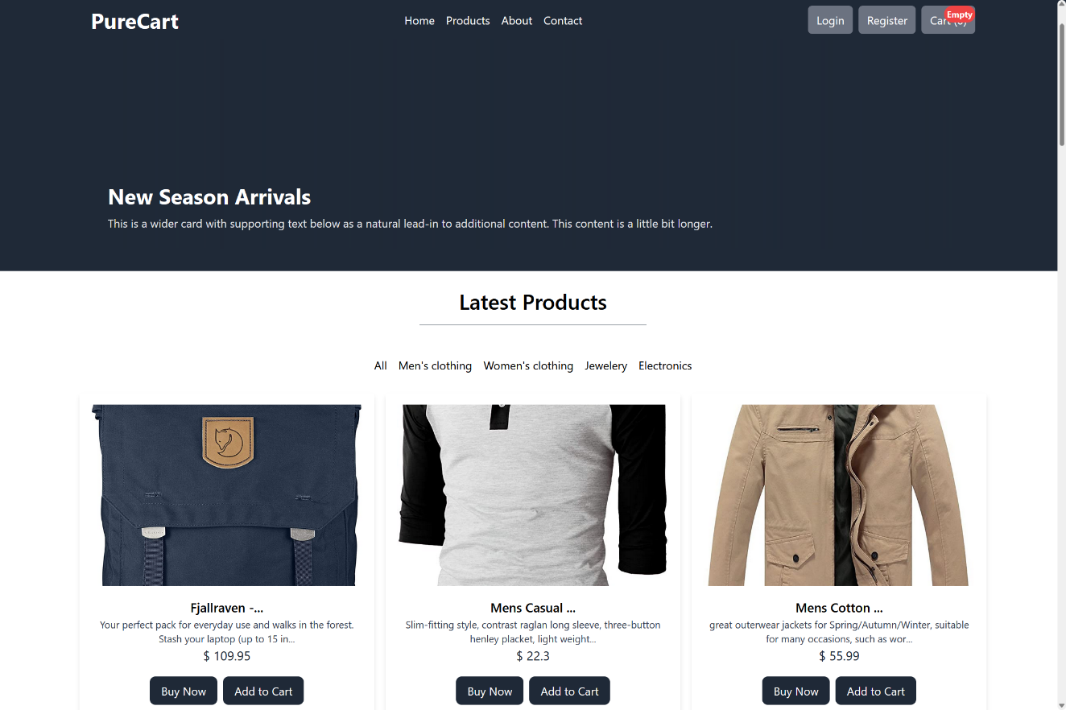

**Product:**

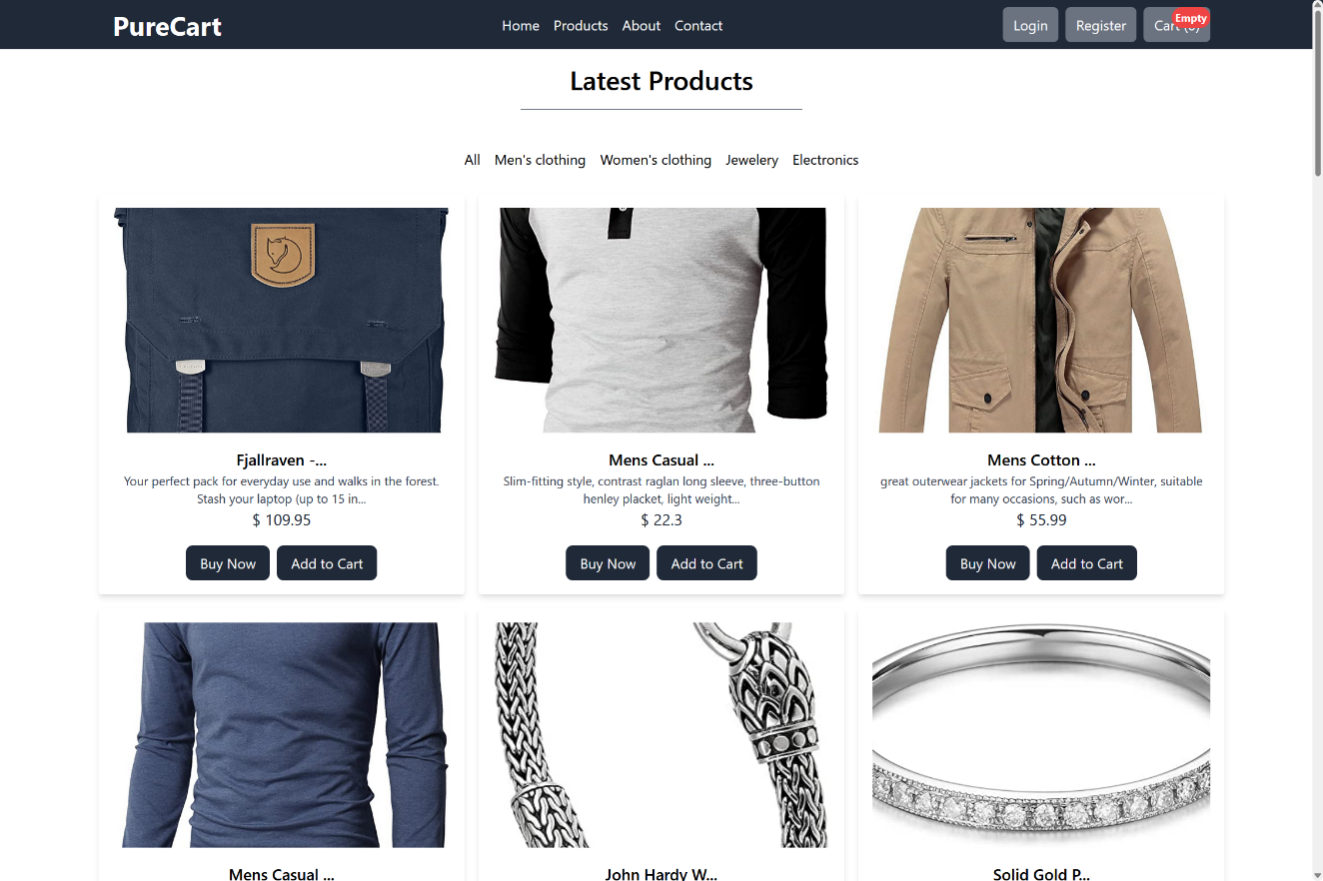

**About:** 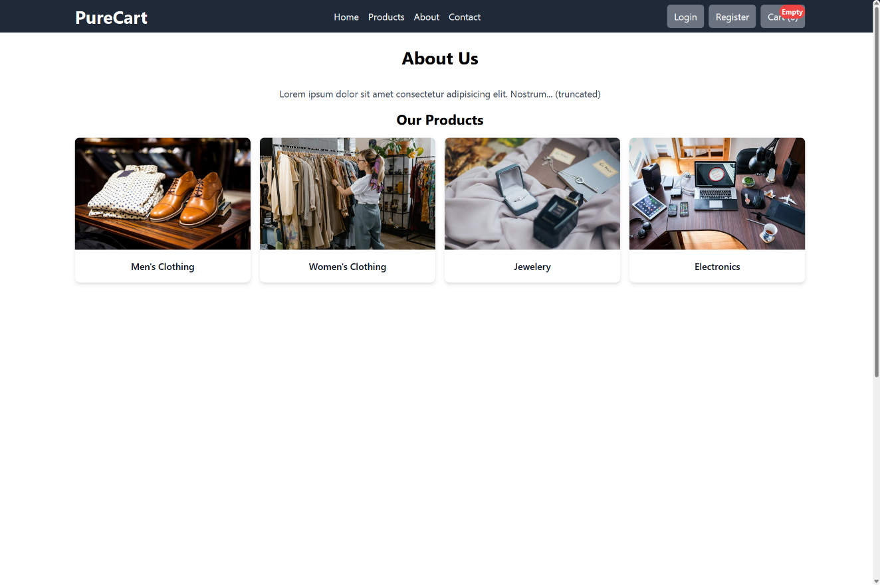

**Contact Us:** 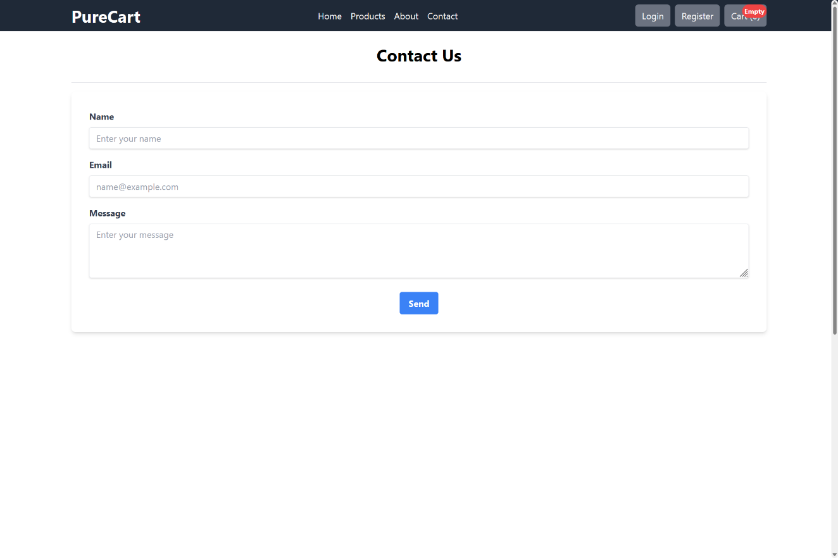

**Register:** 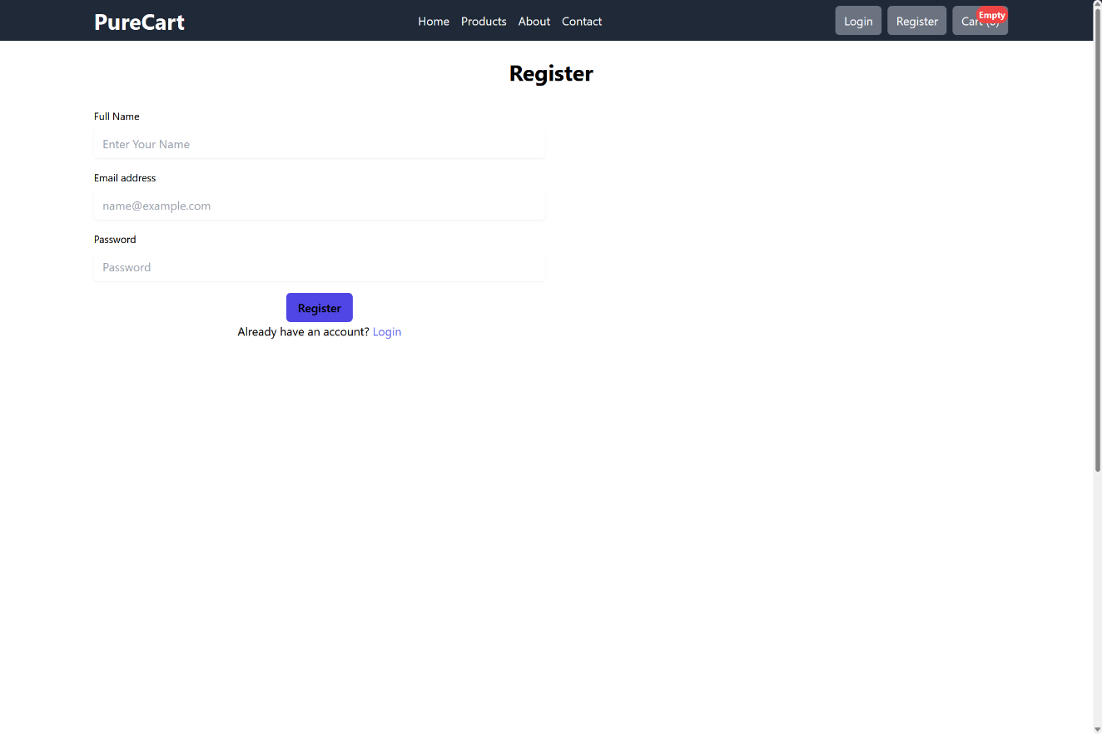

**Login:**

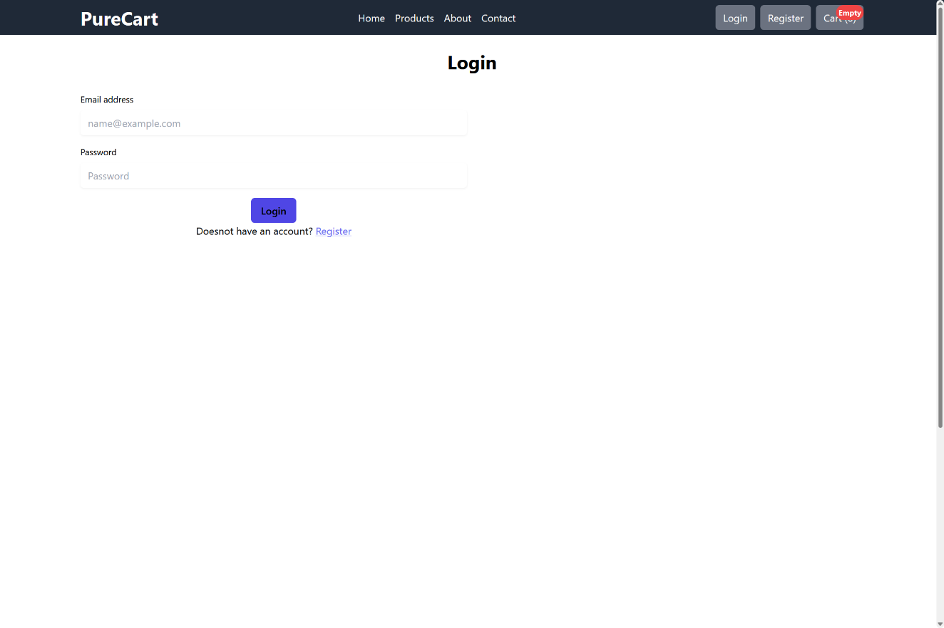

**Empty Cart:**

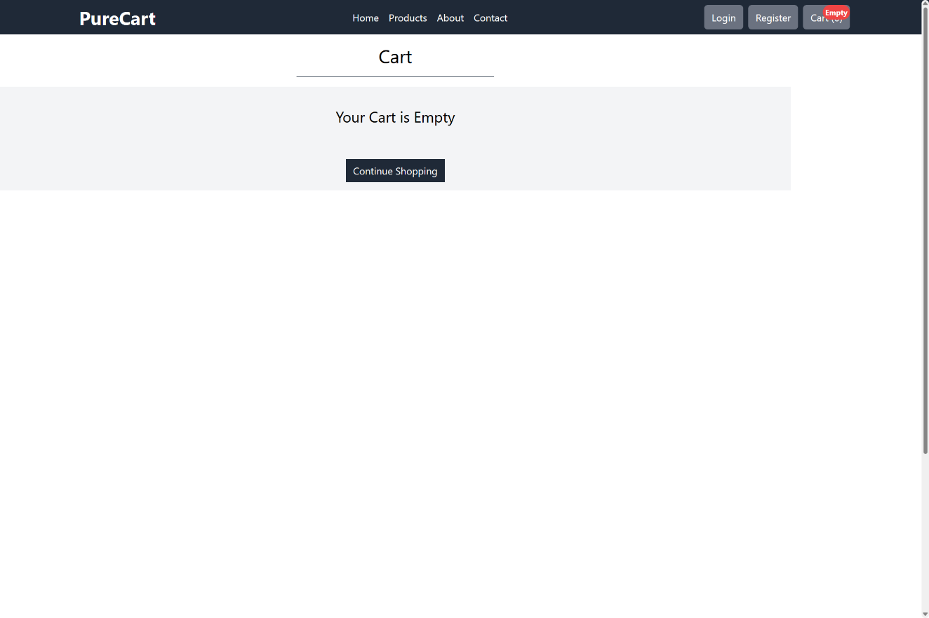

**Cart:**

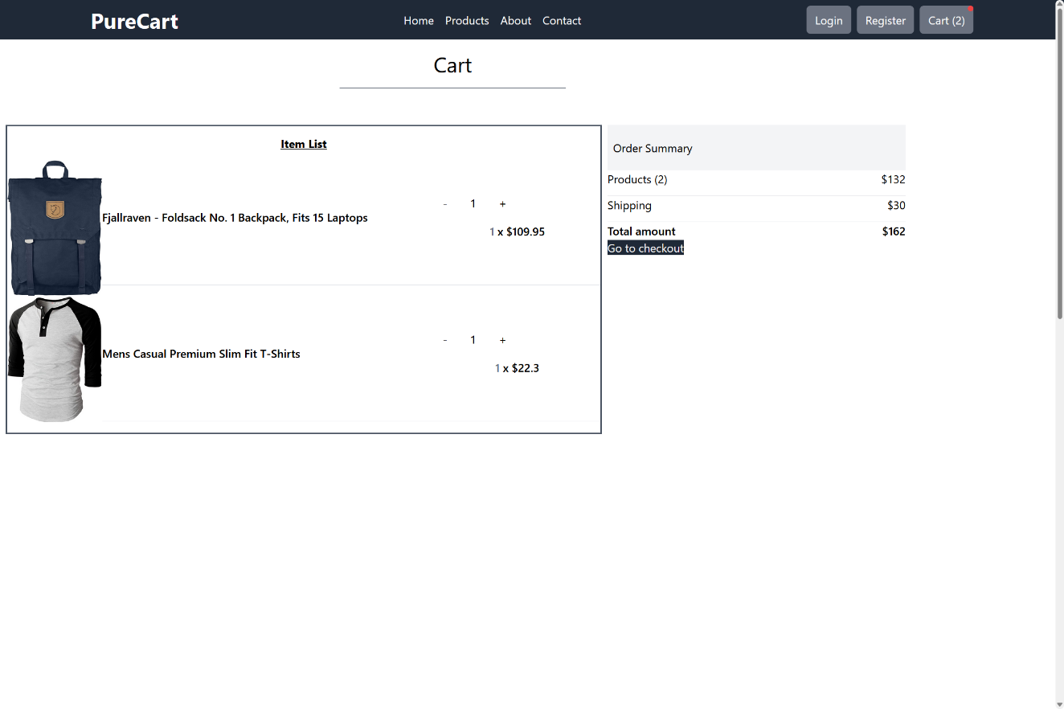

**Payment:**

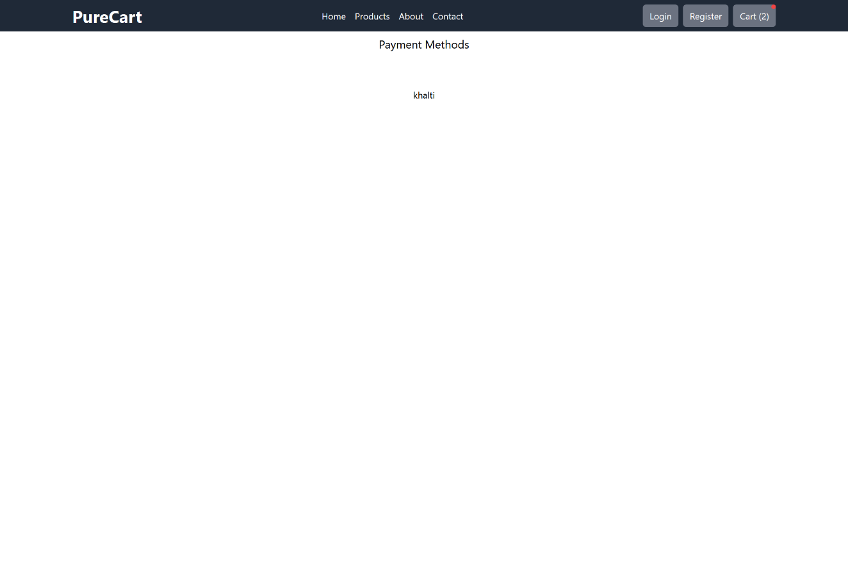

**Summary:**

