Creating Build Definition and Instance

We need builds to let TFS know the shared drive to pick the dll to execute the test cases from TFS. This document describes the procedure to create a new build definition and Instance

# Creating Build Definition:

* Navigate to the “Team Explorer” in the right pane
* Click on the “Home Icon” -  in the Team Explorer to see the list of features
* Click on Builds

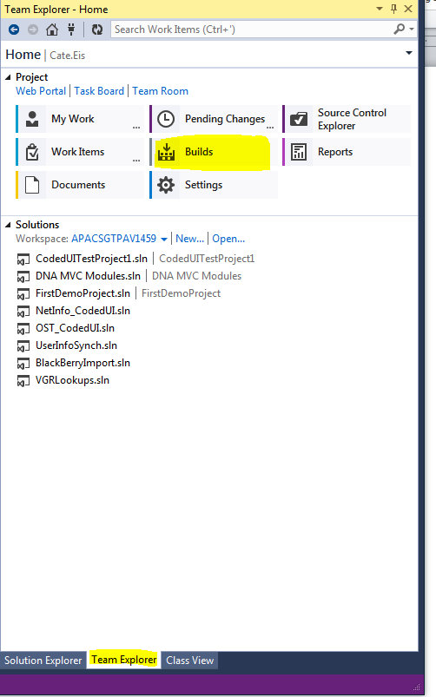

* Click on “New Build Definition” to create new build definition

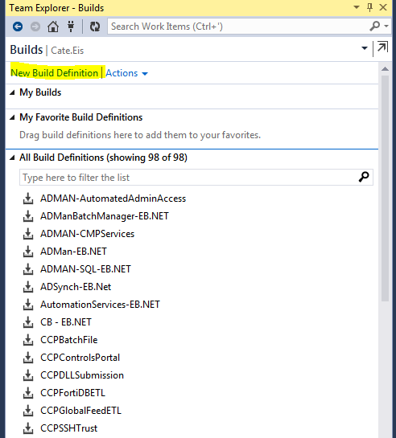

* In the “General” tab, Provide the Name for the build Definition and select the Queue Processing type as “ Disabled” to avoid queuing the build

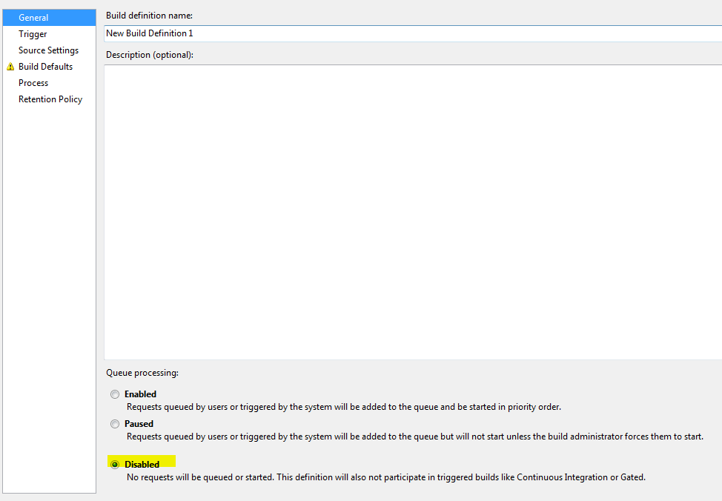

* Click on the “Trigger” tab, and select the triggering type as “Manual” to avoid triggering a new build after each check-in to the solution in the server

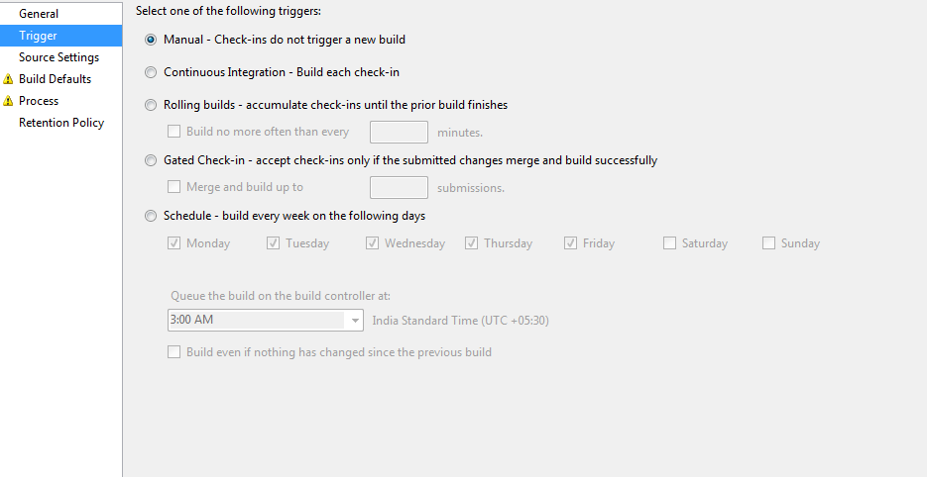

* Click on the “Source Settings” tab and provide the “Path to the Solution folder.

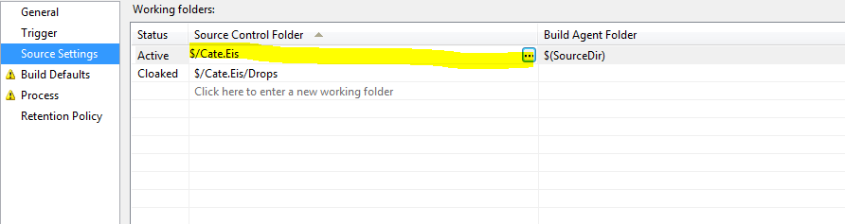

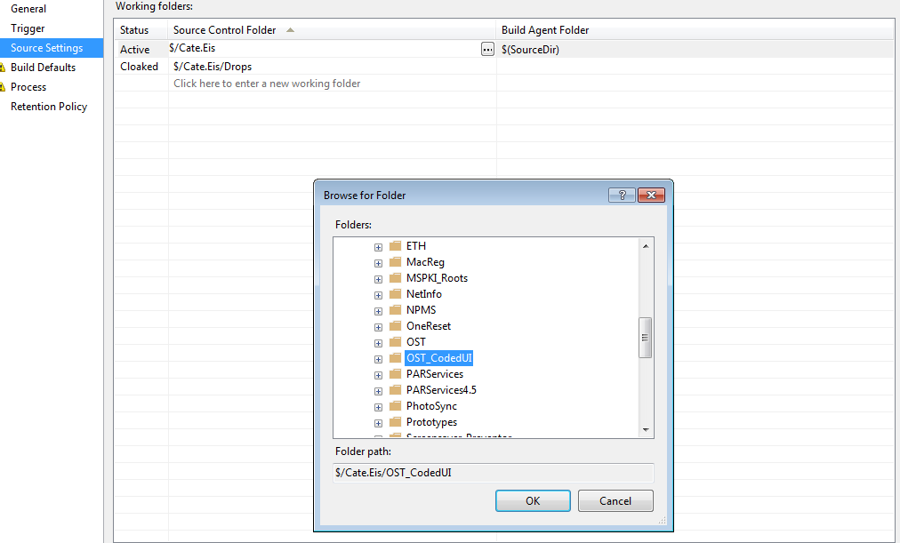

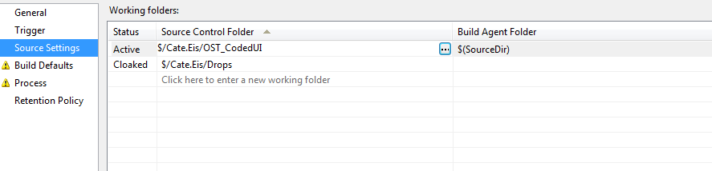

* Navigate to the “Build Defaults” tab and choose the Dev Controller and the Shared path details where the solution is been built in the shared path

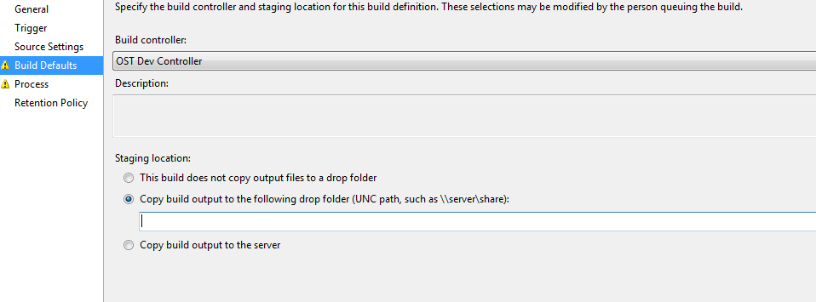

* Click on the “Process” tab, and provide the path to the Solution

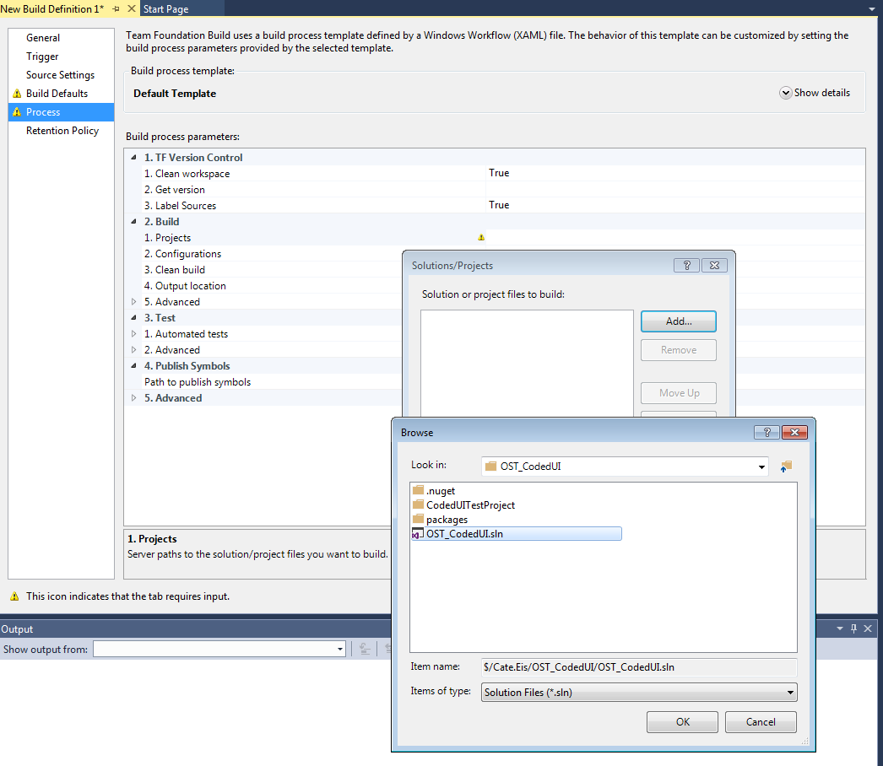

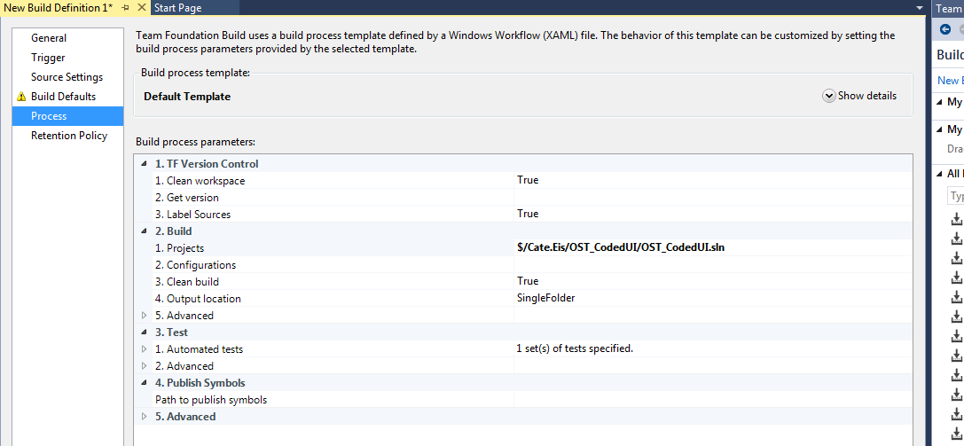

Once all details are filled in, Save the Build definition

# Creating build instance

TFsCreateBuild.exe needs to be downloaded from online.

**Creating build Instance after creating build definition:**

It is done with a command line like this:

**TfsCreateBuild.exe /collection:http://tfs.wlb2.eur.nsroot.net:8080/tfs/saturn /project:SolutionsDevelopment.UserOnOffBoarding /builddefinition:"CodedUI_for_EmployeeLifeCycle_DEV" /buildnumber:"CodedUI_TestRun_Build_DEV_2.0"**

**NOTE:** That executable is available for download from Microsoft website somewhere.

There is no way to delete Builds so need to be careful with everything.

**Output:**

TfsCreateBuild Command Line Utility, Version 12.15.210.1

(C) 2015 Neno Loje. All rights reserved.

Creates a build entry in Team Foundation Server without running it.

Passed in parameters:

  collection      : <http://tfs.wlb2.eur.nsroot.net:8080/tfs/saturn>

  project         : SolutionsDevelopment.UserOnOffBoarding

  builddefinition : CodedUI_for_EmployeeLifeCycle_DEV

  buildnumber     : CodedUI_TestRun_Build_DEV_2.0

Using TFS Object Model version: 2013 Update 4 (2013.4)

Connecting to server... done

Creating build... done

Build "CodedUI_TestRun_Build_DEV_2.0" was created. Time elapsed: 00:00:01.347789

4.

Thank you for using TfsCreateBuild.exe