Visualisation

Appropriate graphs for the RQ
The primary visualisation that is employed is a scatterplot because it distinctly demonstrates the correlation between two continuous variables carat and price which justifies correlation analysis. It includes a histogram of carat to show the distribution of independent variable and also check normality. The two images have been created using the R scripts using informative English labels and titles.
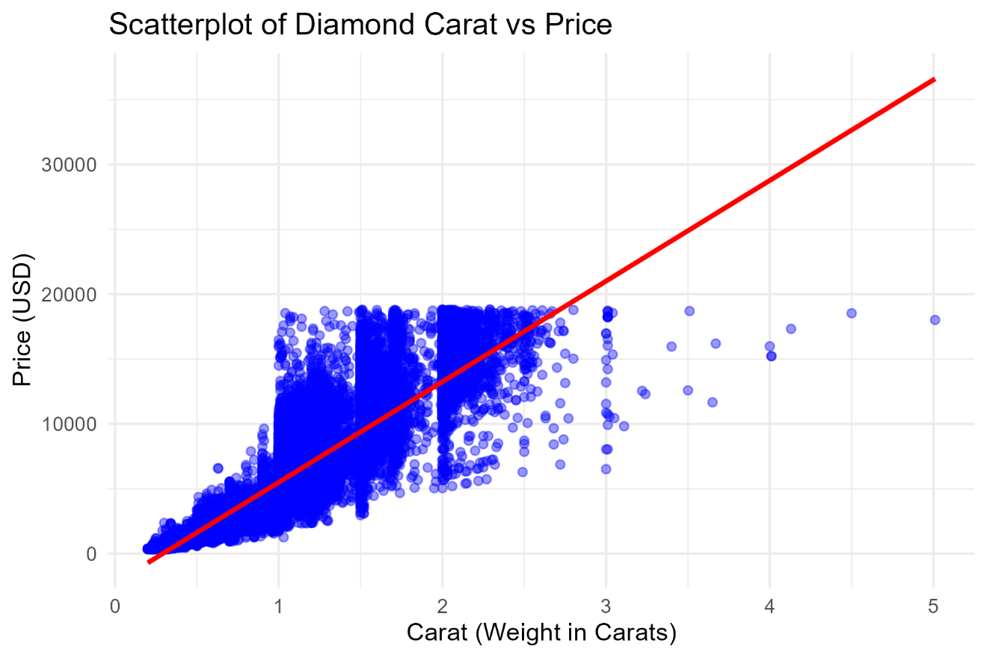
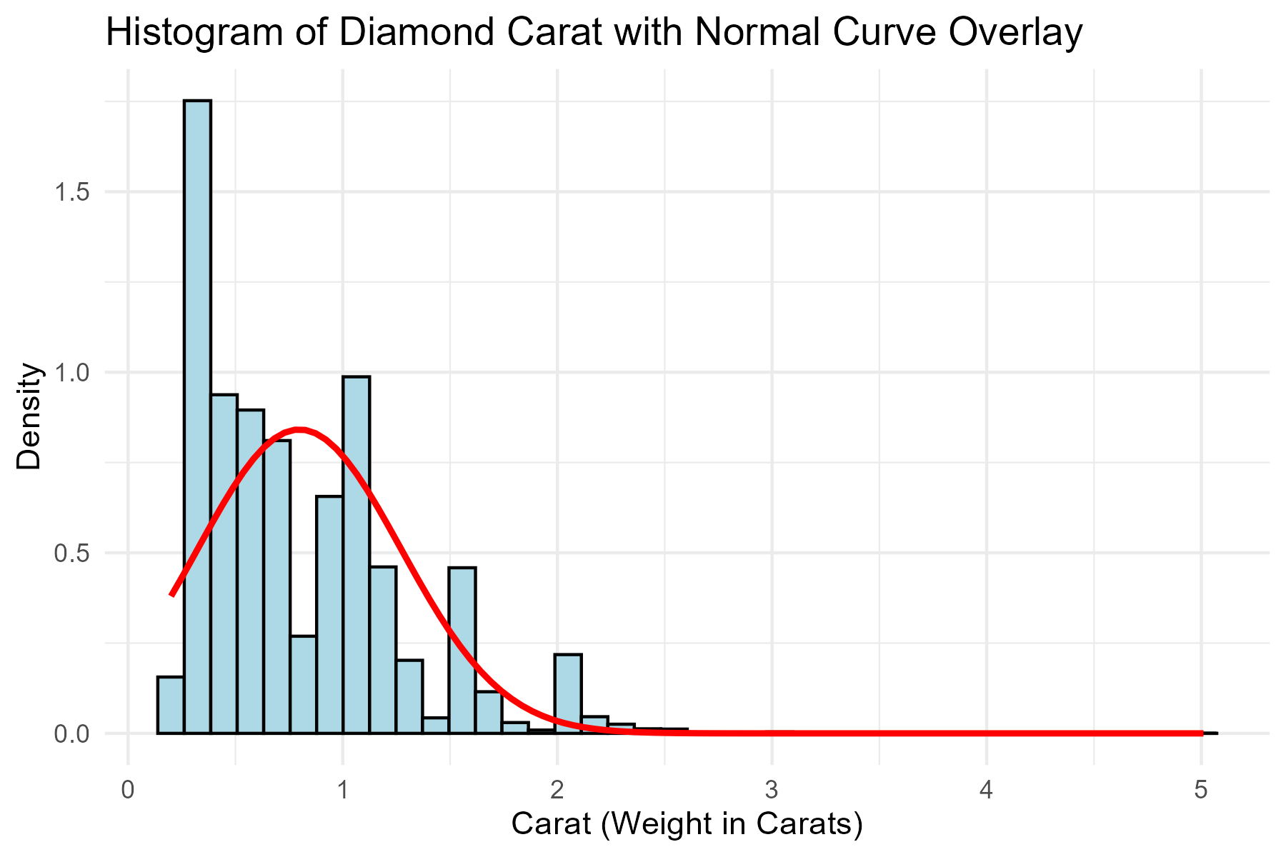

Additional information relating to understanding the data
The scatterplot allows visualising the way price varies depending on carat weight and it has identified a strong positive relationship, which indicates an upward trend. The histogram depicts the frequency of carats which are more likely to occur in the dataset with a larger diamond being much more frequent than the smaller ones. The combination of these plots helps one to get an understanding on the data structure prior to doing correlation analysis.

Useful information for the data understanding
The plots indicate that there is a steep rise in the prices of diamonds with a rise in carat weight hence a significant relationship that could be tested using statistics. The histogram also reveals that the data is skewed to the lower-carat diamonds and this can affect the overall distribution. The observations will put the results of the correlation in perspective and interpret the analysis.

Appendices

Appendix A – R Code Used for Analysis and Visualisation

df <- read.csv("diamonds.csv")

library(ggplot2)

ggplot(df, aes(x = carat, y = price)) +
geom_point(alpha = 0.4, colour = "blue") +
geom_smooth(method = "lm", se = TRUE, colour = "red") +
labs(
title = "Scatterplot of Diamond Carat vs Price",
x = "Carat (Weight in Carats)",
y = "Price (USD)"
) +
theme_minimal()

ggsave("scatterplot.png", width = 6, height = 4)

library(ggplot2)

ggplot(df, aes(x = carat)) +
geom_histogram(aes(y = ..density..), bins = 40, fill = "lightblue", colour = "black") +
stat_function(
fun = dnorm,
args = list(
mean = mean(df$carat, na.rm = TRUE),
sd = sd(df$carat, na.rm = TRUE)
),
colour = "red",
size = 1
) +
labs(
title = "Histogram of Diamond Carat with Normal Curve Overlay",
x = "Carat (Weight in Carats)",
y = "Density"
) +
theme_minimal()

ggsave("histogram.png", width = 6, height = 4)

Appendix B – Rscript.log Output
The R script used in this project was executed successfully, and the statistical output from the Pearson correlation test was saved automatically into a file named Rscript.log. This log file contains the full results of the hypothesis test conducted on the variables carat and price, confirming whether there is a significant correlation between them.
The statistical test performed was:
cor.test(df$carat, df$price, method = "pearson")

Output:
Pearson's product-moment correlation data: df$carat and df$price t = 551.41, df = 53938, p-value < 2.2e-16 alternative hypothesis: true correlation is not equal to 0 95 percent confidence interval: 0.9203098 0.9228530 sample estimates: cor 0.9215913

Appendix C – GitHub Log Output
The full GitHub log is included in Appendix C to show contributions, version history, and collaboration throughout the project. The log demonstrates consistent activity by all group members, including uploading files, writing code, and revising report sections.
Below are the three most significant commits selected from the log, along with their broader impact on the project:
1. Commit Message: “This is The 2nd Commit”
Impact: This commit established the foundation for analysis by preparing the dataset and generating the first reproducible R workflow.
2. Commit Message: “This is the 4th Commit”
Impact: This commit added the supplementary plots, supporting understanding of the relationship between carat and price.
3. Commit Message: “This contains my projectcode and Both the graphs. Also My main report”
Impact: This commit finalised our statistical analysis, enabling us to interpret the correlation and complete the results section of the report.

