HackThisSite.com Domain Investigation

This document contains a complete analysis of the domain 'hackthissite.com' using online reconnaissance techniques such as service scan, WHOIS lookup, DNS records review, and traceroute.

# Table of Contents

1. 1. Service Scan Summary
2. 2. Domain WHOIS Information
3. 3. Contact Details (Registrant, Admin, Tech)
4. 4. Network WHOIS Record
5. 5. DNS Records Overview
6. 6. Traceroute Path

## 1. Service Scan Summary

Below is the captured screenshot for reference:

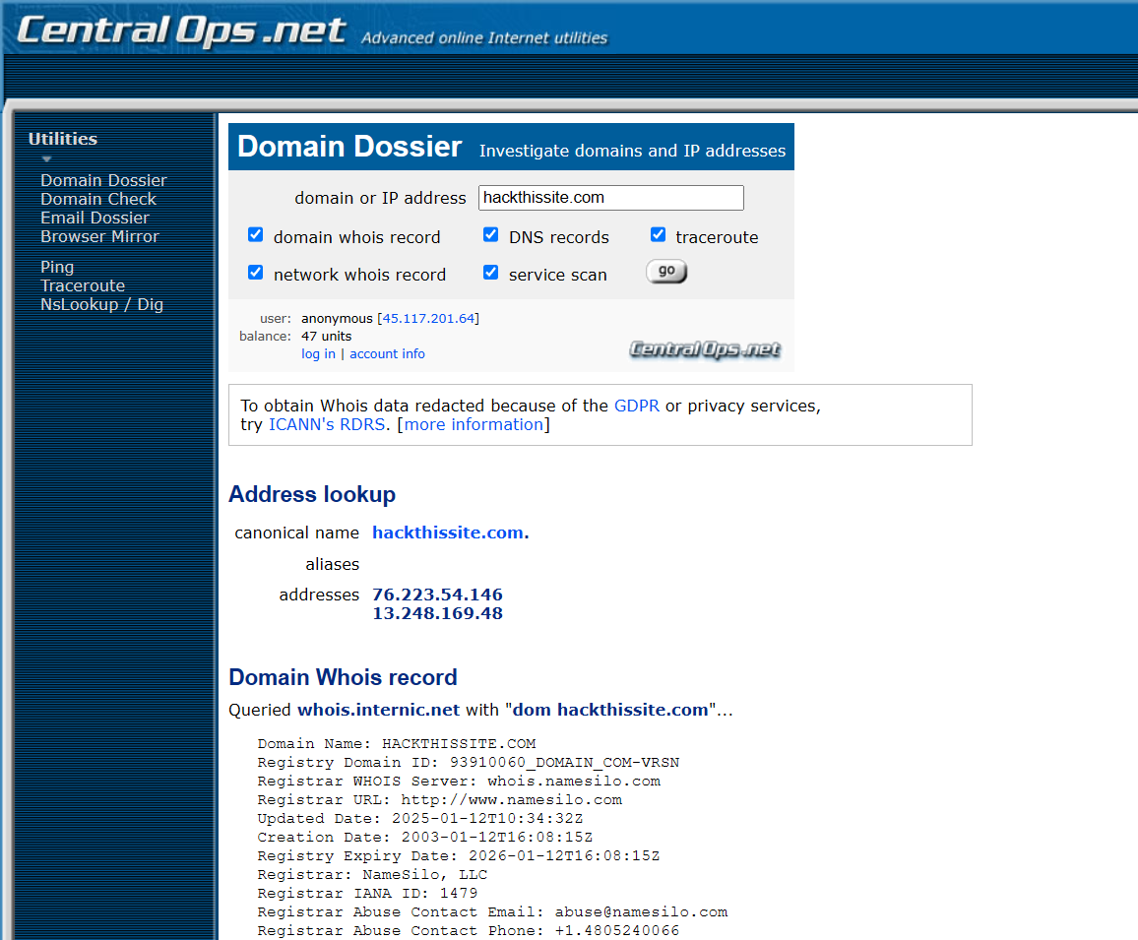

Explanation:

Insert analysis or summary of the above screenshot here. This can include relevant findings, tools used, and key observations.

## 2. Domain WHOIS Information

Below is the captured screenshot for reference:

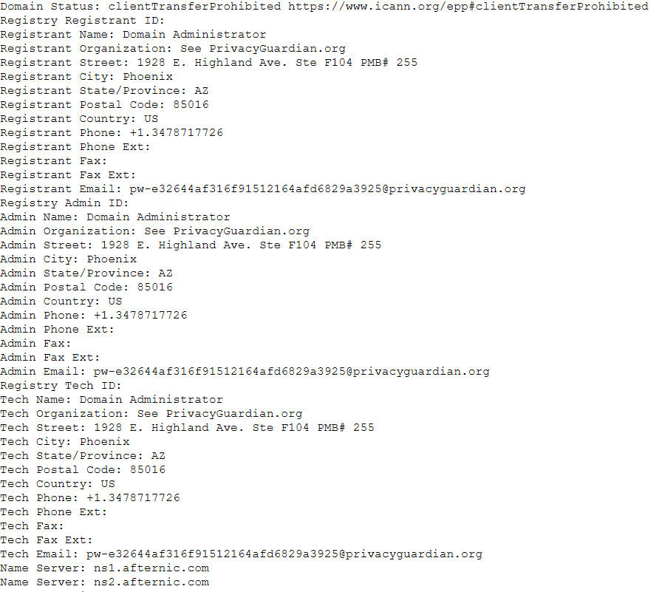

Explanation:

Insert analysis or summary of the above screenshot here. This can include relevant findings, tools used, and key observations.

## 3. Contact Details (Registrant, Admin, Tech)

Below is the captured screenshot for reference:

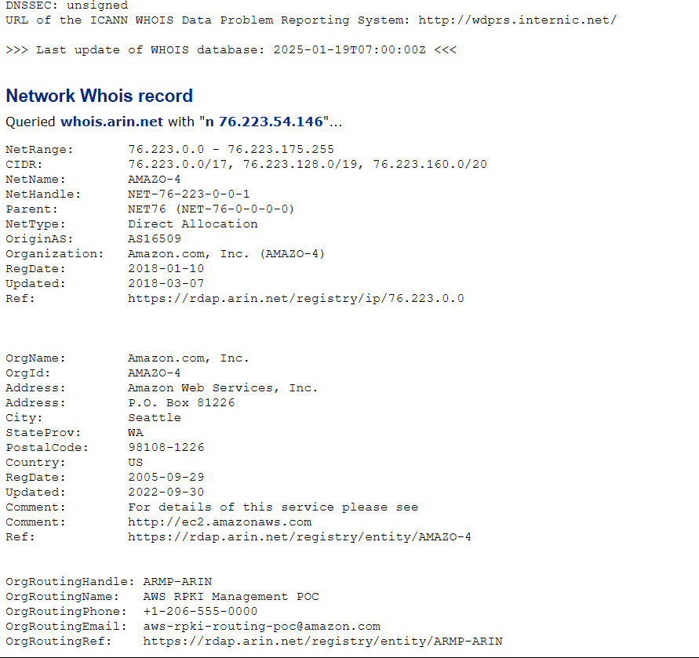

Explanation:

Insert analysis or summary of the above screenshot here. This can include relevant findings, tools used, and key observations.

## 4. Network WHOIS Record

Below is the captured screenshot for reference:

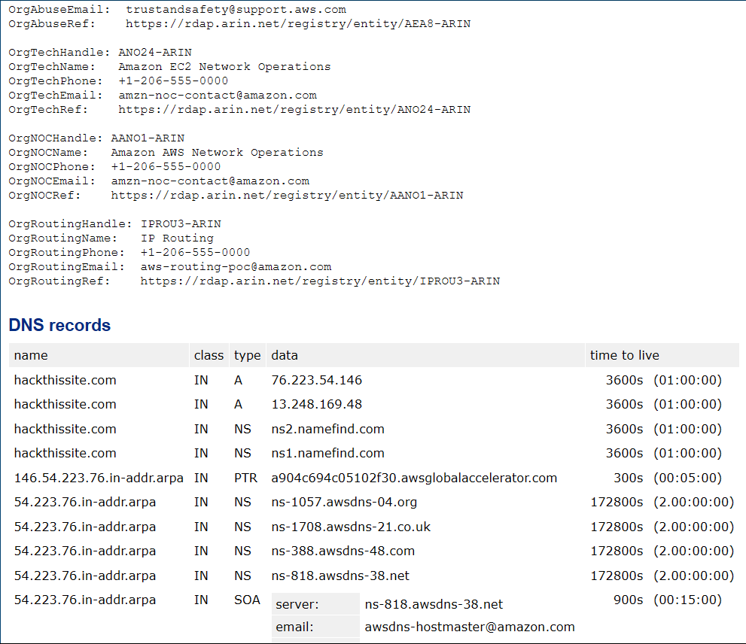

Explanation:

Insert analysis or summary of the above screenshot here. This can include relevant findings, tools used, and key observations.

## 5. DNS Records Overview

Below is the captured screenshot for reference:

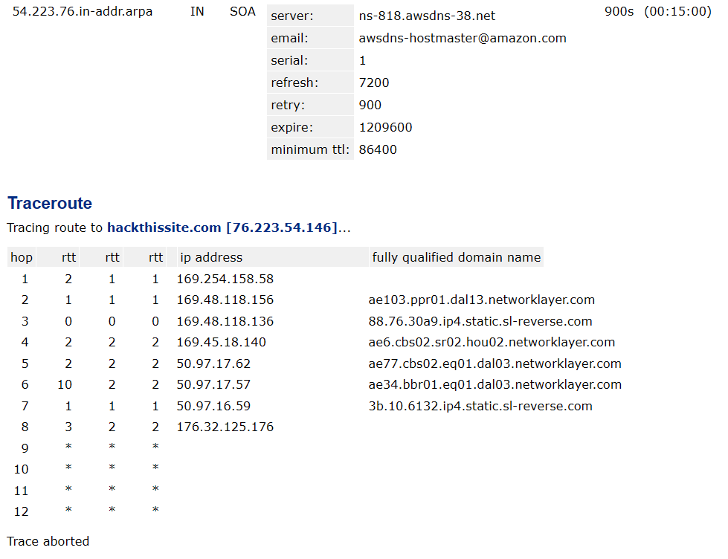

Explanation:

Insert analysis or summary of the above screenshot here. This can include relevant findings, tools used, and key observations.

## 6. Traceroute Path

Below is the captured screenshot for reference:

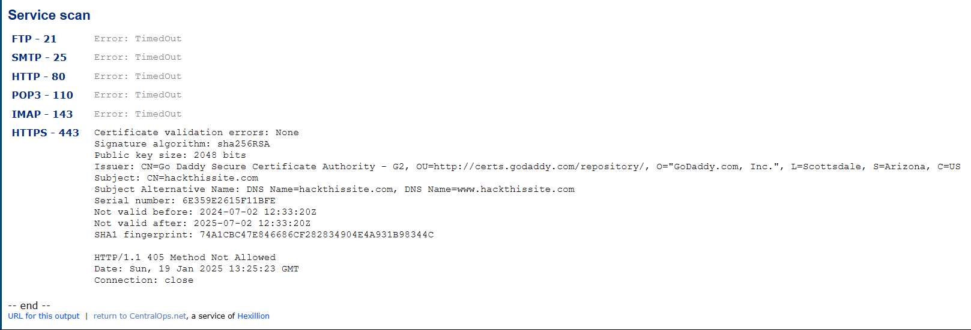

Explanation:

Insert analysis or summary of the above screenshot here. This can include relevant findings, tools used, and key observations.