HackThisSite.com Subdomain Scan

This document contains the results of a subdomain enumeration scan performed against the domain 'hackthissite.com'. The results include scan summary and the list of discovered subdomains.

# Table of Contents

1. 1. Subdomain Scan Summary
2. 2. Subdomain Output

## 1. Subdomain Scan Summary

The scan was completed successfully using a light scan method. It detected one subdomain associated with 'hackthissite.com'. Below is the screenshot showing the summary of the scan:

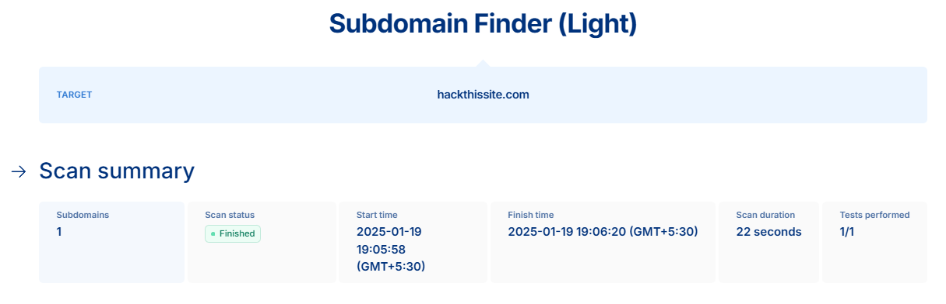

Explanation:

The scan started at 19:05:58 and ended at 19:06:20 on January 19, 2025, with a total duration of 22 seconds. Only one test was performed during this scan, which returned one subdomain.

## 2. Subdomain Output

The following subdomain was found, along with its associated IP address:

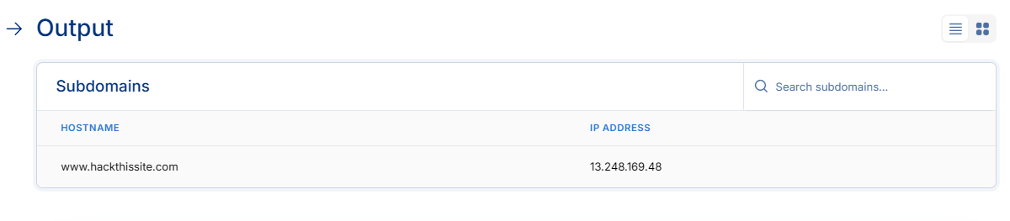

Explanation:

The subdomain 'www.hackthissite.com' resolves to the IP address '13.248.169.48'. This IP address was already identified in the earlier reconnaissance steps and confirms its association.