EXPLAINABLE UPI FRAUD DETECTION
FinGuard AI
Technical Architecture, Model Card, API, Security, and Deployment
PROTOTYPE PROMISE
Detect suspicious UPI-like transactions, expose the top model factors, and turn them into a clear English or Hindi safety action.

MVP v2.0 | 20 June 2026 | Submission package

1. Executive summary
FinGuard AI converts a black-box fraud alert into an actionable explanation. A validated transaction is transformed into behavioral features, scored by an Isolation Forest, attributed with SHAP, and explained in English or Hindi. FastAPI provides the integration surface and Streamlit provides a user and analyst dashboard.
OFFLINE-FIRST DEMO
The included model, seeded synthetic feed, and deterministic bilingual explanation layer allow the complete judge flow to run without Groq or internet access.

2. Goals and boundaries

Prototype goals
- Return a calibrated 0-100 risk score and top-three SHAP factors.
- Explain the same evidence in plain English or Hindi.
- Support live-feed simulation, manual case review, and seven-day analytics.
- Expose predictable API contracts that can sit beside an existing fraud stack.

Explicit boundaries
- No connection to NPCI, banks, real accounts, or real transaction streams.
- No automatic payment decline, reversal, reporting, or enforcement action.
- No UPI PIN, account number, phone number, or personal identifier is required.
- Synthetic holdout metrics are not production-bank performance claims.

3. Architecture
Layer | Technology | Responsibility
Experience | Streamlit | Seeded live feed, manual analysis, alerts, SHAP charts, and analytics.
API | FastAPI + Pydantic | Input validation, prediction, explanation, health, metrics, and demo endpoints.
Detection | Isolation Forest | Learns legitimate behavior and produces an anomaly normality score.
Explainability | SHAP TreeExplainer | Attributes transformed features and aggregates them to user-facing fields.
Language | Groq / Llama or local fallback | Produces constrained two-sentence English or Hindi safety guidance.
Packaging | Docker + Render config | Provides a stateless API deployment unit and health check.

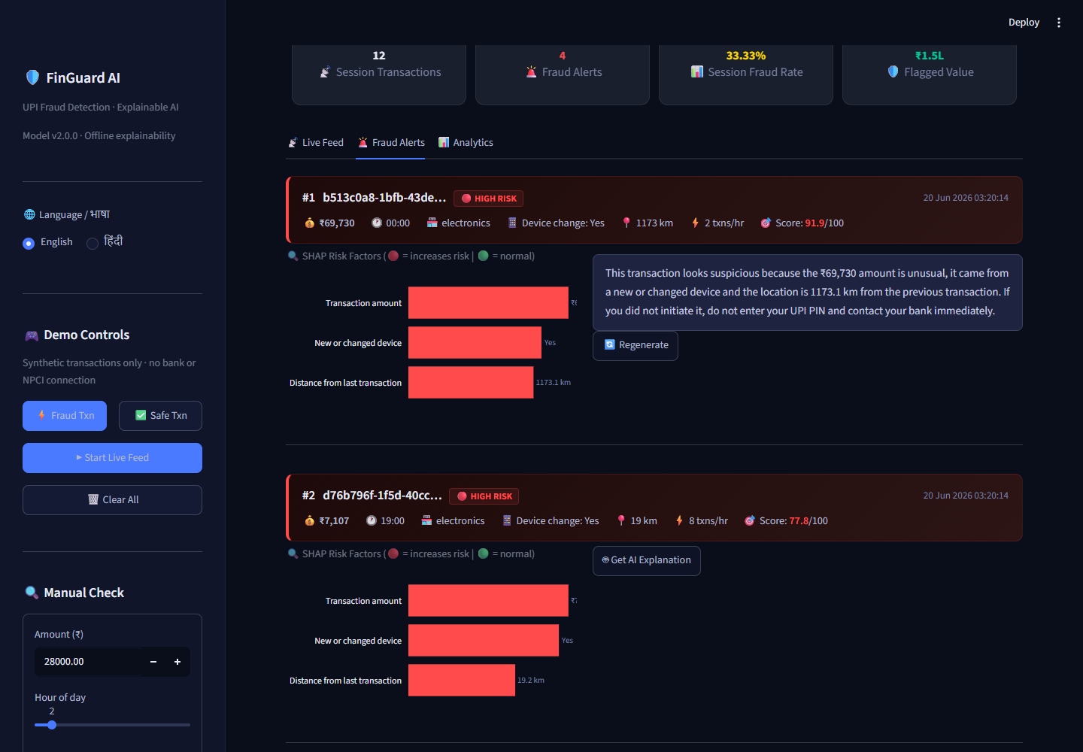
Figure 1. Verified Streamlit fraud alert with SHAP factors and offline explanation.

4. Data and feature engineering
The generated dataset contains 9,000 normal and 1,000 fraudulent UPI-like records. Fraud is injected through late-night high-value payments, device and location jumps, velocity attacks, and social-engineering payments to new merchants.
Input feature | Type | Meaning
amount | Float | Payment amount in INR.
hour | Integer | Local hour from 0 to 23.
merchant_category | Category | Ten merchant groups; one-hot encoded.
device_change | Binary | Device differs from the established fingerprint.
geo_distance_km | Float | Distance from the prior transaction location.
velocity_per_hour | Integer | Transactions observed in the current hour.
is_new_merchant | Binary | Merchant is new to the payer.

Transaction ID, label, and fraud-pattern metadata are not model inputs.

5. Training and model card
- Create a stratified 80/20 split with random seed 42.
- Fit preprocessing and Isolation Forest only on normal training rows.
- Standardize numeric inputs and one-hot encode merchant category.
- Map normality to 0-100 risk with headroom for severe anomalies.
- Select the fraud-class F1-maximizing threshold on the held-out partition.
- Build and persist a SHAP TreeExplainer for the fitted forest.
Held-out metric | Result
Test rows | 2,000
Fraud rows | 200
Fraud precision | 1.0000
Fraud recall | 0.9950
Fraud F1 | 0.9975
ROC-AUC | 0.9999
Calibrated threshold | 60.25

INTERPRETATION
The high score is expected because the synthetic attack rules are deliberately separable. It proves the implementation path, not external validity. Production evaluation requires institution data and temporal validation.

6. Explainability and language safety
Numeric SHAP contributions map directly to their original input. One-hot merchant contributions are summed into a single merchant-category contribution. The API returns value, bilingual label, signed contribution, and risk direction for each factor.
- Only risk score and top contributing factors are sent to the LLM.
- The system prompt forbids certainty, unsupported reasons, and ML jargon.
- The dashboard escapes generated text before inserting it into HTML.
- Timeouts, missing keys, and malformed responses fall back locally without leaking errors.

7. API contract
Method | Endpoint | Purpose
GET | /health | Model readiness and explanation mode.
GET | /model/metrics | Persisted training and evaluation metadata.
POST | /predict | Risk, threshold, decision, version, and SHAP factors.
POST | /explain | Prediction plus English or Hindi explanation.
GET | /demo/feed | Mixed synthetic batch with simulated ground truth.

OpenAPI documentation is generated automatically at /docs. Numeric inputs have explicit upper and lower bounds, and language is restricted to English or Hindi.

8. Security, privacy, and responsible use

Implemented in the MVP
- Strict request validation, limited CORS methods, environment-based secrets, and no key logging.
- No personal or payment credential is needed for scoring or explanation.
- Graceful LLM failure and HTML escaping reduce availability and injection risk.
- The tool is decision support; it does not take consequential payment action.

Required before production
- OAuth2 or mTLS, role-based access, tenant isolation, rate limits, and immutable audit logs.
- TLS, managed secrets, encryption at rest, retention policy, and incident response.
- Model registry, approval and rollback, drift detection, fairness slices, and human review.
- Consent and privacy review before any WhatsApp or user-notification integration.

9. Scalability and deployment
The API loads artifacts once and performs CPU-local inference, so it can scale horizontally behind a load balancer. At bank volume, scoring should consume transaction events from a queue, use a feature store for behavioral history, persist alerts separately, and invoke the LLM only for flagged transactions. Redis can enforce rate limits and cache repeated explanations.
The included Dockerfile serves FastAPI on the platform PORT. The Render definition and Streamlit configuration are included, but no hosted demo URL is part of this package.

10. Verification and failure behavior
Condition | Expected behavior
Model missing | API returns 503; dashboard shows setup instructions.
Groq unavailable | Feature-grounded local English or Hindi explanation.
Invalid input | Pydantic rejects the request with HTTP 422.
Unknown merchant | Encoder ignores the unseen category; other signals continue.
Visible UI error | Automated browser capture fails the QA run.

The automated suite currently contains eight passing tests and covers data rules, model risk ordering, missing fields, language grounding, and API validation. A smoke test confirms the end-to-end explain path.

11. Limitations and next steps
- Replace synthetic data with de-identified, consented institution data and time-based splits.
- Compute device, location, merchant, and velocity deltas from trusted account history.
- Measure alert capacity, false-positive cost, calibration, regional slices, and drift.
- Add authenticated case management, acknowledgment, analyst notes, and audit export.
- Load-test scoring and explanation paths independently before a pilot.

12. References
- NPCI: UPI Product Statistics - https://www.npci.org.in/what-we-do/upi/product-statistics
- Reserve Bank of India: Annual Report Publications - https://www.rbi.org.in/Scripts/AnnualReportPublications.aspx
- scikit-learn: IsolationForest documentation - https://scikit-learn.org/stable/modules/generated/sklearn.ensemble.IsolationForest.html
- SHAP documentation - https://shap.readthedocs.io/
- FastAPI documentation - https://fastapi.tiangolo.com/
Market figures supplied in the challenge brief should be refreshed from the latest NPCI and RBI releases immediately before final upload.

