LOGIN PAGE
1. Add Login with Google button on the login page also.

HOME PAGE

1. Redesign the home screen

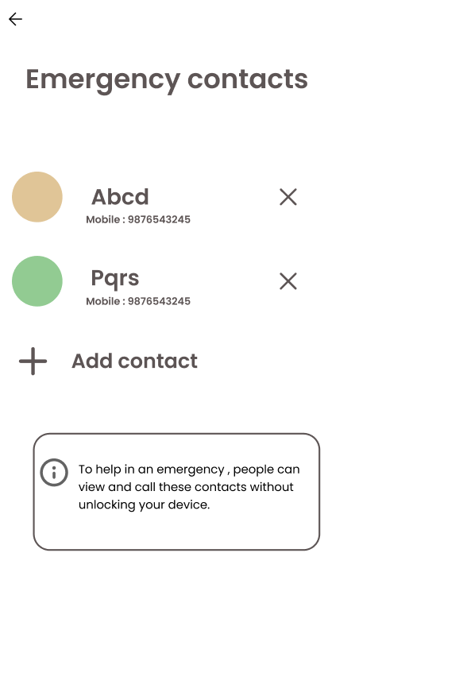
* Emergency screen wali navigation profile to kro hor kitho nhi anni chaidi

eh vali screen profile de vich option avve

* Redesign profile screen

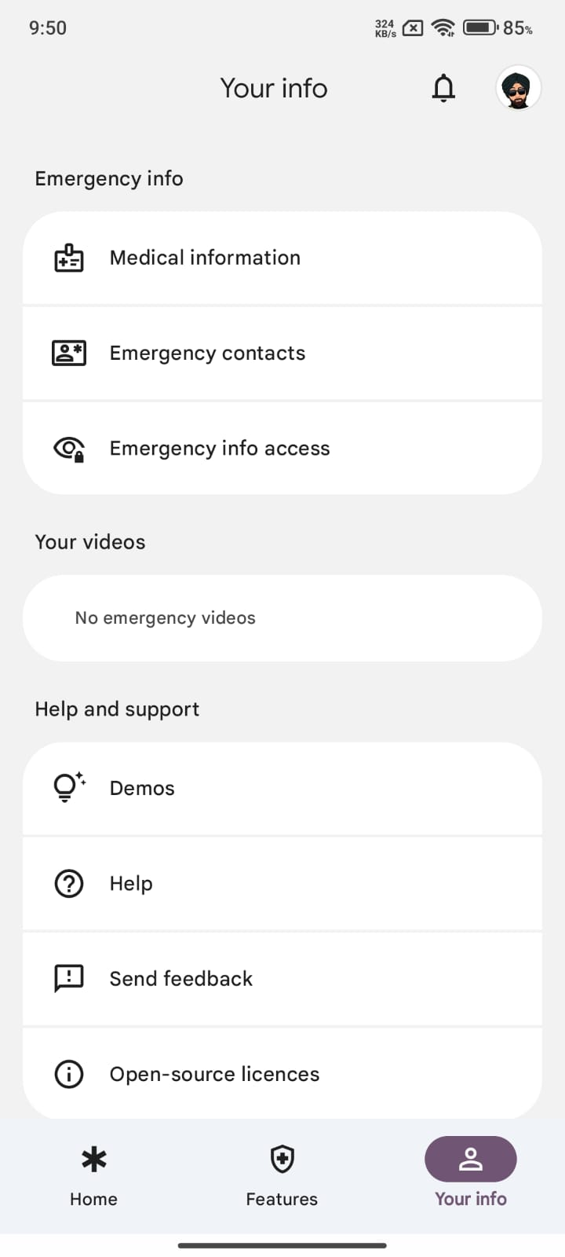
LIKE THIS

jo jo is profile ch hai oh sara add kro

bs DEMOs , HELP, SEND FEEDBACK , and OPEN SOURCE….. eh na include kro

MEDICAL INFORMATION de vich

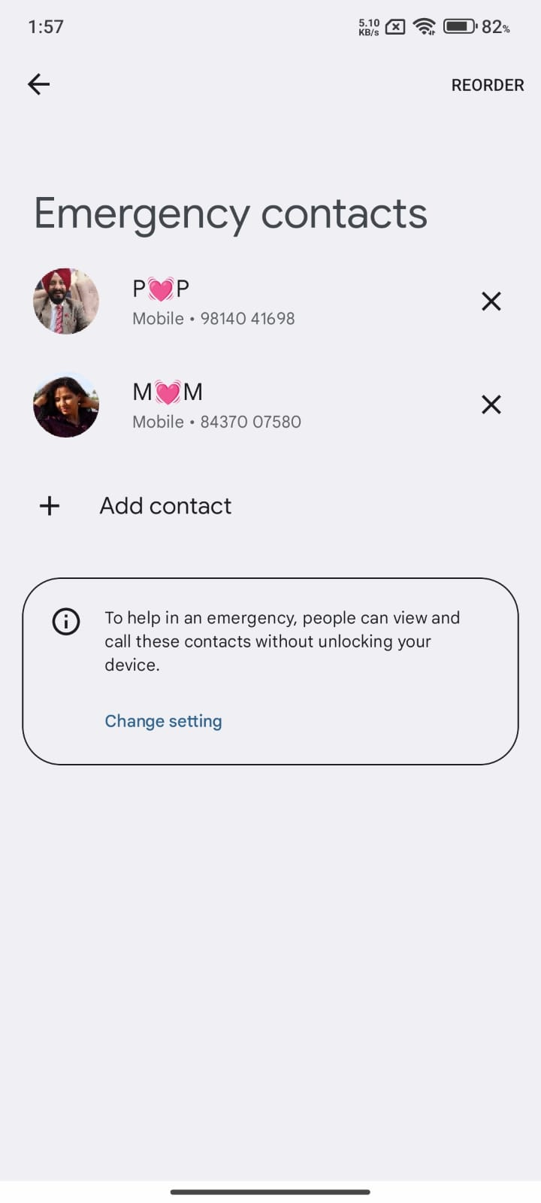
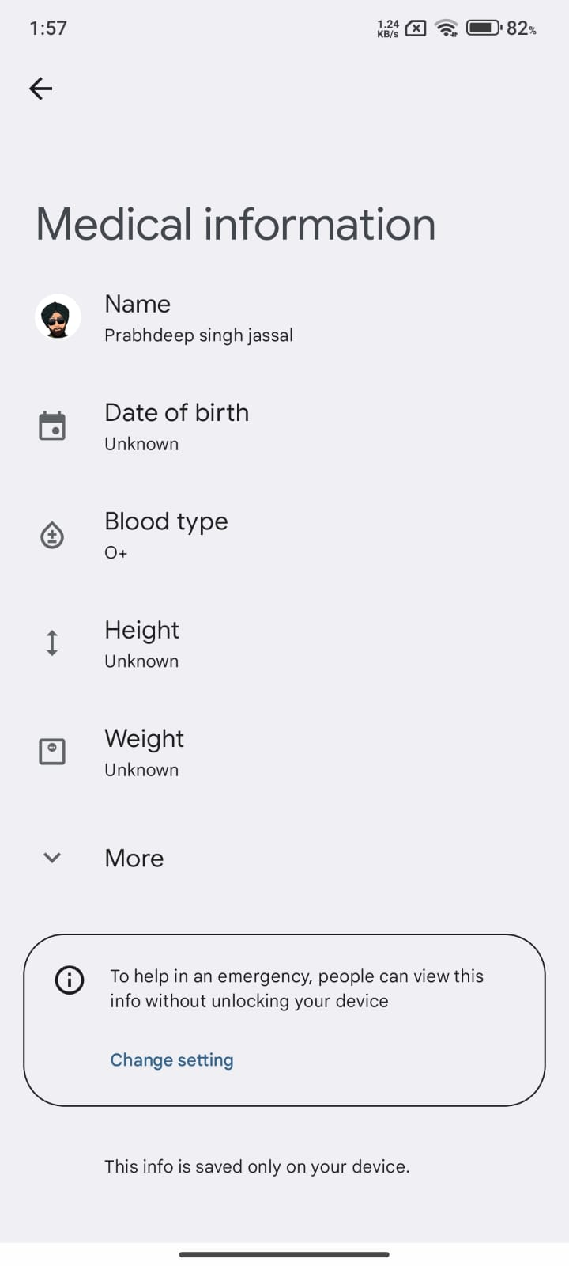

EMERGENCY CONTACTS

EMERGENCY CONTACT INFORMATION

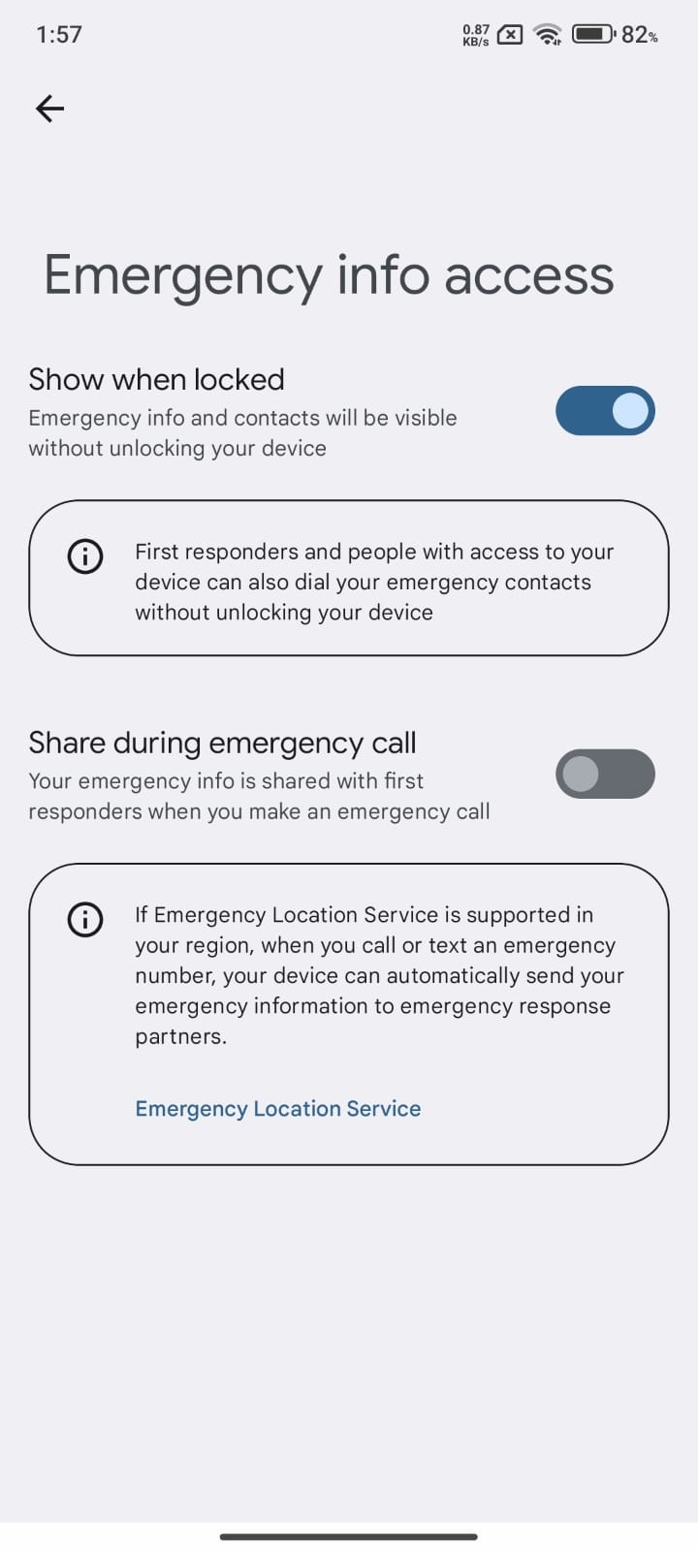

* ALSO MAKE THE NEW SCREEN WHERE WHEN USER navigates the map shows the route

* NAVIGATE THE FEEDBACK FORM (AUDIT VALA) from the route completion

